北京大学信息科学技术学院考试试卷
考试科目：计算机网络（实验班） 姓名： 学号：
考试时间： 2020年 6 月 8 日 任课教师: 边凯归
题号 | 一 | 二 | 三 | 四 | 五 | 六 | 七 | 八 | 总分
分数
阅卷人
装订线内 不要答题
北京大学考场纪律
1、考生进入考场后，按照监考老师安排隔位就座，将学生证放在桌面上。无学生证者不能参加考试；迟到超过15分钟不得入场。在考试开始30分钟后方可交卷出场。
2、除必要的文具和主考教师允许的工具书、参考书、计算器以外，其它所有物品（包括空白纸张、手机等）不得带入座位，已经带入考场的必须放在监考人员指定的位置，并关闭手机等一切电子设备。
3、考试使用的试题、答卷、草稿纸由监考人员统一发放，考试结束时收回，一律不准带出考场。若有试题印制问题请向监考教师提出，不得向其他考生询问。提前答完试卷，应举手示意请监考人员收卷后方可离开；交卷后不得在考场内逗留或在附近高声交谈。未交卷擅自离开考场，不得重新进入考场答卷。考试结束监考人员宣布收卷时，考生立即停止答卷，在座位上等待监考人员收卷清点后，方可离场。
4、考生要严格遵守考场规则，在规定时间内独立完成答卷。不准旁窥、交头接耳、打暗号，不准携带与考试内容相关的材料参加考试，不准抄袭或者有意让他人抄袭答题内容，不准接传答案或者试卷等。凡有严重违纪或作弊者，一经发现，当场取消其考试资格，并根据《北京大学本科考试工作与学习纪律管理规定》及其他相关规定严肃处理。
5、考生须确认自己填写的个人信息真实、准确，并承担信息填写错误带来的一切责任与后果。
学校倡议所有考生以北京大学学生的荣誉与诚信答卷，共同维护北京大学的学术声誉。

以下以下为答题纸，共 页

以下为试题和答题纸，共 15 页。

得分 一、单选题（每小题2分，15题，共30分）
Part A: Multiple Choice (Choose the BEST answer)

1. Consider an HTTPs client that wants to connect to an e-business web server, and retrieve a Web document at a given URL. Assuming that the IP address of the server URL is known, which of the following protocols is not necessarily needed in this case?
(a) HTTP
(b) TCP
(c) DNS
(d) SSL

2. Which of the following statements is correct regarding “socket”?
(a) Socket is an interface with rules for information exchange between adjacent layers.
(b) Socket is a network protocol that resides between application and transport layers.
(c) One socket can handle both HTTP and FTP connections.
(d) De-multiplexing is necessary while multiplexing is optional.

3. The Web cache/proxy can:
(a) store the content that is frequently accessed in memory.
(b) install cookies on local machine to keep the stateful information of a web session.
(c) make copies of files on client machines.
(d) respond to HTTP requests on the behalf of a Web server.

4. In TCP, the timeout interval at the transmitter is used to
(a) estimate the maximum segment size (MSS) of a datagram.
(b) estimate the size of buffer at the receiver.
(c) estimate the round trip time (RTT) at the transmitter.
(d) estimate the congestion window size.

5. Which of the following is NOT an advantage for IPv6 over IPv4?
(a) More IP addresses can be assigned
(b) Security enhancement
(c) Support of Blockchain
(d) Quality of Service (QoS) support

6. What is NOT the difference between a link state (LS) and a distance-vector (DV) routing algorithms?
(a) LS is a centralized algorithm, and DV is a distributed one.
(d) LS has the oscillation problem, while DV is subject to the count-to-infinity problem.
(b) LS can be asynchronous, while DV can be synchronous.
(c) LS can guarantee the convergence to an equilibrium, while DV cannot.

7. In the following figure, four nodes A, B, C, D are transmitting over the same LAN, where |AB|=|BC|=|CD|, and the propagation delay over the distance between nodes B and D is T_{prop}. Nodes B and D always have packets with the same length to send, and the transmission delay of a packet is T_{trans}. Given the CSMA/CD protocol, when nodes B and D start transmitting simultaneously, what condition on the transmission delay T_{trans} and the propagation delay T_{prop} has to be satisfied to guarantee that nodes B or D can detect a collision?
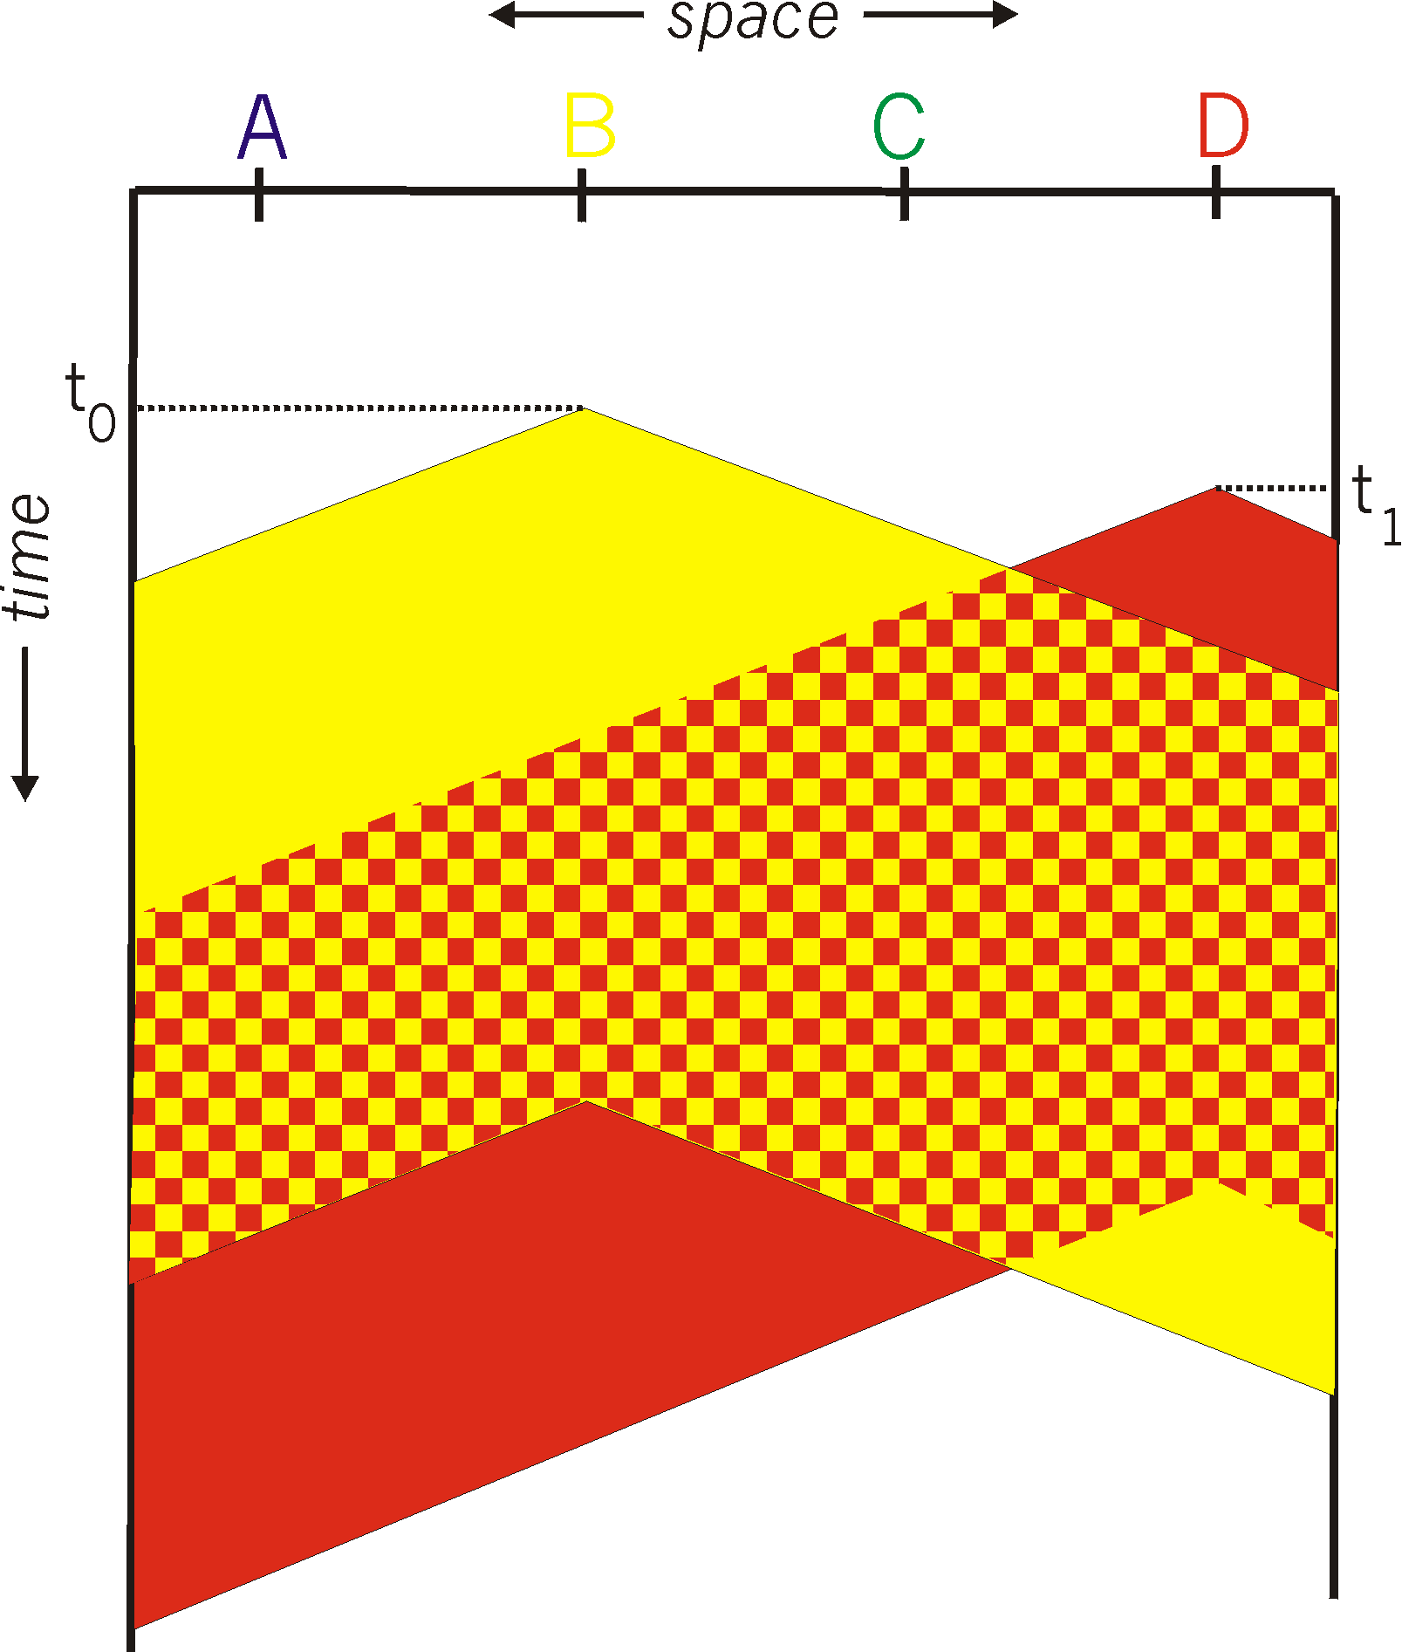

(a) T_{trans} > 2T_{prop}
(b) T_{trans} > T_{prop}
(c) T_{prop} > 2T_{trans}
(d) T_{prop} > T_{trans}

8. In an Ethernet frame, the preamble is responsible for:
(a) sender/receiver synchronization.
(b) collision detection or avoidance
(c) error detection and correction.
(d) multiplexing and demultiplexing.

9. Which of the following statements is NOT a reason why the RTS-CTS handshake mechanism is needed in a CSMA/CA protocol?
(a) To reserve the channel access when a node wants to start a transmission
(b) To prevent neighboring nodes that receive RTS/CTS frames from transmitting.
(c) To address the hidden and exposed terminal problems.
(d) To reduce the waste in wireless channel utilization when a collision occurs

10. In the network, there exist two nodes A and B sharing the same wireless channel by CSMA/CA, and they want to transmit packets with the packet length equivalent to 5 time slots. Their initial back-off timer values are 3 and 5. They have the same contention window size—[1, 15], which is assumed to not change over time. The RTS/CTS handshake is NOT used.
What are the possible back-off timer values after 10 time slots for nodes A and B, respectively?
(a) 0, 2 (b) 14, 0 (c) 13, 0 (d) 14, 1 (e) 15, 1

11. The SIGNAL to NOISE ratio (SNR) is an applicable method for receiving signals in a general communication model. The receiver can detect the wanted SIGNAL sent by the transmitter only when the received signal strength is sufficiently high. Which of the following is correct?
(a) For a laptop in an 802.11 based (WiFi) network, the signal is the DATA frame, and the noise is the DATA frame from other WiFi devices.
(b) For a driver in a car stopped at a crossroad, the signal is the green/screen light signal, and the noise is the yellow light noise.
(c) When a student is sitting in a classroom, the signal is from the instructor and there is no specific noise delivered in the environment.
(d) When a user scans a QR code (or bar code) using the smartphone camera, the signal is black/white blocks of the code, while the noise is from the background light, other light sources, or even image blur due to the user’s operations.

12. The below table summarizes the pros and cons of each category of MAC protocols that we studied.
MAC category | Pros | Cons
X | Easy to implement, and adaptive to dynamic number of users | Collision will reduce the performance
Y | Fairness can be guaranteed when the number of users is known. | Resources may be wasted when the number of users is unknown.
Z | Scheduling users who will receive the allocated resources. | Delay to get a resource, and single point of failure
Which of the following statements is correct?
(a) X = Channel partitioning, Y = Taking turn, Z= Random access
(b) X= Random access, Y = Channel partitioning, Z = Taking turn
(c) X = Taking turn, Y= Random access, Z = Channel partitioning
(d) X = Taking turn, Y= Channel partitioning, Z = Random access

13. Suppose Weighted Fair Queuing is used at a router. Traffic classes 1, 2, 3, 4, and 5 have weights 0.125, 0.25, 0.375, 0.125, and 0.125, respectively. Traffic is always available from all five classes. Which of the following repeating service cycles is valid for this scenario?
(a) 1-1-2-2-1-3-4-4-5-1-1-2-2-1-3-4-4-5-…
(b) 1-2-3-4-3-2-3-5-1-2-3-4-3-2-3-5-…
(c) 3-2-3-4-4-1-2-3-5-3-2-3-4-4-1-2-3-5-…
(d) 1-2-3-4-5-4-5-3-1-2-3-4-5-4-5-3…

14. What are the major concerns for securing the web server(s) of e-business in a distributed computing paradigm?
(a) Integrity
(b) Confidentiality
(c) Authentication
(d) All of above

15. Which of the following application/technique does not depend on both RSA encryption/decryption?
(a) Digital signature
(b) Blockchain
(c) Login on e-business website
(d) Nonce for anti-replay of a message

得分 二、简答题（每小题3分，3题，共9分）
Part B: Short Answer Questions
1. Can you identify the similarity as well as the difference among the “cache in CPU”, “Web cache”, “the cache in web browser”, “GPU cache”, and “disk cache”?

2. We have studied/introduced so many terms related to MAC protocols and standards in the chapters of link layer and wireless networks.
- TD-LTE, FDD-LTE, CSMA, ALOHA, GSM, TDMA, FDMA
Please categorize these terms into the following taxonomy figure, and briefly outline the reasons for your taxonomy. Note that there are two broad groups, and two sub-groups under each broad group.
Protocols for wireless link
General protocols

Reasons:

3 Why RTS/CTS can address the “hidden terminal” in wireless networks? You can draw an illustrative figure when describing your answer.
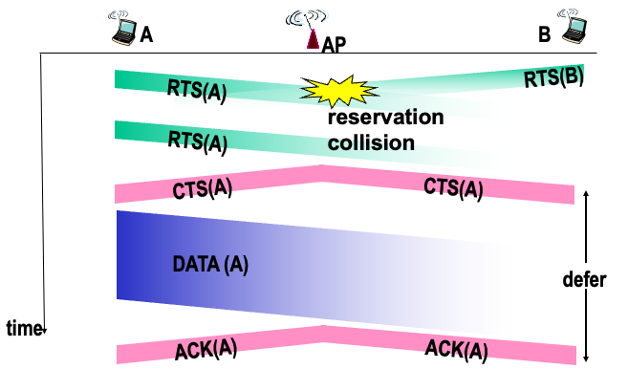

得分 三、计算题 （5题，共61分）
Part C: Analysis and Calculation
1. Transmission Control Protocol (TCP) （11分）
Consider the following plot of TCP window size as a function of time for two TCP connections A and B (Figure 1). In this problem we will suppose that both TCP senders are sending large files. We also assume that the packet loss events are independent in connection A and B.

a. Considering the above values of congestion window (CongWin) for these connections, can we identify the type of TCP connections (Reno or Tahoe) that have been used by connection A and B?
A:
B:

b. What are the values of the Threshold parameter between the 1st and the 14th transmission rounds for each connection?

c. At the 12th transmission round for connection A, is segment loss detected by a triple duplicate ACK or by timeout? Justify your answer.

d. Draw (on Figure 1) the CongWin values of both connections up to the 20th transmission round, considering that there is no timeout or duplicate ACK for any of the connections.
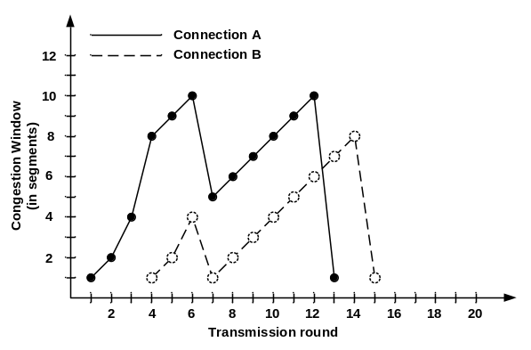
Figure 1: TCP congestion window vs. time (transmission rounds)
- Routing （15分）
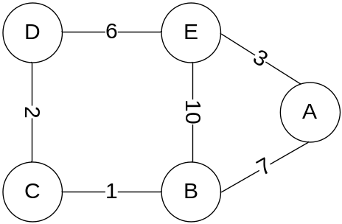
Figure 2: A computer network for illustrations of routing protocols.
Consider the network in Figure 2. The numbers on the links between nodes represent the costs corresponding to these links. Assume that nodes initially know only the cost of adjacent links (link to which they are directly connected).
a. Using the distance-vector algorithm, show the distance tables at node E. Assume that the algorithm works in a synchronous manner, where all nodes simultaneously receive distance vectors from their neighbors, compute their new distance vectors, and inform their neighbors if their distance vectors have changed.
(Fill all or part of the following tables when needed. 不一定所有表格都需要填写)
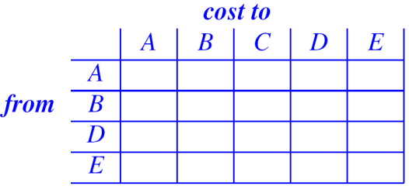

b. Oscillation is possible in a routing protocol using Dijkstra algorithm when the link cost is dynamically changing. Nodes B, C, and D are receiving packets at rates 2, x, 2, respectively (dotted arrow lines). Note that 0< x <2.
Please write down the correct link cost values (over solid arrow lines) in the following in Figure 3 (b)(c)(d).

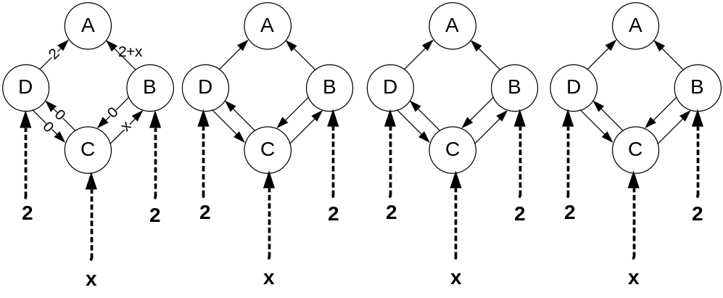
- (b) (c) (d)
Figure 3: Illustration of oscillation in Dijkstra-based routing protocols.

c. In Figure 4, the link cost values are: (x, y) = 4, (x, z) = 15, and (y, z) = 1. The distance vector routing algorithm has converged at a stable state: every node has found the shortest paths to each of all nodes.
- What kind of problem will occur when we change the link cost between x and y from 4 to 30?
- How many iterations are needed before the three-node network becomes stable again?
- Briefly explain why.
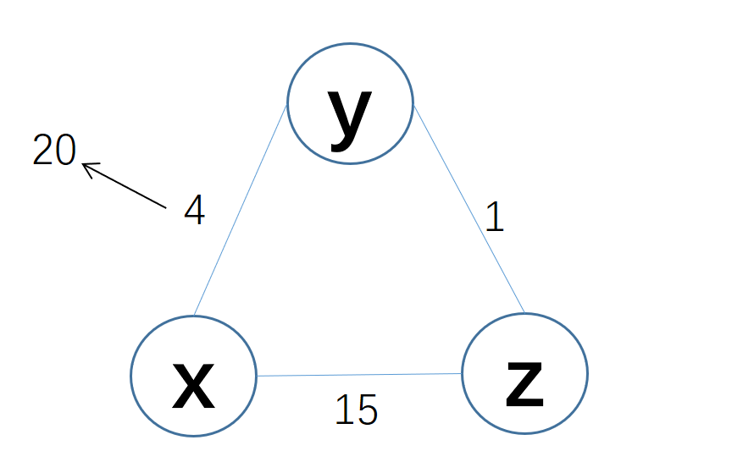
Figure 4: A computer network for illustrations of routing loops.

3. Queuing in routers (15 points)
Answer the following questions about the network of four routers below. Each link has capacity of 1 Mbps. You can assume there is no contention on the access links, or for router backplane resources; i.e., the only constraints are the link capacities between routers. There are four flows in the network, labeled F1...F4, that traverse the routers indicated. F4 shares links with every other flow, traversing R3→R1→R2→R4, as shown in Figure 5.

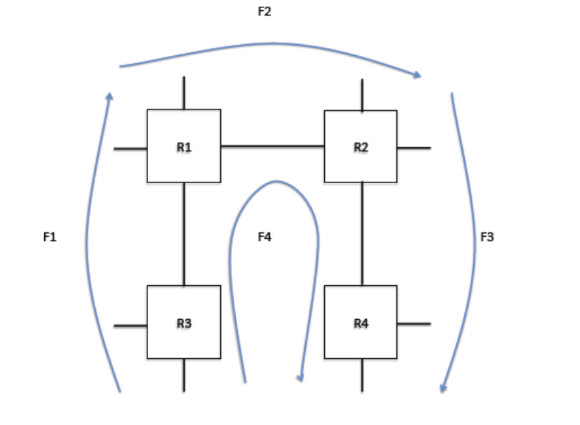
Figure 5: Four interconnected routers.

a. Assume each router implements FIFO queuing. If each flow consists of an identical, 1-Mbps constant bit rate UDP flow with equal packet sizes, what will the resulting rate be for each flow?

b. Now consider the case where all routers implement fair queuing. What would be the throughput of each flow now?

c. Finally, assume all routers implement WFQ, and each flow is assigned a weight equal to its number (i.e., flow F1 gets weight 1,…, flow F4 gets weight 4). What are the resulting throughputs?

4. Link Layer and Medium Access Control （7分）
Suppose two active nodes N₁, N₂ share a channel using slotted ALOHA. The channel capacity is 10 Mbps. Assume that each node has an infinite number of packets to send. In the slotted ALOHA protocol, every node attempts to transmit in each time slot with probability p.
Suppose we change the slotted ALOHA protocol, and name it as a new ALOHA-X protocol (Figure 6).
- Node N₁ makes an attempt to transmit with probability p only in each of odd timeslots (slots 1, 3, 5, 7,…); it is silent in even slots (slots 0, 2, 4, 6,…).
- Node N₂ makes an attempt to transmit with probability p only in each of even timeslots; it is silent in odd slots.
The slot boundaries are always aligned in ALOHA-X.
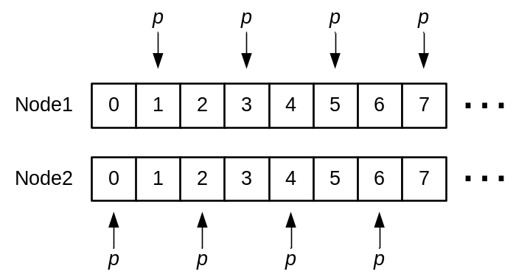
Figure 6: ALOHA-X: slot boundaries are aligned; two nodes’ odd/even slots are synchronized.
a. What is the collision probability when the two nodes’ odd/even slots are NOT synchronized? Suppose the clock drift is only one time slot.

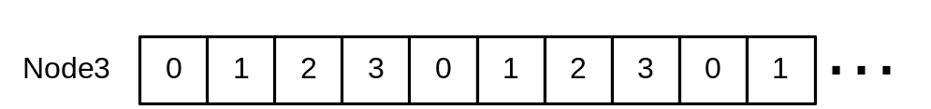
p p p p p
Figure 7: The transmission schedule of the third node.

b. In addition to nodes 1 and 2, in Figure 7
- The third node N₃ makes an attempt to transmit with probability p only in each i-th slot where the slot index i (mod 3) = 0; it is silent in other slots.
What is the collision probability when three nodes 1, 2, and 3 coexist in the same network? Clocks and boundaries of slots for the nodes are aligned.

5. Channel Allocation in Wireless Networks （13分）
Consider the following four wireless (i.e., WiFi multi-hop) network scenarios with different topologies shown in Figure8(a)(b)(c)(d), where
- Each line (实线) represents a one-hop wireless link between two nodes and the two nodes over this link are within the transmission (and interference) range with each other.
- Each arrowed line (带箭头的线) with an arrow shows a data flow traversing in the network along a given route.
- NO RTS/CTS packets are used.
Up to five independent wireless channels, labeled by channel indices such as 1, 2, 3, 4, 5, are available for allocation to each node to maximize the throughput using the least number of channels. Each channel has a capacity of 1Mbps. Note that a node needs to do a channel switching operation (频道切换) if it serves two links that are allocated two different channels, which causes a performance loss.
For example, in Figure8(a), there are two data flows over the wireless networks, ABC, and ED, respectively.
The optimal channel allocation is that:
- Nodes A, B, C for the flow ABC are allocated on one channel, say channel #1; Nodes D and E for the flow ED are allocated on another channel, say channel #2; Nodes F and B for the flow BF are allocated on the same channel as flow ABC, that is channel #1;
- In such an allocation, node C can receive packets from B, because they are in same channel #1; meanwhile, node C cannot hear packets from E (to D), because nodes E and D are staying on channel #2. Hence, flow ED can get a throughput about 1Mbps;
- The flow BF and flow ABC share the common node B, and node F should be allocated same channel as A, B, and C. The reason is that if we assign node F a third channel, say channel #3, then node B has to do channel switching (频道切换) between channel #1 and #3, because node B has to serve nodes C and F in two flows. Channel switching will degrade the performance of each flow;
- Hence, when node F is assigned channel #1 as shown in Figure 8(a), then flow BF can obtain a throughput around 1/2Mbps, and flow ABC can obtain a throughput around 1/2Mbps, because the two flows share the channel #1;

The inefficient allocation is that: nodes A, B, C, D and E are allocated the same channel #1. In such a case, node C can hear packets from both B and E; that is to say, packets from B and E will collide at node C. To avoid such co-channel collision, we have to allocate two different channels to two data flows ABC and ED.
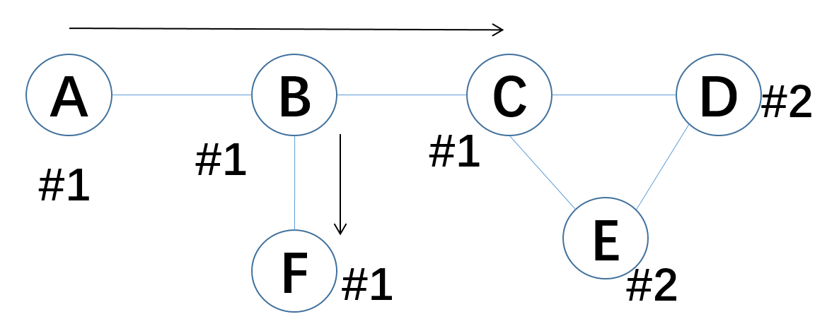
Figure 8(a): Three flows ABC, BF, and ED, in a 6-node wireless network.

- Draw a channel allocation in each figure (by labeling each link between two nodes who have a solid line between them, using a channel index), such that the throughput of each flow can be maximized using the least number of channels in each given network topology
- Roughly estimate the throughput that each flow can obtain in each network.
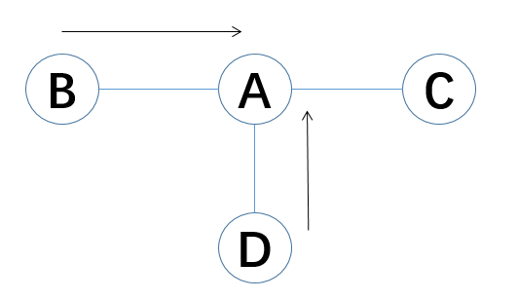
Figure 8(b): Two flows BA, and DA, in a 4-node wireless network.
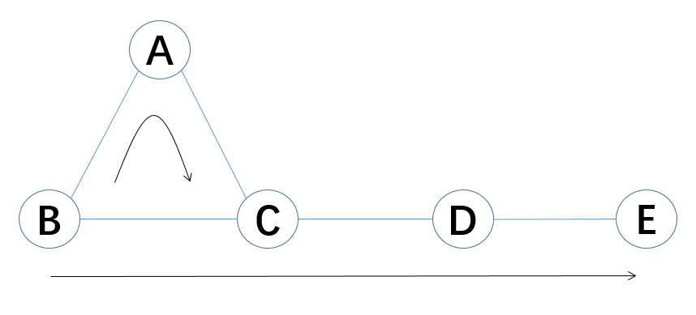
Figure 8(c): Two flows BAC, BCDE, in a 5-node wireless network.
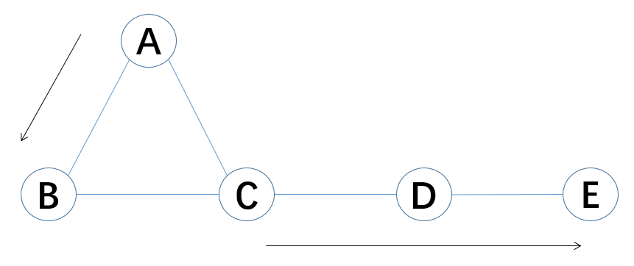
Figure 8(d): Two flows AB, and CDE, in a 5-node wireless network.

