北京大学信息科学技术学院
考试专用纸
姓名： 学号： 授课教师： 边凯归
考试科目：计算机网络（实验班） 考试时间： 2022年6月13日 上午
题号 | 一 | 二 | 三 | 四 | 五 | 六 | 七 | 八 | 九 | 十 | 总分
分数
北京大学考场纪律
1、考生要按规定的考试时间提前5分钟进入考场，隔位就座或按照监考人员的安排就座，将学生证放在桌面。无学生证者不能参加考试；迟到超过15分钟不得入场；与考试无关人员不得进入考场。如考试允许提前交卷，考生在考试开始30分钟后可交卷离场；未交卷擅自离开考场，不得重新进入考场继续答卷；交卷后应离开考场，不得在考场内逗留或在考场附近高声喧哗。
2、除非主考教师另有规定，学生只能携带必要的文具参加考试，其它所有物品（包括空白纸张、手机和智能手表等电子设备）不得带入座位；已经带入考场的手机和智能手表等电子设备必须关机，并与其他物品一起集中放在监考人员指定位置，不得随身携带或带入座位及旁边。
3、考试使用的试题、答卷、草稿纸由监考人员统一发放和收回，考生不得带出考场。考生在规定时间前答完试卷，应举手示意请监考人员收卷后方可离开；答题时间结束监考人员宣布收卷时，考生应立即停止答卷，在座位上等待监考人员收卷清点无误后，方可离场。
4、考生要严格遵守考场规则，在规定时间内独立完成答卷。不准旁窥、交头接耳、打暗号或做手势，不准携带与考试课程内容相关的材料，不准携带具有发送、接收信息功能或存储有与考试课程内容相关材料的电子设备（如手机、智能手表、非教师允许的计算器等），不准抄袭或协助他人抄袭试题答案或者与考试课程内容相关的资料，不准窃取、索要、强拿、传、接或者交换试卷、答卷、草稿纸或其他物品，不准代替他人或让他人代替自己参加考试，等等。凡违反考试纪律或作弊者，按《北京大学本科考试工作与学习纪律管理规定》给予相应处分。
5、考生须确认填写的个人信息真实、准确，并承担信息填写错误带来的一切责任与后果。

以下以下为答题纸，共 页

得分 一、单选题（每小题3分，10题，共30分）

1. 给定一个HTTPs客户端，连接了一个邮件服务器（比如gmail服务器），有固定的URL地址。这样一个场景下，下面哪一个协议不是必须的？ Consider an HTTPs client that wants to connect to an email web server (e.g., gmail.com) at a given URL. Which of the following protocols is not necessarily needed in this case?
答：( d )
(a) HTTP
(b) SSL 身份验证
(c) DNS url，转地址
(d) UDP

2. 下面关于socket的陈述哪一个是正确的？
Which of the following statements is correct regarding “socket”?
答：( c )
(a) Socket 是一个网络协议，在应用层和传输层之间。Socket is a network protocol that resides between application and transport layers.
(b) Socket 是一个网络协议，它规定了多路复用和解多路复用的操作行为。Socket is a network protocol that prescribes the behaviors of both multiplexing and de- multiplexing.
(c) Socket是一个网络接口，它规定了临近两层的信息交换操作。Socket is a network interface with rules for information exchange between adjacent layers.
(d) Socket是一个网络接口，它仅增加了HTTP和TCP连接的安全功能。Socket is a network interface that only adds security functions to HTTP and TCP connections. 这个对结合了ssl的secure socket才对

3. 网页缓存可以 The Web cache can:
答：( c ) web cache在哪？是在局域网里的机器上（网关or代理）
(a) 存储网页内容，这些内容被客户端的内存频繁访问。store the web content that is frequently accessed in the local memory of clients.
(b) 代表网页服务器在客户端上安装cookies。install cookies on client on the behalf of a Web server.
(c) 代表网页服务器回应HTTP请求，并返回网页内容。respond to HTTP requests with cached web content on the behalf of a Web server.
(d) 代表网页服务器复制网页make copies of files of webpages on the behalf of a Web server.

4. TCP的source节点计算的时间窗口是用来：In TCP, the timeout interval at the source node is used to
答：( d )
(a) 估计路由器上的丢包概率。estimate the packet loss probability at an intermediate router.
(b) 估计重传之前的时间（由三个重复ACK引发的）。estimate the time before retransmitting a packet triggered by three duplicate ACKs.
(c) 估计传输延迟。estimate the propagation delay between the source and the destination
(d) 估计source和destination节点之间来回的时间。estimate the round trip time between the source and the destination.

5. 下面哪个是IPv6相对于IPv4的优点？Which of the following is a potential advantage for IPv6 over IPv4?
答：( d )
(a) 匿名网页代理。Support of anonymous web proxy
(b) 数据隐私保护加强。Data privacy enhancement
(c) 网络审查。Internet censorship
(d) 更多的IP地址可用。More IP addresses for less NAT usage 这是最优的优点

6. 为何LS路由算法不同于一个DV路由算法？Why a link state (LS) algorithm is different from a distance-vector (DV) routing algorithms?
答：( a )
(a) LS路由算法是中心化的，而DV是分布式的。LS is a centralized algorithm, and DV is a distributed one.
(b) LS路由算法引发count-to-infinity问题，而DV算法引发震荡oscillation问题。LS has the count-to-infinity problem, while DV is subject to the oscillation problem. 反了
(c) LS路由算法是时钟异步的，而DV是时钟同步的。LS can be asynchronous, while DV can be synchronous. 反了
(d) DV路由算法可以保证算法收敛，而LS不能。DVcan guarantee the convergence to an equilibrium, while LS cannot. 反了

7. 有线网络链路层的以太网协议的数据帧中，先导码preamble的作用是：In an Ethernet frame, the preamble is responsible for:
答：( c )
(a) 检测超时。detection of the timeout
(b) 检测节点发送数据之间的碰撞。detection of collisions between nodes
(c) 检测数据帧的开始。detection of the start of a frame
(d) 检测数据丢包。detection of packet loss
8. 下面关于CSMA/CA协议中使用RTS-CTS机制正确的陈述是？Which of the following statements is true regarding the usage of the RTS-CTS handshake mechanism in a CSMA/CA protocol?
答：( d )
(a) 同时解决隐藏终端和暴露终端问题。To address both the hidden and exposed terminal problems.
(b) 解决暴露终端问题，但是会引起隐藏终端问题。To address the exposed terminal problem, which leads to hidden terminal problem
(c) 同时减少隐藏终端和暴露终端问题带来的负面效果。To mitigate the negative impact of the hidden and exposed terminal problems.
(d) 解决隐藏终端问题，但是会引起暴露终端问题。To address the hidden terminal problem, which leads to exposed terminal problem

9. 假设一个无线网络中，存在A、B、C三个节点设备存在于同一个无线信道上，使用的协议是CSMA/CA。这三台设备互相之间可以听到其他设备发送的数据信号，他们发送的数据包长度为5个时间槽。A、B、C三个设备他们的最初的back-off倒计时器的值为3，5，2。他们的竞争窗口大小是一样的，为[1,15]，并且该窗口不会变。因为节点设备数目较少，RTS-CTS并不启用。问：9个时间槽之后，下面选项中哪组数值是三台设备最有可能的back-off倒计时器的数值？In a wireless network, there exist three nodes A, B, and C sharing the same wireless channel by CSMA/CA, and they want to transmit packets with the packet length equivalent to 5 time slots. Their initial back-off timer values are 3, 5, 2. They have the same contention window size—[1, 15], which is assumed to not change over time. The RTS/CTS handshake is NOT used. What are the most possible back-off timer values after 9 time slots for nodes A, node B, and node C, respectively?
答：( a )
(a) 0, 2, 13 (b) 1, 3, 14 (c) 1, 2, 13 (d) 0, 3, 15

10. 下表列举了三类随机MAC协议在无线网络中的优缺点。The below table summarizes the pros and cons of each of random MAC protocols when used in wireless networks.

MAC category  MAC协议分类 | Pros  优点 | Cons  缺点
X | Easy to implement, and no synchronization  容易部署，不需要时钟同步 | Easy to have collisions will reduce the performance。  容易引起无线数据信号之间的碰撞
Y | Listen before talk etiquette.  发送之前先侦听 | Hidden terminal problem  隐藏终端问题
Z | Listen before talk etiquette and collision avoidance  发送之前先侦听，并且有冲突避免CA机制 | Exposed terminal problem  暴露终端问题
下面哪一种组合是正确的？Which of the following statements is correct?
答：( c )
(a) X = Pure ALOHA, Y= CSMA/CA, Z = CSMA/CD
(b) X= Slotted ALOHA, Y= CSMA/CA, Z = CSMA
(c) X = Pure ALOHA, Y= CSMA, Z = CSMA/CA
(d) X = Slotted ALOHA, Y= CSMA/CA, Z = CSMA/CD

得分 二、简答题（每小题4分，5题，共20分）

1. 假设路由器使用Weighted Fair Queuing 来进行多个数据流的优先级排序。该路由器收到四个数据流，其数据包的编号分别为1,2,3,4，这四个数据流的权重分别为，0.5, 0.25, 0.125, 0.125。写下该路由器处理的数据包编号的可能排列情况？Suppose Weighted Fair Queuing is used at a router. Traffic classes 1, 2, 3, and 4 have weights 0.5, 0.25, 0.125, and 0.125, respectively. Traffic is always available from all five classes. Show a possible repeating service cycle that is valid for this scenario.

1, 1, 1, 1, 2, 2, 3, 4

2. 设计一个安全的电子商务交易网站系统需要哪四个基本要求？What are four security requirements for securing an e-business application?

- Confidentiality
- Authentication
- Integrity
- Access and availability

3. 能否简要解释以下CPU cache，网页Cache，网页浏览器Cache这几个名词的异、同点吗？Can you identify the similarity as well as the difference among the “cache in CPU”, “Web cache”, “the cache in web browser”?

Similarity: All those caches are used to store frequently used information near the users to speed up.
Difference: The stored contents and users are different. ...

4. 我们已经学习过了以下无线网络、移动蜂窝网络、有线网络的协议名词：GSM, Ethernet, WiFi, Bluetooth, FDD-LTE, TD-LTE。请将这些名词分别填入下图的分类框中，左边是3GPP组织发布的协议和标准，右边是IEEE 802组织发布的协议和标准
We have studied/introduced so many terms related to MAC protocols and standards in the chapters of link layer and wireless networks.
- GSM, Ethernet, WiFi, Bluetooth, FDD-LTE, TD-LTE
Please categorize these terms into the following taxonomy figure (each box can contain one or multiple terms). Note that there are two broad groups, and two sub-groups under each broad group.
3GPP
standards
IEEE 802
standards

GSM

FDD-LTE
TD-LTE
Ethernet
WiFi
Bluetooth

5 为什么RTS-CTS机制可以解决隐藏终端问题？可以画一个图辅助解释。Why RTS/CTS can address the “hidden terminal” in wireless networks? You can draw an illustrative figure when describing your answer.

The RTS-CTS mechanism can be used to reserve the channel. Although two senders may be hidden from each other, when the receiver broadcast CTS to confirm the channel reservation, the broadcast CTS can be heard by all senders so they will know that the channel is occupied. In this way, the “hidden terminal” problem is solved!

得分 三、计算题 （4题共50分）

1. TCP拥塞控制TCP congestion control （10分）
图1所示为两个TCP连接A和B的拥塞控制窗口随着时间变化的图示，A和B持续发送很大的文件，并且两个连接的丢包率互相独立。Consider the following plot of TCP window size as a function of time for two TCP connections A and B (Figure 1). In this problem we will suppose that both TCP senders are sending large files. We also assume that the packet loss events are independent in connection A and B.
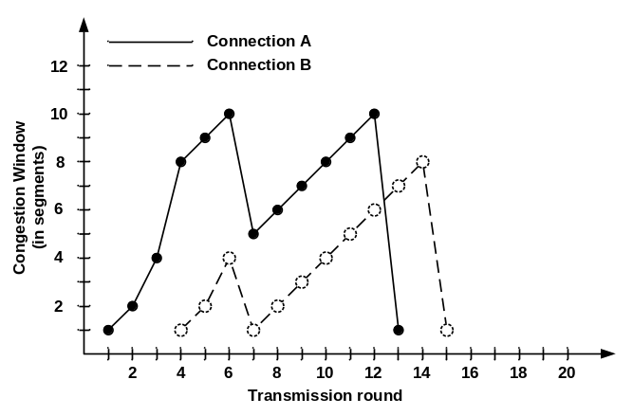
图1：两个TCP连接A和B的拥塞控制窗口随着时间变化的图示。 TCP congestion window vs. time (transmission rounds) for two TCP connections A and B.

a. （5分）考虑到图1中两条曲线的变化，是否能够确定TCP连接A和B的类型，即连接A是TCP Tahoe还是TCP Reno，或者无法确定？连接B是TCP Tahoe还是TCP Reno，或者无法确定？Considering the above values of congestion window (CongWin) for these connections, can we identify the type of TCP connections (Reno or Tahoe) that have been used by connection A and B?

A is TCP Reno because it implements fast recovery.
B is unsure because ...

b. （5分）在图1中画出、或者写出两条曲线（实线、虚线）的后续变化的Congestion Window大小，直到横轴时间为20。Draw, or write down the Congestion Window values of both connections up to the 20th transmission round, considering that there is no timeout or duplicate ACK for any of the connections.

Timeslot | 13 | 14 | 15 | 16 | 17 | 18 | 19 | 20
实线 | 1 | 2 | 4 | 5 | 6 | 7 | 8 | 9
虚线 | 7 | 8 | 1 | 2 | 4 | 5 | 6 | 7

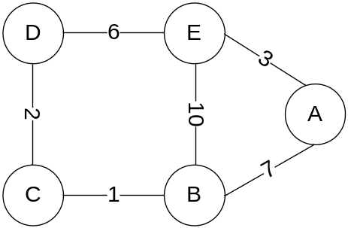
图2: 示例网络，每条边上的数字是该条边的路由开销routing cost。A computer network for illustrations of routing protocols.

2. 路由算法Routing （15分）
考虑图2中的网络，执行distance-vector 算法。
Consider the network in Figure 2. The numbers on the links between nodes represent the costs corresponding to these links. Assume that nodes initially know only the cost of adjacent links (link to which they are directly connected).

- （5分）图2中执行distance-vector 算法，请在下表中填入node E的距离向量（不一定所有表格都需要填满）。假设该算法执行过程中，所有节点同时和周围节点交换距离向量，即交换distance vectors，然后计算新的距离向量，然后再发给周围节点，如此反复循环。
Using the distance-vector algorithm, show the distance tables at node E. Assume that the algorithm works in a synchronous manner, where all nodes simultaneously receive distance vectors from their neighbors, compute their new distance vectors, and inform their neighbors if their distance vectors have changed. (Fill all or part of the following tables when needed)

cost to
from |  | A | B | C | D | E
from | A | inf | inf | inf | inf | inf
from | B | inf | inf | inf | inf | inf
from | C | 不存 | 不存 | 不存 | 不存 | 不存
from | D | inf | inf | inf | inf | inf
from | E | 3 | 10 | inf | 6 | 0

cost to
from |  | A | B | C | D | E
from | A | 0 | 7 | inf | inf | 3
from | B | 7 | 0 | 1 | inf | 10
from | C | 不存 | 不存 | 不存 | 不存 | 不存
from | D | inf | inf | 2 | 0 | 6
from | E | 3 | 10 | 8 | 6 | 0

cost to
from |  | A | B | C | D | E
from | A | 0 | 7 | 8 | 9 | 3
from | B | 7 | 0 | 1 | 3 | 10
from | C | 不存 | 不存 | 不存 | 不存 | 不存
from | D | 9 | 3 | 2 | 0 | 6
from | E | 3 | 9 | 8 | 6 | 0

cost to
from |  | A | B | C | D | E
from | A | 0 | 7 | 8 | 9 | 3
from | B | 7 | 0 | 1 | 3 | 9
from | C | 不存 | 不存 | 不存 | 不存 | 不存
from | D | 9 | 3 | 2 | 0 | 6
from | E | 3 | 9 | 8 | 6 | 0

cost to
from |  | A | B | C | D | E
from | A
from | B
from | C
from | D
from | E

cost to
from |  | A | B | C | D | E
from | A
from | B
from | C
from | D
from | E

- （5分）振荡问题是link state路由算法（即Dijkstra 路由算法）中的一个问题，特别是当链路路由开销（link cost）动态变化的时候。图3(a)中，节点B，C，D分别接受数据速率为2，x，2，如图3中箭头虚线所示，其中0< x <2。请在图3(b)(c)(d)子图的边上（箭头实线上），或者下面的空格处，分别标出该条链接上的开销。
Oscillation is possible in a routing protocol using Dijkstra algorithm when the link cost is dynamically changing. Nodes B, C, and D are receiving packets at rates 2, x, 2, respectively (dotted arrow lines). Note that 0< x <2. Please write down the correct link cost values (over solid arrow lines) in the following in Figure 3 (b)(c)(d).

Figure 3(b):
cost of DA =__4+x__ cost of BA =_0__ cost of CD = __2+x
cost of DC =__0__ cost of BC =_2__ cost of CB = __0__

Figure 3(c):
cost of DA =__0__ cost of BA =_4+x cost of CD = _0__
cost of DC =__2__ cost of BC =_0__ cost of CB = __2+x

Figure 3(d):
cost of DA =__4+x cost of BA =__0_ cost of CD = _2+x___
cost of DC =__0 cost of BC =__2_ cost of CB = _0___

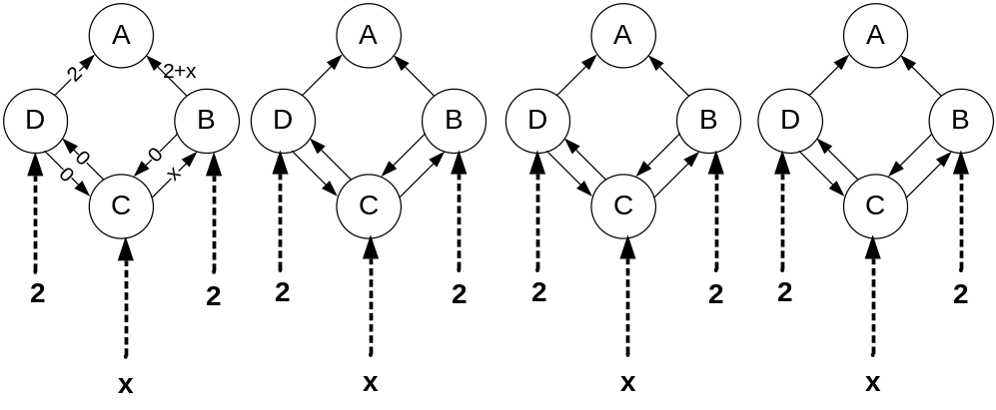
- (b) (c) (d)
图3: Dijkstra 路由算法中的振荡问题示例。Illustration of oscillation in Dijkstra-based routing protocols.

c. （5分）图4中展示的是计算机网络应用Distance Vector算法可能面临的问题，各个链路上的cost值如图所示。In Figure 4, the link cost values are: (x, y) = 4, (x, z) = 15, and (y, z) = 1. The distance vector routing algorithm has converged at a stable state: every node has found the shortest paths to each of all nodes.
- 如果把从x到y的cost增加到20，会出现什么问题？What kind of problem will occur when we change the link cost between x and y from 4 to 20?
Bad news travel slow - “count-to-infinity’ problem.
- 需要多少次迭代才能回复稳定状态？How many iterations are needed before the three-node network becomes stable again?
10
- 简要解释原因。Briefly explain why.
When (x, y) changes to 20, y updates dy(x) to 6 because it knows dz(x)=5
Iter1: y tells z dy(x) = 6, z updates dz(x) to 7
Iter2: z tells y dz(x) = 7, y updates dy(x) to 8
......
Iter9: y tells z dy(x) = 14, z updates dz(x) to 15 (correct)
Iter10: z tells y dz(x) = 15, y updates dy(x) to 16(correct)
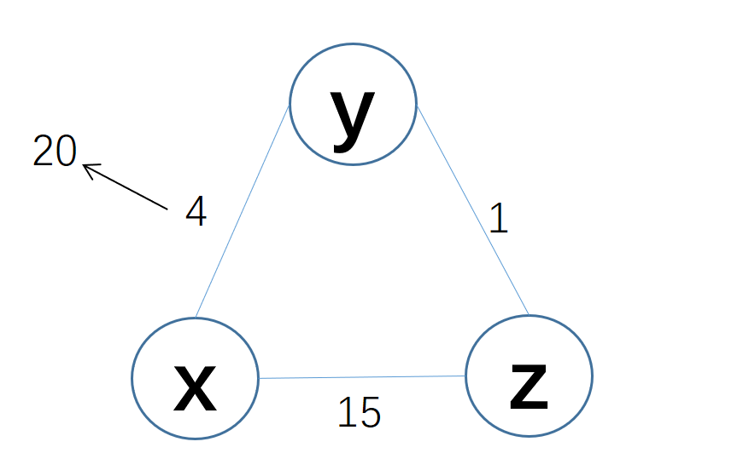
图4: 计算机网络Distance Vector算法面临的问题；A computer network for illustrations of routing loops.

3. 链路层媒介访问Link Layer and Medium Access Control （10分）
假设有两个节点Node 1和Node 2使用 slotted ALOHA来公用一个信道。每个时间槽内，每个节点传输的概率为p。
Suppose two active nodes N₁, N₂ share a channel using slotted ALOHA. Assume that each node has an infinite number of packets to send. In the slotted ALOHA protocol, every node attempts to transmit in each time slot with probability p.
假设我们将slotted ALOHA改动一下，改动后的协议名字叫ALOHA-X（图5所示）。
- 节点Node 1在奇数时间槽内，即1, 3, 5, 7等时间槽内，以概率p进行传输；在偶数时间槽内，即0, 2, 4, 6, 8等时间槽内，以概率q进行传输；
- 而节点Node 2在偶数时间槽内，即0, 2, 4, 6, 8等时间槽内，以概率p进行传输；在奇数时间槽内，即1, 3, 5, 7等时间槽内，以概率q进行传输。
- 节点1和2的时间槽边界是对齐的。p不等于q。
Suppose we change the slotted ALOHA protocol, and name it as a new ALOHA-X protocol (Figure 5). Node N₁ makes an attempt to transmit with probability p in each of odd timeslots (slots 1, 3, 5, 7,…); it transmits with probability q in each of even timeslots (slots 0, 2, 4, 6,…). Node N₂ makes an attempt to transmit with probability p in each of even timeslots; it transmits with probability q in each of odd timeslots The slot boundaries are always aligned in ALOHA-X. p is not equal to q.
- （2分）图5中，节点Node 1和Node 2的时间完全同步，他们之间的传输是否会发生碰撞？

Yes, the collision probability is pq.

- （8分）假如节点Node 1和Node 2的序列、时间槽前后错开1个时间槽，那么两个节点之间传输的碰撞概率是多少？
What is the collision probability when the two nodes’ odd/even slots are NOT synchronized? Suppose the clock drift is only one time slot.

(p**2 + q**2) / 2

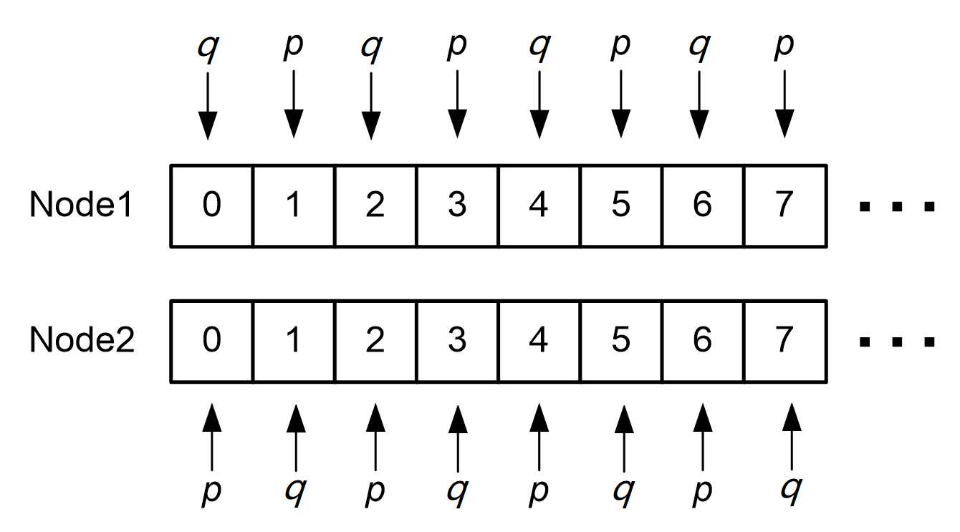
图5: ALOHA-X: 两个节点分别有各自的发送时序。 Two sequences of two nodes when they send packets.

4. 无线网络信道分配Channel Allocation in Wireless Networks （15分）
考虑图6中的WiFi多跳网络。Consider the following four wireless (i.e., WiFi multi-hop) network scenarios with different topologies shown in Figure 6(a)(b)(c)(d), where
- 实线代表一跳无线链路，连接两个无线节点；链路长度代表相邻无线节点之间传输/干扰距离。Each solid line (实线) represents a one-hop wireless link between two nodes and the two nodes over this link are within the transmission (and interference) range with each other.
- 带箭头的线代表一条数据流。Each arrowed line with an arrow shows a data flow traversing in the network along a given route.
- 假设节点之间不需要发送RTS、CTS包。NO RTS/CTS packets are used.
假设有五个无线信道，编号为1、2、3、4、5，每个信道的容量是1Mbps。当一个节点服务两个链路，且两个链路分配了不同的频道时，该节点需要做频道切换，频道切换会花费10毫秒，会带来一定的性能损失。例如图6（a）中，一条数据流经过ABC节点，另一条数据流经过ED节点。Up to five independent wireless channels, labeled by channel indices such as 1, 2, 3, 4, 5, are available for allocation to each node to maximize the throughput using the least number of channels. Each channel has a capacity of 1Mbps. Note that a node needs to do a channel switching operation if it serves two links that are allocated two different channels, which causes a performance loss. For example, in Figure8(a), there are two data flows over the wireless networks, ABC, and ED, respectively.
最优的无线信道分配如下。The optimal channel allocation is that.
- ABC分配信道1，而ED分配信道2。Nodes A, B, C for the flow ABC are allocated on one channel, say channel #1; Nodes D and E for the flow ED are allocated on another channel, say channel #2;
- ABC和ED在不同信道上，因此不会互相干扰，In such an allocation, node C can receive packets from B, because they are in same channel #1; meanwhile, node C cannot hear packets from E (to D), because nodes E and D are staying on channel #2. Hence, flow ED can get a throughput about 1Mbps;
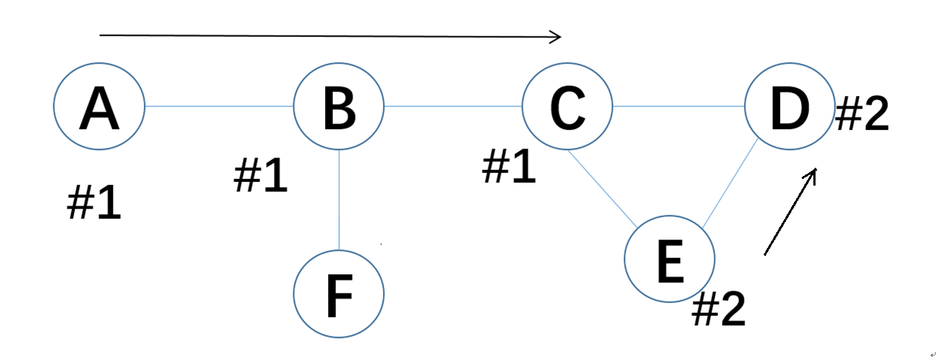
Figure 6(a): Two flows ABC and ED, in a 6-node wireless network.

- 写出（或画出）最优信道分配情况下每个节点的信道号码。Draw or write down a channel allocation in each figure, such that the throughput of each flow can be maximized using the least number of channels in each given network topology
Figure 6(b):
Node A with channel #___1___ Node B with channel #___1___ Node C with channel #___1___

Figure 6(c):
Node A with channel #___1___ Node B with channel #___1___ Node C with channel #___1___
Node D with channel #___1___ Node E with channel #___1___

Figure 6(d):
Node A with channel #___1___ Node B with channel #___1___ Node C with channel #___2___
Node D with channel #___2___ Node E with channel #___2___
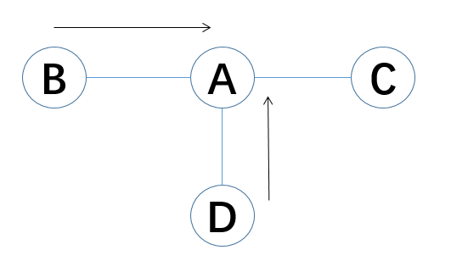
Figure 6(b): Two flows BA, and DA, in a 4-node wireless network.
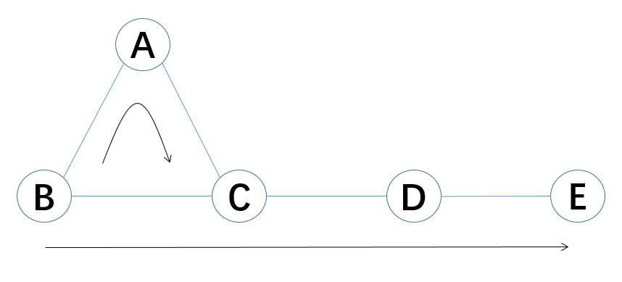
Figure 6(c): Two flows BAC, BCDE, in a 5-node wireless network.
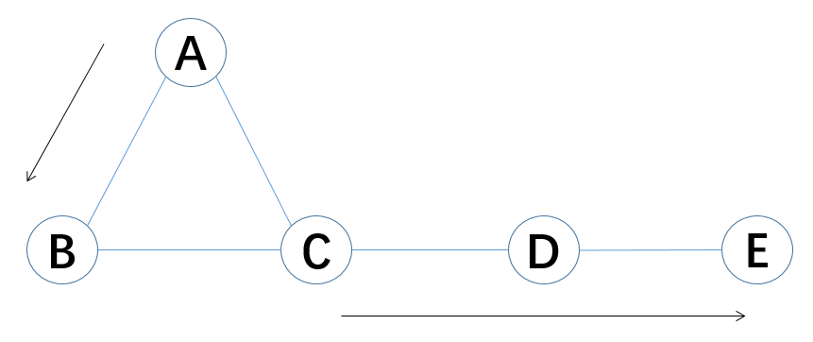
Figure 6(d): Two flows AB, and CDE, in a 5-node wireless network.

- 估算在以上最优信道分配情况下，每条数据流的吞吐量。Estimate the throughput that each flow can obtain in each network.

Figure 6(b):
Throughput of flow BA = 1/2Mbps
Throughput of flow DA = 1/2Mbps
T1 BA 通信，T2 DA 通信

Figure 6(c):
Throughput of flow BAC = 1/4Mbps
Throughput of flow BCDE = 1/4Mbps
涉及C的三个AC BC CD肯定得分开
BC T1, AC T2, CD T3
BA 可以在T3发，不冲突
DE发的时候会干扰C接受AC、BC，所以DE不能在T1，T2发，又因为DE和CD都涉及D，所以DE也不能在T3，所以DE只能是T4

Figure 6(d):
Throughput of flow AB = 1Mbps
Throughput of flow CDE = 1/2Mbps
T1 CD, T2 DE

