YIELDNYARN
  - An MSME Multi Vertical Commodity Marketplace
with AI Assisted Quality Grading
PROJECT FINAL REPORT
Submitted for
Software Engineering BCSE301L
Submitted by
Yash Raj 24BDS1209
Aryan Raj 24BDS1094
Bachelor of Technology
Under the guidance of
Dr Softya Sebastian
Assistant Professor

School of Computer Science and Engineering
VIT Chennai
Chennai 600 127
October 2026

ABSTRACT
YieldnYarn is a business-to-business marketplace for small agricultural and textile suppliers. It addresses limited access to reference prices, uncertainty in remote quality inspection, and fragmented inventory that prevents one seller from meeting a bulk requirement. The project provides shared marketplace workflows with configurable quality attributes, units, and pricing rules for each commodity vertical.
Sellers create listings and submit photographs through a Kotlin Android application that retains offline drafts. A FastAPI service uses MobileNetV3-Small models to suggest visible-quality scores and routes uncertain results to human verification. Buyers use a Next.js website to inspect approved stock, estimate costs, negotiate offers, and submit requirements that can be allocated across several listings. Django REST Framework manages identity, role permissions, and transaction records over a shared PostgreSQL database.
The local prototype demonstrates evidence upload, verifier correction, negotiated orders, inventory reduction, and multi-seller allocation. Allocation and grade-calculation tests passed during final validation. Recorded model evaluations show balanced accuracy of approximately 58 percent for wheat and 57 percent for fabric, making human review necessary. The project establishes an integrated academic marketplace prototype; further work includes improving visual grading, verifying a cloud deployment, and integrating payments and shipment services.
Keywords: MSME marketplace; quality grading; human verification; offline synchronisation; multi seller allocation.
TABLE OF CONTENTS
1 Introduction 1
1.1 Background and problem statement 1
1.2 Objectives and scope 1
1.3 Team responsibilities 1
1.4 Related work and development process 2
1.5 Process model and work breakdown 2
2 Software requirements specification 3
2.1 Target users 3
2.2 Functional requirements 3
2.3 Quality requirements and operating boundaries 4
3 System design and architectural modelling 5
3.1 Architectural responsibilities 5
3.2 Use case model 6
3.3 Entity relationship model 7
3.4 Class model 9
3.5 Listing and grading sequence 12
3.6 Negotiation sequence 13
3.7 Offline listing activity 14
3.8 Order activity 15
3.9 Context data flow 16
3.10 Level 1 data flow 17
3.11 Level 2 data flow 18
3.12 Listing state model 19
3.13 Order state model 20
3.14 Component model 21
3.15 Deployment model 22
4 Implementation details 23
4.1 Final technology stack 23
4.2 Quality grading logic 24
4.3 Price calculation 25
4.4 Matching and allocation logic 26
4.5 Authentication offline synchronisation and configuration 27
4.6 Version control and collaboration 27
5 Software testing and quality assurance 28
5.1 Testing strategy 28
5.2 Recorded integration and device results 28
5.3 Evidence interpretation 28
5.4 Critical test cases and bug resolution 29
5.5 Model evaluation and performance results 30
6 Results and user manual 31
6.1 Public marketplace 31
6.2 Buyer overview 32
6.3 Browsing stock 33
6.4 Listing evidence 34
6.5 Price quantity and quality 35
6.6 Posting a requirement 36
6.7 Estimating a price 37
6.8 Reviewing an offer 38
6.9 Inspecting an order 39
6.10 Verifier queue 40
6.11 Inspecting quality evidence 41
6.12 Recording a quality decision 42
6.13 Administrator overview 43
6.14 Configuring quality 44
6.15 Configuring prices 45
6.16 Maintaining reference prices 46
6.17 Complaint review 47
6.18 Seller Android application 48
6.19 Running the project 49
7 Conclusion and future enhancements 50
7.1 Outcome against the objectives 50
7.2 Future enhancements 50
7.3 Project repository 50
REFERENCES 51

1 Introduction

1.1 Background and problem statement
Small suppliers often sell a commodity in lots that are smaller than the quantities required by a bulk buyer. A farmer may have forty quintals of wheat available while a buyer needs one hundred. A textile producer may offer fabric in metres with a different set of quality attributes. These transactions need a way to describe stock consistently, explain its quality and combine suitable supply without losing the identity of each seller.
Remote trading also limits what a buyer can inspect. A photograph can show broken kernels or visible fabric defects, but it cannot reliably establish moisture content, fabric weight or laboratory composition. A useful marketplace must preserve the evidence, identify the source of a grade and allow a person to review uncertain findings. Price estimates need a similarly clear basis: the reference price, quality adjustment and quantity discount should be identifiable.

1.2 Objectives and scope
The project aims to connect MSME sellers and buyers through one marketplace, beginning with agriculture and textiles. Its main objectives are to collect listing evidence, suggest visible-quality scores, provide a verifier workflow, calculate rule-based estimates and fulfil buyer requirements from available listings. The final build also supports offers and counter-offers, order allocations, complaint records and administration of category rules.
The implemented scope is a local academic prototype. It includes a seller Android application and web workspaces for buyers, verifiers and administrators. The same grading, pricing and allocation services process both verticals using their stored configuration. Adding an unfamiliar commodity still requires suitable quality definitions, evidence and model support; creating a category row alone does not train a new visual grader.

1.3 Team responsibilities
Table 1 Project team
Team member | Registration number | Primary contribution
Yash Raj | 24BDS1209 | Django backend, FastAPI services and ML implementation
Aryan Raj | 24BDS1094 | Web dashboard implementation and ML implementation

1.4 Related work and development process
e-NAM provides agricultural trading with quality assaying, commodity information and electronic bidding. Its trader documentation explains how buyers can inspect assaying certificates and obtain quality and price information (National Agriculture Market, n.d.). This makes it a useful reference for evidence and price visibility in agriculture. Ninjacart describes technology services spanning commerce, finance and fulfilment in agricultural supply chains (Ninjacart, n.d.). These examples establish the practical importance of connecting quality, demand and transaction information.
YieldnYarn explores a smaller engineering problem: reusing one marketplace workflow across agricultural lots and textile stock. Its contribution is the combination of stored vertical rules, evidence-backed grading with a verifier decision, and an order-allocation record that can refer to several listings. The project does not establish that this combination is absent from every commercial platform. Its evaluation concerns the implemented prototype and the recorded test cases.
MobileNetV3 provides the model family used for visible-quality classification. Howard et al. (2019) describe Small and Large variants intended for different resource constraints. YieldnYarn uses MobileNetV3-Small with separate wheat-kernel and fabric-patch processing paths. Choosing the model family does not establish marketplace accuracy; the project evaluates its own checkpoints and retains human review.

1.5 Process model and work breakdown
The Lab 1 submission selects Agile development so that API, web, mobile and grading work can be reviewed in increments. The work breakdown in Lab 2 separates requirements and design, marketplace services, web interfaces, Android workflows, grading, integration and validation. This ordering allows the transaction path to be built while model and external-service assumptions are still being tested.
Review 1 described several components as planned or incomplete, including trained grading models, the seller application and API wiring. The final repository contains the Android application, trained checkpoints, compute integration, editable rules and tests. The local review records demonstrate how these components work together. Cloud deployment and external payment or shipment services remain separate work items.

2 Software requirements specification

2.1 Target users
The seller is a small producer who needs to publish stock from a phone, attach photographs and respond to offers. The seller may lose connectivity during entry, so listing creation begins with a local draft and resumes synchronisation later. Agriculture uses quintals in the review configuration; textiles use metres.
The buyer needs to inspect approved listings, understand quality evidence, compare prices and purchase a suitable quantity. A bulk requirement can be supplied by several sellers. The buyer must therefore see each allocation, its quantity and its agreed unit price within the resulting order.
The verifier examines low-confidence evidence and can approve corrected quality scores or send a listing back. The administrator controls categories, grading attributes, price rules, user activation and complaints. These roles have distinct API permissions; a hidden menu item is not the access-control mechanism.

2.2 Functional requirements
Table 2 Prioritised functional requirements
ID and priority | Required behaviour
FR01 Essential | Register and authenticate users; restrict actions by seller, buyer, verifier and administrator role.
FR02 Essential | Create listings with quantity, unit, location, asking price and evidence; retain phone drafts while offline.
FR03 Essential | Generate quality suggestions and route low-confidence findings to a verifier; retain grading history.
FR04 Essential | Browse active stock and inspect its evidence, grade, price and seller information.
FR05 Essential | Estimate price using stored market data, grade adjustment and quantity tiers.
FR06 Essential | Match a requirement against eligible stock and store one or more order allocations.
FR07 Essential | Exchange offers and counter-offers; create an order and reduce stock after acceptance.
FR08 Supporting | Record notifications and complaints; let administrators edit schemas, rules and market prices.

2.3 Quality requirements and operating boundaries

Performance and scalability
Catalog and detail requests should remain responsive during an interactive demonstration, while model work is handled by the compute service. The repository includes an endpoint load-test result and model evaluation timings. These measurements apply to their recorded workloads and do not establish a production capacity guarantee. Separating the marketplace API from the compute API allows their workloads to be managed independently, although both still depend on the shared database.

Security and data integrity
The API must validate authenticated roles, prevent unauthorised access to private records and preserve the relationship between an order and its allocated listings. Inter-service grading and matching support a shared token, which must be configured for deployment. Web refresh tokens use an httpOnly cookie; the current client keeps its access token in localStorage. Production configuration must use HTTPS, suitable cookie settings and managed secrets.

Reliability and usability
An interrupted seller upload should resume from its recorded step. The phone assigns a client UUID before submission, and the backend uses that UUID to avoid duplicate listing creation on a repeated request. English and Hindi interfaces, labelled units and readable quality explanations support the intended users. Unsupported physical attributes need manual input or other evidence instead of an invented image estimate.

External service and product limits
Market-price ingestion code can obtain agriculture prices through data.gov.in when access is configured. The local review uses historical and manually entered price records, including fixtures labelled for Agmarknet. Those records are not proof of a fresh live-feed update. Textiles use administrator-entered price data because the prototype has no equivalent general textile feed.
Orders represent agreed quantities and prices. The demonstrated system does not complete a live payment, ship goods or issue an automated refund. Firebase push is optional and is not configured in the local review; in-app notifications remain available. The Azure resources and deployment workflow describe a target deployment, while the report results concern the local build.

3 System design and architectural modelling
The modelling work describes how sellers, buyers, verifiers, and administrators interact with the marketplace. It covers information flow, persistent relationships, application behaviour, and the proposed deployment. The diagrams in this chapter reproduce the submitted laboratory figures. Implementation terminology is explained alongside the relevant model.

3.1 Architectural responsibilities
The Android and web clients send marketplace operations to Django. Django applies permissions and records listings, requirements, bids, orders, and complaints. FastAPI handles image analysis, price estimation, and allocation. Both services use PostgreSQL; Django owns the schema migrations. Evidence photographs remain associated with their listing throughout grading and review.
The seller application keeps drafts and upload progress in Room. WorkManager resumes synchronisation when connectivity returns. The component model connects these responsibilities to the web application, compute service, persistence layer, and external integrations.

3.2 Use case model
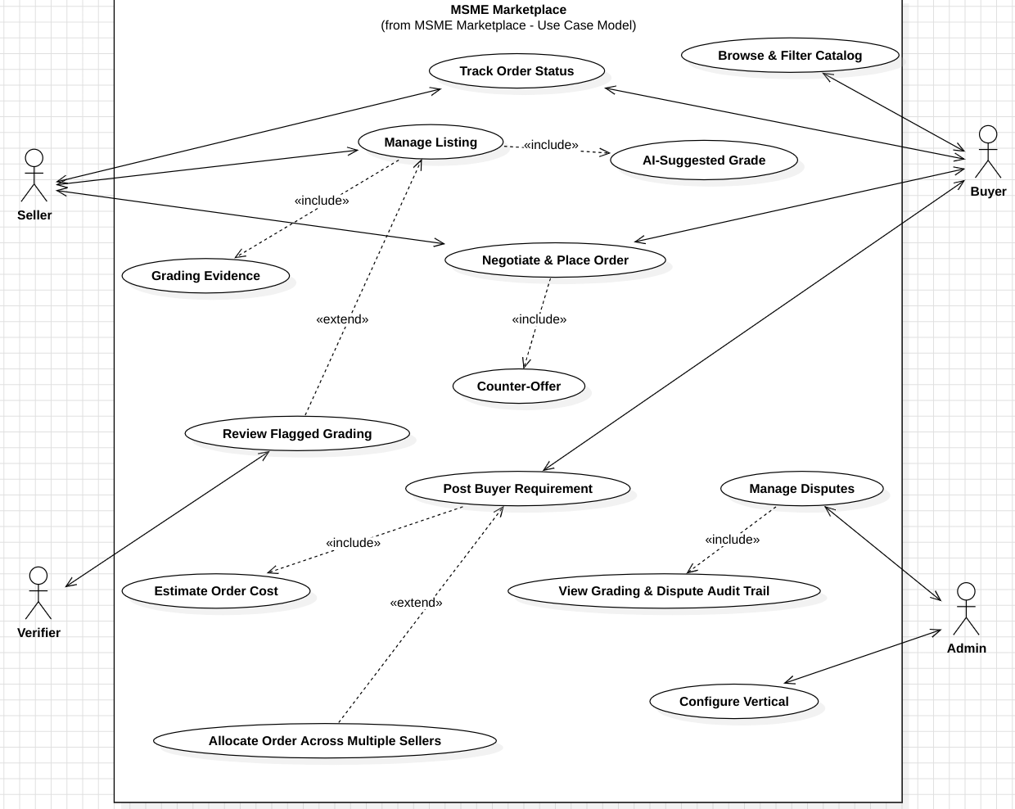
Figure 1 Use case model from Lab 4
Sellers manage listings and offers; buyers inspect stock and place requirements. Verifiers assess uncertain quality results, while administrators maintain the shared category and transaction settings. The estimator can be opened independently of a purchase.

3.3 Entity relationship model
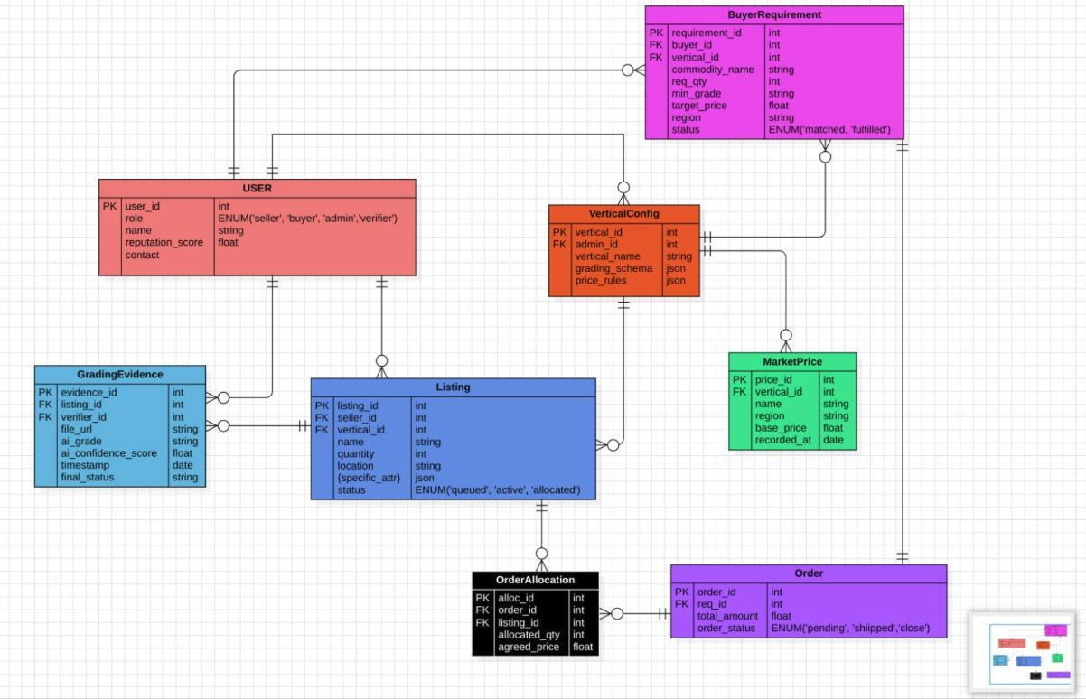
Figure 2 Entity relationship model from Lab 3
The design relates users, listings, grading, requirements, and orders. In the implementation, a listing retains multiple evidence files and grading decisions. The evidence record and the quality decision are separate entities.

Entity details for users and listings
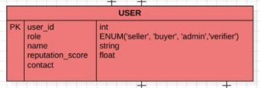
Figure 3 User entity enlarged from the original diagram
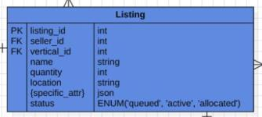
Figure 4 Listing entity enlarged from the original diagram
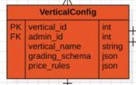
Figure 5 Vertical configuration entity enlarged from the original diagram

3.4 Class model
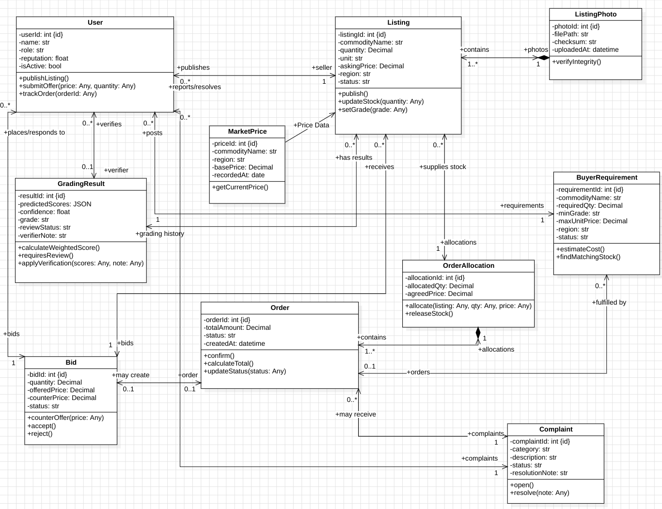
Figure 6 Class model from Lab 9
Order allocations connect an order to one or more source listings and preserve the quantity and unit price. Submitted names such as ListingPhoto and Complaint correspond to GradingEvidence and Dispute in the implemented models.

Class details for users and quality
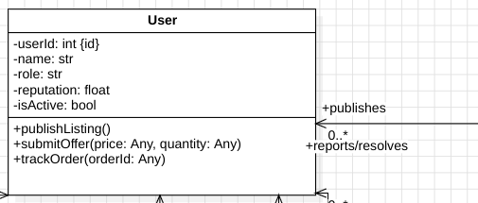
Figure 7 User class enlarged from the original diagram
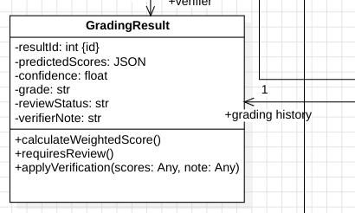
Figure 8 Grading result class enlarged from the original diagram

Class details for offers and orders
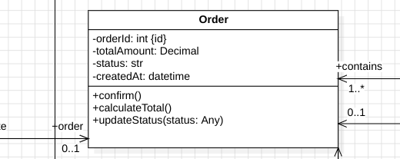
Figure 9 Order class enlarged from the original diagram
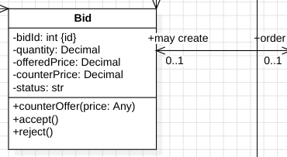
Figure 10 Bid class enlarged from the original diagram

3.5 Listing and grading sequence
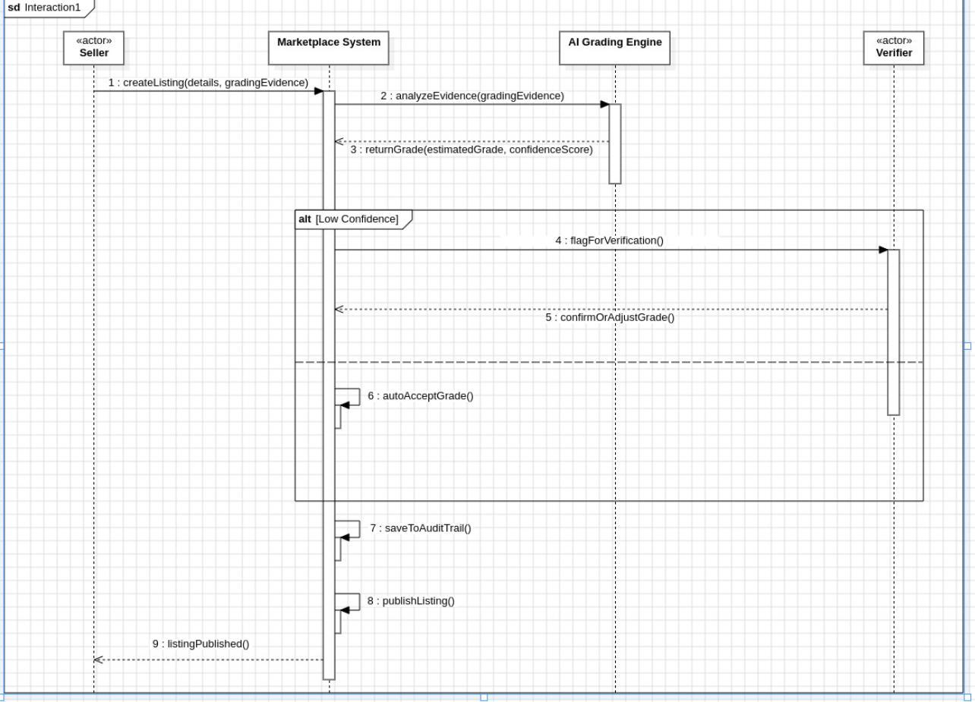
Figure 11 Listing and grading sequence from Lab 6
The seller sends listing information and photographs. Image analysis returns a suggestion, then uncertain evidence enters the verifier queue. With the current confidence caps, the human review path applies to model-generated results.

3.6 Negotiation sequence
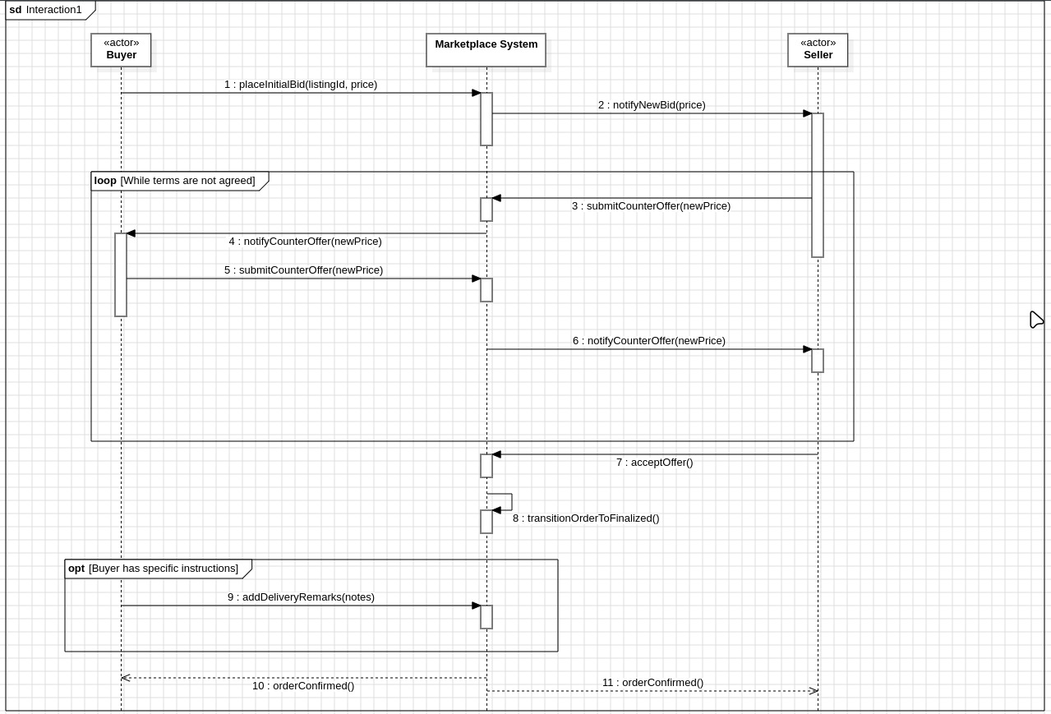
Figure 12 Offer and counter offer sequence from Lab 6
A buyer proposes terms and the seller can respond with a counter offer. Acceptance records an order at the agreed quantity and price and reduces available stock. Each offer keeps its link to the preceding proposal.

3.7 Offline listing activity
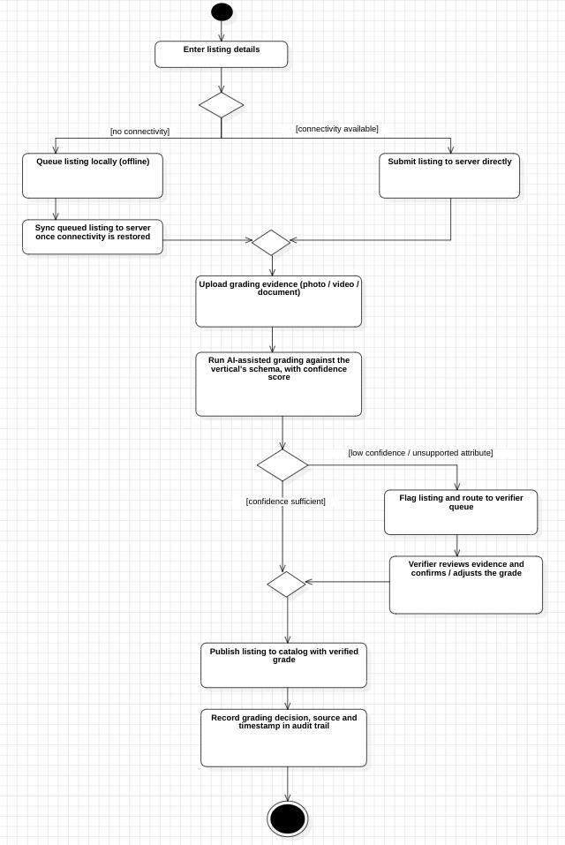
Figure 13 Listing creation activity model from Lab 7
The phone retains an offline draft, resumes its upload, and sends evidence for grading. The server client UUID prevents retries from creating a duplicate listing. Verification controls publication of uncertain results.

3.8 Order activity
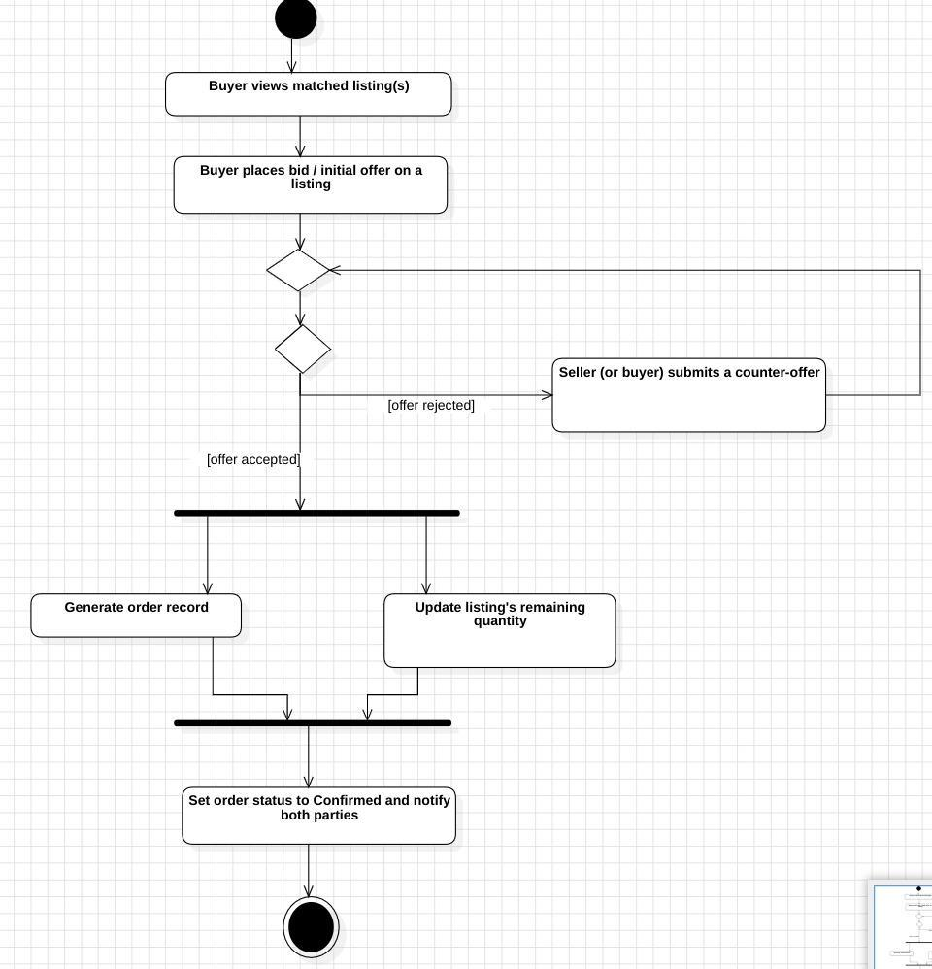
Figure 14 Negotiation and order activity model from Lab 7
The activity model follows the negotiation loop into order creation and inventory updates. The API retains those changes within its transaction workflow.

3.9 Context data flow
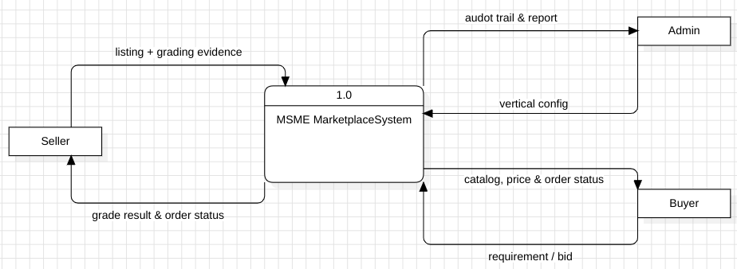
Figure 15 Context data flow model from Lab 5
The context model treats the marketplace as one process interacting with users and external services. It identifies exchanged information without assigning each actor a separate database.

3.10 Level 1 data flow
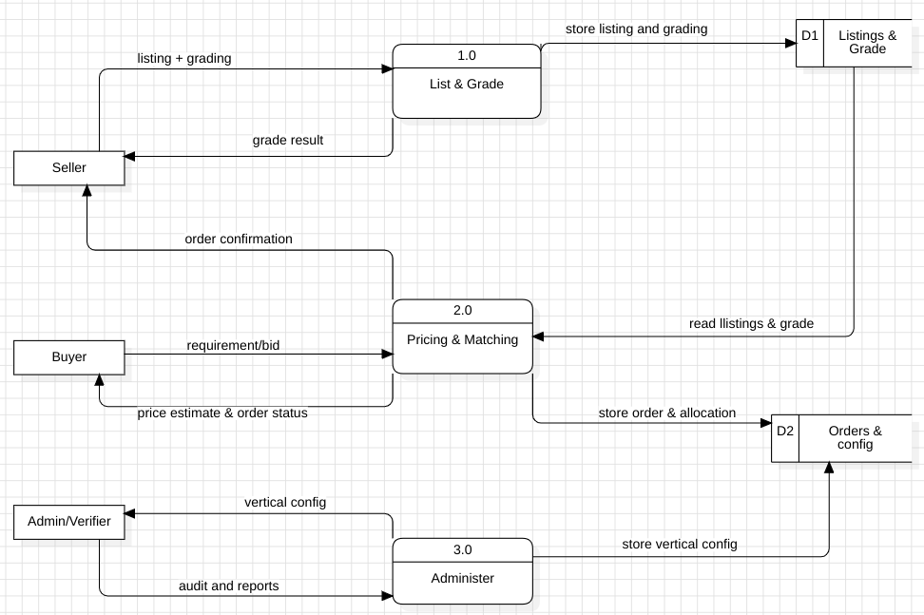
Figure 16 Level 1 data flow model from Lab 5
The decomposition separates listing and grading, price estimation and matching, and administrative configuration. The stores represent logical groups of records within the shared persistence layer.

3.11 Level 2 data flow
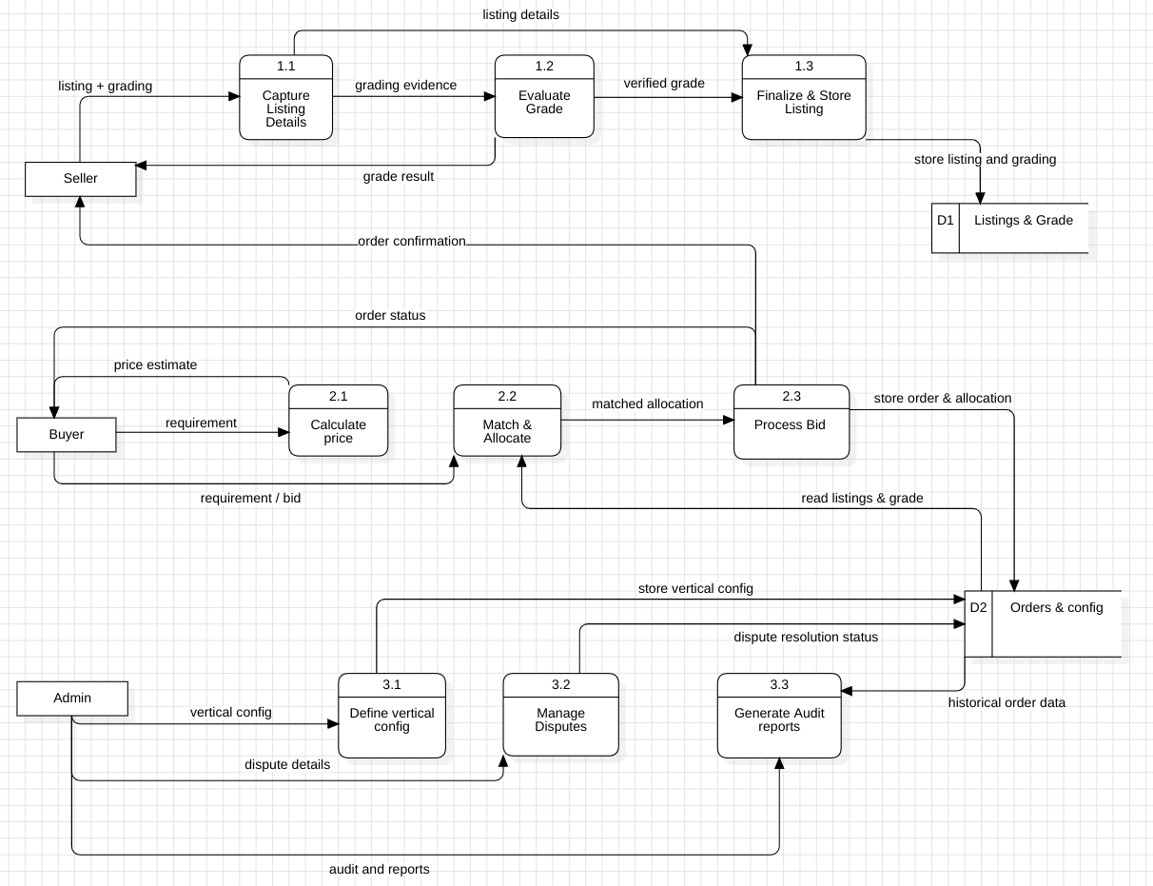
Figure 17 Level 2 data flow model from Lab 5
The detailed flow traces evidence capture, grading, estimation, allocation, and order finalisation. Configuration supplies the grading and price rules used by those processes.

3.12 Listing state model
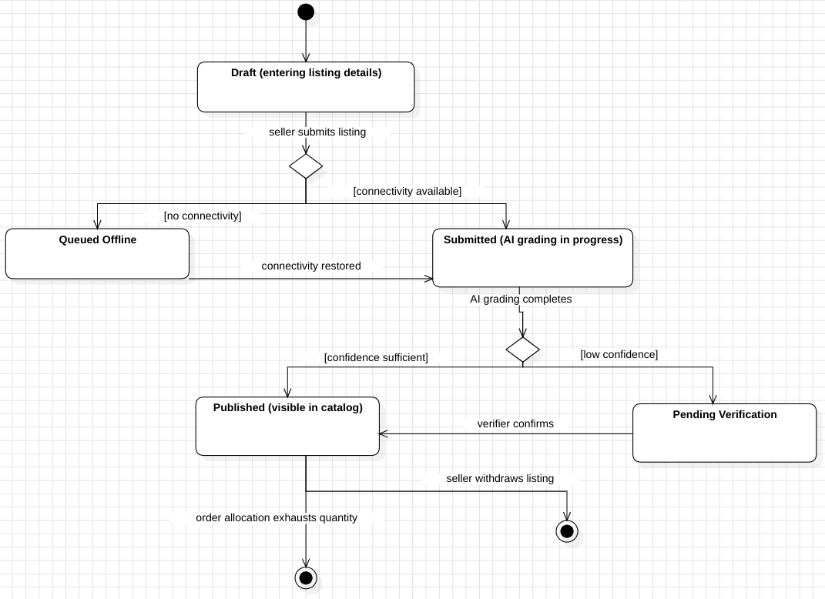
Figure 18 Listing state model from Lab 8
Local draft and queued states belong to the phone workflow. The server uses DRAFT, PENDING_GRADING, PENDING_VERIFICATION, ACTIVE, SOLD, and EXPIRED. Published stock corresponds to ACTIVE; exhausted stock becomes SOLD.

3.13 Order state model
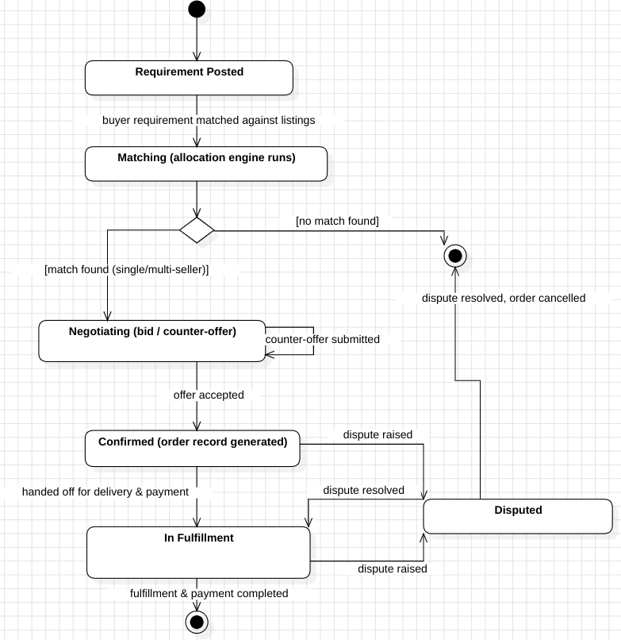
Figure 19 Order state model from Lab 8
The submission combines requirement, negotiation, order, and fulfilment concepts. The implemented Order states are PENDING, CONFIRMED, FULFILLED, DISPUTED, and CANCELLED. Payment and carrier stages remain proposed integrations.

3.14 Component model
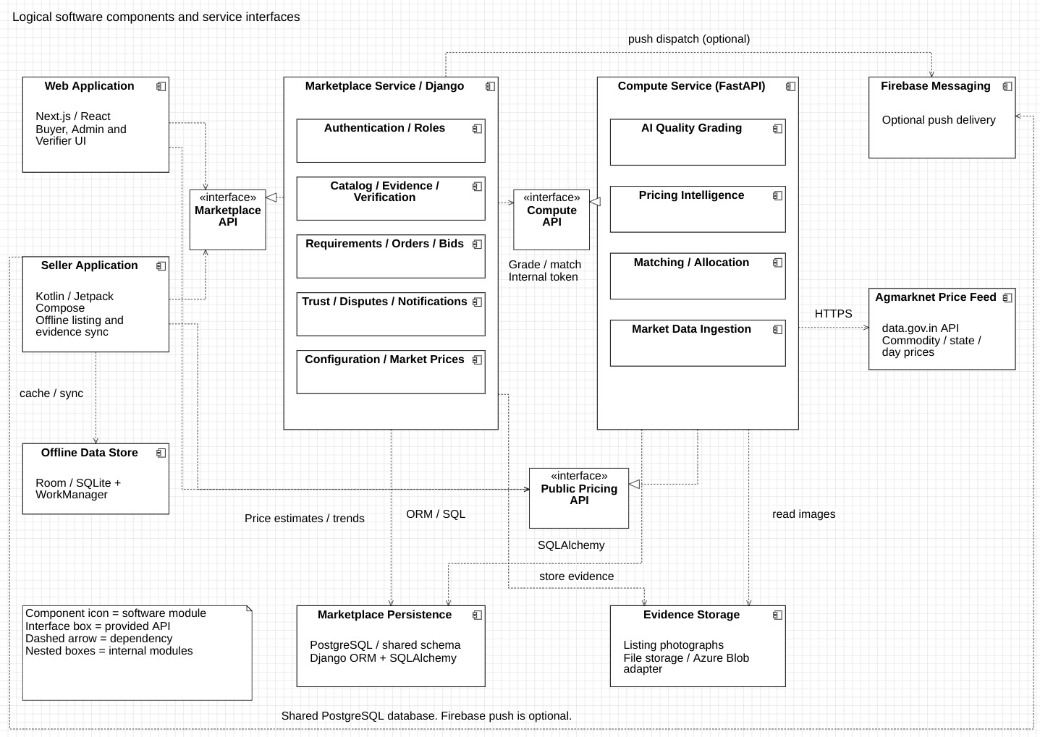
Figure 20 Logical component model from Lab 10
The clients share the marketplace service, while quality, pricing, and allocation use the compute service. The phone includes its own local database. Firebase and market-price collection require configured integrations.

3.15 Deployment model
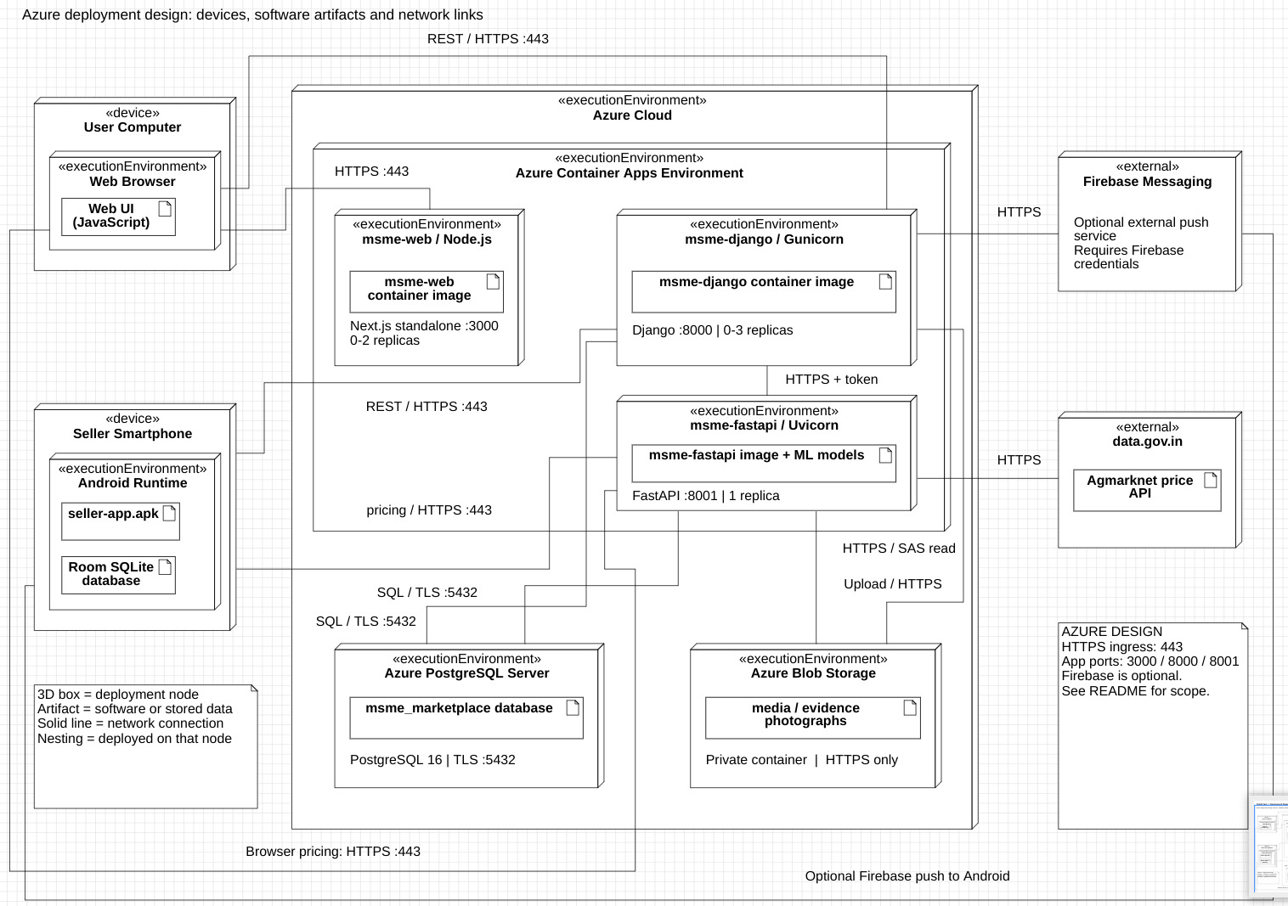
Figure 21 Azure deployment design from Lab 10
The target design places application containers in Azure Container Apps with managed PostgreSQL and evidence storage. The demonstrated build runs locally; cloud rollout remains a separate deployment task.

4 Implementation details

4.1 Final technology stack
Table 3 Technology stack in the final repository
Layer | Implementation and responsibility
Web | Next.js 16, React 19, TypeScript and Tailwind CSS; buyer, verifier and administrator workspaces.
Seller mobile | Kotlin, Jetpack Compose, Room and WorkManager; offline drafts, evidence upload and offer responses.
Marketplace API | Django, Django REST Framework and SimpleJWT; identity, permissions and business records.
Compute API | FastAPI, SQLAlchemy and APScheduler; grading, pricing, allocation and price collection.
Persistence | PostgreSQL with PostGIS support; common schema managed through Django migrations.
Quality analysis | PyTorch and timm MobileNetV3-Small with OpenCV processing; one grader per supported vertical.
Packaging and delivery | Docker Compose, GitHub Actions and Azure Bicep; local execution and a configured cloud deployment path.

Implementation organisation
The web and phone clients share a marketplace API. Model preparation and compute logic remain separate from the transaction service, while documented API contracts support integration between components.
Vertical configuration is stored as data. Agriculture and textiles have separate units, grading attributes and pricing rules, while the engine code shares the same input and output contracts. The visual graders remain specialised models; their checkpoints and analysis settings provide the category-specific inference behaviour.

4.2 Quality grading logic
The agriculture grader segments kernels and particles before classifying crops as sound, damaged, foreign or husk-covered. The textile grader resizes a photograph and divides it into patches, then classifies good and defective regions. The pipeline converts these classifications to normalised quality scores in the range zero to one, where a higher value means better quality.
For wheat, foreign-matter and damaged-kernel scores contribute according to the configured weights. The current agriculture schema gives each a weight of 0.5. Moisture has no image-derived contribution. For textiles, the defect-rate quality score contributes to the letter grade, while GSM is a separate physical attribute.
weighted_score = sum(weight[i] * score[i]) / sum(weight[i])
score = round(weighted_score, 4)
Grade A if score >= 0.85
Grade B if score >= 0.65
Grade C otherwise
Only attributes with a recognised non-zero weight contribute. If there is no usable weighted evidence, the grade derivation returns no grade. Rounding before comparing the thresholds prevents floating-point accumulation from moving an exact boundary value into the lower grade.
Confidence expresses support for the prediction and is separate from the quality score. A lot can receive a high quality score with low confidence. The current checkpoints cap confidence at their measured validation balanced accuracy, approximately 0.5792 for wheat and 0.5703 for fabric. These values are below the 0.80 automatic-acceptance threshold, so a human verifier must review the outputs.
A verifier correction creates a human decision record and can activate the listing. It does not change the model weights or retroactively improve its accuracy. Verified evidence can later be exported for labelling, retraining and a new evaluation.

4.3 Price calculation
The pricing service selects stored reference data for a vertical and commodity, then applies the grade multiplier and the highest qualifying quantity tier. It rounds the adjusted unit price to two decimal places. An estimate multiplies that unit price by the requested quantity.
unit_price = round(base_price * grade_multiplier
* quantity_multiplier, 2)
estimated_total = unit_price * requested_quantity
Table 4 Baseline review pricing configuration
Rule | Agriculture | Textiles
Grade A / B / C | 1.10 / 1.00 / 0.88 | 1.10 / 1.00 / 0.88
First discount tier | 50 quintals: 0.98 | 500 metres: 0.97
Second discount tier | 200 quintals: 0.95 | 2000 metres: 0.94

For a worked example with a stored base price of INR 2500 per quintal, Grade A and a quantity of 100 quintals, the unit estimate is 2500 × 1.10 × 0.98 = INR 2695. The total estimate is INR 269500. This example explains the arithmetic; a live estimate uses the most recent applicable stored price and can therefore show another value.
Reference estimates, listing asking prices and accepted offer prices are separate values. The estimator does not create an order. In the current web form the buyer enters no region, so the estimate can use the latest matching commodity record across regions. The chart shows historical base prices, not the totals paid in orders.
Administrators can edit grade adjustments and quantity tiers. Their changes affect later calculations through the stored JSON rules. A category with unfamiliar visual properties still needs a suitable grading method even when the price rules are already configured.

4.4 Matching and allocation logic
The allocator is a deterministic greedy algorithm. It loads active stock in the required vertical and commodity, filters it by minimum grade and maximum unit price, then sorts by unit price. Seller reputation breaks equal-price ties. It takes the required quantity from each candidate until the request is filled or no eligible stock remains.
eligible = filter(active_stock, grade, max_price, location)
eligible.sort(key=(unit_price, -seller_reputation))
remaining = required_quantity
for listing in eligible:
take = min(remaining, listing.available_quantity)
record(listing, take, listing.unit_price)
remaining -= take
if remaining <= 0: break
return allocations, max(remaining, 0)
Sorting dominates the pure allocation step, giving O(n log n) time for n candidates. This is not a learned matching model. With fixed unit prices and divisible stock it chooses cheaper eligible units first; the implementation does not optimise transport costs, minimum seller commitments or future demand.
Table 5 Recorded multi-listing allocation from the October integration rehearsal
Recorded allocation | Quantity | Unit price | Amount
Listing 72 | 40 quintals | INR 2000 | INR 80000
Listing 73 | 20 quintals | INR 2000 | INR 40000
Order 18 total | 60 quintals | Zero shortfall | INR 120000

The persisted allocation path creates the order rows and decrements listing quantities. Exhausted stock becomes SOLD. A shortfall is returned explicitly, and a partially supplied requirement remains OPEN. Coordinate-based filtering applies when a centre and radius are supplied; the website Place field is descriptive text and does not geocode itself. Listings without coordinates are treated permissively by the current filter.

4.5 Authentication offline synchronisation and configuration
Django validates user identity and applies role permissions to marketplace endpoints. On the web, the long-lived refresh token is stored in an httpOnly cookie and refreshes the access token after an expiry response. The current access token and user profile remain in localStorage. When configured, the shared internal token protects grading and matching calls independently of the user session. It must be set before exposing the compute service.
The seller app saves a draft and its client UUID before making network requests. Room retains the listing fields and photo references. WorkManager waits for connectivity and schedules retries with backoff. The sync engine records creation, each evidence upload and grading as individual steps, so an interrupted operation resumes from the last stored state.
After successful synchronisation, the server copy becomes the cached listing and the completed local draft is removed. The backend recognises a repeated client UUID and returns the existing listing rather than creating another. This behaviour is useful when a request succeeds on the server but its response never reaches the phone.

4.6 Version control and collaboration
The team uses the GitHub monorepository to version application code, configuration, model checkpoints and infrastructure definitions. Review 1 assigns backend and compute work primarily to Yash Raj and web dashboard work primarily to Aryan Raj, with both contributing to ML implementation. Related changes remain in their component directories and meet through the shared API contracts.
The repository includes backend and frontend lint/test workflows, seller-app validation, container builds and a manual Azure deployment workflow. Feature work can be reviewed on branches before integration, while API schema checks help detect contract drift.

5 Software testing and quality assurance

5.1 Testing strategy
Testing separates pure calculation rules from persistence and interface behaviour. Allocation and grade derivation can be checked without a database. API integration tests cover authentication, price retrieval, grading, matching and transaction records against PostgreSQL. Frontend tests cover client behaviour, while browser tests exercise workflows across the running stack. The Android core isolates networking and synchronisation logic for JVM tests.
During final report preparation on 28 October 2026, allocation, grade derivation, and classifier tests were executed together. All 34 tests passed, including 19 allocation and grade tests. They cover multi-listing fulfilment, shortfalls, filters and grade-calculation behaviour.

5.2 Recorded integration and device results
The local review evidence from 8 and 9 October records 34 successful readiness checks across service responses, prepared account logins, catalog and order endpoints, price histories and evidence retrieval. The Android core result records 35 tests, no failures or errors and one skipped test. A separate live-backend Android test records one passing test. These earlier results provide integration evidence for the review build.
The saved workflow record follows listing 85 from original evidence photographs through an AI Grade C suggestion at confidence 0.5792, human correction to Grade A, a buyer offer, a seller counter-offer, acceptance and order 20. The order contains one quintal at INR 2400, and the listing quantity falls from two quintals to one. This is a local demonstration transaction; no physical shipment or live payment occurred.

5.3 Evidence interpretation
A successful API response and a persisted order establish different facts from a model-quality benchmark. The integration records show that the components exchange and retain their outputs. The model evaluations measure classification behaviour on their evaluation data. Both are needed to explain the result without treating a completed workflow as proof of accurate visual grading.

5.4 Critical test cases and bug resolution
Table 6 Critical cases with observed outcomes
Test ID | Description | Expected result | Actual result | Status
TC01 | Multi-listing exact fulfilment | Combine 50 units at 20 with 50 at 25 to supply 100. | 100 allocated; zero shortfall; two allocations. | Pass
TC02 | Insufficient stock | Request 100 when only 30 are eligible. | 30 allocated; shortfall 70. | Pass
TC03 | Quality and price eligibility | Exclude stock below minimum grade or above the maximum unit price. | Eligibility and tie-break assertions passed in the allocation suite. | Pass
TC04 | Exact grade boundary | Keep a weighted score of 0.85 in Grade A. | Grade boundary assertions passed in the grade suite. | Pass
TC05 | Accepted counter-offer and stock | Create one order at accepted terms and reduce the remaining quantity. | Recorded order 20: one quintal at INR 2400; stock 2 to 1. | Pass

TC01 through TC04 are supported by the 28 October pure-function test run. TC05 is supported by the saved October integration record.

Bug resolution
One defect affected grade thresholds. Weighted floating-point arithmetic can represent an exact 0.85 result as 0.8499999999999999, which incorrectly assigns Grade B if compared directly. The grade function now rounds the weighted result to four decimal places before applying the thresholds. The final pure-function test run includes this boundary behaviour.
A second correction concerns bulk allocation. The allocation endpoint previously created order rows while leaving source listing quantities unchanged, allowing later requests to reuse the same apparent stock. The current path decrements each allocated quantity and marks exhausted listings SOLD. The bid-acceptance path also updates inventory. These corrections address recorded behaviour; broader concurrent-purchase stress testing remains necessary before production use.

5.5 Model evaluation and performance results
Table 7 Stored checkpoint evaluation summary
Measure | Wheat grader | Fabric grader
Validation balanced accuracy | Approximately 0.58 | Approximately 0.57
Observed limitation | Damaged kernels are under-detected. | Defect-patch recall is approximately 0.40.
Whole-photo analysis | Foreign-share error 0.026; damaged-share error 0.125 on synthetic held-out samples. | Approximately 2% false alarms on good patches; defect precision 0.85.
Reported CPU inference | 125 to 170 ms per photograph across the documented model evaluation. | Same documented timing range.

The training pipeline uses segmented AgroAI wheat crops and TILDA fabric photographs. Wheat splits are grouped by source photograph, and the fabric calibration uses held-out photographs. These procedures reduce leakage between related crops or patches.
The independent-photo rehearsal processed eight listing cases using fifteen original source photographs: six wheat images, eight cotton-defect images and one AgroAI reference. The clean-looking source-A wheat example was classified as Grade C with a high estimated foreign-particle share. That visible error shows why verifier review is necessary. Source dataset labels and YieldnYarn grades use different definitions, so they cannot be compared as if they were the same ground truth.
The stored 28 September endpoint load test records zero errors in its six workloads. Buyer catalog requests have a p95 of 33.9 ms across 400 requests; listing detail has a p95 of 47.6 ms across 400; the grading trigger has a p95 of 173.3 ms across 180. These are historical local workload results.
The checkpoint confidence cap and the independent-photo error limit the current claim to assisted quality review. Improving the wheat damage detection and fabric defect recall requires better labelled marketplace photographs and renewed validation, rather than simply increasing the acceptance threshold.

6 Results and user manual
The completed interfaces connect listing evidence, quality review, buyer decisions, and transaction records. The web captures below were taken from the running local build on 28 October 2026. The Android overview is retained from the device demonstration.

6.1 Public marketplace
The public page introduces the supported categories and provides registration and sign in. Buyer, verifier, and administrator workspaces are available on the website. Sellers use the Android application to publish stock and respond to offers.
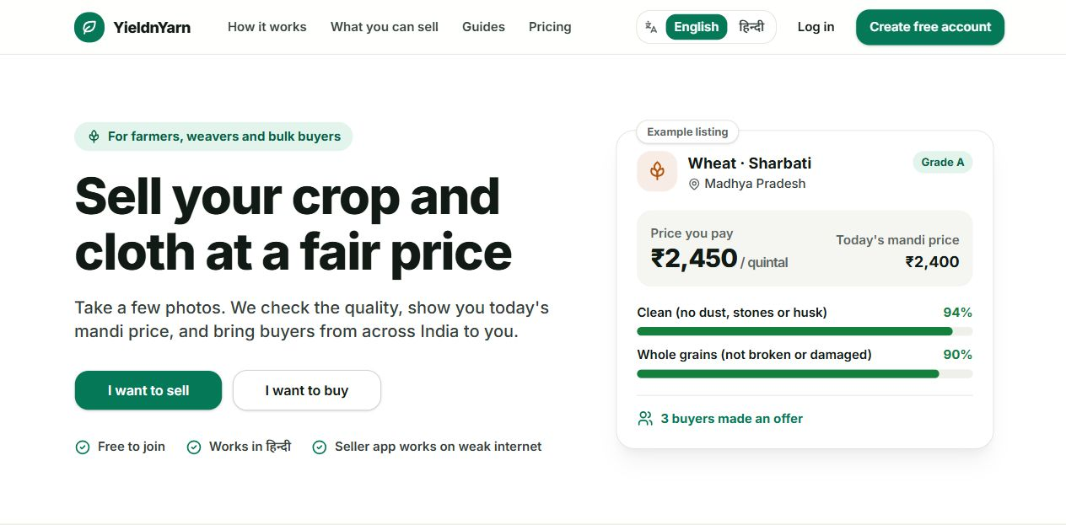
Figure 22 Public marketplace introduction

6.2 Buyer overview
The dashboard summarises open requests, orders, expenditure, and available stock. Its main actions open the market, create a requirement, or estimate a price. The values reflect the prepared demonstration records.
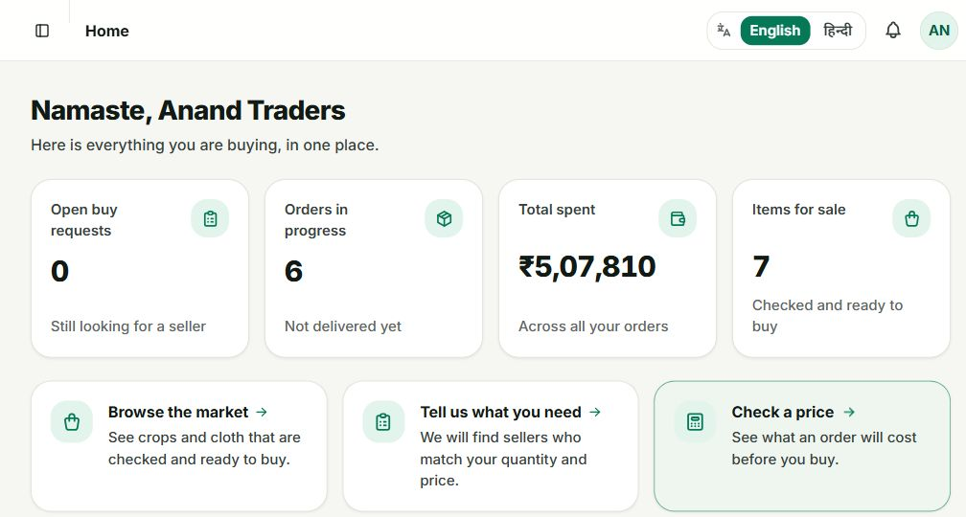
Figure 23 Buyer dashboard with complete summary and action cards

6.3 Browsing stock
The market lists active stock with its grade, asking price, available quantity, and place. Category and search filters help buyers narrow the catalog before opening an item.
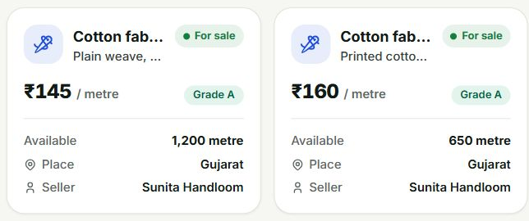
Figure 24 Two complete catalog cards

6.4 Listing evidence
An item page groups the seller’s photographs with the commodity and lot information. Buyers can inspect the evidence before deciding whether its visible condition is suitable.
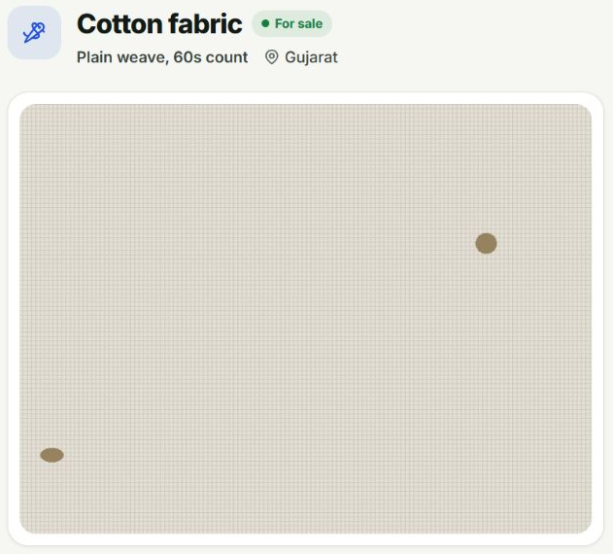
Figure 25 Complete listing photograph panel

6.5 Price quantity and quality
The purchase panel shows the asking price, remaining quantity, and seller, with direct purchase and offer actions. The quality panel identifies the approved result and its attribute scores. A quality percentage describes the configured visual score; moisture and GSM require separate measurement.
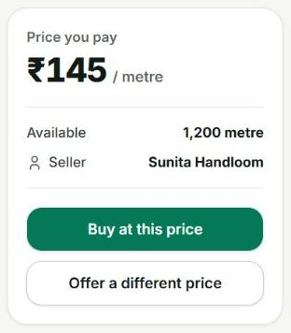
Figure 26 Complete purchase panel
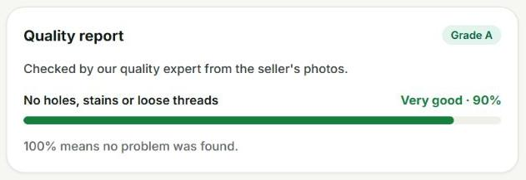
Figure 27 Complete approved quality panel

6.6 Posting a requirement
Choose a category and commodity, enter the required quantity and maximum unit price, and select the lowest acceptable grade. A place name provides descriptive location information. Coordinate-based matching requires actual coordinates. The allocator can combine eligible stock from several listings and reports any shortfall.
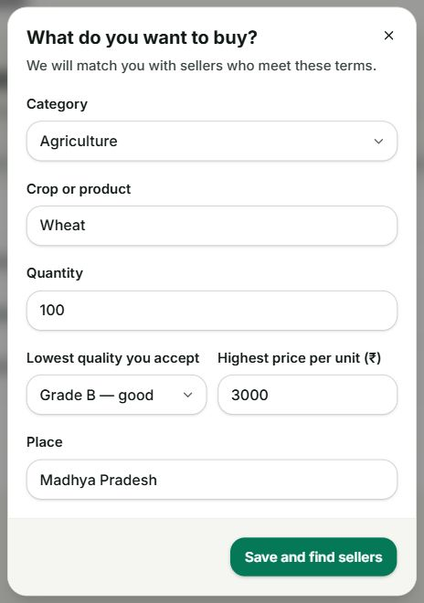
Figure 28 Requirement form with every field and action visible

6.7 Estimating a price
Choose a category, commodity, quantity, and optional grade, then request the estimate. The result applies the stored grade and quantity rules to an available reference price. The trend chart shows stored historical prices; its dates should be checked when using an estimate. The illustrated 100-quintal request uses a base price of INR 2489.27 and a two-percent quantity discount, giving INR 2439.48 per quintal and INR 243948 in total.
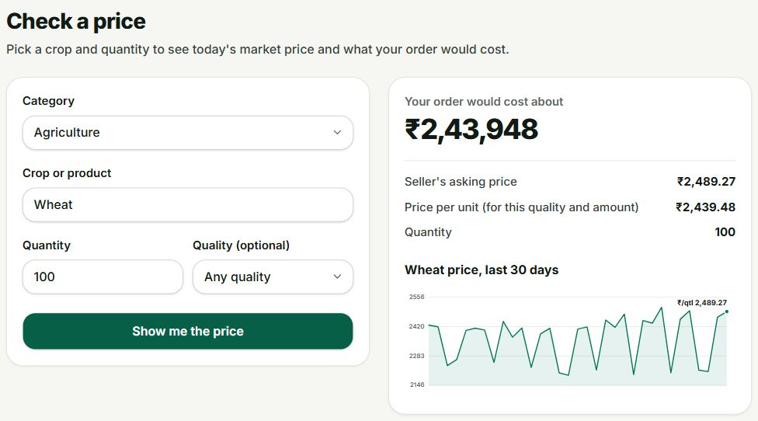
Figure 29 Complete estimate form result and dated price chart

6.8 Reviewing an offer
The offer workspace separates proposals awaiting the buyer from those awaiting the seller and completed negotiations. The illustrated seller counter offer is INR 4520 per quintal for 25 quintals. A buyer can accept, suggest another price, or decline. Acceptance records the agreed order and updates stock.
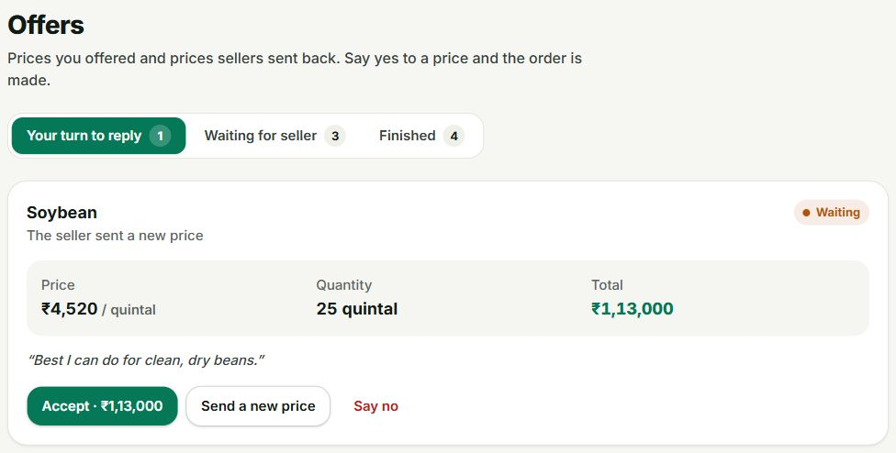
Figure 30 Complete counter offer with price quantity and response actions

6.9 Inspecting an order
Expand an order to see its seller, commodity, allocated quantity, and agreed unit price. Order 20 records one quintal of wheat from Ramesh Patil at INR 2400. In the recorded workflow, acceptance reduced the listing from two quintals to one. The report action links an order problem to that transaction.
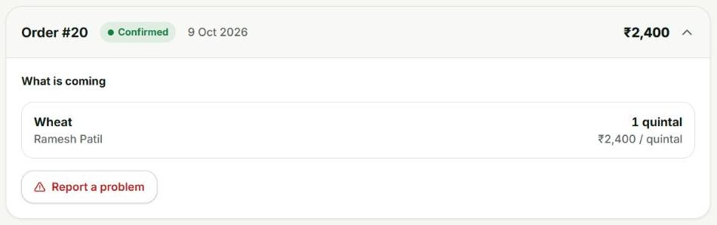
Figure 31 Complete expanded order and allocation

6.10 Verifier queue
The verifier sees items whose quality suggestions need review, ordered by priority. The table preserves the item, reason, suggested grade, confidence, and action in one row. The current model confidence caps are below the automatic approval threshold.
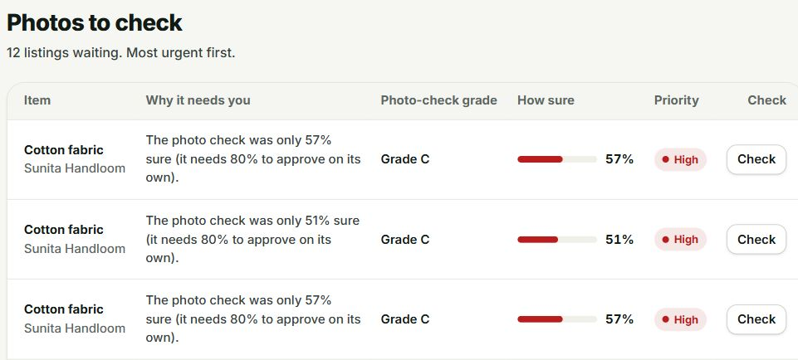
Figure 32 Queue heading and first three complete rows with all columns

6.11 Inspecting quality evidence
The verifier opens the original evidence images and can move between photographs. The fabric example contains a visible hole. Keeping the original evidence beside the assessment helps the reviewer relate a score to what was actually photographed.
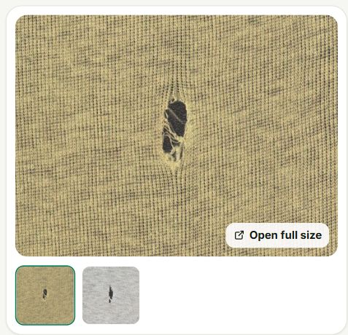
Figure 33 Complete evidence image and thumbnail panel

6.12 Recording a quality decision
The reviewer can retain or correct the quality score and add a note explaining the decision. Approve publishes the accepted result; sending the item back requires a reason for the seller. Each human decision remains distinct from the model suggestion.
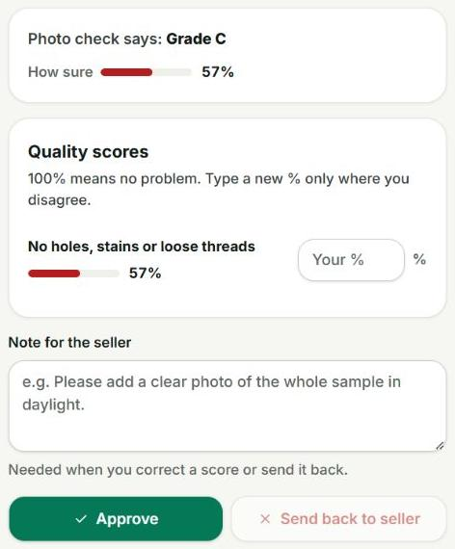
Figure 34 Complete quality review and decision controls

6.13 Administrator overview
The administrator dashboard provides counts and entry points for categories, quality review, prices, users, and complaints. These operations require an administrator role on the API as well as access to the staff interface.
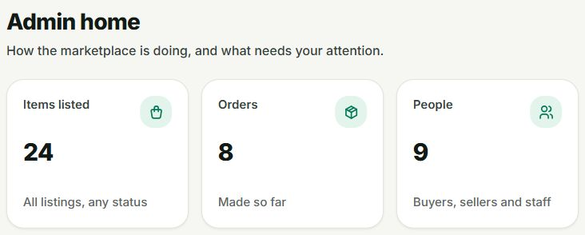
Figure 35 Administrator overview with three complete summary cards

6.14 Configuring quality
Each category stores its unit and quality schema. Recognised attribute weights determine the combined score. Agriculture uses foreign-matter and damaged-kernel quality scores; physical moisture is not inferred from a photograph. A new schema alone does not train a new visual model.
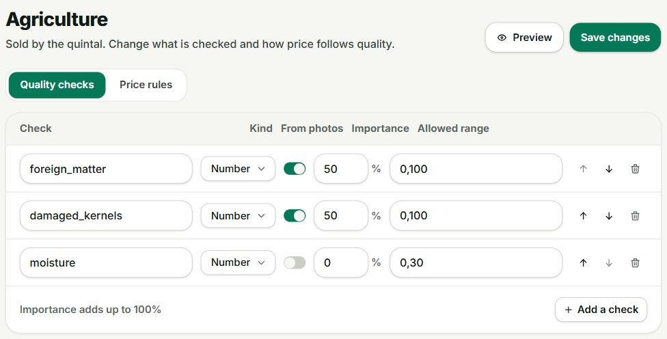
Figure 36 Complete agriculture quality configuration

6.15 Configuring prices
Grade multipliers and quantity tiers change subsequent price estimates. The largest reached quantity tier supplies the discount. The agriculture baseline applies a ten-percent Grade A premium and a two-percent discount from 50 quintals.
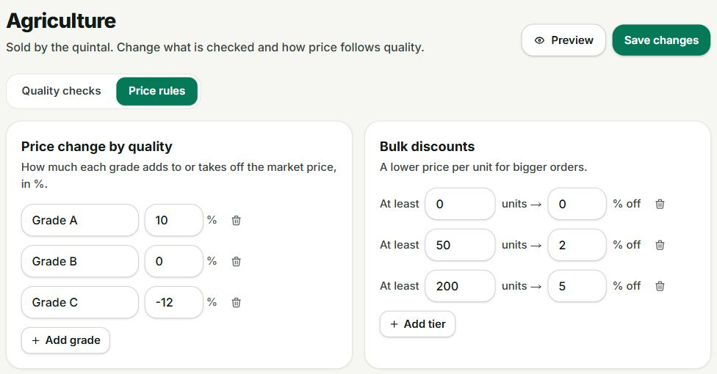
Figure 37 Complete grade adjustments and quantity tiers

6.16 Maintaining reference prices
The price register identifies category, commodity, region, value, time, and source. Administrators can enter records when an external feed is unavailable or does not cover the commodity. Freshness and source information are needed to interpret the resulting estimate.
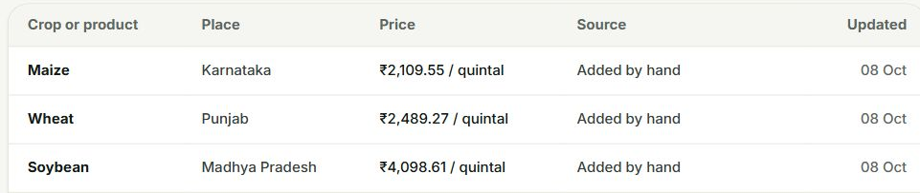
Figure 38 Reference price table with all columns and three complete rows

6.17 Complaint review
A complaint retains its transaction context, description, status, and resolution notes. Administrators review the issue and record the outcome. A complaint decision does not itself execute a payment refund or carrier action.
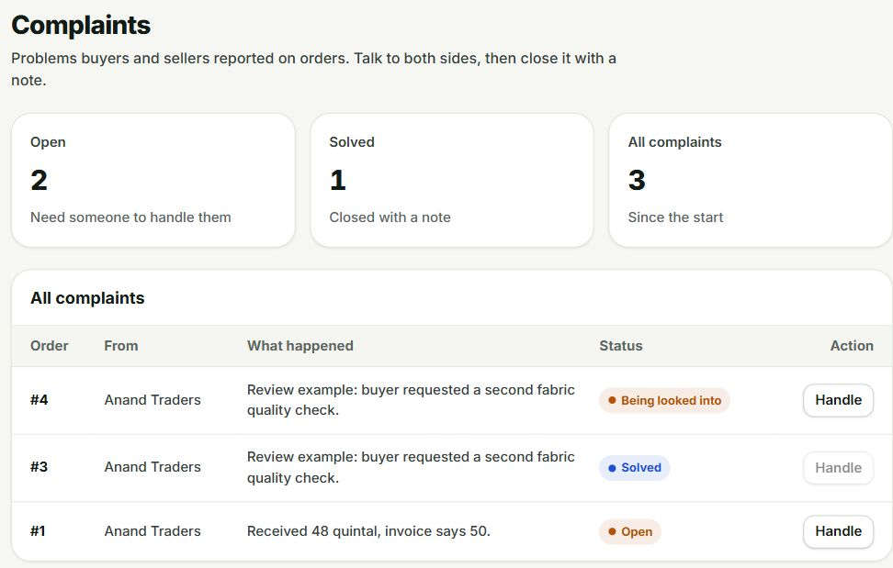
Figure 39 Complaint register with complete table columns

6.18 Seller Android application
The seller overview summarises active stock, quality checks, offers awaiting a response, and inventory value. Listing creation saves fields and photo references locally before upload. Room retains drafts, while WorkManager resumes synchronisation after connectivity returns. The saved client UUID makes retries safe when an earlier server response was lost.

Figure 40 Seller overview showing all four complete summary cards

6.19 Running the project
The repository README provides Docker and source-based setup, component links, and Android configuration. The container route starts PostgreSQL, Django, FastAPI, and Next.js. Django applies migrations and seeds the two category configurations. Create accounts appropriate to the installation before using the role-specific workspaces.
git clone https://github.com/SparkleYR/YieldnYarn.git
cd YieldnYarn
cp .env.example .env
docker compose --profile app up -d --build
Open the website at http://localhost:3000 and the marketplace API documentation at http://localhost:8000/api/docs/. Android emulator builds reach the computer through 10.0.2.2. A physical phone needs a reachable host address or configured USB forwarding. The Android API base URL ends in /api/ and the compute URL ends in /compute/.

Reviewing an end to end workflow
Create a seller draft, attach photographs, and synchronise it. Inspect the uncertain result in the verifier queue and record a decision. Open the approved item as a buyer, negotiate an offer, and inspect the resulting order allocation. Check that the available quantity fell by the allocated amount. A separate bulk requirement demonstrates how multiple sellers can contribute to one order.

7 Conclusion and future enhancements

7.1 Outcome against the objectives
YieldnYarn implements the main local marketplace path for agriculture and textiles. Sellers can submit stock and photographs from Android, verifiers can review uncertain grading results, and buyers can browse approved inventory, estimate prices, negotiate and inspect their orders. Category rules are stored as configuration, and the allocation model records how several listings contribute to one requirement.
The saved integration records connect these operations through persistent data. They include a two-listing allocation totalling sixty quintals, a verifier-corrected listing followed by an accepted one-quintal offer, and the corresponding reduction in stock. The final pure-function test run passed all nineteen allocation and grade-calculation tests. Together these results support the prototype as a functioning academic implementation.
The visual models remain the largest limitation. Their approximately 58-percent and 57-percent balanced accuracy, together with the independent-photo misclassification, require human verification. The software makes that uncertainty visible through the queue and retained grading history. It does not claim reliable autonomous inspection of arbitrary phone photographs.

7.2 Future enhancements
The first priority is a better labelled marketplace dataset, with lot-level train and test separation and representative phone capture conditions. New evaluation should measure damaged-kernel detection and fabric-defect recall before the confidence cap changes. Non-visual properties need structured measurement or certificate workflows.
A second release can harden the transaction and deployment path through concurrent-purchase testing, stock-locking review, monitoring and a verified Azure rollout. External price collection should be checked for freshness and provenance, and geographic matching should receive actual coordinates rather than relying on free-text place names.
A later product release can integrate a payment provider and shipment tracking with explicit settlement and refund states. Those services should extend the current order and complaint records with their own verified external references and failure handling.

7.3 Project repository
The source code, setup instructions, model evaluation, and project deliverables are available at https://github.com/SparkleYR/YieldnYarn.

REFERENCES
DefectSpectrum. (n.d.). Defect_Spectrum [Data set]. Hugging Face. https://huggingface.co/datasets/DefectSpectrum/Defect_Spectrum
Howard, A., Sandler, M., Chu, G., Chen, L.-C., Chen, B., Tan, M., Wang, W., Zhu, Y., Pang, R., Vasudevan, V., Le, Q. V., & Adam, H. (2019). Searching for MobileNetV3. arXiv. https://doi.org/10.48550/arXiv.1905.02244
National Agriculture Market. (n.d.). Traders. Retrieved October 28, 2026, from https://enam.gov.in/stakeholders-Involved/traders
Ninjacart. (n.d.). About us. Retrieved October 28, 2026, from https://ninjacart.com/about-us/
Raj, Y., & Raj, A. (2026). Software engineering laboratory submissions 1 through 10 [Unpublished course submissions]. VIT Chennai.
Raj, Y., & Raj, A. (2026). YieldnYarn [Computer software]. GitHub. https://github.com/SparkleYR/YieldnYarn
Raj, Y., & Raj, A. (2026). YieldnYarn project review 1 [Unpublished course report]. VIT Chennai.
sachin235. (n.d.). AgroAI [Source code and dataset]. GitHub. https://github.com/sachin235/AgroAI
SamWithAi. (n.d.). Wheat_Grading_Dataset [Data set]. Hugging Face. https://huggingface.co/datasets/SamWithAi/Wheat_Grading_Dataset
sivasgitt. (n.d.). AI-Fabric-Defect-Detection [Source code and dataset]. GitHub. https://github.com/sivasgitt/AI-Fabric-Defect-Detection

