
BCSE301L – SOFTWARE ENGINEERING
PROJECT REVIEW - 1

1. Project & Team Information
Yield & Yarn: An MSME Multi Vertical Commodity Marketplace with AI-Assisted Quality Grading

Team Information:
Name | Roll Number | Role
Yash Raj | 24BDS1209 | Django Backend, FastAPI Services, ML Implementation
Aryan Raj | 24BDS1094 | Frontend Dashboard Implementation (React,NodeJS), ML Implementation
Repository Link:
https://github.com/SparkleYR/YieldnYarn

2. Project Overview
Problem Statement:
Producers and suppliers of commodity classes such as agricultural products, textiles, basic engineering items, food processing, handicrafts, wood products, chemicals, and plastics suffer from being structurally weak while dealing with a purchaser who can not inspect their products face to face. There are three structural weaknesses that exist in all these sectors of business: lack of transparency regarding prices because sellers have no knowledge about existing market prices and they are dependent upon the middlemen, lack of evidence regarding the quality of products that the sellers sell because buyers need to see the product for verification before buying it, and finally, there is no mechanism to fulfill the complete order of the buyer from the single MSME listing because fragmentation results in the inability of a small supplier to cater to bulk requirements. YieldnYarn is designed to solve these three structural weaknesses of these fragmented sectors, starting from two different verticals: agriculture and textiles.
Proposed Solution:
The YieldnYarn platform is designed as a multi-vertical B2B commodity market with a plug-in approach to its development, which means three common engines, grading, pricing, and matching or allocating are developed once but configured per vertical via schemas and rules stored in a database, not hardcoded in the engine for each vertical. Sellers put their offers of the commodities and provide grading evidence in terms of pictures, videos, or certification, an AI grading algorithm determines quality per the schema of the specific vertical, whereas all low-confident and unknown attributes go for human Verifiers rather than get invented. Price is calculated based on ingested market data per the formula including the grading score and the volume. Buyers place their offers including quantity, minimal acceptable grade, budget, and locationand also matching/allocating engine matches several sellers listings for fulfilling one buyers request.

3. Review of Related Works
Existing Solutions:
- e-NAM (National Agriculture Market): This Government of India initiative integrates all the mandis in a single online marketplace for trading in agricultural products with features eg. quality assessment prior to auctioning, online bidding, and direct electronic payment to the bank account of farmers. More than 1600 mandis and 1.8 crore farmers are on eNAM in 2026.

- IndiaMart/TradeIndia: The biggest B2B marketplace in India covering all kinds of MSME categories and they include textiles, chemicals, and engineering goods with millions of suppliers and buyers in its network with badges of verified suppliers and lead generation tools which help buyers find sellers based on category.

- Ninjacart: An agri tech supply chain company connecting farmers directly with retailers with demand forecasting through AI and they also do quality grading through AI with Ninjacart acting as a complete aggregator, taking up logistics of the produce itself.

- DeHaat https://agrevolution.in/ :A complete agritech platform catering to smallholder farmers and integrate input distribution, crop advisory, credit facilitation and marketing through their physical DeHaat Centres
- Marketplace for Fresh Produce with AI Based Real Time Price Estimation and Seller-Customer Communication (Sharma et al., 2025)
https://www.researchgate.net/publication/397497662_AI-Based_Real-Time_Marketplace_for_Fresh_Produce_with_Integrated_Quality_Assessment_and_Direct_Buyer-_Seller_Interaction
Academic version of an application that uses a CNN to rate the quality of the produce and incorporates an API of government regarding prices to derive reasonable prices based on quality grading, and holds auctions between producer and consumer to make the process of price generation more transparent.
Gap Analysis:
Each of the platforms listed above addresses one or two aspects of the problem, but none tackles all three at once, and none does so across a heterogenous range of MSME sectors. e-NAM truly provides a solution to both the quality assessment and the price transparency issues. however, it does so for agricultural products sold in government-regulated mandis, and its price calculation engine and logic of product auction is not applicable to textile, chemicals or handicrafts trading. IndiaMART and TradeIndia have a wide variety of industries covered, which is closer to the objective of this project, yet their main purpose is still lead generation, thus price is usually not indicated or calculated, and the quality is marked with a badge on the supplier profile rather than assessed per each individual listing. Ninjacart and DeHaat offer a good solution to both grading and logistics coordination problems, yet they are limited to agricultural sector, and they also function as full stack aggregators rather than plug-in marketplace platform that other MSME sectors may use without building a whole new platform from the ground up.

4. Novelty & Value Proposition
The key difference lies in the architectural approach. Rather than developing eight separate grading, pricing, and matching engines for each of the structurally different MSME verticals, YieldnYarn develops only three general purpose engines once and leaves every vertical to define their own unit of measure, grading scheme, and pricing scheme as configuration data. The addition of another vertical is merely another configuration row and not a change to the engine code base where something that was already proved in the current implementation where two structurally different verticals (agriculture and textiles)are already running through the same grading, pricing and matching code base today.

In addition to the above mentioned architecture, there are three other unique features that differentiate this project from all reviewed alternatives:
- Confidence gated grading with audit trail- AI based grading with a predefined confidence threshold level and a Verifier-based fallback for any estimate which AI can’t grade with sufficient confidence and an audit trail containing both AI and Verifier decisions and which serves as a training data set for the grading model at the same time.

- Transparent, computed pricing- transparent, computed pricing calculated from reference market prices using the grade-adjustment multiplier and the quantity based discount factor.

- Multi-seller allocation, and not 1:1 matching- multi seller order allocation where "fill this buyer's requirement" is an actual constrained-optimization problem on many small listings, rather than the 1:1 listing to order matching all platforms above are restricted to.
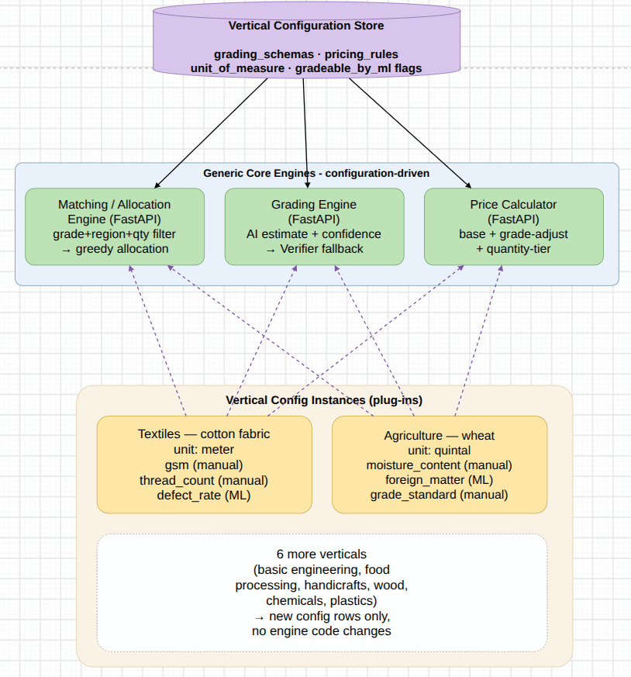

5. Technical Specifications
Tech Stack:
Layer | Technology | Implementation
Web Frontend | Next.js 16(App Router), React 19, TypeScript, Tailwind CSS v4 | Buyer, Admin, and Verifier consoles in one app, UI sourced from Aceternity UI, Magic UI, shadcn, modified for the marketplace
Seller Mobile App | Kotlin (native Android) planned | Contains listing creation, image clicking for proof submission etc
Backend Admin/CRUD | Django (5.2 line, resolves to 6.1) + Django REST Framework + SimpleJWT | Authorization, catalog, orders, disputes, notifications, pricing, reputation apps
Backend Compute/ML | FastAPI + SQLAlchemy + APScheduler | Grading, pricing, and matching/allocation services,in-process scheduler
Database | PostgreSQL + PostGIS (Docker container) | Shared schema where Django and FastAPI both connect directly
AI Grading | OpenCV + MobileNetV3-Small/ YOLOv8n (PyTorch, Ultralytics) target | Currently an OpenCV edge density heuristic stands in for real model inference (not started)
Object Storage | Local disk (Docker volume) via django-storages | Swappable to Azure Blob Storage through settings only, no application code changes
Auth | Django auth + djangorestframework-simplejwt | Tokens currently stored in localStorage, its a documented, dev only tradeoff pending an httpOnly cookie
Notifications | Firebase Cloud Messaging (planned) + in-app panel | In-app panel is built,Firebase later
CI/CD | GitHub Actions 4 workflows | test workflows for logs implemented
Hosting (future) | Azure Container Apps | Will be done once the entire project is finished

System Architecture:
- It's a local only setup right now:
All the components of this app (the frontend, the two backends, the database) are running on one developer's computer within Docker containers. There's no live server and there's no cloud based hosting currently, this is only built and tested on our laptop.

- One website, three different views:

BUYER VIEW

- Dashboard – a summary page with active requirements and recent orders.
- Catalog Browse – a searchable catalog of all listings with filters (vertical: agriculture/textiles, quality grade, location and price).
- Listing Detail Page – go into any listing and find out everything about it (grading report, price info, "Buy Now / Contact Seller" button).
- My Requirements – a page where you can add new requirements (number of units, min grade, budget, location) and view the previously added ones.
- Orders – your order history, including orders that involved several sellers (each order displayed as an expanded list).
- Cost Estimator – a mini calculator: enter the number of units and the minimum grade to calculate the approximate total cost.
- Notifications Panel – an alert feed like an inbox.

ADMIN VIEW

- Dashboard – platform-wide metrics: total listings, total orders, total users.
- Vertical Configuration (list page) – shows all verticals (agriculture, textiles, and so on) currently present on the platform.
- Vertical Editor – the actual “plug in” screen: an admin can define/edit the vertical’s grade attributes (such as moisture,GSM) and its pricing policy without any code changes.
- Users Management – a table with all the users on the platform: admin can see the roles and activate/disable accounts.
- Verification Queue – similar flagged listings queue available to the Verifier (same page, admin just has additional control rights).
- Disputes – a list of all disputes (such as “wrong grade” “order is not delivered”) and a workflow to solve them.
- Price Management – the screen where prices can be entered manually (textiles since there is no real-time public feed of prices) and where auto ingested prices can be seen (agriculture).

VERIFIER VIEW

- Dashboard -brief overview of: number of listings in queue, recent review history, accuracy stats.
- Verification Queue -listing that AI hasn't been able to evaluate confidently and require a human verifier.
- Review Page -screen comparing side by side: information (photo/documents) provided by the seller and grade suggested by the AI, with options for accepting or overriding the grade provided by the algorithm.

- Django:
It handles everything related to users and user privileges: signing in, registering, determining which actions are allowed for a specific user (e.g., Buyer cannot edit pricing, Verifier cannot place orders), basic operations with data: creating, reading, updating, deleting listings, orders, disputes, notifications.
- FastAPI as the engine room:
Performs heavy computations that Django wasn't meant for: AI grade estimation (grading), price calculations, and seller(s) selection based on order placement (matching/allocation). Also manages background scheduler thats a time driven system that updates prices automatically, every several hours or so, without a manual intervention.
- Both backends talk to the same database:
Rather than allocating each of Django and FastAPI its own database and always keeping them in sync (which leads to a ton of potential bugs in a small project handled by two people), both read/write to the single common PostgreSQL database. Less is more. PostGIS is just a PostgreSQL extension which allows location/region data processing (for filtering listings by location).
- Uploaded files (photos, certificates) live on local disk:
Now the uploaded files simply get stored in the development machine's hard drive. However, all the necessary changes required to make them use cloud storage services (Microsoft Azure) will amount to changing configuration file only. It has been planned to be done in the future, after everything else will be set up locally.
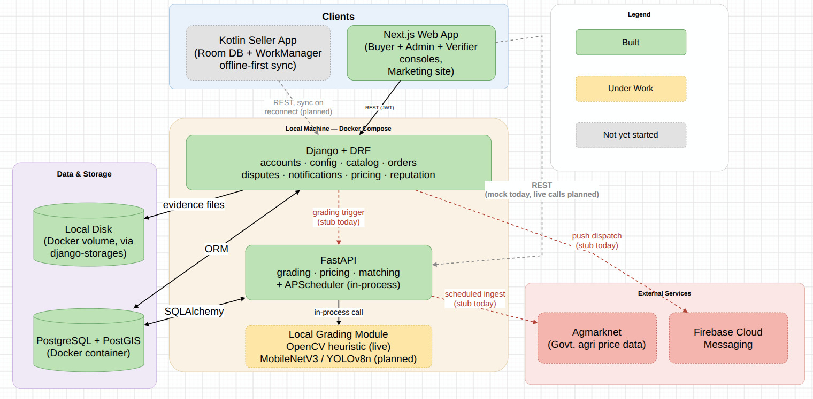
Multi Listing Allocation:

The machine learning algorithm for this has not been built yet, the diagram below covers the plan we have implemented for now.
Step 1 The buyer states what they want
Four items of data: the quantity of the product they are going to buy, the lowest quality grade they accept,the price they are ready to pay, and the region where they want to purchase the item.

Step 2 The system throws out anything that doesn't qualify.
The algorithm checks all listings presented on the platform and filters the ones which
(a) are now available
(b) have a grade equal to or greater than the Buyer's lowest acceptable grade
(c) belong to the Buyer's region. Other data is excluded from further analysis.

Step 3 The remaining listings get lined up, cheapest first.
Of all the items which have passed the filter test, the algorithm sorts them in the order from the lowest price to the highest one. In case of a tie (the same price), the algorithm prioritizes the listing of a seller with higher reputation rating ("tiebreak" rule).

Step 4 The system buys from the cheapest sellers first, one by one.
This is is a "greedy" approach we always choose the best item right now not thinking too much ahead. The algorithm starts purchasing the stocks starting from the cheapest listing, then moves to the second cheapest one, etc. Until the desired quantity is purchased.

Step 5 Check: did we manage to fill the whole order?

This is the one decision point in the whole flow.
If yes -Order is marked as completely fulfilled. The system creates an “Order” object and if there was allocation of stock from multiple sellers, it creates “OrderAllocation” objects separately for each seller to show the exact quantity from each of them.

If no(not enough total stock existed to meet the quantity) -It is marked as partial allocation. Buyer is informed of the short quantity and can opt for accepting the partial quantity or wait until other sellers put up stocks.

Step 6 Either path ends with the same clean output.
Whether the fill was complete or partial, the output will be the same simple list of listings used, quantity from each listing and the price of each.

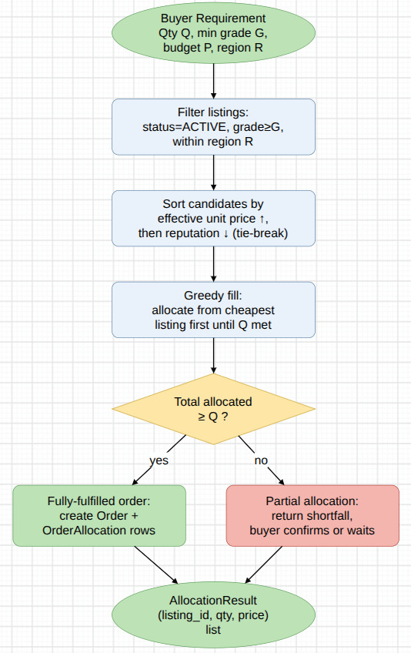

6. Current Progress & Implementation
Completed Modules:
As of this review, the following are built and working:
- The full project repository uploaded (Django and FastAPI services skeletons, Next.js app React, Docker Compose and 4 GitHub Actions CI workflows for testing builds

- The full database schema (all models for all 8 Django apps have been created,migrated and executed against a live PostgreSQL +PostGIS instance).

- The full end-to-end JWT authentication flow (register - login -/me/) with the role based access control over 9 permission classes (Seller, Buyer, Admin, Verifier).

- The full Django REST API interface surface (vertical/grading-schema/pricing rule configuration, catalog listings and evidence uploads, orders/requirements/bids, disputes, notifications, pricing and reputation endpoints).

- The fully implemented and tested FastAPI pricing service: base price retrieval, grade adjusted and tiered price calculator, cost estimator and trend endpoint.

- Grading pipeline (partial) – OpenCV preprocessing step executes in-process in the FastAPI application, model inference still yet to come

- Marketing/Landing Site – 5 pages created, cloned and re-skinned from an open source template using Aceternity UI, Magic UI and shadcn-ui components.

- UI of the Application – 17 routes implemented for Buyer, Admin and Verifier consoles (dashboards, browse/catalog detail, cost estimator, verticals configuration, grading queue/review, disputes and price management), unauthenticated page data is mock at the moment, but seamlessly can be switched to API requests when it is implemented

- File Upload for Grading Evidence – storage abstraction via django-storages library to be able to move to Azure Blob Storage later on configuration level.

Screenshots:
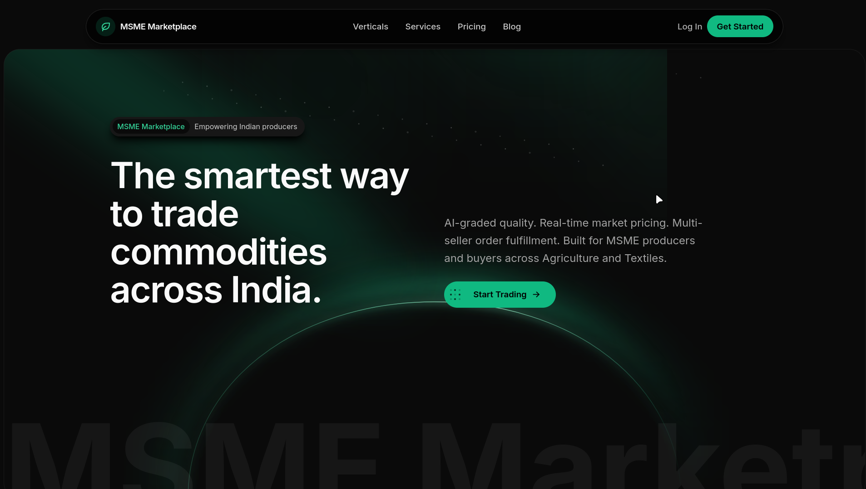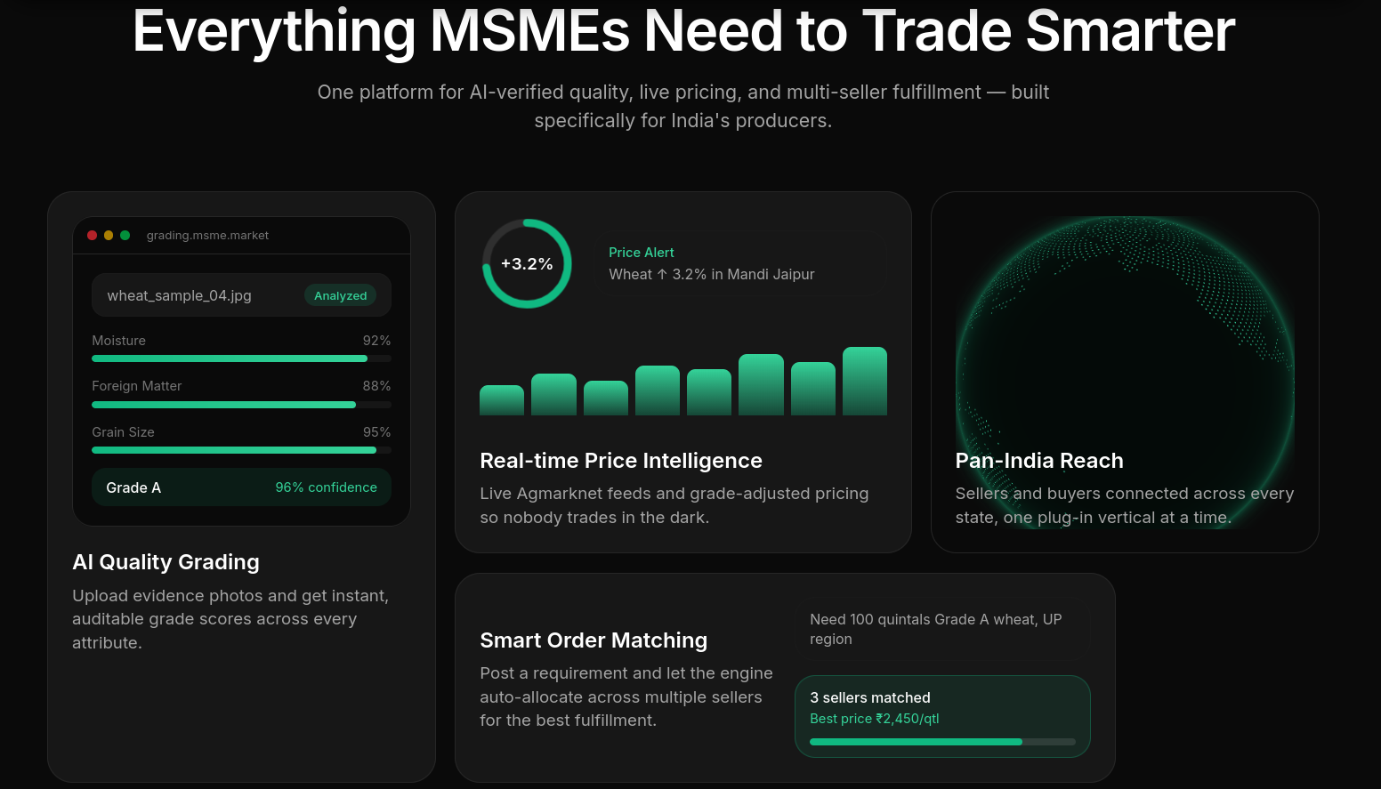
Landing Page – new Buyers will be greeted with this page.
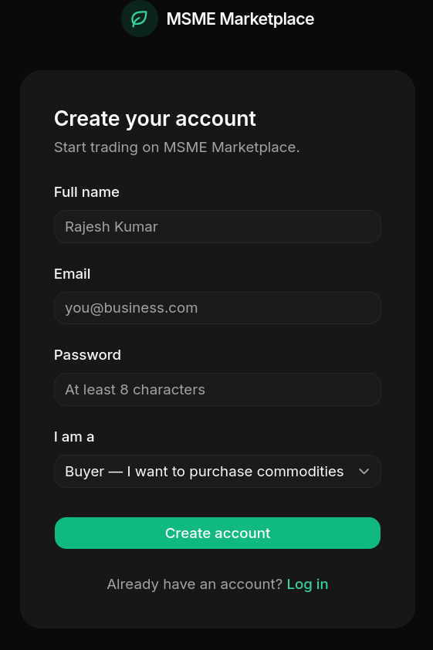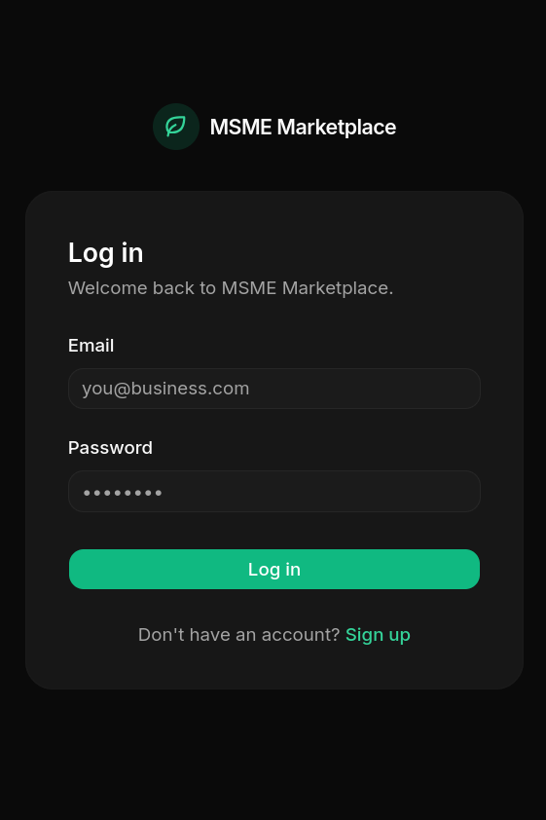
LOGIN/SIGNUP Page for Buyer Accounts.

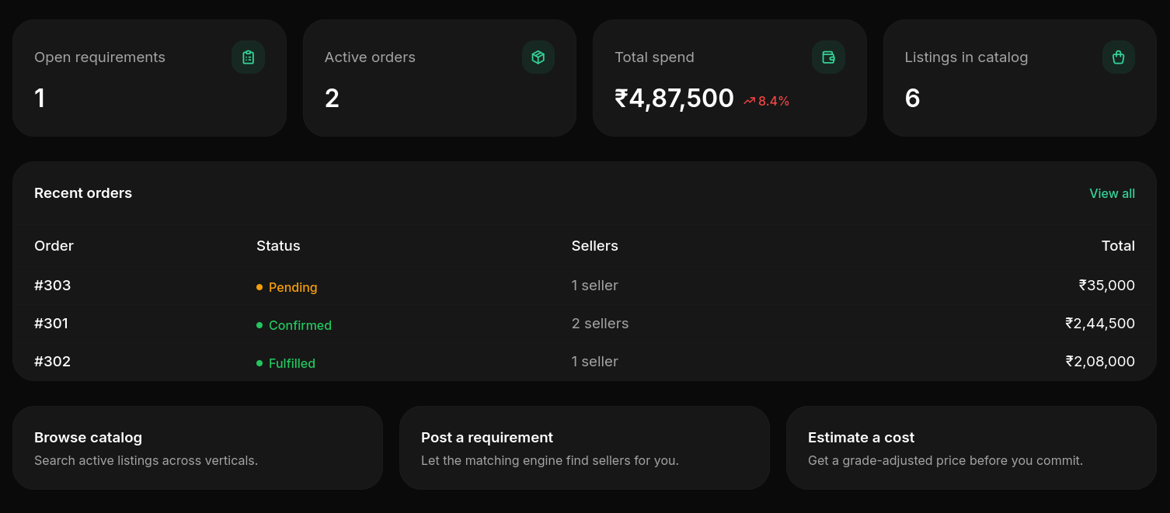
quick stats (1 open requirement, 2 active orders, ₹4.87L total spend, 6 listings in catalog), a table of recent orders with status, and three shortcut cards to browse, post, or estimate.
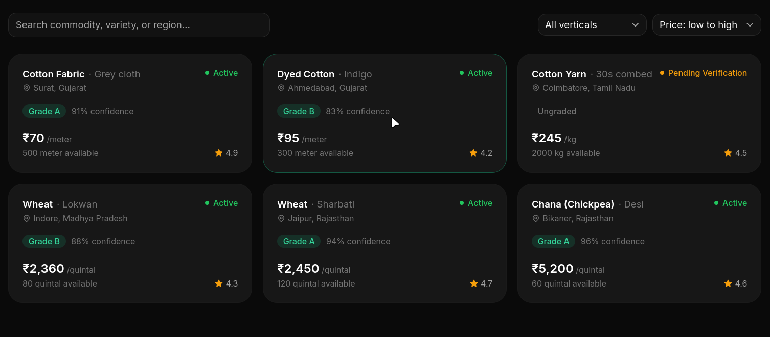
Grid of active listings (cotton fabric, dyed cotton, cotton yarn, wheat varieties, chana), each card shows grade and AI confidence, price per unit, quantity available, and seller rating with search and filter at top.

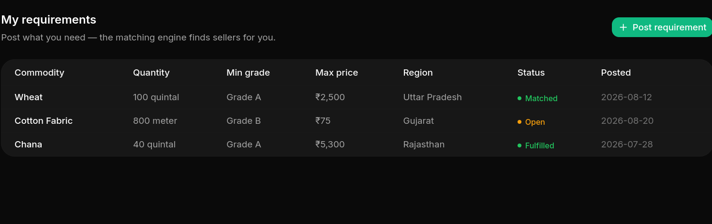
Table of requirements the buyer has posted (commodity, quantity, min grade, max price, region), each tagged by status: Matched, Open, or Fulfilled with a button to post a new one.
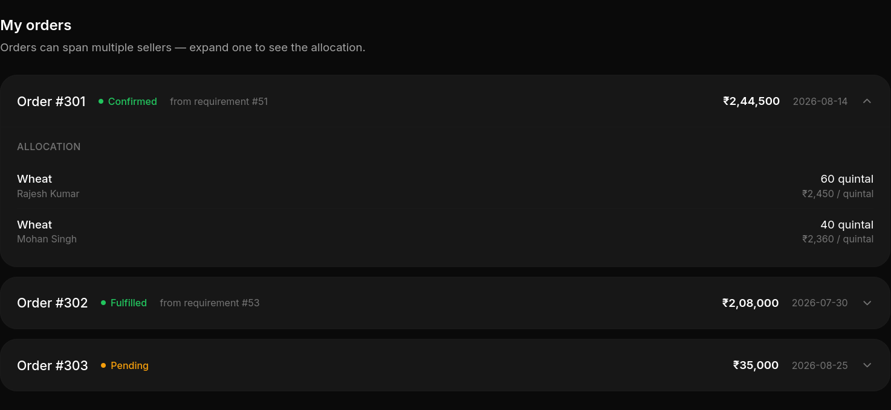Order history list, expanding the order shows the allocation breakdown if it was split across two sellers at different per unit prices, this demonstrates multi listing allocation.

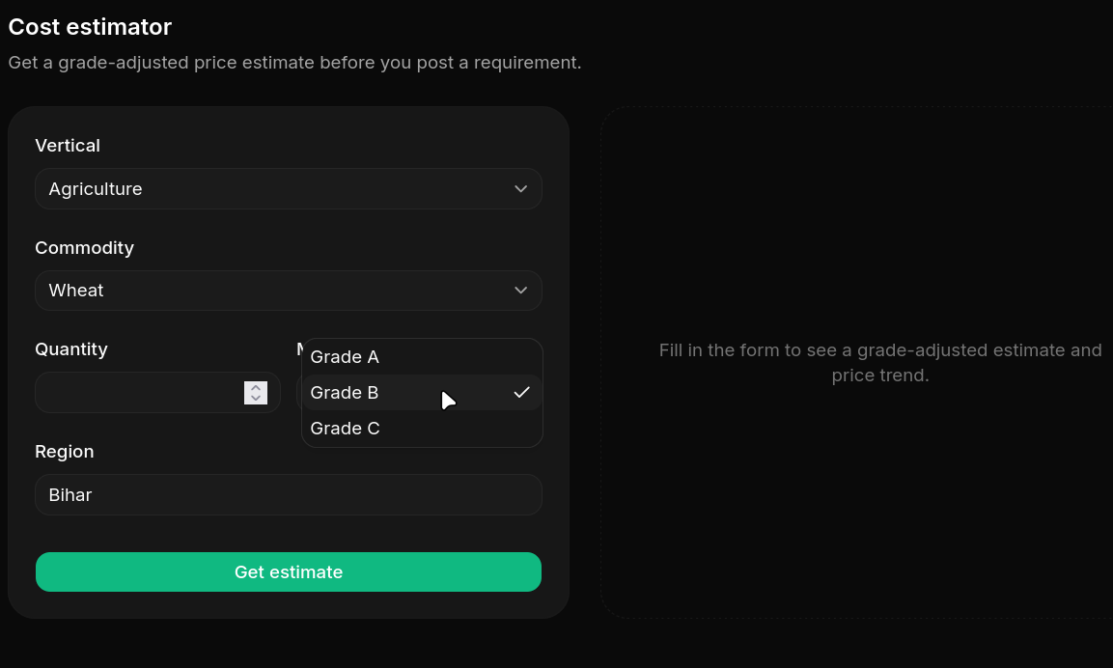
A calculator widget where we enter a quantity, get an estimated total , see the base vs grade adjusted price and see a 30 day price trend chart for that product
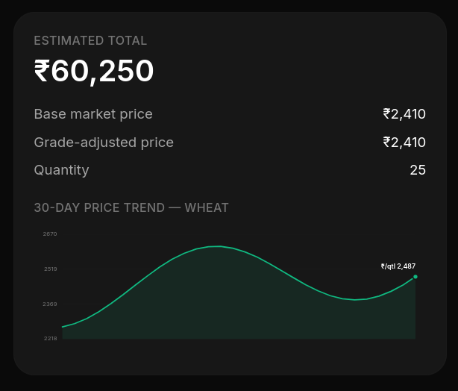

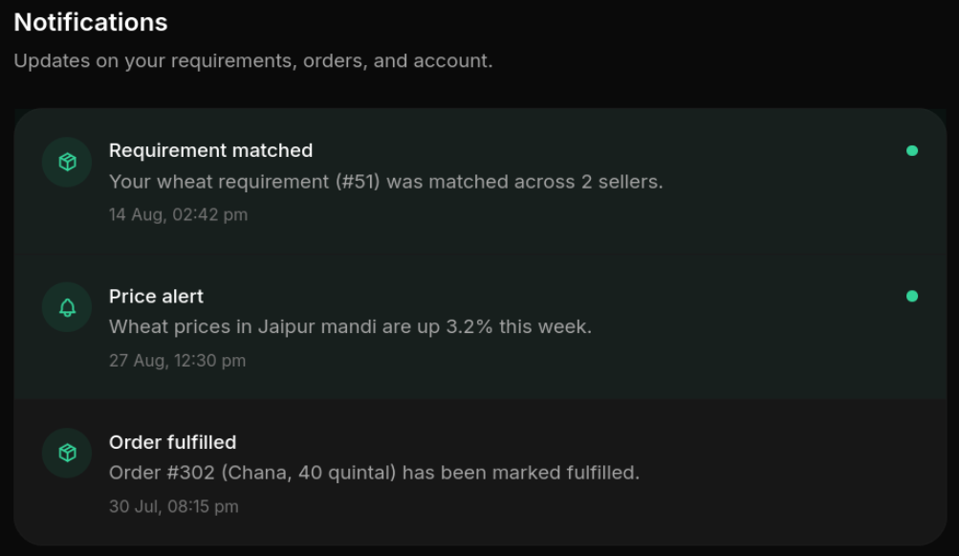
account alerts – here we see requirement getting matched, a price movement alert, and an order being marked fulfilled with timestamps.

Now here is the Verifier’s Dashboard, that works under the same frontend:
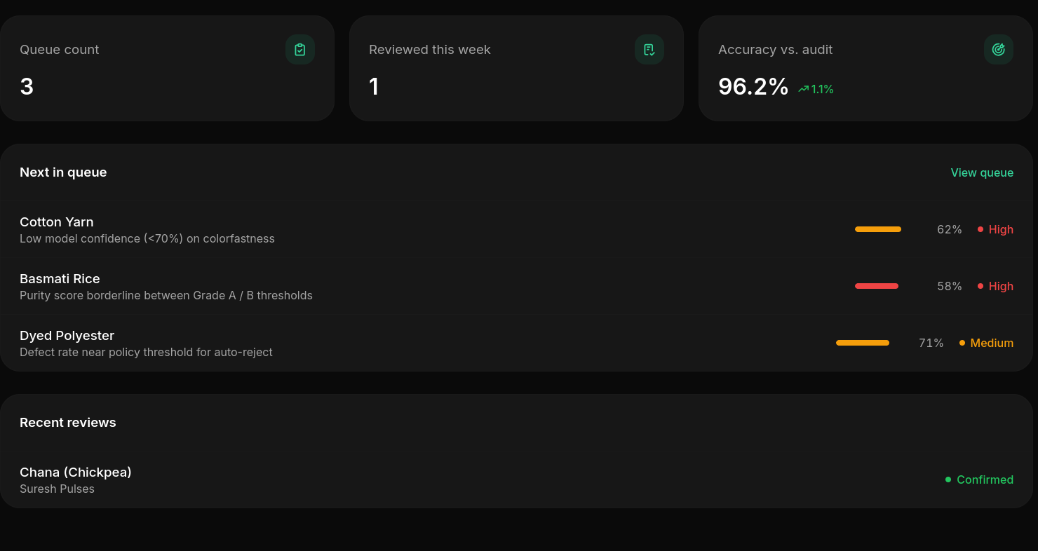
Landing screen for Verifiers shows quick stats on queue size, review activity, and grading accuracy, and "next in queue" preview shows the flagged listing that need attention urgent, and a log of recently completed reviews.

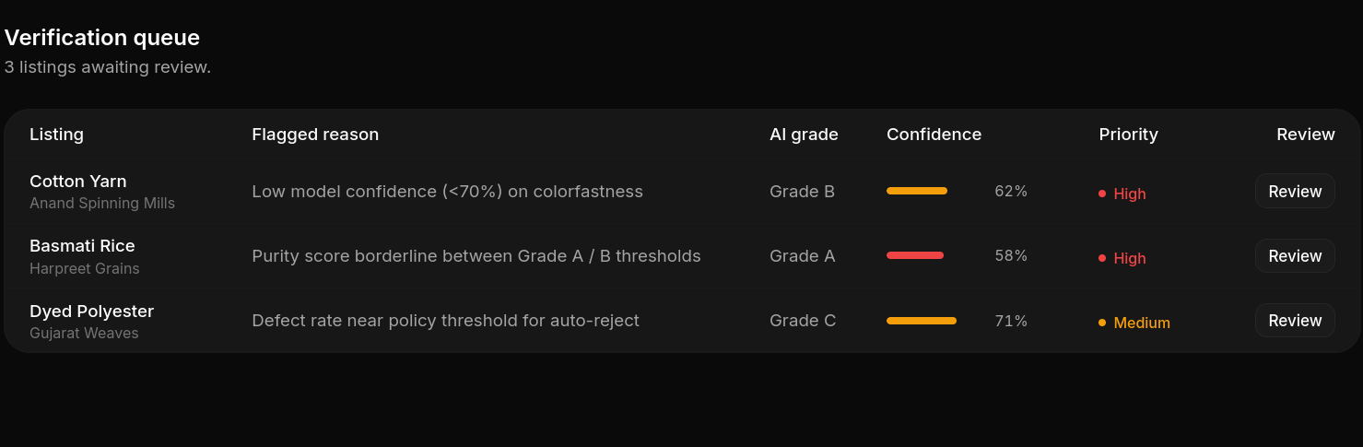
The review screen for one listing where the seller's uploaded evidence photos are there on the left, the AI suggested grade and confidence on the right, broken down into attributes so the Verifier can override any single value that looks wrong and has a note explaining why, before submitting the correction.
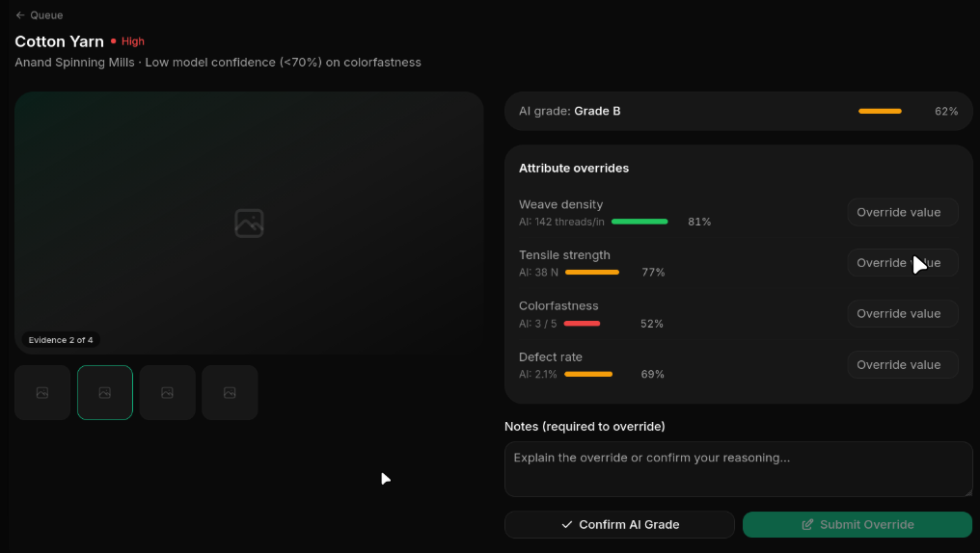
A simple list of every listing currently waiting on verifier review, showing why each was flagged, how confident AI was and how urgent it is with a one-click button to jump into reviewing any of the listings.

Here is the Admin Dashboard for full control and access:
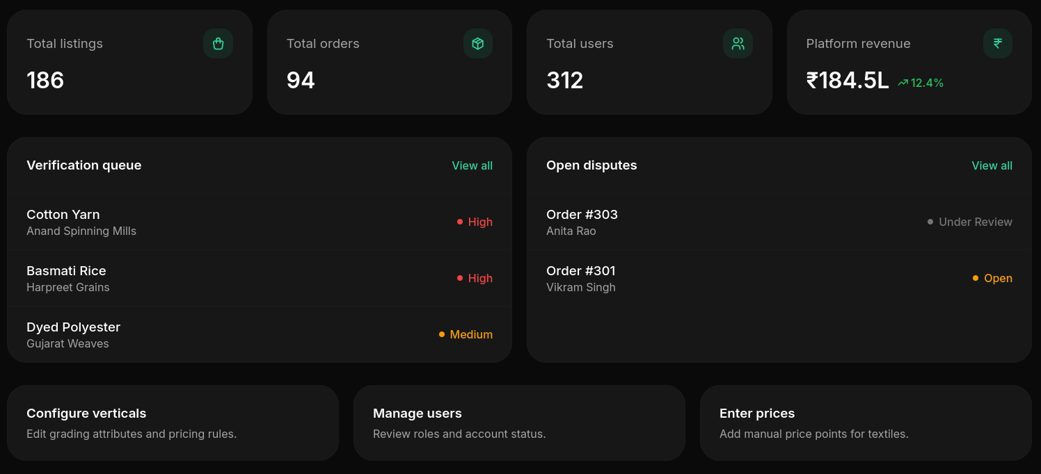
The Admin's control panel home screen has full platform data (listings, orders, users, revenue), a summary of the verification queue and open disputes, and shortcuts to the Admin's main jobs that is configuring verticals, managing users, and entering prices.

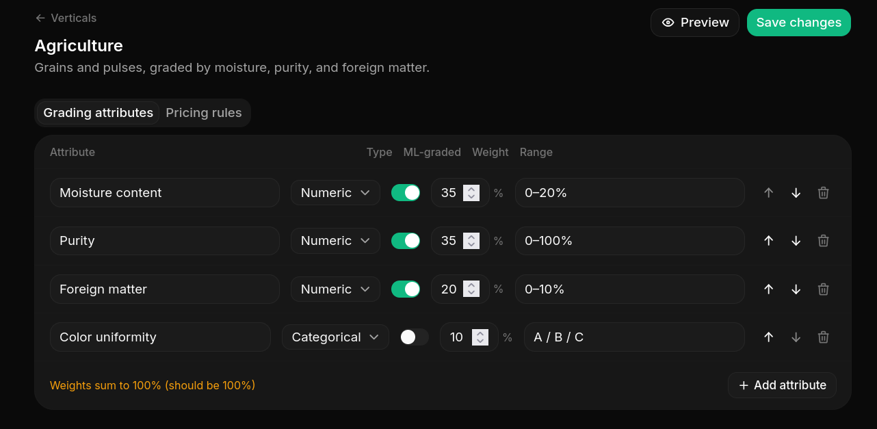

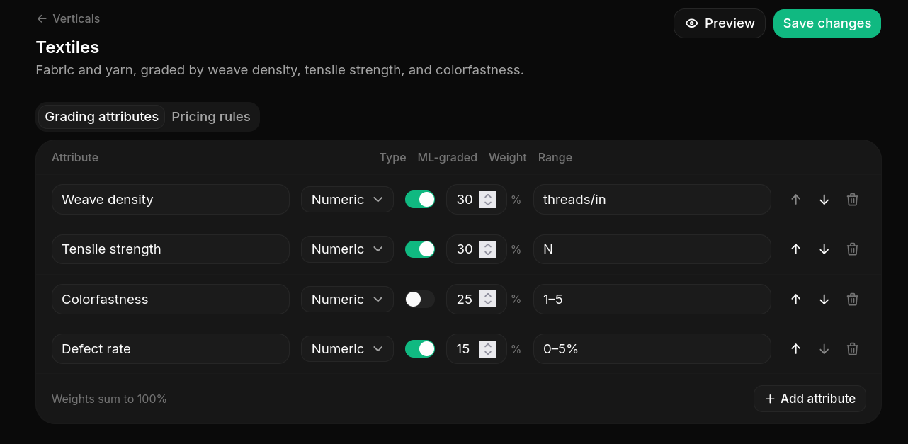
There is a plug in configuration screen for one vertical. This lets an Admin define what quality attributes matter for that listing and whether each one is graded automatically by AI or entered manually by our verifier, how much grade each attribute has got, and what value range is valid.

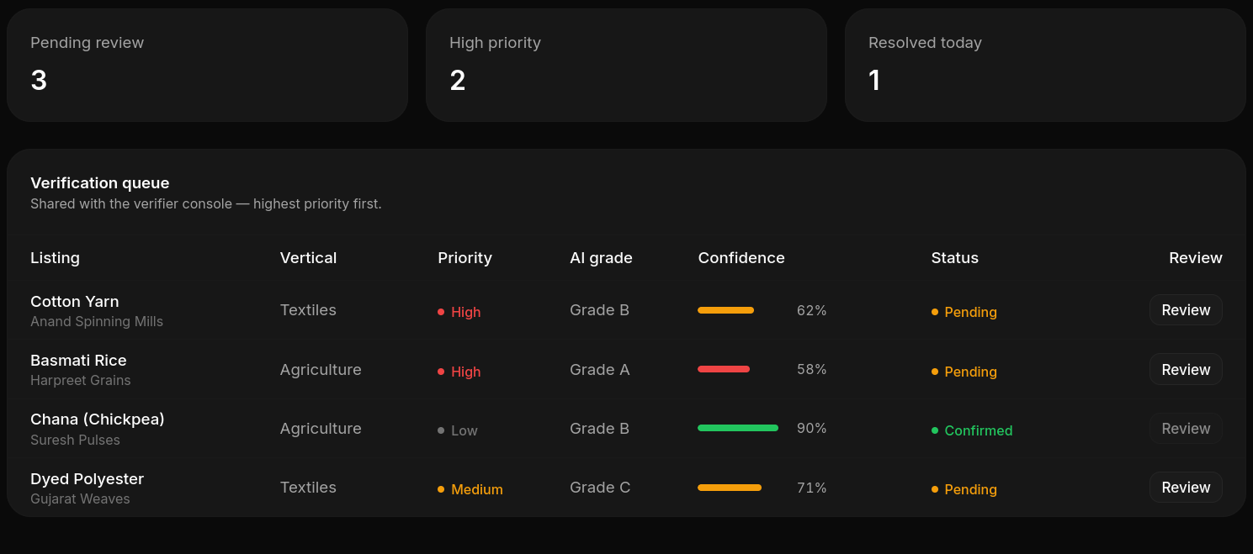
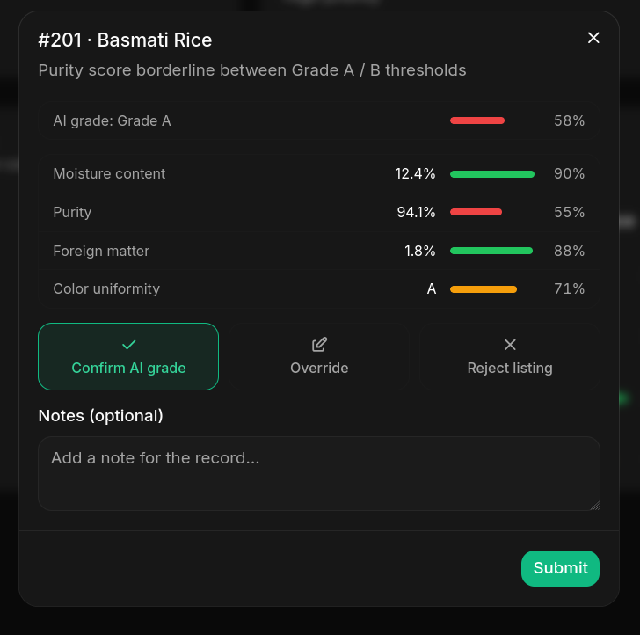
This shows a simplified version of the review screen in a popup form where the AI grade and per attribute confidence is shown with three clear actions on confirming the AI grade, override it, or reject the listing.

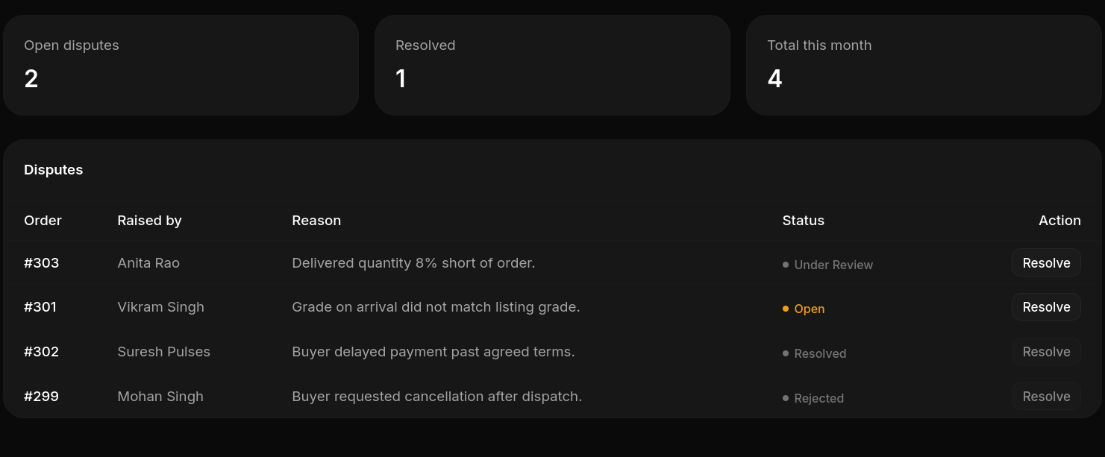
A tracker for buyer/seller complaints page where what the issue was, who raised it, and its current stage (open, under review, resolved, rejected) is shown with a button for the Admin to act on each one.

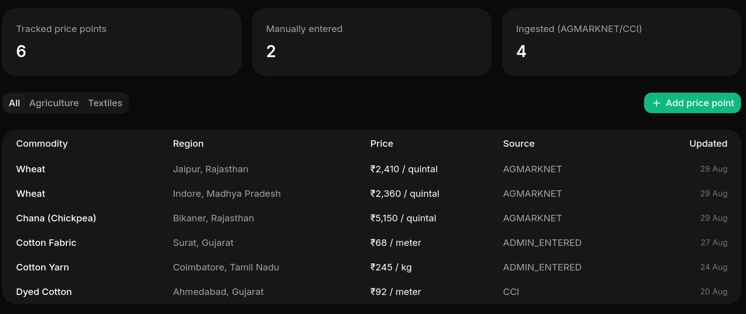
A table of the reference prices the platform is using with proof by showing which ones came in automatically from an external data source versus which ones an Admin typed in by hand(for transparency), with the ability to add new price entries and filter by listings.

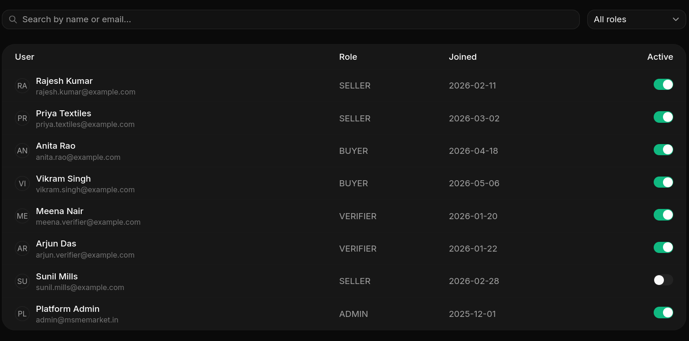
A directory of everyone registered on the platform with their role (Buyer, Seller, Verifier, Admin), when they joined, and full control access to activate or deactivate their account.

7. Challenges & Next Steps
Challenges Faced:
- To coordinate between the two backend frameworks for CRUD/admin and compute/ML tasks respectively and ensure that migrations of the two services never clash over the shared PostgreSQL schema, the write paths had to be determined up front.

- There is no public, reliable feed for the prices of processed fabrics (fabric by GSM/thread-count) unlike agriculture where there is an Agmarknet feed. It was necessary to make a conscious decision about this issue: price of textiles data should be shipped through the app as explicit, admin added data instead of attempting to create a feed that is not present which would be bad since our goal is to create price opacity.

- For real machine learning grading (MobileNetV3/YOLOv8n) it is necessary to have training data which is not available as of now. The grading is done using the interim OpenCV edge density method to allow testing and building of the rest of the pipeline which is confidence thresholding, Verifier queue, and audit trail.
- JWT storage in localStorage is considered a documented dev only hack instead of the originally intended httpOnly refresh token because of the schedule.
Pending Deliverables:
- Backend (Django) –(partial)connect the endpoint that triggers grading to invoke the FastAPI service, connect Firbase Messaging dispatching to Firebase Admin SDK, write tests for the 7 applications that don't have tests yet.

- Backend (FastAPI) –(partial)implement real Agmarknet ingestion (stubbed out logging implementation now), andfinish grade/region derivation TODOs on both the matching and pricing routers

- ML pipeline – gather a labeled data set (goal is more than 200 samples per class per vertical), running the training script that we’ve partially written replace the current OpenCV based heuristic with real MobileNetV3/YOLOv8n inference on production(not yet confirmed, we will choose best based on our tests)

- Seller mobile application – develop the full Kotlin/Android application,pre-requisite for offline synchronization in the Django application already exists.

- Testing & polishing – complete full five layer test setup (Django, FastAPI, ML, React, E2E), testing with respect to performance target, OpenAPI validation as part of CI process.

- Migration of the backend to Azure remains unchanged until all phases above work locally, end-to-end

Timeline to Completion:
Here is our proposed plan for completing this project
Week | Focus
1 | Wire Django and FastAPI integration seams with real grading trigger call, resolve grade/region derivation in matching & pricing routers. Then we can have the backend testcoverage buildout which has the 7 untested Django apps plus FastAPI's grading, pricing, and scheduler modules.
2 | Wire the 7 remaining frontend mock data call sites to live endpoints (post requirement, buy/bid, vertical editor save, user toggle, verifier review, price point entry).
3 | Real FCM push dispatch and then migrate JWT storage to an httpOnly refresh cookie, build the forgot password page.
4 | ML pipeline where we will collect a labelled public dataset(using images/class/vertical), run the existing training script, swap the OpenCV heuristic for real MobileNetV3/YOLOv8n inference.
5 | Seller Kotlin app with scaffold MVVM + Room DB,build Login, Dashboard, and Create Listing screens by using Django API.
6 | Hindi/English i18n (next-i18next), revisit the command palette decision, validate against the performance targets.
7 | Integration pass, OpenAPI schema validation, and bug fixing and finally Azure migration phase where we make the project cloud hosted.

