

Fractal RPG

0th Edition, 5th Revision, 0th Update, 0th Fix (0.5.0.0)

Squishy Meatloaf | Pantsless Robot

Lorebook

# Races

[Star Mercenary notes](https://docs.google.com/document/d/1IACdKasteIjxXKBQfGXJOAMxVJ5Ec7gCDDegM6xoVkE/edit#)

[The Realm of Underhill](https://docs.google.com/document/d/1AUPX8DGTm7piF9JXV2UY0cEvGBx0n3BRAa2YdPi66fI/edit#heading=h.ps1vsxa0ymx3)

## Barvara

Barvara are desert-dwelling humanoids from a planet orbiting a red giant.

**Anatomy**

Red pigmented skin, ranging from a deep near-black bloodred to a pale pink.

Eyes with red sclera and large yellow irises.

Ears with two shallow points, making them look "squared off".

woman -> komara

## Bitlok

Bitloks are a formerly biological race that digitized themselves

[race info doc](https://docs.google.com/document/d/1MFhtyRvYOp4Zjzj_fnrqrHCjZackcR3RoyrhLrs9NK8/edit#)

## Boulld

## Buluzi

* Thin, agile humanoid reptilians
* Typically 2' - 3' Tall
* Semi-bipedal
* Grip pads similar to Earth Geckos

## Doryu-Aleda

* Humanoid insectoid
* Typically 4'6" - 6' Tall
* Resemble Earth Dragonflies
* Winged (4); Capable of flight

## Dragon

Dragon is the overarching group for any draconid races. Any form of dragon may have the ability to spray fire, frost, toxic gas, or lightning from its mouth as a defense mechanism.

### Darradin (western dragon)

Darradins are 4-legged 2-winged lizardlike dragons.

### Drake

Drakes are 4-legged wingless lizardlike dragons.

### Loong (eastern dragon)

Loongs are 4-legged wingless serpentine dragons.

[wikipedia](https://en.wikipedia.org/wiki/Chinese_dragon)

### Wyrm

Wyrms are legless wingless serpentine dragons.

[dragons fandom wiki](https://dragons.fandom.com/wiki/Wyrm)

### Wyvern

Wyverns are 2-legged 2-winged lizardlike dragons.

## Dwarf

## Elemental

choose your element

## Elf

## EMHA

## Faina

* Humanoid
* Typically 6’ - 8’ tall
* Ice-like outer shell
* Partially immaterial core

## Fairy

## Gargoyle

## Gnome

## Ghoul

## Goblin

## Golem

## Goliath

max height ~200% of typical humanoid (~12')

## Hag

## Halfling

max height ~50% of typical humanoid (~3')

## Human

## Laihl

[character descriptions doc](https://docs.google.com/document/d/1ZtNNgavykkk5OS2hgIr5S4hFs29mAtBplbbYuQZzlVg/edit#)

## ~~Lamia~~

humanoid-serpent satyr

## Leneri

[character descriptions doc](https://docs.google.com/document/d/1ZtNNgavykkk5OS2hgIr5S4hFs29mAtBplbbYuQZzlVg/edit#)

## ~~Merfolk~~

humanoid-aquatic satyr

## Naturefolk

Naturefolk is the overarching group for any anthropomorphised animalian, plant, fungal, etc races.

### Apefolk (sasquatch, yeti)

### Catfolk (khajiit)

## 

### Cowfolk (minotaur)

## 

### Dragonfolk (dragonborn)

does not distinguish between types of dragon, since all of them would produce basically the same end result

## 

### Insectfolk

### Lizardfolk (argonian)

## 

### Snakefolk

## 

### Spiderfolk

### Treefolk (ent)

## 

## Nymph

## Ogre

## Ondroti

## Orc

## Pixie

## Phoenix

## Seraph

Seraph is the overarching group for any angelic or demonic races.

### Angel

#### Archangel

#### Cherub

#### Cupid

### Demon

#### Archdemon

#### Imp

#### Erodemon

man -> incubus

woman -> succubus

## Shaemora

## Slime

## Stelka

## Traherne

* Humanoid
* Typically 7’ - 10’ tall
* Layered meshes of metal scales
* Limited ability to shapeshift

## Troll

## Tynorra

* Arthropoid
* Typically 4' - 5' Long
* Resemble Earth centipedes with fewer legs
* Long (1' - 2'), multisegmented, and highly flexible limbs

## Virag

# Race Variants

## Mixed Race

All racial traits at ⅟ₙ effectiveness, rounded up, where ⅟ₙ is amount of parentage (does not need to be power of 2, but all must sum to 1).

## Anatomical Variants

### Android

### Automaton

Clockwork machines which are intricate and complex enough to be almost alive.

### Cyborg

### Cyclops

Cyclopses have only 1 eye in place of the normal amount for their race.

### Gorgon

Gorgons have a mane of snakes and any living being that looks at their face is turned to stone.

### Hydra

Hydras have more heads than the normal amount for their race.

### Winged

gain 1 or more pairs of wings

### Centaur

INCOMPATIBILITIES:

* Satyr
* Chimera

Choose a race for the "body" (conventionally horse), choose a race for the "head" (conventionally human).

### Chimera

INCOMPATIBILITIES:

* Centaur
* Minotaur
* Satyr

Choose any mixture of races you want in any configuration. Only gain racial traits if you use the necessary anatomy from a race.

### Minotaur

INCOMPATIBILITIES:

* Chimera

Choose a race for the body (conventionally human) and a race for the head (conventionally cow).

### Satyr

Choose a race for the legs (conventionally goat), choose a race for the body (conventionally human).

INCOMPATIBILITIES:

* Centaur
* Chimera

## Complexion Variants

Can only take 1.

### Light

### Grey (1/2 light 1/2 dark)

### Dark

## Attribute Variants

RULES Each adds 10% of a being's base height, ignoring size variants.

### Arid

larger/more resistant to dry environments

### Blaze

larger/more resistant to heat

### Blood

larger/heal faster

### Dank

larger/more resistant to wet environments

### Dire

larger/stronger

### Dread

larger/tougher

### Frost

larger/more resistant to cold

### Grim

larger/faster

### Noxious

larger/toxins are more potent

### Vile

larger/more resistant to toxins

## Bodyshifting Variants

### Lycanthrope

Lycanthropy is a transmissible condition. It is spread when a lycanthrope in its lycan form bites another being. Lycanthropes involuntarily transform into a different race, their lycan form, when a certain trigger occurs. The race and trigger is specific to each lycanthrope, and is not transmitted with the condition.

RULES Choose a race to transform into (i.e. your lycan form) and a condition to trigger transformation.

### Shapeshifter

RESTRICTIONS:

* Lycanthropes cannot shapeshift while in lycan form.

### Soulbound

A living being that has bound its soul to an object, thus creating a phylactery. Because its soul is no longer within its body, a soulbound is weaker and frailier the farther away from its phylactery is.

If a soulbound dies while its phylactery is intact, the afterlife will try to collect its soul from its body. Once the afterlife realizes that the body has no soul in it, the soulbound's body will be forced to regenerate by the afterlife. If a soulbound's phylactery is destroyed, its soul is collected by the afterlife, and it becomes a Wraith.

### Vampire

Vampirism is a transmissible condition. It has a chance to spread when a vampire bites another being. It has a variety of symptoms, the most prominent of which is masking a vampire's soul from the afterlife, making vampires immortal.

## Undead Variants

A being is considered undead if its body has lost possession of its soul. Undead beings, therefore, are either a soulless body or a bodiless soul.

### Phantom

A soul summoned from the afterlife. Phantoms are barely intangible, being fully visible and able to physically interact with their surroundings, but cannot be physically harmed.

### Revenant

A soulless corpse that was reanimated. Since it is powered by magic rather than biological functions, it will decompose as normal and cannot heal on its own.

### Shade

A soul left behind by a living being that failed to reach the afterlife. Shades are almost completely intangible, being barely visible and unable to physically interact with anything.

### Wraith

A living being that lost its soul. Since the afterlife already collected its soul, it is immortal, but technically no longer alive.

## Size Variants

Can take only 1.

### Colossal

5x size

### Monstrous

4x size

### Major

3x size

### Greater

2x size

### Superior

1.5x size

### Inferior

0.75x size

### Lesser

0.5x size

### Minor

0.33x size

### Miniscule

0.25x size

### Diminished

0.2x size

# Geographic Variants

### Climate

* Desert
* Tropical
* Wetland
  + Bog
  + Fen
  + Marsh
  + Swamp
* Tundra
* Arctic

### Topography

* Canyon
* Valley
* Plains
* Hill
* Plateau
* Mountain
* Cliff

### Terrain

* Barren
* Grassland
* Shrubland
  + Savannah
* Woodland
* Forest
  + Taiga
* Jungle
  + Rainforest
* Cave
* Beach
* Glacier
* Volcano

### Aquatic

* Lake
  + Fresh Lake
  + Salt Lake
* River
  + Fresh River
  + Salt River
* Sea
  + Fresh Sea
  + Salt Sea
* Oasis
  + Fresh Oasis
  + Salt Oasis
* Spring
  + Fresh Spring
  + Salt Spring

# Materials

## Materials List

* Character Sheet
* Skills Sheet
* Skill Specialties Sheet
* Abilities Sheet
* Traits Sheet
* Stat Scaling Reference
* Stat Scaling Calculator (spreadsheet only)

## Materials Document

[Fractal (in development) - Materials](https://docs.google.com/spreadsheets/d/1it0XsTjvm6J6l9Tzyz928JYYrgV79-lAsx0Z2RLDND0)

{spreadsheet}

{pdf}

Make a copy of the document to edit it.

# Rules

## Rulebook

[Fractal (in development) - Rulebook](https://docs.google.com/document/d/1ae18N-zqR_oe177XlUlzEsnzbkuNjSW5MGDNFhKbmVs/edit?usp=sharing)

{pdf}

# License

2019 - 202X SparkliTwizzl

Fractal RPG is licensed under Creative Commons Attribution-NonCommercial-ShareAlike 4.0 International (CC BY-NC-SA 4.0).

You are free to do whatever you want with the system, as long as you abide by the terms of the license: <https://creativecommons.org/licenses/by-nc-sa/4.0/>



# Main Document

[Brief system overview and links to all versions' materials and Discord server.](https://docs.google.com/document/d/1Di0UDX2f8aMg9MAPPGzFBmBiDwQyURgkFFnE2QvkkfA)



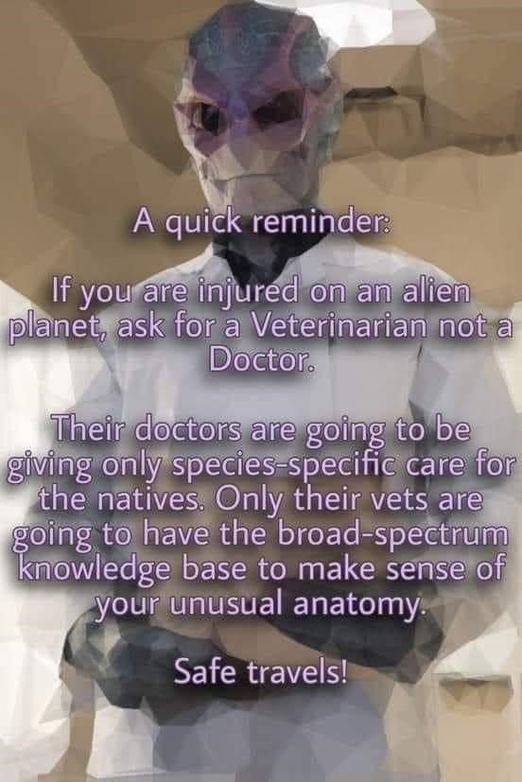

alien sophont medical care - xenophysician

alien fauna medical care - xenoveterinarian