Transitioning to CMMI:

A Guide for Executives

Version 0.51

April 2002

Table of Contents

Introduction 1
Executive Support 1
Background of the CMMI Project 4
Tailored for Your Organization 4
Implementing Change Within an Organization 5
Enterprise-Level Roadmap 6
Transition Cycles 6
Requirements in Each Cycle 6
Early Adopters 7
Sector Business Case Advantages 8
Introduction 8
Government 8
DoD Contractor 10
Joint Government / DoD Contractor 11
Commercial 13
CMMI Compatibility with Departure Models 14
CMMI Compatibility with Standards 15
Introduction 15
Notes Regarding Individual Standards 17
Process Areas Described 18
Process Management Process Areas 19
Project Management Process Areas 19
Engineering Process Areas 20
Support Process Areas 20
Custom Process Areas 20
Adoption Approach 21
The Continuous Representation 21
The Staged Representation 21
Equivalent Staging 21
Resources 22
Personnel 22
Training 23
Budget 24
Schedule 24
CMMI Transitioning Partnering 24
Appendix A: Tailoring Guide (Help for the Advocate) 25
Appendix B: “Traps and Time Wasters” 26

Introduction

The Promise of CMMI
Capability Maturity Model®-Integration (CMMISM) is for projects or organizations that want to do the following:
- Improve delivery of promised performance, cost, and schedule.
- Collaborate with external stakeholders and manage their expectations.
- Provide competitive world-class products and services.
- Implement an integrated, enterprise business and engineering perspective.
- Master system-of-systems evolutionary development complexity.
- Use common, integrated, and improving processes for systems and software.
- Implement proactive program management techniques.
- Develop project leaders who look ahead and not over their shoulder.
- Develop a staff that uses best practices to cope with changing development, technology, and customer environments.
- Enable staff members to move between projects and still use the same processes.
- Create and improve processes that adapt to a changing business environment.

CMMI is a process-improvement model that provides a set of best practices that address productivity, performance, costs, and stakeholder satisfaction.
- CMMI is NOT a set of “bolt-on processes” that last only as long as the wheel is squeaking. CMMI provides a consistent, enduring framework that accommodates new initiatives.

- CMMI focuses on the total-system problem, unlike the SW-CMM or SE-CMM.

- CMMI facilitates enterprise-wide process improvement, unlike single-discipline models that can result in confusion and higher costs.

Executive Support
Process improvement using the CMMI Product Suite improves predictability of the critical measures of cost, schedule, performance, and customer satisfaction. So what are these key and critical processes for process improvement and who is responsible for performing them?

The CMMI Product Suite provides descriptions of best practices that help managers break the code of predictability of cost, schedule, performance, and customer satisfaction. Five process areas are related to process management, and six are related to management oversight. The information contained in these eleven process areas assists the executive in:
- Focusing on long-term viability rather than short-term project and contractual issues
- Establishing a strategic business plan
- Providing and protecting resources for long-term improvement of the organization’s processes
The Malcolm Baldrige Award provides another, complementary perspective for executives to break the code of predictability of cost, schedule, performance, and customer satisfaction. The following seven areas are evaluated for the prestigious award:
- Leadership
- Information and Analysis
- Strategic Planning
- Human Resource Development and Management
- Process Management
- Business Results
- Customer Focus and Satisfaction

At the heart of both CMMI and the Baldrige Award is the role of the leader. The following are critical predictors of the speed and predictability of an organization’s effort to improve its processes:
- Leaders are able to see the business need and express it in a compelling manner.
- Leaders are willing to personally lead the effort.
- Leaders are capable of changing their own behavior as needed to honor the new processes and to support others as they learn to honor them.

Leaders must be proactive, because the most critical element of any implementation is the leadership element. Bottom-up change is too unpredictable. Organizational change must be designed, implemented as a mission-critical project, and led from the top for the following reasons:
- Competing alternative solutions result in piecewise effort vs. integrated effort.
- Resources must be committed and fenced for the process-improvement effort.
- Leaders must establish a mentoring environment for process improvement, reward process improvement efforts, and discourage resistors to process improvement.
- Leaders’ behavior is watched and emulated.
- Leaders must establish and maintain the vision.

Given that our tactical approach to implementation is through a centralized core team, the role of leadership is critical. It is essential for senior leadership to be the “champion” of the activity. This championship involves the following elements:

Establish and Maintain the Vision - It isn’t enough just to set long-term organizational goals. There are as many potential paths to the goals as there are people in the organization. Unless the vision includes additional information to limit implementations to a compatible subset, waste and frustration are the likely results. Personally commit to the implementation and positively state that CMMI-based process improvement is the approach that will be employed.

Deduce Objectives - Communication of critical and concrete elements on the path from today to the future is needed to further reduce the waste from misinterpretation of the vision and potentially incompatible implementations. This communication must include both critical operational mission objectives and critical organizational change/improvement objectives. Engage with leadership and promote the effort by personally briefing the leadership on the benefits of CMMI-based process improvement.

Select Priorities – Determining which efforts will receive your most skilled people and first choice on resources is an important factor. Too often people talk about priorities in the abstract. There aren’t enough resources to staff everything to guarantee success. Warriors know some battles must be won and others are not as critical. These are hard choices; but they MUST be made! Establish management procedures to monitor the involvement of leadership in the process improvement effort.

Apportion Assets – Apportioning assets is the other side of prioritize. Many assets are not interchangeable. How assets are best apportioned may change over time even when priorities remain fixed. Resource apportionment in the absence of leadership results in politics and rice bowls. Commit resources to the process improvement effort.

Measure Effectiveness - Unambiguous situational awareness is the goal. Is the effort on track? What might be the impact of a change? Each leader brings a different perspective and the measures that are meaningful and trusted may be unique. A scan pattern is important (different measures need to be assessed at different rates). The transformation from opinion-based decision making to data-driven decision making is not trivial and may require coaching. Establish evaluation criteria for process improvement.

Delegate and Engage - “Get out of the way” in a manner that ensures the critical work actually gets done in line with the vision. There are still many aspects of the work that benefit from having the leader engaged. If total delegation was an option, then why is there a leader at all? Incorporate process improvement into every-day management.

Develop Subordinates and the Organization - None of us will be here forever. What are we doing to ensure the good work of our people can serve as the foundation for future work? How do we teach our people to learn to stand on the shoulders of giants? How do we ensure it is easy for our successors to leverage the foundational work we have laid without placing them in a box, unable to assert their right to contribute and make the mark they must make in order to survive?

Leaders can delegate authority, but can never delegate away responsibility. The leadership of the organization must make CMMI-based process improvement a priority and provide the visible leadership necessary to keep the process improvement a high priority within the organization.

Background of the CMMI Project
- Sponsored by The Office of the Secretary of Defense (OSD) and the National Defense Industrial Association
- Capitalizes on the similarities of other process improvement models; eliminates differences that increase effort and expense of “stovepiping” models
- Began with the following source models:
- SEI’s Capability Maturity Model for Software (SW-CMM®)
- Electronic Industries Alliance Systems Engineering Capability Model, Interim Standard (EIA/IS 731)—the result of the merger of the SE-CMM, created by the Enterprise Process Improvement Collaboration (EPIC), and the SECAM, created by INCOSE
- A draft model covering Integrated Product and Process Development (IPPD), the IPD-CMM, previously released in draft form by EPIC

Tailored for Your Organization
CMMI is designed to be tailored to the goals set by your business environment, unlike many previous process improvement models. The built-in flexibility of the CMMI provides you the opportunity to:
- fully align process improvement with your business goals
- choose areas providing the biggest “bang for the buck”
- leverage off existing activities
- develop specialized areas to meet your specific business needs
- build on previously isolated activities in software, systems engineering, acquisition, IPPD
- promote maximum flexibility and efficiency in your process improvement approach
- support an enterprise perspective across all business functions

Implementing Change Within an Organization

A general approach that can be used to implement CMMI-based change within an organization that is advocated and supported by the SEI can be found on the SEI web site at:
<www.sei.cmu.edu/ideal/ideal.html>. This IDEALSM model serves as one approach for initiating, planning, and implementing improvement actions. It is named for the five phases it describes: Initiating, Diagnosing, Establishing, Acting, and Learning.

A more detailed methodology for implementing organizational change, based upon the Establishing, Acting, and Learning phases of IDEAL is called the Process Change Method (PCM). A five-day training course based upon the PCM, "Mastering Process Improvement," is available from the SEI.

Another approach to implementing CMMI, similar to that based upon IDEAL is shown in the following roadmap diagram. The purpose of the roadmap is to:
- provide a general framework for assisting organizations in making the transition to CMMI
- show the process required to move an organization to an enterprise based on CMMI principles and practices
- prepare the organization for change by focusing on organizational and people issues that need to be addressed prior to implementation
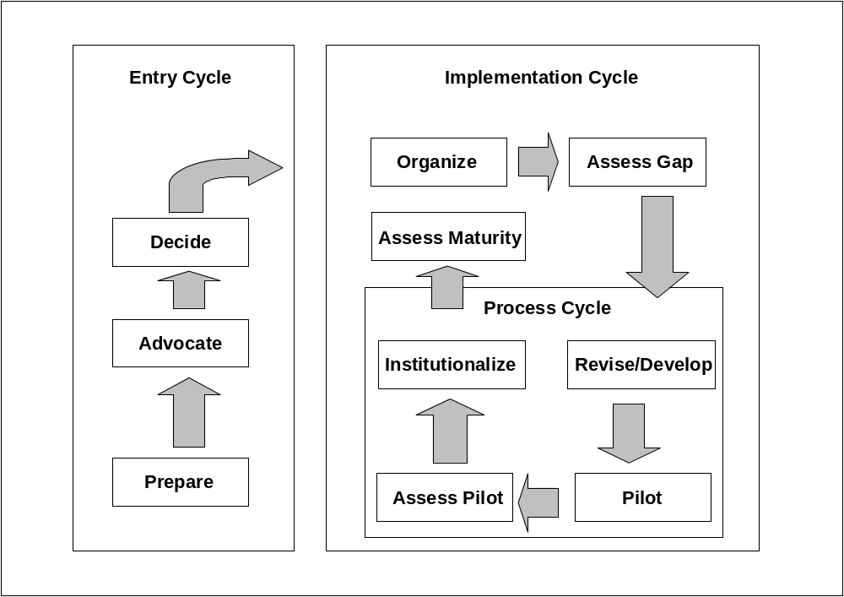

Enterprise-Level Roadmap

Transition Cycles
The enterprise-level roadmap consists of three cycles as described below:
- Entry/Rentry Cycle: Specifies the actions required to evaluate, adopt, and commit to the transition process. This cycle may need to be repeated based on an evaluation of the progress of the transition.
- Implementation Cycle: Specifies the actions required to create the environment and the infrastructure needed for transition. This cycle is re-entered periodically to capitalize on lessons learned and environmental changes.
- Process Cycle: Specifies the actions required to execute and monitor the transition process. This cycle is repeatedly executed with the objectives of continuous process improvement and institutionalization of CMMI principles and practices.

Requirements in Each Cycle
- Entry/Rentry Cycle:
- Identify changes required to make the transition from current practice.
- Examine and select suitable alternatives.
- Determine resource requirements and ensure availability.
- Commit to adopt and implement the transition process.
- Define assessment points and recycle decision criteria.
- Implementation Cycle:
- Identify and involve key stakeholders.
- Develop, internalize, and communicate the vision.
- Define and document goals, expectations, and measures.
- Establish and charter the change agents.
- Process Cycle:
- Reinforce commitments and involvement with key stakeholders.
- Monitor the progress of change agents.
- Assess the institutionalization of CMMI principles and practices.
- Re-evaluate commitments and determine the next steps.

Early Adopters

The organizations listed below were some of the first to implement CMMI-based process improvement initiatives:

- ABB
- Accenture
- BAE SYSTEMS
- The Boeing Company
- Computer Sciences Corporation (CSC), Defense Group
- Concurrent Technologies Corporation (CTC)
National Security Division
- General Dynamics
- Goddard Space Flight Center NASA
- Harris Corporation
- Jacobs/Sverdrup Technology Inc., Advanced Systems Group
Engineering Performance Improvement Center (EPIC)
- Lockheed Martin
- Lockheed Martin Management & Data Systems
- The MITRE Corporation
- Motorola Inc.
- Northrop Grumman Information Technology Sector
- Northrop Grumman Integrated Systems Sector
Airborne Early Warning/Electronic Warfare Systems
- Process Assessment, Consulting & Training
- Q-Labs
- Raytheon Company
- Synchro PP&T
- THALES
- TRW
- United Space Alliance
- U.S. Army TACOM-ARDEC Software Enterprise

For additional information, go to http://www.sei.cmu.edu/cmmi/publications/early-adopters.html.

Sector Business Case Advantages

Introduction
There are a variety of process environments to consider. This section will deal with four specific cases:
- Government
- DoD Contractor
- Joint Government / DoD Contractor
- Commercial

The discussion will be focused on the conditions that generate the need for process and how CMMI-based process improvement can accommodate these environments and meet process needs.

Government
In viewing the government business case, in particular the DoD, the focus will be on the acquisition, operations, and support segments of the DoD. The relationship between these three segments could be depicted as shown in the following diagram:

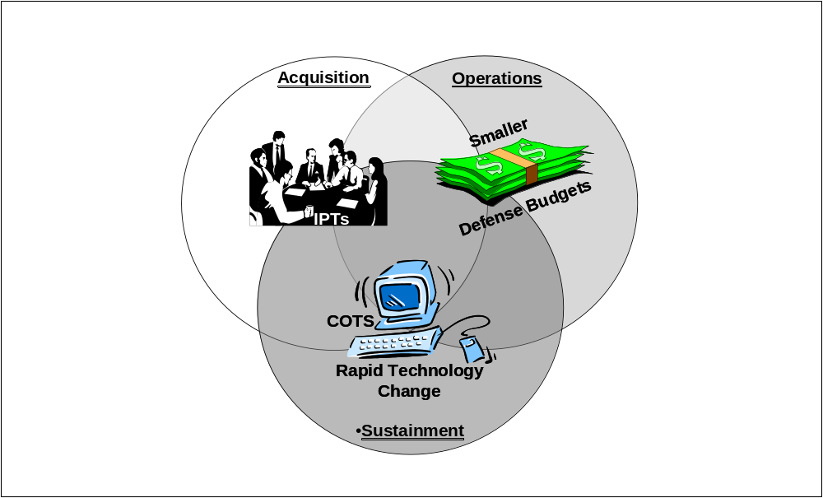

The government has become an interdependent set of stakeholders in the 2000's. This interdependency has evolved due to conditions in the various stakeholder communities. These conditions are shown in the following diagram:

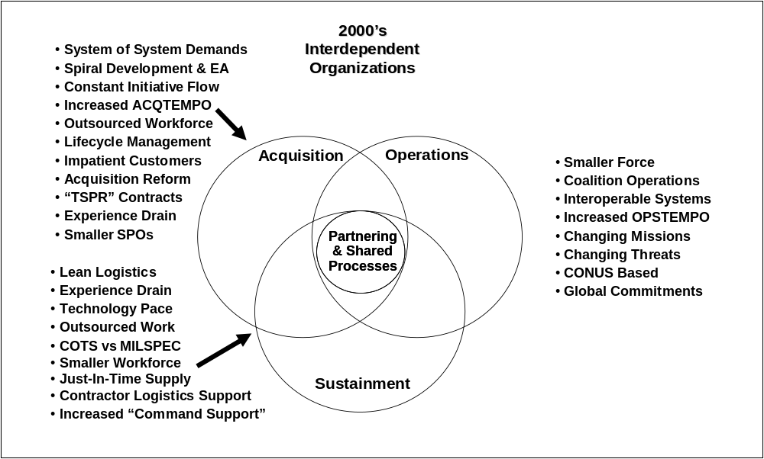

As a result, the government must be prepared to partner to supplement each sector’s conditions. The stakeholders in these sectors must support each other with resources. The sharing of these resources to provide the “force multiplication” impact demands that the sectors become co-sponsors, owners, and users of processes. Due to the diversity of interest in the sectors, engineering, support, and business processes must be established to accommodate the sharing of information for a variety of reasons (e.g., decision making, monitoring, and budgeting). The integrated nature of CMMI is uniquely capable of meeting all these requirements by providing an integrated framework of engineering, program management, and support processes.

DoD Contractor

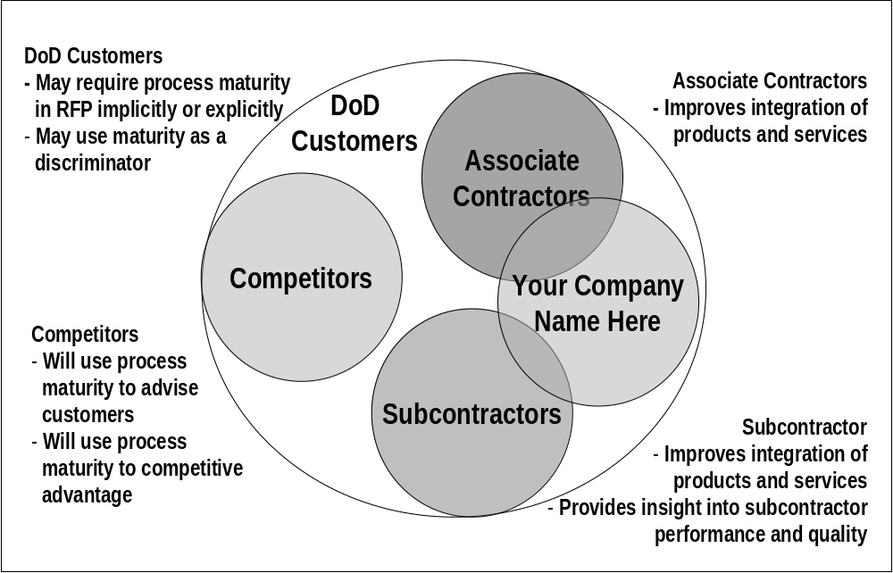

Various levels of process maturity will influence stakeholder interaction for all organizations involved in all phases of development. DoD contractors are motivated to adopt process improvement initiatives for the following reasons:
- DoD acquisition agencies and policy directives require them for bidding
- To improve performance on software development and systems engineering efforts
- To improve interface compatibility with associate contractors
- To gain insight into vendor, supplier, and subcontractor delivery and performance

Joint Government / DoD Contractor
In viewing this business case, we will build on the business case described above for the government. The added dimension is the contractor(s). In this case one or more DoD contractors become government “force multipliers” in addition to their primary role as product developers. This environment is demonstrated in the figure below:

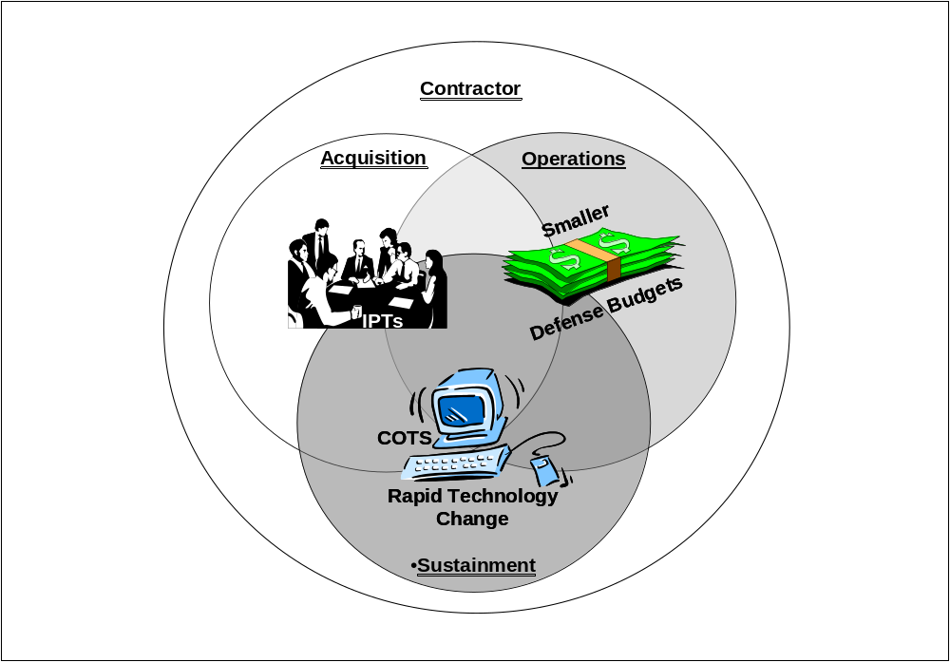

The contractor is shown intersecting all the government segments. In the current government business environment, the contractor has become an integral member of the various government sector communities. Some of the roles played by the contractor are described in the following table:

Government Sector | Contractor Roles
Acquisition | - Prime contractor for product development, product, or service
 | - Subcontractors to the prime contractor for material, product, expertise, or service
 | - System engineering support contractor
 | - FFRDCs (MITRE, Aerospace, SEI, etc.)
Operations | - Contract services (training, unit level maintenance, management services, equipment, etc.)
 | - Contract operators
 | - FFRDCs (MITRE, Aerospace, SEI, etc.)
Sustainment | - Contract depots
 | - Contractor logistic support
 | - Prime contractor for parts and services
 | - Contract services (training, equipment)

Given this variety of roles, it can be see that the contractor in all segments has become a vital member of the team. In addition to the conditions that are requiring the government sectors to form partnerships, the contractors are also experiencing conditions that lead to the need for partnering. The following diagram highlights these conditions:

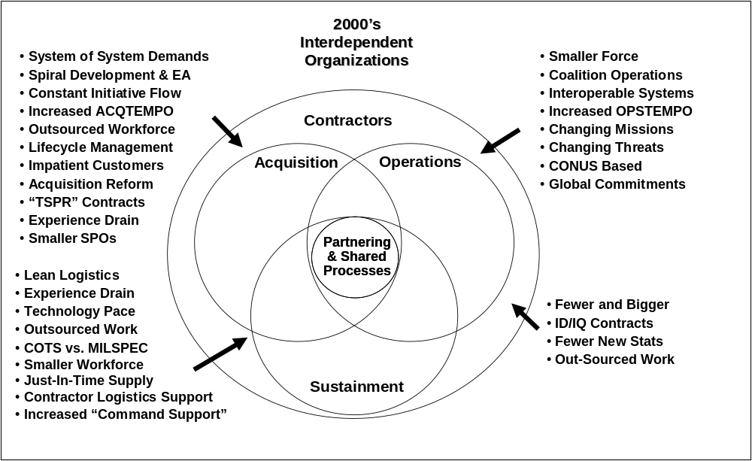

As in the government business case, the result in the Joint Government/DoD Contractor business case is a need to partner and in turn to share processes. Once again the CMMI is uniquely situated to become the framework to facilitate the sharing of processes between the government sectors and the contractors. Not only does it integrate the engineering, program management, and support processes into a seamless process set, it does so while meeting both government and contractor needs. As a joint project between the DoD and the National Defense Industrial Association (NDIA), the CMMI has been developed to not only accommodate the unique nature of the government business model, but has been developed to accommodate the diverse needs of the defense industry. Implementation of CMMI affords all stakeholders in the Joint Government/DoD Contractor environment these benefits:
- A common business/process language
- Improvement in business performance through process improvement (more productivity, higher quality, shorter cycle time)
- More consistent and effective process assessment across multiple business units
- Better integrated processes across multiple disciplines

Commercial

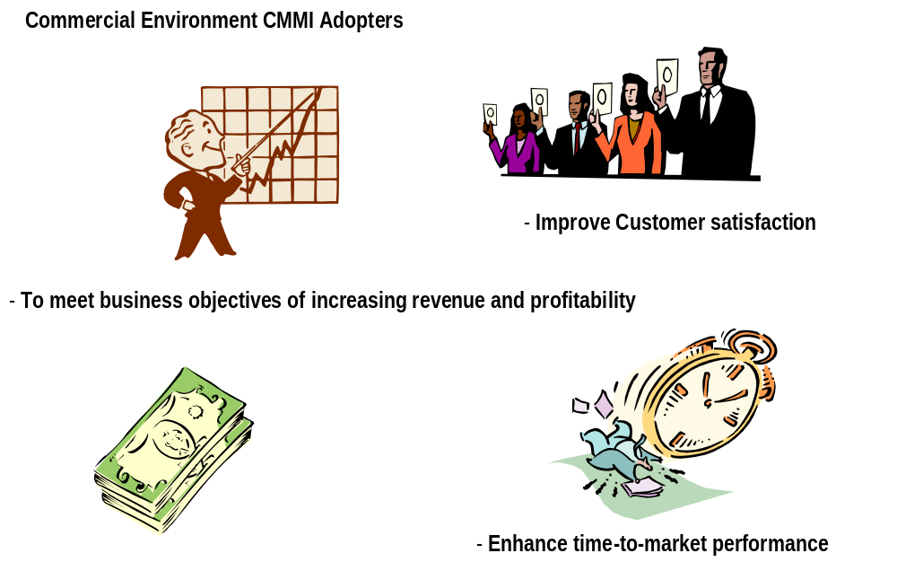

Product development in the commercial environment drives revenue for the corporation:
- Strategic planning for the corporation is driven by market pressures with the ultimate goal of improving revenue and profitability.
- Process discipline will enhance productivity by reducing the time to market.
- Customer satisfaction will increase with measurable improvements in reliability and quality.
- Process improvement activities compete for corporate resources:
  - Return on investment must be equal to or better than other opportunities.
  - Examples for software process improvement:
    - Development time Reduced 73%
    - Rework costs Reduced 96%
    - Average schedule length Reduced 37%
    - Post release defects Reduced 80%
    - Return on investment 21:1

CMMI Compatibility with Departure Models

The CMMI is compatible with a wide variety of capability and process improvement frameworks as shown in the following table:

Departure Model | CMMI- Compatible | Features Enhanced by CMMI | Additional Features Provided by CMMI
SW-CMM | YES | Core processes are integrated | Systems Engineering and Project Management
EIA-731 | YES | Core processes are integrated | Software System Development and Project Management
ISO 9000:2000 | YES | Organizational institutionalization | Progressive levels
SE-CMM | YES | Core processes are integrated | Software System Development and Project Management
PMBOK | YES | Core processes are integrated | Systems Engineering, Software System Development, and Integrated Project Management
Homemade | Maybe | TBD | TBD
Nothing | YES | Addition of process framework | Provides integrated project processes

CMMI Compatibility with Standards

Introduction
Performing standards/guidance document comparisons is, by nature, the comparison of apples and oranges. Each standard or guidance document was created to fit a specific purpose, was targeted to a specific audience, and follows different form and content conventions. However, many organizations are faced with the prospect of being asked to follow, or at least consider, multiple standards and/or guidance documents as the basis for various aspects of organizational, project, or engineering management, so some attempt to help managers understand the similarities and differences in various guidance documents is warranted.

The purpose of the table below is a bit different than the typical standards comparison exercise. There are several publicly and organizationally published detailed comparisons of some subset of the documents in this analysis that are available. These are generally used by process engineers who have the responsibility of ensuring that their organizational policies, processes, and procedures adequately conform to the guidance documents that are relevant for them. Those types of detailed analyses were used as a support for this analysis as well. However, this analysis is intended to provide a synthesized view for managers that allows them to understand (1) what types of topics are covered/not covered in various documents that are relevant to CMMI users and (2) which documents provide more or less guidance in relation to a CMMI topic than CMMI. In addition, areas where a particular document contradicts a CMMI practice are highlighted.

Source documents for CMMI (other CMMs, EIA 731) are not included in this analysis since relationships to them are addressed in other materials.

Caveat: for the first draft of this table, a single analyst was the author of the table, so this analysis does NOT provide a consensus view of the relationships cited.

CMMI Concept | ISO 9001/ 2000 | ISO 10006 | IEEE 1220
Orgn Process Focus | Less guidance/different focus | Out of scope | Out of scope
Orgn Process Defn | Less guidance/different focus | Out of scope | Out of scope
Orgnl Training | Less guidance | Out of scope | Out of scope
Orgn Process Performance | Less guidance | Out of scope | Out of scope
Orgn Innovation & Deployment | Out of scope | Out of scope | Out of scope
Project Planning | Different focus -- plng of QMS and plng of product | More guidance/ different focus--heavy quality focus | Less guidance -- for gen'l project  More guidance -- for sys engrg specific areas

CMMI Concept | ISO 9001/ 2000 | ISO 10006 | IEEE 1220
Project Monitoring & Control | Different focus | Different focus--not systems oriented | Less guidance -- for gen'l project  More guidance -- for sys engrg specific areas
Supplier Agreement Management | More guidance for some subtopics;  Different focus | Different focus | Out of scope
Integrated Project Management for IPPD | Minimal guidance | Less guidance (but more than most non-CMM docs!!) | Less guidance
Risk Management | Out of scope | Less guidance, but most of the major issues are addressed | Less guidance
Integrated Teaming | Out of scope | Less guidance | Less guidance
Quantitative Project Management | Less guidance | Out of scope | Out of scope
Requirements Development | Minimal guidance | Out of scope | More guidance
Requirements Management | Less guidance | Less guidance | Less guidance
Technical Solution | Minimal guidance | Out of scope | More guidance
Product Integration | Minimal guidance | Out of scope | Less guidance
Verification | Less guidance | Out of scope | Less guidance
Validation | Minimal guidance | Out of scope | Less guidance
Configuration Management | Less guidance | Out of scope | Less guidance
Process and Product Quality Assurance | More guidance | Less guidance | Out of scope
Measurement and Analysis | Less guidance | Less guidance | Less guidance
Organizational Environment for Integration | Out of scope | Out of scope | Out of scope
Decision Analysis and Resolution | Out of scope | Out of scope | Similar
Causal Analysis and Resolution | Different focus | Out of scope | Out of scope

CMMI Concept | ISO 9001/ 2000 | ISO 10006 | IEEE 1220
CL 2 Generic Practices | Less guidance | Less guidance | Less guidance
CL 3 Generic Practices | Less guidance | Less guidance | Out of scope
CL 4 Generic Practice | Less guidance | Out of scope | Out of scope
CL 5 Generic Practices | Less guidance | Out of scope | Out of scope

One or more of these can be attributed to each comparison document…
Similar=addressed in similar depth/emphasis as in CMMI
Out of scope = concept is omitted from the reference
More guidance=more guidance/prescription on this topic is included in the document than in CMMI
Less guidance=less guidance/prescription on this topic is included in the document
Minimal guidance=the topic is mentioned but very little guidance for implementing the topic is provided
Different focus=topic is addressed, but from a significantly different perspective than CMMI
Contradicts=topic is addressed, but content contradicts guidance within CMMI

Excluded:
Six Sigma
Balanced Scorecard
---because there is no single reference for these constructs

Notes Regarding Individual Standards

IEEE 1220
IEEE 1220 is a systems engineering life cycle standard.
Assumptions in IEEE 1220 include:
- Quality management system a la ISO 9001:1994 exists
- IEEE 1220 conforms to the requirements of ISO 12207

Clauses 4 and 6 were mapped; clause 5 discusses the application of the systems engineering process to the defined life cycle stages; in general clause 5 adds a good deal of specificity related to requirements development and technical solution development, but adds little specific detail for other phases such as integration and testing.

ISO 10006

Quality Management: Guidelines to Quality in Project Management, 1997
This document is a supplement to ISO 9004-1, and is itself not a "normative" standard (one against which an ISO audit would be held). Rather, it provides interpretation of ISO 9004-1 in the context of project management practices. One of its primarily sources was the Project Management Institute Guide to the Project Management Body of Knowledge, 1996 version.

ISO 9001:2000
This document is focused on organizational level infrastructure to support implementation of an overall quality management system, but does have some project and engineering-related requirements.

Process Areas Described

The following figure demonstrates the integration of the various processes that enterprises use to conduct business and shows the relationship between the various CMMI process areas.

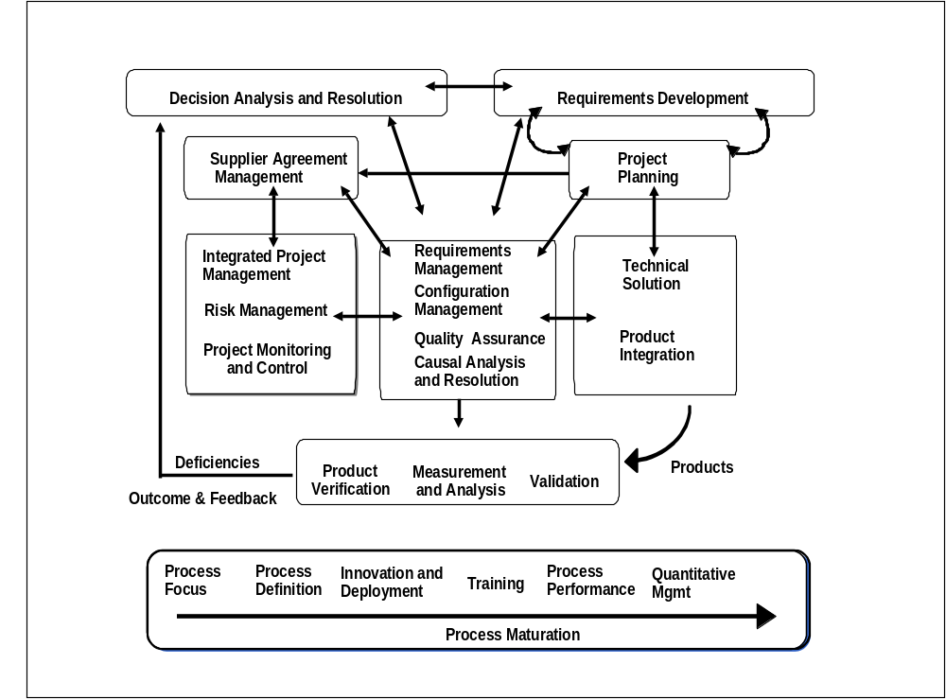

Process Management Process Areas
- Contain the overarching practices related to implementing a successful and mature process improvement program
- Provide capability to document and share best practices, process assets, and learning
- Provide advanced capability to achieve quantitative objectives for quality and process performance

Process Area | Description
Organizational Process Focus (OPF) | Helps organization establish and maintain understanding of its processes and identify, plan, coordinate, and implement improvement
Organizational Process Definition (OPD) | Establishes and maintains organization’s set of standard processes and supporting assets
Organizational Training (OT) | Identifies strategic training needs of organization, as well as tactical training needs common across projects and support groups
Organizational Process Performance (OPP) | Derives common, quantitative objectives for quality and process performance from organization’s business objectives
Organizational Innovation and Deployment (OID) | Selects and deploys proposed incremental and innovative improvements to improve organization’s ability to meet quality and process performance objectives

Project Management Process Areas
- Cover the project management activities related to planning, monitoring, and controlling a project
- Provide mechanisms to establish, maintain, and monitor commitments to customers and from suppliers
- Provide mechanisms to establish and maintain collaborative teaming environment
- Provide common method to proactively and quantitatively manage project

Process Area | Description
Project Planning (PP) | Develops and maintains project plan, involves stakeholders appropriately, obtains commitment to the plan
Project Monitoring and Control (PMC) | Monitors activities and takes corrective action, including re-planning
Integrated Project Management (IPM) | Adapts organization’s processes to project, and establishes project’s shared vision
Integrated Teaming (IT) | Identifies and organizes stakeholders into collaborative teams and develops shared vision aligned with project and organization shared vision
Risk Management (RSKM) | Develops and implements proactive strategy to continuously identify, assess, prioritize, and handle program risks
Quantitative Project Management (QPM) | Collects project process and product metrics, and analyzes results to identify process improvement opportunities
Supplier Agreement Management (SAM) | Manages the acquisition of products from suppliers for which there exists a formal agreement

Engineering Process Areas
- Support product development life cycle activities, from initial requirements development to transition to operational use

Process Area | Description
Requirements Development (RD) | Collects and harmonizes stakeholder needs to plan, develop, integrate, field, and sustain products, and translates needs into product requirements
Requirements Management (RM) | Ensures that agreed-to requirements are understood and managed
Technical Solution (TS) | Converts requirements into product architecture, design, and development
Product Integration (SI) | Combines product components and ensures interfaces
Verification (VER) | Ensures product meets specifications (“the thing is built right”), and that deficiencies are tracked, re-worked, and re-tested
Validation (VAL) | Ensures product fills intended use when placed in intended environment (“we built the right thing”)

Support Process Areas
- Provide essential processes to support product development and maintenance
- Support establishment and maintenance of a work environment that facilitates and stimulates integration and manages people to enable and reward integrative behaviors
- Provide support functions used by all process areas during product development

Process Area | Description
Measurement and Analysis (MA) | Establishes metrics program to provide objective results that can be used in making informed decisions, and in taking appropriate corrective actions
Configuration Management (CM) | Establishes and maintains integrity of work products
Process and Product Quality Assurance (PPQA) | Provides practices for objectively evaluating processes, products, and services
Decision Analysis and Resolution (DAR) | Provides structured decision-making process that ensures alternatives are compared against established criteria, and best alternative is selected
Causal Analysis and Resolution (CAR) | Identifies causes of defects and other problems, and takes action to prevent them from occurring in the future
Organizational Environment for Integration (OEI) | Establishes approach and environment for the implementation of integrated teams

Custom Process Areas
Depending upon business requirements, a customized process area may be required, such as information assurance, enterprise integration, or safety.

Adoption Approach

CMMI models are organized in two representations, continuous and staged. They provide alternative approaches to process improvement that leverage users’ familiarity with either approach. Guidance for selecting a representation is provided in CMMI training.

The Continuous Representation
The continuous representation is based on process capability—the range of expected results that can be achieved by following a process. Process improvement is measured in capability levels that relate to the achievement of specific and generic goals in each process area.

The continuous representation provides flexibility for organizations to choose which processes to emphasize for improvement, as well as how much to improve each process. It enables selection of the order of process improvement that best meets the organization’s business objectives and that most mitigates risk.

The Staged Representation
The staged representation is based on organizational maturity—the combined capabilities of a set of related processes. Organizational improvement is measured in maturity levels. This representation has a recommended order for approaching process improvement, beginning with basic management practices and progressing along a proven path.

Equivalent Staging
Sometimes it may be desirable to convert an organization’s capability level achievements into a maturity level. This conversion is made possible by “equivalent staging.” The CMMI model includes rules for determining which capability levels must be satisfied in each process area to achieve each maturity level.

Resources

This section describes some of the personnel and training resources that may be required for an effective implementation of CMMI-based process improvement.

Personnel
The following figure illustrates one possible organization for process improvement personnel:

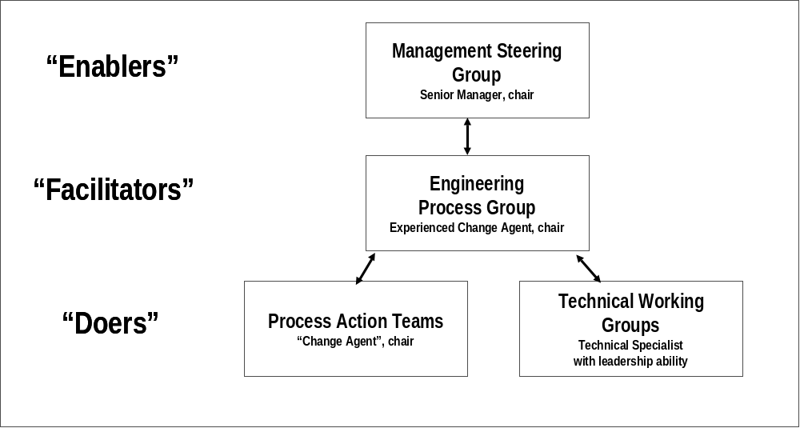

Establishing and sustaining a process improvement initiative is critical to its long-term success:

A Management Steering Group, chaired by a senior manager and consisting of one or more line managers in the organization, does the following:
- Authorizes process-improvement activities
- Supplies vision for process improvement objectives and establishes clear ties to the organization’s business objectives
- Commits needed resources (people and funding) to accomplish tasks
An Engineering Process Group, chaired by a “change agent,” which typically has process improvement experience and a sound understanding of how process improvement relates to the organization’s business objectives, does the following:
- Is able to function as a process improvement mentor in many areas (e.g., process and product quality assurance, configuration management, project management)
- Organizes process improvement activities across the enterprise and may be composed of a whole subordinate business down to small, individual projects
- Exists for the duration of the process improvement activity in the organization, possibly in perpetuity
Process Action Teams (PATs), chaired by a “change agent” who understands the organization’s culture and history and has the ability to effect change in concert with, and sometimes despite, the culture and history, does the following:
- Develops and maintains action plans to address specific process area work that must be initiated and subsequently improved
- Exists for the period of time necessary to get the organization or project from one assessment to the next

Training
Training must be tailored to various levels of the organization:

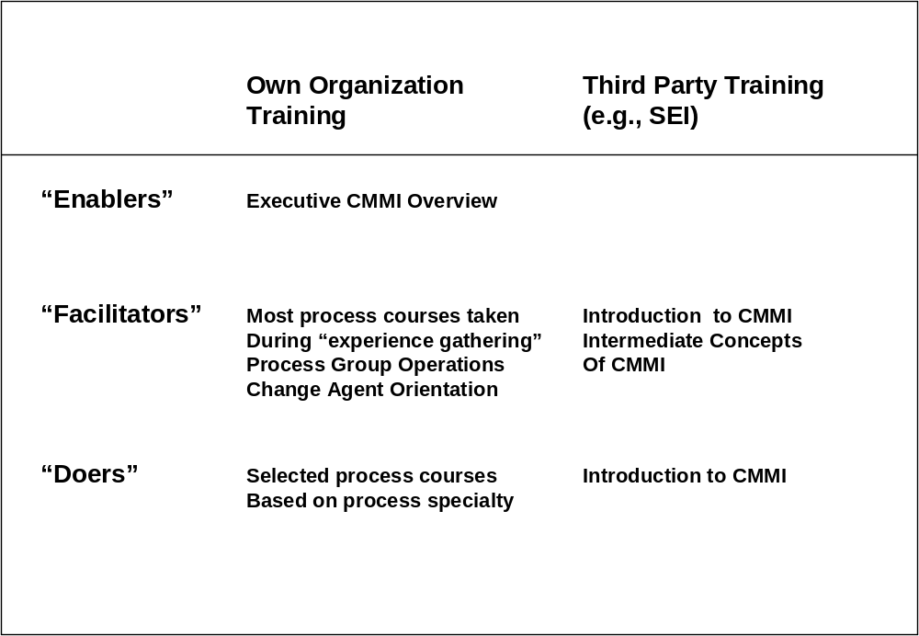

Budget
Treating the transition to CMMI like any other existing project in the organization will help ensure its successful completion. For example, the owner and major stakeholder of the CMMI transition project should develop a budget to support transition activities.

While each budget is different, the following guidelines may be helpful:
- Plan on funding the experienced change agent full time. Experience shows that successful change agents can have only one agenda; in this case, helping the organization to make the transition to CMMI.
- Focus on one organization at a time and fund the PAT members at least 50 percent of their time. For economics, keep the PAT membership small and of limited duration.
- Track expenditures and results of the PAT. Be prepared to adjust the funding or scope of activities if there are issues.
- Include proper CMMI training for the change agent and the PAT. Budget for at least one week each of the introductory and intermediate CMMI courses. Once trained, the PAT can be used to cross-train the organization and other organizations. Investing in sending at least one member of the PAT to CMMI transition workshops is also beneficial. Some amount of CMMI training is required.

Schedule
A key part of managing the CMMI transition project is setting the schedule. The schedule of activities varies depending on the starting point in the organization’s process improvement journey. While each starting point is different, consider the following guidelines:
- Making the transition to CMMI is like implementing other cultural changes in an organization; the further the starting point on the journey, the longer the trip will take.
- Based on SEI measurements on implementing the CMM for Software, organizations with little existing infrastructures or experience with process improvement projects typically require 18 to 24 months to reach maturity level 2. To reach maturity level 3 typically requires an additional 12 months.
- Organizations at higher maturity or capability levels in software and systems engineering will probably require one year, depending upon the current measurement programs and the number of new processes that need to be developed and rolled out. Typically, new processes take at least six months to be rolled out in an organization.

CMMI Transitioning Partnering
The SEI licenses the intellectual property (IP) rights regarding the Introduction to CMMI course and SCAMPI appraisals. There are two options to obtain or access a negotiated license to this intellectual property:
- Negotiate a transition partner license with the SEI directly. This license permits the licensee to teach the Introduction to CMMI course and to conduct benchmarking assessments.
- Use a third party with a negotiated transition partner license.

For details, contact the SEI or a CMMI transition partner. The SEI provides a list of all transition partners at http://www.sei.cmu.edu/collaborating/partners/partners-tech.html.

Appendix A: Tailoring Guide (Help for the Advocate)

Organizations are approaching CMMI adoption from many different current “states.” The pyramid below demonstrates some of the factors that must be considered in building adoption for the total enterprise:

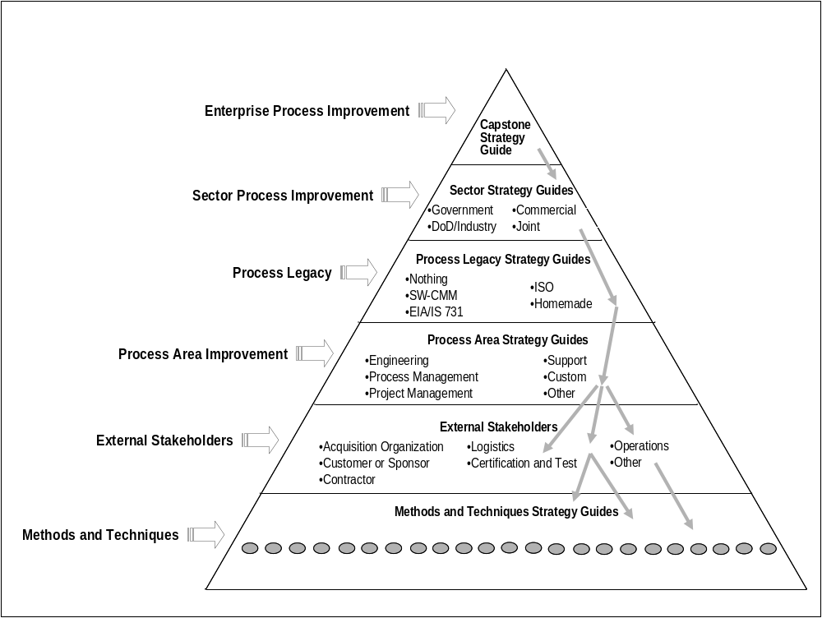

Appendix B: “Traps and Time Wasters”

At an initial workshop on CMMI transition, a team brainstormed ways to limit or forestall CMMI adoption in an organization. These are presented here for your enjoyment–but perhaps also as reminders of what can go wrong:
- Have process group meetings with no project representation.
- Don’t link process to product quality, cost, schedule, and performance.
- Rely on current Introduction to CMMI training as sufficient for appraisal team training.
- Let experts/zealots write the procedures.
- Set artificial level requirements and put the people with the lowest estimate in charge.
- Spend most of your time on the open-ended questions during a SCAMPI appraisal.
- Don’t train—it costs too much. Just do it—follow the appraiser.
- Management should dictate process changes without any coordination, because it speeds things up.
- Don’t bother to capture the hearts and minds of middle management.
- Select your most important project as your CMMI pilot–get the biggest bang for your buck.
- Change the organization structure six months before the appraisal, to clarify reporting structures.
- Include zealots in specific areas in your appraisal team.
- Tell people they can understand the model just by reading it.
- Align your practices exactly to the CMMI, instead of to what you do.
- Use a benchmark method (e.g., Class A appraisal) for your first contact.
- Put as many lead appraisers on your appraisal team as possible. Different opinions add spice!
- Make the Introduction to CMMI course your program managers’ first contact with CMMI.
- Rotate your SEPG leader every three months–use someone with a fresh look who has never read the policy.

 CMM and Capability Maturity Model are registered in the U.S. Patent and Trademark Office.
S M CMMI is a service mark of Carnegie Mellon University.
“Leading 21st Century Teams,” L. R. Carter, Software Engineering Institute, Carnegie Mellon University, March 2000.
ibid.
S M IDEAL is a service mark of Carnegie Mellon University.
A Business Case for SPI Revised – Measuring ROI from Software Engineering and Management, DACS, September 1999, see http://www.dacs.dtic.mil/techs/roispi2

