Project 1 : Hierarchical Modeling and Animation

Siddharth Gupta

MSCS

.

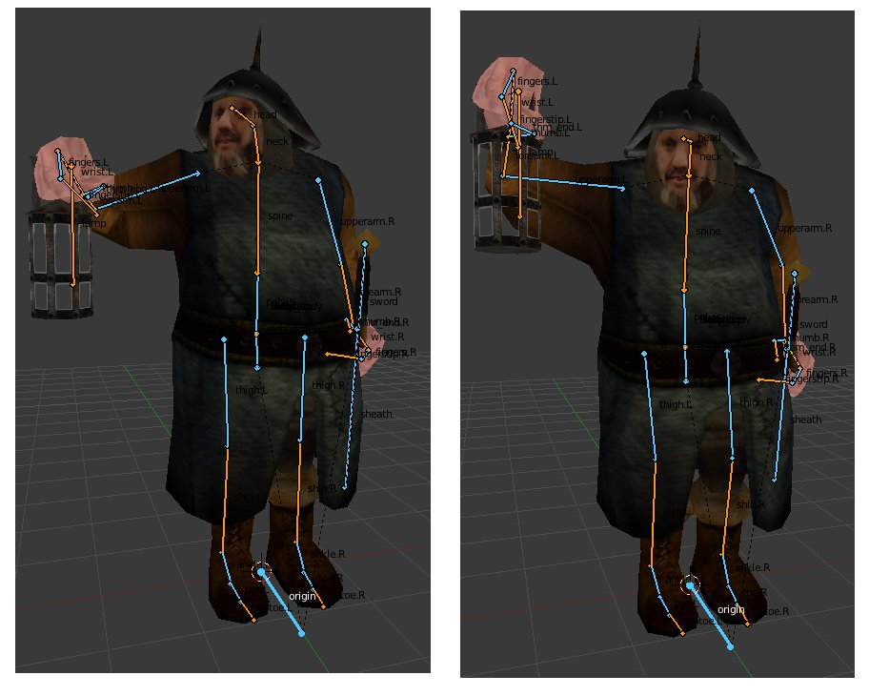 The sample bone structure.

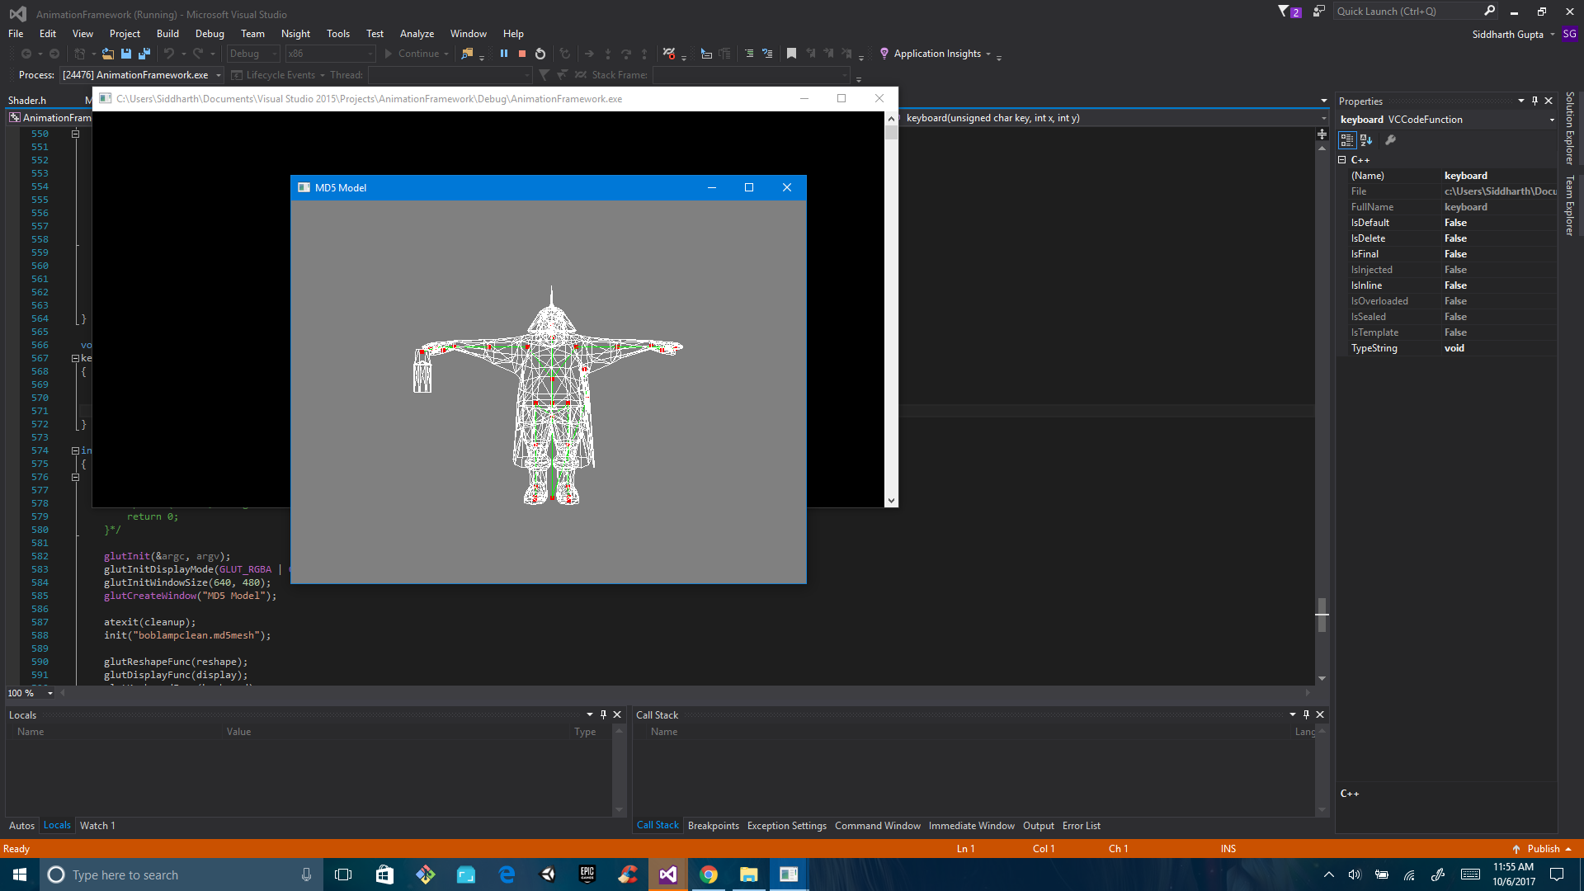

This picture shows the bones of the model in bind pose.

Instructions:

The project links and compiles fine.

Viewer Controls:

Basic WASD controls to move the camera

Scrolling for Zoom In and Zoom Out

Press ‘C’ to see the skeleton.