SC Mini-Project

**Smart Irrigation System using Fuzzy Logic**

Submitted by

**Akash Dubey**

**Ayush Falor**

**Preyas Hanche**

**Navid Kagalwalla**

***Under the Guidance of***

**Dr. Mahesh Maurya**



**Mukesh Patel School of Technology Management & Engineering, Mumbai**

**MARCH 2021**

**Table of Contents**

|  |  |  |
| --- | --- | --- |
| Sr. No | Title | Page Number |
| 1 | Introduction | 3 |
| 2 | Scope | 4 |
| 3 | Literature Review | 5 |
| 4 | Implementation Approach | 6-7 |
| 5 | Diagrams | 8-9 |
| 6 | Impact | 9 |
| 7 | Code | 10-12 |
| 8 | References | 13 |

**INTRODUCTION**

Smart irrigation systems tailor watering schedules and run times automatically to meet specific landscape needs. These controllers significantly improve outdoor water use efficiencies.

Unlike traditional irrigation controllers that operate on a preset programmed schedule and timers, smart irrigation controllers monitor weather, soil conditions, evaporation and plant water use to automatically adjust the watering schedule to actual conditions of the site.

For example, as outdoor temperatures increase or rainfall decreases, smart irrigation controllers consider on site-specific variables, such as soil type, sprinklers’ application rate, etc. to adjust the watering run times or schedules. There are several options for smart irrigation controllers.

In the United States, outdoor water use alone averages more than 9 billion gallons of water each day, mainly for landscape irrigation. As much as 50% of this water is wasted due to overwatering caused by inefficiencies in traditional irrigation methods and systems. Smart irrigation technology is the answer.

In India, agriculture plays an influential role for development in food production and also for the economy and development of a country. In the agriculture’s field, use of proper methods of irrigation plays a paramount role. Indian agriculture is mainly reliant on the monsoon which is not a reliable source of water. Therefore there is a need for a smart irrigation system in the country which can provide sufficient water to the farms or fields according to their soil’s moisture content. Many areas of agricultural fields are effectively over or under irrigated due to spatial variability in water infiltration and runoff of rainfall and irrigation. Under-irrigated areas are subject to water stress, resulting in production loss, while over-irrigated areas suffer from plant disease and nutrient leaching. Relevant soil water level is a mandatory call for optimum plant growth. As, water is a prerequisite element for life sustenance, there is the necessity to avoid its undue usage. Irrigation is a dominant consumer of water, which consumes a lot of groundwater. A need occurs to regulate water supply for irrigation purposes.

**SCOPE**

Agriculture is the primary occupation in India and is called India’s backbone. But of late, a lot of problems are being faced in agriculture by the farmers. One of the major problems being water scarcity. As per surveys, almost 20 percent of the agricultural land is wasted due to water scarcity and becomes a barren land. Thus, this research gives an idea of a smart irrigation system. A smart, intelligent, and fully automated agricultural system was required and extremely desirable in some last decades when our population grew exponentially in comparison to the natural resources. Traditional farming is the most unpredictable and becomes the cause of more water wastage.

The decision of watering plants based on fuzzy logic can be made based on input parameters such as humidity, temperature, soil moisture, and light intensity. The same fuzzy logic has been applied to many healthcare systems, in which use of biosensors helped monitoring temperature, blood pressure, oxygen, and infection status of the wound. Similarly, in fire alarming applications, this technology helped a lot in 2018 and 2019.

In India, agriculture plays an influential role for development in food production and also for the economy and development of a country. In the agriculture’s field, use of proper methods of irrigation plays a paramount role. Indian agriculture is mainly reliant on the monsoon which is not a reliable source of water. Therefore there is a need for a smart irrigation system in the country which can provide sufficient water to the farms or fields according to their soil’s moisture content. Many areas of agricultural fields are effectively over or under irrigated due to spatial variability in water infiltration and runoff of rainfall and irrigation. Under-irrigated areas are subject to water stress, resulting in production loss, while over-irrigated areas suffer from plant disease and nutrient leaching. Relevant soil water level is a mandatory call for optimum plant growth. As, water is a prerequisite element for life sustenance, there is the necessity to avoid its undue usage. Irrigation is a dominant consumer of water, which consumes a lot of groundwater. A need occurs to regulate water supply for irrigation purposes.

We make use of three inputs namely Soil Moisture, Humidity and Temperature to determine the Valve opening for water irrigation. This makes use of water efficiently and leads to optimum plant growth.

**LITERATURE REVIEW**

1. Drip Irrigation System: It works by distributing water into the soil directly with the help of tubes which are placed very near to the soil surface. This makes sure that the water is soaked into the ground before it evaporates into the atmosphere and hence this makes drip irrigation a very efficient method in agriculture. The water flow in this system can be regulated using an IoT controller and a program using Fuzzy Logic with the instructions sent over GSM or CDMA protocol.
2. Fuzzy Logic: It is essentially a form of multi-valued logic, where instead of dealing with 0’s and 1’s, the truth value can be between 0 and 1, which means it can be partially true as well as partially false. It can also be considered a superset of boolean logic.

The fuzzy logic is used for the decision making part. It is mainly utilized to get incomplete data to make decisions with the concepts called degrees of truth and true or false. The fuzzy set fully contains the classical set. The membership function property is used for implementing the fuzziness of elements in the set that will have the solution based on the experience in spite of knowledge. The membership function is implemented using weighted averages with the fuzzy inference system. Another advantage of using fuzzy logic is that when the intelligent agent is applied to the irrigation system, it will not “oscillate” between two hard values (example: wet and dry) since it would not have any hard binary representation.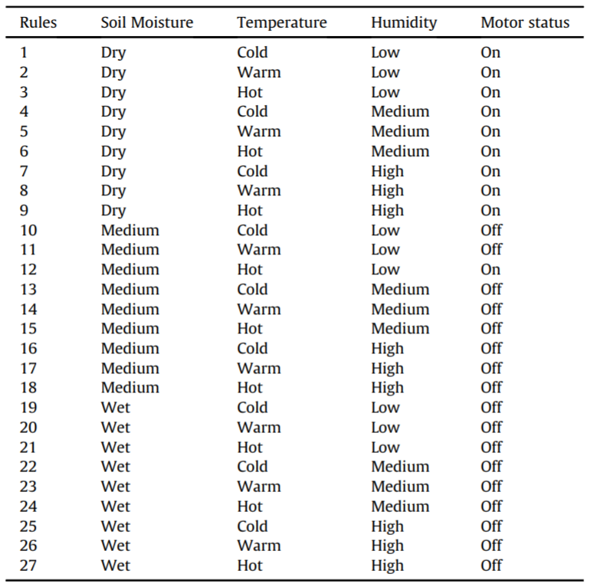

The fuzzy rule base system is used to produce the outputs according to the given input for the system. In this study, 3 input parameters are considered and each parameter consists of 3 membership functions as shown in the below equations. The number of rules is calculated based on each input parameter’s membership function. Hence, each parameter consists of 3 membership functions. The total number of rules framed is 27.

Input Membership Function for Moisture:

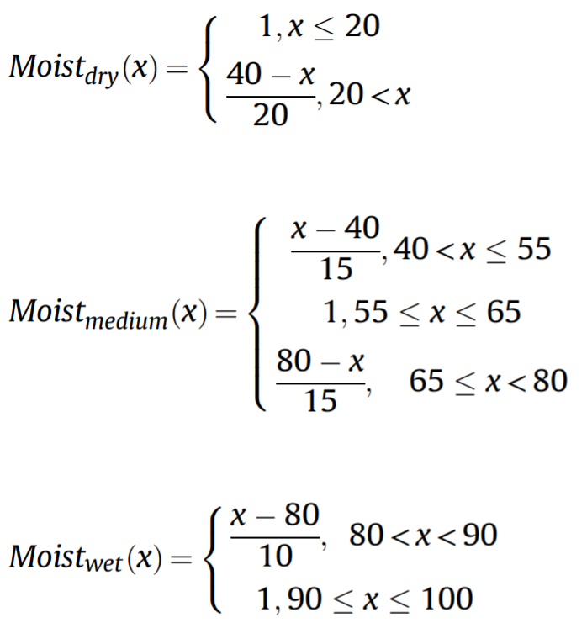

Input Membership Function for Temperature:

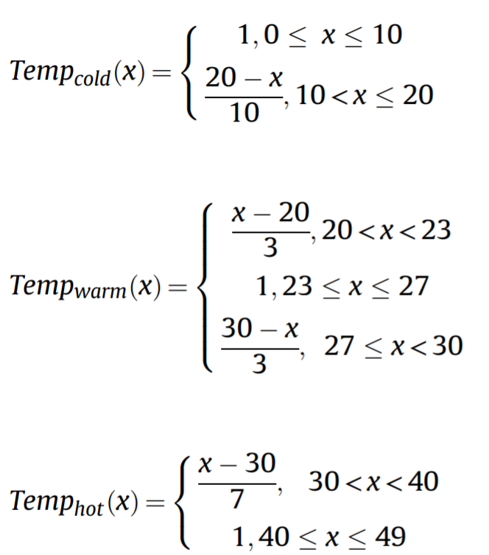

Input Membership Function for Humidity:

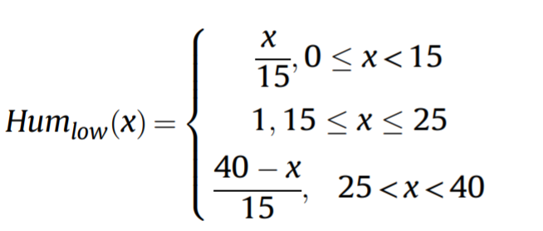

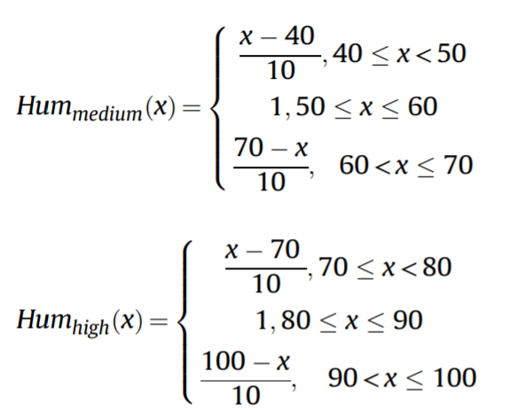

Output Membership Function for Irrigation Motor:

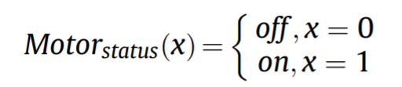

**IMPLEMENTATION APPROACH**

This program is implemented with the use of fuzzy logic working with a neural network. With the help of different criterias such as humidity, moisture content and temperature, the program calculates the fuzzified values which then infer from the predefined rules to control the irrigation system.

VALUES

Soil Moisture:

Dry Soil Moisture ranges from 30 to 60 Centibars

Normal Soil Moisture ranges from 18 to 36 Centibars

Adequately Wet Soil Moisture ranges from 6 to 24 Centibars

Saturated Soil Moisture ranges from 0 to 12 Centibars

Humidity:

Low Humidity ranges from 0 to 20 percent

Medium Humidity ranges from 15 to 35 percent

High Humidity ranges from 30 to 50 percent

Extremely High Humidity ranges from 45 to 60 percent

Temperature:

Very Cold Temperature ranges from -10 to 10 deg C

Cold Temperature ranges from 5 to 25 deg C

Normal Temperature ranges from 20 to 40 deg C

Hot Temperature ranges from 36 to 60 deg C

Valve:

Very Small Valve Opening ranges from 0 to 20 percent

Small Valve Opening ranges from 15 to 45 percent

Medium Valve Opening ranges from 40 to 70 percent

Large Valve Opening ranges from 65 to 85 percent

Full Valve Opening ranges from 80 to 100 percent

**DIAGRAM**

Membership function and output plots:

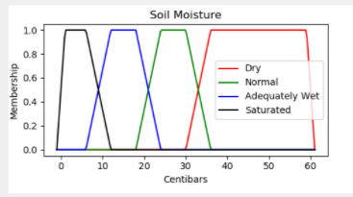

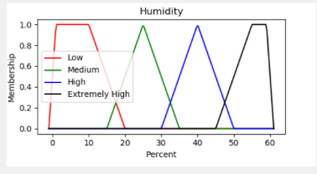

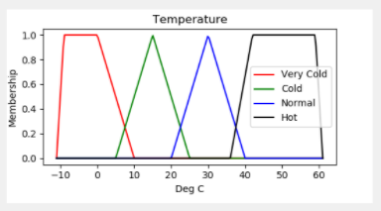

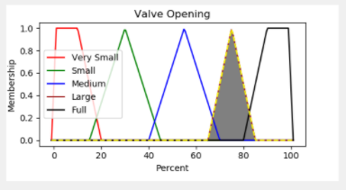

Input GUI:

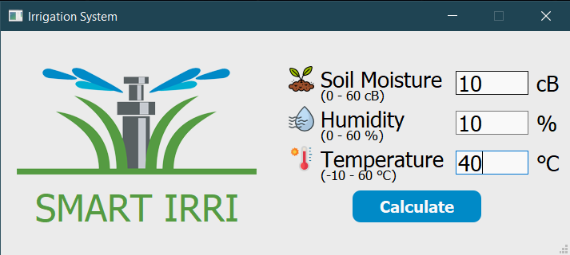

**IMPACT**

With water scarcity being a major problem in the years to come, using water resources wisely with next-gen technology to ensure sustainable agricultural output is the need of the hour. A smart irrigation system ensures that water usage is kept to a minimum and at the same time ensuring crops grow. A smart irrigation system using fuzzy logic is easy to use and understand. The GUI used is easily understandable, attractive and user friendly which ensures the user can understand the output produced by the code.

**CODE**

The entire code is based on controlling an Irrigation system, which we have simplified to read with a GUI to help facilitate the input and output of values. The program includes:

mainWindow :

Simple GUI window made using the PyQt5 library that handles all the GUI input and display elements in the window. This serves also as the main method of the whole program and helps pass values between the calculation modules involved in the program. The inputs are defined with names and characterise the type of input required per input box. They input value i initially checked again the limitations of the input i.e., the input must lie between the specified limits. This is done taking the most common characteristics of the environment into account.

Mplvalveopen:

Controls the valve open graph and also handles the output of the defuzzified values to a crisp output. This graph is inlaid in a subplot among the other graphs. It also showcases the defuzzified output on the graph along with other values in the graph.

Mpltemperature:

Controls the temperature graph and also handles the output of the defuzzified values to a crisp output. This graph is inlaid in a subplot among the other graphs. It also showcases the defuzzified output on the graph along with other values in the graph.

Mplsoilmoisture:

Controls the soil moisture graph and also handles the output of the defuzzified values to a crisp output. This graph is inlaid in a subplot among the other graphs. It also showcases the defuzzified output on the graph along with other values in the graph.

Mplhumidity:

Controls the humidity graph and also handles the output of the defuzzified values to a crisp output. This graph is inlaid in a subplot among the other graphs. It also showcases the defuzzified output on the graph along with other values in the graph.

resultWindow:

This module controls all the main calculations required in the program. The imputed values are sent to this module where according to the specified rules the values are calculated. This also controls the values that are sent to the mpl files for rendering the required graphs. The rules followed are as follow:

Full Valve -

1.aDry Soil Moisture and Low Humidity and Hot Temperature

Large Valve -

2. Dry Soil Moisture and Low Humidity and Normal Temperature

3. Dry Soil Moisture and Low Humidity and Cold Temperature

5. Normal Soil Moisture and Medium Humidity and Very Cold Temperature

7. Normal Soil Moisture and Extremely High Humidity and Normal Temperature

Medium Valve -

4. Dry Soil Moisture and Low Humidity and Very Cold Temperature

6. Normal Soil Moisture and High Humidity and Cold Temperature

Small Valve -

8. Adequately Wet Soil Moisture and Low Humidity and Normal Temperature

9. Adequately Wet Soil Moisture and Medium Humidity and Normal Temperature

10. Adequately Wet Soil Moisture and High Humidity and Normal Temperature

11. Saturated Soil Moisture and Low Humidity and Normal Temperature

12. Saturated Soil Moisture and Medium Humidity and Normal Temperature

17. Saturated Soil Moisture and Extremely High Humidity and Normal Temperature

Very Small Valve -

13. Saturated Soil Moisture and Low Humidity and Very Cold Temperature

14. Saturated Soil Moisture and Extremely High Humidity and Very Cold Temperature

15. Adequately Wet Soil Moisture and High Humidity and Very Cold Temperature

16. Saturated Soil Moisture and Extremely High Humidity and Very Cold Temperature

**REFERENCES**

1. Munir, M. S., Bajwa, I. S., Ashraf, A., Anwar, W., & Rashid, R. (2021). Intelligent and Smart Irrigation System Using Edge Computing and IoT. Complexity, 2021.
2. GS Campos, N., Rocha, A. R., Gondim, R., Coelho da Silva, T. L., & Gomes, D. G. (2020). Smart & green: An internet-of-things framework for smart irrigation. Sensors, 20(1), 190.
3. Anand, K., Jayakumar, C., Muthu, M., & Amirneni, S. (2015, July). Automatic drip irrigation system using fuzzy logic and mobile technology. In 2015 IEEE Technological Innovation in ICT for Agriculture and Rural Development (TIAR) (pp. 54-58). IEEE.
4. Krishnan, R. S., Julie, E. G., Robinson, Y. H., Raja, S., Kumar, R., & Thong, P. H. (2020). Fuzzy logic based smart irrigation system using internet of things. Journal of Cleaner Production, 252, 119902.