Forecast-conditioned, time-expanded routing for household-level wildfire evacuation and rescue in rural Korea
Siyeong Park (박시영)
Shanghai American School Puxi
Manuscript draft, built 2026-09-05 from the repository's committed artifacts. Not for submission before the Korea Code Fair awards (December 2026).

Abstract
Satellite detection and district-level fire-danger forecasts were both operating during the March 2025 Gyeongbuk wildfires, the largest on Korea's record by burned area. Neither answered which way a rural household should walk now, or whether a rescue crew can still reach the house. WildfireGuardian couples an event-held-out ignition-probability model to a time-expanded pedestrian router and a rescue-ingress calculation, and re-derives every published number from a committed artifact. The spread model is deliberately ordinary — a gradient-boosted classifier over sixteen public features, evaluated leave-one-fire-out on six real Korean fires, mean-of-folds held-out ROC-AUC 0.890 (fold range 0.682–0.974; pooled out-of-fold 0.905, a different quantity). Its operating point is weak and reported as such: pooled cell recall at the shipped threshold is 0.138 and three of the six held-out fires produce no true positive at all. The coupling is nonetheless where the decision changes: on the canonical Yeongdeok field, 42 of 458 scanned walk-network origins reach a refuge only under the forecast-aware policy, and 2 have no safe walking route, on a network covering 32.6 % of the predicted fire core whose bias runs in an unmeasured direction. That contrast is measured against a fire-blind baseline, so it does not separate knowing where the fire will be from knowing where it is. Two further results are negative and reported in full: the deadline-first dispatch ordering the system ships never out-rescues nearest-first at the operating window, in 0 of 180 configuration cells, and a geostationary detector sees these fires only at a sub-pixel size floor of roughly 0.1 to 1 hectare, tens of minutes after their recorded occurrence time. On a six-event dataset the transferable contribution is the evaluation design — paired contrasts, matched null controls, and registries that keep withdrawn claims in the tree — rather than the model.

1. Introduction
In March 2025 a wildfire that began in Uiseong-gun spread east across Gyeongsangbuk-do through Andong, Cheongsong and Yeongyang to Yeongdeok. Its surveyed forest damage came to 99,289 hectares — the largest in the Korean series since it began in 1986 — with 3,819 homes damaged and 3,587 people displaced (Gyeongsangbuk-do final tally, reported 6 May 2025; the province's recovery plan of 7 May carries the same area [1]).
Those figures must carry their basis and date, because the published ones share neither and do not agree. The 26 deaths on the chain are the provincial disaster headquarters' count as of 08:30 on 30 March 2025 [2]; Yeongdeok-gun's notice of 29 April puts 10 of them in Yeongdeok where that count had 9, and this paper keeps both rather than asserting one [3]. A rapid attribution study of 30 April 2025 splits them differently between districts and counts alongside them a separate fire's dead, on a "southeastern Korea" extent of "more than 48,000 hectares" that is not the chain's [4]. Nationwide totals are compiled on another basis over another period — the Korea Forest Service's spring fire-watch season, not March — so this paper states the chain's share of any nationwide total nowhere, and the service itself warns that a fire-affected area read off the fire line and a surveyed damage area cannot simply be compared [5].
The dead were old, and so are the survivors. Yeongdeok-gun's notice gives a mean age of 84 among its ten dead and a maximum of 101. In a survey of 300 residents of Andong, Yeongdeok and Uiseong interviewed in October 2025, 189 of 296 respondents (63.9 %) were aged 60 to 79 and 53 (17.9 %) were 80 or older; in Yeongdeok alone 34.0 % were 80 or older and 36.0 % lived alone before the fire [3]. That survey is a non-probability sample of survivors — the dead are absent by construction — so it describes who answered, not the population, and its casualty figures are re-cited rather than measured.
Detection was not the failure, though the paper cannot claim it was an advantage either: Section 4.7 measures the fastest satellite product over Korea and finds its first anomaly tens of minutes after the recorded occurrence time, at a size floor too coarse for an ignition, on a clock whose relation to the emergency call this repository cannot establish. The gap was between knowing and acting. A district-level probability does not tell one household on one lane which direction is still walkable at 09:40, nor a fire crew which of the houses that cannot self-evacuate they can still drive to, or for how much longer. It is sharpest where the deaths occurred: dispersed rural settlement, slow walkers, road networks with few alternatives. The same survey shows how the warning travelled: village broadcast and a neighbour together account for 237 mentions against 112 for the national emergency text message, and in Yeongdeok — where only 48.0 % received the text — 89 against 22.
WildfireGuardian closes that gap on public data. It fits a per-cell ignition-probability model, propagates it into a time-sliced hazard field, and consumes that field twice: in a time-expanded pedestrian router that refuses nodes whose forecast risk will have crossed a cutoff by the walker's arrival, and in a rescue-ingress calculation asking when each approach corridor closes to a vehicle. Its outputs are operator documents (Fig. 1).
We make three claims. The coupling changes decisions, measurably, as a paired contrast: both arms of Section 4.3 run over the same origins, network and field, so neither the routing layer's known approximations nor the coverage limit contaminates it. The operating point is weak, and owning that is part of the result. And the evaluation design is the transferable part: the discipline of matched controls of Section 3.5 is what six fires permit and a large dataset makes easy to skip. The non-claim is the dispatch ordering, which wins 0 of 180 configuration cells against nearest-first at the operating window.

2. Related work
Wildfire spread as a learning problem. Public benchmarks now train next-day spread models over hundreds of fires with multi-modal inputs — Next Day Wildfire Spread over roughly a decade of US observations [6], WildfireSpreadTS as a multi-temporal successor [7], and the WSTS+ extension, which doubles the unique years of history and reports that time-series inputs beat single-day inputs [8]. Six Korean fires cannot compete on that axis, and the metrics are not comparable across these settings anyway: label definition, geometry and above all prevalence differ, and prevalence moves average precision by construction. Physical modelling supplies the alternative framing: minimum-travel-time fire growth [9], and an earlier Rothermel-based surface model in this project captured a small fraction of the burned area, which motivated the move to a data-driven field.
Evacuation routing. Lane-based evacuation routing was posed as a network flow problem two decades ago [10]. Recent work brings wildfire information into that formulation directly: Borgwardt et al. pose wildfire evacuation as maximum flow on a time-expanded network with integrated hazard data [11], and RESCUE routes under stochastic congestion and uncertain spread [12]. Both are vehicle-centric and network-scale. This paper's layer is neither: it routes individual slow pedestrians to refuges on a real walk graph and adds a responder-side ingress term a maximum-flow objective has no notion of, having no crew driving toward the fire.
Evacuation triggers and simulation. The closest conceptual ancestor is the wildfire evacuation trigger point: a spatial line whose crossing by the fire front should start an evacuation, set by coupling spread modelling to GIS [13], refined by reverse geocoding to name the road segments that matter [14], and later coupled to traffic simulation so it accounts for the time evacuation takes [15]. Trigger geometry answers when to leave; our router answers which way, on the same idea that a route's safety depends on arrival time rather than the fire's present extent. At community scale, WUI-NITY couples fire, pedestrian and traffic models into one platform [16]; the wildland-urban-interface framing follows the standard definition [17], whose transfer to rural Korean settlement is untested here.
Detection. Geostationary imagers trade resolution for cadence: GK2A's Advanced Meteorological Imager returns the Korean local area every two minutes at 2 km in the infrared [18]. Section 4.7 measures what that buys, using the mid-infrared contrast and the sub-pixel area inversion standard since Dozier [19].
Calibration and guarantees. Conformal risk control offers distribution-free guarantees on a monotone risk by calibrating a threshold [20]. Section 4.2 reports what happens when it is applied honestly at six fires.
Walking speed. The elderly gait speeds this system assumes sit in the range for which gait speed is an established predictor of survival in older adults [21]; we use a fixed conservative speed rather than an individualised one, and sweep it.

3. Data and methods

3.1 Study fires and public inputs
Six real Korean wildfires form the dataset: Gangneung 2023, Hongseong 2023, Miryang 2022, Uiseong-Andong 2025, Uljin-Samcheok 2022 and Yeongdeok 2025 — five independent events plus one co-located pair, since the last two belong to the same March 2025 chain, a dependence Section 6 returns to.
Inputs are public: active-fire detections from NASA FIRMS (VIIRS and MODIS) [22], whose detection times define the prediction target; weather from ERA5 reanalysis on single levels [23]; terrain from SRTM [24]; fuel from ESA WorldCover at 10 m [25]; and road networks, building footprints and candidate refuge and depot points of interest from OpenStreetMap, graph-built with OSMnx [26, 27]. No proprietary or paid source is used.
One further public input feeds only the detection-timing measurement of Section 4.7: GK2A level-1B radiances, read without credentials from the NOAA open-data mirror. The detector is a mid-infrared-minus-window contrast (3.8 µm against 11.2 µm) under a contextual test whose rule is a conjunction of three conditions, all referred to a 30–80 km background annulus: the pixel's 3.8 µm brightness temperature exceeds its own background median by four robust standard deviations, and the contrast exceeds its background median by four, and the contrast clears an absolute floor of 3 K. The multiplier was fixed at four before any fire was examined and never adjusted. The archive begins in February 2023, so the two 2022 fires fall outside it and were excluded rather than worked around.
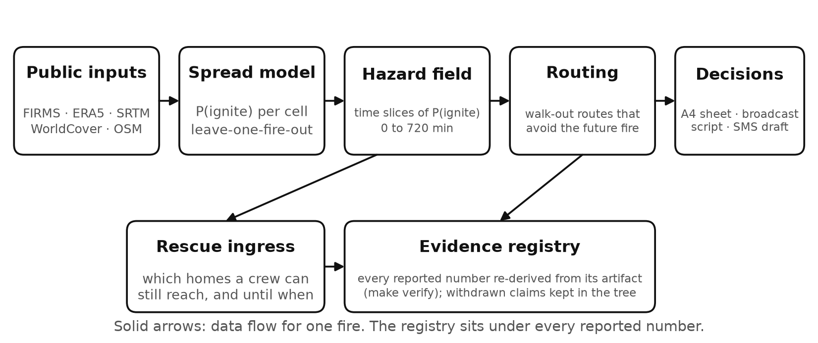
Figure 1. System overview. Public inputs feed a per-cell ignition-probability model; its time-sliced hazard field drives a time-expanded pedestrian router and a rescue-ingress calculation; the outputs are operator documents. Every reported number is re-derived from its committed artifact by the registry gate.

3.2 Spread model and evaluation protocol
The model predicts, for each 500 m grid cell and each satellite overpass, the probability that the cell is detected as burning at the next overpass. It is a gradient-boosted tree classifier (HistGradientBoostingClassifier) over sixteen features spanning fire geometry (distance to the nearest prior detection, elevation above the source), terrain (slope, aspect), fuel (burnable fraction from land cover) and weather (temperature, humidity, vapour-pressure deficit, wind speed, wind alignment, antecedent precipitation and dryness). The training table holds 151,904 rows with 2,989 positives, a prevalence of 0.0197; the seed is fixed and the projection is EPSG:5179.
Evaluation is leave-one-fire-out (leave-one-group-out with the fire as the group): the model is trained on five fires and scored on the sixth, so no cell of the held-out fire is in training. Two summaries of the same run are reported, and they are different quantities that must never be substituted for each other. The mean of folds gives each fire one vote and is the generalisation figure. The pooled out-of-fold AUC scores one ROC over all 151,904 out-of-fold rows, weighting each row once, and is dominated by the two largest folds, at 54.5 % and 27.4 % of the rows. Fold sizes differ by a factor of 208.9 and the smallest carries 0.26 % of the rows, so neither summary is neutral.
Three baselines run through the same folds, features and seed — random forest, logistic regression and the shipped model — against the objection that it only beats a bad physics model.

3.3 Hazard field and time-expanded routing
The classifier's calibrated probabilities are propagated forward into a hazard field: a stack of time slices, each a grid of P(ignite) values, covering 0 to 720 minutes from the trigger in 180-minute steps on the canonical Yeongdeok field. Both downstream layers consume a field of that form, though not the same instance: the pedestrian results below are computed on this canonical field and the committed responder series on the synthetic one of Section 3.4.
The pedestrian router is a Dijkstra search over a time-expanded state (node, time bin) on the OpenStreetMap walking graph, at a fixed elderly gait speed of 0.7 m/s adjusted for slope, with a 10-minute time bin and a 600-minute travel budget. An edge is admissible only if the hazard at its head node, read at the arrival time rounded up to the next bin, is below a pedestrian cutoff of 0.5; among admissible paths the search minimises cumulative exposure, the integral of P(ignite) over travel time. Two policies are compared over identical origins: a fire-blind policy taking the shortest-distance route to the nearest refuge without consulting the hazard, and a forecast-aware policy applying the cutoff and the exposure objective. Origins are sampled by walking the graph's node list at a fixed stride of 18; they are walk-network locations and are never called households.
Section 6 records this router's approximations, deliberately not fixed. All divide out of a paired contrast: both arms run through the same scoring function on the same field.

3.4 Rescue ingress and dispatch
A crew driving toward a fire faces the mirror-image problem. For each home the responder route is computed on the OpenStreetMap driving graph from the nearest mapped depot and sampled into points; the ingress survival time is the earliest forecast slice at which any sampled point reaches a separate, higher vehicle cutoff of 0.7. A home is dispatchable if that time exceeds the responder's estimated arrival — dispatch delay plus travel time — by a safety margin. The four-way outcome partitions the origin set exactly and the unreachable class is reported, never imputed: of 439 committed origins, 272 are self-sufficient and 167 need a rescuer, of whom 143 are dispatchable and 24 have no surviving vehicle ingress. An assumed immobile fraction of 0.3 drives the split and is swept. That series is only a partial flip to real data, and every 439-origin number in this paper inherits it. Its roads, refuges and depots are real OpenStreetMap geometry; its hazard field and terrain are labelled synthetic in the artifact's own provenance, the forward simulation needing a raw fire bundle this repository does not distribute. Its policy contrasts are the robust part; its absolute magnitudes are illustrative. The shipped ordering ranks dispatchable homes by urgency — ingress survival minus responder arrival, smallest closing window first — and Section 4.6 measures it against nearest-first, earliest-closure, unsorted scan order and 200 random permutations across a grid of operational window, service time, dispatch delay and team count.

3.5 Controls, sweeps and the evidence registry
Every result below carries at least one of five controls, each of which exists because an earlier version of this project made a claim one of them later removed.
- A flat-terrain control beside every slope result. Under flat timing edge time is proportional to length, so a distance-ranked router must produce identical routes; a non-zero flat control means the pipeline moved, not the terrain.
- A column-addition null beside every experiment that changes the feature count. Adding two columns of pure noise to the sixteen raises pooled AUC by +0.0041 on average over 60 draws, 95th percentile +0.0093; on far-band AUC the same null runs from -0.0363 at its 5th percentile to +0.0425 at its 95th. Such an arm must clear that envelope, not zero.
- A platform-drift floor beneath every cross-run comparison. Re-running the committed protocol on a second machine moves pooled AUC by 0.0064 and far-band AUC by 0.0307; smaller differences are not measurements.
- A null-hazard control, an identically-zero hazard field, beneath every claim that the fire changed an outcome.
- Sweeps rather than defaults for the parameters carrying the most weight: evacuation-time budget, slope sampling interval, immobile fraction, vehicle cutoff, dispatch delay and forecast-perturbation magnitude.
The registry makes the rest checkable. Each publishable value has an entry in docs/NUMBERS.json naming its source artifact, its JSON path, the expression that re-derives it, its caveat, and the phrasings that misstate it; a gate re-derives every entry on every change, scans the prose for retired figures and quantity-name collisions, and refuses a document that states a registered quantity with a different value. Superseded values are annotated in place, never deleted. A second registry holds the claims this project has withdrawn — what each asserted, what retired it, what should be said instead, and the spellings that restate it — and every tracked document is read against it, so a withdrawn claim cannot survive in a file nobody thought to list. It matches spellings, not meaning: in an independent probe, sentences reusing a registered spelling were caught and sentences reworded around one were not, and that limit is recorded rather than designed away. This manuscript is scanned by both gates like any other document here. Figures from outside the repository — the tallies of Section 1 — are not registry values and carry their agency, date and scope instead.

4. Results

4.1 Held-out spread skill
Under leave-one-fire-out cross-validation the mean of the six held-out ROC-AUC values is 0.890, with a sample standard deviation across folds of 0.107 and a range of 0.682 to 0.974 (Fig. 2). The pooled out-of-fold AUC over all 151,904 rows is 0.905. The difference is structural, not cosmetic: pooled is row-weighted, effectively an average over the two largest fires, while mean-of-folds gives Gangneung 2023 — 396 rows, 8 igniting cells, 0.26 % of the evidence — the same vote as Uiseong-Andong 2025 with 82,736 rows. The weakest fold is the smallest one, and any single-number headline hides it.
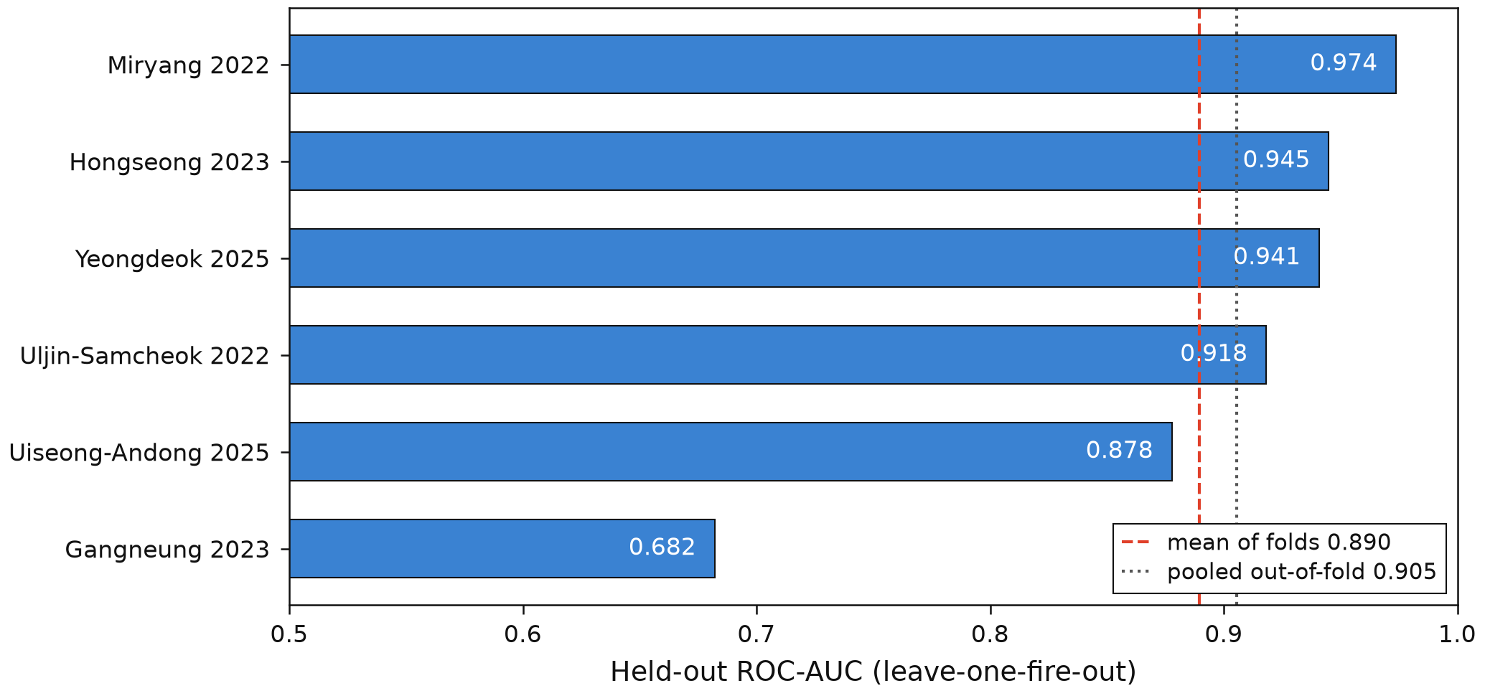
Figure 2. Held-out ROC-AUC per fire under leave-one-fire-out cross-validation. The dashed line is the mean of folds; the dotted line is the pooled out-of-fold AUC, a different quantity that weights each row once and is therefore dominated by the two largest fires.
Standard baselines over the same folds, features and seed do not establish the shipped model as the most accurate (Table 1).
Table 1. Baselines over the same six leave-one-fire-out folds, the same sixteen features and the same seed. Hyperparameters are untuned. ⚠ Lineage: these rows were produced on the corrected-DEM bundle, which is why the shipped model reads 0.8943 here against the committed headline's 0.890 in the text — the same model on a different, deliberately not-adopted lineage, not a second estimate of the same quantity. Read the ordering, not the gap: the shipped model leads on pooled AUC (0.9036 against 0.8963) and trails on mean-of-folds, and calibration does not separate it from the random forest either. That pooled gap is 0.0073, barely clear of this project's own 0.0064 platform-drift floor, so it is an ordering that reproduces across both lineages rather than a measured margin.
model | mean-of-folds AUC | fold sd | pooled Brier | pooled ECE
Random forest | 0.9142 | 0.0437 | 0.0174 | 0.0068
Logistic regression | 0.9028 | 0.0605 | — | —
Gradient-boosted trees (shipped) | 0.8943 | 0.0924 | 0.0183 | 0.0086

The measured reasons for shipping the gradient-boosted model are therefore pooled-AUC advantage, inference speed, native handling of missing values and permutation importances — not calibration and not mean-of-folds accuracy. An earlier version of this project justified the choice by a finding that fire-weather severity dominates wind direction by a large ratio in permutation importance. That claim is withdrawn and described here only as withdrawn: it compared the sum of six features against a single variable, and ERA5's 0.25° grid does not resolve the winds concerned.
Two further results bear on how much of this skill is real. Correcting a defective digital elevation model that had filled the East Sea with a ramp to -497 m across half of one fire's raster — training data for every fold, since training pools all six fires — moves mean-of-folds by +0.0048 and pooled by -0.0017. Two summaries of one re-run disagreeing in sign is why that lineage was not adopted; the far-band figure moves by -0.0358, the largest correction in the number set and the reason far-band values must carry their lineage. Separately, an arm adding two directional terrain features sits at the 66.7th percentile of its matched column-addition null on the pooled metric — inside the noise of adding any two columns. It exceeds all 60 noise draws on mean-of-folds, but excluding the 8-positive fold that supplies the gain leaves -0.0002: the exceedance was a fold, not a finding.

4.2 The operating point, and why no threshold guarantee is available
A ranking metric is not an operating point. What the system does at the threshold it ships is weak, and Fig. 3 states it plainly.
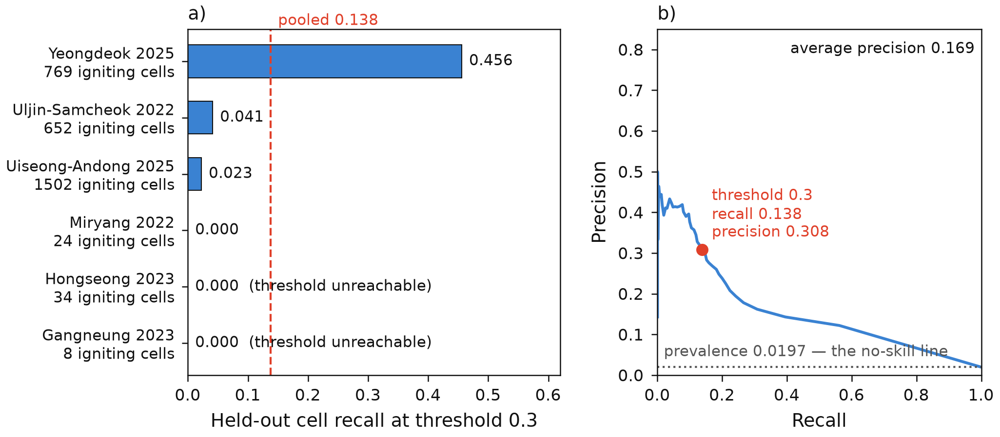
Figure 3. Operating point of the spread model. Left: held-out cell recall at the shipped 0.3 advance threshold, per fire, with each fold's igniting-cell count; on Gangneung 2023 and Hongseong 2023 no cell anywhere in the fold reaches 0.3, so the threshold can produce neither a true nor a false positive. Right: the pooled out-of-fold precision-recall curve against the no-skill prevalence baseline, with the shipped cut marked.
At the 0.3 advance threshold the pooled out-of-fold recall is 0.138 — 412 true positives among 2,989 igniting cells — with precision 0.308 and F1 0.19. The unweighted mean of the six per-fold recalls is 0.0867, and the gap is structural: three of the six folds have exactly zero true positives at 0.3. On two the threshold is not merely unmet but unreachable, the largest out-of-fold probability anywhere in the fold being 0.0241 at Gangneung 2023 and 0.296 at Hongseong 2023; on the third, Miryang 2022, two cells exceed 0.3 and neither ignites. Average precision over the full ranking is 0.169 against a no-skill baseline of 0.0197 — 8.6 times chance, and for the reasons given in Section 2 not comparable with published average precision elsewhere.
Two clarifications travel with these numbers. First, 0.3 is a configuration default never tuned on these probabilities; the F1-maximising threshold here is 0.14, recorded in the artifact and deliberately not adopted, because a threshold chosen on the probabilities it is scored on is optimistically biased. Second, this recall is not the router's miss rate: it cuts the classifier's per-step output, where the router thresholds the cumulative, survival-accumulated field at 0.5.
Calibrating the threshold with a distribution-free guarantee [20], done honestly at six fires, produces a negative result. With five calibration fires the finite-sample correction is 1/(n+1) = 0.167, consuming 0.833 of a 0.20 false-negative-rate budget. Under the naive convention the bound holds on 3 of 6 held-out fires, worst held-out rate 0.75, and a satisfying threshold flags 9.9 % to 18.5 % of all cells. Under the conformal convention it holds on 6 of 6, worst rate 0.108, but flags 26.0 % to 45.6 % of the map — against a 1.97 % prevalence. Exchangeability breaks twice besides: the held-out fire's probabilities come from a model trained on the calibration fires, and a fire-level finite-sample term is applied to a cell-level quantile. No threshold computed here is adopted; the operating point stays at 0.3, and the reason is now stated rather than defaulted.

4.3 What hazard awareness changes about who can walk out
On the canonical Yeongdeok hazard field, 458 origins are scanned; the fire-blind route reaches a refuge without entering the predicted hazard for 414 of them and enters the hazard for 44. Of those 44, the forecast-aware router brings 42 to a refuge without entering the hazard and finds no route at all for 2 (Fig. 4; the routes and the origins themselves are mapped in Fig. 5). No origin falls into the budget-exceeded class at 600 minutes, and none enters the hazard under the forecast-aware policy, which is structural: the policy refuses any node at or above the cutoff.
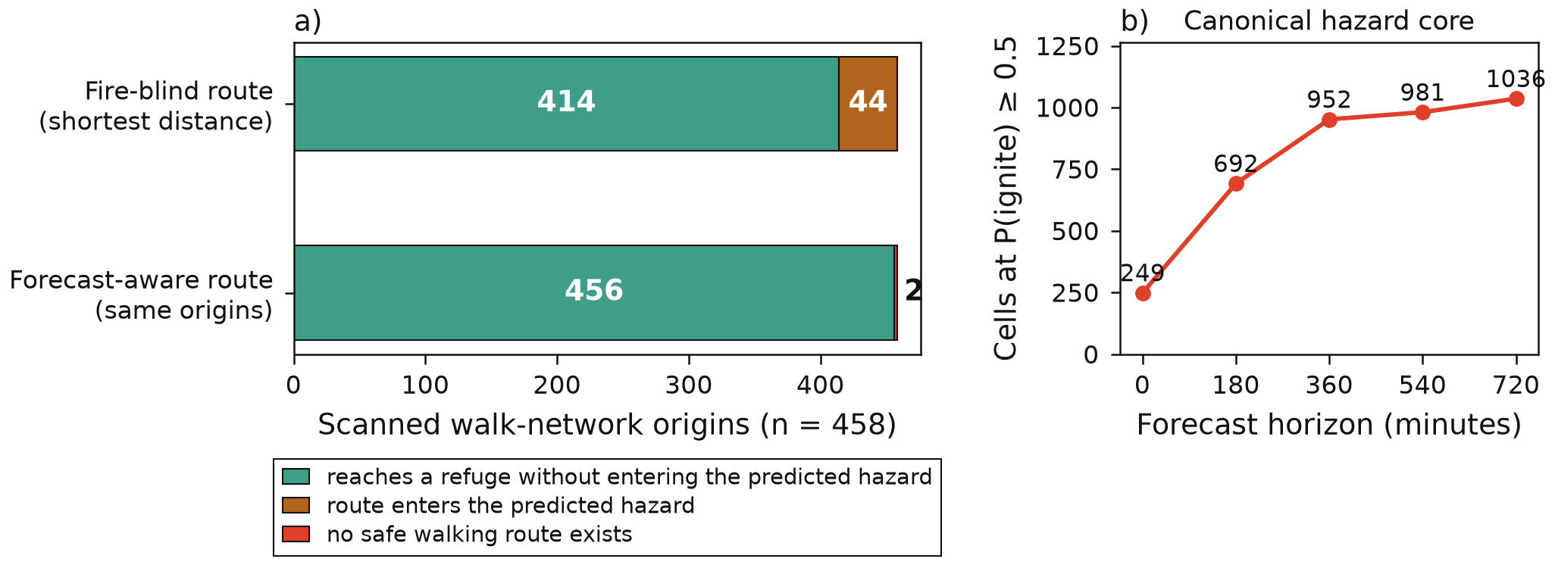
Figure 4. Decision shift on the canonical Yeongdeok field. Left: the same 458 scanned origins under the fire-blind and the forecast-aware policies. Right: the predicted hazard core over the forecast horizon. The fire-blind arm consults no hazard at all, present or forecast, so the shift between the two bars is what hazard awareness of any kind buys and not what the forecast alone buys (Section 4.3, third caveat). The absolute rates on the left are computed on a walk network covering 32.6 % of the predicted fire core; the remaining two thirds are unmeasured and the direction of the bias is unknown. Not re-acquiring the region is deliberate: the walk box does not fit the simulation grid, so redrawing it would force re-extending the canvas and re-simulating the field, replacing a stated limit with an unstated one.
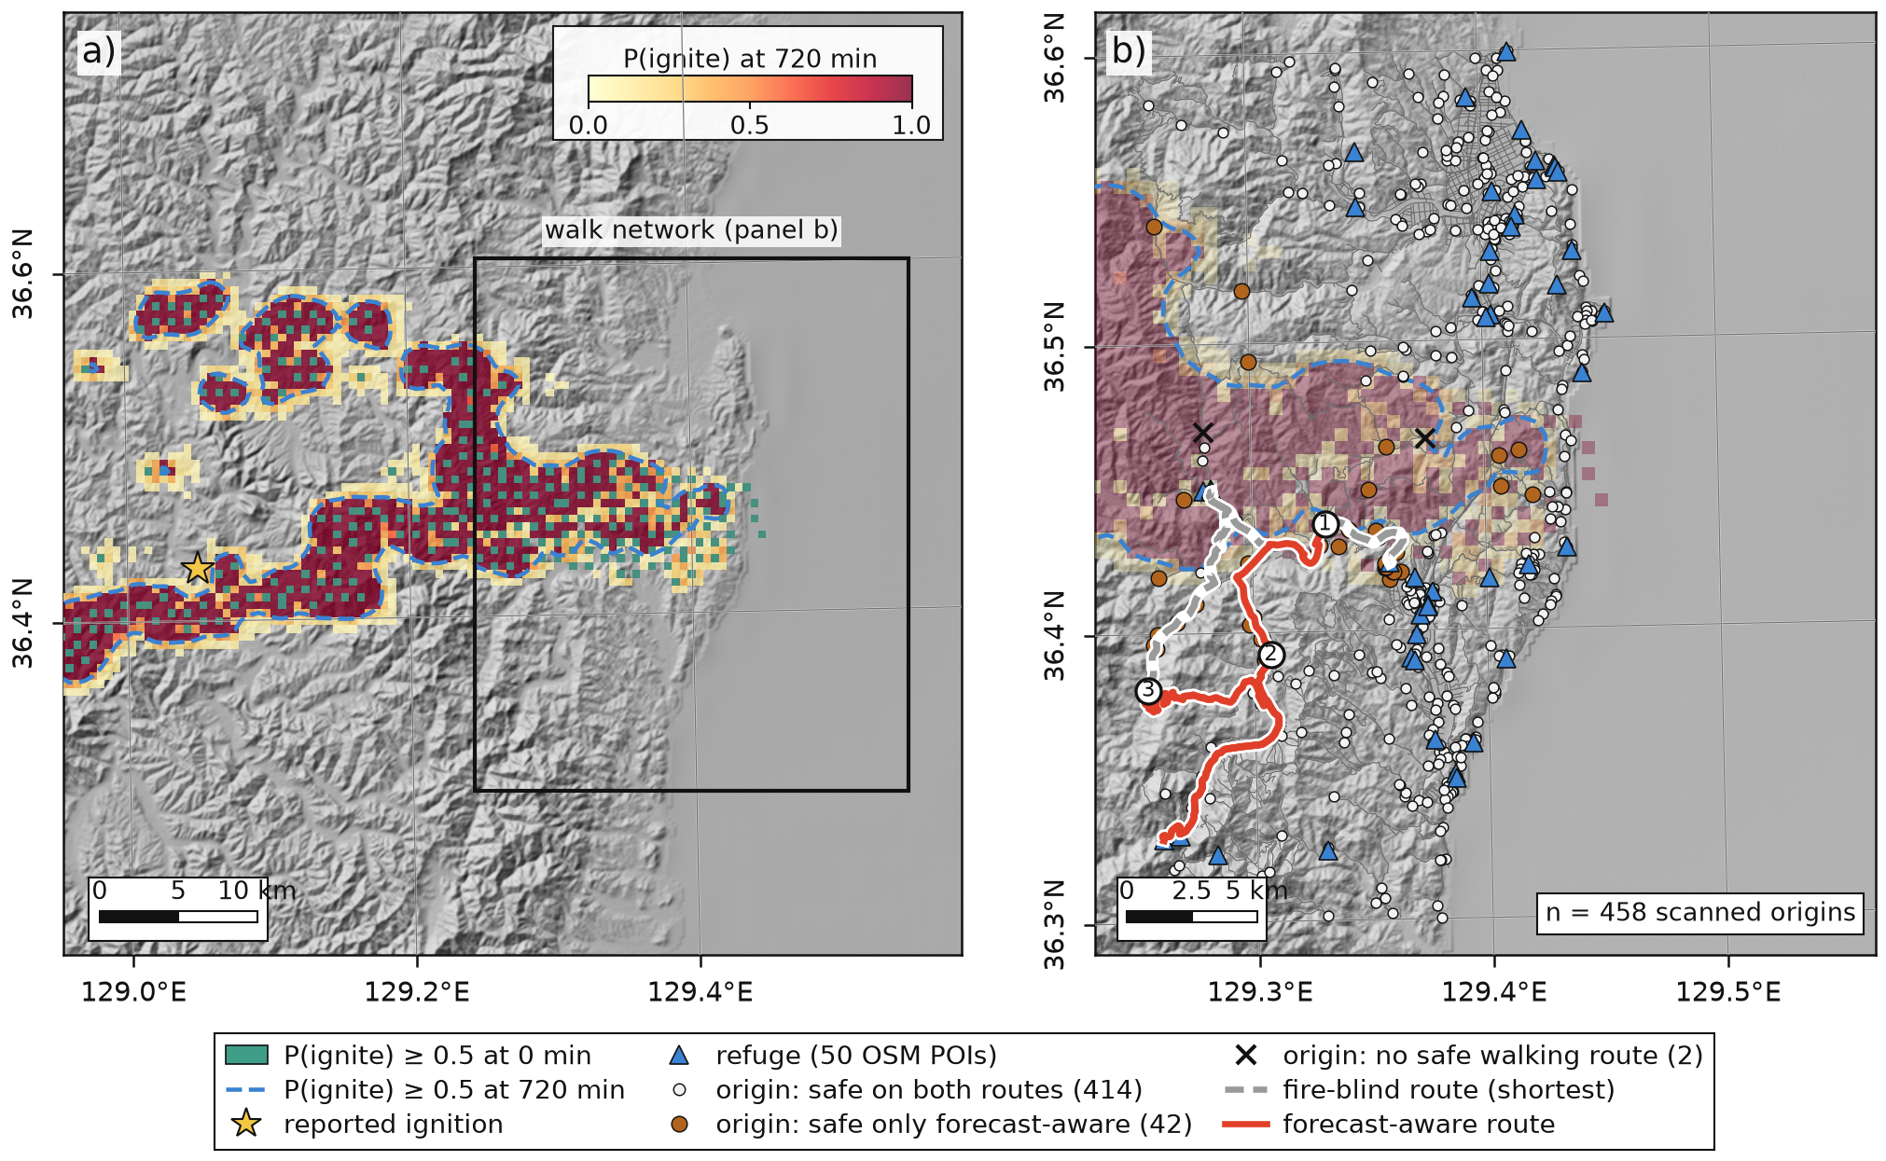
Figure 5. The canonical Yeongdeok 2025 case on the SRTM hillshade. (a) Forecast P(ignite) at 720 min, the cells at P ≥ 0.5 at 0 min (teal), the 720-min 0.5 isoline (dashed), the reported ignition (star); the rectangle is the walk-network extent. (b) The walk network, the refuge nodes snapped from 50 OSM points of interest (triangles), all 458 scanned origins classed as in the committed artifact (414 safe on both routes, 42 safe only on the forecast-aware route, 2 with no safe walking route), and three example origins with the fire-blind shortest route (grey, dashed) against the forecast-aware route (red). Routes are recomputed at figure time with the repository's own router from the committed snapshots, and the recomputed partition equals the committed one; the isoline is drawn on a one-cell smoothing of the slice for display only.
Three caveats are inseparable from those counts. First and most important, they are rates on a covered third. Yeongdeok's walk-network bounding box contains only 32.6 % of the grid cells at P(ignite) ≥ 0.5 in the field's final slice; the western part of the predicted core has no road network in the box at all. The origins are a spatially biased sample, the bias is real and its direction is unmeasured. Every absolute Yeongdeok rate in this paper carries that caveat; paired contrasts are unaffected, both arms using the same origins. Second, the field itself was reconstructed. An earlier lineage of these counts came from a run reverted the next day, and the "quasi-static fire core" limitation recorded against those numbers was a property of that reverted field, not of the fire: on the canonical field the core grows by 316.06 % from the first slice to the last. The two lineages differ on more than one axis, so the movement between them is not a single-variable contrast and no per-origin ledger exists.
Third, the counterfactual is a fire-blind walk. The baseline consults no hazard at all, present or forecast, so the 42 measure what hazard awareness of any kind buys, not what the forecast alone buys: a router refusing only the cells alight at departure would recover an unmeasured share of them. This is a coupling effect, not a forecasting effect. [GAP: the arm that separates them, a present-perimeter baseline over the same origins, is specified in the project backlog and scheduled after this sprint]

4.4 Three regions under one rule
The same rule, parameters and stride ran over two further regions acquired identically (Fig. 6, Table 2).
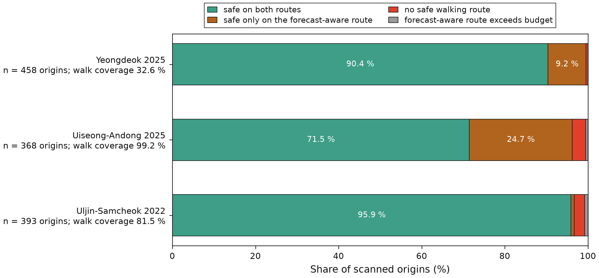
Figure 6. Three-region routing partition, as a share of scanned origins, with each region's walk-network coverage of its own predicted fire core beside its name. The three regions must not be ranked on the orange band alone: n = 3 and the covariates in Table 2 move together.
Table 2. Three regions under one identical rule. The right-hand columns are the covariates that must travel with any cross-region statement: OpenStreetMap mapping density and the share of each region's own predicted fire core that its walk-network box actually contains. Densities are over the geodesic bounding-box area. Depot density is a statement about what OpenStreetMap maps, not about where fire stations are; see the text below on Uiseong-Andong, whose responder side is recorded as not applicable rather than as zero dispatches.
region | origins | safe on both | safe only forecast-aware | no safe route | over budget | core coverage | core area (ha) | road km/km² | nodes/km² | refuge POIs/100 km² | depot POIs/100 km²
Yeongdeok 2025 | 458 | 414 | 42 | 2 | 0 | 32.6 % | 25,900 | 1.803 | 9.43 | 5.58 | 0.45
Uiseong-Andong 2025 | 368 | 263 | 91 | 12 | 2 | 99.2 % | 3,275 | 2.39 | 7.45 | 3.79 | 0.00
Uljin-Samcheok 2022 | 393 | 377 | 3 | 10 | 3 | 81.5 % | 7,300 | 1.663 | 8.21 | 2.92 | 0.45

The forecast-aware-only share is 9.17 %, 24.73 % and 0.76 %. All three are measured against the same fire-blind baseline, so §4.3's third caveat binds them too. These three rows must not be ranked against each other on that column. With n = 3, coverage, core area and mapping density all move together; the predicted-core areas span a factor of 7.91 under one definition, and one region's rate is computed on a third of its own core. The one ordering that carries information runs against the naive reading: the Spearman rank statistic relating a region's core growth to its share of origins safe on the forecast-aware route alone is -0.5 over three regions — an ordering, not an association, with no p-value claimed. A second quantity shows the mechanism: of the origins whose fire-blind route is unsafe, the share the forecast-aware router still gets to a refuge is 0.955, 0.883 and 0.231. Where the core advances fastest, unsafe origins fall into "no safe route" rather than the forecast-aware bucket.
Uiseong-Andong has no amenity=fire_station mapped inside its 896.5 km² walk box, though the wider acquisition box contains six, so its responder side is recorded as not applicable rather than as zero dispatches.

4.5 Sensitivity and controls
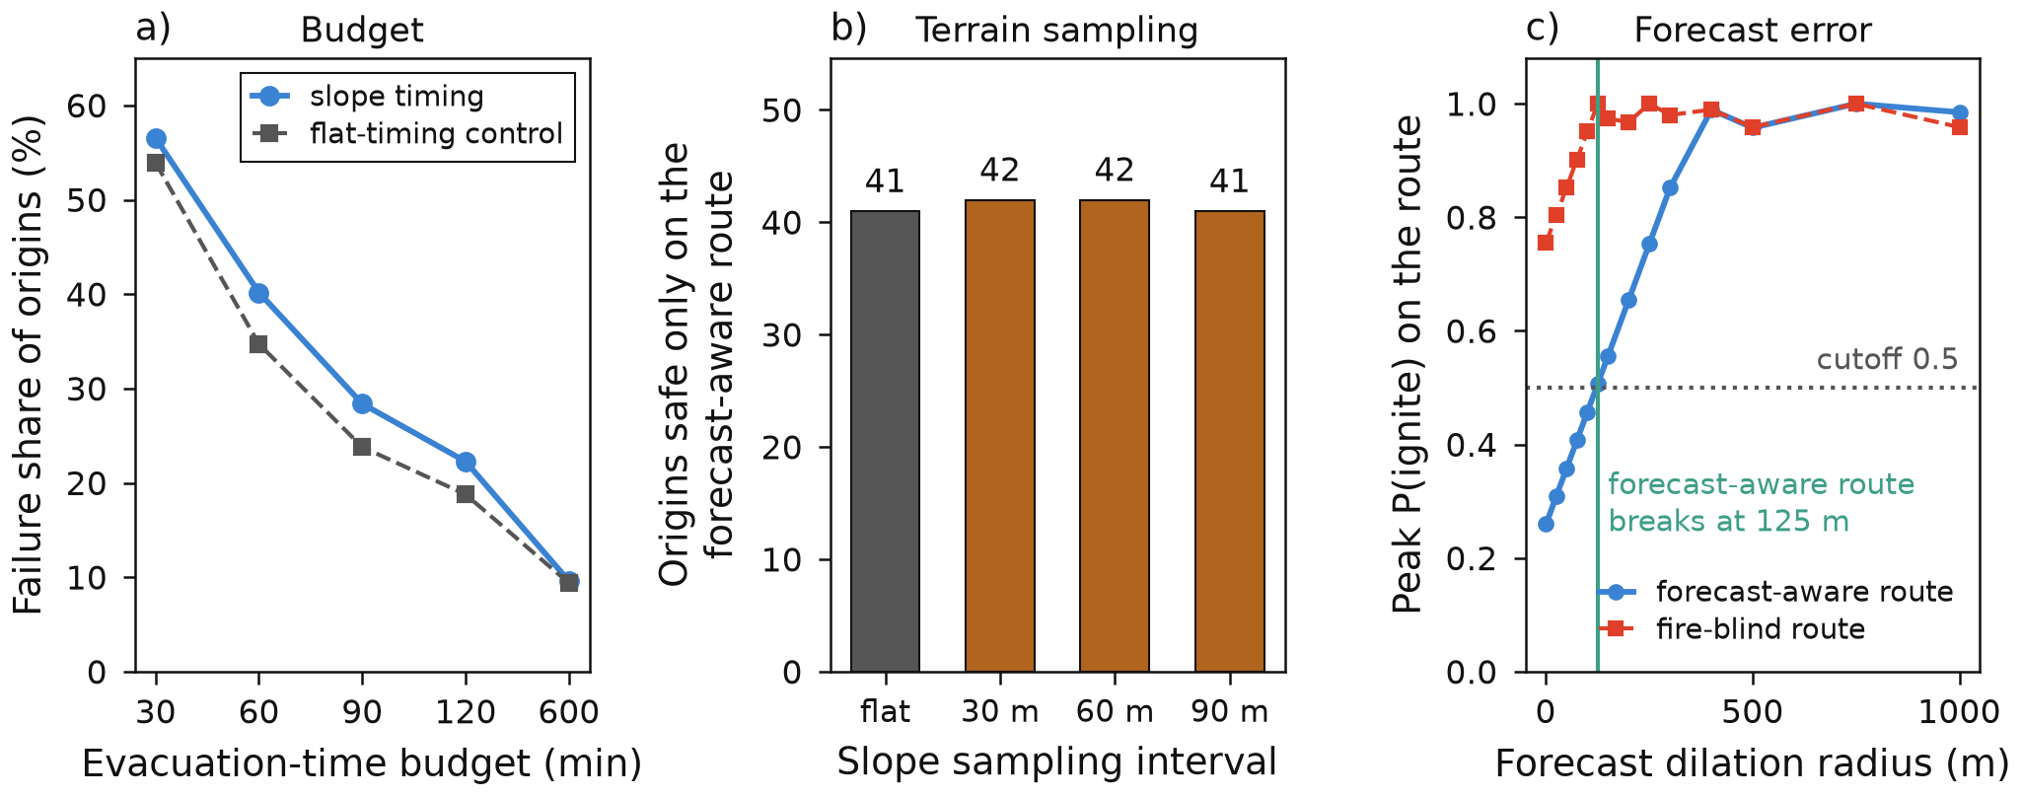
Figure 7. Sensitivity on the canonical Yeongdeok field. Left: the share of origins whose fire-blind route fails, against the evacuation-time budget, with a flat-timing control. Centre: origins safe only on the forecast-aware route, against the slope-sampling interval, with a flat control. Right: peak P(ignite) along one committed route pair as the forecast field is dilated, with the pedestrian cutoff and the radius at which the forecast-aware route first crosses it. ⚠ Scope: that pair is a real pipeline output but its origin differs from the committed routing_demo.json headline case, so both artifacts state their result as robustness of the routing method and not a restatement of the headline. The dilation and translation axes and the Monte-Carlo figure quoted in the text come from the committed artifacts forecast_robustness.json and dilation_perturbation.json, which do not yet carry registry keys of their own; they are flagged here as artifact values rather than registered ones.
The evacuation-time budget is the binding assumption, not the terrain. Sweeping the budget on the canonical field (Fig. 7, left), the share of origins whose fire-blind route fails rises from 0.0961 at 600 minutes to 0.5655 at 30 minutes, a ratio of 5.89. A short-budget failure share is meaningless without its budget attached. The forecast-aware class stays empty here because a budget failure is a walk-time failure, and walk time belongs to the graph.
The count of fire-blind routes entering the predicted hazard rises from 20 to 44 between the reverted and the canonical fields. That belongs to the fire-blind baseline, not to the proposed system: the forecast-aware router cannot enter the hazard at all, and a fire-blind walk is likelier to walk into a fire four times larger.
Terrain changes how people walk, not whether they arrive. Applying real slope to edge times raises whole-network traversal time by 26.6 % at Yeongdeok at 60 m sampling (15.14 % and 23.67 % in the two other regions), with a mean directional asymmetry of 0.1996 of flat time — which is why the walking graph is directed. Yet the classification barely moves (Fig. 7, centre): 42 origins are safe only on the forecast-aware route at 30 m and 60 m sampling and 41 at 90 m, against 41 in the flat control, and the number whose bucket differs from the flat control at all three intervals is zero, while 179 forecast-aware routes, 39.1 %, differ from the flat control at 60 m. Switching the objective from distance to time under slope timing changes 150 of 458 routes and cuts the longest walk from 444.0 to 352.8 minutes; the flat control changes 0 routes, as it must.
Forecast error has a characterised failure mode, not robustness. Under perturbation the forecast-aware route's exposure is below the fire-blind route's in 86 % of 2,000 Monte-Carlo draws, but the safety margin is fragile: under morphological dilation the forecast-aware route's peak risk first reaches the 0.5 cutoff at a radius of 125 m, and an independent spatial-translation axis first breaks at that same 125 m — the minimum over eight directions, with the band running to 530 m, so the fragility is strongly direction-dependent. A quarter of one grid cell of error in the worst direction invalidates the margin.
The road network itself is a source of uncertainty. Re-acquiring the OpenStreetMap network eleven months later changed the walk-graph node count by 0.0474 % and moved the count of origins with no surviving vehicle ingress by 33.3 % (24 to 32), while the paired exposure-reduction contrast moved by 0.5614 percentage points. Neither network is the right one; the reported quantity is sensitivity, and it says binary verdicts are network-fragile where paired contrasts are not.

4.6 Rescue ingress, and a dispatch ordering that does not work
On the committed 439-origin responder run, survival-aware routing reduces mean responder exposure from 6.12 to 1.71 probability-minutes over the 143 dispatchable origins, a 72.0 % reduction: a relative contrast between two policies on one synthetic hazard field (Section 3.4) on the responder side only, not an absolute safety guarantee. 57 of the 143 shortest-path routes cross the hazard, which is what the survival-aware policy avoids.
The dispatch ordering is negative, and reported as such. It carries a different lineage, stated in the caption of Fig. 8 and binding on every number below. "Homes" is shorthand for the sampled walk-graph origins of Section 3.3.
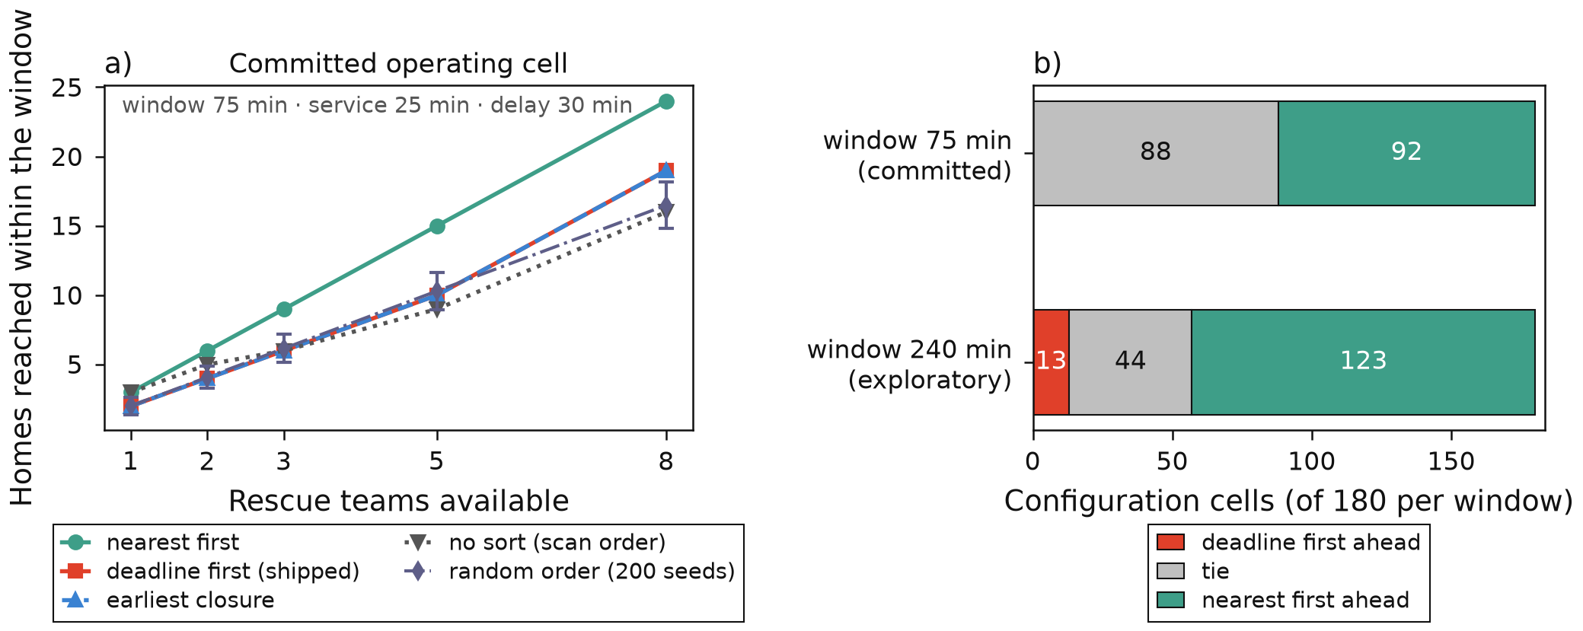
Figure 8. Dispatch ordering. Left: homes reached within the operational window against the number of rescue teams, at the committed operating cell, for the shipped deadline-first ordering and four alternatives including 200 random permutations. Right: win, tie and loss tally of deadline-first against nearest-first across 180 configuration cells per window. The second window is exploratory and more than three times the committed one. ⚠ Lineage: this grid was measured on a re-acquired network vintage rather than the committed 439-origin series, two of its four arms use a synthetic hazard and terrain, and it runs a travel-aware occupancy rule in which a team stays occupied for its return leg — a rule the shipped triage code does not use, and without which the number rescued is teams times slots and no ordering can differ from any other. What is shown is therefore a contrast between orderings under that rule, on those arms; it is not a rescue-capacity forecast for any region and carries no lives-saved reading.
Table 3 tallies deadline-first against nearest-first on two grids: the headline grid of Fig. 8, and an exploratory grid that widens the window axis to twelve points to look for an operating region where the shipped ordering would pay.
Table 3. Deadline-first against nearest-first, on the headline grid and on a widened window axis. The headline grid is four arms by two windows by three service times by three dispatch delays by five team counts; the widened grid replaces the two windows with twelve points from 60 to 600 minutes. Both carry the lineage stated in the caption of Fig. 8. Each entry is a number of configuration cells and its share of that row's grid; these are cells, not people. Every one of the headline grid's 13 wins falls at the exploratory 240-minute window, so the committed-window row is the operationally relevant one. The per-window cell count on the widened axis is its 2,160 cells over twelve window points.
grid | cells | wins | ties | losses
Headline, both windows | 360 | 13 (3.6 %) | 132 (36.7 %) | 215 (59.7 %)
Headline, committed 75-min window | 180 | 0 (0.0 %) | 88 (48.9 %) | 92 (51.1 %)
Widened window axis, 60–600 min | 2,160 | 115 (5.3 %) | 561 (26.0 %) | 1,484 (68.7 %)
Widened axis, at the 600-min window | 180 | 22 (12.2 %) | 22 (12.2 %) | 136 (75.6 %)

At the most operationally relevant cell — committed window, 25-minute service, 30-minute delay, eight teams — deadline-first reaches 19 homes against nearest-first's 24, a gap of -5; unsorted scan order reaches 16 and 200 random permutations average 16.49 ± 1.69, so the sort beats no sort and loses to nearest-first. The worst cell is -31, where it falls below an arbitrary order as well. Over the widened axis it beats unsorted order in only 31.5 % of cells and the random mean in 37.8 %.
The mechanism is measured rather than guessed. The urgency key is corridor closure minus responder arrival, and at the committed window the window closes before most corridors do, so the distinct deadline values are few: 2 over 116 homes in one arm, 6 over 142 in another. With two distinct deadlines the key is nearly constant and sorting it sorts noise — a property of the window relative to the closure times, not of the sort. Widening the window does not repair that: the first win comes at 120 minutes, and neither a window threshold nor the number of distinct deadlines separates a winning region, 1,580 cells failing to win despite having at least as many deadlines as the lowest-scoring winning cell. No operating region recommends the shipped ordering, and the paper does not construct one. What the analysis does establish positively is reproducibility: re-deriving 3,744 values from the earlier run cell by cell produced 0 differences.

4.7 How early could a satellite have seen these fires?
Four of the six fires fall inside the GK2A archive and three produced a detection under the rule of Section 3.1 (Table 4). In each, the first satellite-detectable anomaly follows the fire's recorded occurrence time by 22 to 64 minutes. That reference clock is the weakest part of the measurement and we do not lean on it, for the reasons given in the caption and in Section 5.
Table 4. First GK2A infrared anomaly at each archived fire, relative to that fire's recorded occurrence time. That reference is the start field of the project's fire manifest, which the manifest marks as provenance only, sources to no emergency-call record, and nowhere says what the field is; its relation both to the true ignition and to the emergency call is unestablished, so these are delays behind a recorded time and not detection-behind-report figures. FIRMS delays are for the same events against each event's own recorded report time, which differs from the GK2A reference by one minute at Uiseong-Andong and at Yeongdeok. Yeongdeok is a confounded case, not a miss: see the text.
fire | GK2A | FIRMS | contrast at detection | pixels | contextual threshold
Uiseong-Andong 2025 | +22 min | +117 min | 22.9 K | 1 | 12.2 K
Gangneung 2023 | +34 min | +151 min | 66.4 K | 1 | 62.1 K
Hongseong 2023 | +64 min | +17 min | 93.8 K | 2 | 32.6 K
Yeongdeok 2025 | confounded | +81 h | 11.6 K (best) | — | 22.0 K

The rule is not simply permissive. Across 709 control steps at the same four sites, at the same clock times fourteen days earlier, no pixel was ever flagged. Zero of 709 is an upper bound, not an absence: it puts the per-step false-alarm rate at roughly 0.4 % with 95 % confidence, still a few alarms a day at a two-minute cadence. The size floor is firmer than the clock. A two-component sub-pixel split of the weakest detection [19] implies a fire area of 0.19 ha at an assumed 750 K flame temperature; that assumption alone moves the value more than eightfold across a 600–900 K range, so the floor is an order of magnitude, 0.1 to 1 ha.
The fourth archived fire, Yeongdeok 2025, is neither a detection nor a miss and is excluded rather than counted either way. Uiseong-Andong was burning 66 km away that day, inside Yeongdeok's own background annulus, and lifted the contextual threshold there to 21.96 K — above the strongest target anomaly of 11.61 K, seen 28 minutes after the reference time. That contamination is measured but was not separated from the other candidates: the manifest flags this fire's bounding box as reconstructed, the two committed manifests place its ignition point about 30 km apart against a 15 km target radius, and FIRMS saw nothing there for 81 hours. A coordinate error alone could produce the same null, so Yeongdeok is set aside rather than explained.
Against FIRMS the trade runs both ways: GK2A was earlier at two of the three fires and 47 minutes later at Hongseong, where a VIIRS overpass happened to fall well — at n = 3, a description of three events, not an operating characteristic. What survives is narrow: a 2 km pixel does not see a fire until it is of the order of a hectare, and on these fires that took tens of minutes from the recorded occurrence time. Whether that is ahead of or behind the emergency call, this measurement cannot say.

5. Discussion
What the coupling adds over a spread map. A hazard map answers "where will the fire be"; a household needs "is my route still passable when I get there", and the two differ because a slow walker's arrival time is a variable in the answer. Section 4.3 is the measurable form of that difference. It is not a claim that the system knows where the fire will be: the router needs ranking quality, not per-cell precision, because it cuts a cumulative, survival-accumulated surface at its own threshold. That the surface itself goes unchecked is the first limitation in Section 6.
Why n = 6 forbids a threshold guarantee. Section 4.2 quantifies why the intuition that a distribution-free method rescues a small-sample setting is wrong: small-N event datasets do not get guarantees by changing the calibration method, but by having more events.
Where the trigger comes from, and where the warning goes. Section 4.7 establishes a floor: a 2 km geostationary pixel cannot see a fire below roughly a hectare, so a satellite trigger cannot be an ignition-scale alarm whatever its cadence, and the system treats it as corroboration. A floor of that kind rules a source out of the primary slot; it puts nothing into it. The project's design notes had drawn two further readings from it and both are withdrawn, with no number moving: that the satellite arrives after the emergency call, whose time no artifact here records, and that human report is therefore the primary channel — a channel this repository has never measured. The system is built to the narrow statement rather than its converse. The survey evidence at the other end is firmer, and is the measured reason the outputs are a sheet a village head can read aloud and a household-ordered dispatch list rather than a broadcast — a claim about delivery channels only, since the survey does not evaluate the routing.
The instrument is the contribution. Several results here exist only because a control existed: the terrain null because of the flat control, the feature-arm null because of the column-addition envelope, and the claim that distance drives vulnerability was withdrawn because a null-hazard control showed the failing set was set-identical with no fire at all. The same discipline stopped an input before it reached this paper: a designated-site subset labelled with a county name was refused when its points proved to lie outside that county's own study box — a label checked against the geometry it claims rather than against a code table. It was re-cut on the right administrative code, and only then used as the inventory Section 6 reports.
What outside readers asked first. Three domain researchers replied in writing to the author in September 2026; their comments are design feedback rather than data. One of them put two questions that nothing measured here answers: whether prioritising rescue need by age alone stays appropriate in an ageing population, and whether these results are usable without modelling how forest-fire suppression and residential emergency response divide roles during a fire. Another's off-network walking point is a limitation in Section 6.
[GAP: the practitioner consultations — a fire-service duty officer, a village head and a social worker — have not happened; they are design feedback rather than collected data, and any quotation from them needs the author's consent handling first]

6. Limitations
The routing result is graded against the predicted field, not against observed burn. This is the objection we would raise first against this paper. An origin counted in the 42 is one whose fire-blind route crosses a cell the model flagged and whose forecast-aware route does not: a statement about two policies read on one surface, not that the fire went where the surface said. At Section 4.2's operating point the same evidence is consistent with detours around cells that never burned, and with burned cells the model never flagged left unavoided under both policies. Every control here perturbs the predicted field, so none admits external truth. [GAP: settling this needs a third routing pass over the same 458 origins on a hindsight field rasterised from the observed FIRMS detections, reporting how many of the 42 fire-blind routes intersect observed burn inside the walker's arrival window. Those detections are not distributed with the repository, and the two committed manifests for this fire place its ignition point about 30 km apart]
Six fires, and not six independent ones. Because Uiseong-Andong 2025 and Yeongdeok 2025 belong to one chain (Section 3.1), the Yeongdeok fold's training data may contain cells of the same fire complex as the fire it is scored on, and a leak-free refit has not been run. [GAP: refitting that fold with the co-located fire excluded, re-simulating its field and routing the same 458 origins needs the raw acquisition bundle the repository does not distribute; this is the experiment most likely to move the 42-origin result]
Coverage: every absolute Yeongdeok rate rests on a walk network holding 32.6 % of that fire's predicted core (Section 4.3).
Origins are not households, and no interval attaches to a share of them. They are walk-graph nodes at a fixed stride, so their distribution reflects road-network structure. They are also not a probability sample: the 458 are a deterministic systematic subsample — every 18th of the walk graph's 8,443 nodes, then filtered by the hazard at time zero and by a band around the predicted core — so no design-based standard error is defined for the shares in Sections 4.3 and 4.4, and neighbouring origins are not independent. Building footprints are no better: OpenStreetMap maps 124, 339 and 1,220 footprints across the three regions, and 91.5 % of 1 km cells containing built-up land at Yeongdeok hold no mapped building. Origins needing rescue are 2.13 times more dispersed than origins in general and 69.2 % of clusters at a 500 m radius hold a single point — figures about the sample, not the region.
Weather resolution. ERA5's 0.25° (~28 km) grid leaves the severity features nearly uniform within a fire at a time step: they discriminate between fires and days, not between cells within an overpass. It bounds what any wind-direction feature here can show. Permuting the six swappable instantaneous weather features costs 0.0344 of far-band AUC — a ceiling on the cost of a real forecast source, not a measurement, since no forecast data was acquired.
The top feature is partly an acquisition artifact. Days-since-rain ranks first by permutation importance, yet removing it raises mean-of-folds by 0.0270 and far-band by 0.0533, because for three of six fires the ERA5 window contains no wet sample and the feature pins to the window's start. This describes the feature as computed, not dryness.
The 500 m grid attenuates terrain. Native ~30 m effective slope is 3.01 times the 500 m-baseline slope pooled over the six fires, native mean 17.3°, so the grid hides roughly two thirds of the terrain. Direction analyses inherit this: the observed spread bearing sits 83.5° from the ERA5 wind bearing, where 90° is what unrelated bearings give, and upslope agreement is 51.8° on steep steps against 88.4° on gentle ones.
Router approximations, recorded and not fixed. The objective samples risk at the edge head at a rounded arrival time while the reported exposure samples at the tail at the exact departure time; on a constructed example the optimiser can prefer a path whose reported exposure is 2.22 times the alternative's. Remaining-time displays are quantised to the slice grid and are upper bounds. The search is deterministic but not provably optimal over exact-clock paths, though no counterexample exists at the bin sizes in use. The class named "forecast-aware route exceeds budget" names a cause its code condition does not establish; it is empty at Yeongdeok, and elsewhere the search did not complete within the scan's constraints. None was fixed; all divide out of the paired contrasts.
A pedestrian is not confined to the graph, but this router is. A walker can cross a field or a yard where a vehicle cannot, so a shortest-path formulation borrowed from road-bound traffic may not transfer cleanly on foot — a point put to the author in written comments by an external researcher in September 2026. Every route here stays on mapped ways, and whether that makes the reported failures pessimistic or optimistic is unmeasured.
Assumptions the results ride on. A fixed 0.7 m/s gait speed with no individual variation and no pre-movement delay; an immobile fraction of 0.3; a pedestrian cutoff of 0.5 and a vehicle cutoff of 0.7; dispatch operational windows, service times and team counts that are proof-of-concept parameters, not measured capacity — the committed 75-minute window is an assumed constant and nothing here grounds it; and refuge semantics from OpenStreetMap tags, which in rural Korea return parks and pavilions unless corrected for local village-hall tagging.
Every refuge in this paper is an OpenStreetMap point, and a designated list now exists that no result here uses. An agency-designated inventory for Yeongdeok-gun entered the repository from the 주소정보누리집 address portal of Korea's Ministry of the Interior and Safety: on the 2025-03-01 cut, 64 earthquake outdoor evacuation sites, 92 tsunami emergency evacuation sites and 17 cooling centres; on the 2024-01-24 cut, 55 public-service agency points, four of them fire-service and six police — candidate depots where Table 2 puts OpenStreetMap depot density at 0.45 per 100 km². None is a wildfire refuge: the designated categories here are earthquake, tsunami and heat, and this subset is seven of the portal's point layers rather than its whole taxonomy, so it narrows the question rather than answering it. The two sets are also not on one extent and must not be differenced as they stand: the designated counts are for the whole county, between 77 % and 84 % of each layer falling inside the canonical walk box, while the router's refuges are counted inside that box alone. [GAP: the router's 50 OpenStreetMap refuge points have not been compared against that designated list, so how far the routing results depend on refuge provenance is unmeasured. Both inputs are committed and the comparison is runnable now: clip the designated sites to the walk box, re-snap the refuges, and re-run the same 458 origins on the same canonical field]
The detection measurement rests on three fires and an unsourced clock. No night-time detection appears in the sample, so night performance is unmeasured. Only the size floor stands on its own. [GAP: the reference times come from a manifest field marked provenance only. No entry names a report time and none says what the field is, so the delays can be read against neither the true ignition nor the emergency call and the sign of the error is unknown in both directions. One record of the 신고접수시각 for one of these fires would settle it]
Operational status. No trigger has ever fired on a live detection and the messaging layer is a dry run: the SMS path is simulated, private cell-broadcast origination is not authorized in Korea, and the approval-gated email channel has never completed a verification send. Nothing here reached a real resident or a real crew.

7. Conclusion
A wildfire spread model trained on six fires is not a contribution to spread modelling, and this paper does not present it as one. What six real fires, real road networks and a strict evidence discipline support is a different claim: that coupling an event-held-out probability field into a time-expanded pedestrian router and a rescue-ingress calculation changes household-level decisions measurably, as a paired contrast — 42 of 458 scanned origins on the canonical Yeongdeok field reach a refuge only under the forecast-aware policy, on a network covering 32.6 % of that fire's predicted core.
The rest of the contribution is the instrument, and the instrument is visible in what this paper declines to say: the operating point is reported rather than hidden, the conformal calibration is called vacuous at this sample size rather than dressed as a guarantee, the shipped dispatch ordering is reported as losing, the detection floor is reported without the stronger claim its own design notes had drawn from it because the clock that claim needs is unsourced, and withdrawn claims stay in the tree as withdrawn. On a dataset this small, that discipline is the difference between a result and a coincidence, and it is the part of this work that transfers.

Data and code availability
The code, committed artifacts, evidence registry and this manuscript are at https://github.com/Sparkxt-0318/wildfireguardian. Raw geospatial inputs are public and are re-acquired by the scripts in scripts/; the repository distributes no raw data. Every measured number in this paper is registered in docs/NUMBERS.json with its source artifact, derivation and caveat, and re-derived from that artifact by make verify; externally sourced figures are attributed in place with agency, date and scope. Figures are regenerated from committed artifacts by paper/make_figures.py and none was edited by hand. Authorship and the disclosure of agent-assisted drafting are recorded in paper/AUTHORSHIP.md.

References
[1] Gyeongsangbuk-do Provincial Government "경북 초대형 산불, 초고속 회복을 위한 복구계획 최종 확정 [Gyeongbuk mega-wildfire: the recovery plan for a rapid recovery is finalised]." Provincial press release, 7 May 2025, 2025. https://gb.go.kr/Main/governor/page.do?mnu_uid=6792&BD_CODE=bbs_bodo&cmd=2&B_NUM=503433101&V_NUM=11584&tbbscode1=bbs_bodo
[2] 대구MBC "경북 산불 사망자 26명…영덕 9명." 대구MBC, 30 March 2025, 2025. https://dgmbc.com/article/bLdh4s3M4pgcSdYI0MZPc
[3] Greenpeace East Asia Seoul Office and Green Transition Institute and Disaster Victims' Rights Center Uri-Hamkke "2025 영남 초대형 산불 피해 실태조사 최종보고서 — 안동, 영덕, 의성을 중심으로 [Final report of the damage survey of the 2025 Yeongnam mega-wildfires: Andong, Yeongdeok and Uiseong]." Joint survey report, March 2026, 191 pp., 2026. https://www.greenpeace.org/static/planet4-korea-stateless/2026/03/d2fe67f5-2025-%EC%98%81%EB%82%A8-%EC%B4%88%EB%8C%80%ED%98%95-%EC%82%B0%EB%B6%88-%EC%8B%A4%ED%83%9C%EC%A1%B0%EC%82%AC-%EC%B5%9C%EC%A2%85%EB%B3%B4%EA%B3%A0%EC%84%9C.pdf
[4] World Weather Attribution "Climate change made weather conditions leading to deadly South Korean wildfires about twice as likely." World Weather Attribution rapid study, 30 April 2025, 2025. https://www.worldweatherattribution.org/climate-change-made-weather-conditions-leading-to-deadly-south-korean-wildfires-about-twice-as-likely/
[5] 김현수 and 이종섭 "경북 산불 실제 피해 약 10만ha, 산림청 추정치 '2배' 훌쩍…"초기 추산 엉터리" 비판도." 경향신문 (The Kyunghyang Shinmun), 17 April 2025, 2025. https://www.khan.co.kr/article/202504171020011
[6] Huot, Fantine and Hu, R. Lily and Goyal, Nita and others "Next day wildfire spread: a machine learning dataset to predict wildfire spreading from remote-sensing data." IEEE Transactions on Geoscience and Remote Sensing, 2022. https://arxiv.org/abs/2112.02447
[7] Gerard, Sebastian and Zhao, Yu and Sullivan, Josephine "WildfireSpreadTS: A dataset of multi-modal time series for wildfire spread prediction." Advances in Neural Information Processing Systems, 2023. https://doi.org/10.52202/075280-3258
[8] Lahrichi, Saad and Bova, Jake and Johnson, Jesse and Malof, Jordan "Improved wildfire spread prediction with time-series data and the WSTS+ benchmark." arXiv:2502.12003; accepted at WACV 2026, 2025. https://arxiv.org/abs/2502.12003
[9] Finney, Mark A. "Fire growth using minimum travel time methods." Canadian Journal of Forest Research, 2002. https://doi.org/10.1139/x02-068
[10] Cova, Thomas J. and Johnson, Justin P. "A network flow model for lane-based evacuation routing." Transportation Research Part A: Policy and Practice, 2003. https://doi.org/10.1016/S0965-8564(03)00007-7
[11] Borgwardt, Steffen and Crawford, Nicholas and Horton, Drew and Morrison, Angela and Speakman, Emily "Evacuation planning on time-expanded networks with integrated wildfire information." arXiv:2410.14500, 2024. https://arxiv.org/abs/2410.14500
[12] Tammali, Sowjanya and Khanda, Arindam and Satpathy, Anurag and Shovan, S. M. and Das, Sajal K. "RESCUE: Routing under evolving stochastic congestion and uncertain spread in wildfire emergencies." Proceedings of the 27th International Conference on Distributed Computing and Networking, 2026. https://doi.org/10.1145/3772290.3772301
[13] Cova, Thomas J. and Dennison, Philip E. and Kim, Tae H. and Moritz, Max A. "Setting wildfire evacuation trigger points using fire spread modeling and GIS." Transactions in GIS, 2005. https://doi.org/10.1111/j.1467-9671.2005.00237.x
[14] Li, Dapeng and Cova, Thomas J. and Dennison, Philip E. "Using reverse geocoding to identify prominent wildfire evacuation trigger points." Applied Geography, 2017. https://doi.org/10.1016/j.apgeog.2017.05.008
[15] Li, Dapeng and Cova, Thomas J. and Dennison, Philip E. "Setting wildfire evacuation triggers by coupling fire and traffic simulation models: a spatiotemporal GIS approach." Fire Technology, 2019. https://doi.org/10.1007/s10694-018-0771-6
[16] Wahlqvist, Jonathan and Ronchi, Enrico and Gwynne, Steven M. V. and Kinateder, Max and Rein, Guillermo and Mitchell, Harry and B\'enichou, Noureddine and Ma, Chunyun and Kimball, Amanda and Kuligowski, Erica "The simulation of wildland-urban interface fire evacuation: the WUI-NITY platform." Safety Science, 2021. https://doi.org/10.1016/j.ssci.2020.105145
[17] Radeloff, Volker C. and Hammer, Roger B. and Stewart, Susan I. and Fried, Jeremy S. and Holcomb, Sherry S. and McKeefry, Jason F. "The wildland-urban interface in the United States." Ecological Applications, 2005. https://doi.org/10.1890/04-1413
[18] Kim, Dohyeong and Gu, Minju and Oh, Tae-Hyeong and Kim, Eun-Kyu and Yang, Hye-Ji "Introduction of the Advanced Meteorological Imager of Geo-Kompsat-2a: In-orbit tests and performance validation." Remote Sensing, 2021. https://doi.org/10.3390/rs13071303
[19] Dozier, Jeff "A method for satellite identification of surface temperature fields of subpixel resolution." Remote Sensing of Environment, 1981. https://doi.org/10.1016/0034-4257(81)90021-3
[20] Angelopoulos, Anastasios N. and Bates, Stephen and Fisch, Adam and Lei, Lihua and Schuster, Tal "Conformal risk control." arXiv:2208.02814; International Conference on Learning Representations, 2024. https://arxiv.org/abs/2208.02814
[21] Studenski, Stephanie and Perera, Subashan and Patel, Kushang and others "Gait speed and survival in older adults." JAMA, 2011. https://pubmed.ncbi.nlm.nih.gov/21205966/
[22] NASA "Fire Information for Resource Management System (FIRMS)." 2026. https://firms.modaps.eosdis.nasa.gov/
[23] Hersbach, Hans and others "ERA5 hourly data on single levels from 1940 to present." Copernicus Climate Change Service (C3S) Climate Data Store, 2023. https://cds.climate.copernicus.eu/datasets/reanalysis-era5-single-levels
[24] Farr, Tom G. and Rosen, Paul A. and Caro, Edward and others "The Shuttle Radar Topography Mission." Reviews of Geophysics, 2007. https://doi.org/10.1029/2005RG000183
[25] ESA WorldCover consortium "ESA WorldCover: global land cover at 10 m from Sentinel-1 and Sentinel-2." 2021. https://esa-worldcover.org/en
[26] Boeing, Geoff "OSMnx: new methods for acquiring, constructing, analyzing, and visualizing complex street networks." Computers, Environment and Urban Systems, 2017. https://doi.org/10.1016/j.compenvurbsys.2017.05.004
[27] OpenStreetMap contributors "OpenStreetMap: copyright and licence." 2026. https://www.openstreetmap.org/copyright

