1.

2. A process 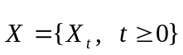 is said to have independent increments if for any 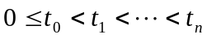, the random variables 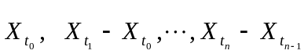 are independent. In general, if  is adapted to the filtration { ℱ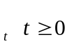}, it is said to have independent increments with respect to this filtration if for any 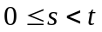, 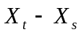 is independent of ℱ. Prove that such a process is Markovian.

