1. Let 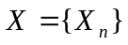be an irreducible and aperiodic Markov chain on some countable state space E with transition matrix 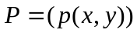, 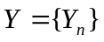 be a copy of  and 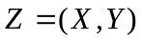 be the independently coupled chain of and .
(1) If for some 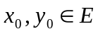, 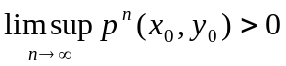, show that  is recurrent and hence for any 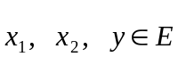,
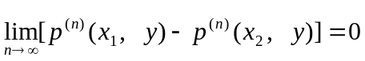;
(2) Furthermore, show that if some for some , , then for some subsequence 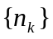, the limit
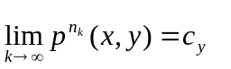.
exists for any x,y and is independent of x. Deduce from this that if is null recurrent, then 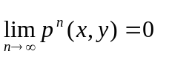for each .

2. Let X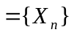be an irreducible Markov chain on some countable state space E with transition matrix . Suppose that the limit 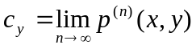 exists for any 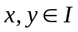 and is independent of . Show that either 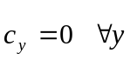, or 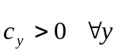. In the late case, show that there exists a unique stationary distribution for the chain X.

