Pocket Card Studio
  - A complete beginner’s step-by-step guide
For the CardMaker.zip version supplied November 5, 2026. Designed for people who are comfortable clicking a mouse but do not need to know anything about card-making software.
What the program does: creates individual 2.5 × 3.5-inch cards, saves designs in your browser, downloads PNG pictures, and prints one card or a 3-by-3 sheet of up to nine cards.

1. Start here: open the program
1. Find the downloaded CardMaker.zip file, usually in your Downloads folder.
2. On Windows, right-click CardMaker.zip and choose Extract All. Pick a location you can find again, then click Extract.
3. Open the extracted CardMaker folder. You should see index.html, styles.css, script.js and preview.png. Keep the first three files together.
4. Double-click index.html. It should open in your usual web browser, such as Chrome or Edge.
5. If Windows asks which app to use, choose a web browser. The editing screen should say Pocket Card Studio at the top left.
IMPORTANT: You do not need to install a program or sign in. Do not open index.html directly inside the ZIP. Do not separate index.html, styles.css and script.js.

2. Learn the three main parts of the screen
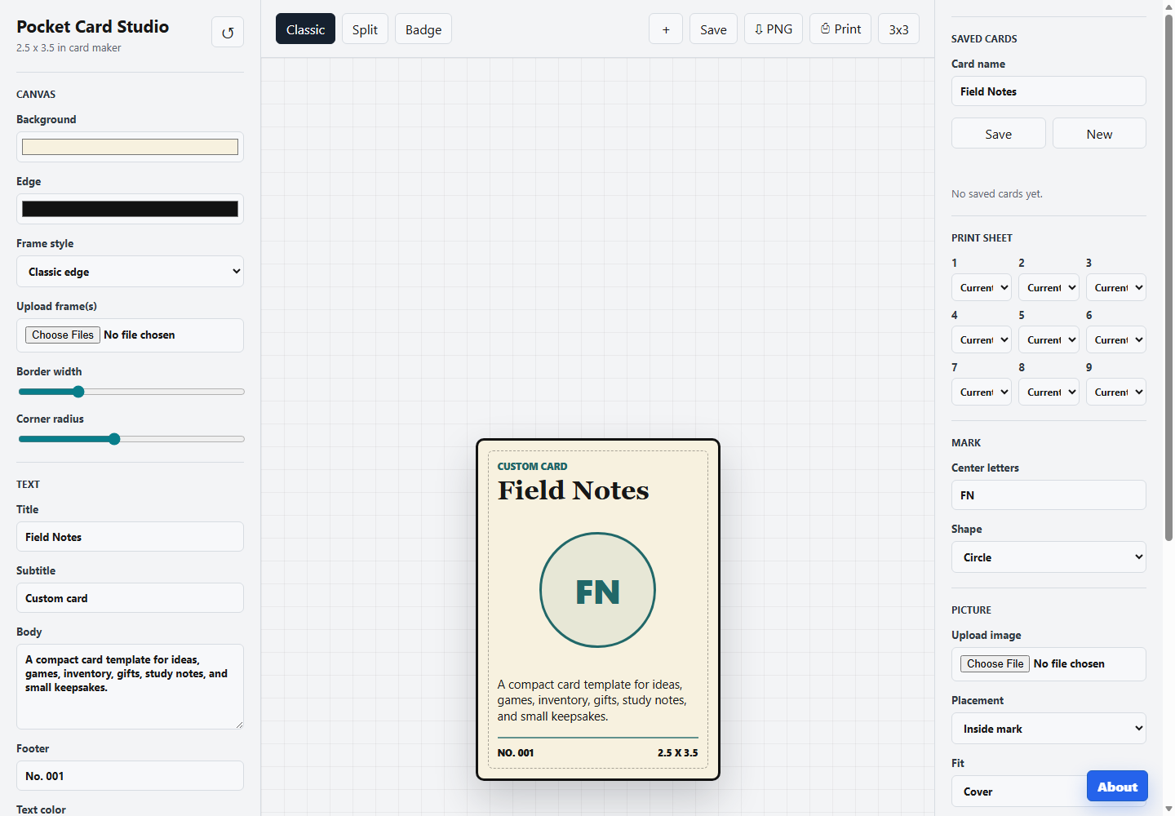
Screenshot from the supplied program. On a smaller screen, you may need to scroll down to see every control.
Left side: Canvas and Text — Choose the card background, frame and border; type its title, subtitle, main writing and footer; change text colors and sizes.
Middle: live preview — See the card change as you work. The top of this area has layout tabs and Save / PNG / Print buttons. The row of colored dots below the card offers ready-made color schemes.
Right side: Saved cards, Print sheet, Mark, Picture and Extras — Store and reopen designs, choose which cards go on a nine-card page, set center initials, add pictures and switch small extras on or off.
Bottom-right About button — Displays the program’s credits. It does not change your card.

3. Make your first card: a simple example
1. Under Text on the left, click inside Title. Press Ctrl+A to select the starter words and type “Birthday Wishes”.
2. Click Subtitle and type “Special Occasion”.
3. Click Body and type “Wishing you a wonderful day!”
4. Click Footer and type “From the Family”.
5. In the middle, click Classic, Split, then Badge to compare the layouts. Choose the one you prefer.
6. Under Mark on the right, change Center letters to “BW”; choose Circle under Shape.
7. Click one of the five small color swatches below the preview to try a complete color combination.
8. Under Saved cards, change Card name to “Birthday Card 1”. Click Save there (or Save above the preview).
9. When you see “Saved.”, click ⇩ PNG to download a picture of the current card.
10. Click ⎙ Print to open the browser’s printer window, if you want a paper copy.
IMPORTANT: Typing changes the card immediately, but does not automatically save your changes. Save again after edits you want to keep.

4. Every button along the top
↺ Reset card (top left) — Returns the editor to the original Field Notes example and clears the current saved-card selection. Previously saved designs stay in the saved list. There is no confirmation.
Classic / Split / Badge — Three different arrangements of the same card content. These are layouts, not the border/frame styles.
＋ Add rule — Adds one thin decorative line above the body text. You can add up to eight; change the number in Extras → Rule count.
Save — Stores the design under the name entered in the right-side Card name field. If editing a loaded saved card, Save updates that existing saved card.
⇩ PNG — Downloads a high-resolution PNG image of the current card to your computer. The file is named custom-2-5x3-5-card.png. Downloading does not add it to Saved cards.
⎙ Print — Opens your browser’s printing window for the current card at 2.5 × 3.5 inches.
3x3 — Opens the print dialog for nine positions arranged in three rows and three columns on one US letter-size page. Choose cards for the nine slots before clicking.
Five colored swatches below the preview — Instantly change background, accent and all text colors. Try Warm paper, Bright blue, Night gold, Clean white or Coral teal; hover your mouse over a swatch to see its name.

5. The Canvas section (left side)
Background — Changes the main color of the card. Click the colored rectangle and pick a new color.
Edge — Changes the outside border color.
Frame style — Changes the decorative treatment around the card. The choices are Classic edge, Fantasy filigree, Dungeon stone, Victorian ornate, Carved wood, Glossy plastic, Brushed metal, and Modern minimal. Select each to compare.
Upload frame(s) — Choose one or more image files from your computer to overlay as custom decorative frames. PNG, JPG and WebP are supported; each must be under 2 MB. A transparent PNG/WebP is usually best. For a full-size frame, 750 × 1050 pixels is recommended. Uploaded frames appear in Frame style; the last uploaded frame becomes selected.
Border width — Move the slider left for a thinner outline, right for a thicker one. Far left is zero.
Corner radius — Move left for squarer corners or right for rounder corners.
IMPORTANT: A custom frame sits on top of your design. A frame image without a transparent middle may cover your text or picture. The uploaded custom-frame list is stored only in this browser.

6. The Text section (left side)
Title — Large main heading. Examples: Dragon, Birthday Wishes, Recipe Card.
Subtitle — Smaller label above the title. Example: Creature, Celebration, Dessert.
Body — Main paragraph. Click inside the larger box and type your description. Keep it brief so it fits.
Footer — Small text at the bottom left, such as No. 001, Edition 1, or Your Name.
Text color — Changes title, subtitle, body and footer text colors together, overwriting any individual choices for those text areas.
Title color — Changes only the large heading.
Subtitle color — Changes only the smaller heading.
Body color — Changes only the main paragraph.
Footer color — Changes only the bottom-left label.
Font size — Controls the card text scale from 80% to 130%. Move left for smaller and right for larger writing.
IMPORTANT: If letters appear cramped or run off the card, shorten your text or reduce Font size. The card is small, so long paragraphs are not practical.

7. Saved cards (right side): save, reopen, delete, and start fresh
Card name — The label used to identify this design in the list. It can differ from the Title printed on the card.
Save — Creates a saved entry for a new design, or overwrites the loaded entry with its latest changes. “Saved.” appears briefly.
New — Starts a fresh starter card and clears the selected saved entry. It does not delete saved cards and does not automatically save the work you were editing.
Load (beside a saved card) — Opens that saved card for editing. Unsaved changes to the current screen are not preserved.
Delete (beside a saved card) — Removes that saved design from the browser’s saved list immediately. The program does not ask for confirmation.
1. Enter a recognizable Card name, for example “Knight Card”.
2. Click Save and look for “Saved.”.
3. To retrieve it later, find “Knight Card” in the list and click Load.
4. After editing it, click Save again to update it.
5. To make a separate version instead of replacing it, click New first, make the new design, give it another name, and Save.
IMPORTANT: Saved cards use the browser’s local storage, NOT a normal document file. They can disappear if browser site data is cleared, you use private/incognito browsing, a different browser or a different computer. Download PNG copies of valuable designs, but remember PNG is an image, not an editable backup.

8. Print sheet: decide what fills each of nine spaces
The nine numbered dropdowns correspond to positions on a paper sheet, read left to right: top row 1–3, middle row 4–6, bottom row 7–9.
Current — Use whatever card is currently showing in the editor. Every slot starts with this choice, so the default prints nine identical copies.
A saved card name — Use that particular saved design in this slot. It stays on the sheet even while a different card appears in the editor.
Blank — Leave that position empty.
1. Save any different card designs you want to include.
2. Under Print sheet, open the dropdown for slot 1 and select Current, a saved card, or Blank.
3. Repeat for slots 2 through 9. For example, choose the same saved card nine times for nine copies.
4. Click 3x3 at the top of the middle panel.
5. In the printer window, select the printer, choose US Letter paper, portrait orientation, 100% / Actual size where available, and turn on background graphics/colors if the browser offers it.
6. Check the preview before printing. Use one plain-paper test sheet first.
IMPORTANT: 3x3 is built for US Letter (8.5 × 11-inch) paper. The nine cards fill 7.5 × 10.5 inches with essentially no space between cards. Printer margins, automatic scaling or borders may cause clipping. Verify the print preview before using expensive card stock.

9. The Mark section (right side)
Center letters — Up to four characters that appear in the middle symbol when a picture is not covering it. Example: DK, 001 or HERO. If empty, the program derives letters from the title.
Shape → Circle — Uses a round mark.
Shape → Diamond — Uses a diamond-shaped mark.
Shape → Square — Uses a square mark.
Shape → None — Removes the visible mark shape.

10. The Picture section (right side)
Upload image — Click Choose File, find a picture and click Open. Accepts PNG, JPG, WebP or GIF, under 2 MB. For a picture meant to cover the whole card, 750 × 1050 pixels is recommended.
Placement → Inside mark — Places the picture inside the center mark area.
Placement → Top panel — Shows a wider picture panel toward the top/middle of the card instead of the center mark.
Placement → Background — Places the picture behind the writing as a card background.
Placement → Hidden — Keeps the uploaded image attached to the current design but does not show it.
Fit → Cover — Fills the allotted picture area, cropping portions if necessary.
Fit → Contain — Shows the entire image within the allotted area; may leave unused space.
Opacity — Changes the picture from faint/see-through (20%) to solid (100%).
Move picture left/right — Changes which part of a picture is centered horizontally, most noticeable with cropping.
Move picture up/down — Changes which part is centered vertically, most noticeable with cropping.
Remove image — Takes the uploaded picture off the current card. This does not remove the original file from your computer.
1. Click Upload image → Choose File.
2. Find the image on your computer and click Open.
3. In Placement, choose Top panel or Inside mark.
4. If your image seems cut off, change Fit from Cover to Contain.
5. Move left/right or up/down sliders until the important subject shows.
6. Use Opacity if you want the picture to be softer, then Save your card.

11. The Extras section (right side)
Grid texture — Checkbox: adds or removes a faint grid pattern on the card.
Bleed guide — Checkbox: displays a dashed inset guide to help keep writing away from the edge. This is an on-card guide, not extra printed bleed beyond the 2.5 × 3.5-inch card.
Footer — Checkbox: show or hide the bottom footer row, including its text and size label.
Rule count — Number box from 0 through 8: choose the number of small decorative lines above the body. You can also increase it with the ＋ button.

12. Printing just one card
1. Finish editing, then Save if you want to keep the design editable in this browser.
2. Click ⎙ Print at the top of the middle panel.
3. Choose a printer or Save as PDF in your browser’s print dialog.
4. Look for paper size US Letter and select 100% / Actual size rather than Fit to page if available. Turn on Print backgrounds / Background graphics to preserve colors.
5. Examine the page preview. The card should measure 2.5 × 3.5 inches, not cover the whole sheet.
6. Print a test copy on ordinary paper, check the size using a ruler, then use your preferred card stock.

13. Downloading an image instead of printing
1. Click ⇩ PNG. Your browser downloads an image, usually into Downloads.
2. Open Downloads and find custom-2-5x3-5-card.png.
3. Double-click the file to view, email or insert it into another document.
4. Rename it in Windows File Explorer to something meaningful, such as Birthday-Card-1.png.
IMPORTANT: Every PNG download uses the same default filename. Your browser may add a number or ask whether to replace the previous file. Rename downloads you want to keep. This exports the current card only, not the whole nine-card print sheet.

14. Quick problem-solving guide
Nothing opens — Extract the ZIP first, then double-click index.html in the extracted folder. Make sure script.js and styles.css remain beside it.
The editor opens but looks plain or does not respond — Check that index.html, styles.css and script.js are in the same folder. Try current Chrome or Edge.
My card went back to “Field Notes” — You probably clicked New or ↺. Use Saved cards → Load if you previously saved your design.
My picture will not upload — Check file type and 2 MB limit. Convert or shrink the image if necessary.
I cannot see my picture — Check Placement: Hidden hides it. Use Remove image and re-upload only if needed.
Part of my picture is missing — Try Fit → Contain and adjust the horizontal/vertical picture-position sliders.
My title or paragraph does not fit — Shorten the words, reduce Font size and try a different Classic/Split/Badge layout.
I cannot find an old saved card — Use the same browser, computer and browser profile. Browser cleanup or private browsing may have erased locally saved entries.
Printout has no colors or is too large/small — Enable browser background graphics; choose actual size/100% and test with paper before card stock.
The 3x3 print clips cards — Use US Letter portrait and check the print preview. Some printers cannot print close enough to the sheet edges; print to PDF or use a printer/settings that accommodate the layout.
I deleted a saved card — Delete is immediate and has no undo. If you separately downloaded a PNG, you still have an image, but the editable saved design cannot be reconstructed automatically from it.

15. Simple glossary
Click — Press the left mouse button once.
Dropdown — A box with a small arrow; click to open a list of choices.
Slider — A line with a small handle; drag it left or right to change a setting.
Checkbox — A little square; click to turn a feature on or off.
Preview — The live picture of what your card looks like.
PNG — A picture file that can be shared or printed, but is not an editable card project.
Browser — The program you use to view websites, such as Chrome or Edge.
Local storage — A browser-only place where Pocket Card Studio keeps saved card designs on this computer.

16. Good habits before you finish
- Save the editable card after every important change.
- Give each saved card a distinct, meaningful name.
- Download a PNG for any card you would hate to lose.
- Print one practice sheet before using costly paper or card stock.
- Do not clear your browser data unless you understand that locally saved cards may be removed.
End of guide • Based on inspection of the supplied HTML, CSS and JavaScript files; descriptions reflect this particular version of Pocket Card Studio.

