**School_District_Analysis**

1. **Overview of the school district analysis:**

The main objective behind school district analysis is find out particular school performance based on different parameters like school type, budget spending, Average math score, Average reading score etc.

1. **Results:**

* **District Summary: -**

Following image show the district summary for all students.



Following image shows the district summary with All 9th graders of Thomas high school with Nan.



From the above analysis we can say that change all 9th graders of Thomas high school as “Nan” not affect to district summary too much.

* **School Summary: -**

Following image show the school summary for all students: -

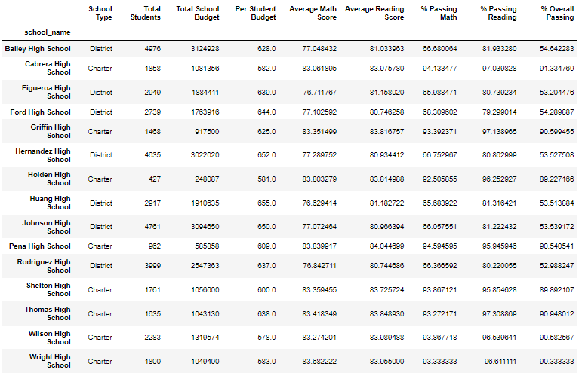

Following image shows the school summary with All 9th graders of Thomas high school with Nan.

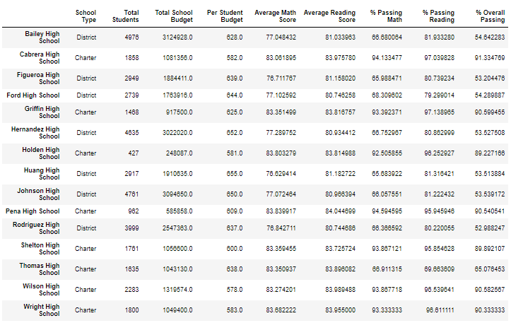

When we compared both image than we found that after placing “Nan” as a 9th graders of Thomas high school math passing, reading passing and overall passing percentage affected and it goes down because data with “Nan” not considered in percentage calculation.

* **School Ranking**

Before replacing the ninth graders’ math and reading scores as “Nan” Thomas high school had 2nd rank in top five school. After placing “Nan” as 9th graders maths and reading score Thomas high school loss its place from top 5 performing schools.

Following image shows top 5 performing schools before grade change as “Nan”.

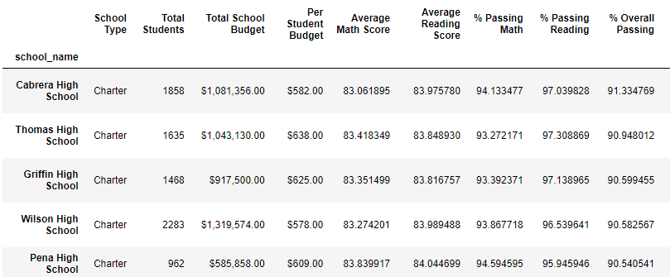

Following image shows top 5 performing schools After grade change as “Nan”.

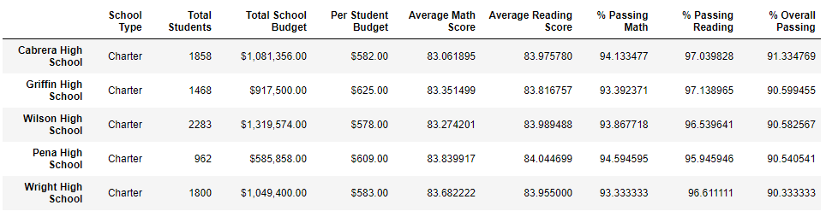

* **Math and Reading Score by grade: -**

Obliviously when we place 9th graders math and reading score as “Nan” its affect to only math and reading score of 9th graders of Thomas high school .

* **Scores by schools spending: -**

When we made four bin based on school spending range 9per student) Thomas high school in second bin $585-629. so score values in this bin affected when put “Nan” to 9th graders math and reading score of Thomas high school.

Following image show the score by spending for all students.

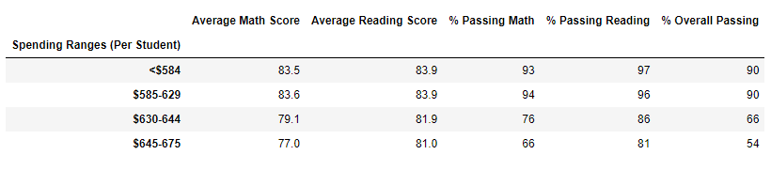

Following image shows the score by spending with All 9th graders of Thomas high school with Nan.

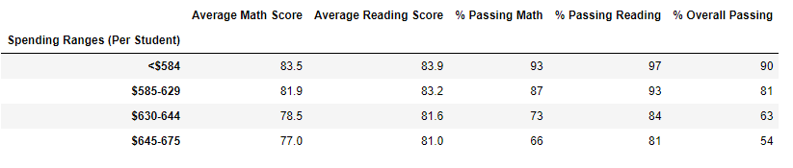

* **Scores by school size: -**

When we made three bin based on school size Thomas high school in second bin 1000-2000(medium ). so percentage values for math, reading and overall in this bin affected when put “Nan” to 9th graders math and reading score of Thomas high school.

Following image show the score by school for all students.

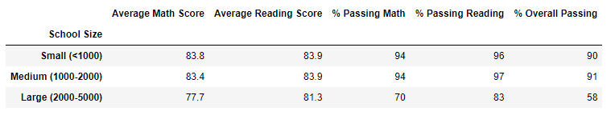

Following image shows the score by school size with All 9th graders of Thomas high school with Nan.

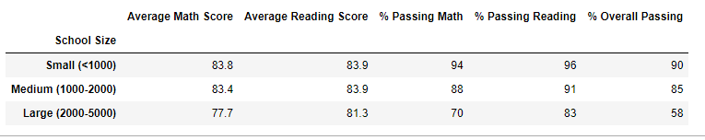

* **Scores by school size: -**

When we preform analysis based on school type Thomas high school so percentage values for math, reading and overall, in this bin affected when put “Nan” to 9th graders math and reading score of Thomas high school.

Following image show the score by type for all students.

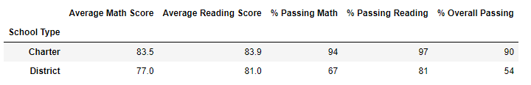

Following image shows the score by school type with All 9th graders of Thomas high school with Nan.

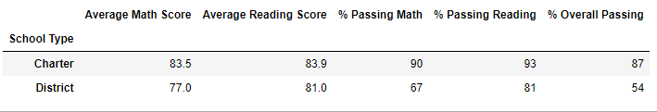

1. **Summary:**

When replacing original grade with “Nan” for all 9th graders of Thomas high school its affect to all following analysis.

* District summary
* School summary
* Top preforming school
* By spending (per spending)
* School by size
* School by type

Above analysis shows that due to “Nan” values as a grade score value down and also down Thomas high school performance.

To remove this effect we performed analysis for 10th to 12th graders of Thomas high school students.