Api-endpoint: [**http://localhost:4000/api-docs/**](http://localhost:4000/api-docs/)

**1)Endpoint ScreenShot**

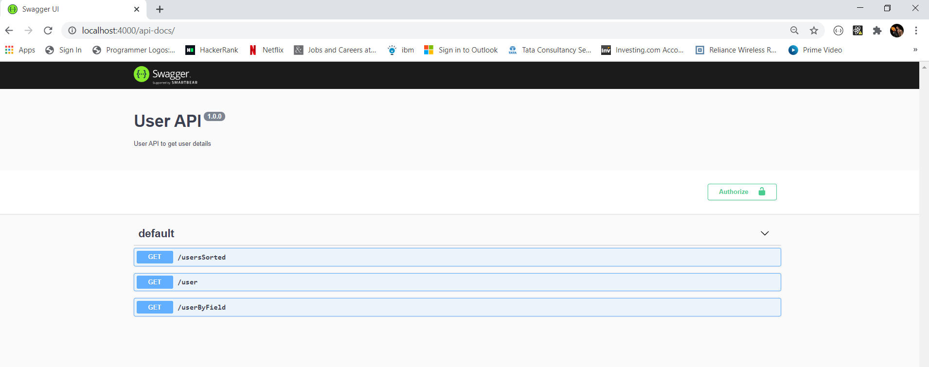

**2)userSorted by name**

[**http://localhost:4000/usersSorted**](http://localhost:4000/usersSorted)

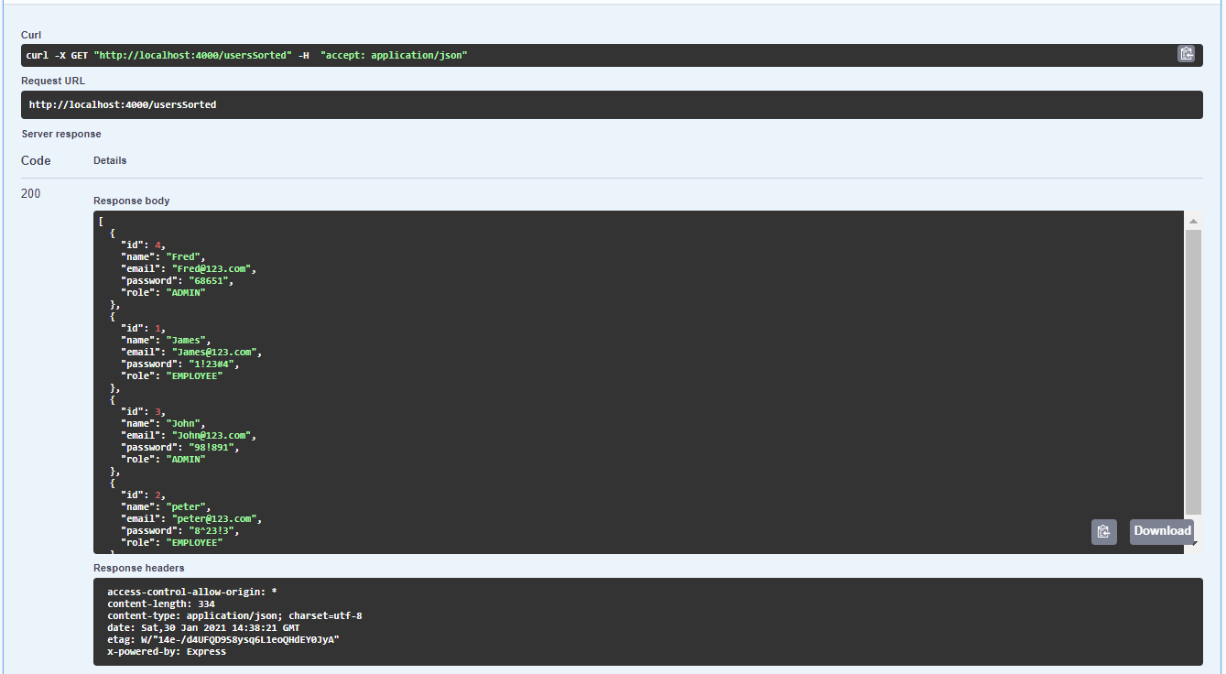

**3)get userby id**

[**http://localhost:4000/user?id=(provide**idnumber](http://localhost:4000/user?id=(provideidnumber)**)**

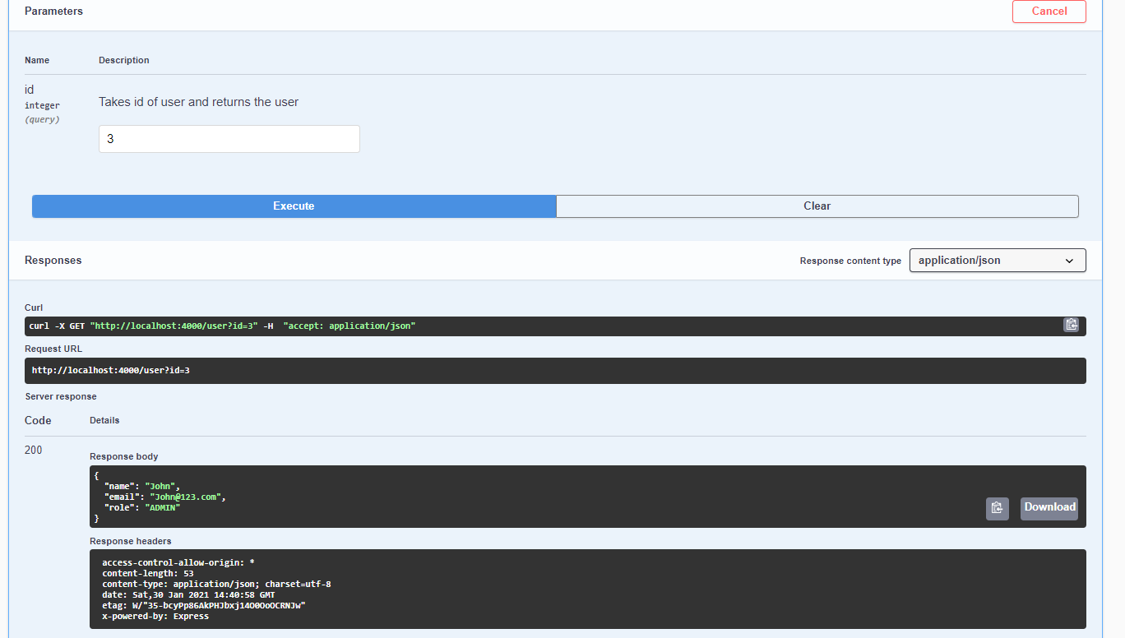

**4)searching user by an id which is not present**

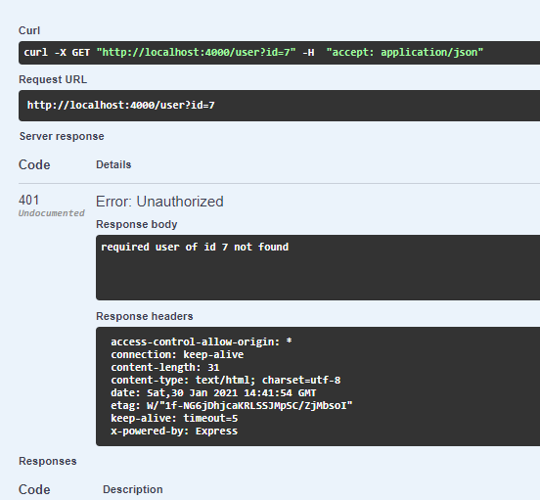

**5)get sorted users by id**

<http://localhost:4000/userByField?sortBy=(pass> “id” or “email” or “role” )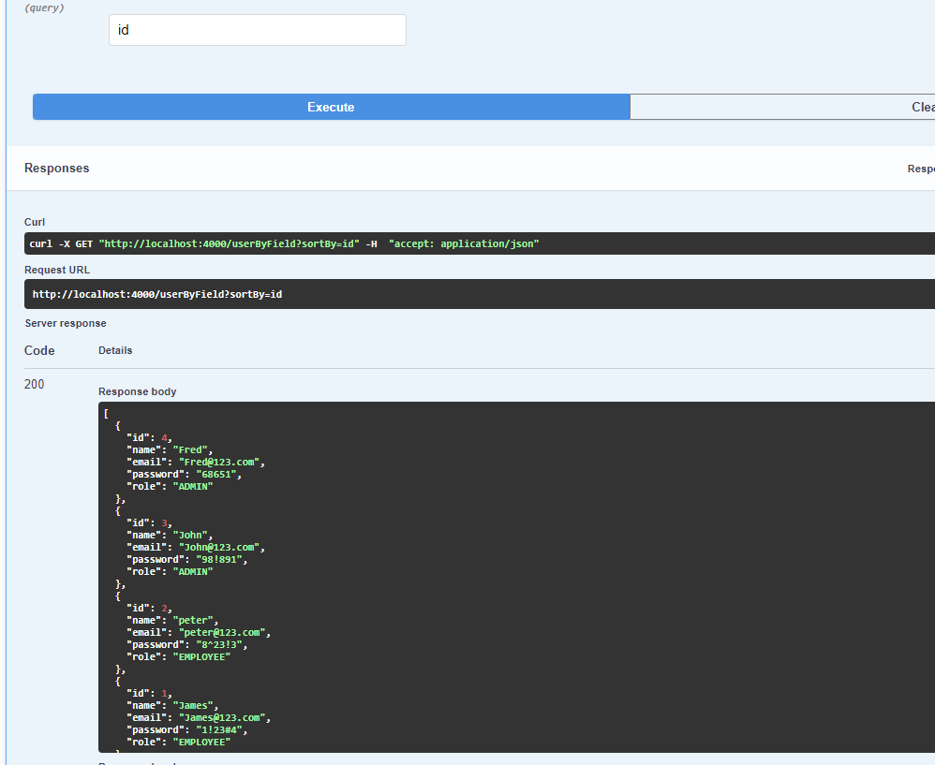

**6)get sorted users by email**

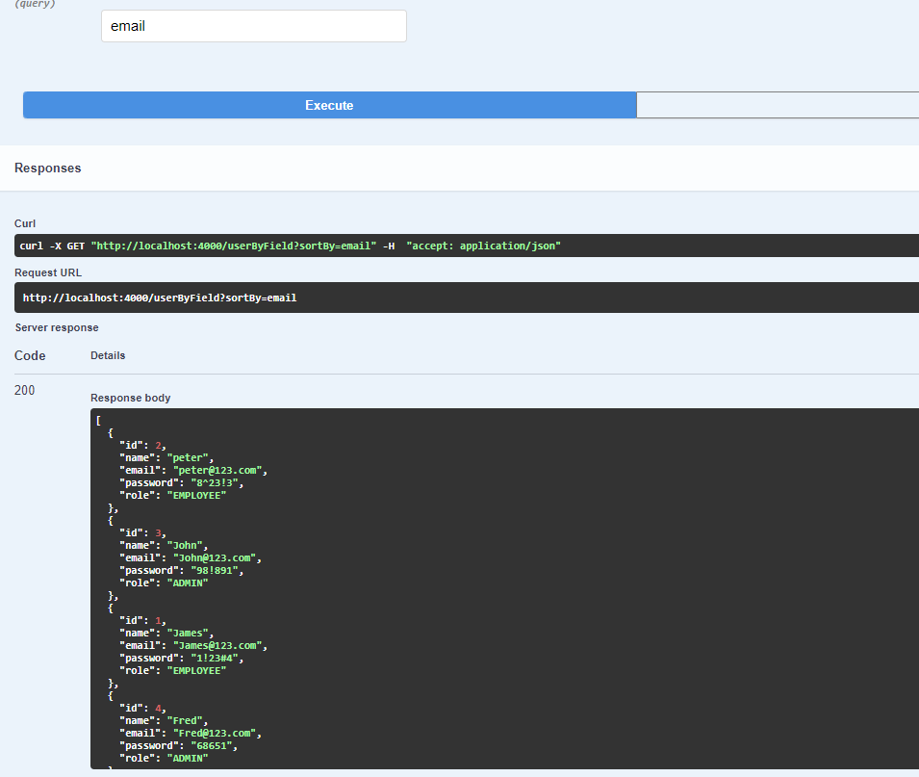

**7)sort users by role**

