Project Overview
Project Title: Digital Music Store Analysis
Domain: E-commerce, Music Retail, Business Intelligence
Technology Stack: PostgreSQL, Power BI, SQL, Data Visualization
Data Size: 10+ tables with 1,000+ records across artists, albums, tracks, and sales data

PROBLEM STATEMENT:
Primary Challenge
The digital music store lacks a comprehensive data analysis system to understand customer behavior, sales performance, and music catalog effectiveness. Business decisions are currently made based on intuition rather than data-driven insights, leading to:
- Ineffective Marketing: Unable to target the right customers with relevant promotions
- Poor Inventory Management: No visibility into which genres/artists drive revenue
- Customer Retention Issues: No system to identify and reward loyal customers
- Revenue Optimization: Missing opportunities to maximize sales from top-performing content
- Geographic Expansion: Limited understanding of regional music preferences
Specific Pain Points
- ❌ Cannot identify top customers for loyalty programs
- ❌ No clear visibility on most profitable music genres
- ❌ Unable to track artist performance and revenue contribution
- ❌ Lack of geographic sales analysis for targeted marketing
- ❌ No system to analyze customer purchasing patterns
- ❌ Manual reporting processes consuming significant time

DATABASE SCHEMA:
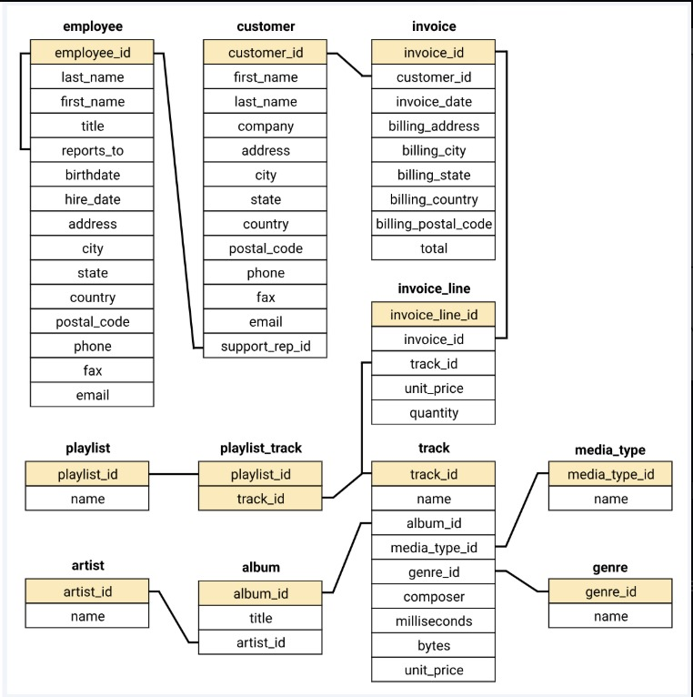

ANALYSIS OUTPUT:
Question Set 1: Basic Business Intelligence
- Senior Employee Identification - Organizational hierarchy

- Geographic Sales Distribution - Market penetration analysis
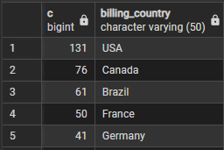
- Top Invoice Values - Large transaction identification
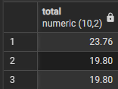
- Best Performing Cities - Geographic revenue optimization

- VIP Customer Identification - Loyalty program targeting

Question Set 2: Customer & Catalog Insights
- Genre-specific Customer Base - Targeted marketing lists
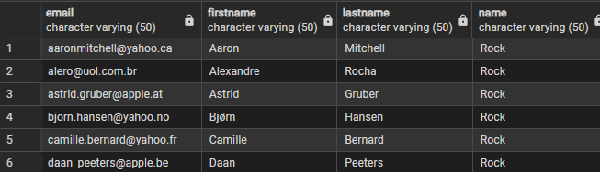
- Top Performing Artists - Partnership and promotion opportunities
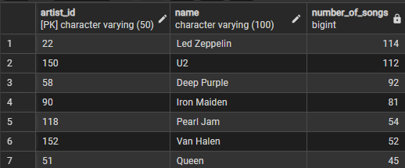
- Catalog Performance Analysis - Content strategy optimization
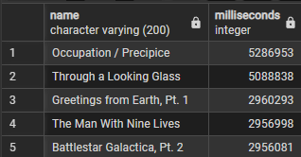
Question Set 3: Advanced Analytics
- Customer-Artist Relationship Analysis - Superfan identification
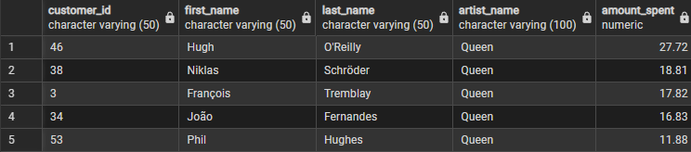
- Geographic Genre Preferences - Regional marketing strategies
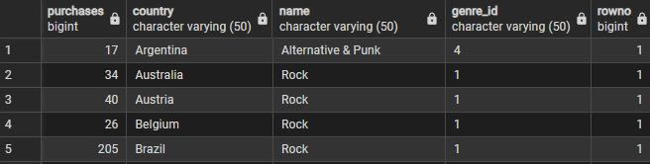
- Country-specific VIP Customers - Localized loyalty programs
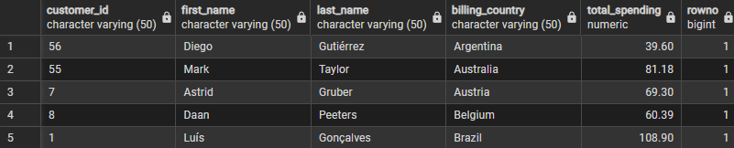
POWER BI DASHBOARD
