**Code:**

import mysql.connector  
from mysql.connector import Error  
con = mysql.connector.connect(host="localhost", user="root", passwd="Admin", database="lms")  
  
def add_book():  
 bid = int(input("Enter Book Id:"))  
 b = input("Enter Book Name:")  
 c = input("Enter Publisher Name:")  
 d = input("Enter Author Name:")  
 e = int(input("Total Quantity:"))  
 f = input("Enter the Genre:")  
 data = (bid, b, c, d, e, f)  
 sql = "insert into book values(%s,%s,%s,%s,%s,%s);"  
 g = con.cursor()  
 g.execute(sql, data)  
 con.commit()  
 print("BOOK ADDED SUCCESSFULLY")  
 main()  
  
def issuebook():  
 bid = int(input("Enter Book Id:"))  
 h = input("Enter Student Name:")  
 i = int(input("Enter Student Code:"))  
 j = input("Enter Issue Date:")  
 k = "insert into issuer values(%s,%s,%s,%s);"  
 data = (bid, h, i, j)  
 g = con.cursor()  
 g.execute(k, data)  
 con.commit()  
 print("BOOK ISSUED SUCCESSFULLY")  
 bookup(bid, -1)  
 main()  
  
def returnbook():  
 bid = int(input("Enter Book Id:"))  
 h = input("Enter Student Name:")  
 i = int(input("Enter Student Code:"))  
 l = input("Enter Return Date:")  
 k = "insert into returnbook values(%s,%s,%s,%s);"  
 data = (bid, h, i, l)  
 g = con.cursor()  
 g.execute(k, data)  
 con.commit()  
 print("BOOK RETURNED SUCCESSFULLY")  
 bookup(bid, 1)  
 main()  
  
def bookup(bid,u):  
 m = "select total from book where Book_id=%s;"  
 data = (bid,)  
 g=con.cursor()  
 g.execute(m, data)  
 myresult = g.fetchone()  
 n = myresult[0] + u  
 sql = "Update book set Total=%s where Book_id=%s;"  
 o = (n, bid)  
 g.execute(sql, o)  
 con.commit()  
 main()  
  
def delete_book():  
 ab = int(input("Enter Book Code:"))  
 m = "delete from book where Book_id=%s;"  
 data = (ab,)  
 g = con.cursor()  
 g.execute(m, data)  
 con.commit()  
 print("BOOK DELETED SUCCESSFULLY")  
 main()  
  
def display_books():  
 m = "select * from book;"  
 g = con.cursor()  
 g.execute(m)  
 myresult = g.fetchall()  
 for i in myresult:  
 print("Book Code:", i[0])  
 print("Book Name:", i[1])  
 print("Publisher:", i[2])  
 print("Author:", i[3])  
 print("Total:", i[4])  
 print("Genre:", i[5])  
 main()  
  
def report_issue_books():  
 m = "select * from issuer;"  
 g = con.cursor()  
 g.execute(m)  
 myresult = g.fetchall()  
 for i in myresult:  
 print(i)  
 main()  
  
def report_return_books():  
 m = "select * from returnbook;"  
 g = con.cursor()  
 g.execute(m)  
 myresult = g.fetchall()  
 for i in myresult:  
 print(i)  
 main()  
  
def main():  
 print("""LIBRARY MANAGEMENT SYSTEM  
 1. ADDBOOK  
 2. ISSUE BOOK  
 3. RETURN BOOK  
 4. DELETE BOOK  
 5. DISPLAY BOOKS  
 6. REPORT MENU  
 7. EXIT PROGRAM""")  
 choice = int(input("Enter Task No.:"))  
 if choice==1:  
 add_book()  
 if choice==2:  
 issuebook()  
 if choice==3:  
 returnbook()  
 if choice==4:  
 delete_book()  
 if choice==5:  
 display_books()  
 if choice==6:  
 print("""REPORT MENU  
 1. ISSUED BOOKS  
 2. REPORT BOOKS  
 3. GO BACK TO MAIN MENU""")  
 ch=int(input("Enter Task No.:"))  
 if ch==1:  
 report_issue_books()  
 if ch==2:  
 report_return_books()  
 if ch==3:  
 main()  
 else:  
 print("Please Try Again")  
 main()  
 if choice==7:  
 print("THANK YOU")  
 else:  
 print("Please Try Again")  
 main()  
main()

**Table:**

**Book:**

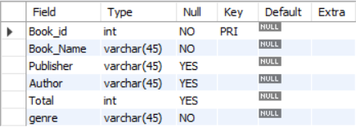

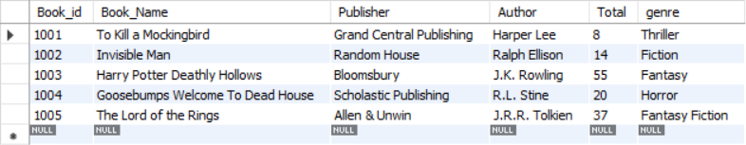

Issue:

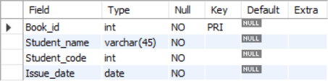

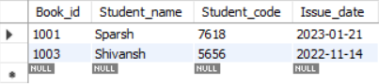

Returnbook:

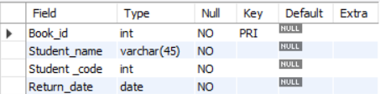

**OUTPUT:**

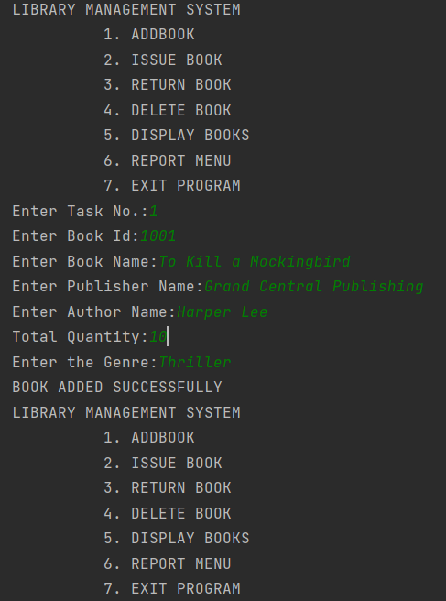

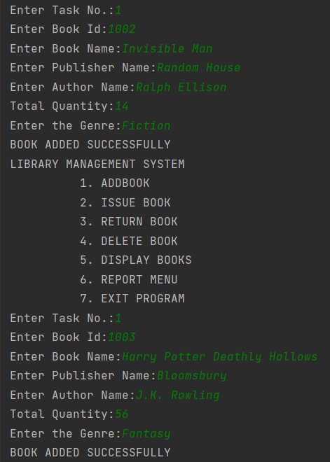

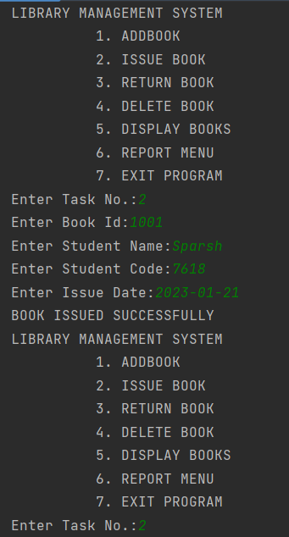

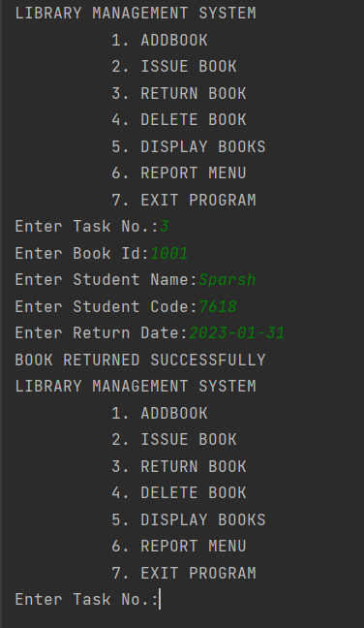

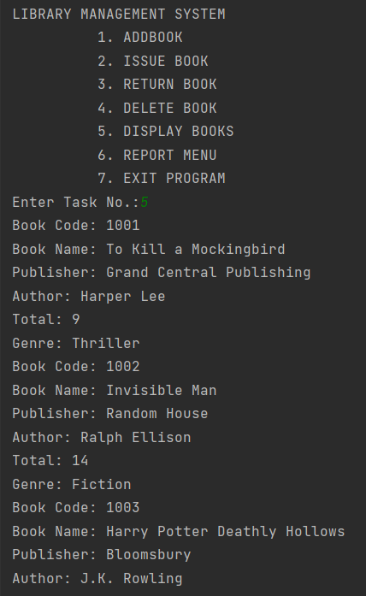

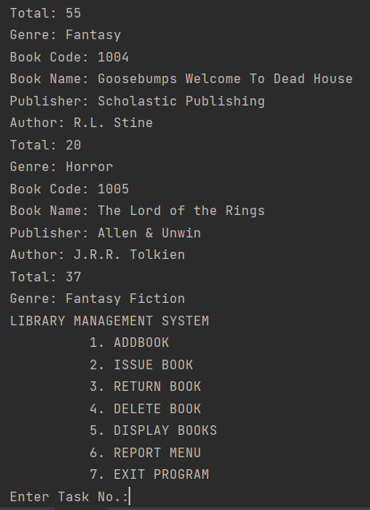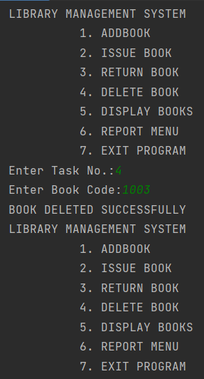

After deletion

