GitHub repository URL
https://github.com/Sparsh-singhal/github-skills-challenge

Pull request URL used to validate the workflows
https://github.com/Sparsh-singhal/github-skills-challenge/pull/1

Screenshot showing the GitHub Actions workflows
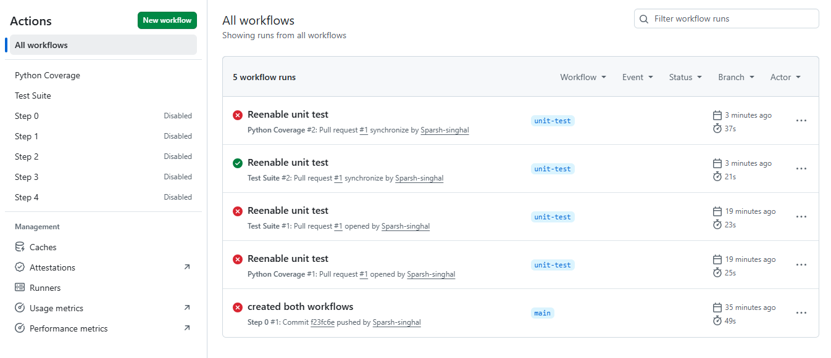

Screenshot showing a successful test workflow execution
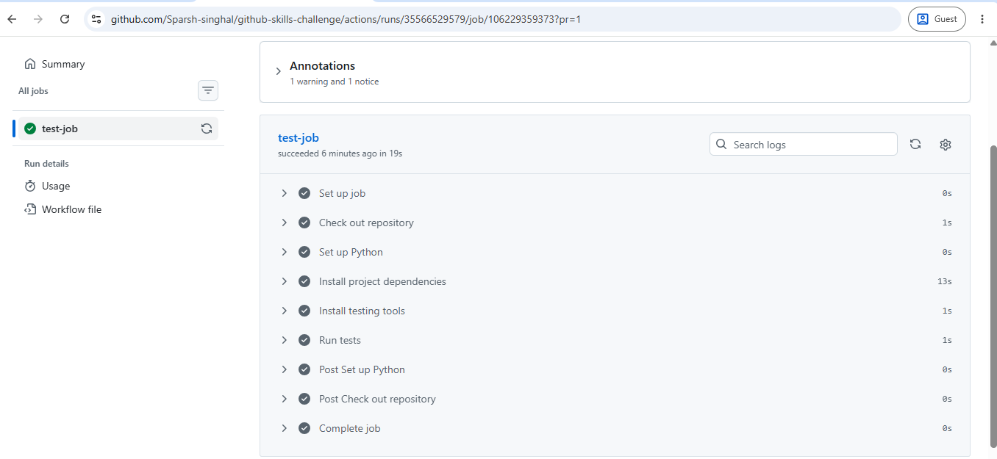

Screenshot showing the coverage result/comment on the pull request
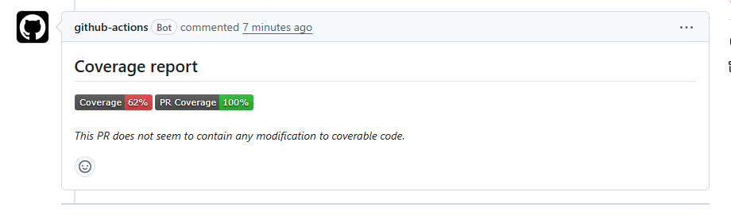
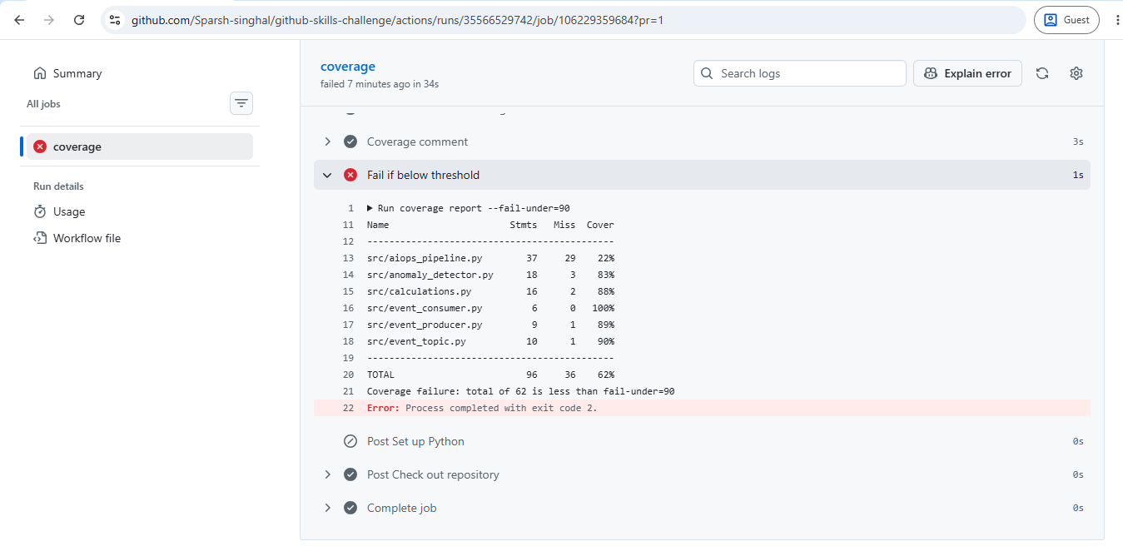

Screenshot showing the final repository/workflow files
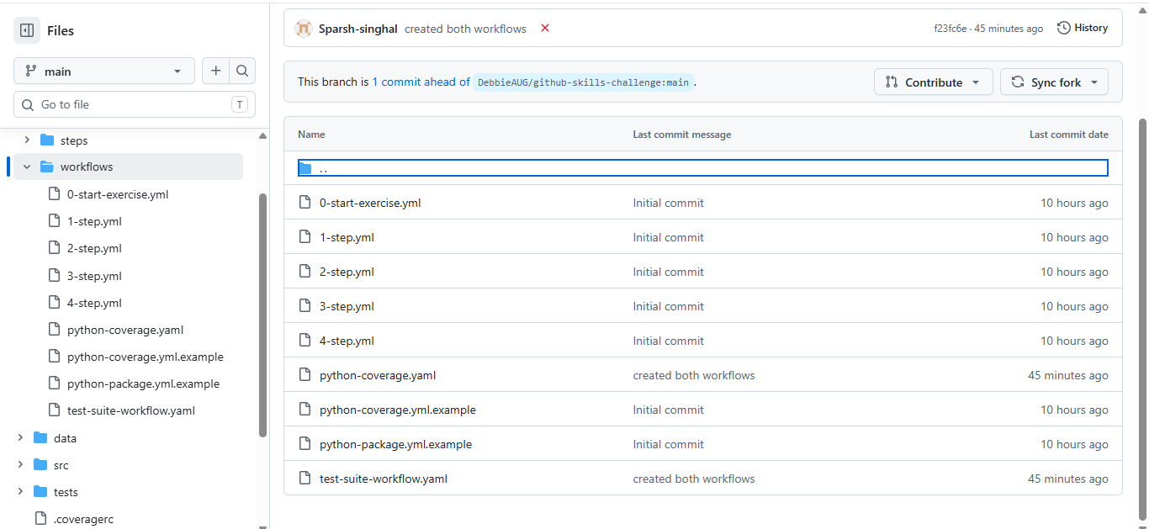
Python coverage workflow
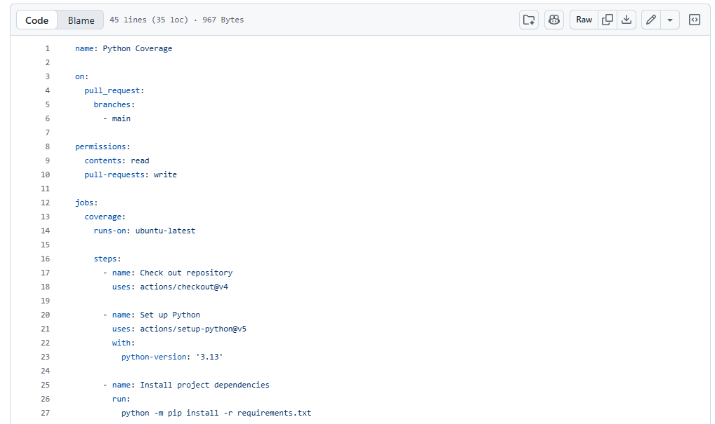

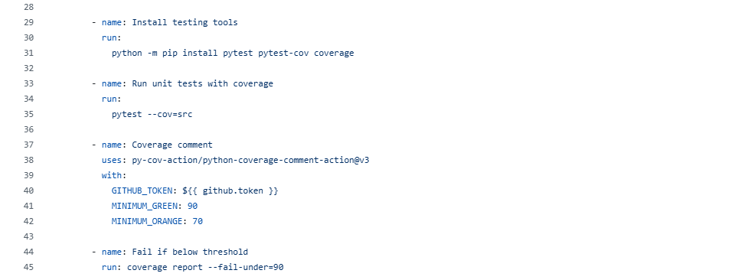

Test workflow
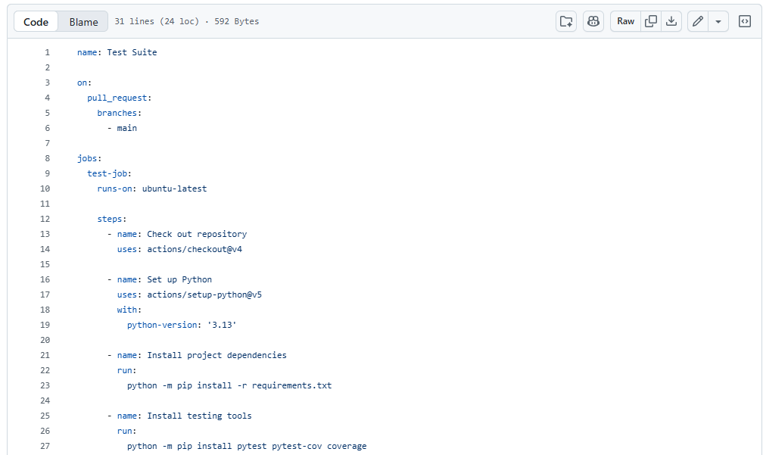

Ruleset
