nYKAAKLE Society's
KLE Technological University


Open Ended (OE) Assessment Report
On
Nykaa
Object Oriented Programming (20ECSC204)
Object Oriented Programming Lab (20ECSP203)
Submitted by
Name | Roll no | SRN
Vibhashree B.S | 103 | 01fe21bci003
Mitali.K | 129 | 01fe21bci029
Team Number: 08

Faculty In-charge:
Vijaylakshmi. Sajjanavar
SCHOOL OF COMPUTER SCIENCE & ENGINEERING
Academic year 2022-23

1. | Introduction
Overview of the problem statement
Nykaa platform faces several challenges that needs to be addressed to ensure seamless user experience and operational efficiency. The project aims to implement effective Object-Oriented Programming (OOP) principles to resolve the operational issues and user pain points on the Nykaa platform, leading to enhanced customer satisfaction, increased sales, and improved overall performance.

Features of Application
•NYKAA:
This is the base class representing a Nykaa user.
It has three data members:
Username: A string representing the user's username.
Password: A string representing the user's password.
Id: An integer representing the user's ID.
It provides two constructors:
Default constructor: Initializes the data members with default values.
Parameterized constructor: Initializes the data members with provided values after checking the password
It has a virtual method login_credentials() to display the user's login credentials. 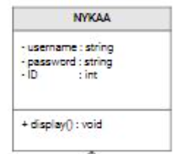

•MAKEUP
- This class represents the Makeup section of Nykaa products and extends the functionality of the base Nykaa class.
- It has four data members:
ProductType: A string representing the type of makeup product (Lipstick, Blush, Mascara).
Brand: A string representing the brand of the makeup product.
Shade: A string representing the shade of the lipstick product.
Price: A float representing the price of the selected makeup product.
- It provides several member functions:
selectProductType(): Allows the user to choose a product type (Lipstick, Blush, Mascara).
selectBrand(): Allows the user to choose a brand (Maybelline, Loreal, MAC).
selectShade(): Allows the user to choose a shade (for Lipstick product type only).
setPrice(): Sets the price based on the selected product type and brand.
display(): Displays the user's selected makeup product and its details.

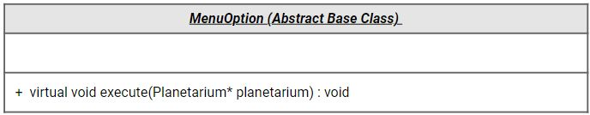
•VisitorOption: Concrete implementation of MenuOption, allowing visitors to view scheduled shows, events, and book tickets.
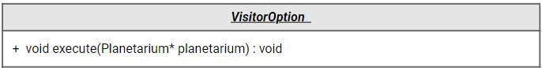

•ExhibitsOption: Concrete implementation of MenuOption, enabling staff to manage exhibits, add new exhibits, and display existing ones.
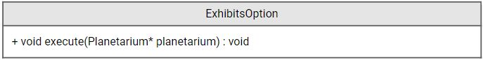
•StaffOption: Concrete implementation of MenuOption, providing staff management options to administrators, including adding and displaying staff members.
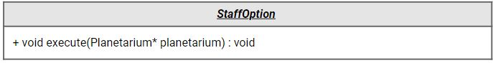
•RevenueOption: Concrete implementation of MenuOption, displaying the total revenue generated by the planetarium.
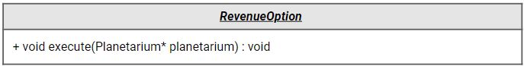
•InvestorsOption: Concrete implementation of MenuOption, allowing administrators to manage investor details like organization name and investment amount.
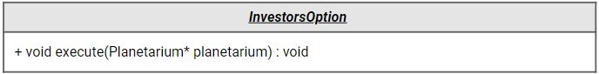
•ScheduleOption: Concrete implementation of MenuOption, enabling staff to manage the schedule of shows and events.
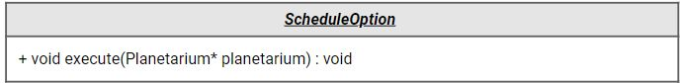

•ExitOption: Concrete implementation of MenuOption, allowing users to exit the system.
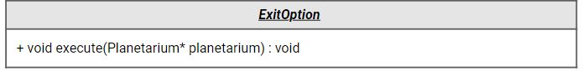
•Staff: Abstract base class representing staff members, containing common attributes like name and role.
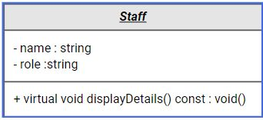
•Administrator: Subclass of Staff, storing additional information about administrators, like the department they belong to.
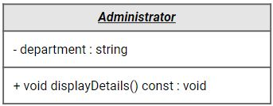
•Housekeeping: Subclass of Staff, containing details about housekeeping staff, including their shift timings.
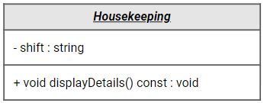

•Schedule: An abstract base class representing the schedule of shows and events
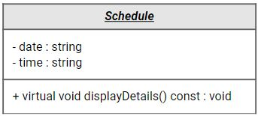
•Visitor : Abstract base class representing visitors visiting the planetarium, containing attributes like name , number of tickets booked, and the amount to be paid.
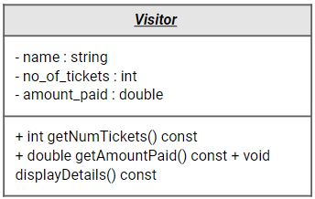

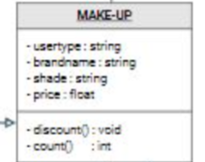
- HAIRCARE:
- This class represents the Haircare section of Nykaa products and extends the functionality of the base Nykaa class.
- It has three data members:
brand: A string representing the brand of the haircare product (Moroccanoil, Loreal).
productType: A string representing the type of haircare product (Shampoo, Conditioner, Serum, Mask).
price: A float representing the price of the selected haircare product.
- It provides several member functions:
selectBrand(): Allows the user to choose a brand (Moroccanoil, Loreal).
selectProductType(): Allows the user to choose a product type (depending on the selected brand).
setPrice(): Sets the price based on the selected brand and product type.
display(): Displays the user's selected haircare product and its details.

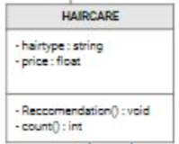

- FRAGRANCE:
This class represents the Fragrance section of Nykaa products and extends the functionality of the base Nykaa class.
It has four data members:
category: A string representing the category of the fragrance (Men, Women, Unisex).
fragrancenote: A string representing the fragrance note (Aqua, Floral, Fruity, Woody, Spice).
brandname: A string representing the brand of the fragrance product.
price: A float representing the price of the selected fragrance product.
It provides several member functions:
selectCategory(): Allows the user to choose a category (Men, Women, Unisex).
selectFragranceNote(): Allows the user to choose a fragrance note.
setBrand(): Sets the brand and price based on the selected category and fragrance note.
display(): Displays the user's selected fragrance product and its details.

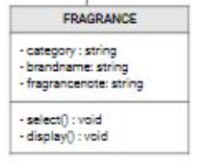

- SKINCARE
- This class represents the Skincare section of Nykaa products and extends the functionality of the base Nykaa class.
- It has four data members:
skintype: A string representing the user's skin type (Dry, Oily, Normal, Combination).
brandname: A string representing the brand of the skincare product (Loreal, Olay, Neutrogena, Cetaphil, Clinique).
producttype: A string representing the type of skincare product (Moisturizer, Toner).
- It provides several member functions:
selectSkinType(): Allows the user to choose their skin type.
selectBrand(): Allows the user to choose a brand (Loreal, Olay, Neutrogena, Cetaphil, Clinique).
selectProductType(): Allows the user to choose a product type (Moisturizer, Toner).
display(): Displays the user's selected skincare product and its details, including the price

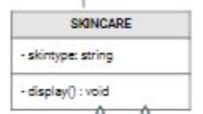

- REATIL STORE
- This class represents the Retailstore section of Nykaa, where the user can find the nearest Nykaa store in a selected city.
- It has two data members:
cityname: A string representing the city name where the user wants to find the nearest Nykaa store.
nearestStore: A string representing the name of the nearest Nykaa store in the selected city.
- It provides several member functions:
selectCity(): Allows the user to choose a city (Delhi, Mumbai, Bangalore, Chennai, Kolkata).
display(): Displays the user's selected city and the nearest Nykaa store.

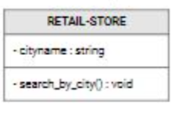

2. Design
Uml Class Diagram
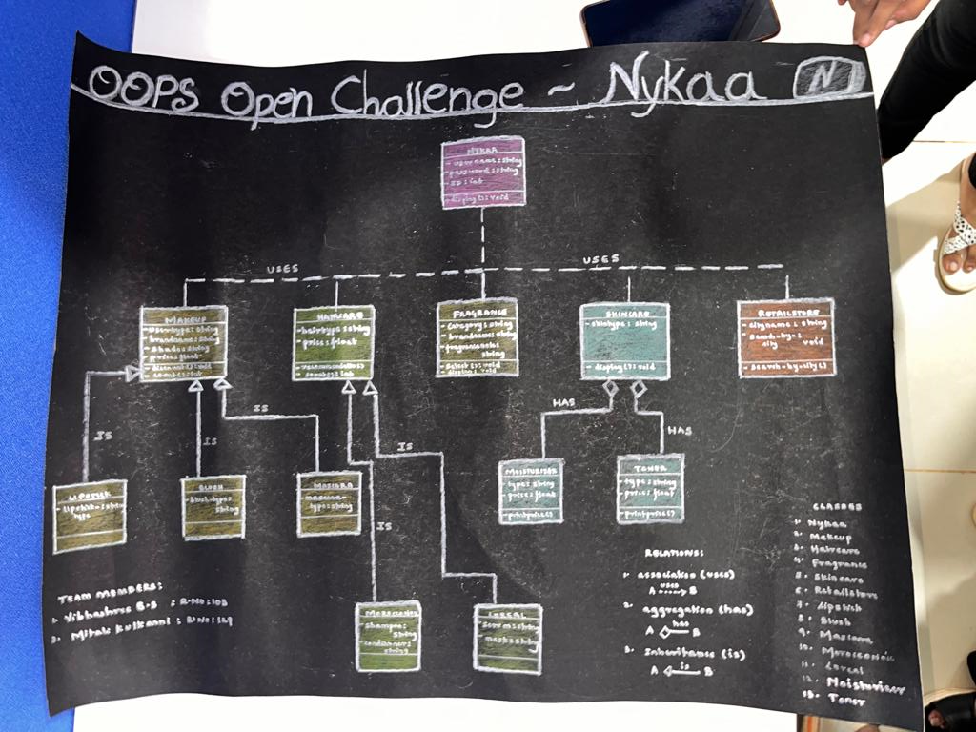
3. Implementation
3.1 Results
