M S RAMAIAH INSTITUTE OF TECHNOLOGY

(Autonomous Institute affiliated to VTU, Belgaum)

MSR Nagar, Bangalore-560054



January to May 2016

Department of Computer Science & Engineering

**INTRUSION DETECTION IN WIRELESS NETWORKS :   
AN AI APPROACH**

Submitted by

**SPARSH GUPTA 1MS12CS110**

**SUNAYANA BHOWMIK 1MS12CS117**

**HENA 1MS12CS038**

**SUMEET SEN 1MS12CS116**

Under the guidance of

Dr. Annapurna P Patil

Professor

Gantt Chart









EFFORT ESTIMATION:using cocomo

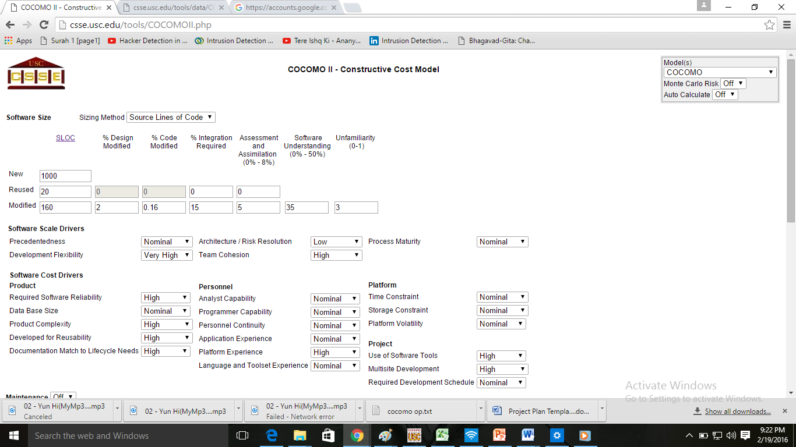

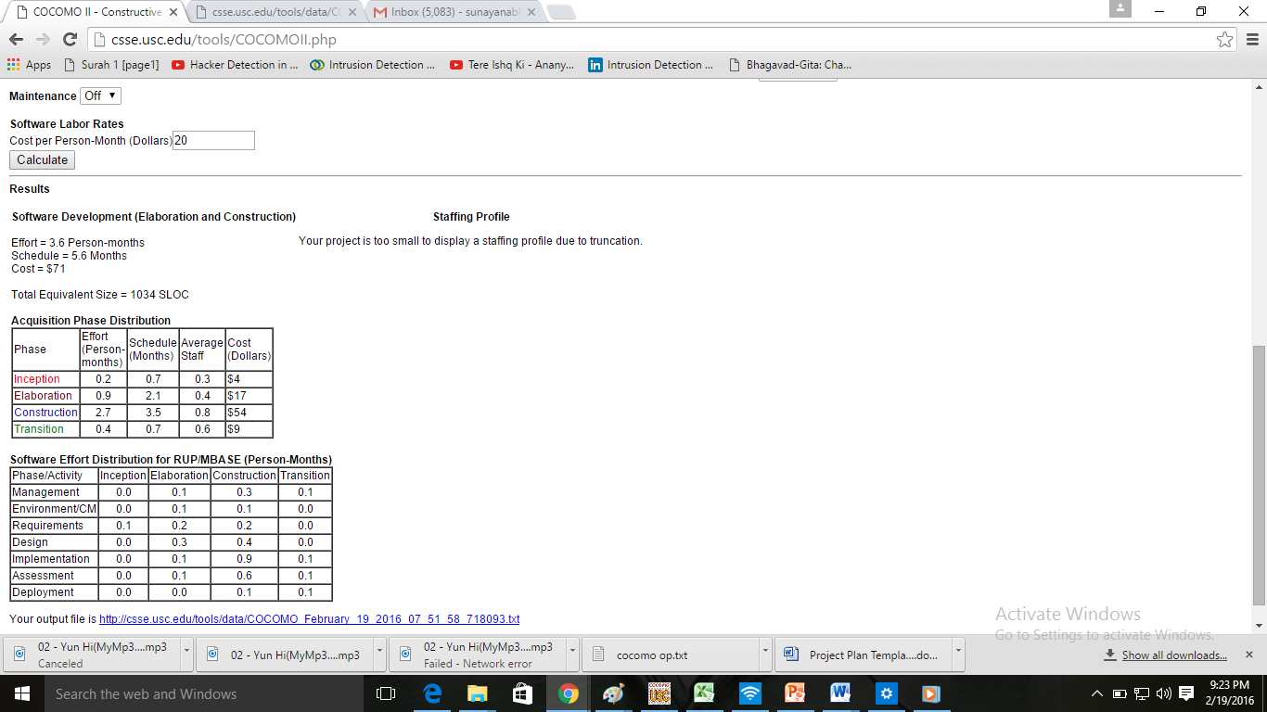

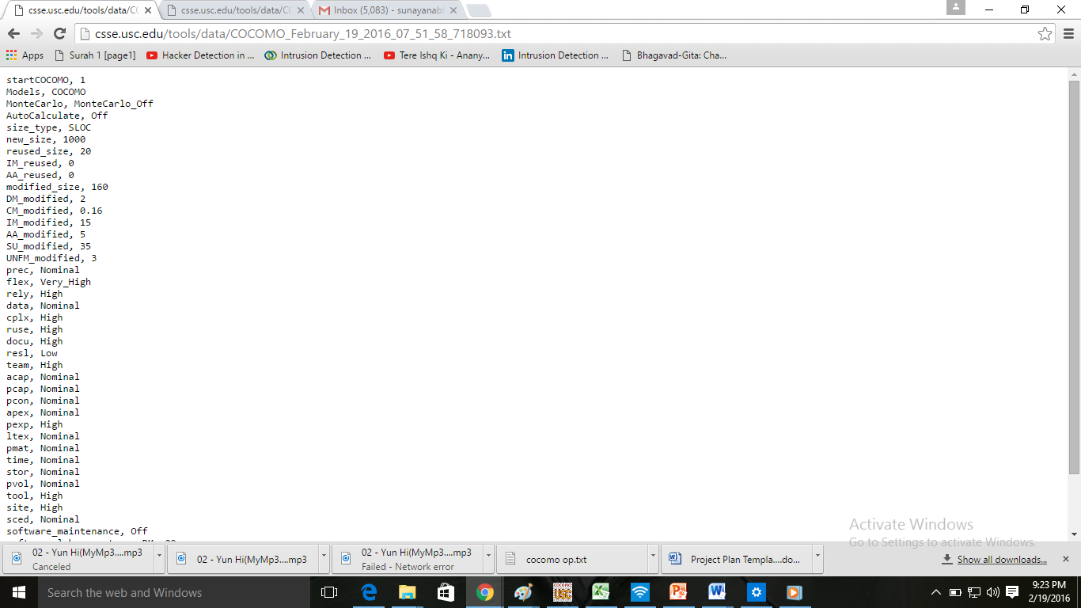

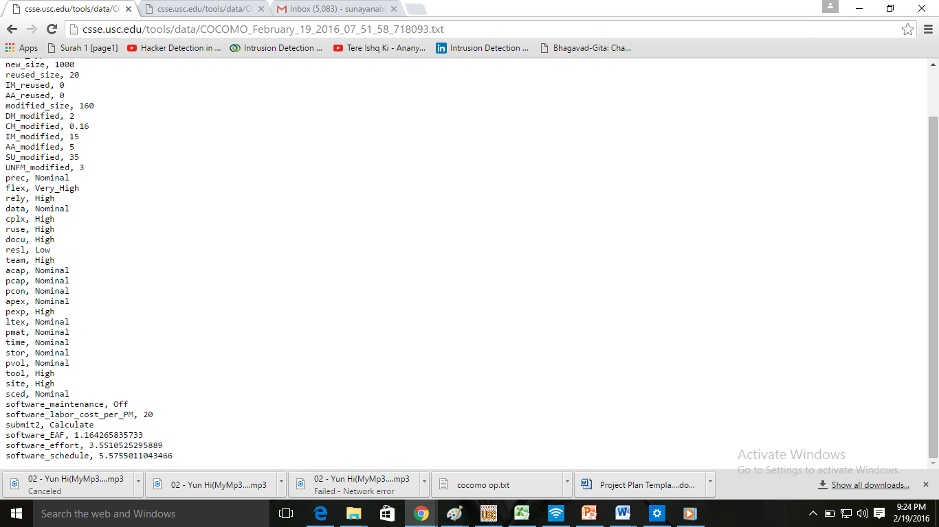

PROCESS MODEL:Prototyping model

**Software Process Model:**

The process model used is prototype model.Here the requirements are not freezed before a design or coding can proceed, a throwaway prototype is built to understand the requirements. The goal is to provide a system with overall functionality.

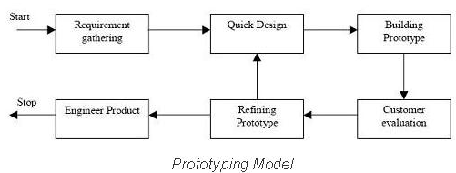

Advantages:

* This methodology a working model of the system is provided, the users get a better understanding of the system being developed.
* Errors can be detected much earlier.
* Quicker user feedback is available leading to better solutions.
* Missing functionality can be identified easily

Disadvantages:

* Leads to implementing and then repairing way of building systems.
* Practically, this methodology may increase the complexity of the system as scope of the system may expand beyond original plans.
* Incomplete application may cause application not to be used as the  
  full system was designed

**Prototyping model for our system:**

