Quiz- 2
sparsh.24bai10017@vitbhopal.ac.in Switch account

Not shared

Draft saved
* Indicates required question
*

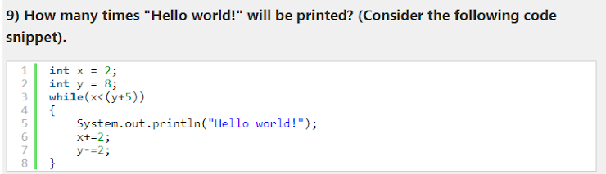
3
4
5
6
*

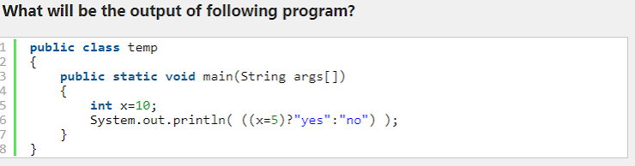
yes
Error
No
*

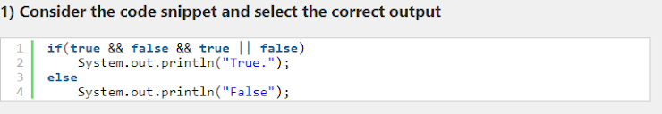
true
false
Which of the following is not a valid jump statement?*

break
goto
continue
return
*

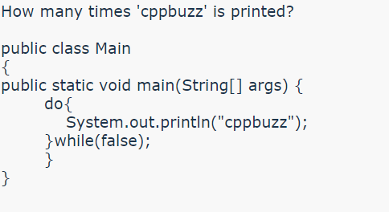
0
1
Infinite Times
Compilation Error
What is the output of Java program with IF statement? if(1){ System.out.println("OK");}*

OK
No output
Compiler error
None
*

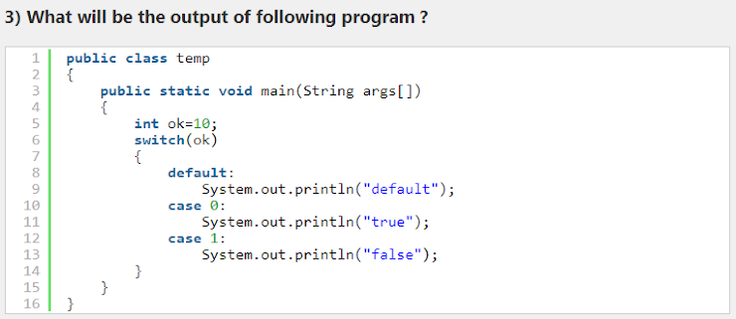
Error
default
true false default
default true false
The condition of an IF statement evaluates to boolean only if the expression contains?*

logical operators
relational operators
boolean operands
All
*

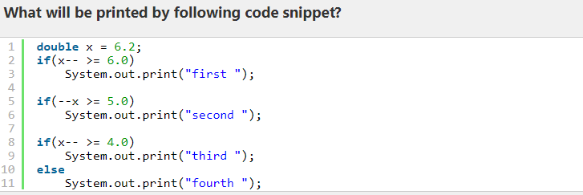
first second third
first second fourth
first third
fourth
*

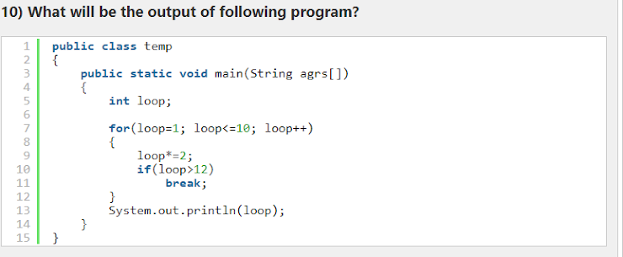
11
12
13
14
*

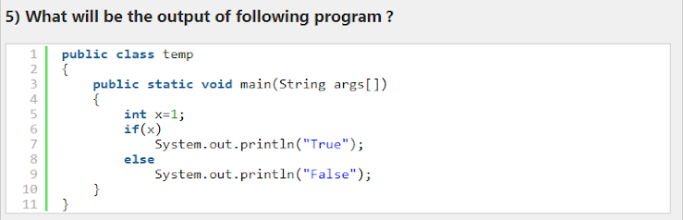
True.
False.
Error
*

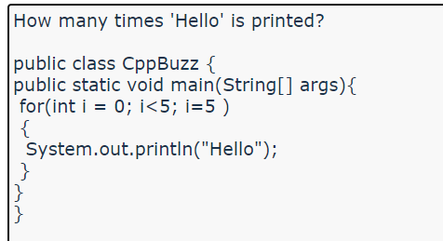
5
4
2
1
Which of these jump statements can skip processing the remainder of the code in its body for a particular iteration?*

break
return
exit
continue
*

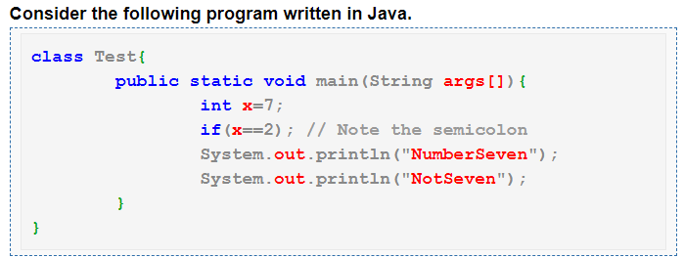
NumberSeven NotSeven
NotSeven
NumberSeven
Compiler error
Which of these are selection statements in Java?*

if()
for()
continue
break

1. Which control statement is used to execute a block of code repeatedly based on a given condition?

if statement
for loop
while loop
do-while loop
2. The switch statement in Java can only be used with which data types?

int and char
int and float
char and float
int and double
3.What will be the output of the following code?
int x = 5;
if (x > 3) {
System.out.println("x is greater than 3");
} else {
System.out.println("x is not greater than 3");
}

x is greater than 3
x is not greater than 3
x
5
4. Which control statement is used to exit a loop prematurely when a specific condition is met?

break statement
continue statement
return statement
exit statement
5. In a for loop, what happens if the update statement is omitted?

The loop will not execute.
An error will occur during compilation.
The loop will run infinitely.
The loop will execute only once.
6. What is the correct syntax for a switch statement in Java?

switch(condition) { }
switch { }
case(condition) { }
case { }
7. Which loop executes the loop body at least once, even if the condition is false?

for loop
while loop
do-while loop
until loop
8. What is the purpose of the 'else' statement in an if-else structure?

To handle exceptions
To provide an alternative code block if the condition is false
To stop the execution of the program
To restart the execution of the program
9. What will be the output of the following code ?
int x = 10;
if (x % 2 == 0) {
if (x > 5) {
System.out.println("x is even and greater than 5");
} else {
System.out.println("x is even and not greater than 5");
}
} else {
System.out.println("x is odd");
}

x is even and greater than 5
x is even and not greater than 5
x is odd
No output will be printed
10.What is the purpose of the 'break' statement in a loop?

To restart the loop
To skip the current iteration and move to the next one
To force the immediate termination of the loop
To return a value from the loop

