Team 7:
- Shweta Yadav
- Siddhartha Vardhan Somvanshi
- Skandita Dwivedi
- Sparsh Maurya

Water Level Detector Using Arduino UNO, Ultrasonic Sensor, and I2C LCD

Abstract
This project presents the design and implementation of a digital water level detector using the Arduino UNO R3 microcontroller, an ultrasonic sensor (HC-SR04), and a 16x2 LCD display with I2C interface. The system reliably monitors the water level inside a tank and displays real-time information including both height (in cm) and percentage. This solution is cost-effective, easy to assemble, and ideal for household, agricultural, or industrial water management.

Introduction
Water level monitoring is vital for various applications: household water tanks, irrigation, industrial storage. Traditional float sensors can sometimes be unreliable and fail mechanically. Our project uses an ultrasonic sensor for non-contact, precise measurement, processed by the Arduino UNO, and displayed on an LCD screen for user-friendly monitoring.

Components Required
- Arduino UNO R3 (1x)
- Ultrasonic Sensor HC-SR04 (1x)
- 16x2 LCD Display with I2C module (1x)
- Jumper Wires
- Water Tank or Container
- USB Cable (for Arduino programming/power)

Circuit Diagram & Connections
- Key Connections
Ultrasonic Sensor (HC-SR04):
Pin |  | Arduino UNO
VCC |  | 5V
GND |  | GND
Trig |  | Pin 12
Echo |  | Pin 11
LCD 16x2 with I2C Module:
Pin | Arduino UNO
VCC | 5V
GND | GND
SDA | A4
SCL | A5

Wiring Diagram::
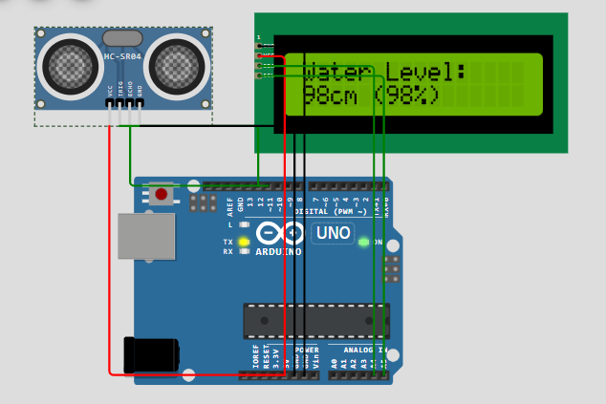

Working Principle
- The ultrasonic sensor is placed at the top of the tank.
- It emits ultrasonic pulses toward the water's surface and listens for the echo.
- The Arduino calculates the distance using the speed of sound and time of flight.
- Water level is found by subtracting this measured distance from the total tank height.
- The LCD shows both centimeter value and percentage.
Advantages
- Non-contact measurement (no submerged parts)
- Accurate and easy to adjust
- Upgradeable (e.g., add buzzer, Wi-Fi alert)

Arduino Code

#include <LiquidCrystal_I2C.h>
LiquidCrystal_I2C lcd(0x27, 16, 2);

const int trigPin = 12;
const int echoPin = 11;
long duration;
int distance;
// Set according to your tank depth (in cm)
const int TANK_DEPTH_CM = 10;
const float SOUND_SPEED_CM_PER_US = 0.034;
const int LOOP_DELAY_MS = 100;

void setup() {
pinMode(trigPin, OUTPUT);
pinMode(echoPin, INPUT);
Serial.begin(9600);
lcd.init();
lcd.backlight();
lcd.clear();
}

void loop() {
digitalWrite(trigPin, LOW);
delayMicroseconds(7);
digitalWrite(trigPin, HIGH);
delayMicroseconds(10);
digitalWrite(trigPin, LOW);

duration = pulseIn(echoPin, HIGH);
distance = duration * SOUND_SPEED_CM_PER_US / 2;
int waterLevel = TANK_DEPTH_CM - distance;
if (waterLevel < 0) waterLevel = 0;
if (waterLevel > TANK_DEPTH_CM) waterLevel = TANK_DEPTH_CM;
int percentage = (waterLevel * 100) / TANK_DEPTH_CM;

lcd.clear();
lcd.setCursor(0, 0);
lcd.print("Water Level:");
lcd.setCursor(0, 1);
lcd.print(waterLevel);
lcd.print("cm (");
lcd.print(percentage);
lcd.print("%)");
Serial.print("Water Level: ");
Serial.print(waterLevel);
Serial.print(" cm (");
Serial.print(percentage);
Serial.println("%)");
delay(LOOP_DELAY_MS);
}

Step-by-step Procedure

- Assemble the Circuit:
Carefully connect each component to the Arduino as above. Double-check VCC and GND.
- Mount the Ultrasonic Sensor:
Attach the HC-SR04 at the top, facing down toward the water surface.
- Upload the Code:
Open Arduino IDE, install the LiquidCrystal_I2C library, paste the code, and upload it.
- Calibrate:
Set TANK_DEPTH_CM to your tank’s actual height in cm.
- Test and Observe:
The LCD now shows live water level information. Changing water level will update the reading.
PROTOTYPE IMAGES::
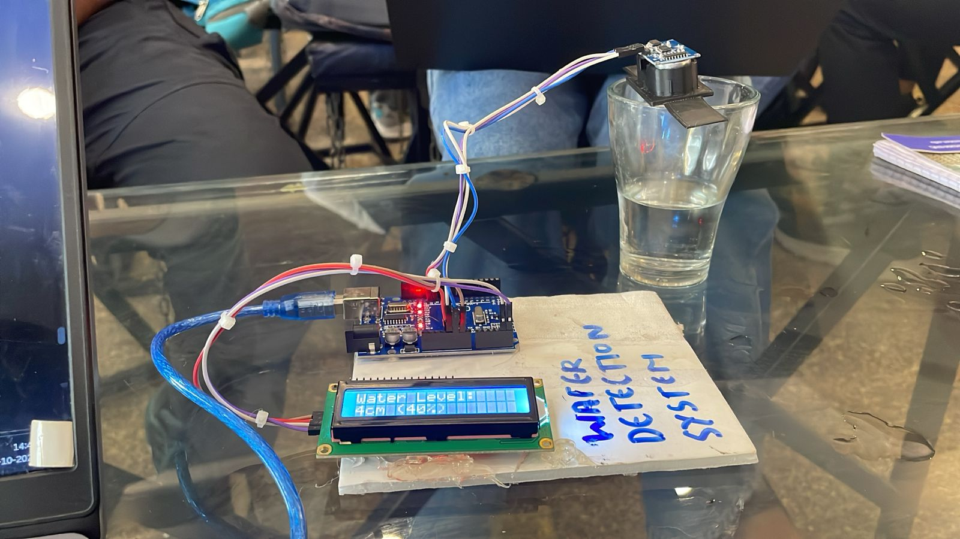
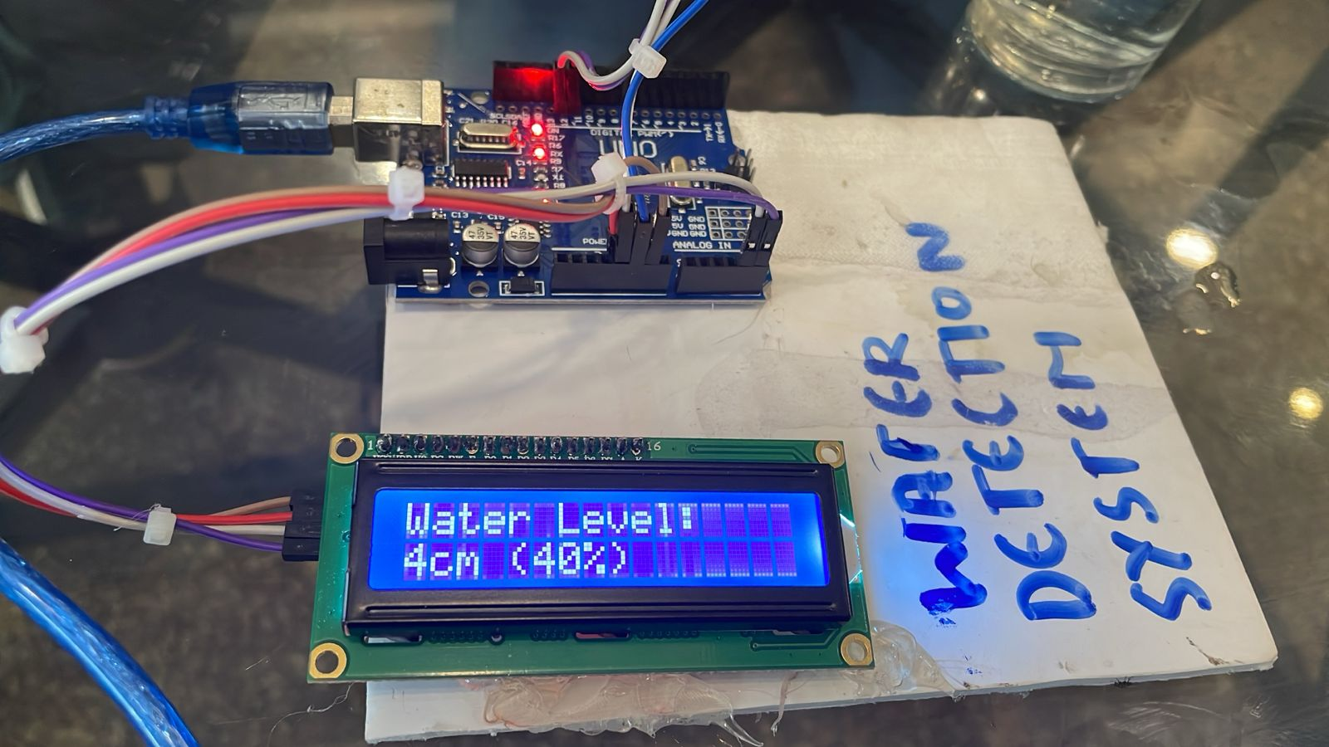

Result
- Accurate water height and fill percentage displayed on the LCD.
- Can be adapted for different tank depths (update code).
- Real-time monitoring.

Applications and Improvements
- Domestic water tanks
- Agricultural irrigation monitoring
- Industrial liquid/chemical storage tanks
- Add-ons: Wi-Fi/Bluetooth remote alerts, relay controls, buzzer for alarms

Conclusion

This project presents a reliable and non-intrusive solution for monitoring water levels using affordable and commonly available electronic components. By integrating the Arduino UNO microcontroller, HC-SR04 ultrasonic sensor, and I2C LCD display, the system efficiently measures and displays real-time water levels with high accuracy. Its design emphasizes simplicity, cost-effectiveness, and scalability, making it suitable for various applications such as household water tanks, irrigation systems, and industrial water management setups. Overall, the project demonstrates how modern embedded technology can contribute to smarter and more sustainable water resource management.

