**How to manage backup setup for the Linux Server EC2?**

**Created By : Pratik Sharma**

**Date : 28/02/2022**

**Product : Web servers (ec2 Instance)**

**Brief Summary: This guideline is all about “How to manage backup setup for the Linux Server EC2”:**

**1: How to Install script :**

**2: It's setting and stop or start of script :**

**3: List of running web site for automated backup script :**

**1:-** After change on the server we have a new fresh ec2 instance web server. so for the backup "connect the server with winscp or filezila and copy the script file" from local machine or wget the script from s3 bucket with ssh connection.

Run the following command :-

$ sudo su sudo

$ wget https://appbackupcurrent.s3.ap-south-1.amazonaws.com/ucanassess_pratik/autobackup-script/backup.sh

$ chmod +x backup.sh

$ crontab -e (after this command type the following text inside)

10 16 * * * sudo sh /home/ec2-user/backup.sh

30 16 * * * aws s3 cp /var/app/current_backup-* s3://appbackupcurrent/mckv-website/autoBackup/

02 17 * * * sudo rm -vf /var/app/current_backup-*



**2: It's setting and stop or start of script :**

*To "****stop"*** *this script we need to run the following command and edit the first line of the file.*

$ crontab -e (after this command type "i" button for edit)

10 16 * * * sudo sh /home/ec2-user/backup.sh

30 16 * * * aws s3 cp /var/app/current_backup-* s3://appbackupcurrent/mckv-website/autoBackup/

02 17 * * * sudo rm -vf /var/app/current_backup-*

***To stop the script file add # at the beginning of the first line. then for save and exit type*** *":wq!"*

*To "****start"*** *this script file just do the same & remove the # mark from the beginning of the first line.*

**\*** Under the S3 bucket "appbackupcurrent" the following path is used for our automated backup

s3://appbackupcurrent/mckv-website/autoBackup/

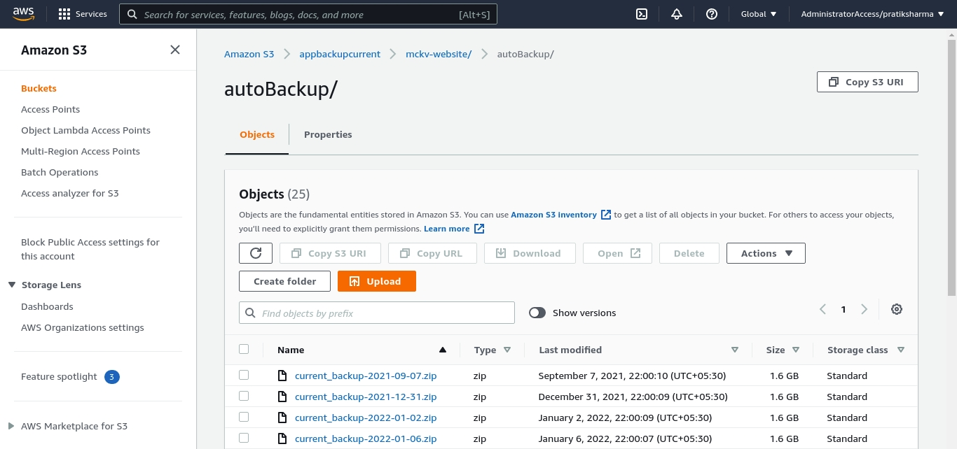



**3: List of running web site for automated backup script :**

mckv-website

ucl-niftem

raiganj-website

**#!/bin/bash**

**cd**

**sudo rm -vf /var/app/current_backup-\***

**cd /var/app && sudo zip -r "current_backup-$(date +"%Y-%m-%d").zip" * .[^.]\***

**Steps for EC2 backup:**

1. Every time, after change in the server, we will have a fresh server which is empty (No data).
2. Connect to the server via ssh.
3. After the connection is successful, use the following command.
4. Run the command ==> “**sudo su”**to change from ec2 user to root user.
5. Create a file named **“backup.sh”**  by using **“vim”** command.
6. ==> **“vim backup.sh”**
7. The vim editor will open up.
8. Paste the following code in the vim editor.

**#!/bin/bash**

**cd**

**sudo rm -vf /var/app/current/current_backup-\***

**cd /var/app/current/ && sudo zip -r "current_backup-$(date +"%Y-%m-%d").zip" * .[^.]\***

1. Save and exit the vim editor using **“:wq”** command.
2. Now make the backup.sh file, an executable one using the following command.

**“chmod +x backup.sh”**

1. The backup.sh file will become executable and will be shown in green colour and it is executed automatically.
2. Now run the following command.

**“crontab -e”**

1. An editor will open. Paste the following code in the editor.

**10 16 * * * sudo sh /home/ec2-user/backup.sh**

**30 16 * * * sudo aws s3 cp /var/app/current/current_backup-* s3://appbackupcurrent/mckv-website/autoBackup/**

**02 17 * * * sudo rm -vf /var/app/current/current_backup-\***

1. After the execution of backup.sh file, the backup will start automatically.
2. The crontab file will be executed after half an hour from the start of backup.sh file.

**10 16 * * \***

**Minute hour day (month) month day (week)**