Game Design Document

Fill up the following document

1. Write the title of your project.

Subway Surfers

1. What is the goal of the game?

It would be a infinite runner game

1. Write a brief story of your game.

There would be a boy who was painting a train and the watchman man watches him and tries to catch the boy

1. Which are the playing characters of this game?

* Playing characters are the ones who respond to the user based on the input from the user.
* Cars, monkeys, dinos, wizards, etc., are the playing characters in the game.

|  |  |  |
| --- | --- | --- |
| Number | Character Name | What can this character do? |
| 1 | Jake | When jumps speed increases by 0.1 |
| 2 |  |  |
| 3 |  |  |
| 4 |  |  |
| 5 |  |  |
| 6 |  |  |
| 7 |  |  |
| 8 |  |  |

1. Which are the Non-Playing Characters of this game?

* Non-Playing characters are the ones that don't have an action or behavior when the user interacts with the game.
* Hurdles, stones, bananas, coins, etc., are non-playing characters in the game.

|  |  |  |
| --- | --- | --- |
| Number | Character Name | What can this character do? |
| 1 |  |  |
| 2 |  |  |
| 4 | Watchman |  |
| 5 | Watchman’s dog (optional) |  |
| 6 |  |  |
| 7 |  |  |
| 8 |  |  |

Draw your imagination of this game. What does this game look like?

* Draw the game either on your computer or on paper.
* Add images of the game scenes to show each of the playing and non-playing characters at least once.

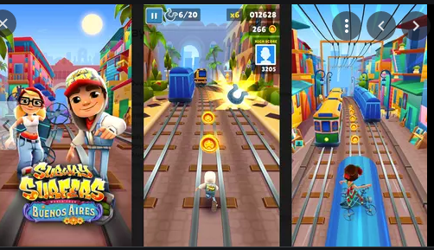

How do you plan to make your game engaging?

For much fun and intrest we will add coins between the track

And if the watchman catches us the game would be over and we can restart it