Sparsh Rai

Indian Institute of technology Kanpur

Off Grid Solar Powered EV Charging Station

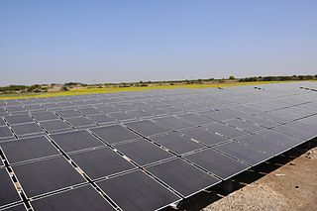

EV Charging

Location-

* Azad Maidan(26.26’81’’N 80.32’28’’E)
* Elevation 120m

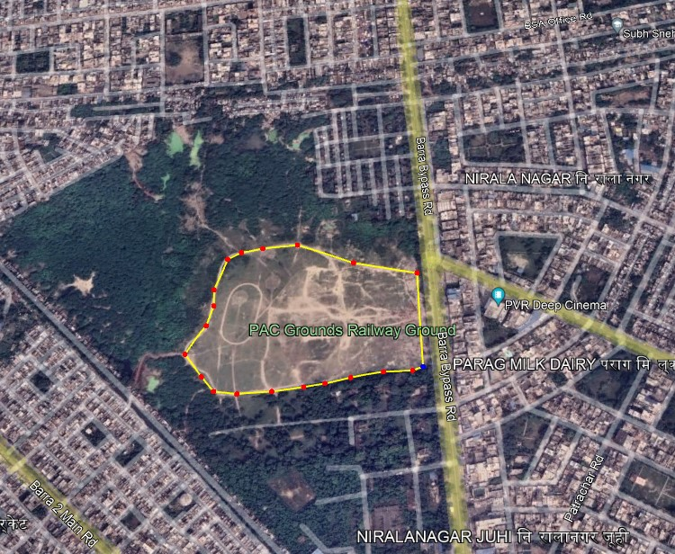

Specifications and Standards-

1. Charging Capacity of 50KWh/day

* Level 2 charging
* 50Kw During Day time
* 2 Chargers of 10 Kw
* 5 Charger of 3 Kw
* 3 Chargers of 7Kw

1. Bharat DC 001 (15Kw) Charger

* Max Output Voltage of 240 V for 4 wheeler
* Max Output Voltage of 48 for 3 Wheeler and 2 Wheeler
* Single Connector gun

1. Solar Module Configuration

* AEG Solar
* 325Wp Max power
* 1.50m^2 Area
* Detailed Specification sheet is attached
* at the end

1. Battery Specifications

* Li Ion Battery
* 25.6V Nominal Voltage
* C10 Capacity =100Ah
* DOD=95%
* 5 Years Battery Life

Load Requirement and Calculations

* This Charging station is designed to Handle 2400Kwh/day of charging in a whole day of which 50Kwh will be during the day time and 50Kwh During the night time.

1. **Total consumption calculation**

* Consumption = 100 KWh/day

1. **Calculation of Solar Power plant according to MNRE:**

* Total Consumption = 100 KWh/day
* Plant peak sunny hour operation = 4.5s (Normal consideration)
* Plant Performance = 70% = 0.7
* Solar Power plant capacity =

= = 31.74 KW (Plant capacity to be installed)

* Plant Capacity = 32 KW
* Module Rating = 325 Wp

Total no of modules required = (32 x 1000 )/325 = 99

1. **Battery Sizing Calculation: (Li Ion Battery)**

Battery will be required for night time only.

* Total consumption = 100 KWH
* Day of Autonomy = 2day (Means how many days it will carry the charge)

Margin is 15% extra i.e. (100% + 15%) = 115% =1.15 Battery unit is in AH

* PCU Charge controller Voltage 20 KW to 30 KW = 96 V
* Depth of Discharge (DOD) =Assume depth of discharge as 95 % = 0.95
* Battery Efficiency = 100 % = 1
* AH =

AH = = AH = 1260 AH So, we need 1260 AH Battery.

* Total storage of battery for 2 day = 2X96V X 1260

AH = 241KWH