**INTERNATIONAL SCHOOL OF   
MANAGEMENT AND TECHNOLOGY**



**FACULTY OF COMPUTING**

**ASSIGNMENT COVER SHEET**

*This form is to be completed by students submitting assignments of level 4 and level 5. Students are required to complete all sections and attach to your assignment.*

|  |  |
| --- | --- |
| STUDENT DETAILS | |
| STUDENT NAME | Sparsh Shrestha |
| STUDENT ID | PG77125 |

|  |  |  |  |
| --- | --- | --- | --- |
| UNIT AND ASSIGNMENT DETAILS | | | |
| UNIT TITLE | Unit 14: Business Intelligence | | |
| UNIT NUMBER | M/615/1641 | | |
| ASSIGNMENT TITLE | Business Intelligence – City Production Company | | |
| ISSUE DATE | 29th April, 2023 | DUE DATE | 28th June, 2023 |
| ASSESSOR NAME | Sujan Timsina | | |
| ESTIMATED WORD LENGTH |  | | |

|  |  |
| --- | --- |
| SUBMISSION | |
| HAND IN DATE |  |

**DECLERATION AND ACKNOWLEDGEMENT**

***When submitting assignments, each student must sign a declaration confirming that the work is their own.***

Plagiarism and Collusion

**Plagiarism:** to use or pass off as one’s own, the writings or ideas of another without acknowledging or crediting the source from which the ideas are taken.

**Collusion:** submitting an assignment, project or report completed by another person and passing it off as one’s.

In accordance with the*Academic Integrity and Plagiarism Policy*:

1. **I declare that:**
2. this assignment is entirely my own work, except where I have included fully-documented references to the work of others,
3. the material contained in this assignment has not previously been submitted for any other subject at the University or any other educational institution, except as otherwise permitted,
4. no part of this assignment or product has been submitted by me in another (previous or current) assessment, except where appropriately referenced, and with prior permission from the Lecturer / Tutor / Unit Coordinator for this unit.
5. **I acknowledge that:**
6. if required to do so, I will provide an electronic copy of this assignment to the assessor;
7. the assessor of this assignment may, for the purpose of assessing this assignment:
8. reproduce this assignment and provide a copy to another member of academic staff;
9. communicate a copy of this assignment to a plagiarism checking service such as Plagiarism Check (which may then retain a copy of this assignment on its database for the purpose of future plagiarism checking).

|  |  |  |  |
| --- | --- | --- | --- |
| I am aware of and understand that any breaches to the Academic Code of Conduct will be investigated and sanctioned in accordance with the College Policy. | | | |
| SIGNATURE |  | DATE |  |

**Table of Contents**

Part 1 1

1.1. Introduction 1

1.2. Business Process 1

1.2.1. Steps of Business Process 2

1.2.2. Example of Business Process 3

2.1. Business process categories 4

2.1. Operational Processes 4

2.2. Supporting Processes 5

2.3. Management Processes 5

3.1. Supporting Processes 5

3.1.1. Area of Supporting Process 5

3.1.2. Example of supporting process 6

4.1. Differentiate between unstructured and semi-structured data within an organisation 6

4.1.1. Unstructured Data 7

4.1.2. Semi-structured Data 7

4.1.3. Difference between unstructured and semi-structured Data 7

5.1. Application Software 9

5.1.1. Benefits of application software using in Business Process 10

5.1.2. Drawbacks of application software using in Business Process 11

Conclusion 11

Part 2 12

6.1. Introduction 12

6.1. Types of support available for business decision making 13

6.1.1. Decision-making Support 13

6.1.1.1. Communication-driven support 13

6.1.1.2. Knowledge-driven support 13

6.1.1.3. Document-driven support 14

6.1.1.4. Data-driven support 14

6.2. Decision-making at Different Levels in the Organisation 14

6.3. Comparative study on different decision making at varying level 15

7.1. Justifying, example, features of business intelligence functionality 17

7.1.1. Business intelligence functionality 17

7.1.1.1. Predictive Analytics and Modelling 17

7.1.1.2. Interactive Reports and Operational Reports 18

7.1.1.3. Data visualization 19

7.1.1.4. Open Integration 19

7.1.1.5. Ranking Report 19

8.1. Compare and contrast a range of information systems and technologies that can be used to support organizations at operational, tactical and strategic levels 20

8.1.1. Four Major Types of Systems 20

8.1.1.1. Executive Support System (ESS) 21

8.1.1.2. Management Information System (MIS) 21

8.1.1.3. Decision Support System (DSS) 22

8.1.1.4. Transaction Support System (TPS) 23

8.1.1.5. Relationship of system to one another 24

Conclusion 25

Part 3 27

9.1. Introduction 27

9.2. Business Intelligence 28

9.2.1. Example of Business Intelligence 29

9.2.2. Tools and techniques associated 30

9.2.2.1. Predictive Analytics Tool 30

9.2.2.2. Multi-Cloud Strategy 31

9.2.2.3. OLAP (Online Analytical Processing) 32

9.2.2.4. Data Mining 32

9.2.2.5. Sisense 32

9.2.2.6. Tableau 33

9.2.2.7. Clear Analytics 34

9.2.2.8. Microsoft Power BI 34

9.2.2.9. SAP Business Intelligence 34

10.1. Design Business Interface Tools, application or interface 35

11.1. Critical Review of Design 43

12.1. Business Intelligence tools contribute to effective decision making 44

12.1.1. Decision-making tools used in Business Intelligence 45

14.1. Legal issue involved in the secure exploitation of Baines intelligence tools 47

14.1.1. Cyber Security Management 48

14.1.2. Discovering BI Security Risk 48

14.1.3. Methods to protect the Risk 49

14.1.3.1. Encrypting and Segmenting Data Insights 49

14.1.3.2. Determining Access and Permission 49

14.1.3.3. Applying BI to Data Security 49

14.1.4. Policy Enforcement 50

14.1.5. Leadership Competencies 50

14.1.6. Training and Support 50

15.1. Identifying Specific example of Organisation have used BI Tools 51

15.1.1. BD Technology Centralized Digital Marketing reporting issues conversions 51

15.1.2. Coca-Cola operational efficiency Bottling Company maximized 51

15.1.3. Baisnav Created a unified view of Restaurant Operations 52

15.1.4. New Capital Public School Identifies and helps at-risk students 52

15.1.5. Justification 53

16.1. Evaluate Organization 53

16.1.1. Swift Decision Making 53

16.1.2. Timely Recognition of Trends 54

16.1.3. To power up Productivity 54

16.1.4. To beat the Competition, know the Competition 55

16.1.5. The Overall Best Sources of Data 55

16.1.6. Steps for effectively analyzing our Competition 56

16.1.7. Higher Customer Satisfaction 56

Conclusion 57

References 58

# Part 1

**Based on the scenario, prepare a report which:**

* **Examines** business process and supporting processes using specific examples
* Shows the **differentiate** between unstructured and semi-structured data

**Evaluates** the advantages and disadvantages of using application software for business process

# Introduction

"City Production Company" is a business that I started. I also work for the company as a business analyst. I started a modest business, but now it is growing rapidly, and there is a tonne of data. That can be either structured, partially structured, or unstructured. As a business analyst, I currently have to handle data utilising various business intelligence tools in order to make decisions that are productive. In addition, my company can have a lot of projects or tasks. I wish to keep tabs on each employee's records as well as the status of my projects and responsibilities. Therefore, I need to create business intelligence tools, applications, or programmes that can handle a particular project or problem.

However, I must first conduct a small-scale study to identify other organisations that have used business intelligence to enhance their operations before designing any tools, applications, software, or programmes. Moreover, figuring out whether or not designed tools are user-friendly is one of the most crucial things.

Therefore, I will first document business processes, supporting processes, structured, semi-structured, and unstructured data, and then I will assess the benefits and drawbacks of using application software for business processes.

# Business Process

A business process is an activity or set of activities that accomplish a specific organizational goal. [Business processes should have purposeful goals](https://www.techtarget.com/searchcio/tip/How-to-develop-a-business-process-in-8-steps), be as specific as possible and produce consistent outcomes (Pratt, 2022). A business process is an action or combination of actions that can achieve a certain firm goal. A business process is made up of a number of phases that are carried out by various firm stakeholders in order to accomplish a specific objective. Business process management (BPM) is a methodical strategy for enhancing processes, which aids organisations in achieving their objectives.

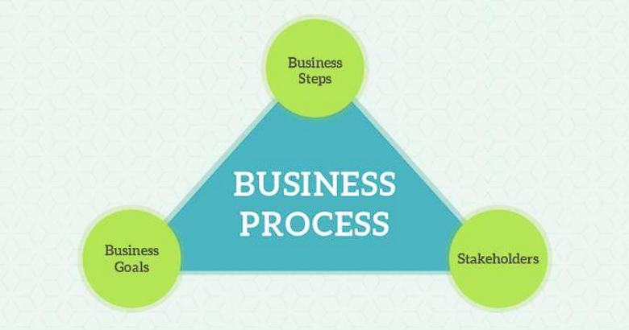

The three key components of a business process business stages, business goals, and stakeholders can be seen in the images above. It describes a variety of organised initiatives that are put into place to achieve a predefined organisational objective. All organisational levels employ business processes; some may be visible to customers and some may not. In large organisations, the benefits and necessity of a business process are quite obvious. Any business relies on its processes to streamline individual tasks, ensure that resources are used effectively, and serve as the lifeblood of the organisation. Business processes assist in determining the tasks that are crucial to the success of your overall operation, streamlining them for improvement, and facilitating communication between individuals, groups, and departments to carry out particular tasks. It establishes a hierarchy of approvals where necessary to promote accountability, make the best use of available resources, prevent chaos from invading daily operations, and standardise a set of processes for finishing tasks that are crucial to your company's success.

## Steps of Business Process

**Step 1:** Define your goals

In business process first, we have to know about purpose of business process, why it was created and how will we know if it is successful?

**Step 2:** Plan and map your process

In this step, we have to know what are the strategies needed to achieve the goals? And we need to make board roadmap for the process.

**Step 3:** Set actions and assign stakeholders.

To run a successful business process, we must determine the specific tasks that teams and machines must complete in order to carry out the strategy.

**Step 4:** Test the Process

Checking to see if the design process performs as intended in an experiment. Therefore, we must test the process on a small scale first. If there are any gaps, fill them in.

**Step 5**: Implement the process

After the process has been successfully tested, we can implement it, which means we can begin using it in a real-world setting. Train and communicate with all parties as necessary.

**Step 6:** Monitor the results

Reviewing the process, analysing its pattern, and recording its history constitute monitoring the process.

**Step 7:** Repeat

If the procedure was successful in achieving the desired results, we can repeat it in subsequent stages.

## Example of Business Process

Take the marketing process's content as an illustration. It's a procedure that all marketing departments employ. The problem is that, unless you understand the procedure, it may be quite stressful and chaotic. To produce one piece of content, writers, designers, SEO specialists, and site designers will collaborate.

Naturally, this involves al lot of steps and communication. Although, this can vary from organisation to organisation, the basic steps would be as follows:

* If it is an article on a blog or piece of copy, then the content writer would be receiving that proposal and writing its contents. In order to produce the final draft, the first draft shall be written and reviewed, which shall be passed on to the next person in the process.
* In order to ensure that the content is free from grammatical or paraphrase errors, the editor shall review it. It moves to the designer as soon as it's finished.
* The designer is taking the content, adding any infographic or images that are appropriate to the content.
* After that, the article shall be reviewed by an expert on Search Engine Optimisation to make sure it contains all of the relevant keywords as well as any modifications needed.
* The article will be published on the internet once this has been done, with a marketing team supporting its visibility.

Web engineers will need to take an extra step to code the website for the necessary adjustments if the material is duplicate work.

# Business process categories

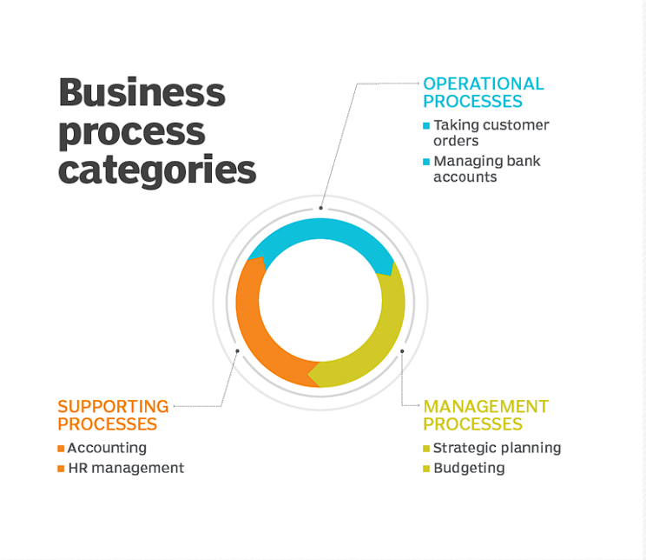On the basis of company, industry, organisation and nature of work, business process are categories into different types and category, like:

## Operational Processes

These processes, which are also known as primary ones, deal with the core business and value chain and provide value to the customer's experience by assisting in the creation of a good or service. Operational procedures are fundamental company actions that achieve goals like revenue generation. Example:

* Taking customer orders
* Processing Product Payment
* Managing Bank Accounts

## Supporting Processes

These are back-office procedures within the corporate operations that are also referred to as secondary procedures. The fact that supporting processes don't directly benefit customers distinguishes them from operational procedures. Example:

* Accounting
* HR Management
* Workplace Safety

## Management Processes

These procedures assess, keep tabs on, and regulate corporate systems and procedure-related activities. Management procedures, like supporting processes, don't immediately benefit the clients. Example:

* Internal Communication
* Governance
* Strategic Planning
* Budgeting
* Infrastructure or capacity management

# Supporting Processes

Supporting processes are those in the organisation that enable the main organisational process to perform at its best. Since they assist with the primary processes, they ensure that the business resources are available in the required quality and quantity, as well as covering the general efficient operation of the organisation. It offers some of the supporting practises and ideas required to support the other categories. The adoption and continuous upkeep of all the data-organized procedures outlined in the document are supported by support processes.

## Area of Supporting Process

Supporting process possess the following areas:

* **Measurement and analysis:** The support process outlines the methods by which the practise can assess the success of the data management procedures they have put in place.
* **Process management:** Support process describes the methodology used for creating work products, such as policies, procedures, business glossaries, etc.
* **Process quality assurance:** It concentrates on enhancing the execution of data management operations.

## Example of supporting process

Supporting processes includes following instances:

* Management finance including costing
* It manages information system
* Human resources management
* It processes
* Vendor management processes
* Risk management processes
* Security management processes
* Quality management processes
* Corporate governance processes

In contrast to fundamental processes, they are broadly identical across organisational forms. Because there are more people involved and a taller organisational structure in larger companies, support processes are typically more complicated and complex. In contrast, just one person can be in charge of a specific support procedure or activity in small businesses. These procedures do not directly benefit the client. Having stated that, the enterprise also depends on the support processes. Processes like management, accounting, and human resource processes make it easier for an organisation to function.

Making these procedures stronger from a fundamental and strategic standpoint can improve them. Although the support processes don't directly benefit the client, they do aid in creating a productive workplace.

# Differentiate between unstructured and semi-structured data within an organisation

Data is the raw information or unorganised form that represents condition, ideas or objects. It is limitless and occur everywhere in the universe. In business intelligence data can be in different forms such as structured, unstructured and semi-structured data.

## Unstructured Data

Unstructured data is the data which does not conforms to a data model and has no easily identifiable structure such that it cannot be used by a computer program easily (ihritik, 2022). The vast majority of new data being generated today is unstructured, prompting the emergence of new platforms and tools that are able to manage and analyze it. These tools enable organizations to more readily take advantage of unstructured data for business intelligence (BI) and analytics applications (Hanna, 2021).

## Semi-structured Data

Semi-structured data is a type of data that is not purely structured, but also not completely unstructured. It contains some level of organization or structure, but does not conform to a rigid schema or data model, and may contain elements that are not easily categorized or classified (ihritik, 2022).

Semi-structured data is becoming increasingly common as organizations collect and process more data from a variety of sources, including social media, IoT devices, and other unstructured sources. While semi-structured data can be more challenging to work with than strictly structured data, it offers greater flexibility and adaptability, making it a valuable tool for data analysis and management (ihritik, 2022).

## Difference between unstructured and semi-structured Data

Here is the difference between:

|  |  |  |
| --- | --- | --- |
| Properties | Unstructured Data | Semi-Structured Data |
| Technology | It is based on character and binary data. | It is based on XML/RDF |
| Transaction management | No transaction management and no concurrency. | Transaction is adapted from DMBS not matured. |
| Version management | Versioned as whole. | Versioning over tuples or graph is possible. |
| Flexibility | It is flexible and there is absence of schema. | It is less flexible than unstructured data. |
| Scalability | It is very scalable. | It is less scalable than unstructured data. |
| Robustness | Robust property is absent. | New technology but not very spread. |
| Query Performance | Only textual query is possible. | Queries over anonymous nodes are possible. |

I have to deal with a variety of types of data, which can exist in many forms as owner and data analyst for an IT firm. I'm going to have to sort them out and analyse the data collected. There are two forms of data sources: unstructured and partially structured. Videos, images are included in unstructured data, and audios. Today, in our digital universe 90% of data which is increasing is unstructured data. This data is not fit for relational database and in order to make them store, scenario came up with NoSQL database. Today, we have four families of database: key value, column oriented, graph oriented and document-oriented NoSQL. Most well-known organizations of today are Amazon, LinkedIn, Google, YouTube, Facebook, etc. is dealing with NoSQL data and they are replaced their convention database to NoSQL database.

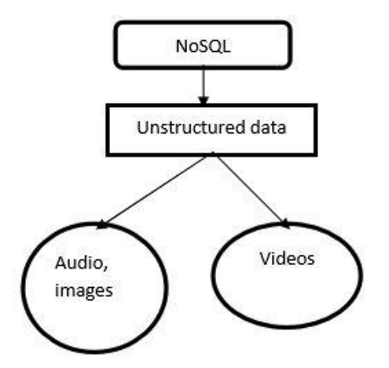

Unstructured data is not based on Schema. Today's 90% increase in unstructured data is not compatible with a Relational Database. It's composed of multimedia files like Word documents, PDF images and stored in a NoSQL database.

Emails, XML, and JSON are examples of semi-structured data. Semi-structured data cannot be described using edges, labels, or tree topologies in relational databases. These have attributes and labels and are represented by trees and graphs. These data lack a schema. Graph-based data models can hold semi-structured data. A NOSQL model called MongoDB supports JSON, or semi-structured data. Data that are self-descriptive and include of tags are often semi-structured data. Compared to organised and unstructured data, they are distinct. Famous data models that represent semi-structured data include Data Object Model, Objects Exchange Model, and Data Guide. Document instance, document schema, element attributes, and element connection sets are concepts for a semi-structured data model.

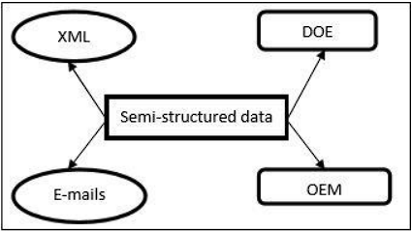

Schema is not the foundation for semi-structured data either. It is produced from numerous web sites and is represented by a label and edges. It has a variety of qualities.

As a result, I am able to properly organise certain types of data in my organisation.

# Application Software

Application software is any program or interface that helps the end user perform certain functions. Not all software is in the form of applications, but all applications are a type of software. Application software differs from system software because it's more focused and specific (Team, 2022). Business intelligence application software is a set of tools used by companies to retrieve, analyze, and transform data into meaningful information. It includes data visualization, data warehousing, dashboards, and reporting. Word processing software, Database programs, Entertainment software, Business software, Educational software, Computer-aided design (CAD) software, Spreadsheet software etc. are some example of application software. Also, ad-hoc solution, simplified workflow, full BPM, custom application software etc. are application software uses in business processing mechanisms (TechnologyAdvice, 2023).

## Benefits of application software using in Business Process

Following are some benefits of using application software in business process:

1. **Business Process modelling**: Application software helps to create and test multiple processes and work flows within the company by using a visual process design tool.
2. **Agility:** Any company can face with the need of changed constantly. So, change may become necessary as a result of new regulation. Application software facilitate the design of processes that are flexible. We can get flexibility of making change to business process with the minimal costs.
3. **Productivity:** It facilitates the automation of a lot of repetitive elements within regular workflows. So, application software of business process improvements like removal of bottlenecks, parallel processing, and elimination of redundant steps can easily be achieved. It allows employees to spend more time on other activity.
4. **Efficiency and reduced risks:** The ability to focus on inefficiencies is made possible by the transparency of corporate operations. Organisations are able to conserve resources because application software enables them to perform more productively. Additionally, it leads to the development of better-designed, carried out, and monitored processes, all of which can aid in lowering the risk of fraud.
5. **Consistency, Repeatability and Transferability:** Each task is carried out exactly as intended and planned while using application software. Even while responsibilities do change, same issues are handled in the same manner, negating the need to reinvent the wheel.
6. **Workflow Management:** Design, test and implement advanced workflows by integrating robust communication between team members, system, and data.
7. **Sustainability:** In order for business processes to achieve the desired results, they are continuously modified to adapt to shifting organisational situations. Application software can be used to adapt while yet preserving administrative supervision or control.
8. **Business Rules Engine:** Design business riles and conditions for each business process.
9. **Analytics:** Application software define metrics, get insights in real time, and run any report with ease.

## Drawbacks of application software using in Business Process

1. For developers, creating application software with a specific goal in mind may be rather expensive. This may have an impact on their spending plan and cash flow, particularly if too much time is spent on a piece of software that is not widely regarded as satisfactory.
2. Some software that is specially designed for a given undertaking may be incompatible with the rest of the general software. This may prove to be one of the most important obstacles for a number of companies.
3. It requires a lot of work to develop them, because they have to be constantly communicated by the developers and clients. The whole process of production, which may be harmful in certain cases, is therefore delayed.
4. Applications that are widely used by many people and then shared online represent a real risk of infections caused by computer viruses or other malicious programs.

# Conclusion

As a result, business processes assist in determining which activities are crucial to your overall business, streamlining them for improvement, and facilitating communication between individuals, groups, and departments to complete certain duties. It establishes a hierarchy of approvals where necessary to promote accountability, make the best use of available resources, prevent chaos from invading daily operations, and standardise a set of processes for finishing activities that are crucial to your company's success. So, in this section, I've covered business processes, supporting processes, various data types, including structured, unstructured, and semi-structured data, as well as application software and the benefits and drawbacks of using it in business processes.

# Part 2

**Write an article which**

* **Compares** the different types of support available for decision making for decision making at varying levels within an organization.
* **Justifies** the key features of business intelligence functionality with reference to specific examples.

**Compares and contrasts** different information systems and technologies that can be used to support to support organizations at operational, tactical and strategic levels.

# Introduction

In this part I am going to prepare an article which compare the different types of support available for decision making ideas at varying levels within an organisation, justification on the key features of BI functionality and also going to compare and contrast different information systems and technologies that can be support organisation at operational, tactical and strategic levels.

**Unlocking Decision-Making Potential: Exploring Business Intelligence, Information System, and Support Mechanisms**

Sparsh Shrestha

**Abstract**

Businesses in today's dynamic business environment face several daily considerations. Every business must make judgements occasionally as part of the managerial process. The organization's best interests are considered when making decisions. Making decisions, whether strategic, tactical, or operational, is a difficult task. Small businesses employ all levels of management, while sophisticated businesses place a strong emphasis on specialists who have received the training necessary to make a variety of decisions. Similar to this, there are many business intelligence tools available, including a dashboard for viewing real-time data, a pivot table for sorting, averaging, and counting the data in the table, and storage for keeping business data on hand and retrieving it whenever necessary. The information system of a company also gathers, modifies, stores, and disseminates information as required. Any business has a management, operation, and decision-support information system in place. Effective information systems help and support growth in areas like marketing and sales, production, accounting and finance, as well as human resource management at every level of the organisation, including operational, strategic, and tactical levels.

Keywords: Making decisions, important elements of business intelligence tools, and the organization's information system.

# Types of support available for business decision making

A decision-making process is a series of steps taken by an individual to determine the best option or course of action to meet their needs. In a business context, it is a set of steps taken by managers in an enterprise to determine the planned path for business initiatives and to set specific actions in motion. Ideally, business decisions are based on an analysis of objective facts, aided by the use of business intelligence ([BI](https://www.techtarget.com/searchbusinessanalytics/definition/business-intelligence-BI)) and analytics tools (Burns, 2023).

In today’s dynamic world business firms have to take a number of decisions every now and then. Managers know how important decision-making is form the organisational point of view. For example, in research and development management has to decide whether to pursue one or multiple design strategies. Decision making capacity plays vital role in every types of business. So, we have to make correct decision in our every step of business. For that we can use different types of support system available for business decision making at different level that helps us to make correct decision. A decision support system is a computer information system used to support the decision making of an organization or company. DSS allows users to browse and analyze vast amounts of data and produce information that can be used to solve problems and make better decisions. Decision support systems enable more informed decisions, timely problem solving, and improved rapid problem-solving. variables.

## Decision-making Support

### Communication-driven support

It is a form of support system that has an emphasis on supporting communication, teamwork, and shared decision-making. It makes it possible for people to communicate with one another in groups, makes it easier for individuals to share information, encourages cooperation and coordination, and aids in collective decision-making activities.

### Knowledge-driven support

Knowledge ought to be spread. It only expands by being shared. Determining what to share with whom is just as crucial as deciding to share information within the organisation. Not all information can be disclosed to everyone. This means that in order for information sharing to be used responsibly and efficiently, norms and regulations must be established. It is a computer-based reasoning system that helps people make decisions by giving them information, understanding, and suggestions.

### Document-driven support

A document driven support aids in document analysis, document indexing and summarization, document and knowledge management, and search engines for a group of connected, unstructured documents. The decision support system is capable of collecting and presenting a variety of common information, including comparative data figures, accessing information assets such as relational and legacy data sources, consequences of various decision alternatives, providing past experiences in a specific context, as well as projecting data based on assumptions or new data.

### Data-driven support

It is a sort of assistance that places an emphasis on time-series access to and manipulation of internal corporate data, as well as occasionally external data. The simplest degree of capability is provided by straightforward file systems that may be accessed by query and retrieval tools. Additional functionality is offered by data warehouse systems that permit data to be manipulated by computerised tools designed for a particular task and environment or by more universal tools and operators. The maximum degree of functionality and decision assistance related to the analysis of huge quantities of historical data is provided by data-driven DSS with On-line Analytical Processing (OLAP). Geographic information systems (GIS) and executive information systems (EIS) are specialised DSS driven by data.

In above I have discussed different types of support available in business decision making. Now I am going to discuss this support system in different varying level regarding our company “City Production Company”.

# Decision-making at Different Levels in the Organisation

The decision-making process in organisations is carried out by a team of professionals whose purpose is the improving of the company’s proceedures. Therefore, it is a continuous and dynamic activity that permeates all other activities relating to the organization (Siteware, 2022).

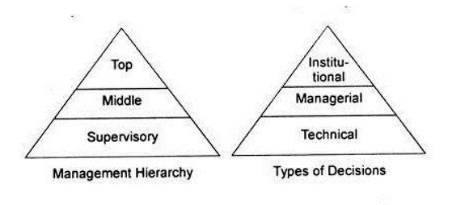

A decision support system analyst must consider the varied types of decisions and distinct elements impacting decision-making before starting to build the architecture, just as judgements made in each department at each level are unique. The above graph illustrates the proportion of decisions of each category made at each organisational level. The categories shouldn't be viewed as mutually exclusive, though. For instance, the production manager of a company that manufactures machinery may be largely concerned in technical issues, but the company's legal advisor may be interested in institutional problems.From above, we have different three types of decision-making level. They are given below:

* Strategic level (Top level Management)
* Tactical level (Middle level Management)
* Operational level (Bottom level Management)

# Comparative study on different decision making at varying level

The comparison of the different sorts of help offered for business decision-making at various levels within an organisation is shown in the following table.

|  |  |  |  |
| --- | --- | --- | --- |
| **S.N.** | **Strategic Level (Top Level Management)** | **Tactical Level (Middle Level Management)** | **Operational Level (Bottom Level Management)** |
|  | This involves judgements on technology (such as the selection of the best tools, processes, and levels of automation), capacity (amount, timing, and kind), facilitation (size, location, and specialisations), and vertical integration (direction, extent, and balance). | Establishing parameters (for gauging operational effectiveness and productivity), planning for modernization, deciding whether to make or buy, and planning for medium-term maintenance (preventive and condition monitoring) to increase the availability of production facilities are all included. | It creates operational strategies, defines activities required to meet operational objectives, establishes quality requirements, and specifies inspection and test procedures. |
|  | Creative Skills are need in Top Level management | Persuasive skills are needed in Middle level management. | Operative skills are needed in low level management. |
|  | Planning at the strategic level for production aids in achieving the objectives in the most effective manner. | Fixing performance parameters, producing data to comparing actual and intended performance, and taking actions to close the gap between the two are the main areas of focus. | Plans are concrete and action-oriented, and they are articulated in terms of quantifiable metrics. |
|  | All strategic level planning involves risk and is employed in some futuristic assumptions. | Plans to increase the manufacturing function's overall productivity and equipment availability. | Monitoring the plan's development and, if necessary, taking remedial action can help you reach your goal. |
|  | This is type of support is carried out for a long period of time. | This type of support is for certain period of time. | Operation are normally carried out for a short period of time. |
|  | This type of support coordinates the activities of different department. | This type of support cooperates with other department for smooth functioning of organisation. | This type of support ensures whether good working condition is provided to the workers. |
|  | Only few numbers of persons are needed to support. | Moderate number of persons are need to provide support. | Large number of persons are need to provide support. |

# Justifying, example, features of business intelligence functionality

Executives, managers, and other end users can utilise business intelligence, a technology-driven process that analyses data and presents useful information, to help them make smart business choices. BI employs a wide range of instruments, programmes, and procedures that let businesses gather information from several sources. Because it connects the data, technology, analytics, and knowledge that business professionals need to ensure success, business intelligence provides the insight executives need to make the best decisions. Businesses and organisations are able to obtain a competitive edge thanks to business intelligence. As they harness the power of Big Data, businesses around the world are only now starting to realise all of the potential advantages of business intelligence. Businesses that properly use BI also spot market trends and operational problems that need to be fixed.

## Business intelligence functionality

Here are the some of the key features of business intelligence functionality which are given below:

### Predictive Analytics and Modelling

Predictive analytics is the use of data to predict future trends and events. It uses historical data to forecast potential scenarios that can help drive strategic decisions (Cote, 2021).

Predictive modeling is a mathematical process used to predict future events or outcomes by analysing patterns in a given set of input data. It is a crucial component of [predictive analytics](https://www.techtarget.com/searchbusinessanalytics/definition/predictive-analytics), a type of data analytics which uses current and historical data to forecast activity, behavior and trends (Lawton, 2022).

By analysing your prior data sets, BI solutions greatly assist you in analysing data and patterns. A BI system must, however, have the capacity to forecast; this feature helps decision-makers to foresee market trends as well as other company needs, such as sales, staffing, market trends, etc. Utilising predictive analytics enables a company to be proactive, forward-thinking, retain and grow its customer base while also improving business operations.

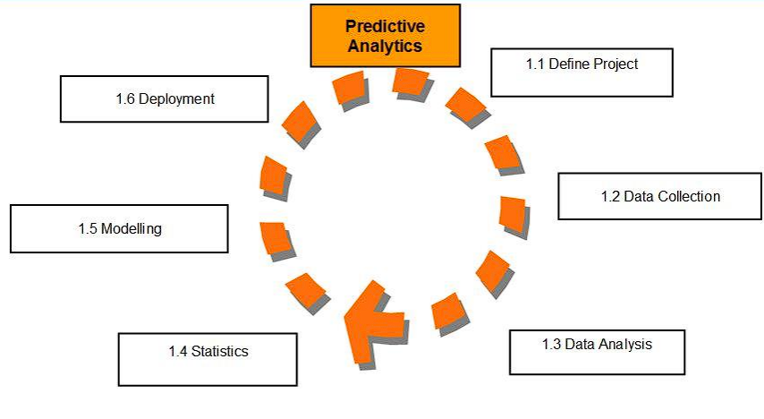

Today's Big Data Trends represent predictive analytics, and its instruments are basically Big Data Technologies. Predictive analytics software demand is correlated with a closely similar group of technologies called big data analytics solutions. It aids in risk reduction, fraud detection, and marketing campaign optimisation. Predictive analytics are most commonly used in the retail industry, which is continually seeking to strengthen its sales position and build stronger relationships with customers. The most typical illustration is Amazon's suggested reading list. When you make a purchase, a list of additional, related items that other customers also bought is displayed. Pre-sale activities such as customer segmentation, business model modification, IT alignment with business units, inventory management to take seasonality into account, and optimum retail locations make up a large portion of this. However, it also works after the sale to cut down on returns, entice customers to buy again, and increase warranty sales.

### Interactive Reports and Operational Reports

Users may distil the enormous volumes of acquired data into a broad range of different views using interactive reports. To find patterns, abnormalities, and outliers in the data, users may benefit from capabilities like statistical analysis and regression, while The executives of your company may receive a thorough overview of the day's events via business intelligence tools like these at the conclusion of each day, giving them the knowledge they need to make important choices.

### Data visualization

Data visualization is the representation of information and data using charts, graphs, maps, and other visual tools. These visualizations enable data professionals to easily understand any patterns, trends, or outliers in a data set (Coursera, 2022).

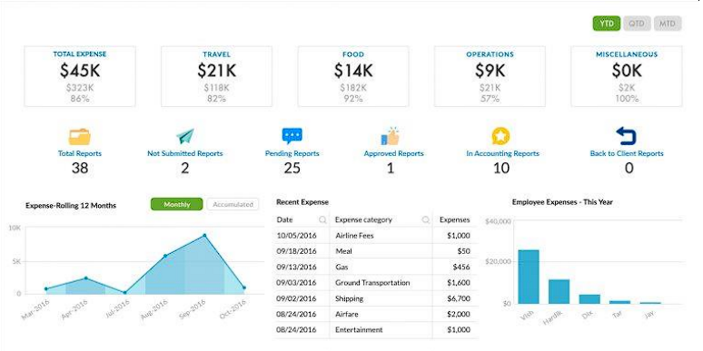

In above figure we can see monthly expenses report that compares spending data across categories—travel, office supplies, etc. or even across departments. While such trends could be easily overlooked in a spreadsheet, a bar chart will visualize the data. It’s an easy way to compare information, as it will uncover highs and lows at a quick glance. An accounting department can present the information to leadership or department heads and gain immediate understanding of challenges.

### Open Integration

Smart BI solutions will have access to information from email, social media, websites, and more in addition to the data that belongs to your company. For instance, your BI platform may include reviews and comments about your items together with that information rather than just your internal sales data. With so many data formats and so many applications to pull from, it’s important that your BI platform is able to integrate as many different types of data as possible under a single roof, seamlessly combining disparate forms of information into an actionable report.

### Ranking Report

By choosing precise criteria, this tool enables you to generate reports that rank particular categories of data from several dimensions. An organisation may learn what aspects of their business are doing well and poorly with the use of a ranking report. By examining the ranking report, an organisation may make important decisions that influence their condition. You may evaluate the top and worst performing areas of your organisation using ranking reports. For instance, you may produce a report that lists the top 10 selling goods, geographical areas, or sales representatives.

# Compare and contrast a range of information systems and technologies that can be used to support organizations at operational, tactical and strategic levels

Over the past twenty years, various information system types have been created for various uses, depending on the needs of the industry. There are many different types of information systems used in business today, including executive information systems (EIS), expert systems (ES), office automation systems (OAS), management information systems (MIS), and transaction processing systems (TPS). Each has a unique function within the management structure and organisational hierarchy. This study tries to clarify the function of each type of information system in corporate settings.

## Four Major Types of Systems

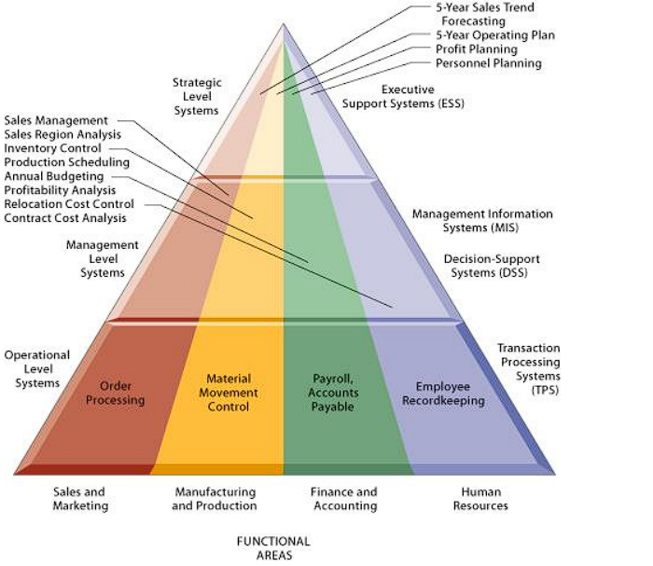

The detailed types of information systems that are appropriate to each organisational level can be found in the above figure. The organisation has executive support systems (ESS) at strategic level; management information systems (MIS) and decision support systems (DSS) at management level; and transaction processing systems (TPS) at operational level. The systems at all levels are designed to serve each of the main functional areas in turn. In this way, typical business systems found in organisations are designed to assist workers or managers at each level as well as those performing the duties of selling and marketing, production engineering, finance and accounting etc. The four major information support systems are discussed below:

### Executive Support System (ESS)

An Executive Support System (ESS) is software that allows users to transform enterprise data into quickly accessible and executive-level reports, such as those used by billing, accounting and staffing departments. An ESS enhances decision making for executives (Rouse, 2012).

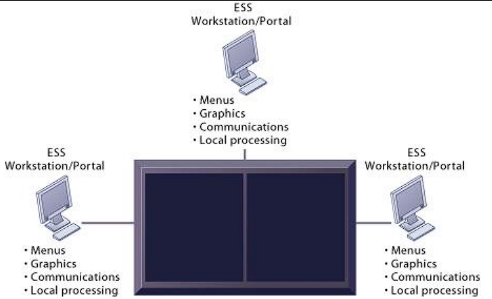

Executive support systems (ESS) are tools used by senior managers to aid in decision-making. ESS support the organization's strategic level. They deal with non-routine judgements that call for discretion, analysis, and insight because there is no established process for coming up with a solution. Executive information systems give executives and managers quick access to vital information from a wide range of internal and external sources (including MIS, DSS, and other sources catered to their information needs). Senior managers can use an EIS as a tool to help them make strategic and tactical choices. In order to satisfy senior management, an executive information system is created to produce information that is abstract enough to display the entire business function in a condensed manner.

### Management Information System (MIS)

Computer information systems called management information systems may gather and process data from many sources to support managerial decision-making. Informational management systems to aid in corporate decision-making, provide information in the form of predetermined reports and presentations. Low level managers and supervisors occupy the next level of the organisational structure. Computer systems at this level are there to help operational management monitor and regulate the transaction processing operations that take place at the clerical level. The data gathered by the TPS is used by management information systems (MIS) to give supervisors the required control reports. Taking internal data from the system and synthesising it into useful and actionable information is a sort of information system called a management information system. In order to assist management operations and decision-making, management information systems gather internal data from the system and summarise it into understandable and practical formats like management reports.

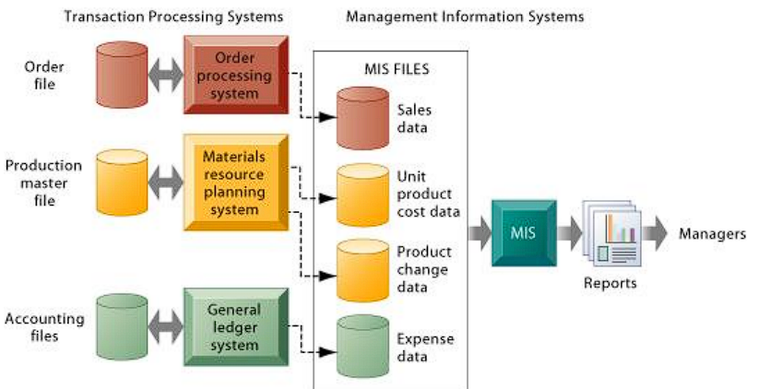

Above figure shows how a typical MIS transforms transaction level data from inventory, production, and accounting into MIS files that are used to provide managers with reports.

### Decision Support System (DSS)

A decision support system (DSS) is a computer program application used to improve a company's decision-making capabilities. It analyses large amounts of data and presents an organization with the best possible options available (Contributor, 2021).

A decision support system is a computer-based tool designed for managers at any organisational level to utilise while solving a semi-structured choice. Typically, a group of managers will use a decision support system. Decision Support Systems are a class of computerised organisational information systems that assist managers in making decisions that require modelling, formulation, calculation, comparison, choosing the best alternative, or scenario prediction. Systems for decision support are created expressly to assist managers in making choices when there is ambiguity surrounding the results of such choices. A decision support system is a computer-based informational tool that helps managers make a variety of difficult decisions, including the choices necessary to address vaguely defined or ill-defined issues.

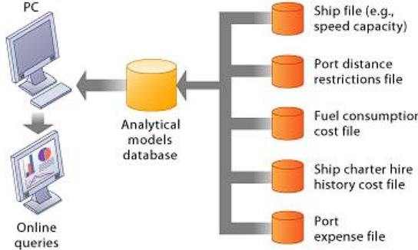

Above figure illustrates the DSS built for this company. The system operates on a powerful desktop personal computer, providing a system of menus that makes it easy for users to enter data or obtain information.

### Transaction Support System (TPS)

The fundamental business systems that support an organization's operational level are known as transaction processing systems (TPS). A computerised system known as a transaction processing system executes and records the everyday transactions required for the operation of a firm. The transaction processing systems that support the everyday operations of the business are located at the lowest level of the organisational structure.

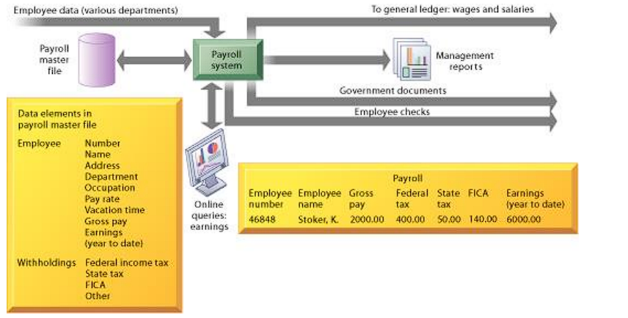

The payroll TPS shown in the above graphic is a standard accounting transaction processing system used by most businesses. Money paid to employees is tracked by a payroll system. Data components, often known as discrete bits of information (such a name, address, or employee number), make up the master file. The system receives data input, which updates the data components. The components on the master file are put together in a variety of ways to create reports that are interesting to management and governmental organisations, as well as to mail employees' paychecks. These TPS can provide more report combinations using the current data pieces.

### Relationship of system to one another

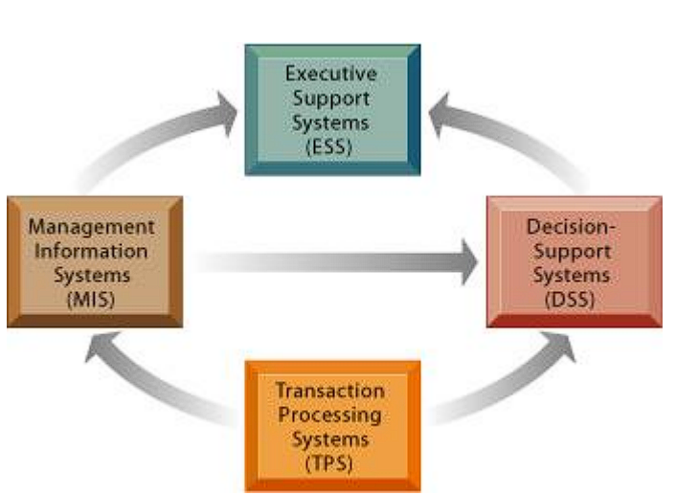

The systems supporting the various levels of the organisation are connected to one another, as seen in the above picture. While ESS are primarily a recipient of data from lower-level systems, TPS are typically a significant data source for other systems. Data can also be exchanged across the other system kinds. Data can also be shared across systems supporting various functional domains. For instance, a sales system may send an order it has received to a manufacturing system as part of a transaction so it may produce or deliver the goods indicated in the order, or it may send it to a MIS for financial reporting.

**Characteristics comparisons of different information support system**

|  |  |  |  |  |
| --- | --- | --- | --- | --- |
| **Type of System** | **Information Inputs** | **Processing** | **Information Outputs** | **Users** |
| Executive Information System (EIS) | Aggregate data; external, internal | Graphics; stimulations; interactive | Projections; responses to queries | Senior managers |
| Decision Support System (DSS) | Analytical models and data analysis tools; low volume data or large databases designed for data analysis. | Interactive; stimulations; analysis | Specialised reports, analysis of decisions, and answers to inquiries | Professionals; staff managers |
| Management Information System (MIS) | Summary transaction data; high volume data; simple model | Routine reports; simple models; low-level analysis | Summary and exception reports | Middle managers |
| Transaction process system | Transaction; events | Sorting; listing; merging; updating | Detailed reports; lists; summaries | Operative personnel; supervisors |

# Conclusion

Different information system types are employed by commercial organisations. systems for processing transactions that are created to record the everyday transactions required for commercial operations. systems for supporting office duties in the office. systems for monitoring and controlling physical or industrial processes. The main goal of a management information system (MIS) is to transform data from internal sources into information that is then communicated to managers at all levels and in all functions to help them plan, direct, and control the activities for which they are accountable. Systems for supporting decision-making are created to assist managers in making decisions that require modelling, formulation, calculation, comparison, choosing the best alternative, or scenario prediction. Senior managers have a system to help them make tactical and strategic choices thanks to executive information systems. A programme called an expert system is intended to mimic human thinking. The goal of this study is to make clear how each sort of information system functions inside commercial organisations.

As a result, I have covered several decision-making support options, essential functionalities of business intelligence, and various information systems and technologies that have been utilised to help organisations at the operational, tactical, and strategic levels.

# Part 3

* D**etermines** (establish) the concept what business intelligence and illustrate the concept with reference to specific examples. And list out tools and techniques associated with it.
* **Designs a business intelligence tools**/apps/program that can perform specific task to support problem solving or decision making for your organization. Also, customize how a design can be user friendly and has a functional ability.
* **Provides** a critical review of the design in terms of how it meets a specific user or business requirements and identify what customization has been integrated into the design. **n2**
* **Discusses** how business intelligence tools can contribute to effective decision-making.
* **Explores** the legal issues involved in the secure exploitation of business intelligence tools.
* **Conducts** small survey to **identify specific** examples of organizations that have used business intelligence tools to enhance or improve their operations.

**Evaluates** how organizations could use business intelligence to extend their target audience to make them more competitive within the market, taking security legislation into consideration.

# Introduction

Being the founder and a business analyst for an IT company, I should be very knowledgeable about BI in order to operate the company profitably. Therefore, for this portion of the task, I will create a report that defines business intelligence and the tools and techniques related to it with examples. I will also design a business intelligence tool, application, or interface that can carry out a specific task to support advanced problem-solving or decision-making. Finally, I will provide a critical review of the design in terms of how it meets a specific user or business requirement. I'll talk about how business intelligence tools can aid in making effective decisions, I'll look at the legal concerns related to the secure exploitation of business intelligence tools, I'll conduct a quick survey to find specific instances of companies using business intelligence tools to strengthen or improve their operations.

**Summary**

Business intelligence is primarily used for quicker and more accurate reporting, better business decision-making, user satisfaction, increased business efficiency, etc. The strategic, tactical, and operational business decisions of an organisation are directly impacted by BI. Understanding the principles relating to the BI tools and procedures is much more essential in order to run the business intelligently. Being the founder and a business analyst for an IT company, I should be very knowledgeable about BI in order to operate the company profitably. Here, I will define business intelligence and the tools and techniques related to it with the help of examples. I will also design a business intelligence tool, application, or interface that can carry out a specific task to support advanced problem-solving or decision-making. I will also customise the design to make sure that it is user-friendly and has a functional interface, and I will provide a critical review of the tool, application, or interface in the end. Finally, I will consider how organisations might use business intelligence to broaden their target audience. To do this, I will conduct a small survey to identify specific examples of organisations that have used business intelligence tools to enhance or improve their operations. I will also explore the legal issues associated with the secure exploitation of business intelligence tools.

**Scope**

* Helps in the measurement of performance and progress toward business goals
* Initiates quantitative analysis through predictive analytics, predictive modelling, business process modelling and statistical analysis
* Helps in obtaining goals of the organisation

**Objective**

* To determine the concept what business intelligence is, illustrate the concept with reference to specific examples
* To design a business intelligence tools/apps/program that can perform specific task to support problem solving or decision making for organisation
* To discuss how business intelligence tools can contribute to effective decision making
* To evaluate how organisation could use business intelligence to extend their target audience
* To explore the legal issues involved in the secure exploitation of business intelligence tools

**Report on Business Intelligence**

**By: Sparsh Shrestha**

# Business Intelligence

Business intelligence (BI) is a technology-driven process for analyzing data and delivering actionable information that helps executives, managers and workers make informed business decisions. As part of the BI process, organizations collect data from internal IT systems and external sources, prepare it for analysis, run queries against the data and create data visualizations, [BI dashboards](https://www.techtarget.com/searchbusinessanalytics/definition/business-intelligence-dashboard) and reports to make the analytics results available to business users for operational decision-making and [strategic planning](https://www.techtarget.com/searchcio/definition/strategic-planning) (Stedman, 2023).

## Example of Business Intelligence

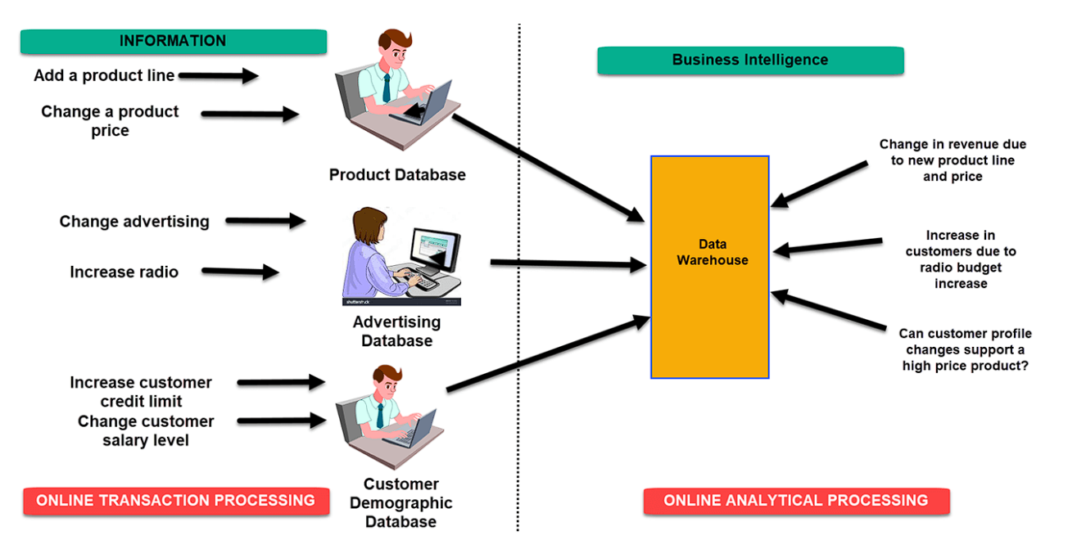

The diagram above shows the fundamentals of business intelligence. It shows the process of the collection and analysis of data systematically is described in this report. A product line can be added and the price changed by means of an online transaction processing system, which is able to store information for a products database via OLTP. In the same way, it might be possible to add new product lines or price changes in order to increase revenue when performing a Business Intelligence query relating to an area where products are concerned.

Changes in advertisement options and an increase in radio budget could be used to perform a query in an advertising database of an OLTP system. How many new clients were added as a result of the adjustment in radio budget is a query that might be run in the BI system. Customer credit limits could be raised and customer wage levels could be modified in OLTP systems that deal with client demographic data bases.

Correspondingly, the possibility for a change in customer profile to help increase product prices could also be included in an OLAP query that can be executed.

**Example 2**

The BI applications are being made available to branch managers by the bank. This helps to identify the most profitable clients and customers that a branch manager should be working with. IT staff are no longer tasked with producing analytical reports for departments as a result of the use of BI tools. It will also allow more extensive data sources to be accessed by the staff of the department. In the 21st century, Business Intelligence is one of the most valuable tools for business.

## Tools and techniques associated

The BI has a direct influence on the organisation's strategy, tactics and operational decisions. BI's support to make informed decisions on the basis of actual data, as opposed to assumptions and gut feelings. For users to have a complete understanding of the nature of their business, BI tools perform data analyses and develop reports, summaries, dashboards, maps, charts or diagrams. A great source of improvement to your business may be Business Intelligence tools.

Business intelligence tools are exploding with the growing amount of information in today's digital age, making data and analysis available to more than just analysts. What's business intelligence supposed to be? In order for decision makers to make better and more informed commercial decisions and strategies, BI technology is an instrument used in the analysis and dissemination of information. In BI, here are some tools and techniques to be used.

### Predictive Analytics Tool

By analysing your previous data sets, BI solution will greatly assist you in analysis of the data and trends. However, a BI solution is only capable of anticipating market developments and other business requirements such as sales, staff etc. It must also have foresight capabilities which enable the decision makers to anticipate changing trends on the market at any time. The use of Predictive Analytics helps organisations to be proactive, forward looking, retaining and expanding their customer with an improvement in the business's operations.

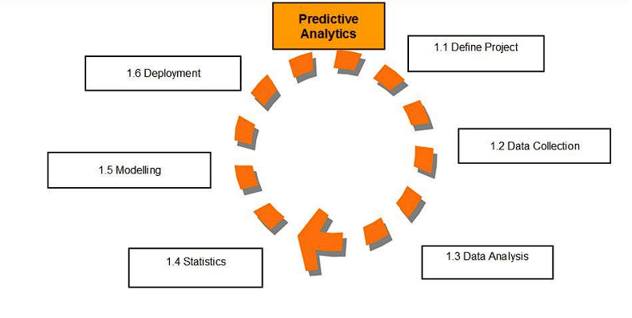

Today's Big Data trends refer to the use of predictive analytics, and they constitute a type of big data technology. The demand for predictive analytics software is closely related to the tool set, Big Data Analytics Tools. This will help to improve marketing campaigns, increase the efficiency of operations, detect fraud and reduce risks. As an example, retail is most likely the largest sector to make use of Predictive Analytics as it constantly seeks improvement in its sales position and closer relations with customers. Amazon recommendation is one of the most widely used examples. Once you've made your purchase, they put a list of other similar items that have been bought by other buyers.

Pre-sale activities such as customer segmentation, business model modification, IT alignment with business units, inventory management to take seasonality into account, and optimum retail locations make up a large portion of this. However, it also works after the sale to cut down on returns, entice customers to buy again, and increase warranty sales. Marketers can use it to try to understand consumer buyer journeys and the best places to place call to actions, while the financial sector can use it to evaluate investment risks and see where the market can go. By studying the past, predictive analytics technologies can assist you in understanding the future.

### Multi-Cloud Strategy

A multi-cloud strategy is the use of two or more [cloud computing](https://www.techtarget.com/searchcloudcomputing/definition/cloud-computing) services. While a multi-cloud deployment can refer to any implementation of multiple software as a service (SaaS) or platform as a service (PaaS) cloud offerings, today, it generally refers to a mix of public [infrastructure as a service (IaaS)](https://www.techtarget.com/searchcloudcomputing/definition/Infrastructure-as-a-Service-IaaS) environments, such as Amazon Web Services and Microsoft Azure (Earls, 2021).

### OLAP (Online Analytical Processing)

OLAP (online analytical processing) is a computing method that enables users to easily and selectively [extract](https://www.techtarget.com/searchbusinessanalytics/answer/Examining-different-data-access-methods-OLAP-and-data-mining) and query data in order to analyze it from different points of view. OLAP business intelligence queries often aid in trends analysis, financial reporting, [sales forecasting](https://www.techtarget.com/searchcustomerexperience/definition/sales-forecast), budgeting and other planning purposes (Biscobing, 2020).

### Data Mining

Business intelligence is a tool for transforming data into knowledge and information. It's the best way of optimising decision making processes for businesses. To that end, Business Intelligence is a set of methodologies, applications and technologies for collecting, refining and transforming this data from transactional systems and unstructured information, internal and external to the company, into structured information for direct use or analysis.

By analysing actual trends and behaviours, data mining technologies also improve customer relationship management. In a resume, business intelligence strategy should be employed to put the information to use in a way that maximises the advantages for the business.

To this end, Business Intelligence plays an important role: it provides businesses with relevant information to respond to business challenges such as entry in new markets, finance control, cost optimisation, production planning, analysis of customer profiles and profitability. Therefore, data mining is used for the purposes of creating business intelligence.

For instance, business intelligence programs could have the potential to speed up and enhance decision making; improve internal processes of businesses; increase efficiency in operations; result in new revenue streams or gain competition advantages over competitors. Businesses could also be helped by BI systems to predict market trends and find business problems which need to be addressed.

### Sisense

Sisense is a software company specialising in Business Intelligence solutions that provide an end to end solution for creating, analysing and visualizing complex data. It makes it easy for users to connect and analyse data from different sources, transform them into practical insights that can be shared across the organization.

A variety of features are included in Sisense's system, e.g. data modelling, data preparation and visualizing the data. Advanced analytics features, like predictive modeling and machine learning, are also supported.

It is designed to serve a broad range of users, from business analysts to data scientists and can be implemented across different industries such as finance, health care, e commerce or anything else. Sisense has been recognized by the Gartner's Analytics and Business Intelligence Platforms Magic Quadrant as a leader in its technology.

### Tableau

Tableau is a data visualization and business intelligence software that allows users to connect, visualize, and share data in an interactive and meaningful way. It is an extensive set of tools and features enabling users to analyse and explore data from a number of sources, produce Explanations and share their findings with others.

With Tableau's drag and drop interface, it is simple for users at all skill level to build interactive dashboards, reports, graphs that do not require complex coding or data manipulation. It's also helping to support a wide variety of data sources, including spreadsheets, databases and cloud computing platforms such as AWS or Google Cloud.

For users who want to gain even more insight from their data, Tableau provides them with sophisticated analytics like blending, forecasting and statistical modelling. In addition, it is also home to a large and active community of users who share best practices, tips or solutions for common problems.

Tableau has been recognised by Gartner as a leader in theMagic Quadrant for Analytics Platforms and Business Intelligence Platforms, enabling organisations of all sizes to use its software across different sectors such as finance, healthcare, education or public administration. Salesforce, a top customer relationship management software company bought Tableau in 2019.

### Clear Analytics

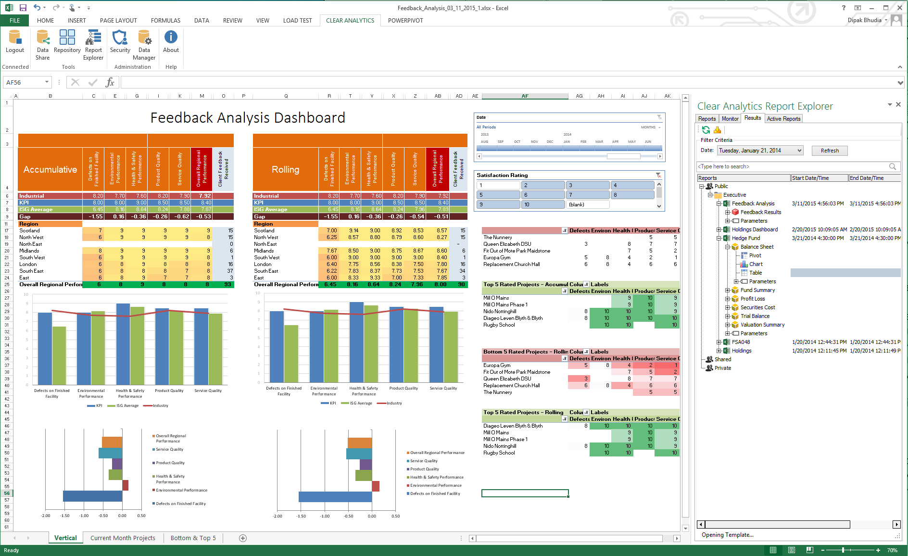

One of the useful tools for businesses is clear analytics. The business intelligence tool is an intuitive Excel application that can be used by employees who have even the most basic knowledge of Excel. What you'll get is a system of self-service business intelligence products that includes several BI features such as the creation, automation and analysis of data visualization for your company.

### Microsoft Power BI

Microsoft Power BI is a [business intelligence](https://www.techtarget.com/searchbusinessanalytics/definition/business-intelligence-BI) (BI) platform that provides nontechnical business users with tools for aggregating, analyzing, visualizing and sharing data. Power BI's user interface is fairly intuitive for users familiar with [Excel](https://www.techtarget.com/searchenterprisedesktop/definition/Excel), and its deep integration with other Microsoft products makes it a versatile self-service tool that requires little upfront training (Scardina, 2022).

### SAP Business Intelligence

SAP Business Intelligence (BI) is a suite of enterprise software solutions that provide tools for data warehousing, reporting, data analysis, and data visualization. In support of business decisions, SAP BI allows organisations to integrate, transform and consolidate information from different sources into a single platform that can be used by businesses.

Numerous modules are available through SAP BI, such as SAP BusinessObjects BI, SAP Lumira, and SAP Analytics Cloud. Data modelling, ETL (extract, transform, load), data analysis, and data visualisation are among the features offered by these modules. Additionally, they help with a variety of data sources, such as cloud-based data sources and SAP and non-SAP systems.

With the use of interactive charts, tables, and other visualisations, users of SAP BI may produce reports and dashboards that offer insights into corporate processes. Additionally, it has sophisticated analytics capabilities including machine learning and predictive analytics.

Numerous industries, including banking, healthcare, manufacturing, and retail, among others, heavily rely on SAP BI. The largest companies in the world employ SAP's BI solutions, and it has been named a leader in the Gartner Magic Quadrant for Analytics and Business Intelligence Platforms.

# Design Business Interface Tools, application or interface

The business intelligence application is initially created using the open source software AppSheet. Users may create mobile, tablet, and internet apps using their own data sources as well as data from Google Sheets, Google Drive, Dropbox, Office365, and database systems using the intelligent, logical, no-code AppSheet platform. The main components of this software or platform are a declarative programming paradigm, data collection, data collaboration, and data display.

The following steps are used to create the business intelligence mobile app City Production Company in AppSheet.

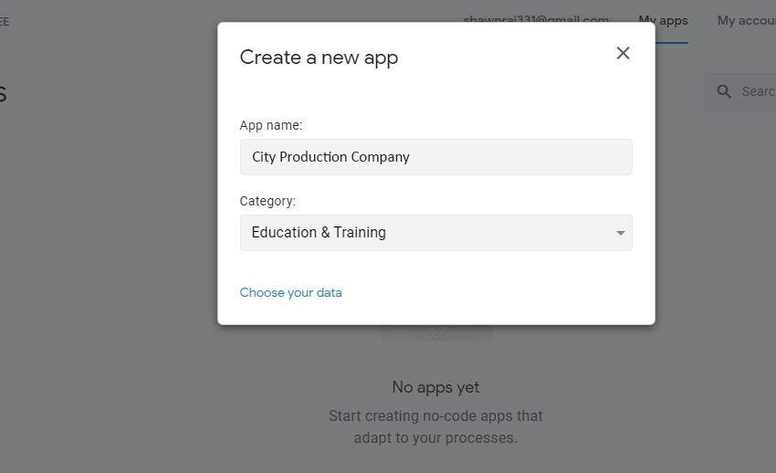

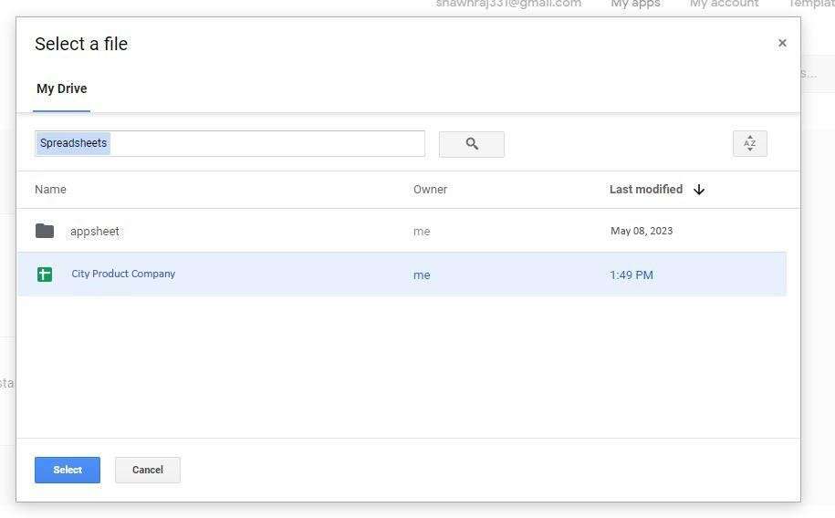

Choosing information from Google Spreadsheets. I am going to implement three entities in the City Production Company: an employee with the attribute’s employee name and ID, employee post, contact information, email address, and employee photo; a project with the attributes project id, project name, start and end dates, completed, incomplete, and upcoming projects; and a project with the attributes project id. Additionally, a separate table for the project's status has attributes like Status ID, in production, under review, completed, or incomplete.

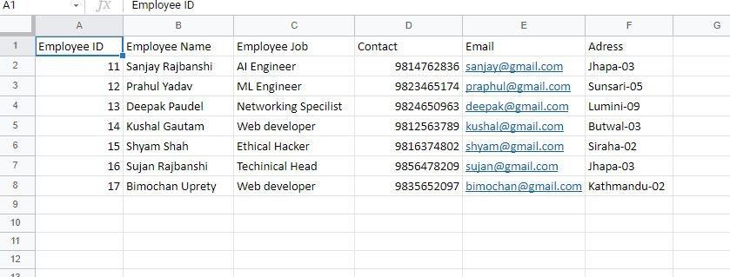

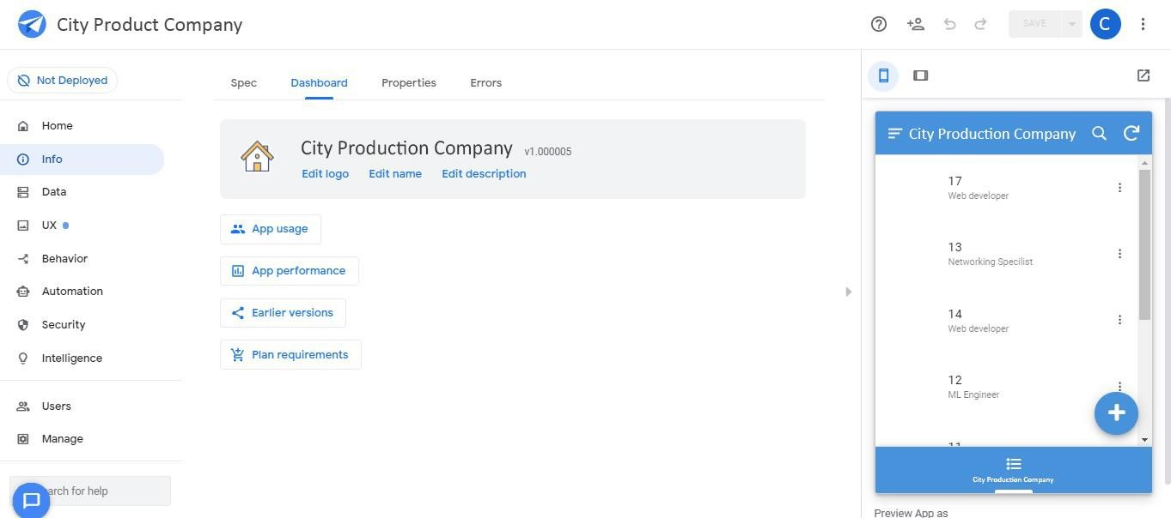

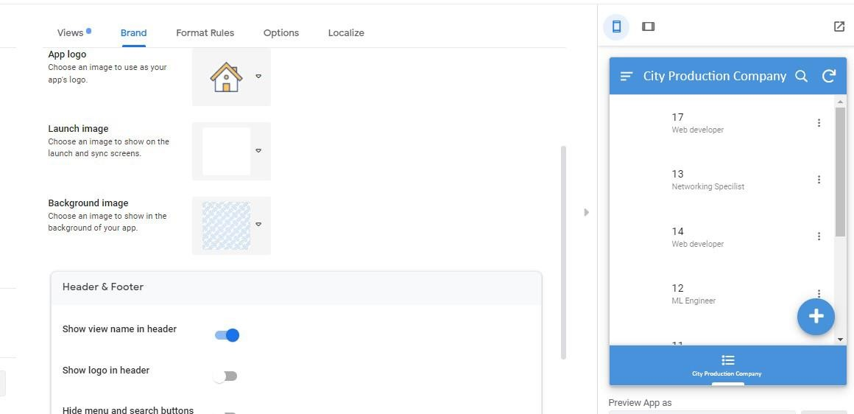Clicking User interface button and clicking Brand to add icon and app launching image for the application. Completed adding icon and launching image to the application and clicking save.

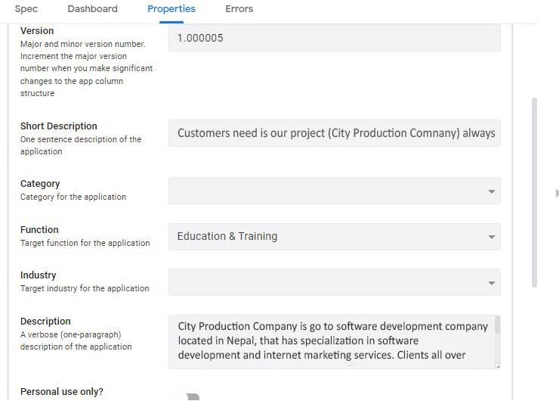

Adding the Table Project and Status by clicking data in navigation panel and clicking Tables.

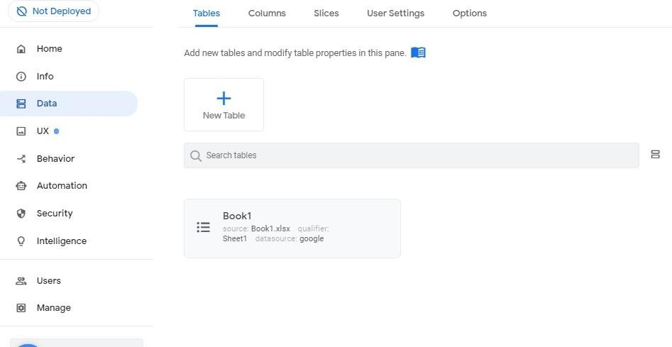Absolute mobile view of City Production Company Application and page of Employee.

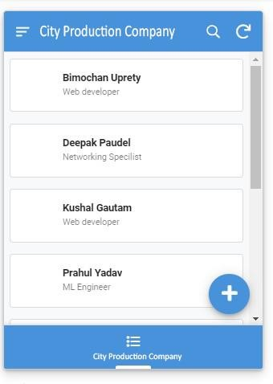

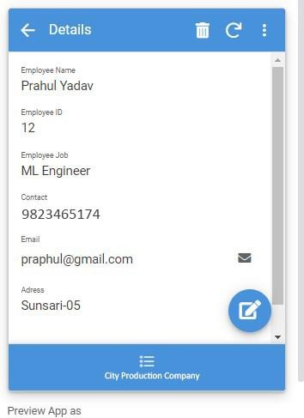

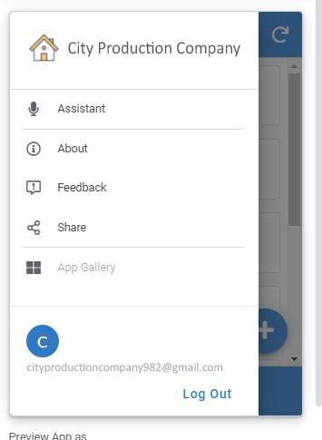

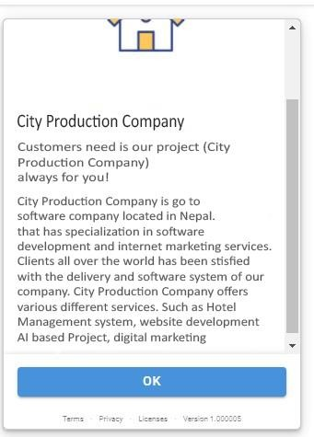

The steps and diagrams above show how to configure City Production Company application and create a business intelligence tool that can help our organization's decision-making and problem- solving processes. Software development and other types of IT services are provided by City Production Company. We used AppSheet to create an application for our business, and we believe we are working with the proper vendor to create an amazing product. As we know, in the newly created application, there are main four entities and more others entities which are employee entities for storing data of employees like employee id, employee name, employee address etc, this data of employee helps us to know the employee location and whenever we need the detail of our employees then we can easily extract the data from the application, which helps solving the problems of employee which they are facing and another entities is project for storing the data or information of project, the main reason for including the project entities is to gain information of project like identification of project, project start and end date and it also shows whether the employee are completing their task in time or not, it helps to make decision over the employee

whether they are following their company rules or not and if they are not finishing their project in time, then it helps to take strong decision to them. The project status is the last but not least significant component of this application. Project status provides full project information by supplying every project detail and aids in determining if a project is progressing according to plan or not. Additionally, this programme is functional and user-friendly. This application has capabilities that allow users or customers to know if their project has been completed or not and to see whether an employee from our organisation will finish the project on time because it is entirely based on our organisation and user-friendly. This application is easy to understand, and I believe it is user-friendly. In terms of functionality, this application has a number of features that are used, such as bulk updating or import, which requires proper validation for all fields when creating a new project or employee. This application also has other exciting features, like advanced search with millions of records and various categories of e-commerce.

Therefore, I believe that this programme supports our organization's ability to solve problems and make decisions. It is also user-friendly and has good bulk and updating functionalities.

# Critical Review of Design

This programme, in my opinion, is the most appropriate for our organisation since it is user- friendly, offers a wide range of features, behaviours, and functions, and can assist us in making business decisions and resolving issues with employees, projects, and other business transactions. using the help of this programme, you can construct appealing dashboards using information from straightforward Google Spreadsheets or Google Drive. One of the three entities in this programme is the employee, which has attributes like the employee name and ID, employee post, contact information, email address, and employee photo. Project is another object with the properties project id, project name, start and finish dates, as well as completed, incomplete, and forthcoming projects. We can quickly retrieve the information from the programme whenever we need to know an employee's details or their whereabouts thanks to this employee data. When it comes to a project, we can find out things like the project's identification, start and end dates, whether or not the employee is finishing their project on time, or whether it aids in hiring or firing decisions, and the project's status, which has a separate table with attributes like Status ID, in production, under review, completed, or incomplete. It offers stronger importing and bulk updating capabilities, such as adding a new employee or project, which necessitates sufficient validation for all data. It also has a more advanced search box, which often processes it and presents results rapidly. Because of this, I think the prgramme is simple to use and offers useful features that will aid in issue solving and decision-making our company.

# Business Intelligence tools contribute to effective decision making

BI (Business Intelligence) is a set of processes, architectures, and technologies that convert raw data into meaningful information that drives profitable business actions. It is a suite of software and services to transform data into actionable intelligence and knowledge (Taylor, 2023).

Business intelligence decision-making entails a sequence of actions intended to use data and analytics to make wise judgements that might enhance organisational performance. The first step in the process is to identify the business opportunity or problem and to specify the key performance indicators that will be used to track development. Then, pertinent data is gathered and integrated from numerous sources into a data warehouse or data lake. To ensure quality and consistency, this data is cleansed and preprocessed. To gather insights and spot patterns, the data is analysed using a variety of methods, including descriptive analytics, diagnostic analytics, predictive analytics, and prescriptive analytics. To assist decision makers in rapidly and simply understanding the information, the results are displayed in a visual style such as charts, graphs, or dashboards. A choice is made to help address the identified business opportunity or problem based on the insights gathered from the investigation. The outcomes are then tracked and assessed to gauge the success of the choice and make any necessary corrections. In order to produce the greatest results for the organisation, decision making in business intelligence is a process that depends on accurate and trustworthy data, efficient analytics, and trained decision makers.

Let's focus on a specific example to show how the marketing department benefits from increased top line revenue. They can use it to analyse the effectiveness of their marketing and advertising campaigns. Additionally, it aids them in optimising their expenditures for higher ROI. Business intelligence assists the sales department in determining the best course of action and best practises, the price and duration of customer acquisition, process improvement, and year-over-year analysis of turnover and sales. Employee turnover, attrition rates, the hiring process, and other factors are tracked and managed by the human resources department with the aid of business intelligence. Aside from this, every other function inside a corporation will gain from business intelligence, either directly or indirectly. When applied correctly, this method has produced good outcomes in a variety of industries, including e-commerce, media, non-profits, healthcare, telephony, financial services, energy, and more.

In terms of making decisions, due to the wide range of strong elements that business intelligence contains, it plays a key role. This includes interactivity, data visualization, database connection, mobile business intelligence, predictive analytics, application integration, and ad hoc reporting. Now we will look at each of these elements in greater detail.

## Decision-making tools used in Business Intelligence

Some of the decision-making tools which are used in Business intelligence are given below:

* **Interactivity**

The dashboard and difference reports should have a strong degree of interactivity. As an example, some interaction needs to take place when a person sees and analyses the overall sales report. That way, you can dig a little deeper into the report and figure out region wise sales, product specific sales, time period or so on. The more interactions, the larger the amount of key information that is to be found and the better decisions will be made.

* **Data Visualization**

Presenting data and information in a graphical or visual manner that is simple to understand and comprehend is known as data visualisation. Data visualisation aims to effectively and simply explain complicated information to the user, enabling them to rapidly recognise patterns, trends, and relationships in the data that might otherwise be challenging to identify.

It is very important to have data displayed in the correct format so as to make it easier for you to understand them. As an example, instead of mere words or verbal communication, month on month sales may be presented in a line graph form. In this respect, a pie chart may best represent the contribution of component wise. Any usable insight can be derived from the data when it is displayed in an appropriate format.

* **Connection to database**

In the course of business intelligence activities, an analyst in charge should have access to relevant information via links with various databases and web services so that he or she can obtain accurate information regardless of its source. In order to help a company evolve, it is possible to make good recommendations based on the right information.

* **Predictive Analytics**

Certain forecasts can be made, e.g. the likelihood that customers will return for repeat sales, anticipated revenue, expected regional sales, machine failures and so on, thanks to historic data and sophisticated algorithms. That's going to help the company act more proactively.

* **Application Integration**

You should be able to easily integrate a business intelligence tool into your existing application or software. Regardless of which platform it is built on, either Java, C, Ruby, or PHP.

* **Mobile Business Intelligence**

Using mobile devices, such as smartphones and tablets, to access and analyse company data while on the road is known as mobile business intelligence (BI). Without being restricted to a desktop computer or one particular place, mobile BI enables decision makers to access vital information whenever and wherever they choose.

A mobile BI solution usually comprises specific software which is optimised to your device, e.g. for the responsiveness of dashboards, data visualizer or reports that have been made available on a smaller size screen such as smartphones and tablets. Secure data access and offline capability are also required for Mobile BI due to the fact that users need reliable internet connections on a regular basis.

This is applicable to all positions within the company. Decision-makers must be trustworthy and accountable at all levels. And the likelihood that employees will do it correctly increases if organisations can provide them with the appropriate tools. Current and thorough information is essential for making informed decisions. Many different databases, documents, spreadsheets, social networks, and websites can contain pertinent information. Decision-makers can be supplied with current information and avoid surprises by having access to data models that meaningfully combine these sources. However, there can be too much information. We can only properly visualise and summarise it in order to grasp and analyse it, generate insights, and draw conclusions. When we are able to see information as pertinent to the business model, this occurs. Intelligent tools can help us find trends, analyse potential outcomes, and make better plans. These realisations have a significant impact on decisions.

Therefore, the ability to be confident and accountable is a key element in decisive decision making. Decisiveness that works comes from being informed, insightful and impactful. Results are made by confidence in comprehensive information, deep understanding and ability to implement it.

# Legal issue involved in the secure exploitation of Baines intelligence tools

The business intelligence tools that are used for the effective decision making for a business can have some legal issues as well. As everything is digital, the tools used are also some sort of software. So, the software that are used should be used the authorized person so that one can make the use of the analyzed data. As these things are critical and are supposed to be kept safe. The privacy and security are also a legal issue. The privacy of the data should be maintained and the security should be great enough to protect the data. For the various tools and techniques are available. The tools are supposed to be correctly and for the benefit of the business and not for personal use.

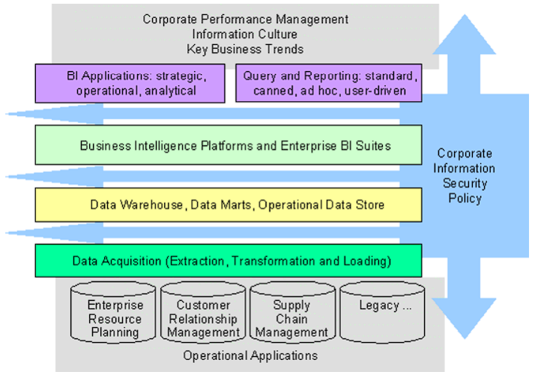

## Cyber Security Management

Cyber security management covers the protection of information, systems and networks from cyber threats like hackers, malware, phishing attacks and other forms of cybercrime. In order to ensure transparency, integrity and availability of information, it shall include the implementation of policies, procedures and controls.

In order to support business intelligence activities, cyber security management has a key role to play by safeguarding and protecting the data that are required for this activity. Information is the basis for business intelligence and cybersecurity management plays an important role in protecting this information from threats such as fraud, unauthorised access or breach of personal data.

Data could be at risk if they are not adequately protected, which would lead to loss of confidence in the customer or stakeholders as well as damage to an organisation's reputation. The responsibility to ensure that an organisation is in compliance with the regulations and standards on data privacy and security, which can help prevent prosecution or financial penalties from being imposed as well as protecting its reputation, lies also with cybersecurity management.

In essence, Business Intelligence tools are applied to the organisation, personal and legislation context in order to store important data. We use Business Intelligence tools to store the data we've collected from the research and to analyse the data we've stored for an organization such as our IT company. We'll be giving competition to a lot of organisations like ours by doing this. One point can be stated that BI tools for data storage and protection are used most of the time within a given context.

## Discovering BI Security Risk

If left unattended, the act of creating, receiving, or housing data itself always carries a risk. At the very least, those who integrate BI strategy into their operations are more aware of their data—what it is and where it is stored. But security is not the same as knowing. A hacker would value the insights gained by BI and data analysis even more because they are no longer unstructured 1s and 0s but rather highly sensitive information that is simple to understand. They are essentially taking the very secrets to your success if they can steal data that has already undergone analysis. Compare that to a vehicle burglar. Instead of merely stealing a few spare components from a garage, they are boosting Ferraris directly off the showroom floor.

## Methods to protect the Risk

There are different types of risks associated with BI and BI tools in the current context. In order to protect this risk in organisational, private and legislative context the following methods should be used:

### Encrypting and Segmenting Data Insights

It's crucial to secure data after it has been unwrapped since BI insights are extremely valuable to hackers. Business intelligence requires many fundamental security practises that must be modified. Insights must be encrypted before being saved or shared to another person. This practise will, at the very least, significantly hinder a hacker from deciphering our personal information. The IBM Z system, which can process 12 billion encrypted transactions per day, serves as proof that it is now possible to quickly encrypt enormous volumes of data. A mistake that may have contributed to the massive Equifax breach is ignoring encryption. Additionally, consider strategically segmenting our network as well as our data storage. Although segregated data insights can be a safe practise, siloed raw data is ineffective for analysis. By doing this, if a hacker manages to access just one part of our network, they won't instantly have access to all of our data. It's the distinction between walking into a Fort Knox vault and prospecting for gold nuggets.

### Determining Access and Permission

Powerful BI insights might be deadly if it falls into the wrong user's hands. It's risky to grant all of our staff complete access to these insights, even though we may trust them all. Employees should see data findings and trends that are relevant to their occupations, although many of these things can be given to them by a manager or supervisor. Every employee's position must be carefully examined at the start of a BI plan to identify whether or not they need access to BI tools and data. Even if we are confident that a dissatisfied employee won't attempt to cause chaos and alter our data, if they don't actually need access to some BI tools, they may overlook simple security steps (like resetting their password) and unknowingly serve as an invitation to a hacker.

### Applying BI to Data Security

Many business leaders are aware that data can be used to acquire important information about their companies, and they often overlook the fact that BI is an effective way of dealing with security. Analysis of the data can reveal backdoors, network inconsistencies and technical shortcomings that may be exploited by hackers. The security strategy of BI can monitor data as they enter or exit your organisation to see if a suspicious action is taking place right away, by means of realtime results.

## Policy Enforcement

Stakeholders should be considering the establishment of a Corporate Czar responsible for monitoring data input to ensure its integrity. Low quality data on the front end does not align with Actionable BI.

## Leadership Competencies

Leadership competencies are skills and behaviours that contribute to higher levels of productivity at work. By analysing the existing scenario and improving leadership abilities, a person can use various business intelligence tools in an organisation to make better business decisions and boost output. In addition, an organisation may create its vision and strategy with the use of business intelligence technologies, allowing it to make better decisions regarding its policies and manage risk with ease. Additionally, changes to, and monitoring of, devices within an organisation can be made without any issues.

## Training and Support

An essential component of any business intelligence initiative is training and support. In order to help users effectively use business intelligence tools, it is important that they receive training and support so as to enable them to fully exploit their potential.

Data literacy, which is the ability to read, analyse and communicate data in an efficient way, can be improved through training. This, in turn, can help users make informed decisions based on the data as well as provide them with valuable insight into their businesses, customers and markets. Users will also be able to keep in touch with the most recent features and functionalities of BI tools through continuous training.

In order to maximise productivity and efficiency in the use of business intelligence tools, training and support can also be provided. In order to increase the accuracy and effectiveness of decisions made, users can gain access to a complete platform's capabilities through which they can save both time and effort.

In general, support and training are essential elements of a business intelligence initiative's success. Organisations can boost productivity, promote data literacy, and enable users to use business intelligence tools to make data-driven decisions by supplying users with the information and tools they need to do so.

# Identifying Specific example of Organisation have used BI Tools

For research purposes I have selected particular examples of organisations that use business intelligence tools to make their operations better or more effective by using sites visited as my source. Examples of which can be found are the following:

## BD Technology Centralized Digital Marketing reporting issues conversions

**Company:** BD Technology

**Problem:** Digital Marketing Report was time-intensive, manual, and inefficient.

**Solution:** A centralised business intelligence solution has saved the Marketing Analytics team 8 to 20 hours of work per day, through automated reporting processes, for company BD technology. It has also enabled a larger marketing team to take on the responsibility of setting up local, tailored campaigns for online advertising.

HelloFresh, in order to guide their efforts, has developed three buyer personas based on an overall analysis of customer behaviour. The fact that the team is able to see and monitor realtime data means they can respond to customer behaviour and optimise their marketing campaigns. The result has been an increase in the conversion rate and better retention of customers.

## Coca-Cola operational efficiency Bottling Company maximized

**Company:** Coca-Cola Bottling Company (CCBC), Coca-Cola largest independent bottling partner.

**Problem:** Real-time operations and sales data were only partially accessible due to manual reporting processes.

**Solution:** The business intelligence unit of Coca-Cola manages reporting for all of the company's delivery and sales activities. The team simplified manual reporting procedures using its BI platform, saving over 260 hours annually—more than six 40-hour work weeks. Mobile dashboards that offer timely, useful information and a distinct competitive edge put customer relationship management (CRM) data back into the hands of sales people in the field through report automation and other enterprise system interfaces.

The implementation of self-service BI makes it easier for IT users and businesses to cooperate more effectively in order to maximize participants' expertise. Analysts and IT can focus on big-picture strategy and long-term innovations such as enterprise data governance rather than manual research and reporting tasks.

## Baisnav Created a unified view of Restaurant Operations

Company: Baisnav

**Problem:** Disparate data sources hindered teams from seeing a unified view of restaurant

**Solution:** Baisnav's a Nepalese restaurant chain with more than 5 locations in Nepal. Baisnav has dropped their old BI solution for the modern, self-service BI platform. In this way they were able to combine a centralised view of operations so that the effectiveness of restaurant operation can be assessed at regional level.

The timeliness of delivery of Strategic Projects reports has tripled from quarter to month, saving thousands of hours in the last few months as staff have more access to data. "This is the way forward for all metrics and understandings to reach a new level," said Bikash Dhakal, Director of Business Intelligence.

## New Capital Public School Identifies and helps at-risk students

**Organisation:** New Capital Public Schools

**Problem:** Manual Excel reporting meant administrators couldn’t see up-to-date data like attendance, preventing timely intervention.

**Solution:** Administrators were unable to see updated data such as attendance, which prevented timely intervention because of the manual Excel reporting.

The NCPS Research and Data Management team weighed student variables to determine which students would be at risk of dropping out of school using a multiple linear regression model known as the dropout coefficient. To make use of the concept, they employed a business intelligence platform. Staff found it simple to spot specific, at-risk students and give them the attention they require thanks to data visualisation.

Dashboards set up by the Research and Data Management Team delivered real-time analytics to 1,00 NCPS teachers and staff so they could adapt and intervene sooner, dramatically improving the intervention success rates. Five years of historical data have been used to support realtime analytics. Therefore, to verify the insights of today's students, employees would be able to dig in historic data at their disposal.

## Justification

The research mentioned above shows that BI tools are significantly more essential to creating a successful firm. The particular organisation in the aforementioned five situations was dealing with five different types of issues. The BI tools helped to resolve such issues in the end. BI technologies are used not simply to store data but also to compare data and assist the organisation in making better decisions. I encourage my staff to use various BI tools in my organisation for a variety of reasons. I recommend that an Excel application be used by one of my employees to store and make decisions, because it's far easier to store data in Excel. And you can easily analyse the various types of data related to decision making. We faced many problems in our company at first, such as: collecting data, analyzing data, and making decisions but when we were using Business Intelligence tools like Excel it was much easier for us to do the things that previously might not have been possible. We use business intelligence tools to do all kinds of things that are relevant to our businesses. You can make your business process more efficient and profitable by using BI tools.

# Evaluate Organization

Executives, managers, and other corporate end users can use business intelligence, a technology-driven process for data analysis and information presentation, to make educated business decisions. Business intelligence is primarily used for quicker and more accurate reporting, better business decision-making, user satisfaction, increased business efficiency, etc. The following features or advantages of business intelligence can aid in broadening their target demographics.

# Swift Decision Making

The ability to make prompt, effective decisions is referred to as swift decision-making. It entails examining your alternatives, reviewing pertinent data, considering probable outcomes, and finally deciding on a plan of action with confidence and clarity. When time is of the essence or when immediate action is required, making quick decisions can be especially crucial. It's crucial to remember that deciding quickly doesn't always entail doing it without giving it careful thought. Making an informed decision still requires acquiring pertinent information, weighing your options, and doing it quickly.

Accelerate and enhance decision making are among the main benefits of using business intelligence systems. Businesses can have a centralised database management system through Business Intelligence, which allows the user to log on whenever he or she wants to examine any data and extract information that is needed. The decision making of managers, who are able to act on the basis of numbers, is made easier through access to past data.

## Timely Recognition of Trends

Managers can immediately spot patterns that have an effect on daily business operations thanks to business intelligence. Better and more accurate planning and forecasting can be accomplished with the use of business intelligence results. It can be used to create customer service tactics that are effective and get rid of those that don't. Essentially, the use of data, statistical inference, and intelligent analysis of that data makes the recognition of trends simpler in theory as well as in practise. Businesses can quickly identify patterns thanks to BI technologies, which can guide their investment decisions.

## To power up Productivity

Product is one that decides for the better and to be a successful organisation. Therefore, an organisation can deploy improved equipment and skilled labour with the help of Business Intelligence to produce high-quality products. Aside from that, they may also analyse their commercial trade, and with the right oversight of each activity, a company can manufacture high-quality, in-demand goods with which to satisfy their customers' wants and benefit. Additionally, the usage of BI within an organisation contributes to increased efficiency by facilitating quicker and simpler business decisions and more effective workforce deployment.

Businesses compete with one another for customers and profits. Customers gain from this underlying economic dynamic because businesses are compelled to continuously enhance their offerings and lower their pricing. Competition enters the corporate world sooner or later. A company must thoroughly research its rivals in order to be competitive, then attempt to develop a strategy based on the data. Business intelligence is primarily used for quicker and more accurate reporting, better business decision-making, user satisfaction, increased business efficiency, etc.

It's difficult to say what data is important for our success against the competition, depending on how we use Social Media, focus groups, independent surveys and sales figures. To know what all of this really means, you've got a guide.

## To beat the Competition, know the Competition

It can be hard to find the right type of data for our analysis in order to gain an advantage over competitors, unless we know what kind of competition is out there. Assess a competitive landscape and the type of competition we're going to encounter once we establish ourselves in this new market.

We can find the best way of analysing data which is relevant to defeating competition once we have formulated a list of competitors in both indirect and direct terms, as well as an understanding of the business environment. In the case of our competitor who is heavily promoting itself on Facebook, we should assess their approach to determining how it works with them and best able to cope with any challenges they or we may face.

We should look into using a customer relationship management tool, so that we can better take advantage of the world of Social Media. We may be able to obtain highly useful information from these services.

We’ll be able to see what the people you are talking with display on the Internet in terms of tone and overall interest. To help us to strengthen our bonds with potential clients, all this may enable us to develop approaches.

## The Overall Best Sources of Data

When it comes to assessing the market and competition there is no best source of data. There are various sources of data which have a particular importance. The best organisation will try to take advantage of the benefits while minimising possible risk because of inaccurate data and untrustworthy sources. We can learn a great deal from social media about our competitors and how successful they are, what their customers think of them or other relevant metrics. But there is a danger that any single source of the data may not be reliable and could mislead. An organisation's target audience is helped to understand by focus groups. However, focus groups often do not provide sufficient data, unless they are extensively conducted, because people's views and perceptions differ. Partial surveys may be useful for getting a sense of what's happening, but they don't always give accurate information. Sales figures should not, in any case, be taken as an indicator of the next trends unless they are helpful for making more important decisions. In order for us to get a clear view, we need to really investigate the various data.

## Steps for effectively analyzing our Competition

Analyzing entails collecting data which may involve a large amount of research, finding out factual facts and searching for valuable information. First and foremost, it is important to take account of all the features that make us different from our competitors, such as product characteristics, strengths and value add services.

To find out more about how well-liked our items are, we should consult focus groups, social media, and other methods of data collection. Compare them next. Based on who is surveyed, the priorities of the customers, the identity of the competitors, and other pertinent aspects, each comparison is likely to be different. To create tactics that will be effective for our items, in-depth investigation will be needed.We should analyse the data to determine our company's strengths and shortcomings so that we may consider them when formulating a strategy. More often than not, how we use the data matters more than its accuracy or source. Following these guidelines will help us choose the data type that will best serve our needs and, potentially, provide us the best chance to outperform our competitors and draw in customers.

## Higher Customer Satisfaction

Customer satisfaction (CSAT) is a measure of how well a company’s products, services, and overall customer experience meet customer expectations. It reflects your business’ health by showing how well your products or services resonate with buyers (Franklin, 2023).

By obtaining insight into consumer behaviour, business intelligence technologies enable companies to swiftly gauge how satisfied customers are with their services. The technologies give companies the ability to analyse their markets and customers, revealing difficulties like long customer response times, prolonged problem resolution times, important geographic locations where customers are having troubles, etc. Using solutions like chat software, which offers live assistance on websites, businesses can try to resolve such problems. The analysis of customer support data can help the company not only streamline its customer service procedures but also develop more creative and successful marketing and promotional plans. This will enable the company to provide highly focused customer service, which will eventually lead to higher customer satisfaction levels.

# Conclusion

There are many resources available to educate and empower buyers, so business intelligence doesn't have to be frightening. There are many different types of BI tools available for exploration and experimentation. The alternatives will grow completer and more potent as the user community becomes more knowledgeable. BI is a flexible and effective tool that practically every industry may benefit from. In this report, I've explained what business intelligence is and the tools and techniques related to it, with examples. I've also designed a business intelligence tool, application, or interface that can carry out a specific task to support advanced problem-solving or decision-making. I've customised the design to make sure that it is user-friendly and has a functional interface, and I've provided a critical review of it. Additionally, I've explained and provided examples of how a certain business intelligence tool will assist every component of an organisation in order to help it make better business decisions. Then, I looked into the legal concerns related to a company's proper use of business intelligence tools, including the industries it will support and the advantages they will gain from each, such as increased productivity, data privacy and security, statistical analysis, etc. Here, I've carried out a research programme to determine whether or not a certain organisation makes use of business intelligence tools to analyse, visualise, and report organisational data for increased productivity and product quality. In addition, if they do not use, how will they be able to manage their organization's operations and the ways they employ. Last but not least, I've evaluated how these business intelligence tools will help a particular organisation target its audience and what it should do. Furthermore, it is also necessary to consider security legislation so that the particular organisation can make its product better in order to gain a competitive advantage on the market as well as improve organisational development.

# References

Biscobing, J., 2020. *Techtarget.* [Online]   
Available at: https://www.techtarget.com/searchdatamanagement/definition/OLAP  
[Accessed 5 May 2023].

Burns, E., 2023. *TechTarget.* [Online]   
Available at: https://www.techtarget.com/searchbusinessanalytics/definition/decision-making-process#:~:text=In%20a%20business%20context%2C%20it,(BI)%20and%20analytics%20tools.  
[Accessed 4 May 2023].

Contributor, T., 2021. *TechTarget.* [Online]   
Available at: https://www.techtarget.com/searchcio/definition/decision-support-system#:~:text=A%20decision%20support%20system%20(DSS)%20is%20a%20computer%20program%20application,the%20best%20possible%20options%20available.  
[Accessed 4 May 2023].

Cote, C., 2021. *Harvard Business School Online.* [Online]   
Available at: https://online.hbs.edu/blog/post/predictive-analytics  
[Accessed 4 May 2023].

Coursera, 2022. *Coursera.* [Online]   
Available at: https://www.coursera.org/articles/data-visualization  
[Accessed 4 May 2023].

Earls, A. R., 2021. *TechTarget.* [Online]   
Available at: https://www.techtarget.com/searchcloudcomputing/definition/multi-cloud-strategy  
[Accessed 5 May 2023].

Franklin, A., 2023. *Zendesk Blog.* [Online]   
Available at: https://www.zendesk.com/blog/3-steps-achieving-customer-satisfaction-loyalty/#:~:text=One%20thing%20is%20certain%3A%20High,just%20one%20bad%20customer%20experience.  
[Accessed 6 May 2023].

Hanna, K. T., 2021. *TechTarget.* [Online]   
Available at: https://www.techtarget.com/searchbusinessanalytics/definition/unstructured-data  
[Accessed 2 May 2023].

ihritik, 2022. *GeeksforGeeks.* [Online]   
Available at: https://www.geeksforgeeks.org/what-is-unstructured-data/  
[Accessed 2 May 2023].

ihritik, 2022. *GeeksforGeeks.* [Online]   
Available at: https://www.geeksforgeeks.org/what-is-semi-structured-data/  
[Accessed 2 May 2023].

Lawton, G., 2022. *TechTarget.* [Online]   
Available at: https://www.techtarget.com/searchenterpriseai/definition/predictive-modeling  
[Accessed 5 May 2023].

Pratt, M. K., 2022. *TechTarget.* [Online]   
Available at: https://www.techtarget.com/searchcio/definition/business-process  
[Accessed 2 May 2023].

Rouse, M., 2012. *Techopedia.* [Online]   
Available at: https://www.techopedia.com/definition/543/executive-support-system-ess  
[Accessed 4 May 2023].

Scardina, J., 2022. *TechTarget.* [Online]   
Available at: https://www.techtarget.com/searchcontentmanagement/definition/Microsoft-Power-BI  
[Accessed 5 May 2023].

Siteware, 2022. *Siteware.* [Online]   
Available at: https://www.siteware.co/leadership/decision-making-in-organizations/  
[Accessed 4 May 2023].

Stedman, C., 2023. *TechTarget.* [Online]   
Available at: https://www.techtarget.com/searchbusinessanalytics/definition/business-intelligence-BI  
[Accessed 5 May 2023].

Taylor, D., 2023. *GURU99.* [Online]   
Available at: https://www.guru99.com/business-intelligence-definition-example.html  
[Accessed 6 May 2023].

Team, I. E., 2022. *Indeed.* [Online]   
Available at: https://www.indeed.com/career-advice/career-development/what-is-application-software  
[Accessed 5 May 2023].

TechnologyAdvice, 2023. *TechnologyAdvice.* [Online]   
Available at: https://technologyadvice.com/business-intelligence/  
[Accessed 5 May 2023].