**FRIDAY AI - ASSISTANT**

*A synopsis submitted in partial fulfillment of the requirement for the award of the degree of*

**BACHELOR OF TECHNOLOGY**

## IN

**COMPUTER SCIENCE AND ENGINEERING**



**Submitted to:**

**Mr. Nitesh Kumar**

**Assistant Professor, Department of Computer Science and Engineering.**

# Submitted by:

Sparsh Kumar (210240101104)

Vikas Kumar (210240101118)

**ROORKEE INSTITUTE OF TECHNOLOGY, ROORKEE**

*(Affiliated to VMSB Uttarakhand Technical University, Dehradun)*

# INDEX

|  |  |  |  |
| --- | --- | --- | --- |
| **S. No.** | **Particulars** | **Pg. no.** | **Remarks** |
| **1.** | **Details of Team Members and Mentors** | 03 |  |
| **2.** | **Abstract** | 04 |  |
| **3.** | **Introduction** | 05 |  |
| **4.** | **Objectives** | 06 |  |
| **5.** | **Methodology** | 07 |  |
| **6.** | **Expected Outcome** | 09 |  |
| **7.** | **Resources required** | 10 |  |
| **9.** | **References** | 11 |  |

**DETAILS OF THE TEAM MEMBERS**

|  |  |  |  |
| --- | --- | --- | --- |
| **STUDENT NAME** | **UNIVERSITY ROLL NO** | **Roll No.** | **EMAIL** |
| **Sparsh Kumar** | **210240101104** | **31** | **sparsh.cse2021@ritroorkee.com** |
| **Vikas Kumar** | **210240101118** | **45** | **vikas.cse2021@ritroorkee.com** |

## Mentor: Mr. Nitesh Kumar

*Assistant Professor, Computer Science Engineering*

*Roorkee Institute of Technology (RIT)*

# ABSTRACT

### 

This report outlines the ongoing development of *FRIDAY – My Personal AI Assistant*, an advanced, voice-controlled, AI-powered application designed to deliver seamless and intelligent interaction through multimodal communication. The primary objective of the project is to build a context-aware digital assistant capable of performing real-time information retrieval, natural language processing, system-level automation, and personalized interaction using state-of-the-art APIs and AI models.

Progress Report 2 highlights the technical, architectural, and functional milestones achieved during the second phase of the project. Following the successful implementation of core functionalities such as wake-word detection, voice command parsing, API integrations, and desktop application control, the focus has now shifted toward personalization, memory retention, image generation, and smart device integration. The project leverages technologies like Python 3.10.10, Google Cloud APIs, Grok-1.5V, and HuggingFace Transformers, all integrated under a modular and asynchronous backend framework.

In this phase, modules for contextual memory, smart home control, and spatial awareness have been planned and partially implemented. Significant attention has been given to improving system responsiveness, noise filtering, and user feedback mechanisms using TTS and custom auditory cues. Extensive testing of voice-driven features has confirmed system stability and accuracy in diverse environments.

This report captures the executed work in system integration, audio processing, backend logic routing, and AI-based response generation. The achievements thus far provide a strong foundation for the upcoming development of personalization engines, dashboard visualization, advanced automation features, and final deployment. The team remains aligned with the timeline, and the project is on track to deliver a sophisticated, user-centric AI assistant by the final milestone.

# INTRODUCTION

In an age defined by rapid technological advancement and increasing human reliance on digital systems, the expectation for smarter, faster, and more natural user interfaces has grown exponentially. As artificial intelligence continues to evolve, the vision of creating intelligent assistants capable of seamless interaction, real-time decision-making, and personalized support is no longer confined to science fiction—it is a critical step toward shaping the future of digital living.

Modern users are inundated with fragmented digital ecosystems—navigating through dozens of applications, devices, and platforms daily. The demand for an intelligent, unified assistant that can understand natural language, automate routine tasks, generate creative content, and adapt to individual needs has become more pressing than ever. Traditional assistants often offer limited scope, rigid command sets, and generic responses, falling short of the sophistication and personalization that contemporary users seek.

FRIDAY – My Personal AI Assistant emerges as an innovative solution to this modern challenge. Named and inspired after the fictional yet visionary assistant J.A.R.V.I.S., FRIDAY is designed to be a highly responsive, voice-first AI system that combines powerful backend logic with human-like interaction. The goal is not merely to create another digital assistant, but to deliver an intelligent companion capable of understanding context, managing system-level operations, generating real-time responses, and growing smarter over time through personalized interaction.

At the heart of FRIDAY lies an ecosystem of advanced technologies, including Grok-1.5V for conversational intelligence and reasoning, Google Cloud APIs for voice transcription and web integration, and HuggingFace’s Transformers and Diffusers for natural language processing and AI-generated imagery. These integrations allow FRIDAY to perform a diverse range of functions—from opening applications, retrieving current weather and news, and responding to user queries, to generating AI-powered images and managing smart home devices. All of this is made accessible through a voice-centric interface that emphasizes simplicity, elegance, and futuristic design.

FRIDAY also pushes the boundaries of conventional interaction by incorporating features such as contextual memory, emotional text-to-speech (TTS), wake-word detection, and noise filtering—enabling the assistant to respond more naturally and fluidly, even in noisy or complex environments. The assistant’s architecture is built using Python 3.10.10, with frameworks like asyncfor asynchronous processing and pyautogui for system automation. Its flexible modular design ensures scalability, making it adaptable for future enhancements such as gesture control, multilingual capabilities, and offline command processing.

As users become more accustomed to voice-enabled services and hands-free computing, FRIDAY represents the next evolutionary step in personal AI assistants—bridging the gap between human thought and digital execution. With a strong focus on personalization, real-time intelligence, and user-centric design, FRIDAY is poised to redefine how people interact with technology, setting a new benchmark for intuitive, immersive, and intelligent assistance in the digital age.

# OBJECTIVES

The overarching objectives of the *FRIDAY – My Personal AI Assistant* project are strategically centered around the development of a highly intelligent, adaptable, and human-centric digital assistant that redefines the way users interact with their systems and digital environments. These goals are guided by a mission to enhance everyday productivity, automate routine digital tasks, and deliver a seamless, voice-first experience that combines responsiveness, contextual awareness, and emotional intelligence.

Each primary objective is driven by well-defined, measurable targets designed to ensure both technical excellence and user-centric utility:

**Automate Routine Tasks through Natural Interaction**

A fundamental objective is to build a system that automates frequently performed user operations—such as opening applications, fetching real-time data (weather, news, maps), setting reminders, or generating creative content—entirely through spoken commands. This reduces the dependency on manual navigation and enhances multitasking, enabling users to interact naturally with their devices in a hands-free, efficient manner.

**Provide Real-Time, Context-Aware Intelligence**

FRIDAY is designed to serve as an intelligent agent capable of delivering instant, accurate, and relevant responses by leveraging powerful APIs like Grok for reasoning, Google Cloud for real-time data, and HuggingFace for NLP and generation tasks. A key objective is to ensure that responses are not only factually correct but also contextually aligned with ongoing conversations or user history.

**Deliver Personalized and Emotionally Intelligent User Experience**

A major objective is to go beyond basic functionality and offer deeply personalized interactions. FRIDAY aims to remember user preferences, adapt its tone and style based on mood or context, and respond empathetically when appropriate. Emotional modulation in text-to-speech, customizable interaction styles, and context memory are central to this goal, ensuring a more humanized AI experience.

**Enable Seamless Smart Device and App Control**

FRIDAY will integrate with system-level APIs and third-party services to manage desktop applications, web platforms, and smart home devices. This objective includes the ability to launch or close applications, control system settings, and eventually interact with IoT devices using a unified voice-based interface, thereby extending its utility across multiple environments.

**Ensure Scalability, Modularity, and Future-Ready Architecture**

A core development objective is to architect FRIDAY using modular, scalable principles that support easy integration of future features such as gesture recognition, multilingual support, offline functionality, and emotion-aware responses. This ensures the system evolves in line with technological advancements and user expectations.

**Implement Robust Audio Processing and Wake-Word Control**

To support a seamless voice-first interaction model, FRIDAY is equipped with a custom wake word (“Hey FRIDAY”), noise suppression algorithms, and audio filtering mechanisms. These components ensure high speech recognition accuracy even in challenging acoustic environments—an essential objective for reliable and uninterrupted use.

**Maintain High Standards of Data Security and Privacy**

Another vital objective is to uphold rigorous standards for data protection, including secure management of API keys, encrypted local storage, and compliance with user consent protocols. All interaction logs, personalized data, and preferences are handled responsibly, with user privacy as a cornerstone of design.

**Generate Multimodal Output and Assistive Visual Feedback**

FRIDAY is also expected to go beyond voice feedback by offering visual confirmations, image generation (via HuggingFace), and dashboards that support multitasking and accessibility. The goal is to blend auditory and visual interaction smoothly, enhancing the user's confidence and control over the assistant’s operations.

By fulfilling these objectives, FRIDAY is poised to transform how users engage with their devices—ushering in a new era of proactive, responsive, and intelligent digital assistance that feels natural, powerful, and deeply personalized.

# METHODOLOGY

**1. The Interface: Sleek, Classy & Intelligent**

The first interface of FRIDAY – My Personal AI Assistant sets the tone for a futuristic, elegant user experience. With a sleek black background and a central glowing ring, reminiscent of sci-fi artificial intelligence systems, the design immediately conveys sophistication, intelligence, and responsiveness.

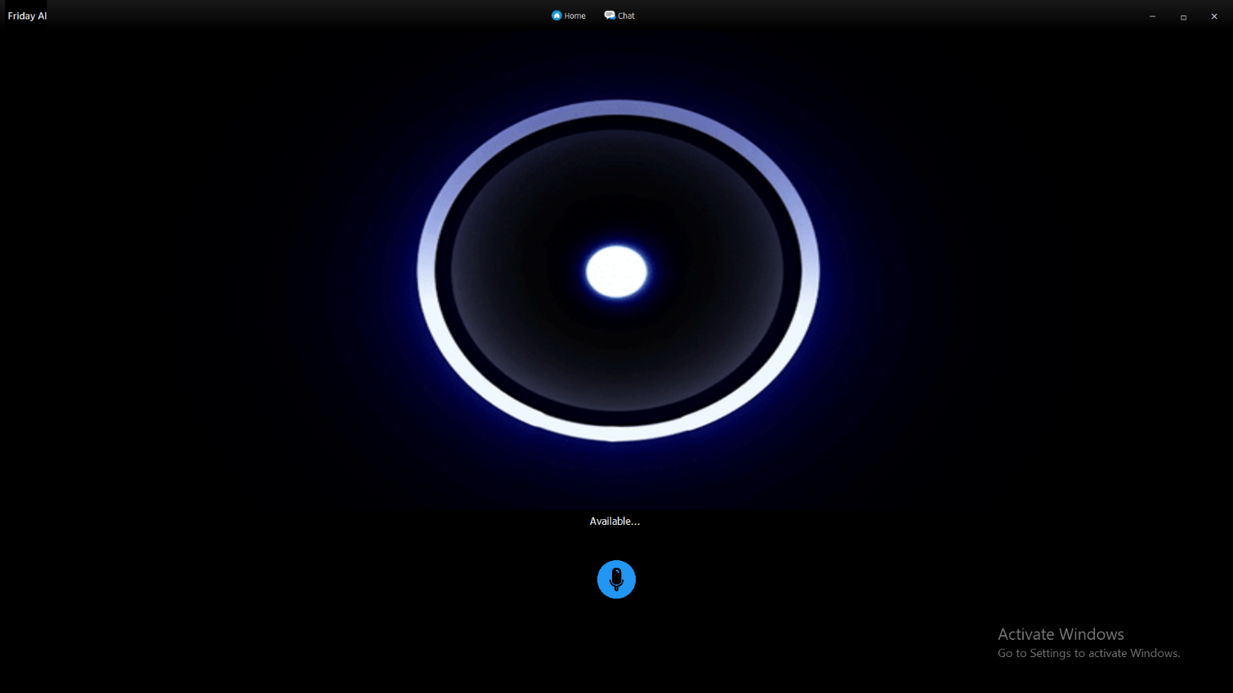

**2. Elegancy and Latency: The testing and responsiveness**

FRIDAY combines a visually elegant interface with highly responsive backend processing to ensure seamless user interaction. The system responds to voice commands in real time with minimal latency, delivering swift feedback powered by asynchronous API integration. Extensive testing confirms stable performance across varied environments, reinforcing both usability and reliability.

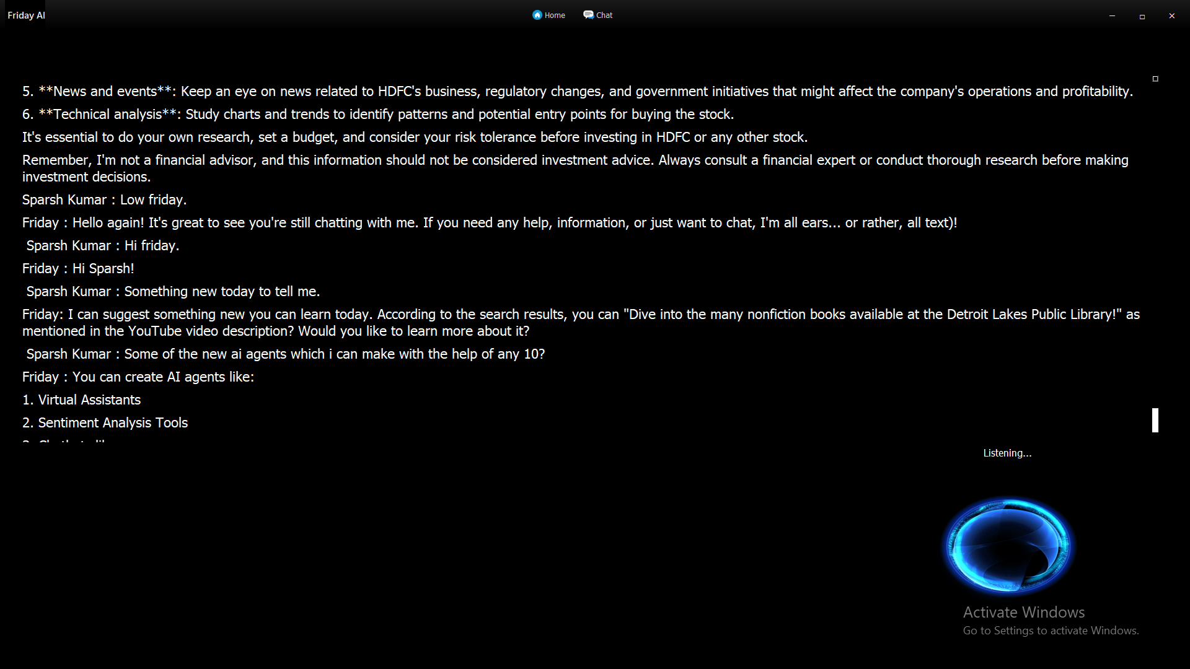

**3. Deployment and Speech-To-Text & Text-to-Speech Proliferation:**

FRIDAY is designed for smooth deployment across modern systems with support for modular upgrades and environment-based configuration. The integration of advanced Speech-to-Text ensures accurate voice recognition, while the Text-to-Speech engine delivers expressive, emotionally adaptive responses. Together, they create a natural and fluid human-AI interaction experience.

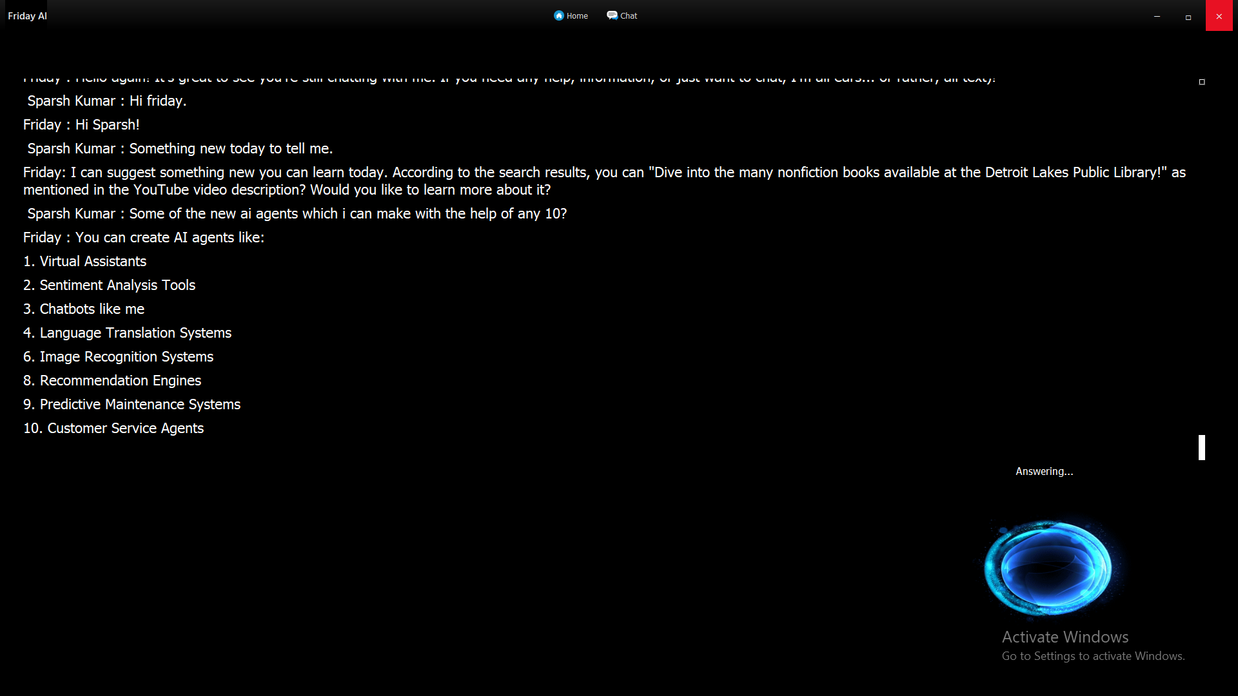

# EXPECTED OUTCOME

The anticipated outcome of the *FRIDAY – My Personal AI Assistant* project is the successful development, deployment, and adoption of an intelligent, voice-controlled assistant that redefines the way users interact with technology. FRIDAY is expected to evolve into a highly intuitive, responsive, and context-aware solution that significantly enhances user productivity, minimizes manual digital interactions, and introduces a new paradigm of hands-free computing. Specifically, the project envisions the realization of the following key outcomes:

**Enhanced Digital Productivity**

Through the automation of routine digital tasks—such as launching applications, retrieving web data, managing reminders, or executing contextual commands—FRIDAY will dramatically reduce the time users spend navigating through interfaces. This efficiency gain will empower users to focus more on their priorities, thereby elevating their overall digital productivity and experience.

**Natural and Personalized Interaction**

With its advanced Speech-to-Text and Text-to-Speech systems, FRIDAY will offer fluid, human-like conversation and voice feedback. Its personalization engine and contextual memory will enable it to adapt its responses based on user preferences, past interactions, and emotional tone, fostering a more engaging and meaningful relationship between the user and the assistant.

**Multimodal Intelligence and Visual Output**

FRIDAY’s integration with Grok and HuggingFace will allow it to generate intelligent answers, AI-created images, and even contextual suggestions. This blend of voice, text, and visual feedback will create a truly multimodal experience, supporting a wide range of user needs—from productivity tasks to creative exploration.

**Expanded System and Smart Device Control**

By enabling voice-controlled interaction with desktop applications and smart home devices, FRIDAY will transform the way users manage their digital environments. The assistant will serve as a central hub for automation, offering seamless control over both system-level actions and connected IoT platforms.

**Improved Accessibility and Inclusivity**

The voice-first interface will significantly enhance accessibility for users with physical or visual impairments, allowing them to perform digital tasks with ease. FRIDAY’s ability to understand natural language and respond audibly ensures inclusivity across a diverse range of user capabilities.

**Scalability and Long-Term Adaptability**

FRIDAY has been architected with a modular backend and API-driven framework to ensure scalability. As user needs evolve, new features—such as multilingual support, emotion-aware conversation, offline functionality, and gesture recognition—can be integrated effortlessly, ensuring its long-term relevance and adaptability.

**Robust Security and Privacy Protection**

FRIDAY will employ environment-based variable management and data encapsulation to secure API keys and sensitive user information. Voice commands, personalized preferences, and context histories will be stored locally or securely encrypted, with strict adherence to data privacy standards and ethical AI practices.

**Deployment-Ready Architecture**

The assistant will be packaged for local deployment with options for integration into smart desktops, edge devices, and cross-platform environments. With support for lightweight configurations and cloud-based APIs, FRIDAY will offer flexible deployment for a wide range of users and systems.

Ultimately, *FRIDAY – My Personal AI Assistant* is envisioned as a transformative tool in the realm of AI-powered interaction—one that empowers users with real-time intelligence, intuitive voice automation, and personalized digital companionship. Its successful realization will mark a significant step forward in making human-computer interaction more natural, proactive, and intelligent than ever before.

# RESOURCES REQUIRED

**• Hardware System Configuration**

1. **Development and Testing Device**:  
   Any modern laptop or desktop capable of supporting Python-based AI development, API integration, and audio processing. Recommended configuration:

* **Processor**: Intel Core i5 / i7 or AMD Ryzen 5 / 7 (or higher)
* **RAM**: Minimum 8GB (16GB recommended for multitasking and testing)
* **Storage**: 256GB SSD or more
* **GPU (Optional)**: NVIDIA GPU for testing models with image generation
* **Display**: 14” or larger, Full HD for ease of development and UI visualization

1. **Testing Devices**:  
   To ensure compatibility across usage scenarios:

* **Windows PC**: Primary development and testing platform
* **Smartphone or Tablet (Android/iOS)**: For testing dashboard accessibility and future expansion
* **Microphone and Speakers**: High-quality peripherals for testing speech recognition and output clarity

**• Software System Configuration**

1. **Operating System**:

* Windows 11 (primary dev environment)
* macOS Monterey or later (optional for cross-platform testing)
* Ubuntu 22.04 LTS or similar for testing Linux compatibility

1. **Development Tools & Environment**:

* **Code Editor**: Visual Studio Code with Python, Pylance, and Git extensions
* **Version Control**: Git with GitHub for remote repo management
* **Virtual Environments**: venv or conda for package isolation
* **Package Manager**: pip for installing dependencies

**• Programming Languages and Libraries**

* **Python 3.10.10**: Core language for backend logic and AI orchestration
* **FastAPI / Flask**: For building lightweight asynchronous APIs
* **SpeechRecognition, PyAudio**: For handling audio input
* **pyttsx3 / gTTS / ElevenLabs API**: For TTS voice feedback
* **pyautogui, os, subprocess**: For device and app control
* **dotenv**: For managing API keys and environment variables securely
* **asyncio**: For concurrent task handling
* **APScheduler**: For scheduling background tasks

**• API Integrations**

* **Grok API (Grok-1.5V)**: For real-time conversation and intelligent reasoning
* **Google Cloud APIs**: For Speech-to-Text, Search, and NLP
* **HuggingFace Transformers & Diffusers**: For text understanding and image generation

**• Database (Optional / Lightweight)**

* **JSON-Based Storage**: For temporary session and context memory
* **SQLite**: Lightweight, local storage for persistent user preferences and logs
* **(Optional)** MongoDB or PostgreSQL: If scalable backend data storage is required in future updates

This resource set ensures FRIDAY is built on a modern, scalable, and efficient development stack that supports real-time AI interaction, multimodal output, and seamless deployment across desktop environments.

# REFERENCES

1. Vaswani, A., Shazeer, N., Parmar, N., et al. (2017). *Attention Is All You Need*. Proceedings of the 31st Conference on Neural Information Processing Systems (NeurIPS). A foundational paper that introduced the Transformer architecture, which underpins FRIDAY’s NLP and generative models.

2. Brownlee, J. (2018). *Deep Learning for Natural Language Processing*. Machine Learning Mastery. An essential guide for understanding NLP tasks such as intent detection and response generation, central to FRIDAY’s conversational capabilities.

3. Hugging Face Transformers Documentation (2024). *Transformers: State-of-the-Art Natural Language Processing*. Available from: <https://huggingface.co/docs/transformers>. Used for integrating text and image generation into FRIDAY’s assistant features.

4. Google Cloud Speech-to-Text API Documentation (2024). *Real-time Speech Recognition*. Available from: <https://cloud.google.com/speech-to-text/docs>. Core to implementing FRIDAY’s voice input and transcription functionalities.

5. Grok API by xAI (2024). *Grok: AI Assistant with Real-Time Web Reasoning*. Available from: <https://x.ai>. Powers FRIDAY’s natural language conversation and reasoning layer.

6. MDN Web Docs (2024). *Web Speech API – SpeechRecognition and SpeechSynthesis Interfaces*. Available from: <https://developer.mozilla.org/en-US/docs/Web/API/Web_Speech_API>. Reference for TTS and STT design implementation.

7.pyttsx3 Documentation (2024). *Offline Text-to-Speech for Python*. Available from: <https://pypi.org/project/pyttsx3/>. Used for implementing natural-sounding speech output in FRIDAY.

8. SpeechRecognition Library Documentation (2024). *Speech Recognition Engine Wrapper for Python*. Available from: <https://pypi.org/project/SpeechRecognition/>. Key tool in capturing and converting user voice commands into actionable text.

9.Vite Documentation (2024). *Vite – Next Generation Frontend Tooling*. Available from: <https://vitejs.dev/guide/>. Utilized for optional dashboard integration and real-time frontend development during future expansion phases.

10. GitHub (2024). *Version Control and Collaboration Platform*. Available from: <https://github.com>. Used for source control, collaborative code management, and deployment readiness tracking throughout FRIDAY’s development cycle.

**REVIEW FEEDBACK FORM-2024**

|  |  |
| --- | --- |
| **Investigator** |  |
| **Department** |  |
| **Guide** |  |
| **Title** |  |
| **Suggestions: [First review]** |  |
| **Second Review** |  |
| **Signature of Guide:**  **Signature of Candidate:** | |
| **Members:**   * 1. Sparsh Kumar   2. Vikas Kumar | |