

Project Title:
Cross-Country Analysis of Economic Growth Trends Using GDP (Current US$), 1970–2024

Course: CSD 301 - Data Analytics Project
Group Members: Rasleen Kaur (08), Sparsh Verma (05)

1️⃣ Introduction

🔹 Problem Statement
To perform a descriptive analysis of country-wise GDP (Current US$) from 1970 to 2024 by examining long-term growth trends, calculating growth rates, analyzing economic fluctuations, and comparing relative economic progression among nations.

🔹 Project Objective
- Study long-term GDP trends across countries
- Measure economic growth using CAGR
- Analyze growth volatility
- Compare economic performance over time
- Identify expansion patterns among nations

📌 Dataset Selection Journey
Before finalizing the GDP dataset for this project, two alternative datasets were initially considered. However, after preliminary inspection and feasibility analysis, both were rejected due to structural and analytical limitations.

1️⃣ Dataset 1: Depression and Anxiety Dataset

Initial Objective
The dataset was intended for analyzing mental health patterns related to depression and anxiety indicators.

Issues Identified
- The dataset contained primarily categorical and textual variables.
- Only one column contained meaningful numerical values suitable for quantitative analysis.
- Lack of multiple numeric features restricted statistical modeling, correlation analysis, and feature engineering.
- Limited scope for meaningful descriptive analytics or multivariate exploration.

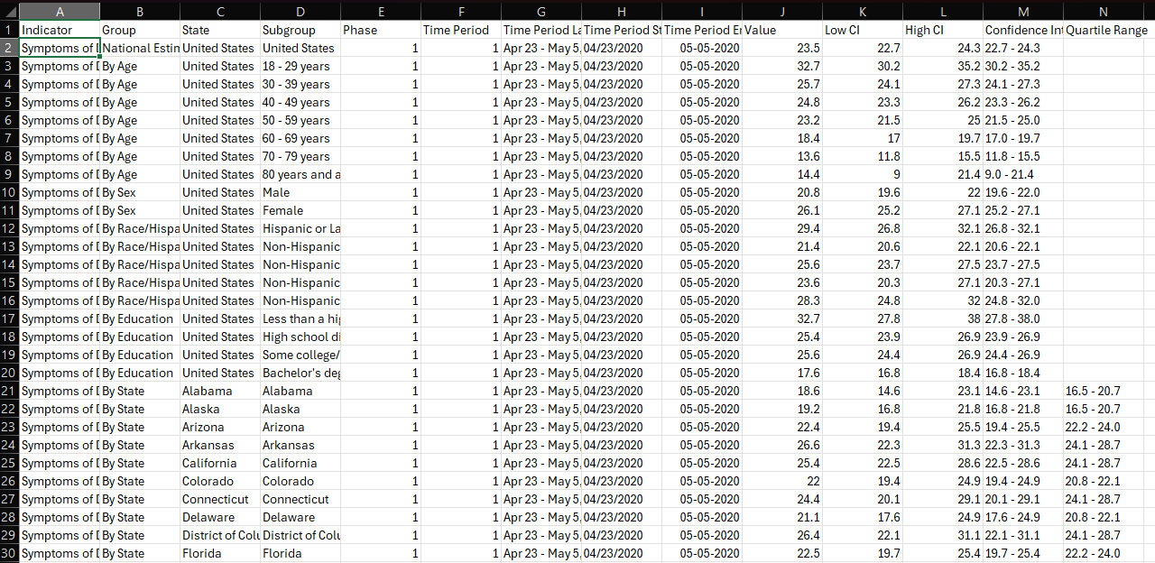

Reason for Rejection
Since the project requires structured numerical time-series or multivariate data for analytical depth, the dataset was deemed unsuitable. The absence of sufficient numeric variables made it difficult to perform meaningful growth, trend, or comparative analysis.

2️⃣ Dataset 2: MACRO-LEVEL ECONOMIC Analysis of Different States Of India

Initial Objective
This dataset was explored for macro-level economic or statistical analysis.

Issues Identified
- The dataset structure was highly clustered and aggregated.
- Data appeared grouped in consolidated formats rather than clean country-wise or row-wise structure.
- Significant preprocessing would be required to restructure the dataset.
- Inconsistent formatting and possible hierarchical grouping reduced usability.
- Limited flexibility for time-series or cross-sectional analysis.
- Data complexity could overshadow analytical clarity within CA-1 scope.

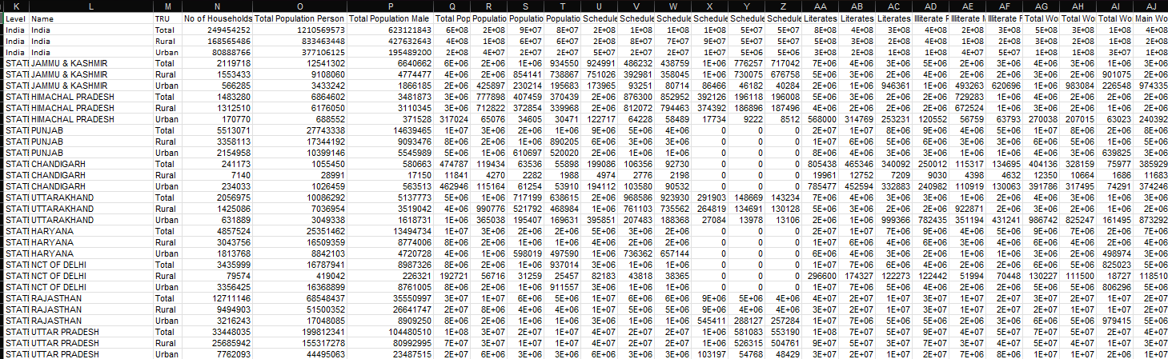

Reason for Rejection
Due to excessive clustering, structural irregularities, and limited straightforward interpretability, the dataset was considered unsuitable for a clear and structured descriptive analysis within the given academic timeline.

🎯 Final Dataset Selection Rationale
After evaluating the limitations of the initial datasets, the GDP (Current US$) dataset from the United Nations Statistics Division was selected because:
- It is structured in a clean country × year format.
- It contains consistent numerical time-series data.
- It allows long-term economic trend analysis.
- It supports meaningful feature engineering (CAGR, Multiplier).
- It aligns with the descriptive analytical objectives of the project.
This structured evaluation ensured that the final dataset was selected based on analytical suitability, reliability, and interpretability.
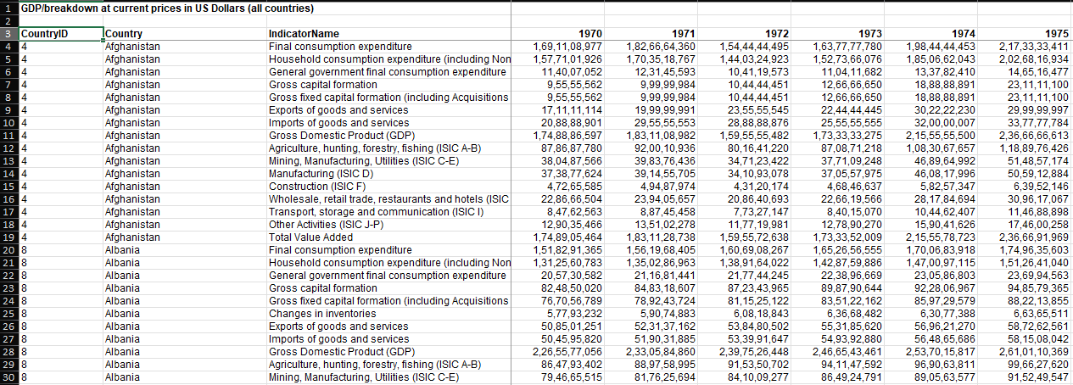

2️⃣ Project Vision / Approach

🔹 Vision
To understand how economies evolved over five decades and assess relative economic progression using structured data analysis.

🔹 Methodology
- Dataset inspection and validation
- Filtering the GDP indicator
- Handling missing values
- Restricting analysis period (1980–2024)
- Feature engineering:
  - Growth Functions
  - CAGR
  - GDP Multiplier
  - Growth

🔹 Tools Used
- Python
- Pandas
- NumPy
- Matplotlib
- Seaborn
- Jupyter Notebook
- Visual Studio Code
- Git, GitHub
GitHub Repository Link: https://github.com/Sparshcoder18/gdp-growth-analysis

3️⃣ Dataset Details

🔹 Dataset Source
United Nations Statistics Division (UN Data Portal)
Dataset: https://unstats.un.org/unsd/amaapi/api/file/2

🔹 Type of Data
- Time-series macroeconomic data
- Numerical (float values for GDP)
- Cross-country panel dataset

🔹 Dataset Size
- Initial shape: 3715 rows × 58 columns
- After GDP filtering: 220 rows × 58 columns
- Final cleaned dataset: (mention your final shape from df_clean)
🔹 Important Features
- Country
- Year columns (1970–2024)
- GDP values

4️⃣ Preprocessing & Feature Engineering

🔹 Data Cleaning Steps
- Removed irrelevant rows
- Filtered only the GDP indicator
- Dropped unnecessary columns
- Checked duplicate countries
- Analyzed missing values
- Removed countries with excessive missing data
- Restricted analysis to 1980–2024
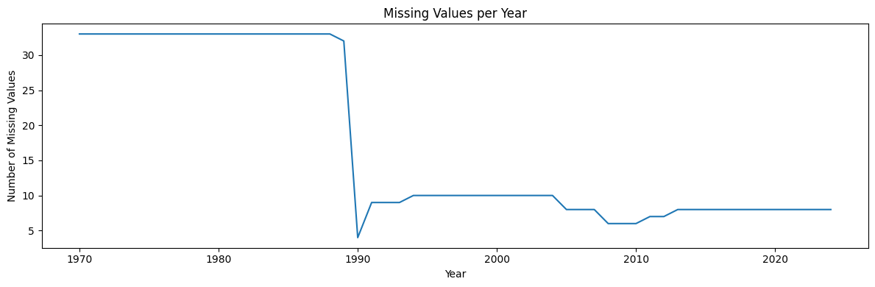Figure 1: Missing Values per Year (1970–2024)]
A year-wise missing value analysis was conducted to assess data completeness. The visualization above shows a sharp decline in missing values after the early 1990s.

🔹 Data Scaling (GDP Conversion to Billions)
To improve interpretability and visualization clarity, GDP values were converted from absolute US Dollar figures to billions scale.
This transformation ensures:
- Easier readability of large numerical values
- Better visual comparison across countries
- Improved interpretability in plots and analysis
The conversion was applied across all year columns using:
GDP (Billions) = GDP (US$) / 1,000,000,000
This step was performed after final dataset cleaning to avoid inconsistencies during preprocessing.

🔹 Preprocessing Techniques
- Missing value analysis (country-wise & year-wise)
- Data type validation
- Index reset
- Column filtering

🔹 Feature Engineering
- CAGR (1980–2024)
- GDP Multiplier
- Growth calculation functions
Include formula:
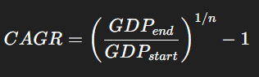

📊 Detailed Description of Dataset Columns

🔹 Original Dataset Columns
After filtering the dataset to retain only the GDP (Current US$) indicator, the dataset contains the following categories of columns:

1️⃣ Country
Type: Object (Categorical)
Description: Represents the name of each country included in the dataset. Each row corresponds to one country.
Purpose in Analysis: Used as the primary identifier for country-wise comparison of GDP trends and growth metrics.

2️⃣ Year Columns (1970–2024)
Type: Float64 (Numerical)
Description: Each column represents GDP (Current US$) for a specific year.
Example:
- 1970 → GDP value for the year 1970
- 1980 → GDP value for the year 1980
- 2024 → GDP value for the year 2024
Data Characteristics:
- Time-series format (wide structure)
- Values expressed in Current US Dollars
- Some missing values in earlier years
Purpose in Analysis:
- Trend analysis over time
- Growth rate computation
- CAGR calculation
- Economic expansion comparison

🧹 Helper Columns (Temporary Columns Used During Cleaning)
These were created during preprocessing but removed in the final dataset.

3️⃣ Missing_Count
Type: Integer
Description: Total number of missing GDP values per country across all years.
Purpose: To identify countries with excessive missing data.

4️⃣ Missing_1980_2024
Type: Integer
Description: Total missing values within the defined analysis period (1980–2024).
Purpose: To filter countries and ensure the reliability of long-term growth analysis.

🚀 Feature Engineered Columns
After preprocessing, the following analytical features were created:

5️⃣ CAGR (1980–2024)
Type: Float64 (Percentage)
Formula:
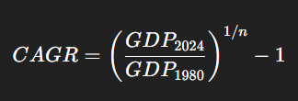
Where: n=44
Description: Represents the compound annual growth rate of GDP between 1980 and 2024.
Interpretation:
- Higher CAGR → Faster long-term economic growth
- Lower CAGR → Slower economic progression
Purpose: Used to compare sustained long-term economic growth across countries.

🔹 Exploratory GDP Analysis (Pre-Comparative Phase)
Before integrating additional macroeconomic indicators, an initial exploratory analysis was conducted on the cleaned GDP dataset to extract key economic insights.

This phase focuses purely on GDP-based comparison to understand:
- Global economic hierarchy
- Distribution of economic size across countries
- Extreme cases (largest vs smallest economies)

6️⃣ GDP_Multiplier
Type: Float64
Formula:
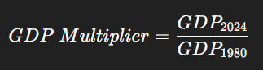
Description: Shows how many times a country’s GDP increased between 1980 and 2024.
Interpretation:
- Value = 2 → Economy doubled
- Value = 5 → Economy expanded fivefold
Purpose: Used to measure total economic expansion over the analysis period.

7️⃣ Growth_Volatility
Type: Float64
Description: Standard deviation of annual GDP growth rates between 1980–2024.
Interpretation:
- High value → Economically unstable growth
- Low value → Stable growth pattern
Purpose: Used to analyze economic stability and fluctuation intensity.

🧠 Functions Implemented in the Project
To avoid the unnecessary creation of multiple growth columns, reusable functions were implemented.

1️⃣ compute_growth(df, year)
Purpose: Calculates GDP growth (%) for a selected year compared to the previous year.
Formula:
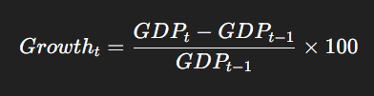
Use Case: To analyze short-term annual growth.

2️⃣ compute_growth_between(df, start_year, end_year)
Purpose: Calculates the total percentage GDP growth between two selected years.
Formula:

Use Case: To compare economic growth across selected periods.

3️⃣ compute_cagr(df, start_year, end_year)
Purpose: Calculates compound annual growth rate between two selected years.
Why Used Instead of Simple Average Growth?
- Removes yearly volatility distortion
- Provides sa moothed long-term growth rate
- More accurate for macroeconomic comparison

📌 Final Dataset Structure
After cleaning and feature engineering:
- Rows → Countries (after filtering excessive missing values)
- Columns →
  - Country
  - Year columns (1980–2024 used for analysis)
  - GDP_Multiplier
  - Growth_Volatility
This structured dataset enables reliable descriptive cross-country economic comparison.

📊 5️⃣ Key Findings

1️⃣ Missing Data Pattern Justifies Analysis Period
The missing values visualization shows a high concentration of missing data prior to the early 1990s, followed by a significant improvement in data completeness. This supports the decision to restrict detailed growth analysis to the 1980–2024 period and avoid forward-filling, thereby maintaining analytical integrity.

2️⃣ Strong Divergence in Long-Term GDP Trends
The GDP trend comparison between India, the United States, and China highlights substantial divergence in economic trajectories:
- The United States maintained steady and dominant economic growth throughout the period.
- China exhibited accelerated growth, particularly after the early 2000s, indicating structural economic transformation.
- India demonstrated consistent upward growth, though at a comparatively lower absolute GDP scale.
This reflects differing development stages and growth strategies among major economies.
To compare long-term economic trajectories,
the GDP trends of major economies were visualized.
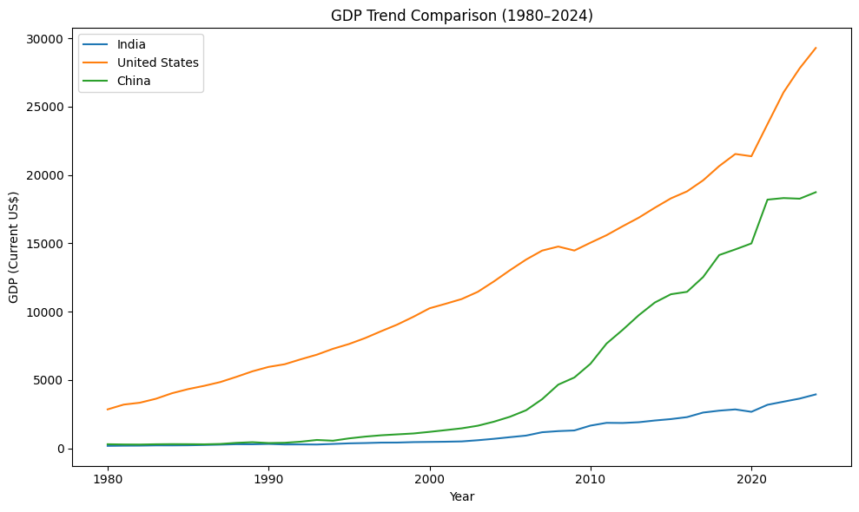
Figure 2: GDP Trend Comparison (1980–2024)
From 1980–2024, the United States maintained the highest GDP, China showed the fastest growth (especially after 2000), and India grew steadily but remained far behind both.

3️⃣ Presence of High Growth Volatility in Certain Economies
The Growth Volatility ranking reveals that several countries, including Equatorial Guinea, Iraq, Angola, and Libya, experienced high fluctuations in GDP growth. This indicates economic instability, possibly influenced by:
- Resource dependence
- Political instability
- External economic shocks
High volatility suggests that strong growth in some periods may have been accompanied by sharp contractions in others.
Growth volatility was analyzed to assess economic stability across countries.
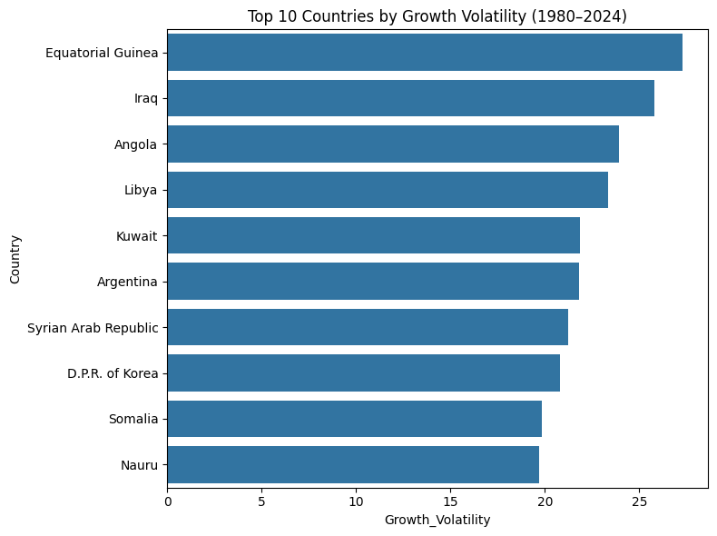
Figure 3: Top 10 Countries by Growth Volatility (1980–2024)
Equatorial Guinea shows the highest GDP growth volatility, followed by Iraq and Angola, indicating these economies experienced the most unstable and fluctuating growth between 1980–2024.

4️⃣ Stability vs. Growth Trade-Off
The analysis suggests a contrast between:
- Economies with stable, moderate growth (typically developed nations)
- Economies with high but volatile growth patterns (often developing or resource-dependent nations)
This demonstrates that high long-term growth does not necessarily imply economic stability.

5️⃣ Multi-Dimensional Economic Assessment
By combining CAGR, GDP Multiplier, and Growth Volatility, the study provides a comprehensive evaluation of economic performance across countries, covering:
- Growth rate
- Scale of expansion
- Stability of growth
This multi-metric approach strengthens cross-country comparison.

6️⃣ Global Economic Distribution (Top vs Bottom Economies)
A comparative visualization of the top 10 and bottom 10 economies (2024) reveals a highly skewed global economic distribution.
Key observations:
- The United States dominates global GDP by a significant margin
- China follows as a strong second, indicating rapid economic expansion
- A sharp drop exists after the top economies, highlighting global inequality
- Small island and micro economies (e.g., Tuvalu, Montserrat) occupy the lowest positions
The V-shaped comparative visualization emphasizes the contrast between economic extremes, making the disparity visually intuitive.
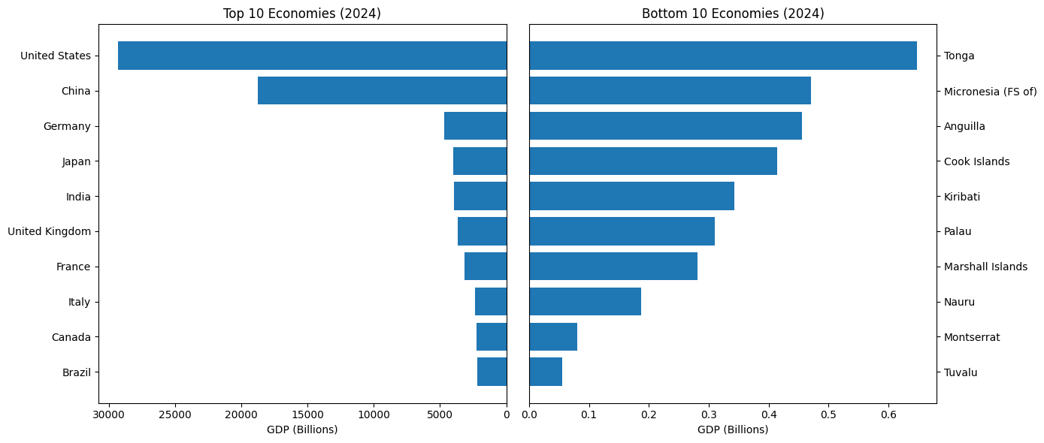
Figure X: Top vs Bottom Economies (2024)

🧾 6️⃣ Conclusion
This study conducted a descriptive cross-country analysis of GDP (Current US$) spanning 1970–2024, with a focused analysis on the 1980–2024 period to ensure data reliability. Through structured preprocessing and feature engineering, key growth metrics such as CAGR, GDP Multiplier, and Growth Volatility were derived.
The findings reveal significant disparities in long-term economic progression across nations. Developed economies demonstrate stable and sustained growth patterns, while several developing and resource-dependent countries exhibit higher volatility. Emerging economies such as China have shown accelerated structural expansion over the past two decades.
The integration of growth rate, expansion magnitude, and stability metrics provides a holistic understanding of global economic evolution. Overall, the analysis highlights the diversity in economic trajectories and emphasizes the importance of evaluating both growth intensity and stability when assessing long-term economic performance.
Additionally, the transformation of GDP values into billions and the preliminary exploratory analysis of top and bottom economies enhanced interpretability and provided a clearer understanding of global economic distribution before proceeding to multi-indicator comparative analysis.

🔹 Phase 2: Structural & Comparative Economic Analysis (Upcoming Work)
This phase extends the analysis beyond GDP by incorporating multiple macroeconomic indicators to understand the structural composition of economies and the drivers of economic growth.
While Phase 1 focused on growth measurement and trend analysis, Phase 2 shifts towards explaining why economies grow by examining sectoral and demand-side contributions.

🔍 Analytical Focus
The following key dimensions will be explored:
• Trade Dynamics
(Exports vs Imports → global integration & trade dependency)
• Domestic Demand Structure
(Final Consumption Expenditure → consumption-driven vs production-driven economies)
• Investment Patterns
(Gross Capital Formation → infrastructure and future growth potential)
• Industrial Strength
(Manufacturing Value Added → level of industrialization)
---

📊 Planned Analysis & Techniques
The following analytical approaches will be applied:
1️⃣ Indicator-wise Trend Analysis
→ Time-series comparison of each indicator across countries
2️⃣ Cross-Country Structural Comparison
→ Identifying economic models (export-driven, consumption-driven, etc.)
3️⃣ Correlation Analysis
→ Examining relationships between GDP and other indicators
(e.g., GDP vs Exports, GDP vs Investment)
4️⃣ Growth Driver Identification
→ Understanding which indicators contribute most to GDP expansion

5️⃣ Comparative Economic Profiling
→ Categorizing countries based on dominant economic characteristics
---

📈 Expected Insights
This phase aims to uncover:
• Whether economies grow through trade, consumption, or investment
• Structural differences between developed and developing nations
• Role of manufacturing in long-term economic growth
• Dependency patterns (import-heavy vs export-driven economies)
---

🧠 Analytical Significance
By integrating multiple indicators, this phase transforms the analysis from:
👉 “How much economies grew” (Phase 1)
to
👉 “What drives that growth” (Phase 2)
This provides a more comprehensive and realistic understanding of global economic behavior.

