

Project Title:
Cross-Country Analysis of Economic Growth Trends Using GDP (Current US$), 1970–2024

Course: CSD 301 - Descriptive Analytics Project
Group Members: Rasleen Kaur (08), Sparsh Verma (05)

Table of Content
1
Project Title: Cross-Country Analysis of Economic Growth Trends Using GDP (Current US$), 1970–2024 1
1. Introduction 5
1.1 Problem Statement 5
1.2 Project Objectives 5
1.3 Dataset Selection Journey 5
Dataset 1: Depression and Anxiety Dataset 5
Dataset 2: Macro-Level Economic Analysis of Different States of India 5
2. Final Dataset Selection Rationale 6
3. Project Vision / Approach 6
3.1 Vision 6
3.2 Methodology 6
3.3 Tools Used 7
4. Dataset Details 7
4.1 Dataset Source 7
4.2 Type of Data 7
4.3 Dataset Size 7
4.4 Important Features 7
5. Preprocessing and Feature Engineering 8
5.1 Data Cleaning Steps 8
5.2 Missing Values Visualization 8
5.3 Data Scaling: GDP Conversion to Billions 9
5.4 Preprocessing Techniques 9
6. Detailed Description of Dataset Columns 9
6.1 Original Dataset Columns 9
Country 9
Year Columns (1970–2024) 9
7. Helper Columns (Temporary Columns Used During Cleaning) 10
Missing_Count 10
Missing_1980_2024 10
8. Feature Engineered Columns 11
CAGR Compound Annual Growth Rate (1980–2024) 11
GDP_Multiplier 11
Growth_Volatility 12
Exploratory GDP Analysis: Pre-Comparative Phase 12
9. Functions Implemented in the Project 12
compute_growth(df, year) 12
compute_growth_between(df, start_year, end_year) 13
compute_cagr(df, start_year, end_year) 13
compute_growth_volatility(df, years) 13
10. Final Dataset Structure 14
11. Hypothesis Testing 14
11.1 Test 1: Was Average GDP Growth in 2020 Significantly Different from Zero? 14
11.2 Test 2: Was Average Post-COVID Recovery Growth (2021–2024) Greater than Zero? 15
11.3 Test 3: Is Long-Run Growth Associated with Growth Volatility? 15
11.4 Test 4: Are the Largest Economies More Stable Than the Rest? 16
11.5 Summary of Hypothesis Test Results 17
12. Visualizations and Insights 18
12.1 GDP Trend Comparison: India, United States, and China (1980–2024) 18
12.2 Top 10 Countries by Growth Volatility (1980–2024) 19
12.3 Global GDP Extremes: Largest vs. Smallest Economies (2024) 20
12.4 Top 10 Fastest Growing Economies by CAGR (1980–2024) 21
12.5 Decade-Wise Growth Performance Heatmap (Top 10 Economies) 22
12.6 Concentration of Global GDP: Top 10 vs. Rest of the World 23
12.7 Economic Risk vs. Reward: CAGR vs. Growth Volatility (1980–2024) 24
12.8 Economic Drivers of India: GDP Component Breakdown (1980–2024) 25
12.9 COVID-19 Shock and Recovery: Top 10 Economies (2017–2024) 26
12.10 Pandemic Shock vs. Post-Pandemic Recovery: Economic Resilience Analysis 27
12.11 Structural Correlation Matrix (2024) 28
12.12 Dominant Structural Profile by Country (2024) 29
12.13 Structural Economic Profiles of Major Economies (1980–2024) 30
13. Key Finding_ 32
13.1 Missing Data Pattern Justifies Analysis Period 32
13.2 Strong Divergence in Long-Term GDP Trends 32
13.3 High Growth Volatility Concentrated in Specific Economies 32
13.4 Stability vs. Growth Trade-Off 33
13.5 Multi-Dimensional Economic Assessment 33
13.6 Persistent Global Economic Concentration 33
13.7 COVID-19 Shock Was Statistically Significant and Universally Felt 33
13.8 Post-COVID Recovery Was Robust and Statistically Validated 33
13.9 Key Findings from Phase 2 34
14. Future Phase: Structural and Comparative Economic Analysis 34
14.1 Analytical Focus 34
14.2 Planned Analytical Techniques 35
14.3 Indicators Prepared for Phase 2 Analysis 35
14.4 Analytical Significance 35
14.5 Scope for Advanced Structural Economic Research and Comparative Analysis 36
15. Conclusion 36

1. Introduction

1.1 Problem Statement
To perform a descriptive analysis of country-wise GDP (Current US$) from 1970 to 2024 by examining long-term growth trends, calculating growth rates, analyzing economic fluctuations, and comparing relative economic progression among nations.

1.2 Project Objectives
- Study long-term GDP trends across countries
- Measure economic growth using Compound Annual Growth Rate (CAGR)
- Analyze growth volatility across economies
- Compare economic performance over time
- Identify expansion patterns among nations

1.3 Dataset Selection Journey
Before finalizing the GDP dataset for this project, two alternative datasets were initially considered. However, after preliminary inspection and feasibility analysis, both were rejected due to structural and analytical limitations.

Dataset 1: Depression and Anxiety Dataset
Initial Objective: The dataset was intended for analyzing mental health patterns related to depression and anxiety indicators.
Issues Identified:
- The dataset contained primarily categorical and textual variables.
- Only one column contained meaningful numerical values suitable for quantitative analysis.
- Lack of multiple numeric features restricted statistical modeling, correlation analysis, and feature engineering.
- Limited scope for meaningful descriptive analytics or multivariate exploration.
Reason for Rejection: Since the project requires structured numerical time-series or multivariate data for analytical depth, the dataset was deemed unsuitable. The absence of sufficient numeric variables made it difficult to perform meaningful growth, trend, or comparative analysis.

Dataset 2: Macro-Level Economic Analysis of Different States of India
Initial Objective: This dataset was explored for macro-level economic or statistical analysis.
Issues Identified:
- The dataset structure was highly clustered and aggregated.
- Data appeared grouped in consolidated formats rather than a clean country-wise or row-wise structure.
- Significant preprocessing would be required to restructure the dataset.
- Inconsistent formatting and possible hierarchical grouping reduced usability.
- Limited flexibility for time-series or cross-sectional analysis.
- Data complexity could overshadow analytical clarity within the project scope.
Reason for Rejection: Due to excessive clustering, structural irregularities, and limited straightforward interpretability, the dataset was considered unsuitable for a clear and structured descriptive analysis within the given academic timeline.

2. Final Dataset Selection Rationale
After evaluating the limitations of the initial datasets, the GDP (Current US$) dataset from the United Nations Statistics Division was selected for the following reasons:
- It is structured in a clean country × year format.
- It contains consistent numerical time-series data.
- It allows long-term economic trend analysis spanning over five decades.
- It supports meaningful feature engineering (CAGR, GDP Multiplier, Growth Volatility).
- It aligns with the descriptive analytical objectives of the project.
This structured evaluation ensured that the final dataset was selected based on analytical suitability, reliability, and interpretability.

3. Project Vision / Approach

3.1 Vision
To understand how economies evolved over five decades and assess relative economic progression using structured data analysis.

3.2 Methodology
- Dataset inspection and validation
- Filtering the GDP indicator from the full dataset
- Handling missing values through systematic analysis
- Restricting the analysis period to 1980–2024
- Feature engineering: Growth Functions, CAGR, GDP Multiplier, Growth Volatility
- Statistical hypothesis testing
- Visualization and descriptive interpretation

3.3 Tools Used
Python, Pandas, NumPy, Matplotlib, Seaborn, SciPy, Plotly, Jupyter Notebook,
Visual Studio Code, and GitHub

4. Dataset Details

4.1 Dataset Source
United Nations Statistics Division (UN Data Portal)
URL: https://unstats.un.org/unsd/amaapi/api/file/2

4.2 Type of Data
- Time-series macroeconomic data
- Numerical (float values for GDP in Current US Dollars)
- Cross-country panel dataset

4.3 Dataset Size
- Initial shape: 3,715 rows × 58 columns
- After GDP indicator filtering: 220 rows × 58 columns
- Final cleaned dataset: 179 rows × 57 columns

4.4 Important Features
- Country primary identifier for each economy
- Year columns (1970–2024) GDP values per year per country
- GDP values numerical (float64), expressed in Current US Dollars

5. Preprocessing and Feature Engineering

5.1 Data Cleaning Steps
- Removed irrelevant rows not pertaining to the GDP indicator
- Filtered dataset to retain only the "Gross Domestic Product (GDP)" indicator
- Dropped the IndicatorName column after filtering
- Checked for and confirmed absence of duplicate country entries
- Conducted year-wise and country-wise missing value analysis
- Removed countries with any missing GDP values in the 1980–2024 analysis window
- Restricted the primary analysis period to 1980–2024
- Reset the dataset index for clean row referencing

5.2 Missing Values Visualization
A year-wise missing value analysis was conducted to assess data completeness across the full dataset. Countries with excessive missing observations in the 1980–2024 analysis window were excluded to maintain a balanced panel.
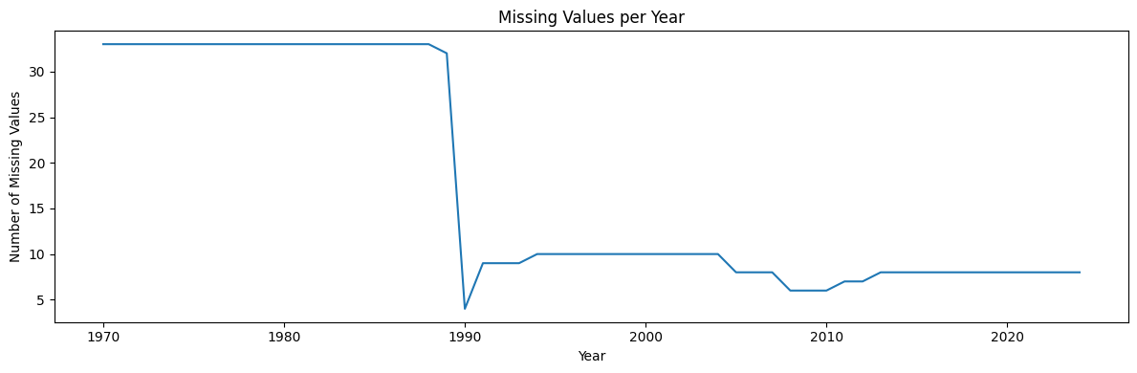
Figure 1: Missing Values per Year (1970–2024)
The visualization shows a high concentration of missing values prior to the early 1990s, followed by a significant improvement in data completeness after 1990. This pattern confirms the suitability of restricting the primary analysis window to 1980–2024 and justifies the decision not to forward-fill missing values, thereby preserving analytical integrity.

5.3 Data Scaling: GDP Conversion to Billions
To improve interpretability and visualization clarity, all GDP values were converted from absolute US Dollar figures to billions of Current US Dollars. This transformation was applied to all year columns after final dataset cleaning.
GDP (Billions) = GDP (US$) / 1,000,000,000
This step ensures:
- Easier readability of large numerical values
- Better visual comparison across countries
- Improved interpretability in all plots and analytical outputs

5.4 Preprocessing Techniques
- Missing value analysis conducted both country-wise and year-wise
- Data type validation all year columns confirmed as float64
- Index reset clean sequential row indexing applied post-filtering
- Column filtering retained only Country, year columns (1980–2024), and engineered features

6. Detailed Description of Dataset Columns

6.1 Original Dataset Columns
After filtering the dataset to retain only the GDP (Current US$) indicator, the dataset contains the following core column categories:

Country
Type: Object (Categorical)
Description: Represents the name of each country included in the dataset. Each row corresponds to one country.
Purpose in Analysis: Used as the primary identifier for country-wise comparison of GDP trends and growth metrics.

Year Columns (1970–2024)
Type: Float64 (Numerical)
Each column represents GDP (Current US$) for a specific calendar year. Examples:
- 1970 → GDP value for the year 1970
- 1980 → GDP value for the year 1980
- 2024 → GDP value for the year 2024
Data Characteristics:
- Time-series format (wide structure)
- Values expressed in billions of Current US Dollars (post-scaling)
- Some missing values exist in earlier years (pre-1990)
Purpose in Analysis:
- Trend analysis over time
- Growth rate computation
- CAGR calculation
- Economic expansion comparison

7. Helper Columns (Temporary Columns Used During Cleaning)
The following columns were created during preprocessing to facilitate data quality assessment. They were removed from the final dataset after serving their purpose.

Missing_Count
Type: Integer
Description: Total number of missing GDP values per country across all years (1970–2024).
Purpose: To identify countries with excessive missing data across the full dataset span.

Missing_1980_2024
Type: Integer
Description: Total number of missing GDP values per country within the defined analysis period (1980–2024).
Purpose: To filter countries and retain only those with complete observations in the analysis window, ensuring the reliability of long-term growth analysis.
Countries with any missing value in the 1980–2024 window were excluded. The final cleaned dataset retains 179 countries with zero missing values across the analysis period.

8. Feature Engineered Columns
After preprocessing, the following analytical features were derived from the cleaned GDP panel to enable multi-dimensional economic comparison:

CAGR Compound Annual Growth Rate (1980–2024)
Type: Float64 (Percentage)
Formula:
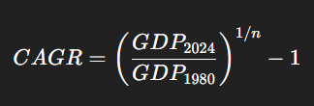
Where: n = 44 (number of years between 1980 and 2024)
Description: Represents the constant annualized growth rate required to move GDP from its 1980 value to its 2024 value.
Interpretation:
- Higher CAGR → Faster long-term economic growth
- Lower CAGR → Slower or stagnant economic progression
Purpose: Used to compare sustained long-term economic growth across countries while smoothing year-to-year volatility.
Why CAGR instead of Simple Average Growth: CAGR removes yearly volatility distortion, provides a smoothed long-term growth rate, and is more accurate for macroeconomic comparison across countries with varying growth trajectories.

GDP_Multiplier
Type: Float64
Formula:
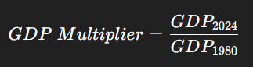
Description: Shows how many times a country's GDP increased between 1980 and 2024.
Interpretation:
- Value = 2 → Economy doubled over the analysis period
- Value = 5 → Economy expanded fivefold
Purpose: Used to measure the total scale of economic expansion over the full analysis period.

Growth_Volatility
Type: Float64
Description: Standard deviation of annual GDP growth rates between 1980 and 2024. Computed using a helper function that calculates year-over-year growth rates for each country across all analysis years, then takes the standard deviation.
Interpretation:
- High value → Economically unstable and erratic growth pattern
- Low value → Stable and predictable macroeconomic trajectory
Purpose: Used to analyze economic stability and quantify fluctuation intensity across countries.

Exploratory GDP Analysis: Pre-Comparative Phase
Before integrating additional macroeconomic indicators, an initial exploratory analysis was conducted on the cleaned GDP dataset to extract baseline insights. This phase focused purely on GDP-based comparison to understand:
- Global economic hierarchy
- Distribution of economic size across countries
- Extreme cases: largest vs. smallest economies

9. Functions Implemented in the Project
To avoid the unnecessary creation of multiple growth columns, reusable helper functions were implemented. These functions accept flexible year parameters to enable comparative analysis across any time window.

compute_growth(df, year)
Purpose: Calculates GDP growth (%) for a selected year compared to the immediately preceding year.
Formula:
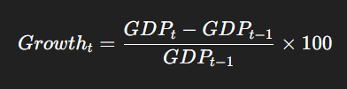
Use Case: To analyze short-term annual GDP growth for any given year.

compute_growth_between(df, start_year, end_year)
Purpose: Calculates the total percentage GDP growth between any two selected years.
Formula:
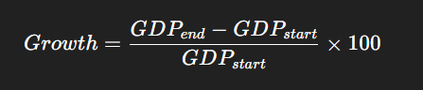
Use Case: To compare cumulative economic growth across selected multi-year periods.

compute_cagr(df, start_year, end_year)
Purpose: Calculates the Compound Annual Growth Rate (CAGR) between any two selected years.

Why CAGR instead of Simple Average Growth:
- Removes yearly volatility distortion
- Provides a smoothed long-term growth rate
- More accurate for macroeconomic comparison across economies

compute_growth_volatility(df, years)
Purpose: Computes the standard deviation of annual GDP growth rates across a specified list of years.
Description: For each consecutive year pair in the provided list, the function computes the year-over-year growth rate, assembles them into a DataFrame, and returns the standard deviation across all computed growth rates per country.
Use Case: To quantify macroeconomic stability and identify economies with erratic versus stable growth patterns.

10. Final Dataset Structure
After all cleaning, scaling, and feature engineering steps, the final analytical dataset has the following structure:
- Shape: 179 rows (countries) × 57 columns
- Rows: Countries with complete GDP observations for the full 1980–2024 period
Columns:
- Country primary identifier
- Year columns (1980–2024) GDP in billions of Current US Dollars
- CAGR_% Compound Annual Growth Rate (1980–2024)
- GDP_Multiplier Ratio of 2024 GDP to 1980 GDP
- Growth_Volatility Standard deviation of annual growth rates
This structured dataset enables reliable, multi-metric, descriptive cross-country economic comparison across five decades.

11. Hypothesis Testing
This section adds statistical validation to the descriptive analysis. Four hypothesis tests are applied to examine whether key visual patterns and economic observations are supported by statistically significant evidence. A significance level of α = 0.05 is applied uniformly across all tests.

11.1 Test 1: Was Average GDP Growth in 2020 Significantly Different from Zero?
Test Type: One-sample t-test
Null Hypothesis (H₀): The mean GDP growth rate across all countries in 2020 is equal to 0.
Alternative Hypothesis (H₁): The mean GDP growth rate in 2020 is significantly different from 0.
Methodology:
Country-level GDP growth rates were computed for the year 2020 using the compute_growth() function. The resulting distribution was tested against a population mean of zero using a one-sample t-test.
Results:
- Sample mean growth (2020): −6.22%
- T-statistic: −7.7372
- P-value: < 0.0001
Conclusion:
Since p < 0.05, the null hypothesis is rejected. The mean GDP growth rate in 2020 is statistically significantly different from zero, confirming that the COVID-19 pandemic caused a measurable and non-random global economic contraction.

11.2 Test 2: Was Average Post-COVID Recovery Growth (2021–2024) Greater than Zero?
Test Type: One-sample t-test (one-tailed)
Null Hypothesis (H₀): The mean post-COVID recovery growth rate is equal to 0.
Alternative Hypothesis (H₁): The mean post-COVID recovery growth rate is greater than 0.
Methodology:
Annual GDP growth rates were computed for each country over the recovery period (2021–2024) and averaged per country. The one-sample t-test was applied with a one-tailed p-value adjustment for the directional hypothesis.
Results:
- Sample mean recovery growth: +8.13%
- T-statistic: 19.0851
- One-tailed P-value: < 0.0001
Conclusion:
Since p < 0.05, the null hypothesis is rejected. The post-COVID recovery growth rate is statistically significantly greater than zero, confirming a robust and economically meaningful global rebound across the 2021–2024 period.

11.3 Test 3: Is Long-Run Growth Associated with Growth Volatility?
Test Type: Pearson Correlation Test
Null Hypothesis (H₀): There is no linear relationship between CAGR (%) and Growth Volatility.
Alternative Hypothesis (H₁): There is a statistically significant linear relationship between CAGR (%) and Growth Volatility.
Methodology:
A Pearson correlation test was performed on the CAGR_% and Growth_Volatility columns across all 179 countries.
Results:
- Pearson correlation coefficient: r = −0.1476
- P-value: 0.0487
Conclusion:
Since p < 0.05, the null hypothesis is rejected. There is a statistically significant, albeit weak, negative relationship between long-run growth rate and growth volatility. Economies with higher CAGR tend to exhibit slightly lower volatility on average though the effect is modest and does not hold universally.

11.4 Test 4: Are the Largest Economies More Stable Than the Rest?
Test Type: Welch's Two-Sample t-test (unequal variance)
Null Hypothesis (H₀): The mean growth volatility of the top 10 economies equals that of all other countries.
Alternative Hypothesis (H₁): The mean growth volatility of the top 10 economies is significantly different from all other countries.
Methodology:
The top 10 economies by 2024 GDP were identified. Growth Volatility was compared between this group and the remaining 169 countries using Welch's t-test, which does not assume equal variance between groups.
Results:
- Mean volatility Top 10 economies: 9.8964
- Mean volatility Rest of world: 12.2440
- T-statistic: −1.9311
- P-value: 0.0811
Conclusion:
Since p > 0.05, the null hypothesis is not rejected. There is no statistically significant difference in growth volatility between the largest economies and the rest of the world at the 5% significance level. While the top 10 economies display slightly lower average volatility, this difference is not statistically conclusive, suggesting that economic size alone does not confer immunity from growth instability.

11.5 Summary of Hypothesis Test Results
The four hypothesis tests collectively strengthen the analytical validity of this study:
- Test 1 confirms the statistical significance of the 2020 pandemic shock it was not a random fluctuation but a measurable, cross-country economic contraction.
- Test 2 validates that the post-pandemic recovery was a genuine, statistically significant rebound, not incidental variation.
- Test 3 establishes a weak but significant inverse relationship between long-run growth and volatility, partially supporting the risk-reward trade-off hypothesis.
- Test 4 finds no statistically significant stability advantage for the world's largest economies, indicating that economic size alone does not guarantee lower volatility.

12. Visualizations and Insights
The following visualizations summarize GDP trends, concentration, volatility, growth leadership, structural composition, and pandemic resilience derived from the engineered features. Each figure includes a brief explanation and key data-driven insights.

12.1 GDP Trend Comparison: India, United States, and China (1980–2024)
To compare long-term economic trajectories among major economies, the GDP trends of India, the United States, and China were plotted across the full 1980–2024 analysis period.
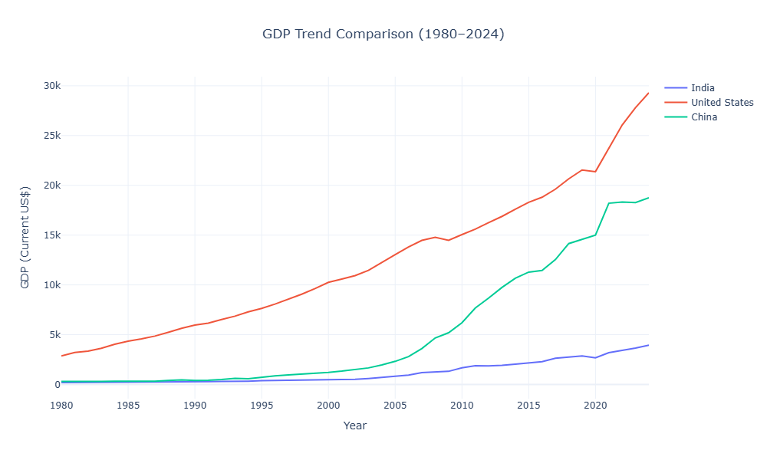
Figure 2: GDP Trend Comparison India, United States, and China (1980–2024)
Key Insights:
- The United States maintained the highest GDP throughout the entire period, reflecting sustained and dominant long-run economic output.
- China exhibited the fastest acceleration, particularly after 2000, driven by rapid industrialization, trade liberalization, and export-led growth indicating a structural economic transformation.
- India demonstrated consistent upward growth from a comparatively lower absolute GDP base, with momentum accelerating notably after 2005.
- The divergence in trajectories reflects differing development stages, growth strategies, and structural economic conditions among these three major economies.

12.2 Top 10 Countries by Growth Volatility (1980–2024)
Growth volatility was computed as the standard deviation of annual GDP growth rates for each country across the 1980–2024 period. The top 10 most volatile economies were ranked and visualized.
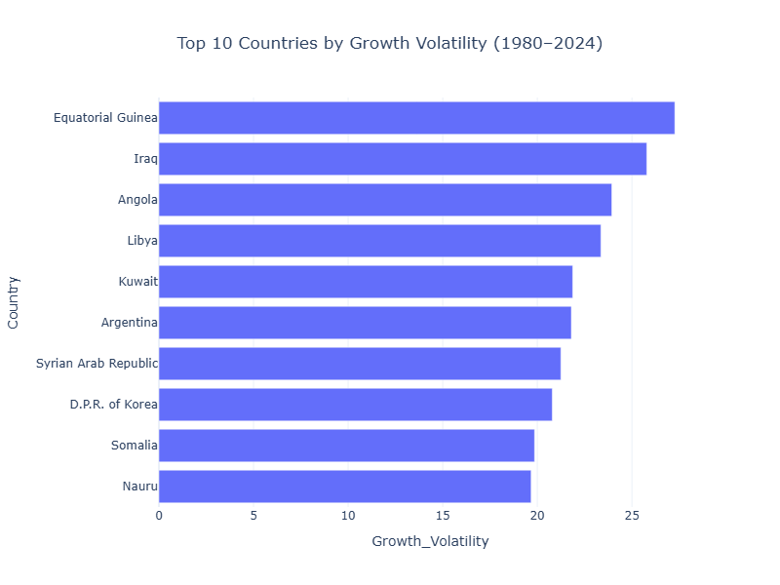
Figure 3: Top 10 Countries by Growth Volatility (1980–2024)
Key Insights:
- Equatorial Guinea records the highest GDP growth volatility, substantially exceeding all other countries, indicating extreme year-to-year fluctuations in economic output.
- Iraq and Angola follow as the second and third most volatile economies, reflecting the impact of conflict, political instability, and dependency on commodity exports.
- The majority of the top 10 most volatile economies are resource-dependent or conflict-affected nations, suggesting that macroeconomic instability is closely associated with structural vulnerabilities.
- High volatility in these economies implies that strong growth in certain years was frequently offset by sharp contractions in others, yielding unreliable and unpredictable development paths.

12.3 Global GDP Extremes: Largest vs. Smallest Economies (2024)
To highlight the scale of global economic inequality, the top 10 and bottom 10 economies by 2024 GDP were visualized in a side-by-side comparative chart.
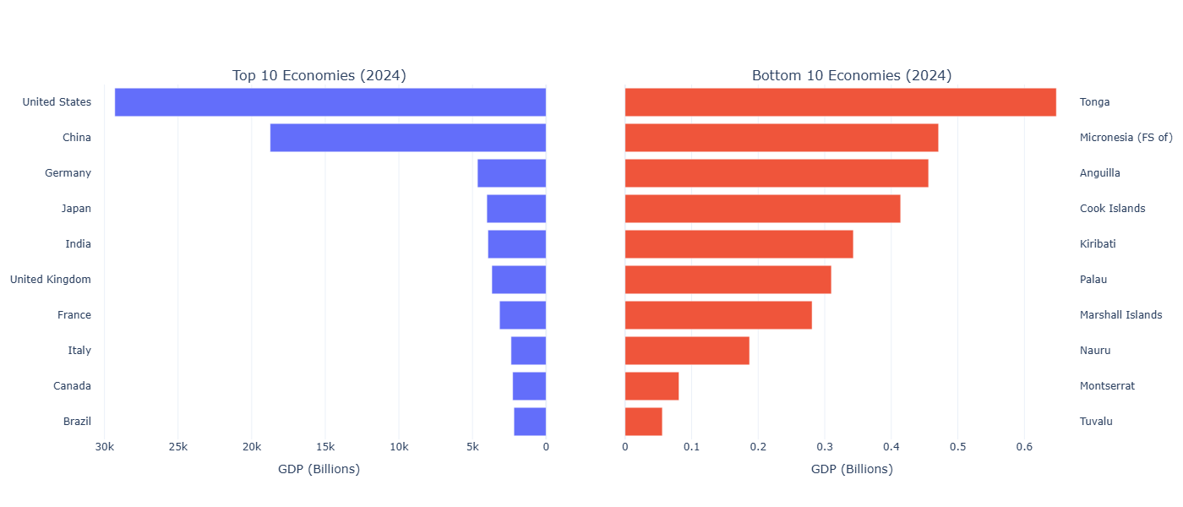
Figure 4: Global GDP Extremes Largest vs. Smallest Economies (2024)
Key Insights:
- The United States dominates global GDP by a significant margin, with China as a distant but strong second reflecting the concentration of economic power at the top.
- A sharp drop in GDP magnitude exists after the top two economies, highlighting the steep hierarchical structure of the global economy.
- Small island and micro-economies such as Tuvalu, Montserrat, and Nauru occupy the lowest positions, with GDP values that are negligible compared to large nations.
- The contrast between the two groups emphasizes the extreme and persistent disparity in economic size across nations, reinforcing the global inequality narrative.

12.4 Top 10 Fastest Growing Economies by CAGR (1980–2024)
To identify the economies that achieved the highest sustained compound annual growth over the full analysis period, countries with a 1980 GDP below USD 1 billion were excluded to avoid base-effect distortion. CAGR was computed for all remaining countries and the top 10 were ranked.
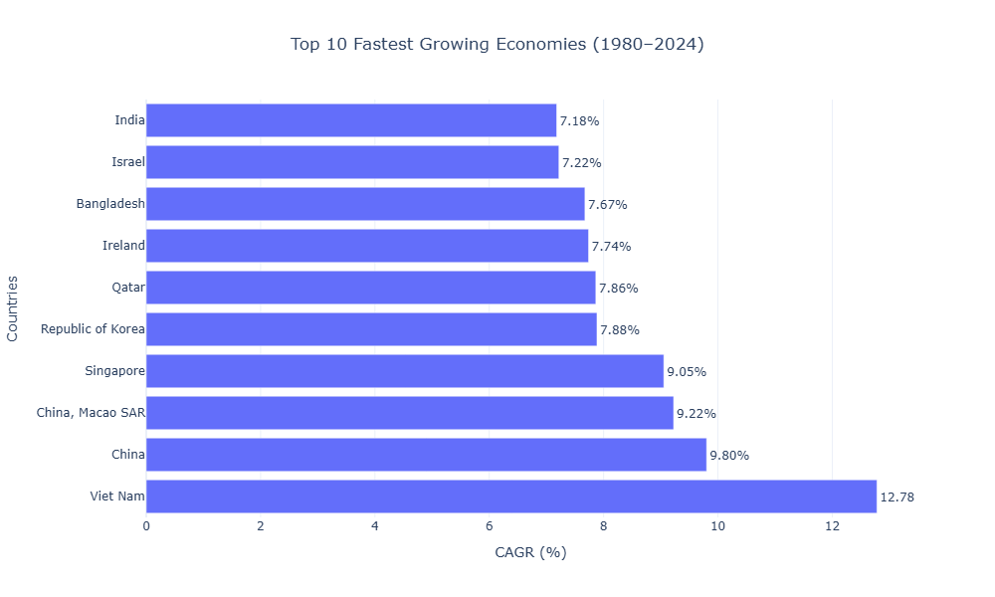
Figure 5: Top 10 Fastest Growing Economies by CAGR (1980–2024)
Key Insights:
- Asian economies dominate the long-run growth ranking, with Vietnam emerging as the top performer with a CAGR exceeding 9.8%, reflecting its successful export-oriented economic transformation.
- China and India also feature prominently, reflecting the structural transformation of their economies through industrialization, trade integration, and policy reforms over four decades.
- Most high-growth countries cluster within a CAGR range of 7–10%, indicating a common trajectory of sustained development driven by similar structural forces.
- The concentration of high-growth economies in Asia underscores the region's role as the primary engine of global economic expansion in the post-1980 era.

12.5 Decade-Wise Growth Performance Heatmap (Top 10 Economies)
To examine how average annual GDP growth rates shifted across decades, a heatmap was constructed covering the 1980s through the 2020s for the top 10 economies by 2024 GDP.
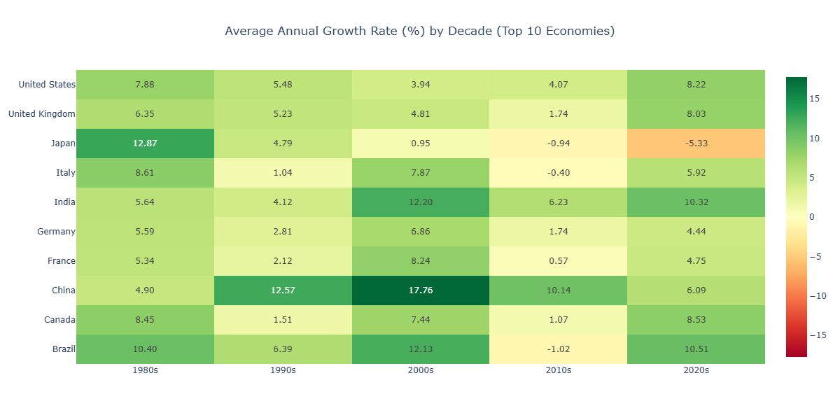
Figure 6: Average Annual Growth Rate (%) by Decade Top 10 Economies
Key Insights:
- A fundamental geopolitical growth shift is visible: Japan dominated the 1980s, while China and India led the 2000s with peak average annual growth rates exceeding 12%.
- Western economies (United States, Germany, France, United Kingdom, Italy) demonstrate a clear cooling trend from the 1980s to the 2010s, reflecting the natural deceleration associated with high-income maturity and demographic aging.
- The 2020s reflect partial recovery from the COVID-19 shock, with India and the United States showing the strongest rebound momentum among the top 10.
- Brazil exhibits significant decade-to-decade variation, reflecting its exposure to commodity cycles and periodic macroeconomic crises.

12.6 Concentration of Global GDP: Top 10 vs. Rest of the World
To assess the degree of concentration in global economic output, the share of world GDP held by the top 10 economies was compared across three benchmark years: 1980, 2000, and 2024.
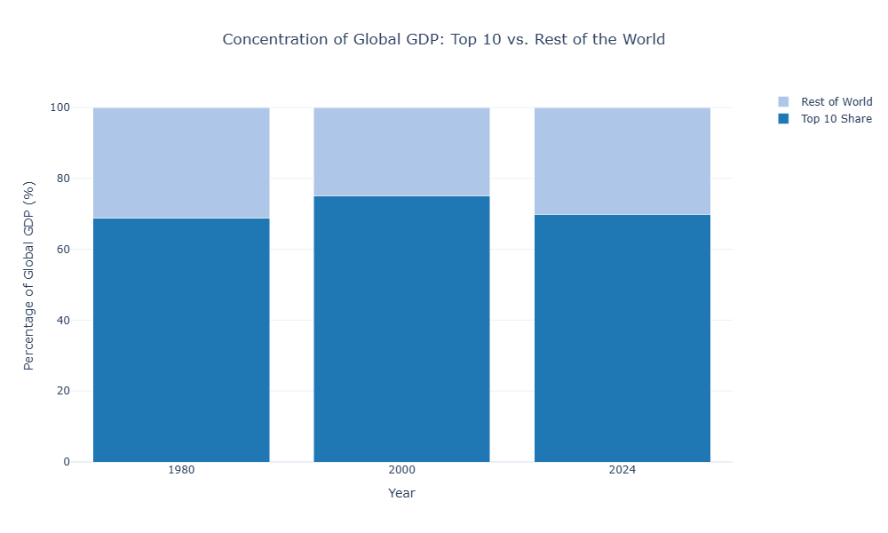
Figure 7: Concentration of Global GDP Top 10 Economies vs. Rest of the World (1980, 2000, 2024)
Key Insights:
- The top 10 economies consistently control approximately 65–70% of world GDP across all three benchmark years, demonstrating a highly persistent concentration of global economic power.
- Despite the rapid growth of emerging markets over four decades, the share held by the Rest of the World has not meaningfully expanded, indicating that economic convergence remains limited at the global scale.
- The stability of this concentration ratio across 1980, 2000, and 2024 suggests that structural barriers to entry into the top economic tier remain extremely high.
- This finding underscores persistent global economic inequality and challenges the notion that growth alone translates into a shift in the global economic hierarchy.

12.7 Economic Risk vs. Reward: CAGR vs. Growth Volatility (1980–2024)
To examine the relationship between long-run economic growth and macroeconomic stability, a bubble scatter chart was constructed. CAGR (%) is plotted on the x-axis, Growth Volatility on the y-axis, and bubble size is scaled by 2024 GDP. Reference lines mark global averages in both dimensions.
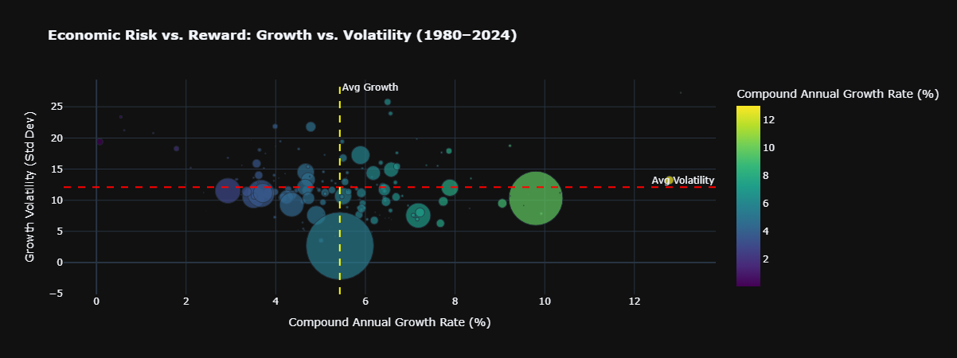
Figure 8: Economic Risk vs. Reward CAGR vs. Growth Volatility (1980–2024)
Key Insights:
- Larger economies (larger bubbles) cluster predominantly in the low-volatility zone, regardless of their CAGR, reflecting the macroeconomic stability associated with economic scale and institutional depth.
- Smaller, high-growth nations tend to occupy higher positions on the volatility axis, confirming that the reward of rapid CAGR is typically accompanied by greater year-to-year economic risk.
- The weak negative correlation between CAGR and volatility (r = −0.1476, confirmed statistically in Test 3) is visually apparent higher-growth economies are not systematically more volatile.
- The four-quadrant structure reveals that the "ideal" quadrant of high growth and low volatility is sparsely populated, indicating that very few economies achieve sustained rapid growth with high stability simultaneously.

12.8 Economic Drivers of India: GDP Component Breakdown (1980–2024)
This visualization illustrates how four major macroeconomic demand-side components Final Consumption Expenditure, Gross Capital Formation, Exports of Goods and Services, and Imports of Goods and Services evolved within India from 1980 to 2024.
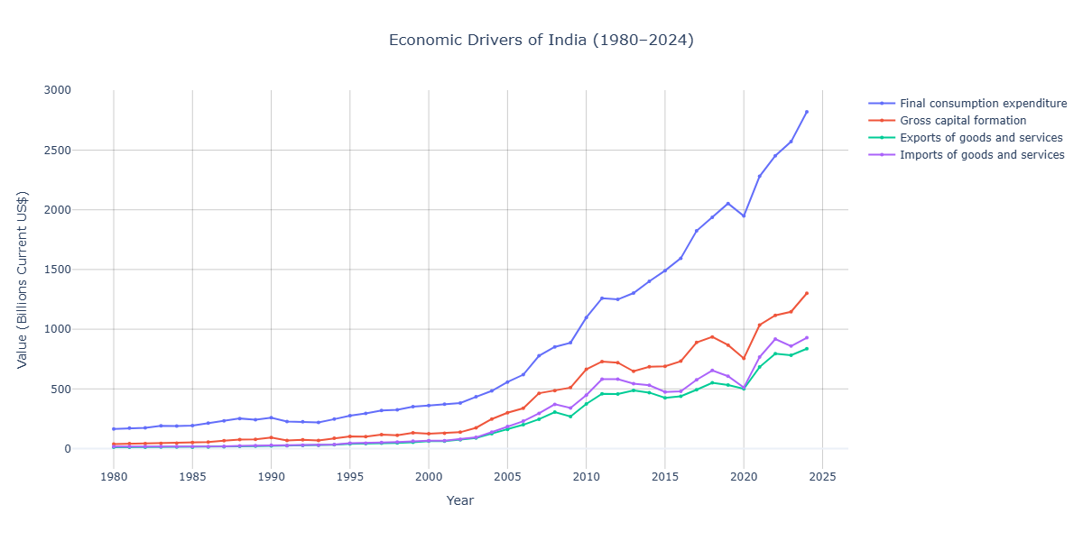
Figure 9: Economic Drivers of India Macroeconomic Component Breakdown (1980–2024)
Key Insights:
- Final Consumption Expenditure remains the dominant driver of India's economy throughout the period, consistently maintaining the largest share confirming India's characterization as a consumption-led emerging economy.
- Gross Capital Formation has risen steadily, particularly post-2000, reflecting increased infrastructure investment and capital deepening associated with India's sustained economic modernization.
- Exports and imports have grown in parallel, indicating progressive integration into global trade networks, especially after the economic liberalization reforms of the 1990s.
- The widening absolute gap between consumption and all other components over time suggests that domestic demand growth has consistently outpaced the expansion of trade and investment activity in India.

12.9 COVID-19 Shock and Recovery: Top 10 Economies (2017–2024)
To understand the precise impact of the COVID-19 pandemic and the nature of the subsequent recovery, GDP trends for the top 10 economies were plotted from 2017 to 2024. The pandemic period (2019–2021) is highlighted to contextualize the shock window.
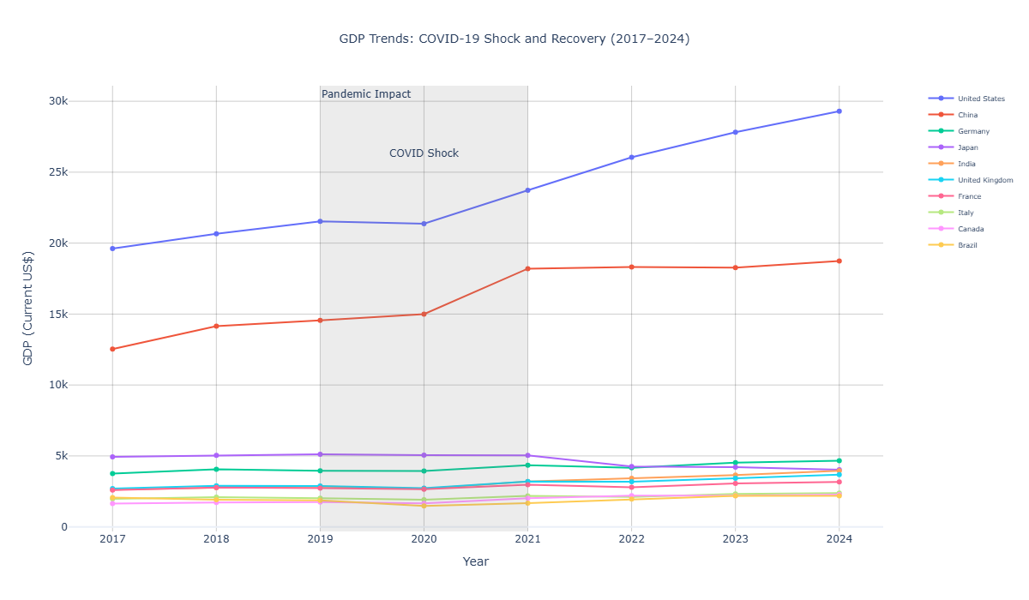
Figure 10: GDP Trends COVID-19 Shock and Recovery Among Top 10 Economies (2017–2024)
Key Insights:
- A sharp, synchronized contraction or stagnation is clearly visible across all major economies in 2020, confirming the universal scope of the pandemic shock regardless of economic scale.
- A V-shaped recovery is evident from 2021 onward, with most top economies returning to or surpassing pre-pandemic GDP levels within two years.
- The United States and India display the most aggressive post-2021 growth trajectories, suggesting greater fiscal stimulus capacity and structural flexibility in their recoveries.
- European economies including Germany, France, and Italy exhibit more moderate recovery slopes, consistent with structural rigidities, energy cost pressures, and tighter fiscal constraints in the post-pandemic period.
- This visualization statistically corroborates the findings of Hypothesis Tests 1 and 2, confirming both the significance of the 2020 contraction and the significance of the recovery.

12.10 Pandemic Shock vs. Post-Pandemic Recovery: Economic Resilience Analysis
To quantify the immediate economic damage of COVID-19 against the strength of subsequent recovery, a grouped bar chart compares the 2020 GDP shock (percentage change vs. 2019) and the post-COVID compound average annual growth rate (2021–2024) for each of the top 10 economies.
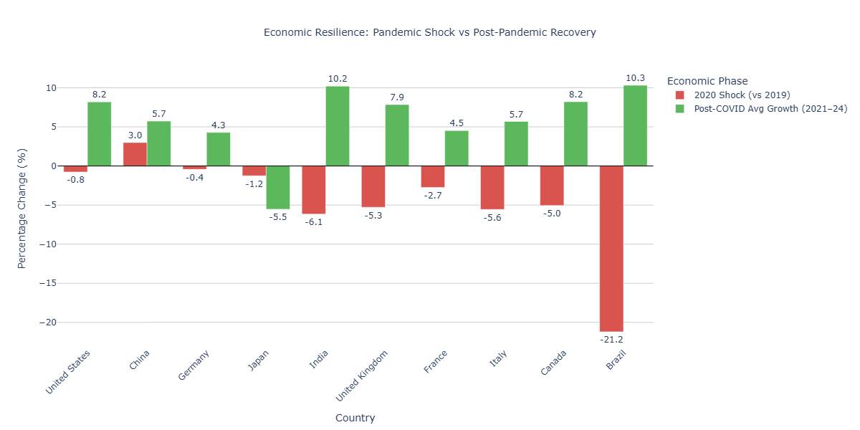
Figure 11: Economic Resilience 2020 Pandemic Shock vs. Post-COVID Average Growth Rate (2021–2024)
Key Insights:
- Every top-10 economy experienced a GDP contraction or significant deceleration in 2020, confirming the universality of the COVID-19 economic shock across the world's largest economies.
- India and the United States exhibit the highest post-COVID average growth rates among the top 10, identifying them as the primary outperformers in the recovery phase.
- European economies particularly the United Kingdom, Italy, and France suffered among the steepest 2020 contractions relative to their size, yet demonstrated moderate rather than exceptional recovery pace.
- The divergence between shock magnitude and recovery strength across countries reflects differences in fiscal stimulus capacity, monetary policy flexibility, sectoral composition, and structural economic resilience.
- This visualization directly reinforces the conclusion of Hypothesis Test 2, confirming that the post-pandemic recovery was not merely incidental but a statistically and economically significant rebound.

12.11 Structural Correlation Matrix (2024)
To examine the interrelationships among major macroeconomic indicators, a structural correlation matrix was developed using GDP, exports, imports, gross capital formation, final consumption expenditure, manufacturing, and trade openness data for the year 2024. The visualization highlights the degree of association among structural economic variables across countries.
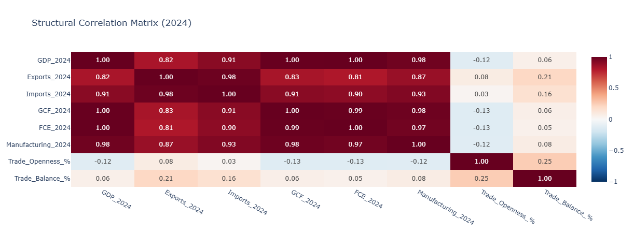
Figure 12: Structural Correlation Matrix of Major Macroeconomic Indicators (2024)
Key Insights:
- Strong positive correlations are observed among GDP, exports, imports, gross capital formation, final consumption expenditure, and manufacturing, indicating high structural interdependence among major macroeconomic variables.
- Most correlation coefficients range between approximately 0.81 and 1.00, reflecting consistent positive relationships across economic indicators.
- Manufacturing demonstrates one of the strongest correlations with GDP (approximately 0.98), emphasizing the significant contribution of industrial production toward overall economic growth and national economic scale.
- Exports and imports exhibit a very high positive correlation (approximately 0.98), highlighting the interconnected nature of international trade and global market integration.
- Gross capital formation and final consumption expenditure also maintain strong positive relationships with GDP, indicating the importance of investment activity and domestic demand in supporting economic expansion.
- Trade openness shows relatively weaker correlation with GDP size, suggesting that smaller economies may still achieve high levels of international trade integration despite comparatively lower economic output.

12.12 Dominant Structural Profile by Country (2024)
To identify the primary structural driver of economies across countries, nations were classified according to the dominant macroeconomic component contributing to their economic structure in 2024. The analysis categorizes countries based on whether final consumption expenditure, exports, or imports constitute the largest structural component.
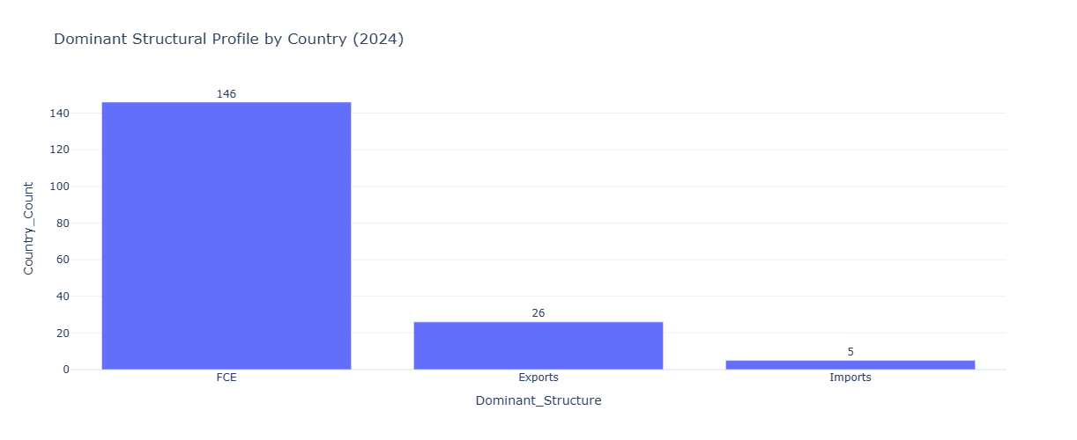
Figure 13: Structural Correlation Matrix of Major Macroeconomic Indicators (2024)
Key Insights:
- Final consumption expenditure emerged as the dominant structural component in 146 countries, indicating that the majority of global economies remain consumption-led in nature.
- Export-oriented structures were dominant in 26 countries, reflecting strong industrial integration, manufacturing specialization, and dependence on international trade.
- Imports represented the dominant component in only 5 countries, suggesting relatively greater reliance on foreign goods and services compared to domestic production.
- The findings demonstrate the global prevalence of domestic consumption as the primary driver of economic activity across both developed and developing economies.
- Export-led economies generally reflect higher levels of industrial competitiveness and integration within global supply chains.
- The structural diversity observed across countries highlights variations in economic strategy, production capability, and external trade dependence.

12.13 Structural Economic Profiles of Major Economies (1980–2024)
A comparative structural analysis was conducted for six major economies — India, China, Germany, the United States, Japan, and Brazil — to evaluate long-term differences in economic composition and development models between 1980 and 2024.
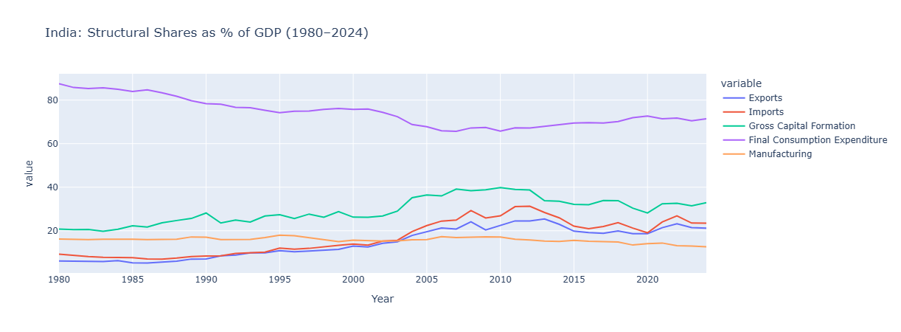
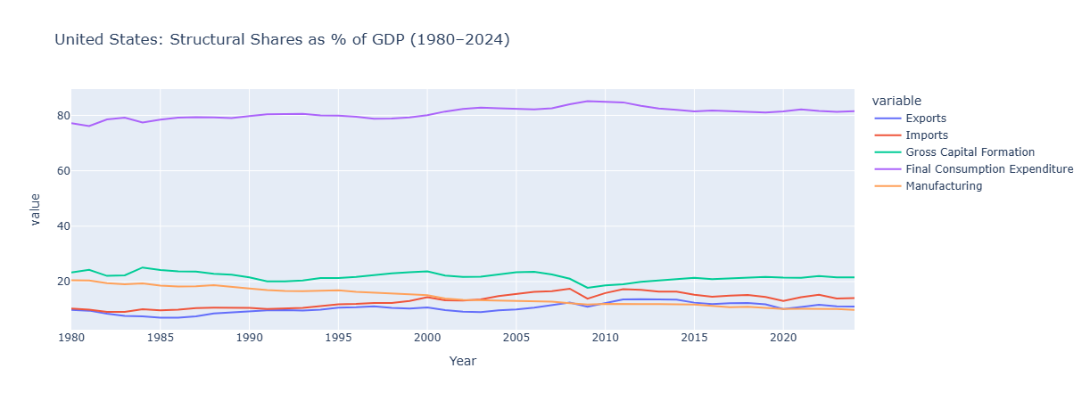
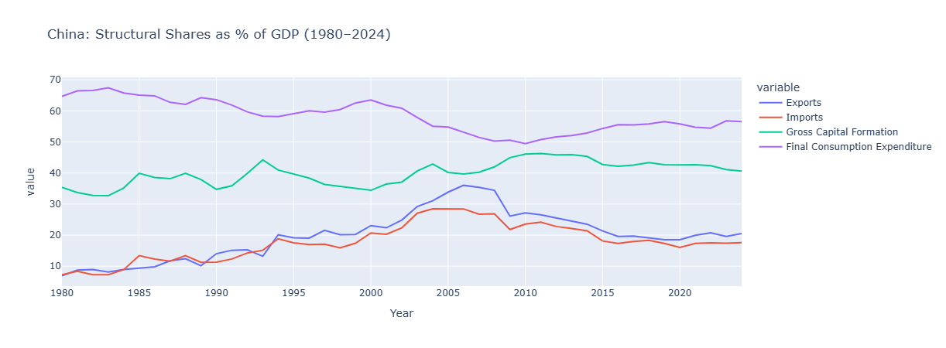
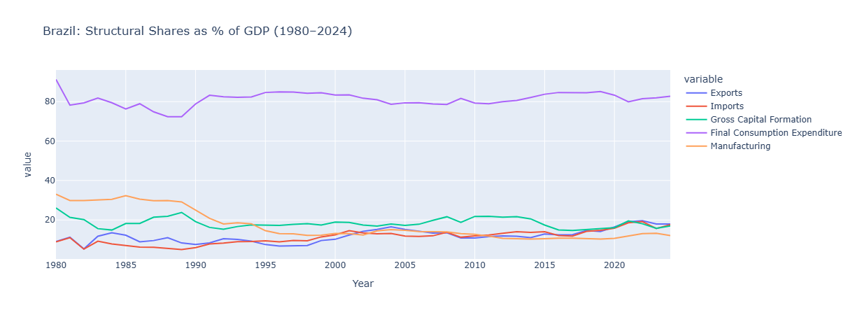
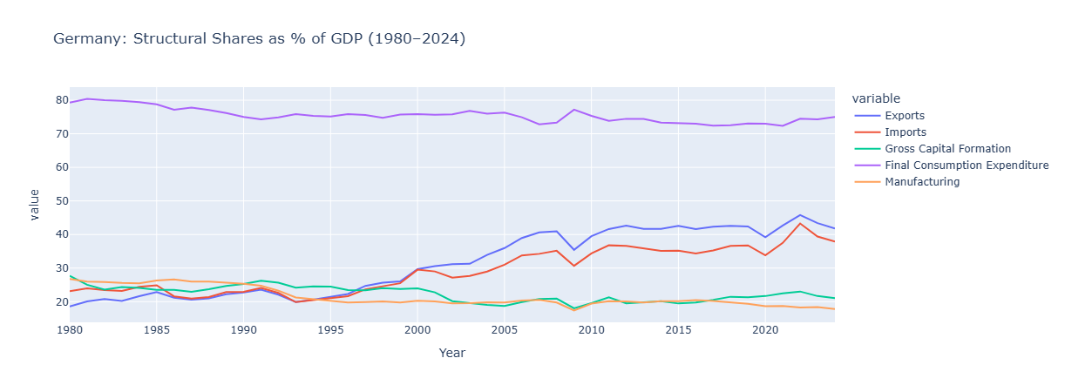
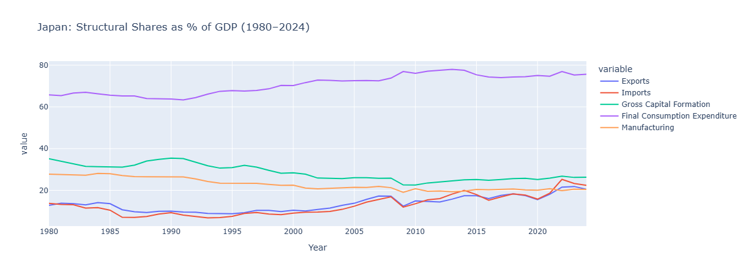
Figure 14: Comparative Structural Economic Profiles of Major Economies (1980–2024)
Key Insights:
- India demonstrates a predominantly consumption-driven economic structure, while simultaneously exhibiting gradual increases in investment activity and international trade integration over time.
- China reflects an investment- and manufacturing-oriented growth model characterized by high capital formation, industrial expansion, and export-led development.
- Germany maintains a strongly export-oriented economic structure supported by advanced manufacturing capabilities and deep integration within global trade networks.
- The United States remains consistently consumption-led, with domestic expenditure serving as the primary driver of economic activity throughout the study period.
- Japan exhibits characteristics of a mature developed economy, including relatively stable structural proportions and slower long-term structural transitions.
- Brazil continues to remain primarily consumption-oriented, although moderate levels of trade integration and industrial activity are also observed.
- The comparative structural profiles reveal substantial variation in development strategies, growth orientation, and macroeconomic composition across major global economies.

13. Key Finding_

13.1 Missing Data Pattern Justifies Analysis Period
The missing values visualization reveals a high concentration of incomplete data prior to the early 1990s, followed by a significant improvement in data completeness. This supports the decision to restrict primary growth analysis to the 1980–2024 period and confirms that avoiding forward-filling preserves analytical integrity.

13.2 Strong Divergence in Long-Term GDP Trends
The GDP trend comparison between India, the United States, and China highlights substantial divergence in economic trajectories across five decades:
- The United States maintained steady and dominant economic growth throughout the period.
- China exhibited accelerated growth, particularly after 2000, indicating structural economic transformation driven by industrialization and trade integration.
- India demonstrated consistent upward growth from a lower absolute base, with momentum accelerating notably after 2005.
This divergence reflects differing development stages, institutional capacities, and economic strategies among major economies.

13.3 High Growth Volatility Concentrated in Specific Economies
The growth volatility ranking reveals that Equatorial Guinea, Iraq, Angola, and Libya experienced the highest fluctuations in GDP growth. This is attributable to:
- Heavy dependence on natural resource exports
- Political instability and prolonged conflicts
- Exposure to external commodity price shocks
High volatility in these economies indicates that strong growth in certain periods was consistently accompanied by sharp contractions, creating unpredictable and unreliable development patterns.

13.4 Stability vs. Growth Trade-Off
The analysis reveals a contrast between economies with stable, moderate growth (typically developed nations) and economies with high but volatile growth patterns (often developing or resource-dependent nations). This demonstrates that high long-term CAGR does not necessarily imply economic stability and vice versa.

13.5 Multi-Dimensional Economic Assessment
By combining CAGR, GDP Multiplier, and Growth Volatility, this study provides a comprehensive multi-metric evaluation of economic performance. The three metrics collectively capture:
- Growth rate how fast an economy grew
- Scale of expansion how much the economy grew in absolute terms
- Stability of growth how consistently and predictably it grew
This multi-metric approach substantially strengthens cross-country comparison relative to any single indicator.

13.6 Persistent Global Economic Concentration
The top 10 economies consistently controlled approximately 65–70% of global GDP across 1980, 2000, and 2024. Despite decades of emerging market growth, this share remained stable, highlighting the persistence of global economic inequality and the structural barriers to shifting the global economic hierarchy.

13.7 COVID-19 Shock Was Statistically Significant and Universally Felt
Hypothesis Test 1 confirmed that the 2020 mean GDP growth rate of −6.22% was statistically significantly different from zero (p < 0.0001). The COVID-19 pandemic constituted a non-random, measurable, and globally synchronized economic contraction of documented statistical significance.

13.8 Post-COVID Recovery Was Robust and Statistically Validated
Hypothesis Test 2 confirmed that the post-COVID average annual growth rate of +8.13% across 2021–2024 was statistically significantly greater than zero (p < 0.0001), validating the V-shaped recovery pattern observed in the visualizations.

13.9 Key Findings from Phase 2
- The structural correlation analysis for 2024 identified strong positive relationships among GDP, manufacturing, exports, imports, gross capital formation, and final consumption expenditure, indicating significant interdependence among core macroeconomic indicators.
- Manufacturing exhibited one of the highest correlations with GDP, emphasizing the importance of industrial production in determining overall economic scale and growth performance.
- The strong positive relationship between exports and imports reflects the increasing interconnectedness of global trade systems and cross-border economic integration.
- Trade openness showed comparatively weaker association with GDP size, suggesting that smaller economies may achieve high trade integration despite limited economic scale.
- Structural profile classification revealed that the majority of countries are consumption-led economies, with final consumption expenditure emerging as the dominant component in most nations.
- Comparative analysis of major economies highlighted distinct development models, including consumption-led growth in the United States and India, export-oriented industrial growth in Germany, and investment-driven manufacturing expansion in China.
- The study demonstrated that long-term economic growth patterns are strongly influenced by structural economic composition, investment behavior, industrial development, and trade orientation.

14. Future Phase: Structural and Comparative Economic Analysis
This phase extends the analysis beyond GDP by incorporating multiple macroeconomic indicators to understand the structural composition of economies and the underlying drivers of economic growth. While Phase 1 focused on growth measurement and trend analysis, Phase 2 shifts toward explaining why economies grow by examining sectoral and demand side contributions.

14.1 Analytical Focus
The following key dimensions will be explored in the next phase:
- Trade Dynamics: Exports vs. Imports assessing global integration and trade dependency
- Domestic Demand Structure: Final Consumption Expenditure distinguishing consumption-driven from production-driven economies
- Investment Patterns: Gross Capital Formation evaluating infrastructure investment and future growth potential
- Industrial Strength: Manufacturing Value Added (ISIC D) measuring the level of industrialization across economies

14.2 Planned Analytical Techniques
- Indicator-wise Trend Analysis time-series comparison of each indicator across countries
- Cross-Country Structural Comparison identifying dominant economic models (export-driven, consumption-driven, investment-driven)
- Correlation Analysis examining relationships between GDP and other macroeconomic indicators
- Growth Driver Identification determining which indicators contribute most to long-run GDP expansion
- Comparative Economic Profiling categorizing countries based on their dominant structural characteristics

14.3 Indicators Prepared for Phase 2 Analysis
The following five macroeconomic indicators were extracted from the source dataset, scaled to billions (Current US$), and structured as separate clean DataFrames aligned with the cleaned GDP panel:
- Exports of Goods and Services to assess global trade integration and export-led growth
- Imports of Goods and Services to measure import dependency and domestic demand
- Gross Capital Formation to evaluate investment patterns and infrastructure development
- Final Consumption Expenditure to capture consumption-driven versus production-driven economic models
- Manufacturing Value Added (ISIC D) to measure the degree of industrialization across economies

14.4 Analytical Significance
By integrating multiple macroeconomic indicators, Phase 2 transforms the analysis from quantifying how much economies grew (Phase 1) to understanding what drives that growth (Phase 2). This provides a more comprehensive, structurally grounded, and realistic understanding of global economic behavior and development patterns.

14.5 Scope for Advanced Structural Economic Research and Comparative Analysis
Future research may incorporate additional structural indicators such as inflation, employment, productivity, foreign direct investment, technological innovation, and sector-wise contribution to GDP in order to obtain a more comprehensive understanding of economic transformation across countries.
The study can also be extended through the application of advanced analytical techniques including cluster analysis, predictive modeling, panel data analysis, and machine learning approaches for identifying hidden structural economic patterns and forecasting future growth trajectories.
Further comparative studies may examine regional economic blocs and income-group classifications to evaluate differences between developed, developing, and emerging economies in terms of structural composition and macroeconomic stability.
Future research may additionally investigate the relationship between trade openness and economic resilience, particularly in small economies that demonstrate high levels of international trade integration despite relatively lower GDP levels.

15. Conclusion
This study conducted a comprehensive descriptive cross-country analysis of GDP (Current US$) and related macroeconomic indicators spanning 1970–2024, with focused analysis restricted to the 1980–2024 period to ensure data reliability and analytical consistency. Through structured preprocessing, systematic data cleaning, feature engineering, statistical testing, and visualization techniques, key analytical metrics such as CAGR, GDP Multiplier, and Growth Volatility were derived to enable multi-dimensional economic comparison across 179 countries.
The findings reveal significant disparities in long-term economic progression across nations. Developed economies generally demonstrate stable, sustained, and predictable growth patterns, while several developing and resource-dependent economies exhibit substantially higher volatility and structural instability. Emerging economies such as China and India have shown accelerated structural expansion over the past two decades, contributing to a partial — though incomplete — shift in global economic influence and production capacity.
Statistical hypothesis testing provided rigorous validation of major analytical observations. The 2020 COVID-19 pandemic shock was confirmed as a statistically significant global contraction, while the 2021–2024 recovery period was validated as a genuine, positive, and economically meaningful rebound. The analysis additionally established a weak negative relationship between CAGR and Growth Volatility, while finding no conclusive evidence that the world’s largest economies possess a statistically significant stability advantage.
Beyond GDP trend analysis, the integration of structural macroeconomic indicators provided deeper insight into the drivers of economic growth. Strong positive interrelationships were identified among GDP, manufacturing, investment, consumption, exports, and imports, demonstrating that economic expansion is shaped by multiple interconnected structural dimensions rather than a single growth factor. The correlation analysis further emphasized the critical role of industrial production and international trade in influencing economic performance across countries.
The structural profile analysis revealed that the majority of economies globally remain consumption-driven, while selected economies demonstrate export-oriented or investment-intensive development models. Comparative structural profiling of India, China, Germany, the United States, Japan, and Brazil illustrated substantial diversity in economic organization, growth orientation, industrial integration, and trade dependence between developed and emerging economies.
The integration of growth metrics, structural indicators, statistical validation, and visualization-based interpretation provides a holistic understanding of global economic evolution across five decades. The study highlights the diversity of economic trajectories and emphasizes that evaluating long-term economic performance requires consideration of both growth intensity and structural composition rather than relying solely on aggregate GDP expansion.
Overall, the research successfully demonstrates the usefulness of descriptive analytics and macroeconomic visualization techniques in understanding long-term global economic patterns. The study contributes meaningful insights into the structural dynamics of economic growth and provides a strong analytical foundation for future comparative, predictive, and policy-oriented economic research.

End of Report

