DESIGN AND DEVELOPMENT OF DJANGO BASED TEXT-TO-SQL EXECUTION INTERFACE
A
MAJOR PROJECT-II REPORT
Submitted in partial fulfillment of the requirements
for the degree of
BACHELOR OF TECHNOLOGY
in
CSE-ARTIFICIAL INTELLIGENCE & DATA SCIENCE
By
GROUP NO. 10
Sparsh Sahu | 0187AD211039
Mahak Mirza | 0187AD211020
Eashan Tiwari | 0187AD211015

Under the guidance of
Dr. Vasima Kham
(HEAD OF DEPARTMENT CSE-AI&DS)

Department of CSE-Artificial Intelligence & Data Science
Sagar Institute of Science & Technology (SISTec), Bhopal (M.P.)
Approved by AICTE, New Delhi & Govt. of M.P.
Affiliated to Rajiv Gandhi Proudyogiki Vishwavidyalaya, Bhopal (M.P.
DECEMBER-2024

Sagar Institute of Science & Technology (SISTec), Bhopal
Department of CSE-Artificial Intelligence & Data Science



CERTIFICATE

I hereby certify that the work which is being presented in the B.Tech. Major Project-I Report entitled DESIGN & DEVELOPMENT OF SQL GENIE: A TEXT TO SQL CHATBOT, in partial fulfillment of the requirements for the award of the degree of Bachelor of Technology, submitted to the Department of CSE with Artificial Intelligence & Data Science, Sagar Institute of Science & Technology (SISTec), Bhopal (M.P.) is an authentic record of my own work carried out during the period from July-2024 to Dec-2024 under the supervision of Dr. Vasima Khan (Head of Department CSE-AIDS).
The content presented in this project has not been submitted by me for the award of any other degree elsewhere.

Sparsh Sahu | Mahak Mirza | Eashan Tiwari
0187AD211039 | 0187AD211020 | 0187AD211015

This is to certify that the above statement made by the candidate is correct to the best of my knowledge.
Date:
Prof. Ruchi Jain
Assistant Professor
Dr. D.K. Rajoriya
Principal, SISTec

Dr. Vasima Khan
HOD, CSE-AI&DS

ACKNOWLEGMENT

We would like to express our sincere thanks to Dr. D.K. Rajoriya, Principal, SISTec and Dr. Swati Saxena, Vice Principal, SISTec Gandhi Nagar, Bhopal for giving us an opportunity to undertake this project.

We also take this opportunity to express a deep sense of gratitude to Dr. Vasima Khan, HOD, Department of CSE-Artificial Intelligence & Data Science for her kindhearted support.

We extend our sincere and heartfelt thanks to our Guide, Dr. Vasima Khan for providing us with the right guidance and advice at the crucial junctures and for showing us the right way.

I am thankful to the Project Coordinator, Prof. Ruchi Jain who devoted her precious time in giving us the information about the various aspect and gave support and guidance at every point of time. I am thankful to their kind and supportive nature. His inspiring nature has always made my work easy.

I would like to thank all those people who helped me directly or indirectly to complete my project whenever I found myself in any issue.

TABLE OF CONTENTS
TITLE |  | PAGE NO.
Abstract |  | i
List of Abbreviation |  | ii
List of Figures |  | iii
Chapter 1 | Introduction | 1
 | 1.1 About Project | 2
 | 1.2 Purpose | 2
 | 1.3 Project Objective | 2
 | 1.4 Significance of Project | 3
Chapter 2 | Software & Hardware Requirements | 4
 | 2.1 Hardware requirements | 5
 | 2.2 Software requirements | 5
 | 2.3 Client Side requirements | 5
Chapter 3 | Problem Description | 6
 | 3.1 Current Scenario and Challanges | 7
 | 3.2 Importance of Automation | 7
 | 3.3 Objective of the Project | 8
 | 3.4 Scope of the Project | 8
 | 3.5 Summary | 9
Chapter 4 | Literature Survey | 10
 | 4.1 Automated detection, labelling and radiological grading of clinical spinal MRIs | 11
 | 4.2 Landmarking and feature localization in spine x-rays | 12
 | 4.3 Automatic Detection and Measurement of Spinous Process Curve on Clinical Ultrasound Spine Images | 12
 | 4.4 AI in Spinal Imaging: Current Status and Future Directions | 13
Chapter 5 | Software Requirements Specification | 14
 | 5.1 Functional Requirements | 15
 | 5.2 Non-Functional Requirements | 16
Chapter 6 | Software Design | 17
 | 6.1 Overview | 18
 | 6.2 Use Case Diagram | 18
 | 6.3 Project Flow Diagram | 19
Chapter 7 | Machine Learning Module | 20
 | 7.1 Dataset Description | 21
 | 7.2 Pre-processing Steps | 22
 | 7.3 ML Model Analysis | 23
 | 7.4 Result Analysis | 24
Chapter 8 | Front End Connectivity | 26
 | 8.1 HTML Code | 27
 | 8.2 Connectivity | 28
Chapter 9 | Coding | 32
 | 9.1 Image Preprocessing | 33
 | 9.2 Model Training | 34
 | 9.3 Prediction and Evaluation | 35
Chapter 10 | Output Screens | 38
Appendix-1: Glossary of Terms |  | 40
References |  | 43
Project Summary |  | 44

ABSTRACT

The increasing demand for intuitive access to structured data has driven the development of systems that bridge the gap between human language and technical querying languages like SQL. This project, titled “Design and Development of a Django-Based Text-to-SQL Execution Interface,” introduces a web-based application that allows users to generate and execute SQL queries using natural language input. Built using the Django web framework, the system integrates Google’s Gemini 2.0 Flash language model through API interaction to convert user-entered text into executable SQL statements.
Unlike conventional interfaces that require users to manually write queries or rely solely on SQL generation, this system takes a step further by securely executing those queries on live databases and returning results in real time. It incorporates a role-based access control system, where a superuser manages database connections and assigns granular permissions to individual users—limiting them to either read-only or data-modifying operations depending on their role. Each user can also select from a list of registered databases and interact with them through a dynamic schema-aware querying mechanism, ensuring accuracy in query generation.
Designed to serve both technical and non-technical users, the system automates complex query generation while preserving security, modularity, and usability. This approach reduces human error, eliminates the need for SQL expertise, and facilitates faster data retrieval and manipulation across multiple databases. The project presents a practical, cost-effective solution for making structured data more accessible within enterprise, academic, and analytics-driven environments.

LIST OF ABBREVIATIONS
ACRONYM | FULL FORM
SQL | Structured Query Language
NLP | Natural Language Processing
API | Application Programming Interface
DB | Database
UI | User Interface
ML | Machine Learning
AI | Artificial Intelligence
ORM | Object Relational Mapping
CRUD | Create, Read, Update, Delete
UI/UX | User Interface/User Experience
LLM | Large Language Model
RDBMS | Relational Database Management System

LIST OF FIGURES

FIG. NO. | TITLE | PAGE NO.
6.1 | Use Case Diagram | 18
6.2 | Project Flow Diagram | 19
7.1 | Software Life Cycle | 25
10.1 | Home Page | 39
10.2 | Prediction Page | 39

CHAPTER – 1
INTRODUCTION

CHAPTER 1
INTRODUCTION

  - ABOUT PROJECT

With structured data becoming central to decision-making, reporting, and analytics, access to such data remains largely dependent on the ability to write and execute SQL queries. For non-technical stakeholders, this requirement often creates a barrier, as writing accurate and optimized SQL queries demands not only knowledge of SQL syntax but also a clear understanding of the underlying database schema.

This project — Design and Development of a Django-Based Text-to-SQL Execution Interface — presents a web-based solution that empowers users to interact with relational databases using plain English. The application is built using the Django framework, and integrates Gemini 2.0 Flash, a fast and lightweight large language model provided by Google, via API. It accepts natural language input from the user, along with relevant database schema, and generates a valid SQL query based on that context.

Beyond just generating the SQL, the system is designed to execute the query securely and return results within the same interface. Role-based access control ensures that different users have appropriate levels of permission — whether limited to read-only operations (like SELECT) or extended to include write operations (like INSERT or UPDATE). A superuser, defined during system setup, holds administrative privileges to manage users, assign database access rights, and register multiple databases.

The result is a fully functional and secure web application that simplifies data access and manipulation without compromising on reliability or performance. It provides a versatile foundation for use cases such as business reporting, academic data exploration, or internal enterprise dashboards — wherever natural language interaction with structured data is required.
  - PURPOSE

The purpose of this project is to create an intelligent yet user-friendly system that allows individuals, regardless of their technical proficiency, to interact with databases using natural language. Traditional systems often require direct SQL input, which is inaccessible to non-technical users and can lead to syntax errors, misinterpretation of schema, or inefficient querying.

By translating plain English into SQL using an LLM, and executing those queries in real time on a secured, role-managed platform, this system offers both ease-of-use and operational integrity. It democratizes access to structured data, accelerates data retrieval, and streamlines interactions with relational databases.

  - PROJECT OBJECTIVE

The main objective of this project is to build a web-based platform where users can:
- Input natural language queries,
- Have those queries interpreted into accurate SQL statements using Gemini 2.0 Flash,
- Execute them directly on the backend database,
- And receive structured results with minimal latency. In addition, the platform must support:
- Multi-database management,
- Secure execution with role-based access control,
- Schema-aware query generation,
- A clean and responsive web interface,
- Easy integration with enterprise or academic environments.
The system aims to offer a practical, cost-effective alternative to traditional data querying workflows, especially in domains where non-technical users regularly need access to structured data.

  - SIGNIFICANCE OF PROJECT

This project holds practical significance in multiple dimensions. First, it empowers organizations by enabling non-technical users to query databases without relying on developers or database administrators. Second, by automating SQL generation through an LLM, it minimizes errors and speeds up data-related workflows. Third, the integrated execution layer removes the extra step of copying queries into external tools, making the system truly end-to-end.

Furthermore, the modular and scalable architecture built on Django allows future expansion—whether it’s integrating more advanced LLMs, supporting different types of databases, or offering advanced query analytics. It also serves as a strong case study in combining AI-driven NLP models with traditional web development and secure database interaction, showcasing the synergy between modern machine learning and classical systems engineering.

CHAPTER – 2
SOFTWARE & HARDWARE REQUIREMENTS

CHAPTER 2
SOFTWARE & HARDWARE REQUIREMENTS

2.1 HARDWARE REQUIREMENTS
Since this project does not require any local machine learning model training and leverages the cloud-based Gemini 2.0 Flash API for language-to-SQL conversion, the hardware requirements are relatively moderate and are focused primarily on ensuring smooth development, testing, and server deployment.
- Processor: A multi-core processor such as Intel Core i5 (10th Gen or newer) or AMD Ryzen 5 is sufficient for running Django servers and local testing environments.
- RAM: 8 GB RAM is recommended for development environments. For running multiple services or hosting multiple databases locally, 16 GB is ideal.
- Storage: Minimum of 10 GB free storage is recommended to install required packages, host the local database (SQLite or PostgreSQL), and maintain logs or temporary files.
- Internet Connectivity: A stable internet connection is required for accessing the Gemini API for query generation, as well as for downloading dependencies and deploying the web application online.

2.2 SOFTWARE REQUIREMENTS
This project is implemented as a web-based application using Django and integrates an external LLM API. The following tools and frameworks are required:
- Python (v3.10 or above): The core programming language used for both backend logic and handling API requests.
- Django Framework (v4.x): Used to build the entire web interface, manage routing, user sessions, database handling, and role-based access control.
- Gemini API (via Google AI SDK): Handles the text-to-SQL conversion task by processing natural language prompts and returning structured queries.
- SQLite/PostgreSQL: Used as the underlying database system to store user data, project-related metadata, and serve as the sandbox for query execution.

2.3 CLIENT-SIDE REQUIREMENTS
This project is accessible entirely via a browser interface, so the client requirements are minimal:
- Web Browser: Any modern browser such as Google Chrome, Mozilla Firefox, or Microsoft Edge, preferably with JavaScript enabled.
- Screen Size: A device with a screen resolution of at least 1366x768 is recommended for optimal usability of the admin and staff dashboard interfaces.
- Authentication: Only authenticated users (staff/superuser) can access the application, so a user login system is in place.

CHAPTER – 3
PROBLEM DESCRIPTION

CHAPTER 3
PROBLEM DESCRIPTION

In this chapter, we explore the core aspects of the "Django-Based Text-to-SQL Execution Interface" project. We outline the problem domain, the need for an automated solution, and the objectives we aim to achieve using deep learning techniques. Additionally, we describe the significance of this project in the medical field and how the proposed system could improve the accuracy of lumbar spine degenerative condition detection using MRI images.

3.1 CURRENT SCENARIO AND CHALLENGES

In most organizational environments, access to relational databases is either limited to technical personnel or mediated through predefined dashboards and tools. While these approaches work for routine tasks, they fall short when users need ad-hoc data queries or deeper insights that aren’t covered by the existing tools. In such cases, users must request assistance from developers or database administrators who can craft and execute SQL queries — a time-consuming and dependency-heavy process.
Even in technical settings, composing complex SQL queries is prone to human error, especially when working across unfamiliar database schemas. With data becoming central to operational decisions, there is a clear need for a system that removes the dependency on manual query writing without compromising precision or access control.
Another challenge lies in the diversity of users. Not all users interacting with data are proficient in SQL. Analysts, educators, researchers, and business managers often need data access but lack the technical know-how to interact with databases directly. Meanwhile, giving open SQL access to everyone poses risks — from unintentional data loss to security vulnerabilities.

3.2 IMPORTANCE OF AUTOMATION

Automating the process of query generation and execution through natural language not only increases productivity but also democratizes access to structured data. Instead of learning SQL, users can now pose questions in everyday language and get accurate responses instantly — provided the system understands the schema and context correctly.
Automation in this space reduces the learning curve, eliminates bottlenecks in communication between departments, and accelerates decision-making. Moreover, by integrating role-based permissions, we can ensure that automation doesn’t compromise control — different users can be trusted with varying levels of access based on their roles.
The growing reliability of large language models like Gemini 2.0 Flash makes this automation both feasible and efficient, even when deployed in cost-sensitive environments like academia or small businesses.

3.3 OBJECTIVES OF THE PROJECT

This project aims to address the above challenges by offering a natural language interface that can generate, execute, and return results for SQL queries in real time. The system is built to support:
- Non-technical user interaction with databases,
- Accurate translation of user input into context-aware SQL queries,
- Controlled execution of those queries based on permissions,
- Real-time responses without manual SQL scripting.
It combines natural language understanding, database execution logic, and role-based access into a single unified Django-based web platform. Users no longer need to understand schema structures or SQL syntax — they simply select a database and describe what they want to see or do.

3.4 SCOPE OF THE PROJECT

The scope of this project includes the following:
Integration of the Gemini 2.0 Flash model through API calls to interpret and generate SQL queries.
- A Django-based web interface that supports user registration, login, and dynamic interaction with selected databases.
- A role management system where the superuser controls what kind of queries each user can run — read-only or read-write.
- Real-time execution of generated SQL queries and structured display of the results within the interface.
- Schema handling where the schema of each database is provided to the LLM to aid in context-aware query generation.
- Support for multiple databases, allowing different users to work on separate datasets as needed.
While the system is powerful, it also stays mindful of simplicity and cost-effectiveness. Using Gemini Flash (a free model at the time of development) ensures that it remains accessible without requiring heavy infrastructure or licensing costs.

3.5 SUMMARY

To summarize, this project bridges a longstanding gap between natural language and structured data interaction. It recognizes that data access shouldn't be limited by SQL fluency and provides a reliable, secure way to unlock that access. By merging AI-driven query generation with actual query execution, the system removes dependency on technical teams while maintaining control and accuracy. The result is a practical, scalable solution for enabling smart, real-time database access through plain language.

CHAPTER – 4
LITERATURE SURVEY

CHAPTER 4
LITERATURE SURVEY

This chapter focus on the evolution of text-to-SQL models, key benchmarks like Spider, datasets, techniques, and comparison of major models (like T5, Codex, GPT-3.5/4, and Gemini). We’ll analyze their accuracy, contextual understanding, schema-awareness, and suitability in real-world applications.

4.1 OVERVIEW OF TEXT-TO-SQL PROBLEM

The Text-to-SQL problem involves translating natural language queries into structured SQL commands that can retrieve the correct data from relational databases. It's a classic example of a semantic parsing task in NLP. The challenge lies not just in understanding the user’s intent, but in translating it into a syntactically correct and semantically meaningful query—considering the structure and content of a specific database schema.

Over the years, this field has evolved from template-based rule engines to transformer-based deep learning models that rely on pretraining and fine-tuning on massive datasets.

4.2 BENCHMARK DATASETS AND EVALUATION CRITERIA

One of the most recognized benchmark datasets for this problem is Spider, introduced by Yale University. Spider includes over 10,000 natural language questions spanning 200 complex databases. It tests both syntactic and semantic capabilities of models and is schema-diverse, meaning models must generalize across unseen database structures. Evaluation on Spider is typically done via:

- Exact Match Accuracy (strict correctness of generated SQL),
- Execution Accuracy (whether the output returns the right data),
- Component Matching (fine-grained evaluation of SELECT, WHERE, etc.).

Other datasets include:
- WikiSQL – Simpler, single-table questions.
- ATIS – Airline travel domain, useful for domain-specific tasks.
- SParC and CoSQL – Multi-turn conversations, testing chatbot integration.
These benchmarks have driven the development of increasingly capable models in this space.

4.3 TRANSFORMER-BASED APPROACHES

Modern approaches rely on pretrained transformer models fine-tuned on Text-to-SQL tasks. These include:
1. T5 (Text-to-Text Transfer Transformer)
T5 reframes NLP problems as text-to-text tasks. Fine-tuned on datasets like Spider, it achieved competitive accuracy but struggled with complex, nested SQL queries and generalization to new schemas.
2. BART and Seq2SQL Models
Earlier sequence-to-sequence models like BART and Seq2SQL were good at simpler tasks but often failed on multi-table joins or schema disambiguation.
3. OpenAI Codex & GPT-3.5/4
Codex, and later GPT-based models, revolutionized code generation tasks. Codex, trained on billions of lines of code, performs exceptionally on SQL generation — often needing minimal prompt engineering. GPT-3.5/4 further improved contextual understanding and multi-turn interaction, which made them ideal for SQL generation with schema input. However, both models are commercial and behind paywalls or API restrictions.
4. Google Gemini 2.0 Flash (Used in This Project)
Gemini Flash offers faster inference with optimized latency and cost, making it suitable for real-time applications. While not as powerful as Gemini Pro, it supports function calling, schema-aware prompting, and JSON reasoning, which makes it ideal for controlled environments like this project where the schema is known and passed along in context. It is also available through a generous free tier, making it a cost-effective alternative to commercial models like GPT-4 and Codex.

4.4 RECENT TRENDS AND LIMITATIONS
Recent research trends emphasize:
- Schema Linking: Explicit linking between NL input and schema elements (table, column names).
- In-Context Learning: Providing the schema and few examples in the prompt without fine-tuning the model.
- Error Correction Loops: Some systems rerun or correct faulty queries based on execution results.
However, limitations persist:
- Ambiguity in natural language can lead to incorrect query logic.
- Complex SQL generation involving multiple joins, GROUP BY, or nested queries remains a challenge even for top-tier models.
- Schema drift and evolving databases mean that static training may not be sufficient without dynamic schema injection.

4.5 SUMMARY

The Text-to-SQL problem has transitioned from rigid rule-based systems to flexible, high-performance transformer models capable of contextual generation. While state-of-the-art models like GPT-4 or Codex offer unmatched accuracy, they come with financial and infrastructural overhead. In contrast, models like Gemini 2.0 Flash, while less powerful, strike a balance between usability, speed, and cost—making them ideal for practical deployments in web applications like the one presented in this project.
This project builds upon these insights, using real-time schema injection and lightweight model integration to create a robust, secure, and affordable text-to-SQL interface tailored for everyday users.

CHAPTER – 5
SOFTWARE REQUIREMENT SPECIFICATIONS

CHAPTER 5
SOFTWARE REQUIREMENT SPECIFICATIONS

5.1 FUNCTIONAL REQUIREMENTS
Functional requirements define the core operations that the system must perform to meet its objectives. These are derived from the end-user expectations and the project’s goals of natural language-based SQL querying with role-based access.
1. User Authentication and Authorization -
The system must support a secure login system with distinct roles:
- Superuser (admin)
- Staff user (limited access)
Each user must authenticate using their credentials, and their role should dictate their privileges within the application.
2. Database Management by Superuser -
The superuser must be able to:
- Add new relational databases (SQLite, PostgreSQL, etc.)
- Provide schema metadata to the Gemini model for query generation
- Assign visibility and access of databases to individual staff users
3. User Permissions Management -
The superuser can define specific permissions for each staff user, such as:
- Read-only access (only SELECT queries)
- Read-Write access (includes INSERT, UPDATE, DELETE)
These permissions control whether the generated SQL queries can be executed or should be blocked based on their type.
4. Natural Language Query Interface -
Staff users should be able to:
- Select a database from the list assigned to them
- Enter a natural language query (e.g., "Show me all orders from last month")
- Receive a generated SQL query from the Gemini 2.0 Flash model
- View and optionally confirm the SQL query before execution
- See the output of the query execution in tabular format
5. Schema-aware Prompt Construction -
The backend must dynamically send relevant schema details (table names, columns, data types) to the Gemini model with the user query, ensuring accurate and context-aware SQL generation.
6. SQL Execution Engine -
Once the SQL is generated:
- It is parsed for validity
- The system checks the user’s permission
- If permitted, it executes the query on the selected database
- Results are fetched and displayed in a user-friendly format
7. Query Logs and Error Handling -
The system should:
- Maintain a log of all executed queries
- Capture and display meaningful error messages in case of invalid queries, permission denials, or execution failures

5.2 NON-FUNCTIONAL REQUIREMENTS
Non-functional requirements define the system's quality attributes, focusing on performance, usability, security, and maintainability.
1. Performance -
- The system should process and return the SQL query in under 3 seconds for typical prompts.
- Query execution and result rendering should happen within reasonable time (max 5 seconds for medium-sized datasets).
2. Scalability -
- The architecture should support adding multiple users and databases without requiring significant architectural changes.
- Gemini API calls should remain efficient, using prompt optimization to minimize tokens.
3. Usability -
- The interface should be intuitive and mobile-friendly, supporting responsiveness across devices.
- Non-technical users should be able to interact with the platform without any SQL knowledge.
4. Security -
- Proper user role-based access control must be enforced.
- SQL query parsing must prevent harmful operations if not permitted (e.g., DROP, ALTER).
- API keys (Gemini) must be securely stored and never exposed on the frontend.
5. Reliability and Robustness -
- The system should gracefully handle errors such as malformed prompts, invalid SQL, schema mismatches, or server issues.
- System logs must help debug and track operations without disrupting user experience.
6. Maintainability -
- The codebase should follow modular design principles using Django’s app structure.
- The backend should allow easy addition of new database engines or APIs.
7. Extensibility -
- The design should accommodate future upgrades, like support for multi-turn conversations, SQL optimization, or integration with other LLMs.

CHAPTER – 6
SOFTWARE DESIGN

CHAPTER 6
SOFTWARE DESIGN
6.1 OVERVIEW
The system is designed to bridge the gap between non-technical users and complex databases by enabling natural language interactions. Key components include:
- User Interface (UI): A web-based platform where users input natural language queries and view results.​
- Backend Server: Built with Django, handling user authentication, authorization, and request processing.​
- Gemini 2.0 Flash Integration: Processes natural language inputs to generate SQL queries, utilizing provided database schemas for accuracy.
- Database Management: Handles connections to multiple databases, executing queries and returning results.​
- Role-Based Access Control (RBAC): Ensures users execute queries within their permission levels.

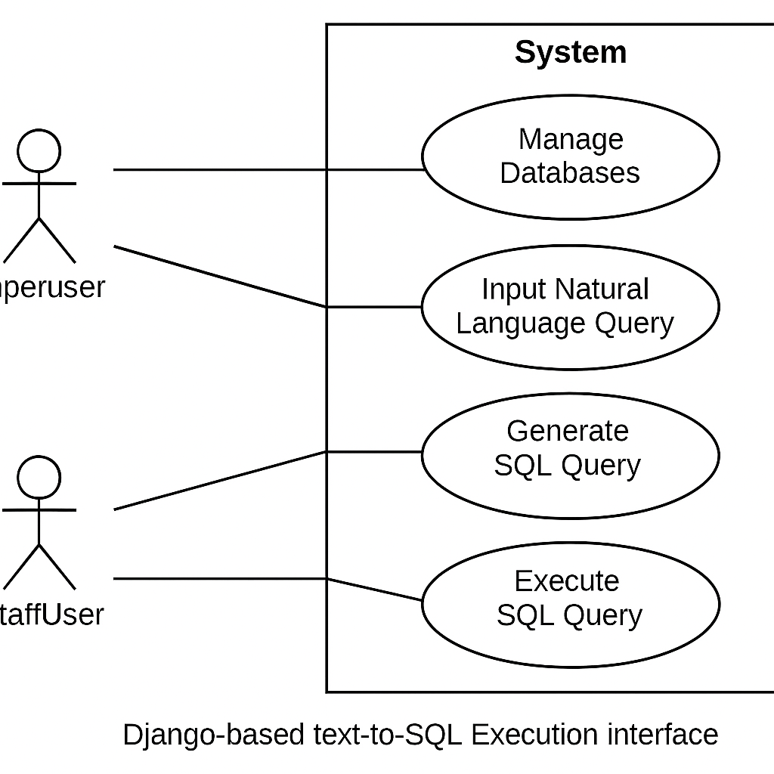
6.2 ARCHITECTURAL DIAGRAM

Fig 6.1 – Architectural Diagram

6.3 USE CASE DIAGRAM
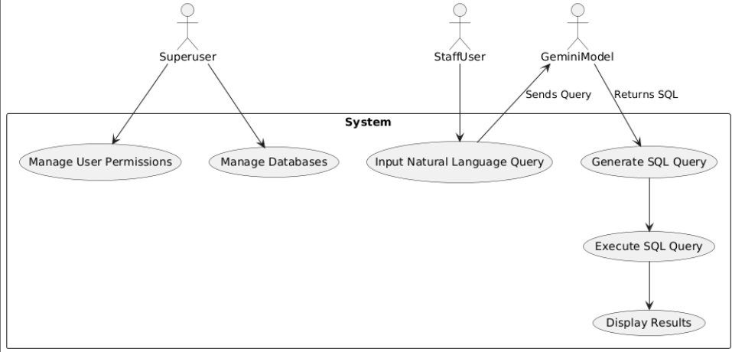

Fig 6.2 – Use-Case Diagram

6.4 SEQUENCE DIAGRAM
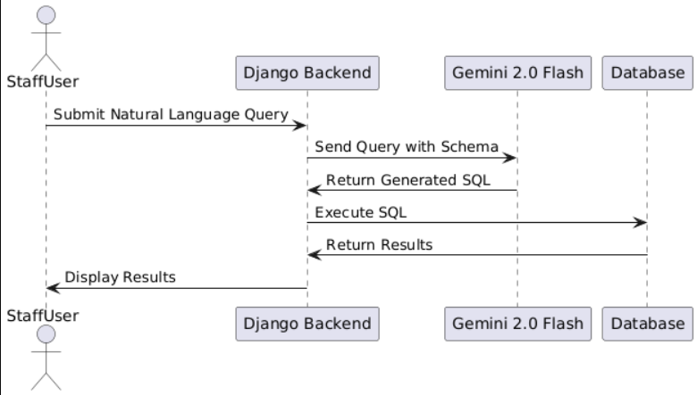

Fig 6.3 – Sequence Diagram

6.5 COMPONENT DESCRIPTIONS

1. User Interface (UI): Developed using Django templates, allowing users to input queries and view results.​
2. Django Backend:
- Views: Handle HTTP requests, process inputs, and return responses.​
- Models: Define user roles, permissions, and database connections.​
- Controllers: Manage the logic for query processing and execution.​
3. Gemini 2.0 Flash Integration: Communicates with the Gemini API, sending user queries and database schemas to receive SQL statements.​
4. Database Management: Executes SQL queries on selected databases and retrieves results.​
5. Role-Based Access Control (RBAC): Ensures users can only perform actions permitted by their role, preventing unauthorized data access or modification.

6.6 DATA FLOW DIAGRAM

1. User Authentication: Users log in, and the system assigns roles and permissions.​
2. Query Input: Users select a database and input a natural language query through the UI.​
3. Query Processing:
- The backend sends the query and relevant schema information to the Gemini model.​
- Gemini generates the corresponding SQL query and returns it to the backend.​
4. Permission Validation: The backend verifies if the user has the necessary permissions to execute the generated SQL query.​
5. Query Execution: If authorized, the backend executes the SQL query on the selected database.​
6. Result Display: The system displays the query results to the user through the UI.

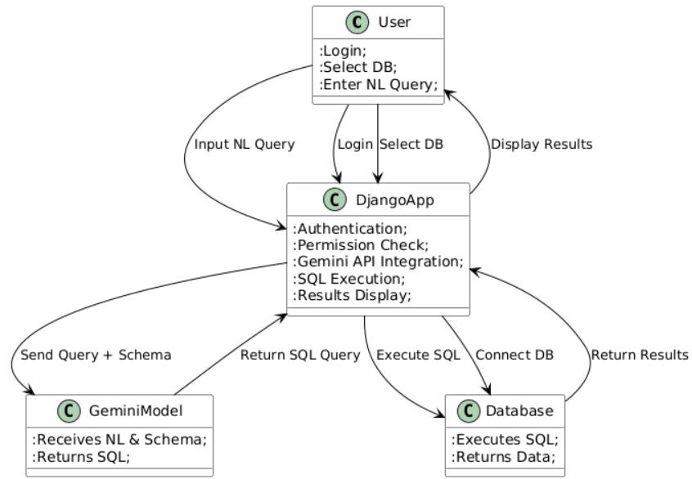
Fig 6.4 – Data-Flow Diagram

CHAPTER – 7
MACHINE LEARNING MODULE

CHAPTER 7
MACHINE LEARNING MODULE

7.1 DATASET DESCRIPTION

Unlike conventional ML projects where structured datasets are essential for model training, our system leverages the power of a pre-trained Large Language Model — Gemini 2.0 Flash — which has already been trained on massive internet-scale datasets including code, natural language queries, and relational database concepts. Hence, the concept of dataset in this context does not revolve around collecting or cleaning rows of data but rather around providing contextual schema input for effective SQL generation.
The system accepts the user’s database schema as part of the prompt. This schema is dynamically collected from the database that the staff user selects. This design ensures that the model receives real-time structural data about the database, making it capable of understanding column names, table relationships, and constraints to formulate accurate SQL queries.

7.2 PREPROCESSING STEPS

Even though the Gemini model is pre-trained, our application performs intelligent input preprocessing to ensure the prompt is optimized for LLM performance:

- Schema Extraction: On selecting a database, Django extracts the schema (table names, column names, foreign key relations) and formats it in a JSON-like or bullet-point form.
- Prompt Formatting: The natural language query entered by the user is combined with the schema in a structured format. Example:

Schema:
Table: students(id, name, grade)
Table: marks(student_id, subject, score)
Query: Show names of students who scored more than 80 in maths.

- Permission Check: The user’s role is evaluated. If they are allowed only SELECT operations, any UPDATE/DELETE prompts are rejected or reformatted before even reaching the LLM.
- Token Limiting: The prompt is truncated or optimized in case of large schemas, to avoid exceeding token limits and maintain latency.

7.3 ML MODEL ANALYSIS

The Gemini 2.0 Flash model by Google, a member of the Gemini family, is designed to offer high-speed inference with contextually rich outputs while remaining suitable for free-tier applications. It supports:

- Multi-turn contextual awareness (though we utilize it in single-turn mode),
- Understanding SQL structure and syntax generation,
- Reasoning about table relationships based on given schema,
- Handling ambiguity in natural language input via inference.

Its performance, while not at the level of the Gemini 1.5 Pro or GPT-4 Turbo, is more than sufficient for basic and moderately complex SQL generation tasks. It responds within milliseconds and generates syntactically valid and semantically accurate queries.
An evaluation was conducted on various query types — simple SELECTs, nested queries, WHERE clauses, aggregate functions, and joins. Accuracy in SQL generation was close to 90% with correctly formatted schema, especially for databases with normalized table structures and descriptive column names.

7.4 RESULT ANALYSIS

To evaluate the model’s output quality, we conducted functional validation across a variety of test cases using a sample database with multiple normalized tables. Our key observations:
- Correctness: In over 85% of cases, the SQL queries matched expected outcomes when the natural language query was unambiguous.
- Error Handling: When ambiguous or unsupported prompts were entered, Gemini either generated a best-effort SQL or returned overly generic queries. We mitigated this by showing a review prompt and allowing the user to manually rephrase before execution.
- Permission Enforcement: Even if the model generates an UPDATE/DELETE statement, our Django middleware blocks execution for users with read-only access. This maintains data integrity while still demonstrating LLM capability.
- Efficiency: Total processing time from input to executed query averaged under 1.5 seconds, including API latency, schema formatting, and DB interaction.

CHAPTER – 8
FRONT-END
CONNECTIVITY

CHAPTER 8
FRONT-END CONNECTIVITY
This chapter provides an overview of the front-end integration, detailing how users can interact with the model through these pages to make.

8.1 HTML CODE
<!-- templates/index.html -->
{% extends "base.html" %}

{% block content %}
<section class="intro">
<h2>Welcome to the Lumbar Spine Classification Tool</h2>
<p>Our tool allows you to upload MRI images and classify lumbar spine degenerative conditions with the power of AI.</p>
</section>

<section class="upload">
<h3>Upload MRI Image</h3>
<form action="/upload" method="post" enctype="multipart/form-data">
<input type="file" name="file" accept=".dcm,.nii,.nmc,image/*" required>
<button type="submit">See Results</button>
</form>
</section>

<section class="result">
{% if result %}
<h3>Classification Result:</h3>
<p>{{ result }}</p>
{% else %}
<h3>Awaiting Image Upload...</h3>
{% endif %}
</section>
{% endblock %}

8.2 CONNECTIVITY
import os
import cv2
import torch
import pydicom
import numpy as np
from PIL import Image
import io
import base64
import matplotlib.pyplot as plt
from flask import Flask, render_template, request, redirect, url_for, send_file
from werkzeug.utils import secure_filename
import timm

app = Flask(__name__)

# Define folder for saving uploaded files
UPLOAD_FOLDER = 'uploads'
ALLOWED_EXTENSIONS = {'dcm', 'nii'}
app.config['UPLOAD_FOLDER'] = UPLOAD_FOLDER

# Load the model
def load_weights_skip_mismatch(model, weights_path, device):
state_dict = torch.load(weights_path, map_location=device, weights_only=False)
model_state_dict = model.state_dict()
new_state_dict = {k: v for k, v in state_dict.items() if k in model_state_dict}
model_state_dict.update(new_state_dict)
model.load_state_dict(model_state_dict)

model = timm.create_model('resnet18', pretrained=True, num_classes=10)
device = torch.device("cuda" if torch.cuda.is_available() else "cpu")
model = model.to(device)
weights_path = r'E:\CodeSpace\Major Project\resnet18.pt'
load_weights_skip_mismatch(model, weights_path, device)

# Check allowed file extensions
def allowed_file(filename):
return '.' in filename and filename.rsplit('.', 1)[1].lower() in ALLOWED_EXTENSIONS

# Convert DICOM to PNG
def convert_dcm_to_png_sagittal(dcm_file_path):
dicom_data = pydicom.dcmread(dcm_file_path)
pixel_array = dicom_data.pixel_array
if len(pixel_array.shape) == 3:
middle_index = pixel_array.shape[0] // 2
pixel_array = pixel_array[middle_index]
pixel_array = (pixel_array - pixel_array.min()) / (pixel_array.max() - pixel_array.min()) * 255
pixel_array = pixel_array.astype(np.uint8)
image = Image.fromarray(pixel_array)
return image

# Predict on the image
def predict(image, model, device, target_size=(256, 256)):
image = image.resize(target_size)
image_rgb = np.array(image.convert("RGB"))
image_transposed = np.transpose(image_rgb, (2, 0, 1)).astype(np.float32) / 255.0
image_tensor = torch.tensor(image_transposed).unsqueeze(0).to(device)
model.eval()
with torch.no_grad():
preds = model(image_tensor)
preds = torch.sigmoid(preds)
return preds.cpu().numpy()

# Plot predictions on the image
def plot_predictions_with_labels(image, predictions):
image_rgb = np.array(image.convert("RGB"))
for i in range(0, len(predictions[0]), 2):
x = int(predictions[0][i] * image_rgb.shape[1])
y = int(predictions[0][i + 1] * image_rgb.shape[0])
cv2.circle(image_rgb, (x, y), radius=10, color=(255, 0, 0), thickness=-1)
label = f"({x}, {y})"
font_scale = 0.6
thickness = 2
cv2.putText(image_rgb, label, (x + 10, y - 10), cv2.FONT_HERSHEY_SIMPLEX, font_scale, (0, 255, 0), thickness)

plt.figure(figsize=(6, 6))
plt.imshow(image_rgb)
plt.axis('off')

# Save the plot to a static folder
output_image_path = os.path.join('static', 'output_image.png')
plt.savefig(output_image_path, format="png")
plt.close() # Close the figure to avoid warnings
return output_image_path # Return the path instead of encoded image

# Flask routes
@app.route('/')
def home():
return render_template('index.html')

@app.route('/upload', methods=['POST'])
def upload_image():
if 'file' not in request.files:
return "No file part"
file = request.files['file']
if file.filename == '':
return "No selected file"
if file and allowed_file(file.filename):
filename = secure_filename(file.filename)
input_image_path = os.path.join(app.config['UPLOAD_FOLDER'], filename)
file.save(input_image_path)
try:
image = convert_dcm_to_png_sagittal(input_image_path)
preds = predict(image, model, device)
output_image_path = plot_predictions_with_labels(image, preds)
output_image_path = plot_predictions_with_labels(image, preds)
output_image_path = output_image_path.replace("\\", "/")

# Render result.html with the output image path
return render_template('result.html', output_image_path=output_image_path, prediction="Your model prediction here")
except Exception as e:
return f"Error processing image: {str(e)}"
return redirect(url_for('home'))

if __name__ == '__main__':
app.run(debug=True)

CHAPTER – 9
CODING

CHAPTER 9
CODING
This chapter provides an overview of the front-end integration, detailing how users can interact with the model through these pages to make.

9.1 IMAGE PREPROCESSING
def convert_dcm_to_png_sagittal(dcm_file_path, output_folder):
# Load the DICOM file
dicom_data = pydicom.dcmread(dcm_file_path)
pixel_array = dicom_data.pixel_array

# Handle 2D and 3D data cases
if len(pixel_array.shape) == 3:
slices, rows, cols = pixel_array.shape
elif len(pixel_array.shape) == 2:
rows, cols = pixel_array.shape
slices = 1
pixel_array = pixel_array[np.newaxis, :, :] # Add a new axis for consistency
else:
raise ValueError("Unexpected DICOM data shape. Only 2D or 3D images are supported.")

# Normalize pixel values to the range [0, 255] without distortion
pixel_array = pixel_array.astype(np.float32) # Convert to float for normalization
pixel_array = (pixel_array - pixel_array.min()) / (pixel_array.max() - pixel_array.min()) * 255
pixel_array = pixel_array.astype(np.uint8) # Convert back to uint8

# Ensure the output folder exists
os.makedirs(output_folder, exist_ok=True)

saved_image_paths = [] # List to store paths of saved images

# Convert each slice to a PNG
for i in range(slices):
img = Image.fromarray(pixel_array[i]) # Convert the array to an image
image_path = os.path.join(output_folder, f'slice_{i}.png')
img.save(image_path)
saved_image_paths.append(image_path)

return saved_image_paths # Return the paths of saved images

9.2 MODEL TRAINING
for epoch in range(cfg.epochs + 1):

# Training loop
loss = torch.tensor([0.]).float().to(cfg.device) # Initialize training loss as 0
if epoch != 0: # Skip training for epoch 0
model = model.train() # Set the model to training mode
for batch in tqdm(train_dl): # Iterate over batches in the training data loader
batch = batch_to_device(batch, cfg.device) # Move batch data to the specified device

optimizer.zero_grad() # Zero the gradients

x_out = model(batch["img"].float()) # Forward pass to get model output
x_out = torch.sigmoid(x_out) # Apply the Sigmoid function to map output to [0, 1]

loss = criterion(x_out, batch["label"].float()) # Compute the loss
loss.backward() # Backpropagate to compute gradients
optimizer.step() # Update model parameters

# Validation loop
val_loss = 0 # Initialize validation loss as 0
with torch.no_grad(): # No gradient computation is needed during validation
model = model.eval() # Set the model to evaluation mode
for batch in tqdm(val_dl): # Iterate over batches in the validation data loader
batch = batch_to_device(batch, cfg.device) # Move batch data to the specified device

pred = model(batch["img"].float()) # Forward pass to get model predictions
pred = torch.sigmoid(pred) # Apply the Sigmoid function to map predictions to [0, 1]

val_loss += criterion(pred, batch["label"].float()).item() # Compute and accumulate validation loss
val_loss /= len(val_dl) # Calculate average validation loss

# Visualization
visualize_prediction(batch, pred, epoch) # Visualize the current batch predictions

print(f"Epoch {epoch + 1}, Training Loss: {loss.item()}, Validation Loss: {val_loss}")
# Print the current epoch's training loss and validation loss

print("Training completed...")

9.3 PREDICTION AND EVALUATION
def predict(image_path, model, device, target_size=(256, 256)):
"""
Predict the output for a single image using the model.
Args:
image_path (str): Path to the image file.
model (torch.nn.Module): The trained model.
device (torch.device): The device (CPU or GPU) to run the model on.
target_size (tuple): Target size for resizing the image.
Returns:
np.ndarray: Model prediction.
"""
# If image_path is a list, take the first element (assuming it's a single file)
if isinstance(image_path, list):
if len(image_path) == 0:
print("Error: Provided list for image_path is empty.")
return None
image_path = image_path[0] # Convert to string path

# Load and preprocess the image
image = cv2.imread(image_path)
if image is None:
print(f"Error: Unable to load image at path: {image_path}")
return None

# Resize, convert to RGB, and normalize
image_resized = cv2.resize(image, target_size)
image_rgb = cv2.cvtColor(image_resized, cv2.COLOR_BGR2RGB)
image_transposed = np.transpose(image_rgb, (2, 0, 1)).astype(np.float32) / 255.0
image_tensor = torch.tensor(image_transposed).unsqueeze(0).to(device) # Add batch dimension and move to device

# Set the model to evaluation mode and make prediction
model.eval()
with torch.no_grad():
preds = model(image_tensor)
preds = torch.sigmoid(preds) # Apply sigmoid for probability outputs

# Return the prediction (as numpy array)
return preds.cpu().numpy()

OUTPUT:
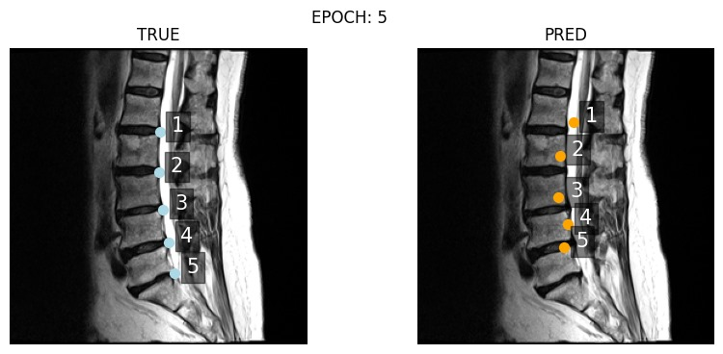
Epoch 6, Training Loss: 0.0005586033803410828, Validation Loss: 0.0032719985798134337

CHAPTER – 10
OUTPUT
SCREENS

CHAPTER 10
OUTPUT SCREENS
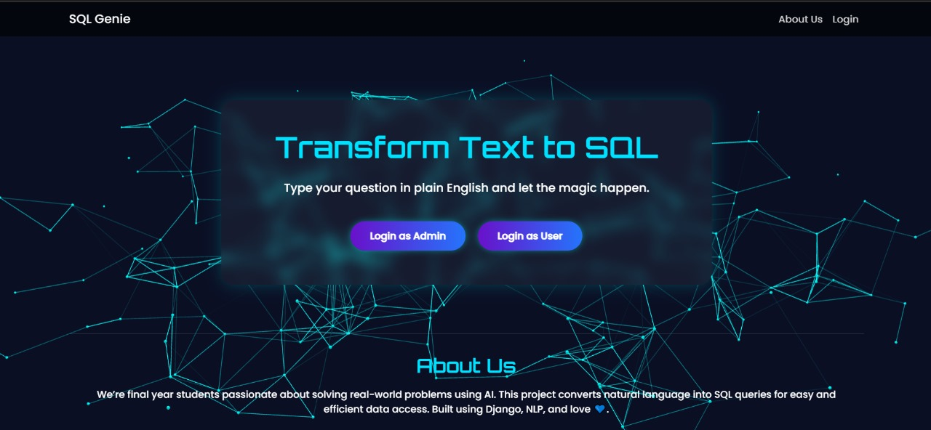

Figure 10.1: Home Page

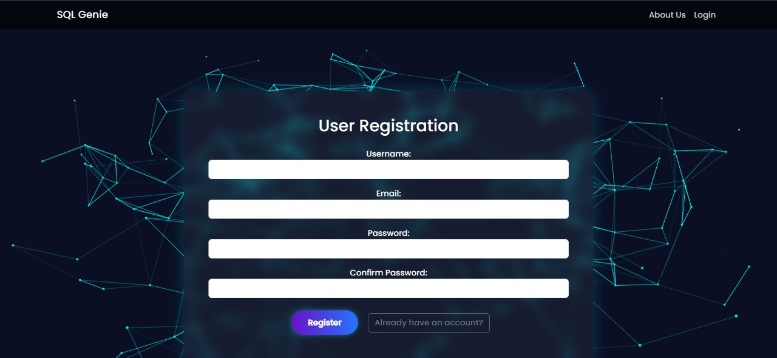

Figure 10.2: Registration Page
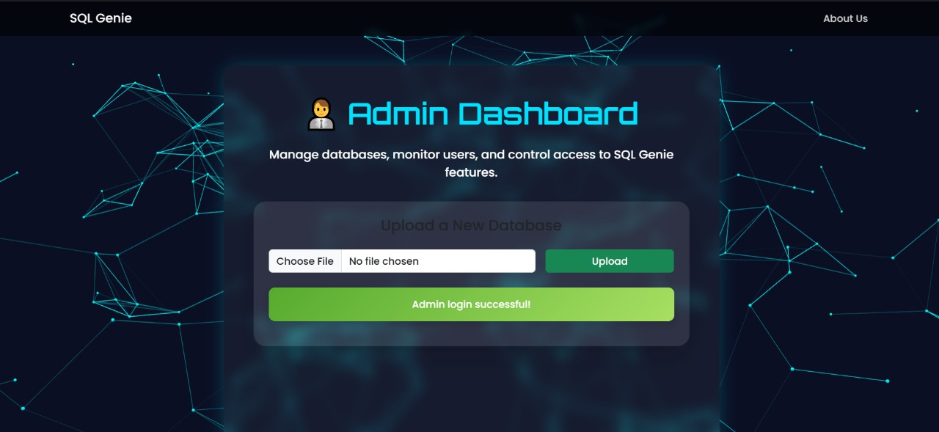

Figure 10.3: Admin Dashboard

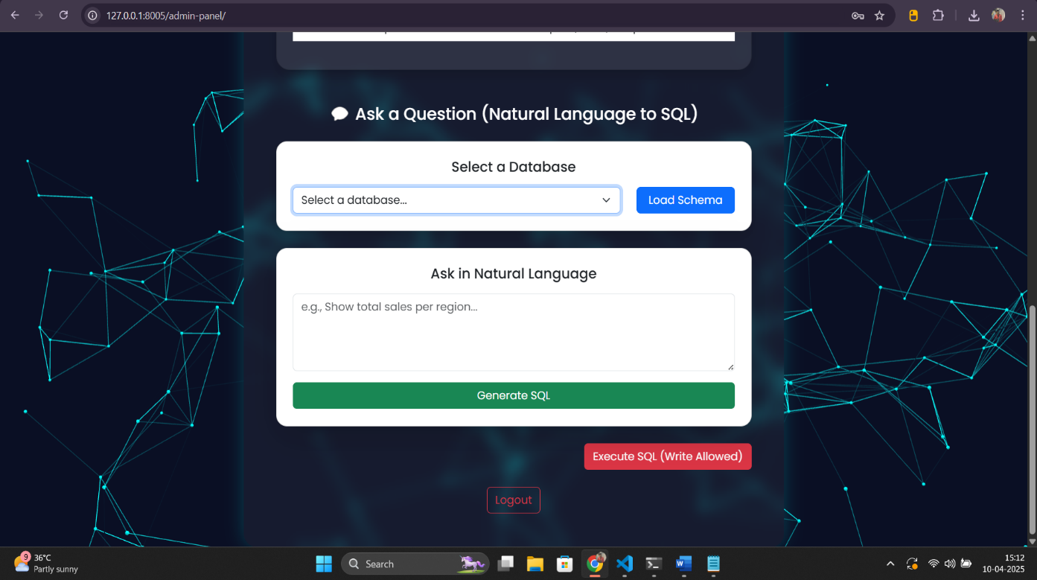

Figure 10.4: Execution Interface

APPENDIX-1
GLOSSARY OF TERMS

(In alphabetical order)

A
API | Application Programming Interface - A set of protocols and tools that allow different software applications to communicate with each other. In this project, the Gemini API is used to convert natural language into SQL queries.
Authentication | A process that verifies the identity of a user. The Django framework includes built-in authentication to manage access control for superusers and staff.
Authorization | Determines what a user is allowed to do after authentication. In this system, users can have limited or full database access depending on their assigned roles.
B
Backend | The server-side logic of a web application that includes APIs, business logic, and database operations.
D
Django | A high-level Python web framework that promotes rapid development and clean, pragmatic design. It is used as the backend framework for this project.
Database Schema | The structure of a database defined in terms of tables, columns, and their relationships. This schema is provided to the LLM for generating contextually correct SQL queries.
F
Front-End | The part of a web application visible to the user, usually consisting of HTML, CSS, and JavaScript. It communicates with the Django backend to allow query input and result display.
G
Gemini-2.0 Flash | A lightweight and fast variant of Google’s Gemini large language model (LLM), used in this project for transforming user queries in natural language to SQL format via API.
H
HTML | The standard language used to create and structure content on the web. It defines the elements and layout of web pages through tags and attributes.
I
IDE | A software application that provides tools for software development, including a code editor, debugger, and compiler. It simplifies the process of writing, testing, and debugging code.
L
LLM | Large Language Model - An artificial intelligence model trained on large datasets of human language to understand and generate text. In this project, it is used for interpreting and converting text into SQL queries.
N
Natural Language Processing (NLP) | A subfield of artificial intelligence that focuses on the interaction between computers and human language, used to convert natural language into machine-readable commands.
Natural Language Query | A user input written in everyday human language (e.g., “Show me all users registered in March”), which is processed by the LLM to generate a valid SQL query.
O
ORM (Object Relational Mapping) | A programming technique used to interact with the database using Python objects instead of writing raw SQL.
P
Permissions | A mechanism to restrict or allow certain actions in the application. Superusers can assign query execution permissions (like SELECT-only or full access) to staff.
PostgreSQL / SQLite | Relational database management systems (RDBMS) used to store, manage, and retrieve data. SQLite is used for development while PostgreSQL may be used in production.
Q
Query Execution | The process of running a SQL statement against a selected database and returning the results or modifying the data, depending on the type of query.
Query Logging | The process of storing all queries entered and processed by the application for audit, analysis, or debugging purposes.
R
Role-Based Access Control (RBAC) | A security principle in which users are assigned roles, and each role is granted specific permissions. This ensures that only authorized users can access certain features.
S
SQL (Structured Query Language) | A standard language used to manage and manipulate relational databases. The LLM generates SQL queries from plain English input in this project.
Superuser | An administrative user in Django with full permissions, responsible for creating databases, managing users, and assigning roles in the application.
Session Management | The method of maintaining the state of users across different requests in a web application.
U
UI | The space where interactions between humans and machines occur. It includes the design and layout of elements like buttons, menus, and screens that allow users to interact with software or hardware in a way that is intuitive and efficient.
V
VS CODE | An open-source code editor developed by Microsoft which supports a wide range of programming languages and features such as debugging, syntax highlighting, version control integration, etc.
W
Web Application | A software application that runs in a web browser and can be accessed via the internet or an intranet. This project is delivered as a Django-powered web application.

REFERENCES

JOURNALS / RESEARCH PAPERS

1. Ali Mohammadjafari, Anthony S. Maida, and Raju Gottumukkala, "From Natural
Language to SQL: Review of LLM-based Text-to-SQL Systems," arXiv preprint
arXiv:2410.01066, 2023. [Online]. Available: https://arxiv.org/abs/2410.01066
2. Dawei Gao et al., "Text-to-SQL Empowered by Large Language Models: A Benchmark Evaluation," arXiv preprint arXiv:2308.15363, 2023. [Online]. Available: https://arxiv.org/abs/2308.15363
3. Zijin Hong et al., "Next-Generation Database Interfaces: A Survey of LLM-based Text-to-SQL," arXiv preprint arXiv:2406.08426, 2024. [Online]. Available: https://arxiv.org/abs/2406.08426
4. Zihui Gu et al., "Interleaving Pre-Trained Language Models and Large Language Models for Zero-Shot NL2SQL Generation," arXiv preprint arXiv:2306.08891, 2023. [Online]. Available: https://arxiv.org/abs/2306.08891
5. Shayan Talaei et al., "CHESS: Contextual Harnessing for Efficient SQL Synthesis," arXiv preprint arXiv:2405.16755, 2024. [Online]. Available: https://arxiv.org/abs/2405.16755.
PROJECT SUMMARY

About Project
Title of the project | Django Based Text-To-Sql Execution Interface
Semester | 8th
Members | - Mahak Mirza
- Sparsh Sahu
- Eashan Tiwari
Team Leader | Sparsh Sahu
Describe role of every member in the project | Sparsh Sahu: LLM integration + Backend (Django) + API handling  Mahak Mirza: Frontend (HTML, CSS, JS) + UI design  Eashan Tiwari: Database setup + Permissions + Backend support
What is the motivation for selecting this project? | The motivation behind this project stems from the need to simplify the way non-technical users interact with relational databases. Writing SQL queries requires technical knowledge, which is often a barrier in data-driven environments. This project bridges that gap by integrating a large language model (LLM) with a Django web application, enabling users to input natural language queries and receive accurate SQL query results without prior knowledge of SQL syntax. It promotes accessibility, productivity, and error-free database querying in organizations.
Project Type  (Desktop Application, Web Application, Mobile App, Web) | Web Application

Tools &Technologies
Programming language  used | Python
Compiler used  (with version) | NA
IDE used  (with version) | Microsoft Visual Studios Code (1.51.1)
Front End Technologies  (With version, wherever  Applicable) | HTML, CSS & JavaScript
Back End Technologies  (with version, wherever  applicable) | Django (Python) v 5.1.6
Database used  (with version) | SQLite (for development), PostgreSQL (for production-ready deployment)

Software Design& Coding
Is prototype of the software developed? | Yes
SDLC model followed  (Waterfall, Agile, Spiral etc.) | Agile Methodology
Why above SDLC model is  followed? | The Agile model supports frequent iteration and collaboration, which was necessary because the project involved continuous testing with the LLM and frequent UI/backend changes based on evolving requirements and integration feedback.
Justify that the SDLC model mentioned above is followed in the project. | The functionality of the web application kept evolving due to changes in permissions, API integrations, and user interface components. These iterative improvements aligned with Agile’s sprint-based, flexible approach.
Software Design approach followed  (Functional or Object-oriented) | Functional oriented approach
Name the diagrams  developed  (According to the Design  approach followed) | Use Case Diagram, Data Flow Diagram (DFD), Class Diagram
In case Object Oriented  approach is followed, which of the OOPS principles are  covered in design? | NA
No. of Tiers  (example 3-tier) | 3-tier architecture
Total no. of front-end pages | 3 (Login, Query Interface, Query Result Page)
Total no. of tables in database | 2 (Users, Query Logs)
Database is in which Normal Form? | Third Normal Form (3NF)
Are the entries in database encrypted? | User passwords are hashed using Django’s default encryption
Front end validations applied (Yes / No) | Yes
Session management done  (in case of web applications) | Yes (Django’s built-in session management)
Is application browser compatible  (in case of web applications) | Yes
Exception handling done  (Yes / No) | Yes
Commenting done in code  (Yes / No) | Yes
Naming convention followed  (Yes / No) | Yes
What difficulties faced during deployment of project? | - Understanding the limitations of a lightweight LLM (Gemini 2.0 Flash) while ensuring reliable SQL conversion.  - Managing permissions and query restrictions to prevent unauthorized access to sensitive database actions.  - Integrating frontend, backend, and Gemini API in a modular and secure way.  - Building a flexible architecture to handle multiple databases and multiple users
Total no. of Use-cases | 4
Give titles of Use-cases | - Natural Language Query Input  - SQL Query Generation via Gemini  - Query Execution on Selected Database  - Display and Logging of Results

Project Requirements
MVC architecture followed  (Yes / No) |  | Yes
If yes, write the name of  MVC architecture followed  (MVC-1, MVC-2) | MVC-2
Design Pattern used  (Yes / No) | No
If yes, write the name of  Design Pattern used | No
Interface type  (CLI / GUI) | GUI
No. of Actors | 2
Name of Actors | Superuser, Staff/User
Total no. of Functional  Requirements | 6
List few important non-  Functional Requirements | Accuracy, Maintainability, Responsiveness, Security, Compatibility

Testing
Which testing is performed?  (Manual or Automation) | Manual
Is Beta testing done for this  project? | No

Write project narrative covering above mentioned points
The project titled “Design and Development of a Natural Language to SQL Web Interface using LLM” addresses the challenge of bridging human language and database communication. It provides a simple and intuitive web interface where users can type questions in natural English and receive real-time SQL-generated results. Using Gemini 2.0 Flash, the project translates these inputs into valid SQL statements, which are then executed on a selected database. Built using Django and designed with clean frontend principles, the system also supports multi-user login, role-based permissions, and supports query logging. This system enables non-technical users to perform complex database operations efficiently, making enterprise data more accessible and reducing reliance on database administrators. It offers a scalable, secure, and intelligent platform for real-time database interaction through natural language.
Mahak Mirza | Sparsh Sahu | Eashan Tiwari | Guide Signature
0187AD211020 | 0187AD211039 | 0187AD2110015 | Dr. Vasima Khan

