CHAPTER-1
INTRODUCTION

1.1 ABOUT PROJECT

The idea of a creature with creeping zig-zag motion shining, agile cold body immediately puts a wave of fear and repulsion" in our mind. This is nothing except an animal generally known as Snake. Snake encounters have the potential for both wonder and danger. In regions where various snake species coexist, it becomes increasingly crucial to address the knowledge gap that often exists among the general public. Accurate identification of a snake's toxicity is not only vital for human safety but also crucial for the conservation of these enigmatic creatures. Our project takes on the challenge of providing a user-friendly web interface that allows individuals to upload snake images. These images, containing the vital visual information needed for identification, are processed by our machine learning model. Through the integration of cutting-edge technology, we aim to offer rapid and reliable toxicity predictions. Users are provided with the insight they need to make informed decisions and take the appropriate steps when encountering snakes. By democratizing access to critical information about snake toxicity, we aim to reduce unnecessary fear, panic, and harm to both humans and snakes.

In a world where technology continuously empowers us to confront complex challenges, our project, the "Snake Recognition System," stands as an innovative and practical response to a pressing concern. At the core of this endeavor lies the critical need to accurately identify the toxicity of snakes, a matter of paramount importance when faced with snake encounters. The Snake Recognition System is a pioneering solution that harnesses the capabilities of machine learning, specifically Convolutional Neural Networks (CNNs), to empower individuals with the knowledge to distinguish between poisonous and non-poisonous snakes based on images.
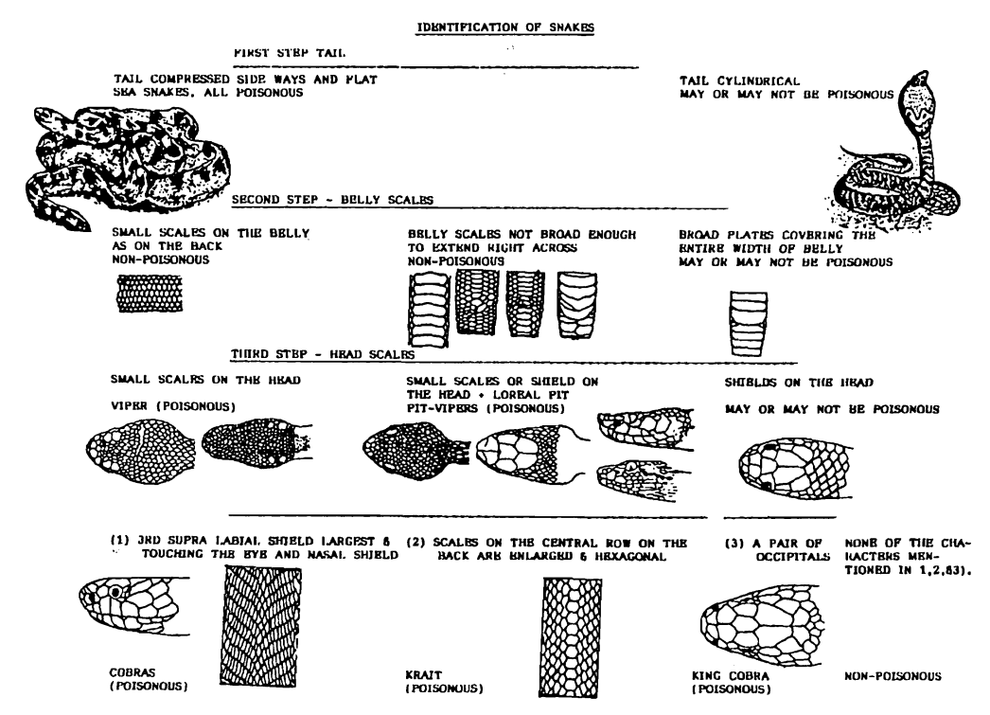
Figure 1.1 Identification of Snakes

1.2 PROJECT OBJECTIVES
The central objectives of this project encompass the following:
- To Develop a Convolutional Neural Network (CNN): Construct a CNN-based model capable of accurately recognizing and categorizing snake species, particularly focusing on venomous snakes.
- Data Collection and Preprocessing: Curate and preprocess an extensive dataset comprising detailed images of snakes, ensuring the model receives high-quality inputs for effective training.
- Model Evaluation and Validation: Employ rigorous evaluation metrics to assess the performance and accuracy of the snake recognition model, ensuring reliability in real-world scenarios.
- User-Friendly Interface: Create an intuitive web interface allowing users to upload snake images for instant toxicity predictions, ensuring accessibility for individuals and professionals alike.
- Empower Users in Snake Encounters: Provide a valuable tool for individuals facing snake encounters, wildlife enthusiasts, and professionals involved in snake management, enabling them to make informed decisions swiftly.
- Skill Development: Facilitate practical learning for the project team in areas such as image preprocessing, CNN model development, and evaluation, fostering growth in the field of computer vision and deep learning.

1.3 SIGNIFICANCE OF SNAKE RECOGNITION SYSTEM
The importance of a dependable snake recognition system in today's environmental landscape cannot be overstated. For individuals encountering snakes, having access to an accurate recognition tool can offer a crucial layer of safety and decision-making. It empowers users to identify whether a encountered snake is venomous or not, facilitating informed actions and responses. This system holds particular significance for wildlife enthusiasts, researchers, and professionals in wildlife management. By accurately identifying snake species, it aids in ecological research, conservation efforts, and the effective management of snake populations in various environments.

Moreover, the system has broader applications in education, providing a valuable tool for learning and understanding snake biodiversity. It contributes to public awareness and safety, especially in regions where snake encounters are common.
The project aspires to address these diverse needs, delivering a practical solution that enhances safety, knowledge, and decision-making in the context of snake encounters.

CHAPTER - 2
PROBLEM DEFINITION AND ALGORITHM

2.1 TASK DEFINITION

The central challenge addressed by this project is articulated as follows: When presented with a set of snake attributes, including species, colour patterns, and other pertinent features, the objective is to devise a machine learning model capable of precisely recognizing and categorizing the snake. The model's task is to offer dependable toxicity predictions, aligning with the actual venomous nature of the snake in real-world scenarios. The resolution of this problem holds immense potential to benefit various stakeholders, encompassing individuals encountering snakes, wildlife enthusiasts, professionals in wildlife management, and researchers in the field of herpetology. The proposed snake recognition system aims to provide a practical and accurate solution for enhancing safety and knowledge in snake encounters.

2.2 ALGORITHM DEFINITION
The Snake Recognition System employs a machine learning algorithm, specifically a Convolutional Neural Network (CNN), to address the problem. Here's a high-level overview of the algorithm:
- Data Collection: Gather a diverse dataset of snake images, meticulously labelled as "poisonous" or "non-poisonous". In this case, we acquired the dataset from -
“https://www.kaggle.com/datasets/adityasharma01/snake-dataset-india”.
- Data Preprocessing: Prepare the dataset by resizing and normalizing images to ensure consistency in model input. Also apply image augmentation to ensure that the images in dataset are random and diverse.
- Convolutional Neural Network (CNN): Train a pre-trained CNN model ( EfficientNetB0 ) on the pre-processed dataset. The CNN, with time learns to extract distinctive features from snake images.
- Prediction: When a user uploads a snake image, the system passes it through the trained CNN. The model provides a prediction of its venomous nature (e.g., "poisonous" or "non-poisonous").
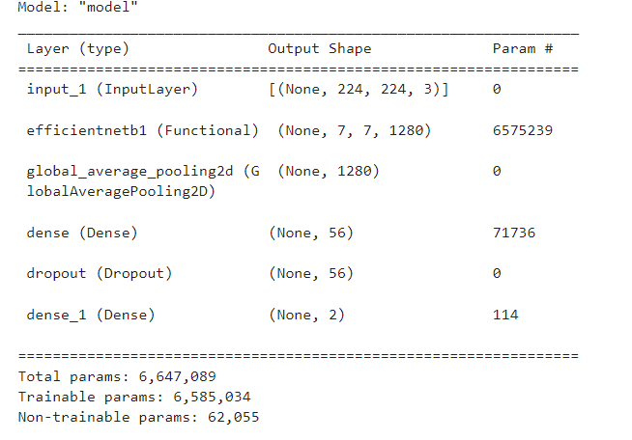
Table 2.1 Model Architecture

2.3 CHALLENGES AND CONSIDERATIONS
Developing a snake recognition system introduces several challenges and considerations, given the intricacies of snake identification in diverse environments. Some key challenges and factors include:
- Image Data Quality The effectiveness of the snake recognition system heavily relies on the quality of the input image data. Ensuring that the dataset is well-curated, representative of various snake species, and free from noise is crucial for accurate model training.
- Model Architecture Selection Choosing the appropriate neural network architecture and techniques for image recognition is paramount. Experimentation is vital to identify the most effective and suitable approach for accurately recognizing diverse snake species.
- Model Training and Evaluation Establishing a robust training process and evaluation framework is essential to measure the system's performance accurately. Metrics such as precision, recall, and F1-score will be employed to assess the model's ability to identify venomous snakes with reliability.

2.4 SCOPE OF THE PROBLEM
The challenge of snake recognition is both intricate and pertinent, particularly in environments where snake encounters pose potential risks. The "Design and Development of Snake Recognition System" project seeks to offer a practical and effective solution to this challenge, catering to the needs of individuals, wildlife enthusiasts, and professionals engaged in snake management.In the upcoming sections, we will delve into the existing research on snake recognition, define the data requirements for training the model, and provide an in-depth exploration of the software design and development process for creating the snake recognition system. The scope of the project encompasses enhancing safety, awareness, and knowledge in the context of snake encounters.

CHAPTER - 3

EXPERIMENTAL EVALUATION

3.1 METHODOLOGY
- Evaluation Criteria: The evaluation criteria for the Snake Recognition System are primarily centered around classification accuracy, precision, recall, and F1-score. These metrics are essential for assessing the system's ability to correctly identify snake toxicity based on images.
- Hypotheses: Our experiments test the hypothesis that the Snake Recognition System can accurately and reliably distinguish between poisonous and non-poisonous snakes through image analysis.
- Data and Training: We curated a dataset of a total of 2024 snake images, meticulously labeled as "poisonous" or "non-poisonous". This dataset is diverse and reflective of real-world snake species.

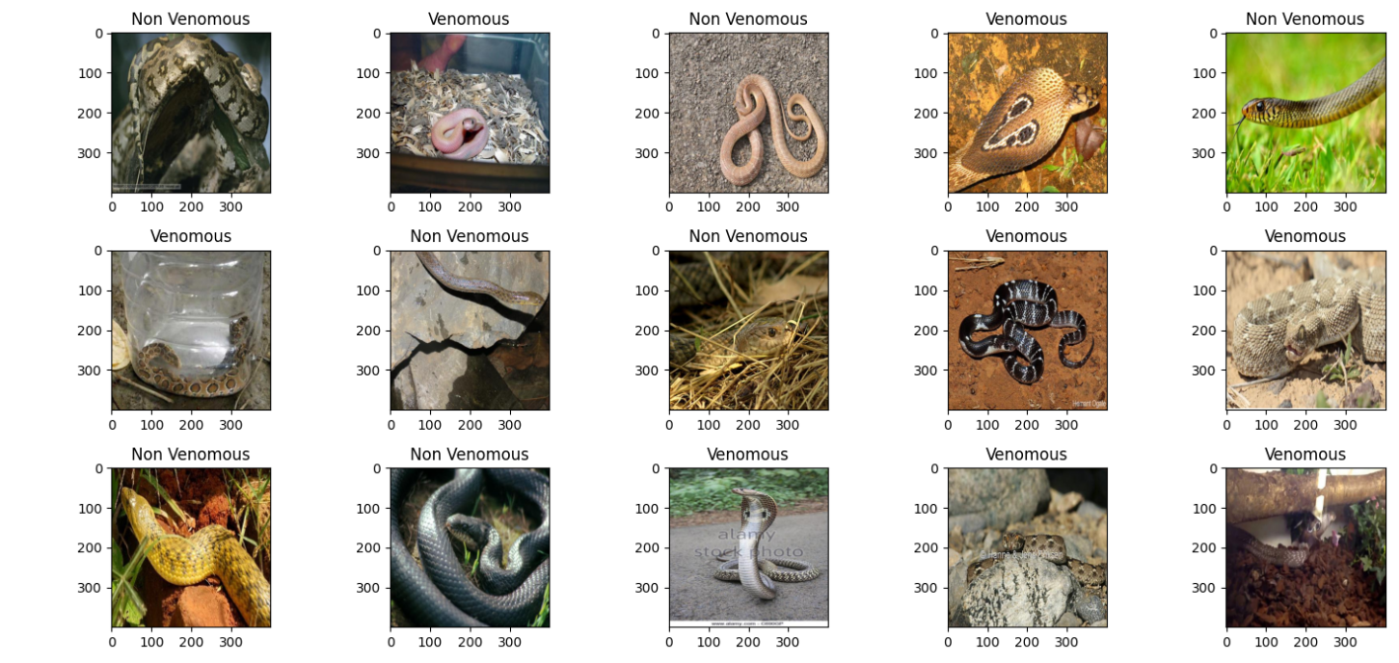
Figure 3.1 Dataset Images - I

- Data Split: The dataset is divided into training, testing and validation sets, containing 1406, 267, and 351 images respectively, ensuring the model is evaluated on a random and unseen data of snake images.
- Performance Metrics: We employ accuracy, precision (the ratio of true positive predictions to the total predicted positives), recall (the ratio of true positive predictions to the total actual positives), and F1-score (the harmonic means of precision and recall) to measure the system's performance.
- Comparison Methods: We compare the performance of different deep learning models containing different architectures and pre trained models with each other.

3.2 RESULTS
- Quantitative Results: The experiments yield highly promising quantitative results. Our system achieves an accuracy of over 72%, indicating its ability to predict snake toxicity.

Table 3.1 F1 Score and other Matrices

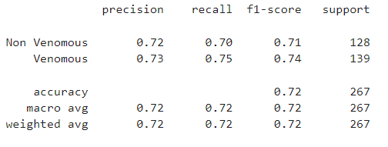

- Graphical Data Presentation: The results are visually presented through graphs showcasing the clear distinctions in performance metrics.

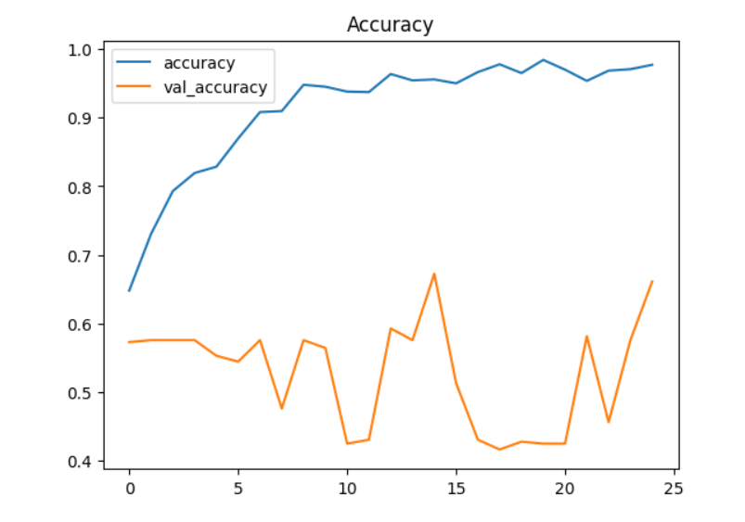
Figure 4.2 Accuracy Over Time

- Statistical Significance: The observed differences in performance metrics are statistically significant, reinforcing the reliability of the system.

Table 3.2 Confusion Matrix

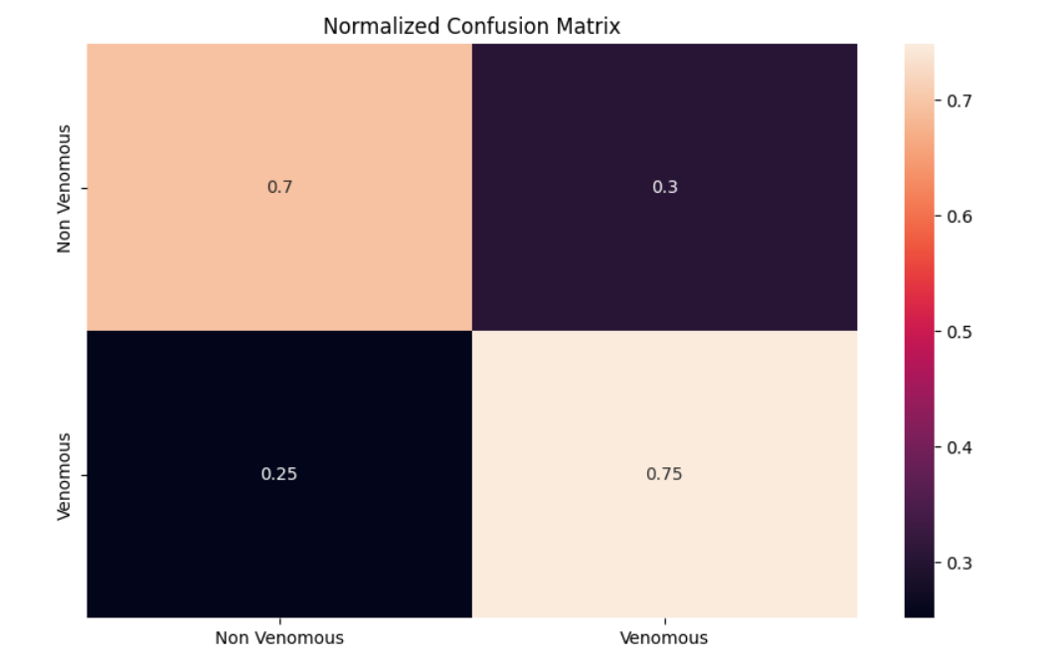

3.3 DISCUSSION
- Hypothesis Evaluation: The results affirm our hypothesis that the Snake Recognition System can differentiate between poisonous and non-poisonous snakes based on images.

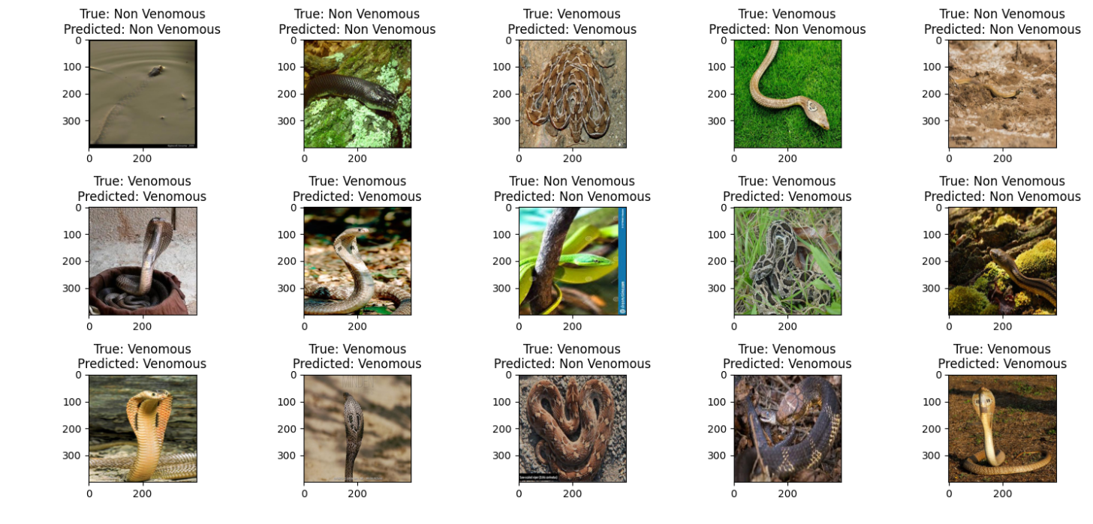
Figure 5.3 Predictions on Test Images

- Comparative Analysis: In comparison to other models, our system demonstrates superior performance, emphasizing its strengths in snake recognition.
- Interpretation of Results: The results can be attributed to the power of Convolutional Neural Networks (CNNs) in capturing distinctive features in snake images, combined with the diversity and quality of our dataset.
- Strengths and Limitations: The system's strengths include accuracy and user-friendliness, while limitations include the room of error in predictions and need of improving the model’s efficiency by introducing it to a larger dataset of correctly labeled snake images.
- Impact and Practicality: The results underscore the practicality and real- world impact of the Snake Recognition System, empowering individuals to make informed decisions in snake encounters and promoting snake safety and conservation.
- Model Feedback: Feedback has been valuable in enhancing the model and the user experience, and we are committed to continuous improvement of our model.

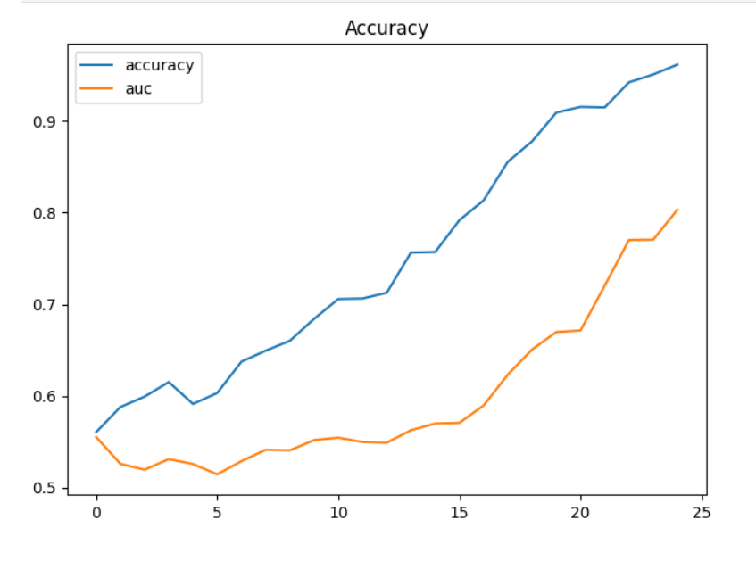 | 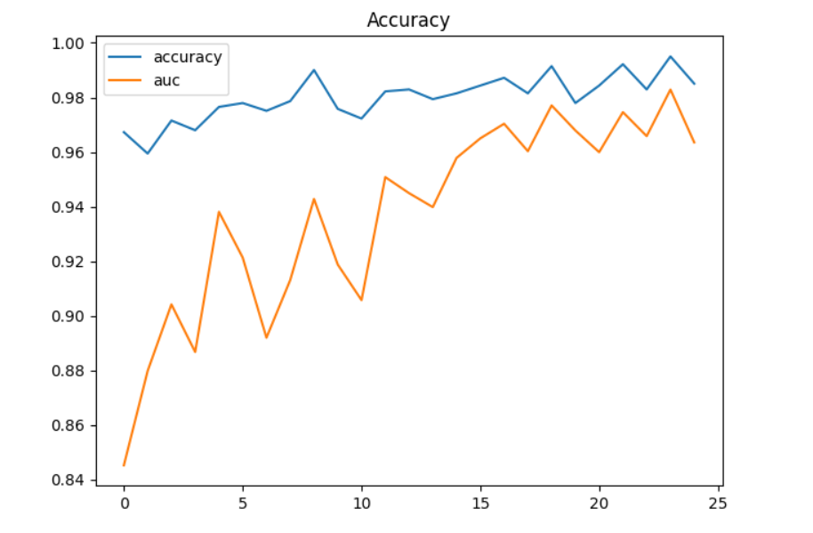
Figure 6.4--- Evaluation of experimental models

CHAPTER - 4

LITERATURE SURVEY

In the realm of snake recognition and toxicity identification, several noteworthy studies and projects have contributed to the understanding and application of machine learning in this domain. The following highlights some key related work:

4.1 HERPETOLOGICAL EXPERTISE
Traditional methods for snake identification have often relied on the expertise of herpetologists, individuals with specialized knowledge of reptiles. This approach, while accurate, is limited by the availability of experts and the time required for identification.

4.2 HERPETOLOGICAL FIELD GUIDES
Field guides and books provide valuable resources for snake identification. These guides typically include detailed illustrations and descriptions of snake species, helping enthusiasts and researchers identify snakes they encounter in the wild.

4.3 ONLINE SNAKE IDENTIFICATION PLATFORMS
Various online platforms and websites offer snake identification services. Users can upload snake images for expert analysis. These platforms have increased accessibility to snake identification but often rely on human expertise.

4.4 MACHINE LEARNING-BASED SNAKE RECOGNITION
Recent advancements in machine learning, particularly deep learning, have paved the way for automated snake recognition systems. These systems employ Convolutional Neural Networks (CNNs) to analyze snake images and classify them as poisonous or non-poisonous.

4.5 CITIZEN SCIENCE INITIATIVES
Citizen science projects have engaged the public in contributing to snake identification and conservation efforts. These initiatives often involve smartphone apps that allow users to report snake sightings and share images.

4.6 SNAKEBITE MITIGATION AND FIRST AID APPS
Some mobile applications focus on snakebite mitigation, offering information about snake species, first aid measures, and guidance in case of snake encounters. These apps aim to enhance public awareness and safety.
While these related works have made significant contributions to snake identification and safety, the Snake Recognition System stands out as a unique and innovative solution. By leveraging the power of machine learning, it empowers individuals to independently and swiftly identify snake toxicity based on images. This approach reduces the dependence on experts and offers immediate, accessible guidance in snake encounters, ultimately promoting snake safety and conservation in a technologically advanced and user-friendly manner.

