University of Maryland Global Campus

CMST 386 7380

Principles of Web Design and Technology II (2212)

Professor Leslie Allen

Website Proposal

Author:

Richard MacFarlane

Date: April 14, 2021

# 

# **Website Proposal**

# Client and Topic

The following website proposal, TITIUS INDUSTRIES (www.*TitusIndustries.com*) is being created by and submitted to CEO and Co-founders: Rich MacFarlane, Patrick Nguyen and Daiske Noguchi of Titus Industries for consideration to further the joint business venture related to the overall business plan.

For the purposes of this proposal, further instances of Titus Industries, TITUS INDUSTRIES and/or [www.TitusIndustries.com](http://www.TitusIndustries.com) will be referred to as TI and/or TI.com respectively.

# Development Process and Engagement

Development of TI.com is a collaborative effort between respective TI stakeholders, potential investors and in conjunction with previous conversations, plans and business ideas. Due to the nature of TI and stakeholder discussions, the potential short and long-term success of TI.com was researched through personal experience, exhaustive online similar successful and failed business ventures thus providing a platform for TI stakeholders to build upon.

# Testing

Initial and continuous testing methods of TI.com will be conducted initially in a non-live environment to ensure the website displays as intended. Development for TI.com will be built with the intention to display and function accordingly for web browser such as: Google Chrome, Firefox (Mozilla), Microsoft EDGE and Internet Explorer respectively. Additionally, further development for mobile applications such as Android, Apple iOS and the potential release of Windows mobile applications will be conducted in conjunction with traditional Microsoft PC and Apple OS operating systems.

Short-term testing will be conducted upon and initial limited release to stakeholders and their respective family, friends and limited colleagues with the intent to test TI.com in a live environment. Long-term testing will be conducted on a recurring basis to coincide with website development security patches, updates, site navigation improvements when needed and overall expansion of TI.com business efforts.

For additional non-TI personnel related testing (an outside source), Quality Assurance testers such as QAWERKS ([*www.qawerk.com*](http://www.qawerk.com) & <https://qawerk.com/services/web-application-testing/>) will be highly considered with respect to their provided professional Web Testing services such as: Functional Testing, Usability Testing, Performance Testing, Security Testing, Compatibility Testing and Interface Testing.

# Description

TITUS INDUSTRIES and TI.com is intended to initially be a multifaceted business venture surrounding the Airsoft industry. Future planning, with respect to talks among stakeholders, where to potentially migrate Titus Industries into a core business platform for additional business ideas and ventures related to rare Japanese automotive sales and rare retro video game sales. However, with respect to this specific proposal and associated CMST 386 Project, TI.com will initially concentrate on the Airsoft industries as this is “where it all began”.

With respect to Airsoft, I offer a short summary of the hobby and sport to better assist in the overall understanding of the intent of TI.com. Airsoft, is for all intents and purposes, a modern-day version of Cowboys and Indians, Cops and Robbers but mainly for adults, although kids have been known to play as well provided, they are with an adult. Airsoft, is an enthusiast’s sport and collectable hobby that was created by the Japanese and originated in the 1970s. Airsoft, although similar to the U.S. paintball sport and hobby, is a sport of ‘Survival Game’ where the overall premise is based on Military war-game simulation. Essentially, it is a game of tag you’re it, or a game of capture the flag, rescue the hostage or save the day by turning off the mock-bomb before it goes off!

This sport of Airsoft is played with life-like weapons that shoot 6mm round plastic biodegradable BB bullets and they replicate their real-steel counterparts 1:1 in almost every physical and functional aspect and typically are referred to as Airsoft guns or in Japan, as Softair. The reason this hobby and sport became popular and still remains this way around the world; is due to owning real-steel firearms is near impossible in Japan, so this is the next best thing for Japanese gun enthusiasts. Additionally, dressing up in your favorite Military attire, simply going with a t-shirt and jeans or dressed as your favorite comic book character is part of the entire fun, it is like cosplay at max involvement and for the uber-nerds to nerd out without discrimination from others. Typically, Airsoft guns primarily work off one of two sources of energy, a battery or a CO2 type gas cartridge. Because of their realism, Airsoft guns are regulated by law and there are enforced rules at game fields but this doesn’t stop the comradery and friendships built around like-mined people for this hobby and sport.

The development of TI.com is to bring like-minded enthusiasts together and provide them a platform to buy Airsoft weapons and gear, upgrade their gear and Airsoft weapons, visit and play on an associated game field and chat on a forum-based engine. Another aspect of TI.com is to introduce modular field creations and offer this as venue to other field operators aspiring to upgrade their current venue. The stakeholders of TI want/plan to market to, produce and offer various modular field configurations as part of an expansion plan for the overall business in the long-term. The modularity options for field use will be made of recyclable materials and can ultimately be shipped to a field for installation and/or sourced locally as the business expands. The premises behind the modular field section are closely related to Lego building blocks and are intended to be moved around at will in an effort to create a dynamic playing field thus bringing a recurring change to the otherwise monotonous and routine game field. Other aspiring avenues of approach for field modules are to market the platform to Law Enforcement and Military as training venues.

The primary initial audience is targeted to Airsoft enthusiasts with a long-term intent to expand to an alternative safe weapons training platform and to offer associated weapons training professionals a venue to conduct their respective offerings. The age group does not necessarily have a limitation and/or cap, however the typical age groups that would be part of the targeted audience falls within the 20-to-40-year age margin. As for gender, the target audience is not limited however the primary participating gender is likely to be males. Target audience considerations with respect to religion, ethnic or race backgrounds, education levels and/or economic levels generally do not have any significant negative or positive impact on business potential and growth. The TI website content such as font text style has been decided to initially be a combination of Berlin Sans FB (Demi) and Calibri, overall background will be Black or Dark Grey and incorporate Grey or Dark Red bordering with accents of Red and/or Dark Red underlining of various headers or sections that divide various page content. Font colors will initially be tested with Gold and/or GoldenRod and sizing is dependent on content viewability. Headings are intended to be Gold with Gray bordering but is dependent on testing overall visual analysis. Additional features include the use of dynamic coloring when hovering over links which would include a combination of Purple (hovered over links) Light Grey (available links), and Neon Green upon previously selected/clicked links, however, these color combinations are subject to change based on visual analysis. Additional and original content will include pictures and subsequently provided by TI stakeholders from past and current experiences and events but will offer a platform for registered end-users to post their related content as well. A preliminary example of the TI landing page can be reviewed in (Fig. 1) which will provide an overall visual intent of all subsequent TI webpages.

The short and long-term audience is likely to be enthusiasts of military, military simulation, law enforcement and weapons hobbyists and therefore the overall look and feel of TI.com would surround those elements accordingly. In an overall effort to create the look and feel of the TI.com website, extensive research of related websites solely for their look and feels aspects will be considering in the design phases and improvements. Updates to the TI.com website would be on a consistent and recurring basis that follows current associated content trends and improvements would be implemented accordingly.

# Growth and Maintenance

Overall growth and maintenance of TI.com will be based on content trends of the industry and other related content providers in an effort to stay ahead of the competition and/or drive and spearhead the industry in a positive and safe forward movement. This will require the TI stakeholders to conduct applicable research into the industry, analyze and implement changes accordingly to industry demands. With respect to some of the features intended to be offered on TI.com such as, membership chat forum, gameday calendar bookings, purchase and/or rental offerings; will require TI stakeholders to update the website based on demand, inventory replenishment, work-order requests and can effectively be updated daily, weekly and monthly accordingly.

# Organization

TI.com will be designed and organized to follow the typical yet effective HTML site design using hierarchal principal structures. Multiple pages of TI.com will link to each other and allow the end-user to navigate the site with ease based off the intent of the visit yet lead the audience to other aspects of intertest. Additionally, TI.com can and will link the audience to other related websites that provide a common platform and/or product that TI may not offer but are potentially affiliated with. The following example of the TI.com website landing page (*Fig. 1*) provides an overall look and feel of the corresponding associated webpages and the website navigation wireframe (*Fig. 2*) is an example and preliminary design of the TI.com navigation intent. Additional explanations of page content intentions are in the following (*Fig. 3*) table and provide an overview of what the corresponding pages in the wireframe will provide in content.

***Fig 1. Titus Industries Landing (Welcome) Page***

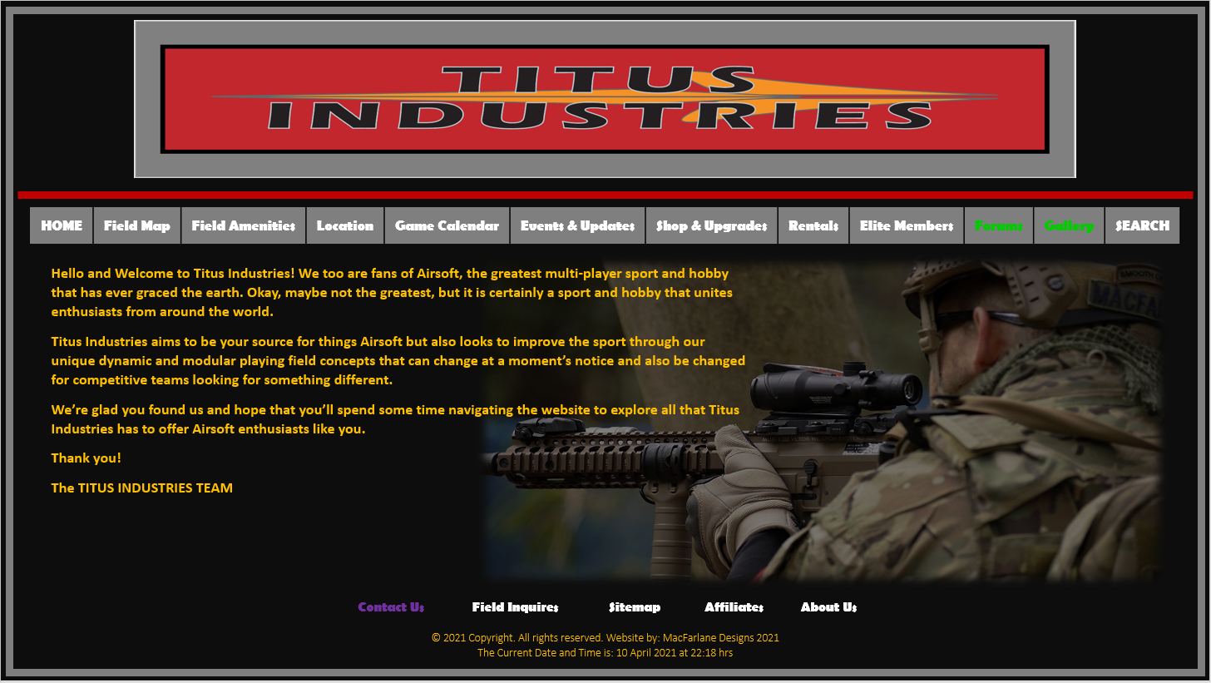

|  |  |  |  |
| --- | --- | --- | --- |
| Site Design Elements | | | |
|  | **Primary Choice** | **Alternate** | **Other Options** |
| Fonts | **Headers:** Berlin Sans FB  **Content Text:** Calibri | **Headers:** Berlin Sans FB Demi | Calibri / Verdana / Arial / Agency FB |
| Font Colors | Gold | GoldenRod | Light Grey / White |
| Background Colors | Black Background  **Potential Option:** Dark Grey | Grey Bordering | Dark Red Bordering |
| Accent Colors | Red | Dark Red | **Underlining:** Red/Dark Red or Grey |
| Hover & Links | **Available links:** Light Grey  As seen in the Mock-Webpage example for the *overall links*  **Hover:** Purple  As seen in the Mock-Webpage example for the *Contact Us link*  **Previously Selected:**  Neon Green  As seen in the Mock-Webpage example for the *Forums and Gallery links* | **Available links:** Blue  **Hover:** Yellow  **Previously Selected:**  Red | ***Depending on visual analysis, other design and color options will be explored.*** |

***Fig 2. Titus Industries Website Navigation Flow***

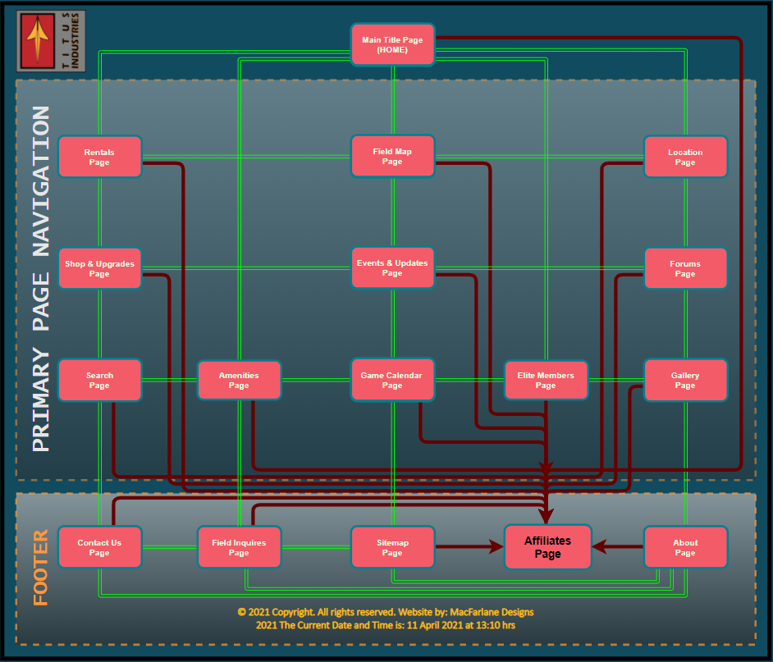

***Fig 3. Titus Industries Page Descriptions Table***

|  |  |
| --- | --- |
| **Site Navigation Table and Overview** | |
| **As indicated in the Website Navigation Flow diagram (*Fig. 2*), the overall site navigation is designed to allow the end-user to navigate freely throughout the Titus Industries eco-system regardless of what page they land on with the exception of the Affiliates Page (reference context below).** | |
| **Page Title** | **Page Description** |
| **Main Title Page**  **(Home)** | Overall welcome page. Unlike the mock-webpage in (***Fig. 1***) the **Home** button will not appear and was included in the example for pure aesthetic reasons. For subsequent pages, the **Home** button will be present.  Additionally, the TITUS INDUSTRIES logo will be linked to the Home navigation. |
| **Field Layout**  **Page** | **Approximate Verbiage:** The Titus Industries field layout is modular and dynamic. The filed barricades, walls and other related obstacles and structures, could be changed at any time in order to provide a unique playing experience thus making the dynamics hard to memorize r get used to. This unique dynamic field design also makes game play challenging for those that strive to improve their skills rather than memorizing the field by muscle-memory. |
| **Field Amenities**  **Page** | **Approximate Verbiage:** Titus Industries offers food onsite as well as a series of vending machine services. Additionally, Titus Industries has amenities such as washrooms, showers, locker rooms and toilets to accommodate men and women.  Titus Industries also offers a shuttle service to take your team to and from the train station (minimum of 5 players). |
| **Location Page** | **Approximate Verbiage:** The Titus Industries playing field and shop are located in Washington State and just minutes from the main highway. We offer shuttle a service as well for large groups that want to park and ride within 25 miles of our location. |
| **Game Calendar**  **Page** | **Approximate Verbiage:** The Titus Industries game calendar is available to book reservations and can be used to research when games and/or events are held as well as field prices that can vary depending on book schedules and holidays. |
| **Events & Updates Page** | **Approximate Verbiage:** Titus Industries will provide a series of recurring updates to our visitors with respect to gear inventory restocking, changes to rules/policies, events both local and yonder. |
| **Shop & Upgrades Page** | **Approximate Verbiage:** Titus Industries intends to provide a limited e-commerce element with respect to the purchase of new gear and Airsoft weapons as well as various custom levels of gear and weapon modifications. |
| **Rentals Page** | **Approximate Verbiage:** Titus Industries offers rentals such as various gear options to wear and rentals for a variety of weapons to suit your individualistic desires and style of play. |
| **Elite Members**  **Page** | **Approximate Verbiage:** Membership does have its perks! Titus Industries offers an elite membership for those that want continuous benefits of the field that includes both discounts for field offerings and special game-day reservations and discounts. |
| **Member Forums**  **Page** | **Approximate Verbiage:** Titus Industries offers a venue where Titus Industries Elite members or non-members can join and share information, strategies, swap equipment and chat about airsoft in general. |
| **Gallery Page** | **Approximate Verbiage:** That’s right, we like seeing all that Airsoft action captured by anyone. Submit your pictures and captions and we’ll review them before posting it for you. |
| **Search Function Page** | A search function will navigate users to a new page that allows them to tailor the search options accordingly. The search function is designed for the end-user to find content old and new that they may be specifically looking for. |
| **Contact Us Page** | **Approximate Verbiage:** Have a question? Can’t find what you’re after using the search function or you just want someone to talk to> Reach out to the Titus Industries Team and we’ll lend an ear. |
| **Field Inquires Page** | **Approximate Verbiage:** Like our dynamic and modular playing field setup? We love it too; it’s kind of like building huge Lego structures. You’ll find an array of information on how we came up with the design and how we can help your field become a better one. |
| **Sitemap Page** | This page provides an overview of content provided within the pages of the Titus Industries website. |
| **Affiliates Page** | This page will navigate users to a listing of Affiliates of Titus Industries. As indicated in the wireframe, the Affiliates Page can be navigated to, however, once the end-user clicks an Affiliate link, they will no longer be on the Titus Industries website and cannot navigate back.  The affiliate page will open in a new browser window.  Affiliate links will also be present within the Shop & Upgrade page and in Events & Updates pages respectively.  Should the user never click an Affiliate link, the applicable navigation within Titus Industries will function as designed.  A Titus Industries Affiliate can however have a link back to the Titus Industries Main Title Page (Home) |
| **About Page** | **Approximate Verbiage:** Titus Industries has been a dream of friends for a years starting as far back as 2015. We too are enthusiasts and players and ultimately want to unite people from around the world to enjoy Airsoft. |

# Security

In addition to TI.com providing like-minded Airsoft enthusiast a platform to gather and discuss their hobby interests, TI.com does intend to provide various elements of e-commerce components related to Airsoft equipment demands, modification services and game field bookings. Although not necessary to create an account to navigate and browse the website content; it is encouraged to create an account to further engage with the overall websites’ intent. Because of the nature of the TI websites account creation process, it will require the end-user to create an associated password protected verification method to engage with e-commerce elements of TI.com. In an effort for the website to apply proper and remain in compliance with current industry security standards; TI stakeholders will not only rely on our chosen website host offerings, but it will seek outside scheduled and/or recurring penetration testing efforts through venues like the previously mentioned QAWerk, Web Application & Website Testing Services.

# Web Hosting

Because of the overall dynamics of TI.com such as an end-user chat forum, e-commerce platform, email exchanges, end-user account processing and maintenance, one of the major considerations and criteria when TI stakeholders research and chose an applicable web hosting service; is that they must offer industry standard website security protocols for our intent to provide a secure e-commerce platform and that they must provide avenues for scalable website growth. Our chosen web hosting service should also follow/offer common industry standards for front-end (client-side) and back-end (server-side) programming languages such as JavaScript, XHP, PHP, C & C++, C#, Python and/or Perl as some of the coding and elements of TI.com may require these in order to function and display as intended and due to the scalable dynamics.

# Marketing

Although word-of-mouth will not be the only avenue for business growth, it will be a significant proponent for overall website and business growth, especially with relation to the game field and the corresponding desire to provide Airsoft field modularity offerings to existing and aspiring Airsoft business with respect to their potential growth. A significant part of TI.com will be offerings related to Airsoft equipment sales, Airsoft weapon upgrades and in-house modification services and will subsequently be advertised accordingly through local or yonder Airsoft events, TI website and with collaborative Airsoft businesses efforts. TI.com Search Engine Optimization (SEO) elements that would work well to attract and drive business to TI are related to using keywords that focus on the platform of the TI website, for example implementing keywords like: Airsoft, Airsoft guns, Airsoft equipment, Airsoft upgrades, Airsoft game field, Airsoft gear, Airsoft forum, Airsoft gallery and so on.

References

QAwerk. (2021b, April 7). *Software Testing Services & QA Company*. https://qawerk.com/

QAwerk. (2021a, March 11). *Web Application & Website Testing Services*. https://qawerk.com/services/web-application-testing/