1.

// hw2_1.cpp : 定义控制台应用程序的入口点。

//

#include "stdafx.h"

int _tmain(int argc, _TCHAR* argv[])

{

int a=-2,b=99,c=2147483647;

unsigned int d=4294954951,f=12345;

char g='d';

float h=53.65;

printf("Int %d, %d, %d, %d, %d, %d, %d\n",(int)a,(int)b,(int)c,(int)d,(int)f,(int)g,(int)h);

printf("unsigned int %u, %u, %u, %u, %u, %u, %d\n",(unsigned int)a,(unsigned int)b,(unsigned int)c,(unsigned int)d,(unsigned int)f,(unsigned int)g,(unsigned int)h);

printf("long %ld, %ld, %ld, %ld, %ld, %ld, %ld\n",(long)a,(long)b,(long)c,(long)d,(long)f,(long)g,(long)h);

printf("short %hd, %hd, %hd, %hd, %hd, %hd, %hd\n",(short)a,(short)b,(short)c,(short)d,(short)f,(short)g,(short)h);

printf("signed char %d, %d, %d, %d, %d, %d, %d\n",(signed char)a,(signed char)b,(signed char)c,(signed char)d,(signed char)f,(signed char)g,(signed char)h);

printf("float %f, %f, %f, %f, %f, %f, %f\n",(float)a,(float)b,(float)c,(float)d,(float)f,(float)g,(float)h);

return 0;

}

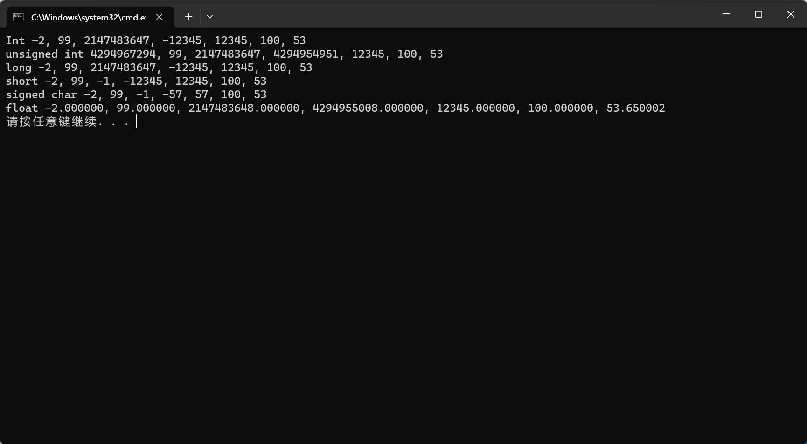

2.

// hw2_2.cpp : 定义控制台应用程序的入口点。

//

#include "stdafx.h"

int _tmain(int argc, _TCHAR* argv[])

{

int chn_pop,chn_gdpa,ind_pop,ind_gdpa;

double ans;

scanf_s("%d%d%d%d",&chn_pop,&chn_gdpa,&ind_pop,&ind_gdpa);

ans=1.0*chn_pop*chn_gdpa/(1.0*ind_pop*ind_gdpa);

printf("%lf\n",ans);

return 0;

}

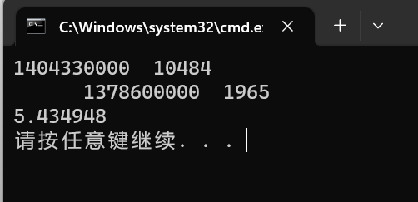

3.

// hw2_3.cpp : 定义控制台应用程序的入口点。

//

#include "stdafx.h"

int _tmain(int argc, _TCHAR* argv[])

{

double p, q ;

p=12345.0123456789;

q=123456789.0123456789;

printf("%lf %lf\n",p,q);

return 0;

}

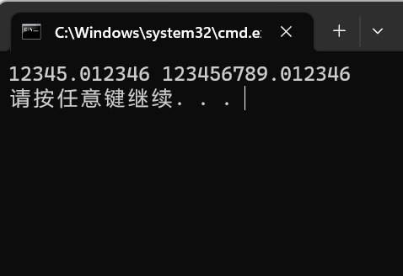

4.

// hw2_4.cpp : 定义控制台应用程序的入口点。

//

#include "stdafx.h"

#define ABS(x) ((x)>0?(x):(-(x)))

#define SIGN(x) ((x)>0?(1):(-1))

int _tmain(int argc, _TCHAR* argv[])

{

double a;

int xs;

int ans;

scanf_s("%lf",&a);

xs=a*10;

xs=ABS(xs);

xs%=10;

ans=a;

if(xs>=6){

ans+=SIGN(ans);

}

printf("%d\n",ans);

return 0;

}

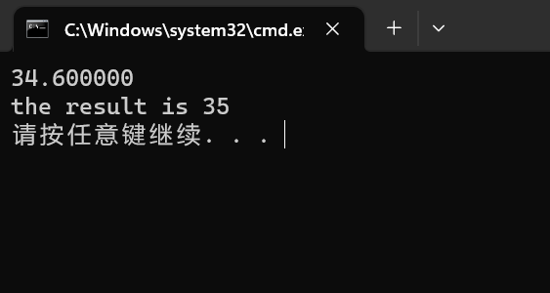

5.

// hw2_5.cpp : 定义控制台应用程序的入口点。

//

#include "stdafx.h"

int _tmain(int argc, _TCHAR* argv[])

{

int in_a,in_b;

int da,db,ha,hb,ma,mb;

int dc,hc,mc;

scanf_s("%d%d",&in_a,&in_b);

da=in_a/10000;

db=in_b/10000;

ha=in_a/100;ha%=100;

hb=in_b/100;hb%=100;

ma=in_a%100;

mb=in_b%100;

ma=da*24*60+ha*60+ma;

mb=db*24*60+hb*60+mb;

mb-=ma;

mc=mb%60;

hc=mb/60;hc%=24;

dc=mb/(24*60);

printf("The journey time is %dday %d hrs %d mins.\n",dc,hc,mc);

return 0;

}

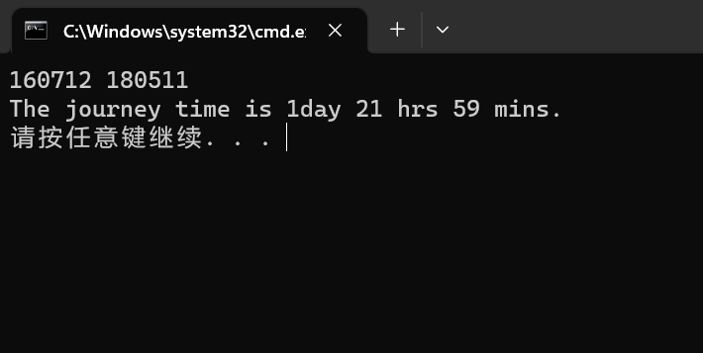

6.

// hw2_6.cpp : 定义控制台应用程序的入口点。

//

#include "stdafx.h"

void swap(char*a,char*b){

char tmp;

tmp=*a;

*a=*b;

*b=tmp;

}

int _tmain(int argc, _TCHAR* argv[])

{

char a[5];

int i;

scanf_s("%s",a,sizeof(a));

for(i=0;i<4;i++){

a[i]=(a[i]-'A'+9)%26+65;

}

swap(a,a+2);

swap(a+1,a+3);

printf("The encrypted chars are %s\n",a);

return 0;

}

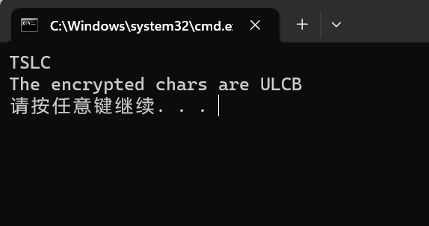

7.

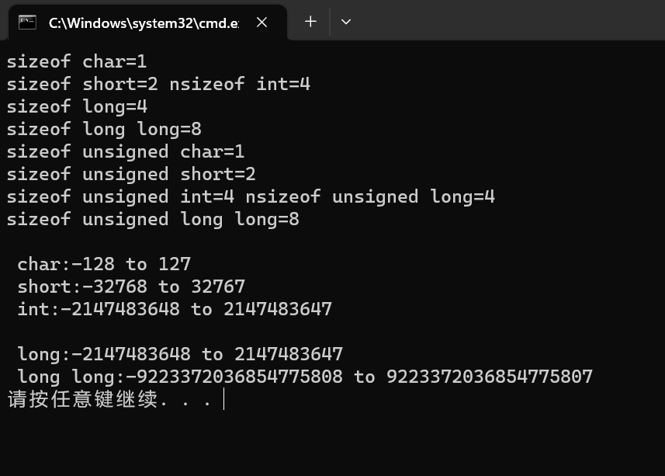

8.

|  |  |  |  |  |  |
| --- | --- | --- | --- | --- | --- |
| （1）Unsigned 无符号数 | | | （2）Two's Complement 二进制补码 | | |
| **Decimal** | **Binary** | **Hexadecimal** | **Decimal** | **Binary** | **Hexadecimal** |
| 10 | 0b0000 1010 | 0x0A | -10 | 0b1111 0110 | 0xF6 |
| 240 | 0b1111 0000 | 0xF0 | -16 | 0b1111 0000 | 0xF0 |
| 15 | 0b0000 1111 | 0x0F | 15 | 0b0000 1111 | 0x0F |
| 161 | 0b1010 0001 | 0xA1 | -95 | 0b1010 0001 | 0xA1 |
| 250 | 0b1111 1010 | 0xFA | 250 | 0b1111 1010 | 0xFA |
|  |  |  |  |  |  |
| 204 | 0b1100 1100 | 0xCC | -52 | 0b1100 1100 | 0xCC |
| -35 | 0b1101 1101 | 0xDD | -35 | 0b1101 1101 | 0xDD |
| 128 | 0b1000 0000 | 0x80 | 128 | 0b1000 0000 | 0x80 |
| 105 | 0b0110 1001 | 0x69 | 105 | 0b0110 1001 | 0x69 |