1.

#define _CRT_SECURE_NO_WARNINGS 1

#define DE(x) printf("%d\n",x)

#include<stdio.h>

void main(){

int a,b;

scanf("%d%d",&a,&b);

printf("%5d\n*%4d\n------\n%5d\n%4d\n------\n%5d\n",a,b,a*(b%10),a*(b/10),a*b);

getchar();

getchar();

}

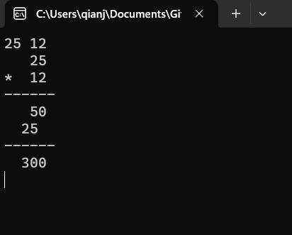

2.

#define _CRT_SECURE_NO_WARNINGS 1

#include<stdio.h>

#define INF 1e200

void main(){

double seg[7]={36000,144000,300000,420000,660000,960000,INF};

double rate[7]={3,10,20,25,30,35,45};

double qk_dec[7]={0,2520,16920,31920,52920,85920,181920};

double inpt;

double ans;

int i;

scanf("%lf",&inpt);

inpt-=60000;

if(inpt<=0) ans=0;

else{

for(i=0;i<7;i++){

if(inpt<=seg[i]){

ans=inpt*rate[i]/100-qk_dec[i];

break;

}

}

}

printf("%.2lf\n",ans);

getchar();getchar();

}

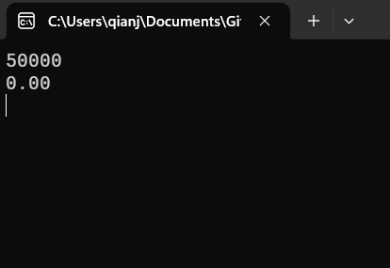

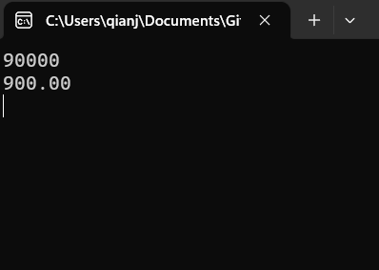

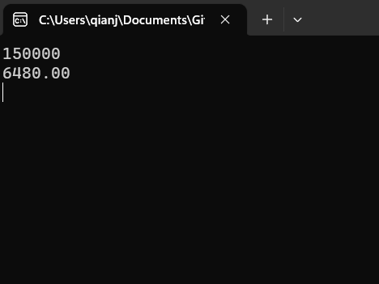

3.

#define _CRT_SECURE_NO_WARNINGS 1

#include<stdio.h>

#include<string.h>

void main(){

int num1,num2;

char op;

scanf("%d%c%d",&num1,&op,&num2);

switch (op)

{

case '+':

printf("%d\n",num1+num2);

break;

case '-':

printf("%d\n",num1-num2);

break;

case '*':

printf("%d\n",num1*num2);

break;

case '/':

if(num2==0) puts("整数2不能为0！");

else printf("%d\n",num1/num2);

break;

case '%':

if(num2==0) puts("整数2不能为0！");

else printf("%d\n",num1%num2);

break;

default:

puts("运算符输入错误！");

}

getchar();getchar();

}

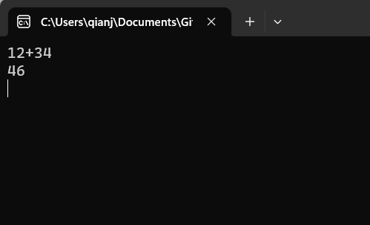

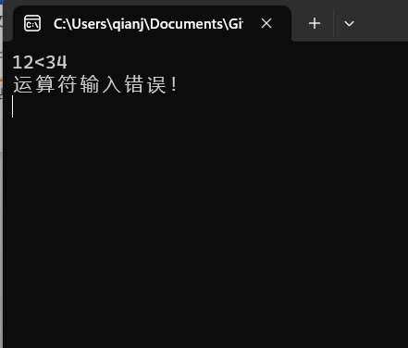

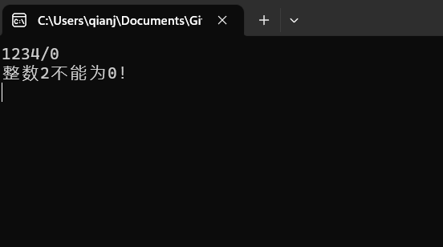

4.

#define _CRT_SECURE_NO_WARNINGS 1

#include<stdio.h>

void main(){

int ssd[13]={0,31,28,31,30,31,30,31,31,30,31,30,31};

int i;

int yy,mm,dd;

int ans;

scanf("%d%d%d",&yy,&mm,&dd);

ans=dd;

if(yy%4==0&&yy%100!=0) ++ssd[2];

if(yy%400==0) ++ssd[2];

for(i=0;i<mm;i++) ans+=ssd[i];

printf("%d\n",ans);

getchar();getchar();

}

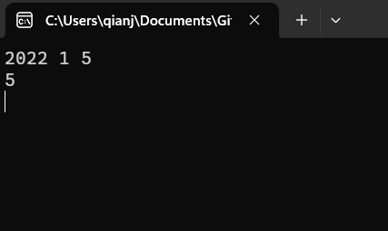

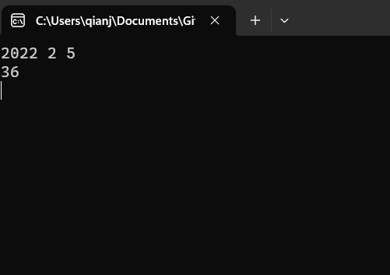

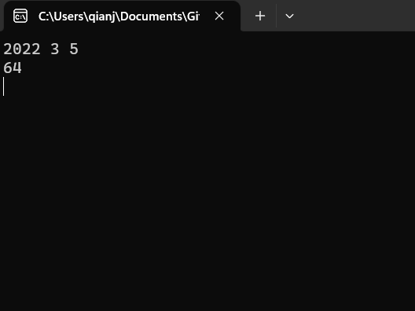

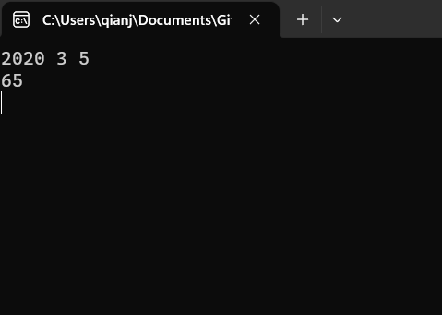

5.

#define _CRT_SECURE_NO_WARNINGS 1

#include<stdio.h>

void main(){

int ntp[505]={0};

int ilm=30,nlm=500;

int i=0,j=0;

int n,m;

int ans=0,cnt=0;

ntp[1]=1;ntp[2]=0;

for(i=2;i<ilm;i++){

if(!ntp[i]){

for(j=i;i*j<=nlm;j++) ntp[i*j]=1;

}

}

scanf("%d %d",&n,&m);

if(n>m){

i=n;

n=m;

m=i;

}

for(i=n+1;i<m;i++) if(!ntp[i]) ans+=i,++cnt;

printf("%d %d\n",cnt,ans);

getchar();getchar();

}

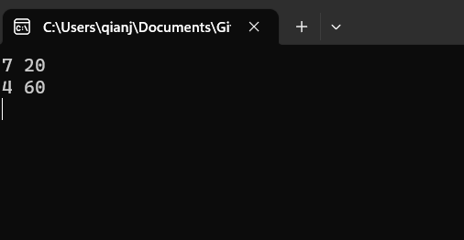 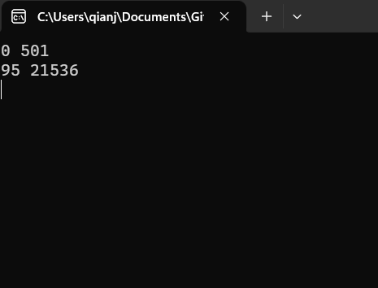

6.

#define _CRT_SECURE_NO_WARNINGS 1

#include<stdio.h>

void main(){

int n,i,j;

scanf("%d",&n);

for(i=0;i<n;i++){

for(j=1;j<n-i;j++) putchar(' ');

for(j=0;j<i;j++) printf("%d ",i+1);

printf("%d\n",i+1);

}

getchar();getchar();

}

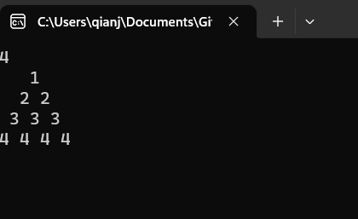

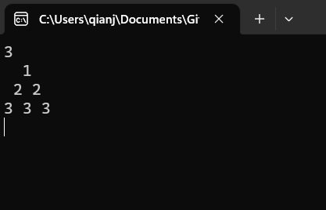

7.

#define _CRT_SECURE_NO_WARNINGS 1

#include<stdio.h>

void main(){

int ssd[13]={0,31,28,31,30,31,30,31,31,30,31,30,31};

int repeat,mm,dc;

scanf("%d",&repeat);

while(repeat--){

scanf("%d %d",&mm,&dc);

if(dc<=160){

printf("%d\n",dc*5);

}else if(dc<=160+ssd[mm]*6){

printf("%d\n",160*5+(dc-160)*9);

}else printf("%d\n",160*5+ssd[mm]*6*9);

}

getchar();getchar();

}

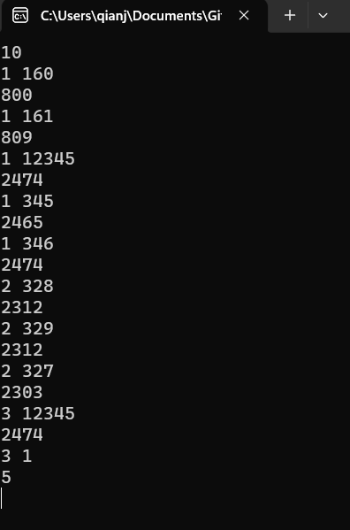

8.

#define _CRT_SECURE_NO_WARNINGS 1

#include<stdio.h>

#define ll long long

ll gcd(ll x,ll y){

ll tmp;

if(x<y){tmp=x;x=y;y=tmp;}

while(y){

x%=y;

tmp=x;x=y;y=tmp;

}

return x;

}

void main(){

ll n,m,k;

ll nx,mx,nmx;

scanf("%lld%lld%lld",&n,&m,&k);

++n;++m;

nmx=k/(n*m/gcd(n,m));

nx=k/n-nmx;

mx=k/m-nmx;

printf("%lld %lld %lld %lld\n",k-mx-nx-nmx,nmx,mx,nx);

getchar();getchar();

}

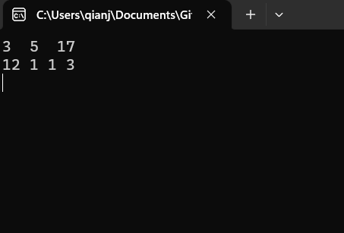

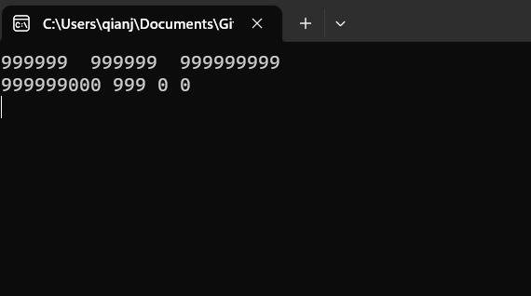

9.

#define _CRT_SECURE_NO_WARNINGS 1

#include<stdio.h>

int ocp[6];

void dfs(int x,int now){

int nxt;

if(x==5){

printf("%d\n",now);

return;

}

for(nxt=1;nxt<=5;nxt++){

if(!ocp[nxt]){

ocp[nxt]=1;

dfs(x+1,now*10+nxt);

ocp[nxt]=0;

}

}

}

void main(){

//freopen("out.txt","w",stdout);

printf("%d\n",5*4*3*2);

dfs(1,0);

getchar();getchar();

}

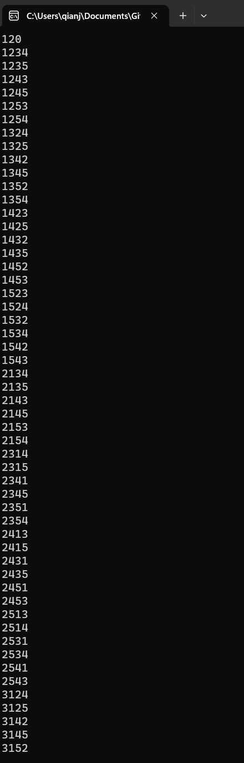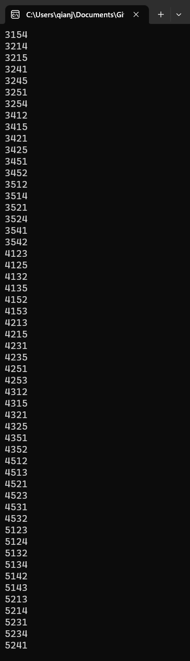

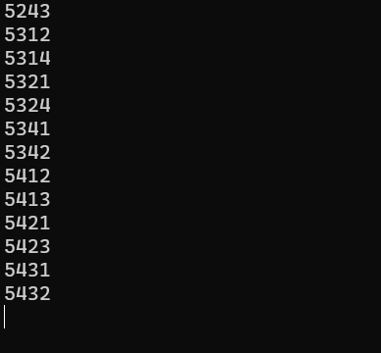

10.

#define _CRT_SECURE_NO_WARNINGS 1

#include<stdio.h>

void main(){

int cur;

for(cur=0;cur<(1<<5);cur++){

if(!((cur&1)+((cur>>1)&1))) continue;

if(((cur&1)+((cur>>3)&1)+((cur>>4)&1))<2) continue;

if((cur&1)&((cur>>2)&1)) continue;

if(((cur>>2)&1)^((cur>>3)&1)){

printf("the result is a=%d,b=%d,c=%d,d=%d,e=%d\n",cur&1,(cur>>1)&1,(cur>>2)&1,(cur>>3)&1,(cur>>4)&1);

}

}

getchar();getchar();

}

