My first Braitenberg vehicle maps the right sensor positively to the left motor and the left sensor positively to the right motor. This causes the robot to turn follow the light and move closer to it because the motor with the darker sensor is turning faster.

My second Braitenberg vehicle maps the right sensor positively to the right motor and the left sensor positively to the left motor. This causes the robot to turn away from the light and keep moving forward.

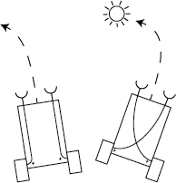

*Behaviors of vehicles 1 (right) and 2 (left).*

My third Braitenberg vehicle maps the right sensor negatively to the right motor and the left sensor negatively to the left motor. This causes the robot to turn towards the light and come to a stop facing it. I had a bit of trouble with this one because my light source wasn't big enough to fully stop the robot at times, but after tweaking some values I finally got some reasonable behavior.

My fourth Braitenberg vehicle maps the right sensor negatively to the right motor and the left sensor negatively to the left motor. This causes the robot to turn away from the light and come to a stop facing total darkness.

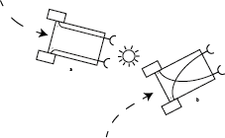

*Behaviors of vehicles 3 (left) and 4 (right).*