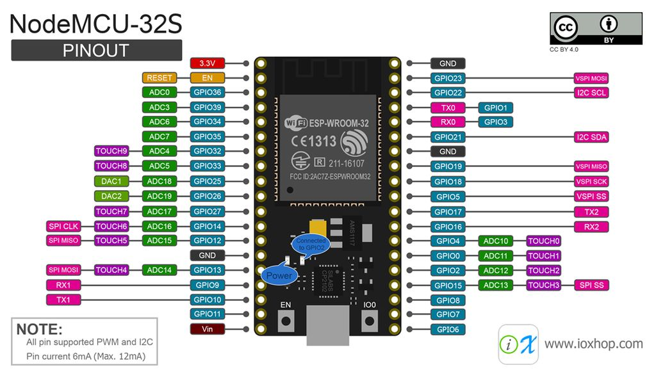

Motors Pins:

|  |  |  |  |  |  |  |  |
| --- | --- | --- | --- | --- | --- | --- | --- |
| 1 | 2 | 3 | 4 | 5 | 6 | 7 | 8 |
| GPIO 12 | GPIO 14 | GPIO 27 | GPIO 26 | GPIO 25 | GPIO 33 | GPIO 32 | GPIO 4 |

**Cam servo pin** – GPIO 10

**Leds Port** – GPIO 23

**Baro I2c pins:**

GPIO 22 (scl) - green

GPIO 21 (Sda) - yellow

GND(by gpio21) - blue

3.3V – red

**power sensing**

GPIO 36 (ADC-0) – system voltage

GPIO 39 (ADC-3) – system current

**Ftdi (PC-esp comm):**

Vin (5v from pc)

GPIO 17 – tx

GPIO 16 – rx

GND