ASP.NET Blog System

A (very) simple blog system created with ASP.NET MVC Framework

Created by:

Spas Kalinov, F74435

# Technical Documentation

## Project Specifications

* ASP.NET MVC Application
* MS SQL Server Database
* User Roles – User, Author and Administrator

## Primary Features

* Home Page (Last 4 posts) – shows excerpts from the last 4 blog posts;
* Posts Page - shows all published blog posts.
* User Registration – email, full name, password, confirm password requirements;
* User Login – email and password;
* Admin Panel - change password.

## Additional Features

### Post Model

* **Index** - a list containing information about all published posts with links for details, editing and deletion;
* **Details** - Title, Author, Full Body, and Publishing Date of the selected post;
* **Create** - a form for creating a new post with fields for Title and Body;
* **Edit** - a form for editing the Title and Body of the selected post;
* **Delete** - a confirmation form for deleting the selected post.

### Roles

* User (default - no role);
* Author;
* Administrator.

### Authentication

* Logged out users can only visit the main page, the posts list and details, as well as the Login/Register pages;
* Users can also visit the main page, the posts list and details, as well as the admin panel where they can change their password, and the Logout page;
* Authors can visit all of the above, as well as the Create Post page, and the Edit and Delete pages for their own posts;
* Administrators can visit all of the above, as well as the Edit and Delete pages for all published posts.

### Helper Classes

* **TextUtils** – a helper class, containing the **TextExcerpt** method, which accepts a string parameter and returns a cut version of it with given length.

# User Guide

Upon entering the main page of the blog system, you will be greeted with the following screen:

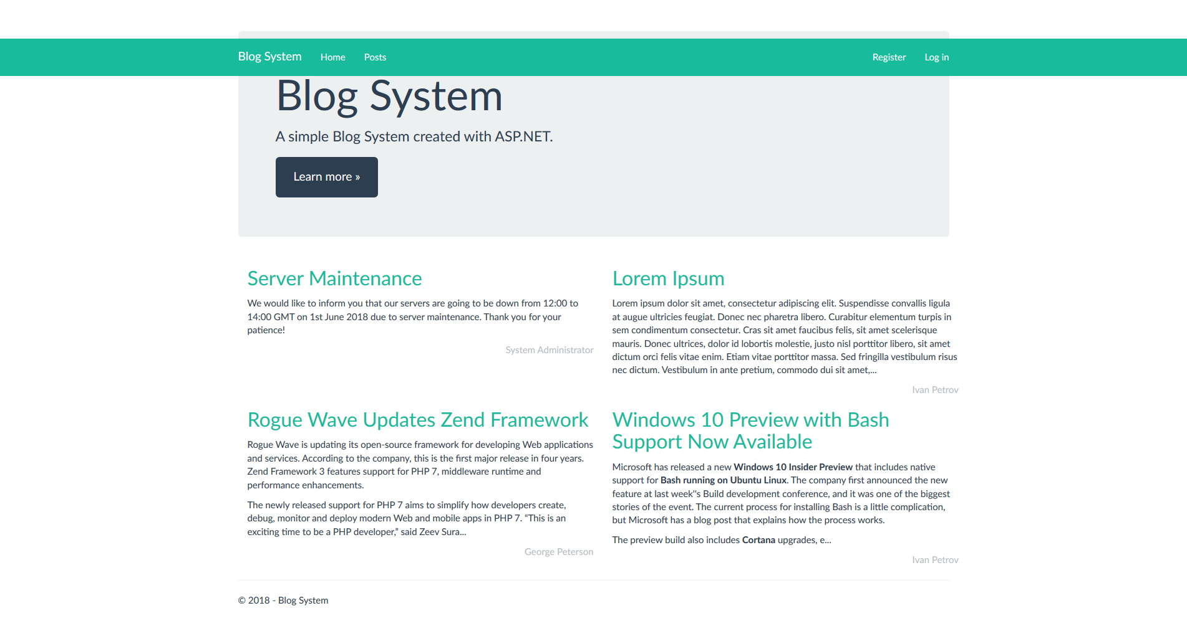

Here you have a few options:

* You can read excerpts of the latest posts or click on their title to read the whole publication.
* You can click on the **Register** button in order to create an account.
* If you already have an account, you can click on the **Log In** button in order to sign into the system.
* You can click on the **Posts** button to see a list of all the published blog posts ordered chronologically.

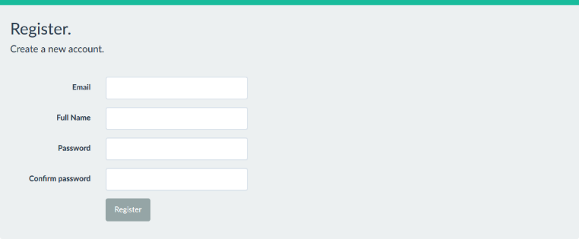If you decide to register, you will see the following form:

Here you have to enter your email address, your full name and your desired password (twice), and then click on the Register button to create your account.

If you decide to sign in, you will see the following form:

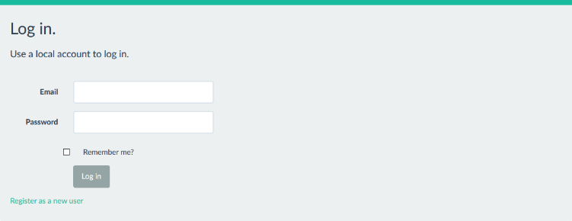Here you have to enter your email address and your chosen password in order to sign into the system.

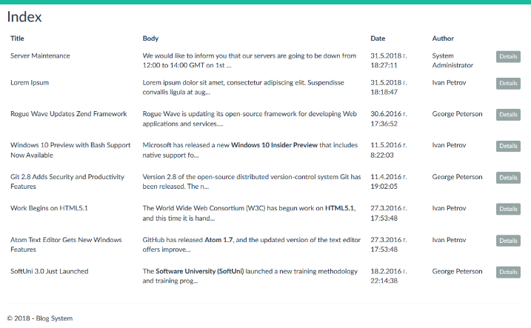If you click on the **Posts** button, you will see a similar table:

The published posts are ordered chronologically. If you want to read a certain post, you can click on the **Details** button, and you will see a page, similar to the next image. If you are an Admin or an Author, you will see two more buttons – **Edit** and **Delete**, depending on your rights. We will talk more about them a little bit later.

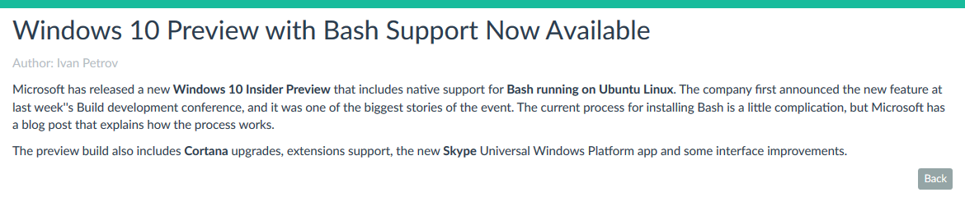Here you see the full post with its title, author and body. If you click the **Back** button, you will be redirected to the **Posts** page.

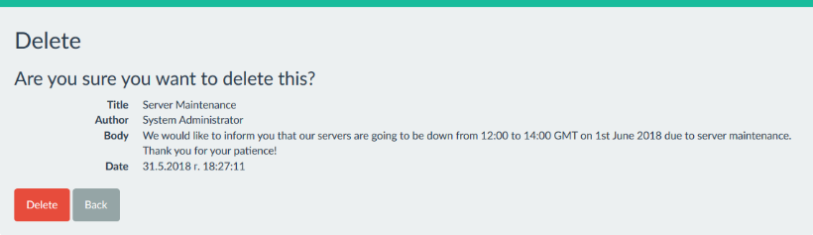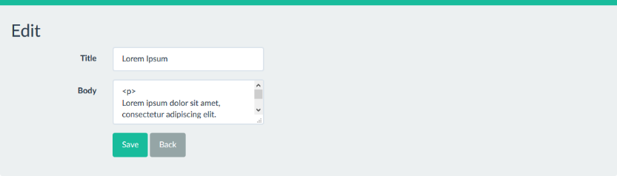If you are an Admin or the Author of this post, you will see two more buttons – **Edit** and **Delete**. If you click the Edit button, you can edit the post’s title or body. If you choose to delete the post, you will see a confirmation form, asking if you are sure about your decision. Both forms are visible below:

The Edit and Delete buttons you see on the Posts page (provided you are an Author or an Admin), lead you to the exact same two forms shown above.

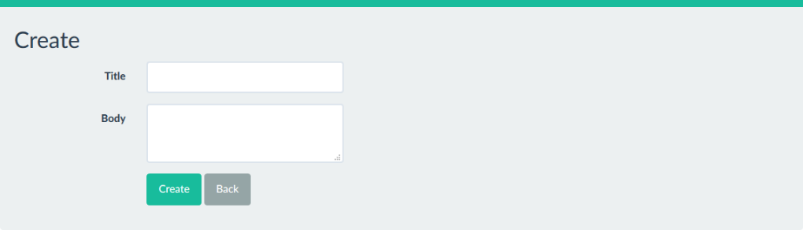If you are an **Author** or an **Admin**, you will also see a **Create New** button on the **Posts** page, which will let you write a new blog post. If you click on it, you will see the following form:

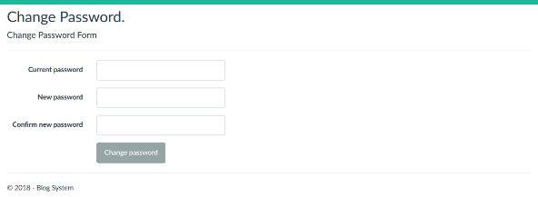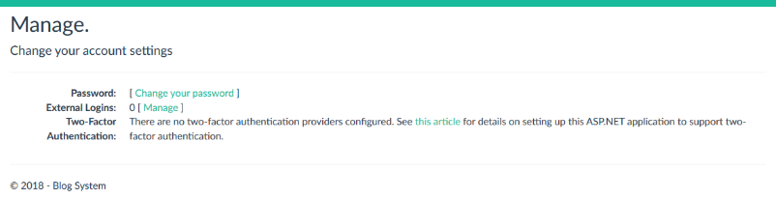If you click on your email addres in the upper right corner, you will see a page with information about your account and a button opening a form where you can change your password:

If you click the **Log off** button, you will be signed off from your account.

# Database

Below you can see a schematic of the database:



To sum it up, there are two roles – **Admin** and **Author**. If the **User** has no role (NULL), then he is a simple default User. Every **Post** has an **Author** (a User). These are the relationships between the different models in the project.

# External Components

The only external component used in this project is a customized Bootstrap that offers some changed buttons and default colors of the main panels.