
OpenSpatialDelay
v1.0 User Manual
Spatial Delay Effect for 3D Audio Production
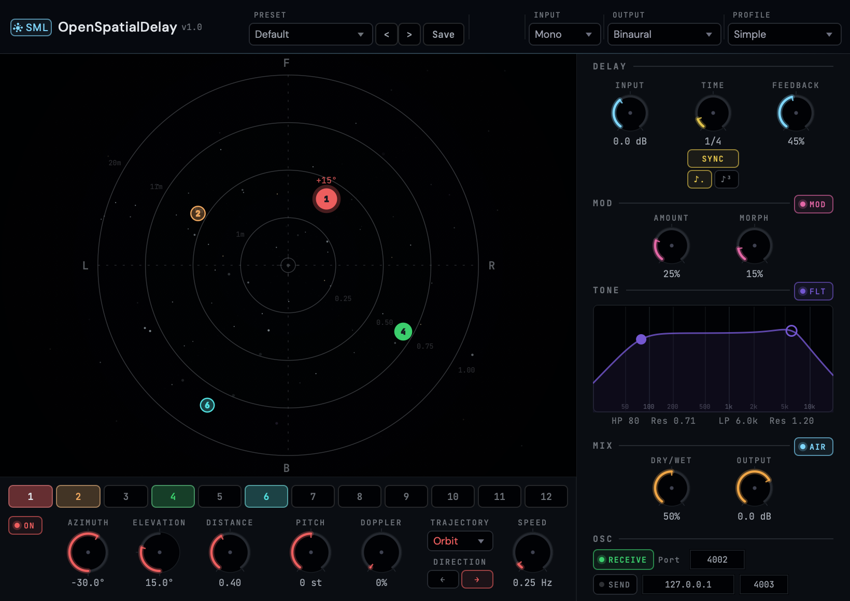

Part of the Spatial Media Library Suite
spatialmedialab.org | 2026

Contents
1 Quick Start
1.1 Installation
1.2 Load in Your DAW
1.3 Interface Overview
1.4 Signal Flow
1.5 Format Quick Pick
2 What is OpenSpatialDelay?
2.1 What Makes It Unique
3 The Spatial Map
3.1 Coordinate System
3.2 Interaction
3.3 Elevation Visualization
4 Output Formats & Algorithms
4.1 Five Rendering Paths
4.2 Binaural & Stereo Formats
4.2.1 Binaural (2 channels)
4.2.2 Stereo (2 channels, 5 modes)
4.3 Surround Formats
4.4 Ambisonics Formats
4.5 Spatialization Algorithms
4.6 HRTF Profiles
5 Controls Reference
5.1 Header Bar
5.2 DELAY Section
5.3 MOD Section
5.4 TONE Section
5.5 MIX Section
5.6 OSC Section
5.7 Per-Tap Controls
6 Trajectories & Animation
7 Creative Tips
8 Presets
8.1 Preset File Locations
8.2 Saving Presets
9 ADM-OSC Integration
9.1 Receive (Incoming Control)
9.2 Send (Broadcast Positions)
10 Troubleshooting

1 Quick Start
This page gets you from installation to first sound in under two minutes. For detailed explanations, see the sections that follow.

1.1 Installation
Download the latest release for your platform from the GitHub Releases page.
macOS: Run the .pkg installer. It places the AU and VST3 plugins in ~/Library/Audio/Plug-Ins/ automatically.
Windows: Run the .exe installer. The VST3 is installed to C:\Program Files\Common Files\VST3\.

1.2 Load in Your DAW
Insert OpenSpatialDelay as an effect (insert/send) on any audio or bus track. For binaural (headphone) output, use a stereo track. For surround formats, match the track channel count to your target format.

1.3 Interface Overview
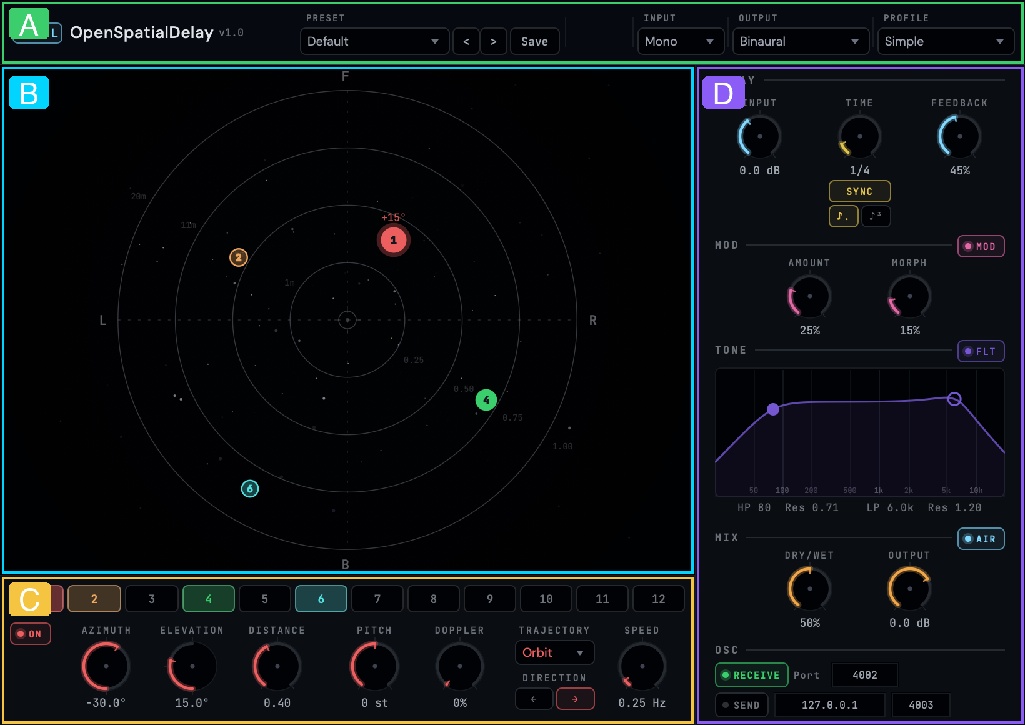

The interface has four regions:
A) Header Bar (top) — presets, output format, and algorithm selection.
B) Spatial Map (left) — top-down view of 3D space where you position delay taps.
C) Bottom Panel (bottom-left) — per-tap controls for the selected object.
D) Right Panel (right) — global controls for delay, tone, modulation, and mix.

1.4 Signal Flow
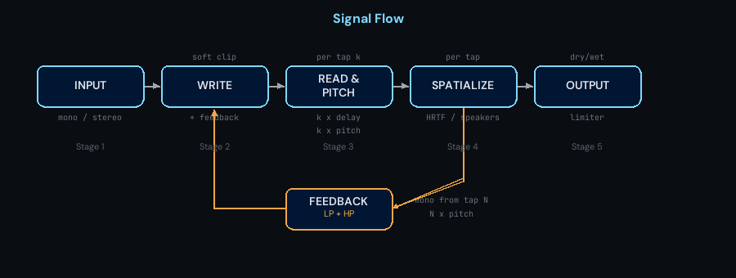
Audio flows through five stages: Input is mixed with feedback and written to the delay buffer. Each enabled tap reads from the buffer at its sequential position and applies pitch shifting. Each tap is then spatialized to its 3D position. The feedback loop reads mono from the end of the tap chain, filtering and soft-clipping before feeding back. Finally, dry and wet signals are mixed at the output. See Controls Reference for parameter details.

1.5 Format Quick Pick
Choose your output format based on your workflow:
Goal | Output Format | Algorithm / Profile
Headphone mixing | Binaural | Select HRTF profile (try Studio Reference)
Stereo monitoring | Stereo | Choose mic mode (Equal Power, XY, MS, etc.)
Dolby Atmos (7.1.4) | 7.1.4 Atmos | VBAP or MDAP
Ambisonics pipeline | FOA through 6OA | Ambisonics Encode (automatic)
Standard surround | 5.1 / 7.1 | VBAP (focused) or DBAP (diffuse)

2 What is OpenSpatialDelay?
OpenSpatialDelay is a spatial delay effect where each delay tap is positioned in 3D space. Think of a classic stereo ping-pong delay — but instead of bouncing between left and right, the echoes travel through up to 12 spatial positions around the listener.
Each tap reads from a shared delay line at sequential intervals: Tap 1 plays at 1× the delay time, Tap 2 at 2×, and so on. Every tap has its own position (azimuth, elevation, distance), trajectory animation, pitch shift, and Doppler amount.
The output is rendered through one of five rendering paths: direct binaural HRTF convolution for headphones, stereo mic simulation, discrete surround speaker panning, or Ambisonics spherical harmonics encoding. See Output Formats & Algorithms for full details.

Key Terminology
Azimuth: Horizontal angle around the listener. 0° = directly in front, +90° = left, −90° = right, ±180° = behind.
Elevation: Vertical angle. 0° = ear level (horizon), +90° = directly above, −90° = directly below.
Distance: How far the sound source is from the listener (0.1 = very close, 3.0 = far away). Affects volume attenuation and air absorption.
HRTF: Head-Related Transfer Function — measurements of how sound changes as it travels around your head and ears. Used to create convincing 3D audio over headphones.
Binaural: Audio rendered for headphone listening, using HRTF processing to simulate 3D positioning.
Surround: Audio rendered to discrete speaker channels (5.1, 7.1.4 Atmos, etc.).
Ambisonics: A format for encoding 3D audio as spherical harmonics. Flexible — can be decoded to any speaker layout later.

2.1 What Makes It Unique
12 independent spatial taps — each positioned anywhere in 3D space, with its own trajectory animation, pitch shift, Doppler amount, and input channel selection.
22 output formats — from binaural headphones to 9.1.6 Dolby Atmos, SpatialMediaLab 13.1, and 6th-order Ambisonics.
7 spatialization algorithms — VBAP, VBIP, MDAP, KNN, DBAP, Ambisonics, and direct binaural HRTF convolution with 6 measured profiles.
Open source — part of the Spatial Media Library suite. Free to use and modify.

3 The Spatial Map
The spatial map is the large visualization on the left side of the plugin window. It shows a top-down view of 3D space with the listener at the center. Each colored dot represents a delay tap positioned in space.
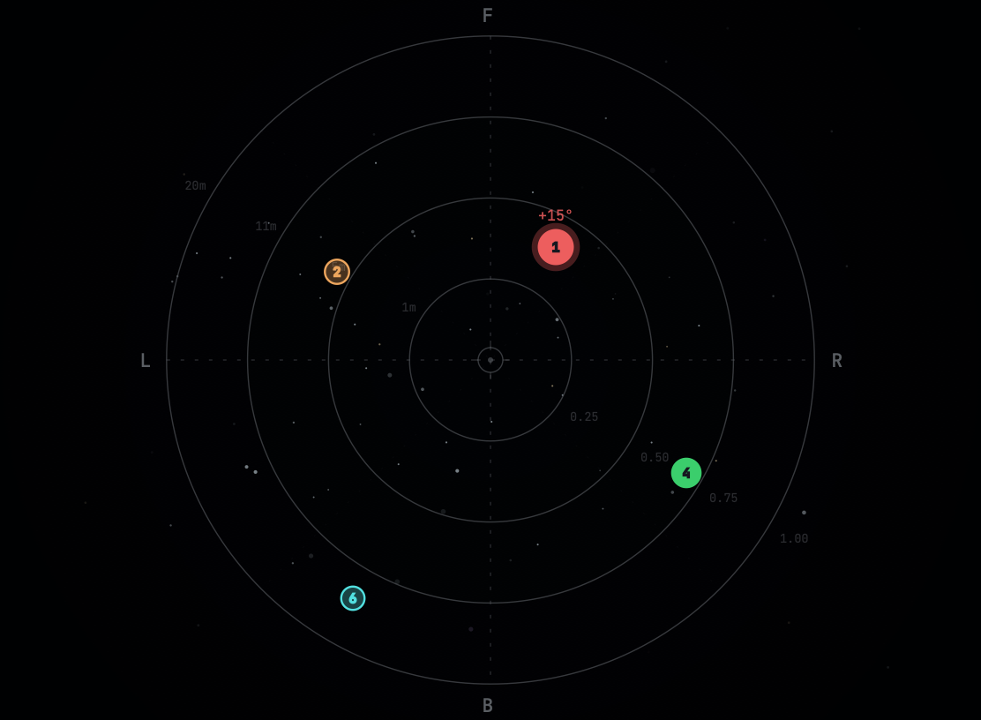

3.1 Coordinate System
The map uses a polar coordinate system. The listener sits at the center. Front is at the top of the map (marked F). Concentric rings represent distance from the listener.
Direction | Azimuth | Position on Map
Front | 0° | Top
Left | +90° | Left
Rear | ±180° | Bottom
Right | −90° | Right

Note: The azimuth knob uses reverse rotation — turning the knob clockwise moves the tap clockwise on the map. This follows the IEM StereoEncoder convention used in professional spatial audio tools.

3.2 Interaction
Click on a tap dot to select it. The selected tap is highlighted with a glowing ring, and the bottom panel updates to show that tap's controls.
Click and drag a tap to move it in azimuth (rotation) and distance (radial position) simultaneously.
Elevation is controlled via the ELEV knob in the bottom panel, not by map interaction.

3.3 Elevation Visualization
Although the map is 2D (top-down), elevation is communicated visually through the dot appearance:
Upper hemisphere (elevation > 0°): Tap dots are solid and opaque, slightly larger (+5px). These represent sounds above ear level.
Lower hemisphere (elevation < 0°): Tap dots become transparent (30% opacity) and slightly smaller (−3px). Minimum dot size is 11px at −90°.
At 0° elevation (ear level), dots are at their default size and full opacity.

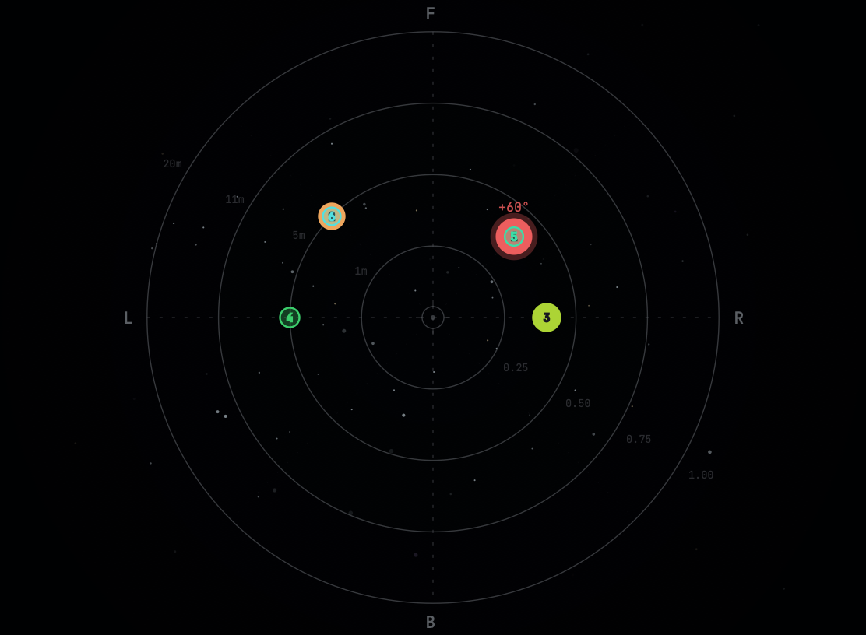

4 Output Formats & Algorithms
OpenSpatialDelay supports 22 output formats organized into four categories. The plugin automatically selects the correct rendering path based on the format you choose in the header dropdown.

4.1 Five Rendering Paths
The plugin dispatches audio through one of five peer rendering paths based on the selected output format:
Rendering Path | When Used | Output
Direct Binaural HRTF | Binaural format + SOFA profile | 2 ch (L/R)
Simple Binaural (Woodworth) | Binaural + Simple profile selected | 2 ch (L/R)
Stereo Variants | Stereo format | 2 ch (L/R)
Ambisonics Output | Any Ambisonics format (FOA–6OA) | 4–49 ch
Discrete Surround | Any surround format (Quad–9.1.6) | 4–16 ch

4.2 Binaural & Stereo Formats

4.2.1 Binaural (2 channels)
The default format. Each tap's 3D position is rendered through per-source HRTF convolution — a separate convolver for each active tap, using measured head-related transfer functions from SOFA files (Spatially Oriented Format for Acoustics). This produces highly realistic 3D audio over headphones. Select a profile from the HRTF Profile dropdown (see HRTF Profiles).

4.2.2 Stereo (2 channels, 5 modes)
When Stereo is selected, the Algorithm dropdown switches to offer five microphone simulation modes:
Mode | Description
Equal Power Pan | Standard cosine/sine pan law from azimuth angle
VBAP (2-speaker) | Virtual speakers at ±30°, VBAP gain computation
XY Pair | Coincident cardioid microphones at ±45°
MS (Mid-Side) | Mid = cos(azimuth), Side = sin(azimuth)
Blumlein | Crossed figure-8 microphones at ±45°

4.3 Surround Formats
14 discrete surround formats, from Quadraphonic to 9.1.6 Atmos and SpatialMediaLab 13.1. Formats with an LFE channel (marked with .1) derive it as a mono sum of all tap outputs through a 120 Hz low-pass filter at −10 dB. Choose a spatialization algorithm from the Algorithm dropdown.
Format | Channels | LFE | Height Speakers
Quadraphonic | 4 | No | None
5.0 Surround | 5 | No | None
5.1 Surround | 6 | Yes | None
7.0 Surround | 7 | No | None
7.1 Surround | 8 | Yes | None
Octaphonic | 8 | No | None (ring at 45° intervals)
5.1.2 | 8 | Yes | 2 top
7.0.2 | 9 | No | 2 top
7.1.2 Atmos | 10 | Yes | 2 top
5.1.4 Atmos | 10 | Yes | 4 top
7.1.4 Atmos | 12 | Yes | 4 top
7.1.6 Atmos | 14 | Yes | 6 top
9.1.6 Atmos | 16 | Yes | 6 top + wide speakers
SpatialMediaLab 13.1 | 14 | Yes | 8 ear-level + 4 height + 1 zenith

4.4 Ambisonics Formats
Six Ambisonics orders using ACN/SN3D (AmbiX) channel ordering. Decoded to speakers by your DAW or external renderer.
Format | Order | Channels
FOA (1st Order) | 1 | 4
SOA (2nd Order) | 2 | 9
HOA (3rd Order) | 3 | 16
4OA (4th Order) | 4 | 25
5OA (5th Order) | 5 | 36
6OA (6th Order) | 6 | 49

4.5 Spatialization Algorithms
When using surround output formats, the Algorithm dropdown lets you choose how tap positions are translated to speaker gains:
Algorithm | Best For | Character
VBAP | Precise point sources, production mixing | Focused, sharp localization
VBIP | Off-axis listener stability | VBAP with intensity weighting, smoother
MDAP | Wide, stable spatial images | VBAP + 8 spread sub-sources around main position
KNN | Irregular or curved speaker arrays | 3 nearest speakers, distance-weighted, natural
DBAP | Non-standard speaker layouts | Distance-based, warm and diffuse
Ambisonics | Ambisonics workflows, high-order setups | SH encode/decode, smooth panning

Which algorithm should I use?
For most surround work, start with VBAP — it produces the most focused spatial images and is the industry standard for object-based audio.
For wider, more stable sources, try MDAP. For non-standard or irregular speaker arrangements, use DBAP.
The algorithm dropdown only appears for surround and Ambisonics formats. For binaural output, HRTF convolution handles spatialization directly.

4.6 HRTF Profiles
When Binaural output is selected, the HRTF Profile dropdown offers six options. Each profile uses different measured head-related transfer functions, producing a subtly different spatial sound:
Profile | Source | Character | CPU
Simple (Low CPU) | Woodworth head model | No convolution — ITD+ILD only, lowest latency | Minimal
Studio Reference | MIT KEMAR Large Pinna | Neutral, classic reference standard | Normal
Immersive | SADIE II D2 KU100 | Rich spatial detail, strong elevation cues | Normal
Natural | CIPIC Subject 003 | Organic, realistic binaural rendering | Normal
Precise | HUTUBS PP2 | Detailed, analytical spatial accuracy | Normal
Spatial | Bernschuetz KU100 | Dense full-sphere measurement, widest coverage | Normal

Choosing a profile
Start with Studio Reference for mixing. Switch to Simple if you need lower CPU usage.
Different profiles suit different head shapes. Try each to find the one that sounds most natural to you — what works best is personal.

5 Controls Reference

5.1 Header Bar

The header bar contains: plugin title and version (left), preset navigation (dropdown, prev/next arrows, save button), OSC toggle (ADM-OSC receive on/off), Output Format dropdown, and either Algorithm (surround) or HRTF Profile (binaural) dropdown, which swap automatically based on the selected format.

5.2 DELAY Section
Controls the core delay timing and feedback. Accent color: cyan.
Parameter | Range | Default | Description
TIME | 1–2000 ms | 500 ms | Base delay time. Tap k reads at k × TIME.
SYNC | On / Off | Off | Locks delay time to DAW tempo
NOTE | 1/32 – 2/1 | 1/4 | Note division (when SYNC is on)
MODE | Notes, Dotted, Triplet | Notes | Sync modifier (when SYNC is on)
FEEDBACK | 0–100% | 30% | Amount of delay output fed back to input

5.3 MOD Section
Delay-time LFO modulation (wobble). Accent color: rose.
Parameter | Range | Default | Description
MOD toggle | On / Off | Off | Enable wobble modulation
AMOUNT | 0–100% | 0% | LFO modulation depth (milliseconds)
MORPH | 0–100% | 0% | Waveform shape: sine → triangle → square

5.4 TONE Section
Feedback path filters and air absorption. Accent color: violet. Filters apply to the feedback path only — the first echo is always unfiltered.
Parameter | Range | Default | Description
FLT toggle | On / Off | Off | Enable feedback path filters
HP | 20–5000 Hz | 50 Hz | High-pass cutoff frequency
LP | 200–20000 Hz | 5000 Hz | Low-pass cutoff frequency
HP RES | 0.1–8.0 | 0.71 | High-pass filter resonance (Q)
LP RES | 0.1–8.0 | 0.71 | Low-pass filter resonance (Q)
AIR toggle | On / Off | Off | Distance-based HF rolloff per tap

5.5 MIX Section
Output mixing and gain staging. Accent color: amber.
Parameter | Range | Default | Description
DRY/WET | 0–100% | 50% | Blend between dry input and processed output
IN | −96 to +24 dB | 0 dB | Input gain (wet path only, not dry signal)
OUT | −96 to +24 dB | 0 dB | Output gain (applied to both dry and wet)

5.6 OSC Section
ADM-OSC receive and send controls. Accent color: green. See ADM-OSC for protocol details.
Parameter | Default | Description
RECV toggle | Off | Enable ADM-OSC receive (incoming position control)
Port | 4002 | UDP port for incoming OSC messages
SEND toggle | Off | Enable ADM-OSC send (broadcast positions)
IP | 127.0.0.1 | Target IP for OSC send
Send Port | 4003 | Target port for OSC send

5.7 Per-Tap Controls (Bottom Panel)
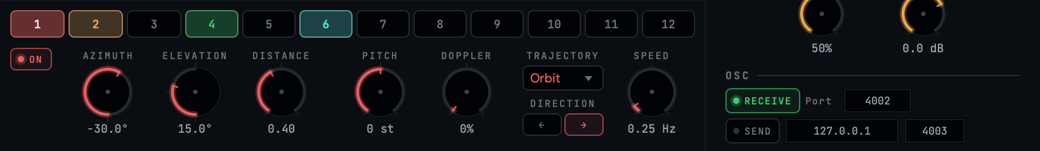

Select a tap by clicking its numbered button (1–12). The controls below update to show that tap's settings:
Parameter | Range | Default | Description
ON/OFF | Toggle | Taps 1–4: On | Enable/disable this tap
AZIMUTH | −180 to +180° | Varies | Horizontal angle (clockwise knob = clockwise map)
ELEV | −90 to +90° | 0° | Vertical angle
DIST | 0.1–3.0 | 0.5 | Distance from listener (affects attenuation)
DOPPLER | 0–100% | 0% | Doppler effect intensity for moving taps
PITCH | −24 to +24 st | 0 st | Per-tap pitch offset (adds to global pitch)
INPUT | L+R / L / R | L+R | Which stereo input channel feeds this tap
TRAJ | 13 shapes | None | Trajectory animation shape
SPEED | 0.00–5.00 Hz | 0.30 Hz | Trajectory animation speed
DIR | Fwd / Rev | Fwd | Trajectory direction (forward or reverse)

6 Trajectories & Animation
Each tap can follow an animated trajectory through 3D space. Select a shape from the TRAJ dropdown in the bottom panel.
Origin-point architecture: The knob values (azimuth, elevation, distance) set the tap's origin point. The trajectory animates around this origin. You can reposition a running trajectory by adjusting the knobs — the animation follows. A crosshair marker on the spatial map shows the origin position.
Shape | Motion | Best For
None | Static position, no animation | Manual placement, static scenes
Bounce | Azimuth and elevation oscillate back and forth | Vertical bouncing motion
Circle | Horizontal orbit at constant elevation and distance | Smooth circular panning
Cross | Alternates between azimuth and elevation axes | X-pattern motion
Figure-8 | Two-tangent-circles pattern in azimuth/elevation | Elegant weaving motion
Heart | Cardioid-shaped path around the origin point | Expressive, organic arcs
Helix | Spiral with rising/falling elevation over time | 3D corkscrew motion
Infinity | Horizontal figure-8 (lemniscate) path | Smooth side-to-side weave
Line | Back-and-forth along a single azimuth axis | Pendulum-like motion
Orbit | Circular path around the listener at constant height | Rotating delays, circular ping-pong
Random | Multi-sine noise on all axes (never repeats) | Organic, unpredictable movement
Spiral | Outward spiral with distance variation | Expanding/contracting patterns
Square | Rectangular path rotated by base azimuth | Angular, geometric motion
Triangle | Triangular path rotated by base azimuth | Sharp directional changes

Speed controls the animation rate (0.00–5.00 Hz). Direction can be Forward or Reverse. Each tap animates independently — mix different shapes and speeds for complex spatial motion.
If ADM-OSC receive is active and an external controller sends position data for a tap, the trajectory pauses for that tap. It automatically resumes 500ms after the last OSC message.

Creative tip
Try setting 4 taps on Orbit at different speeds (0.5×, 1.0×, 1.5×, 2.0×) for a mesmerizing rotating delay pattern. With feedback above 50%, the trails create evolving spatial textures.

7 Creative Tips
OpenSpatialDelay can go far beyond basic delay effects. Here are some techniques to explore:

Self-Oscillation
Set Feedback above 95% to create self-oscillating delay trails that sustain indefinitely. The built-in output limiter (soft saturation at +2 dB) prevents digital clipping.
For analog-style oscillation, enable the TONE filter and set LP to 2–3 kHz. The delay will sing with a warm, filtered tone. Adjust FEEDBACK to control the balance between sustain and decay.

Pitch Spiraling (Shimmer)
Set global PITCH to +12 semitones (+1 octave). Each tap accumulates pitch: tap 1 = +1 octave, tap 2 = +2 octaves, and so on. Each feedback cycle adds another round-trip of pitch.
For subtler shimmer, try +5 or +7 semitones (a fourth or fifth). Combined with high feedback and LP filtering, this creates lush, cathedral-like textures.

Wobble — Tape Effects
Enable MOD and set AMOUNT to 15–25% with MORPH at 0% (sine wave). This creates a subtle tape-like wow and flutter on the delay.
Higher MORPH values (toward 100%) produce more rhythmic, square-wave modulation — useful for choppy, glitchy delay effects.

Stereo Width with Input Routing
On stereo tracks, try setting alternating taps to L and R input channels: Tap 1 = L, Tap 2 = R, Tap 3 = L, and so on.
This creates a natural stereo ping-pong enhanced by spatial positioning. Position L-channel taps on the left side of the spatial map and R-channel taps on the right for maximum width.

Feedback Filter Design
The TONE section filters apply to the feedback path — each time the signal recirculates, it passes through the filters again. Over successive echoes, this creates progressive tonal shaping.
High-pass at 200–400 Hz removes bass buildup in long feedback tails. Low-pass at 3–5 kHz simulates tape machine degradation. Combine both for a focused, telephonic character that opens up beautifully in 3D space.

8 Presets
OpenSpatialDelay includes 60 factory presets across 9 categories: Classic Delays, Spatial Movement, Ambient + Texture, Height + 3D, Surround Production, Wobble + Modulated, Creative + Experimental, Rhythmic, and User.
Browse presets using the dropdown in the header bar. Use the < > arrows to step through presets, or click the preset name to open the full categorized menu.

8.1 Preset File Locations
macOS: ~/Library/Audio/Presets/OpenSpatialDelay/
Windows: %APPDATA%\OpenSpatialDelay\Presets\
Factory presets are written to this directory on first launch. User presets are saved as JSON files in the same location.

8.2 Saving Presets
Click the Save button in the header to open the save overlay. Enter a name and press Return to save, or Escape to cancel.

9 ADM-OSC Integration
OpenSpatialDelay supports ADM-OSC (Audio Definition Model over Open Sound Control), the industry-standard protocol for controlling spatial audio object positions in real time.

9.1 Receive (Incoming Control)
Enable RECV in the OSC section and set the port (default 4002). External tools like SPAT Revolution, L-ISA Controller, or custom scripts can send position data to control tap positions in real time. Supported messages include /adm/obj/N/azim, /adm/obj/N/elev, /adm/obj/N/dist, /adm/obj/N/aed (combined), and /adm/obj/N/xyz (Cartesian, auto-converted to polar).

9.2 Send (Broadcast Positions)
Enable SEND and set the target IP and port (default 127.0.0.1:4003). The plugin broadcasts tap positions as /adm/obj/N/aed messages at 30 Hz, with position-change gating to minimize network traffic. Use this to sync with external spatial renderers.

10 Troubleshooting
Issue | Cause | Solution
No sound output | All taps disabled | Enable at least one tap (click ON button in bottom panel)
Only dry sound, no echoes | Dry/Wet at 0% or format mismatch | Set Dry/Wet above 0%. Ensure track channel count matches selected Output Format.
Binaural doesn't sound 3D | Wrong HRTF profile for your hearing | Try different HRTF profiles. Start with Studio Reference.
Audio crackling/dropouts | Buffer size too small or too many HRTF taps | Increase DAW buffer to 256+ samples. Switch to Simple profile for lower CPU.
Plugin not appearing in DAW | Installation path issue | Verify plugins are in ~/Library/Audio/Plug-Ins/ (macOS). Rescan in DAW.
Delay not syncing to tempo | Tempo Sync is off | Enable the SYNC toggle in the DELAY section
Runaway self-oscillation | Very high feedback + resonant filters | The output limiter prevents clipping, but reduce Feedback or filter resonance if too intense.
OSC not connecting | Port conflict or wrong number | Check that no other app uses the same port. Verify port matches sender/receiver.


OpenSpatialDelay v1.0
Part of the Spatial Media Library Suite
Designed by Andrew Rahman · Architecture by Claude
spatialmedialab.org
github.com/AndrewRahman/OpenSpatialDelay

Open Source · 2026

