

Experimental timestamp data
with entangled photon pairs

Table of Contents
1 Introduction 3
2 Experimental setup 3
3 Data nomenclature 4

Introduction
This document describes timestamp data collected from SpeQtral’s polarization entangled photon pair source. In the following sections, a description of the equipment utilised for the experiment, as well as the conditions under which the experiment took place are described. Additionally, the raw data can be found attached to this document.

Experimental setup
The timestamp data is generated with the experimental setup depicted in Figure 1. First, pairs of polarization-entangled photons are generated via spontaneous parametric downconversion (SPDC) within the entangled photon-pair source. The photon pairs are generated at non-degenerate wavelength (signal: 780 nm, idler: 842 nm) and are separated via their and are accessible for the user via FC/PC fibre ports. The coupling efficiency into the fibre, including all transmission losses is approximately 40%. Multimode fibres (MMF) are used to send the photons towards avalanche photodiodes (APD: Excellitas SPCM-AQRH-FC), which perform the photon detection. The arrival of a photon is registered by a time-to-digital converter (TDC: S-Fifteen TDC), connected to a personal computer (PC), in which the data is stored.

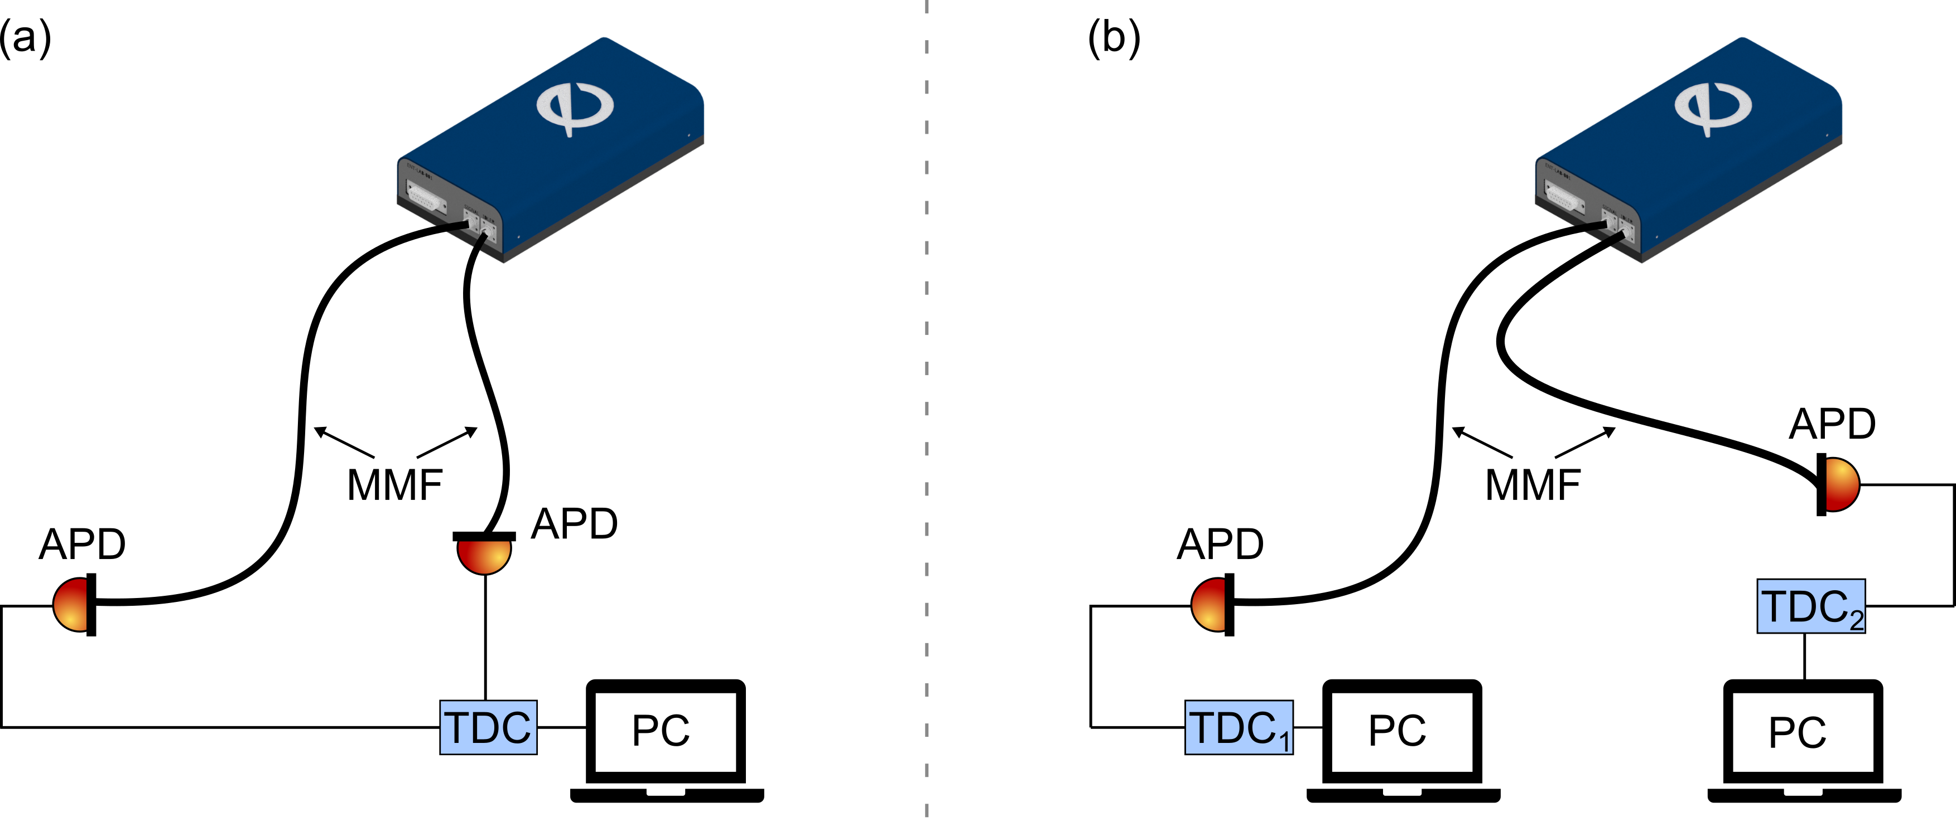
Figure 1. Experimental setup. Blue box: SpeQtral's entangled photon-pair source. MMF: multimode fibre; APD: avalanche photodiode; TDC; time-to-digital converter; PC: personal computer. (a) Configuration 1: both timestamp channels connected to the same TDC with one PC. (b) Configuration 2: individual timestamp channels connected to the different TDCs and different PCs. Following QKD jargon, TDC₁ can be Alice, while TDC₂ can be Bob.

The single photon detection jitter is approximately 350 ps which is not resolvable by the time stamp resolution (2ns). If the detection events from signal and idler photons were tagged using the same time stamping device, their effective time difference can be attributed only to a small offset of the electronic signals, and unresolvable optical delays.
If, on the other hand, two different TDCs were used to simulate the two parties, the offset between signal and idler detection events depends on the synchronization of the two systems (tens of milliseconds). In addition, the S-Fifteen TDC time taggers use non identical reference clocks, with a relative clock drift on the order of 5 microseconds per second. To recover the time correlation of the photon pairs, the clock drift has to be removed.

The source performance was measured before the experiment:
- Coincidence rate: 61,000 entangled photon pairs/second
- Singles rate: 300,000 signal counts/second and 277,000 idler counts/second

Data nomenclature
While the entangled photon source is producing photon pairs in a continuous wave fashion, a script to access the generated timestamps for an arbitrary amount of time (typically few seconds) can be executed. The script was executed under different laboratory conditions, as explained on the below table.

 | Laboratory lights | Delay | Setup configuration | Duration
Value | ON | 0 | 1 | 5 secs
Value | OFF | ~ 1 sec | 2 | 5 secs

The laboratory conditions for each file are contained within the file name:

- testlablightsOff_5secs_sameTD2: laboratory lights off, both channels connected to a single TDC and a single computer.

 | Laboratory lights | Delay | Setup configuration | Duration
Value | OFF | 0 | 1 | 5 secs

- testlab_lightsoff_5sec_2tdc1_1 & testlablightsOff_5secs_differentTDC2-1 (Alice-Bob): laboratory lights off, each channel connected to different TDCs and different computers.

 | Laboratory lights | Delay | Setup configuration | Duration
Value | OFF | 0 | 2 | 5 secs

- testlab_lightsoff_5sec_2tdc1_delay & testlablightsOff_5secs_differentTDC2-delay (Alice-Bob): laboratory lights off, each channel connected to different TDCs and different computers, and with an operator-induced delay (~1 second).

 | Laboratory lights | Delay | Setup configuration | Duration
Value | OFF | ~ 1 sec | 2 | 5 secs

- testlablightsOn_5secs_sameTDC2: laboratory lights off, but laboratory door open to add some background, both channels connected to a single TDC and a single computer.

 | Laboratory lights | Delay | Setup configuration | Duration
Value | ON | 0 | 1 | 5 secs

