
IT342-Section
SYSTEMS INTEGRATION AND ARCHITECTURE 1

FUNCTIONAL REQUIREMENTS SPECIFICATION (FRS)

Project Title: User Registration & Authentication
Prepared By: Ronel Atillo
Date of Submission: 2/8/2026
Version: 3

Table of Contents
1. Introduction 3
1.1. Purpose 3
1.2. Scope 3
1.3. Definitions, Acronyms, and Abbreviations 3
2. Overall Description 3
2.1. System Perspective 3
2.2. User Classes and Characteristics 3
2.3. Operating Environment 3
2.4. Assumptions and Dependencies 3
3. System Features and Functional Requirements 3
3.1. Feature 1: 3
3.2. Feature 2: 3
4. Non-Functional Requirements 3
5. System Models (Diagrams) 4
5.1. ERD 4
5.2. Use Case Diagram 4
5.3. Activity Diagram 4
5.4. Class Diagram 4
5.5. Sequence Diagram 4
6. Appendices 4

Introduction

Purpose
The purpose of the system is to show the requirements for user registration and authentication systems. It is also to show and define to developers and other stakeholders who need a clear process, overview of the system, features, scope, and technical requirements.

Scope
The system allows users to login, register, view their own profile or dashboard, and logout. Just like in my design, the dashboard or profile are being protected, so guest users can’t proceed to such pages when they are not authenticated. So in simple words, the scope is just only authentication and user data management.

Definitions, Acronyms, and Abbreviations
- API - Application Programming Interface
- UI - User Interface
- Auth - Authentication
- JWT - JSON Web Token
- ERD - Entity Relationship Diagram
- DTO - Data Transfer Object

Overall Description

System Perspective
The system is a web app that has React UI, Spring Boot Backend, and a relational database. The UI communicates with the backend through APIs, the backend handles validations, encrypting passwords, storing users in databases, database operations, and token creation.

User Classes and Characteristics
Authenticated User - a logged in user that can access his own dashboard and profile, and can logout.
Guest user - a not logged in user, it can only register and log in.

Operating Environment
Specify the hardware, software, and tools required to operate the system.
Hardware:
- Laptop or desktop computer
- Has a 8gb of ram
- 64gb hard disk
Software:
- Database: MySQL
- Web browser: Chrome
- Frontend runtime: node.js
- Backend runtime: java jdk 21
Backend:
- IDE: VS Code and Intellij
- Database tool: MySQL workbench
- Version control: Git and Github
- Build tool: Gradle

Assumptions and Dependencies
- Emails should be unique
- Passwords are stored in the database as hash passwords, not plain text.
- Token-based authentication is used (JWT)
- Backend and database services must be running and reachable.

System Features and Functional Requirements
Describe each major feature of the system and its functional requirements.

Feature 1: User Registration
Description: It allows users to create an account with their inputted information.
Functional Requirements:
- It has a feature where users can input their email, password, address, and phone number.
- The system will validate the inputted information if there are any invalid inputs such as email without ‘@’ symbol.
- The system also prevents duplicate email addresses during registration.

Feature 2: User login
Description: It allows registered users to log in or authenticate, so that they can access protected pages such as dashboard and profile.
Functional Requirements:
- The system will verify their inputted credentials
- It will then return a token (JWT) as login is successful.
- The system also shows error messages if such credentials are invalid.

Feature 3: Dashboard / Profile
Description: It allows registered users to log in or authenticate, so that they can access protected pages such as dashboard and profile.
Functional Requirements:
- If the user is not authenticated, then the system will restrict the access to the pages.
- The system will display user information after logging in.

Feature 4: Logout
Description: This feature will allow users to end their session.
Functional Requirements:
- The system can invalidate the created or current token.
- The system will redirect the user to the login page.

Non-Functional Requirements
Specify system quality attributes such as performance, security, usability, reliability, etc.
- Performance: Login/Registration responses should complete within 2-3 seconds
- Security: Passwords are hash before storing in the Databases. Protected Pages require login or authentication.
- Usability: UI is simple and clear with error messages.
- Scalability: Must support multiple active users.

System Models (Diagrams)
Insert the necessary diagrams for the system:

ERD
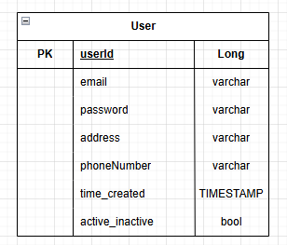

Use Case Diagram
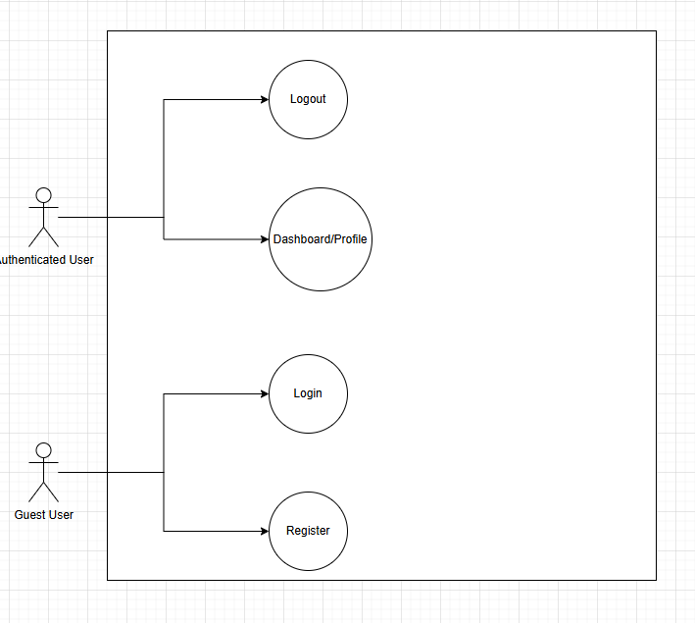

Activity Diagram
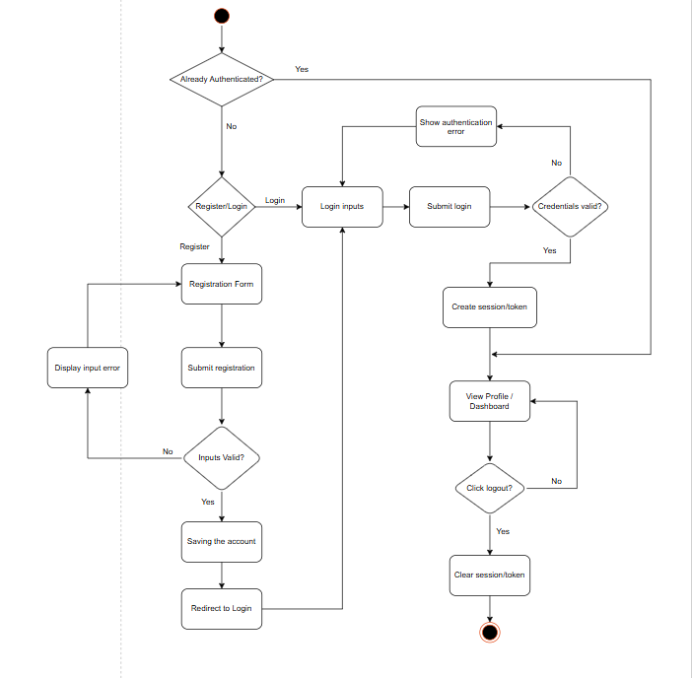

Class Diagram
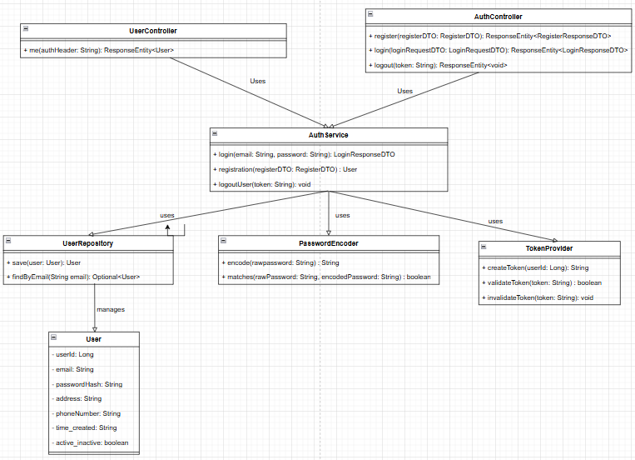

Sequence Diagram
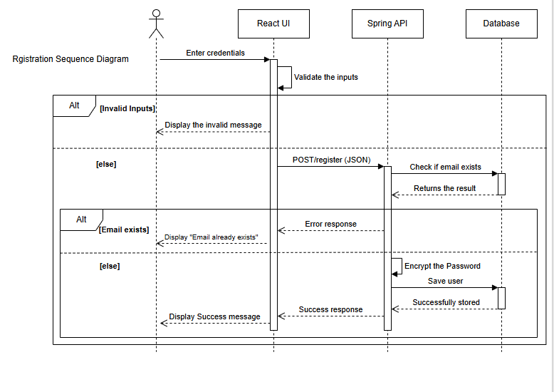
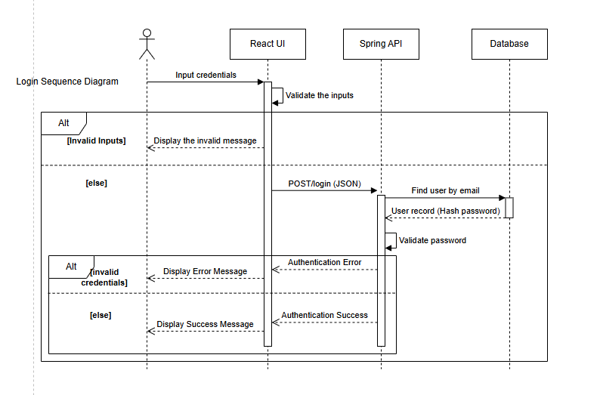
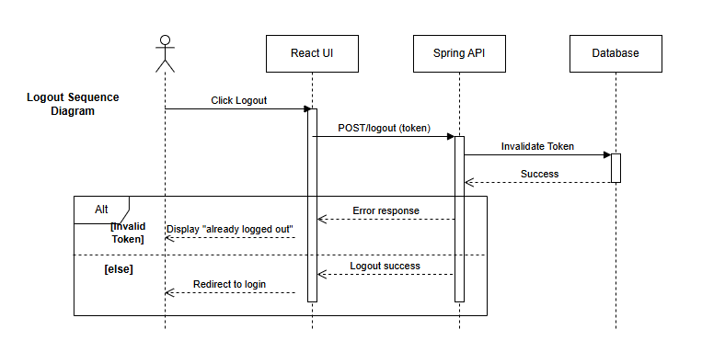

Appendices
Include any additional information, references, or support materials.
- draw.io
- Google.drive
- AI: ChatGPT
- https://www.visual-paradigm.com/guide/uml-unified-modeling-language/what-is-sequence-diagram/
- https://www.perforce.com/blog/alm/what-are-non-functional-requirements-examples
Landing Page:
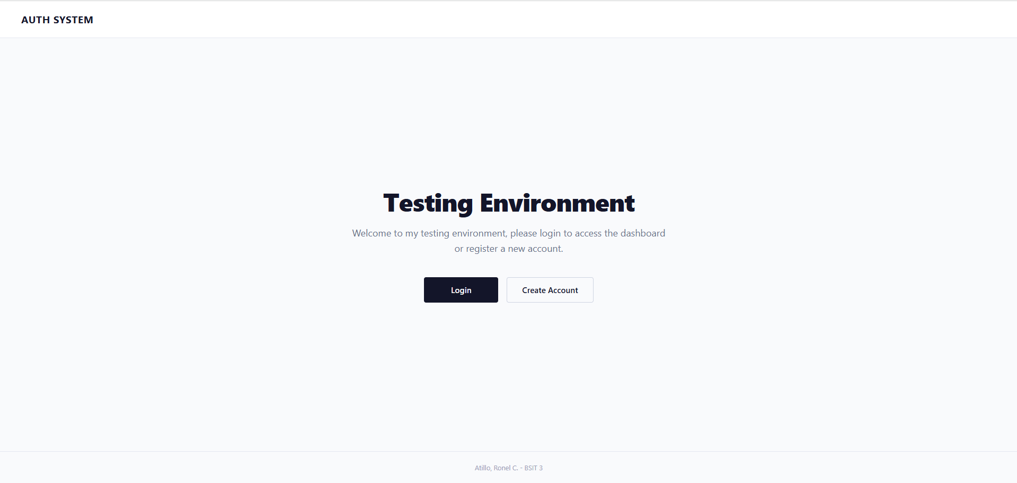

Login Page:
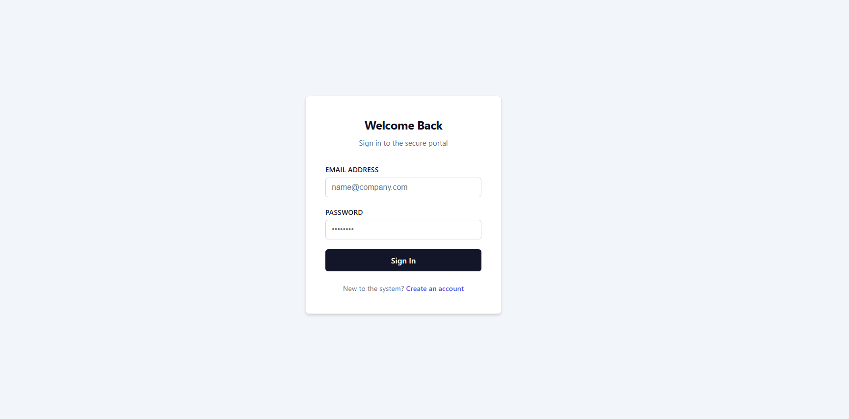
Registration Page:
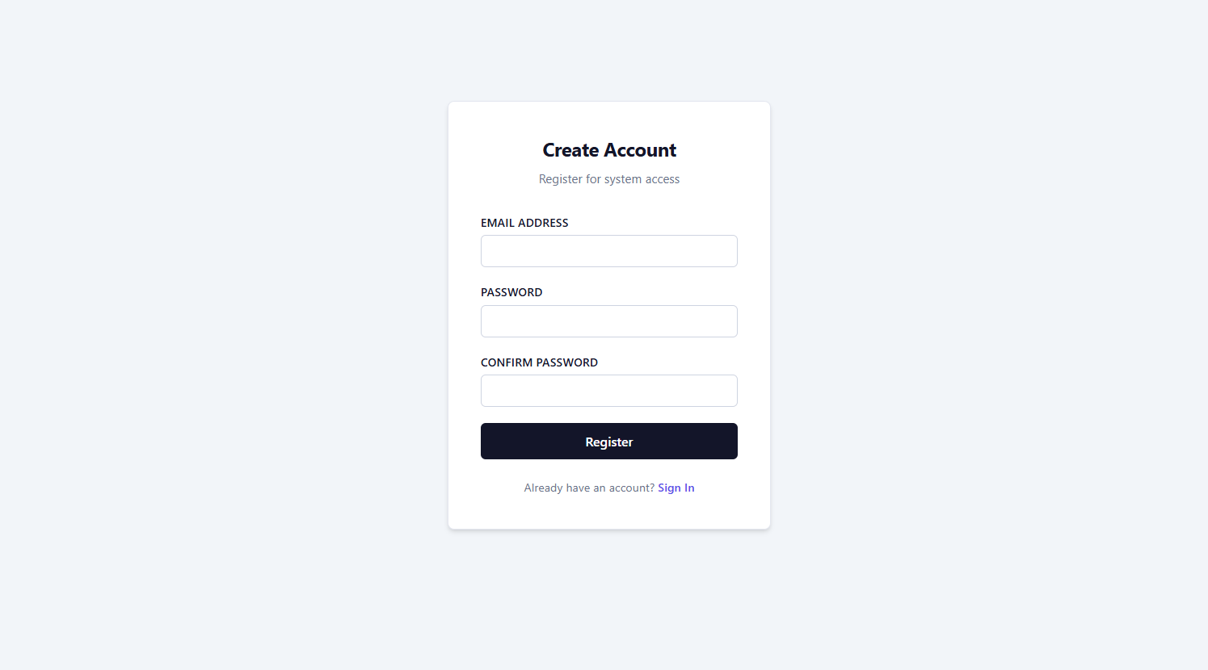

Dashboard:
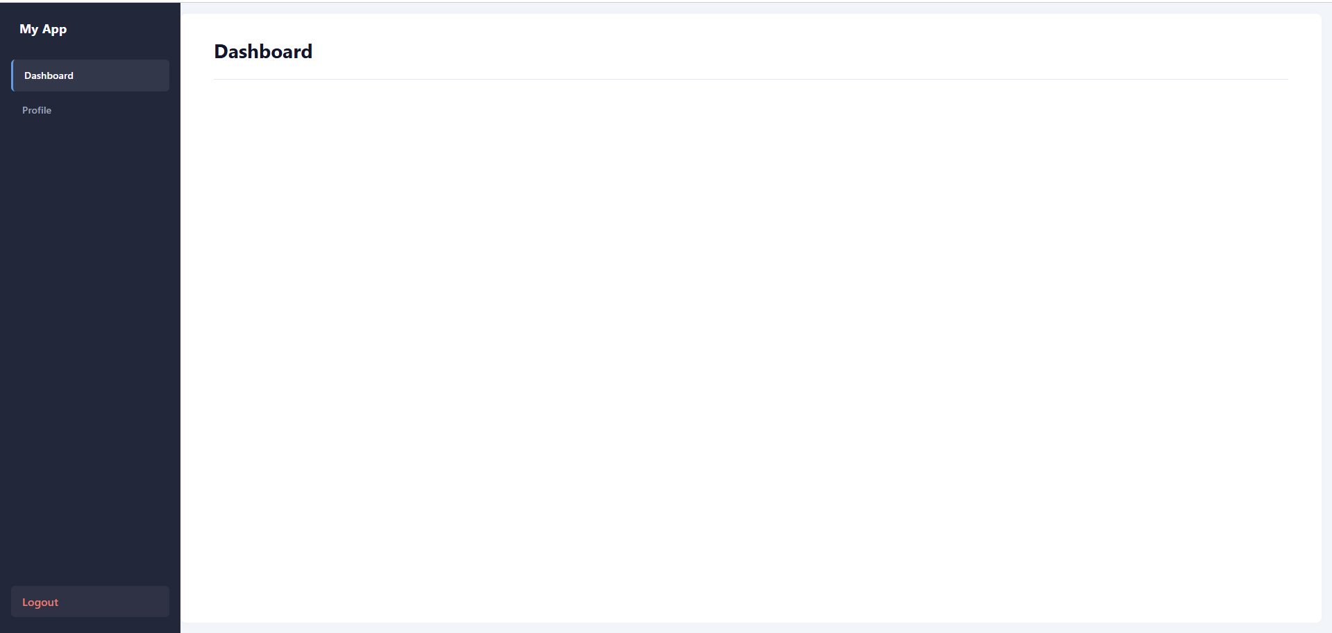
Profile:
