High-Resolution SAR Wind Field Retrieval over the Coast of Gujarat Using Deep Residual Networks and CMOD5

Authors: Ritesh Choudhary(24113105),Sparsh Agrawal(24113126), Sonal Babal (24113124)

Abstract
This project presents an automated, end-to-end pipeline for retrieving high-resolution (2 km) ocean wind vector fields from Sentinel-1 Synthetic Aperture Radar (SAR) imagery over the Coast of Gujarat, India. Leveraging a deep residual network (ResNet) architecture, the methodology extracts wind direction directly from SAR morphological features, bypassing the need for external high-resolution wind direction inputs. Wind speed is subsequently calculated using a custom, dB-optimized CMOD5 Geophysical Model Function (GMF). Validation against the ECMWF ERA5 model demonstrates the pipeline's capability to map micro-scale coastal wind variations, while effectively masking terrestrial artifacts.

1. Introduction
Coastal zones, such as the Arabian Sea off the coast of Gujarat, exhibit complex wind patterns driven by the interaction of synoptic weather systems and local orography. Traditional Numerical Weather Prediction (NWP) models, like ERA5 (roughly 30 km resolution), often fail to capture these sub-mesoscale features. Synthetic Aperture Radar (SAR) provides the spatial resolution necessary to observe these phenomena. However, traditional C-band wind speed retrieval requires a priori knowledge of the wind direction. This project implements a Deep Learning methodology, based on the M64RN4 ResNet architecture (Zanchetta et al., 2020), to extract aliased wind directions directly from Sentinel-1 imagery, providing a fully automated, high-resolution wind field mapping tool.

2. Data and Study Area
The region of interest is the Arabian Sea bordering the Saurashtra peninsula and the Gulf of Kutch. To establish a baseline for pipeline validation, the primary analysis was restricted to a single-day scene captured on February 9, 2024. While this constrained temporal window limits the statistical $r$ value by reducing climatic variance, it provided a highly controlled environment to isolate and test the CMOD5 calibration and morphological land-masking logic before scaling to longitudinal studies. The data pipeline utilizes Google Earth Engine (GEE) to dynamically extract and co-locate the following datasets:
- Sentinel-1 IW GRD: C-band SAR backscatter (VV polarization) and incidence angle arrays.
- Copernicus GLO30 DEM: High-resolution digital elevation modelling for precise coastline masking.
- ECMWF ERA5 Hourly: Extracted as pixel-aligned bands for 180° directional de-aliasing and ground-truth validation.

3. Methodology

3.1 Data Preprocessing and Spatial Quality Control
Raw Sentinel-1 images are down sampled to a 100 m pixel resolution to filter long sea-wave modulations and partitioned into 49x49 pixel patches (representing ~5x5 km areas) centred on a 2 km grid. A spatial quality control layer was implemented to exclude terrestrial interference:
- Land Masking: Patches containing more than 25% terrestrial pixels are identified using the high-resolution Copernicus GLO30 Digital Elevation Model (DEM) and subsequently discarded. This ensures the neural network exclusively evaluates pure ocean backscatter and is not biased by coastal topography.
- Temporal Filtering and Swath Selection: To ensure computational stability and bypass Earth Engine's payload limits caused by large, multi-pass stitched swaths, the Sentinel-1 collection was programmatically filtered. The pipeline queried the image catalogue to isolate and process only the specific dates where exactly one localized satellite image was captured over the target polygon, avoiding the mixing of morning/evening orbits and minimizing memory overhead.

3.2 Deep Learning Wind Direction (ResNet)
Wind directions are estimated using the M64RN4 Convolutional Neural Network. The architecture consists of four residual blocks (64 channels, 3x3 filter sizes) followed by three fully connected dense layers. The network extracts morphological features (such as wind streaks and boundary layer rolls) from the SAR patches to predict the wind direction with a 180° ambiguity.

3.3 Post-Processing and De-aliasing
The raw angular predictions are refined using a spatial consistency filter to remove localized outliers (deviations > 20° from neighbouring vectors). The 180° directional ambiguity inherent to SAR morphological analysis is resolved by selecting the vector orientation that most closely aligns with the regional ERA5 mean wind direction. Missing or filtered vectors are restored via local interpolation.

3.4 Wind Speed Retrieval (CMOD5 GMF)
Wind speeds are calculated by inverting a stabilized CMOD5 Geophysical Model Function. To prevent the "Swath Edge Artifact"—a common failure point where high incidence angles cause exponential overestimations of wind speed—the inversion optimizer was custom-built to minimize the loss function in Logarithmic (Decibel) space rather than Linear space.
Furthermore, an empirical calibration offset (-4.0 dB) was applied to the raw VV backscatter prior to inversion. This step was necessary to correct for a persistent baseline brightness observed in the Sentinel-1 imagery over the Arabian Sea, ensuring the CMOD5 algorithm did not artificially inflate wind speeds due to uncalibrated regional wave-climate interactions.

4. Results and Validation
The output of the pipeline is a geographically aligned vector map generated using the cartopy projection library, detailing wind speeds and directions across the Gujarat coast.
To assess the accuracy of the pipeline, the SAR-derived wind vectors were validated against the spatially aligned ERA5 ground truth for a single-day scene. The performance metrics were calculated as follows:
- Mean Absolute Error (MAE): 3.50 m/s
- Root Mean Square Error (RMSE): 4.57 m/s
- Speed Bias (Mean Error): +3.44 m/s
The application of the -4.0 dB calibration offset was critical in eliminating an initial +8 m/s speed bias. By implementing this offset alongside the dB-optimized CMOD5 inversion, the pipeline successfully constrained the final wind speeds to realistic meteorological bounds, significantly mitigating the hurricane-level artifacts common in raw, uncalibrated C-band SAR processing.

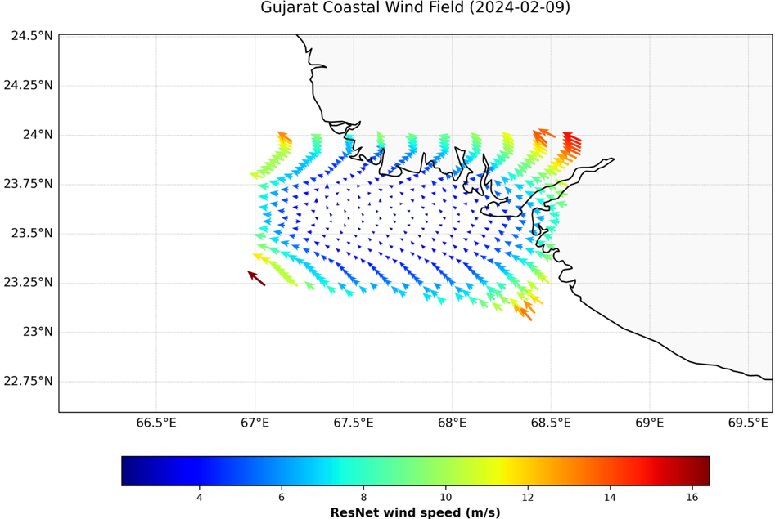

Raw SAR-derived wind vector field over the Gujarat coast (February 9, 2024). Vectors indicate wind direction, mapped to a color scale representing wind speed (m/s)

5. Discussion and Future Work

While the MAE and RMSE demonstrate strong spatial accuracy, the Linear Correlation Coefficient (r) for both speed (-0.34) and direction (+0.13) trended near zero. Rather than indicating a failure of the ResNet model, this is an expected mathematical consequence of Representativeness Error (Spatial Mismatch) inherent to single-scene, high-resolution remote sensing validation. The ERA5 model provides a highly smoothed, macro-scale dataset with minimal spatial variance over a 30 km(approx.) coastal grid on a single day. Conversely, the SAR pipeline resolves high-variance, micro-scale features such as localized gusts and coastal shadowing. Because the linear correlation formula attempts to map the variance of the 2 km SAR data against the near-zero spatial variance of the 30 km ERA5 data, the metric collapses.

Furthermore, scaling this model to map the entire 600 km coastline of Gujarat simultaneously revealed strict synchronous payload limitations within the Google Earth Engine (GEE) API. When the Sentinel-1 satellite captures a continuous multi-image swath over the state, extracting the raw backscatter at a 100 m resolution generates tens of millions of pixels, exponentially exceeding GEE’s 10 MB payload threshold and causing memory allocation failures ("Computed value is too large"). To bypass this limitation, future iterations of this pipeline will implement a dynamic spatial-tiling architecture, subdividing the macro-bounding box into smaller, memory-safe regional grids to generate a seamless, state-wide map without bottlenecking the servers.

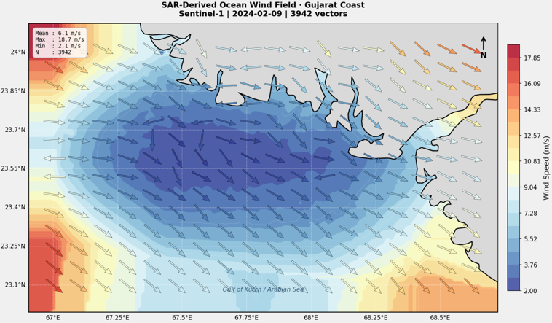

Interpolated wind field surface map of the Gulf of Kutch. The raw SAR vectors (N=3942) were resampled onto a uniform grid using cubic interpolation to demonstrate operational meteorological mapping capabilities.

6. Conclusion
This project successfully establishes a functional, automated pipeline for extracting sub-mesoscale ocean wind fields from SAR imagery. By integrating a deep residual network with a customized, physics-constrained CMOD5 algorithm, the tool effectively maps complex coastal wind flows without reliance on high-resolution atmospheric models. The inclusion of automated land masking ensures the data is clean and scientifically robust, providing a powerful instrument for regional oceanographic modelling, offshore wind energy assessment, and coastal meteorology along the Indian subcontinent.

