Data Analytics for the SpecScout
Smartphone Recommendation Application
Dataset-Based Explanation of Filtering, Feature Matching, Smart Scoring, and Price Analytics
This report explains how the Data Analytics phase of the SpecScout application converts a smartphone dataset into actionable recommendations. The analysis is based on the uploaded dataset, which contains smartphone specifications and prices.

1. Dataset Overview
The dataset contains 1,074 smartphone records in one worksheet named “All Smartphones”. Each row represents a smartphone model and contains technical specifications that can be used as filtering and recommendation features.
Dataset field | Purpose in the application
model | Identifies the smartphone shown to the user.
price | Primary budget filter and value-for-money feature.
rating | Represents overall product quality/popularity for ranking.
sim | Supports filters such as Dual SIM, 4G, 5G, NFC and VoLTE.
processor | Important for gaming and performance recommendations.
ram | Used to evaluate multitasking and gaming capability.
battery | Used to compare battery capacity and charging features.
display | Supports screen size, refresh rate and display-type preferences.
camera | Used to compare camera resolution and camera configuration.
card | Allows users to filter for expandable storage.
os | Allows operating-system preferences such as Android or iOS.

2. Data Preparation and Feature Engineering
The original dataset contains several specification values as text. Before analytics can be performed, the application converts important text fields into numerical or categorical features. This process makes filtering, scoring and comparison faster and more reliable.
Original value example | Derived analytical feature | How it is used
₹24,999 | price_num = 24999 | Budget filtering and value score
8 GB RAM, 128 GB inbuilt | ram_gb = 8; storage_gb = 128 | Gaming and multitasking filters
5000 mAh Battery with Fast Charging | battery_mah = 5000 | Battery comparison
200 MP Quad Rear & 12 MP Front Camera | rear_mp = 200 | Camera scoring
6.7 inches, 120 Hz AMOLED | display_in = 6.7; refresh_hz = 120 | Display preference matching

Missing values must also be handled. In the uploaded dataset, some records have missing ratings or incomplete camera, card, or operating-system information. The application can either exclude incomplete records for a strict filter or use safe fallback values, such as the median rating, during recommendation scoring. This prevents missing data from unfairly dominating the results.

3. How User Filters Work
The first stage of the recommendation engine is filtering. Filters remove smartphones that do not satisfy the user's non-negotiable requirements. For example, if a user has a maximum budget of ₹30,000, the application immediately removes all phones costing more than ₹30,000.
User requirement | Dataset field | Example filter logic
Budget | price_num | price_num ≤ user budget
5G required | sim | sim contains “5G”
Minimum RAM | ram_gb | ram_gb ≥ selected RAM
Large battery | battery_mah | battery_mah ≥ selected threshold
High camera resolution | rear_mp | rear_mp ≥ selected MP
Android/iOS | os | os matches selected operating system
Memory card | card | card contains supported
High refresh display | refresh_hz | refresh_hz ≥ selected Hz

4. Example: Finding a Smartphone the User Desires
Consider a user who wants a smartphone for gaming, camera use and long battery life. The user selects the following filters:
- Maximum budget: ₹30,000
- 5G connectivity: Required
- Minimum RAM: 6 GB
- Minimum battery capacity: 4,500 mAh
- Priority features: Gaming performance, camera quality and battery life
The analytics engine applies the hard filters first. Only smartphones satisfying all required conditions remain in the candidate set. In this dataset-based example, 231 smartphones remain after applying the budget, 5G, RAM and battery filters.

5. Weighted Feature-Matching Recommendation Logic
Filtering alone may return many suitable phones. Therefore, the next step is ranking. SpecScout can assign weights to features according to what the user values most. A higher weight means that feature contributes more strongly to the final recommendation score.
Feature | Example weight | Reason
Gaming / processor capability | 30% | Highest priority for a gaming-focused user
Camera capability | 20% | Important for photography preference
Battery capacity | 20% | Important for long daily usage
RAM | 15% | Supports gaming and multitasking
Rating | 10% | Adds an overall quality signal
Price value | 5% | Rewards lower-priced candidates within the budget

Before combining different features, numerical values are normalized to a common 0-to-1 scale. This is necessary because battery capacity is measured in thousands of mAh, camera resolution in MP, and ratings on a different scale. A normalized score allows these features to be combined fairly.
An example recommendation formula is:
Smart Score = 100 × [0.30(Gaming) + 0.20(Camera) + 0.20(Battery) + 0.15(RAM) + 0.10(Rating) + 0.05(Value)]
The weights are configurable. For example, a photography user could increase the camera weight, while a student looking for an affordable phone could increase the value-for-money weight.

6. Dataset-Based Recommendation Results
Using the example filters and weighted scoring model described above, the following models ranked among the highest-scoring candidates in the uploaded dataset. These results illustrate how the application can turn a large list of phones into a smaller, prioritized shortlist.
Model | Price | Rating | RAM / Storage | Battery | Example Smart Score
Infinix Note 12 Pro 5G | ₹18,999 | 84 | 8 GB RAM, 128 GB inbuilt | 5000 mAh Battery with 33W Fast Charging | 57.3
OPPO A97 5G | ₹23,990 | 79 | 12 GB RAM, 256 GB inbuilt | 5000 mAh Battery with 33W Fast Charging | 57.0
Xiaomi Mi 10T Pro 5G | ₹29,999 | 86 | 8 GB RAM, 128 GB inbuilt | 5000 mAh Battery with 33W Fast Charging | 56.8
Samsung Galaxy F63 | ₹21,999 | 84 | 6 GB RAM, 128 GB inbuilt | 7000 mAh Battery with 33W Fast Charging | 56.0
Moto G64 5G | ₹13,999 | 81 | 8 GB RAM, 128 GB inbuilt | 6000 mAh Battery with 33W TurboPower Charging | 54.5

Important note: these example scores are generated from a demonstration weighting model and from specification patterns available in the dataset. A production application should use a more detailed processor-performance benchmark and richer camera-quality metrics rather than relying only on text categories and megapixel counts.

7. Recommendation Workflow in the Application
Step 1: Collect preferences – The user selects budget, purpose, minimum specifications and optional preferences.
Step 2: Clean and transform data – Prices and technical specifications are converted into comparable numerical features.
Step 3: Apply hard filters – Phones that violate mandatory requirements are removed.
Step 4: Match preferences – Each remaining phone is compared with the user's desired gaming, camera, battery and display profile.
Step 5: Calculate weighted score – Normalized feature scores are multiplied by the user's selected weights.
Step 6: Rank candidates – Phones are sorted from highest to lowest Smart Score.
Step 7: Present explanation – The application shows why a phone was recommended, such as stronger battery, better processor or lower price.

8. Price Analytics and Price-Tracking Alerts
Price analytics is a separate analytical layer. Its purpose is to help users decide not only which phone to buy, but also when to buy it.
The current uploaded dataset contains a single price value for each smartphone record and does not include date-stamped historical prices. Therefore, true time-series calculations such as moving averages and seasonal trend detection cannot be directly calculated from this file alone. To implement the complete price-tracking system described in the application, SpecScout should maintain a historical table with fields such as Model, Date, Retailer, Current Price and Availability.
Historical analysis method | How it would work in SpecScout
Moving average | Calculate 7-day or 30-day average price to smooth short-term fluctuations.
Trend analysis | Compare current price with previous averages to identify rising or falling trends.
Seasonal discount analysis | Detect repeated price reductions during sale periods or festivals.
Price anomaly detection | Flag unusually large price drops or increases compared with normal historical behavior.
Price alert | Notify the user when the current price reaches a target price or drops significantly below its moving average.

Example alert logic: If the current price of a saved smartphone is lower than the user's target price, or if it is significantly below its recent 30-day average, the application can trigger a “Good time to buy” notification.

9. Descriptive Analytics from the Current Dataset
Metric | Dataset value
Total smartphones | 1,074
Average listed price | ₹32,196
Median listed price | ₹19,990
Average rating (available records) | 78.7
Median RAM | 6 GB
Median battery capacity | 5,000 mAh
Median rear camera resolution | 50 MP

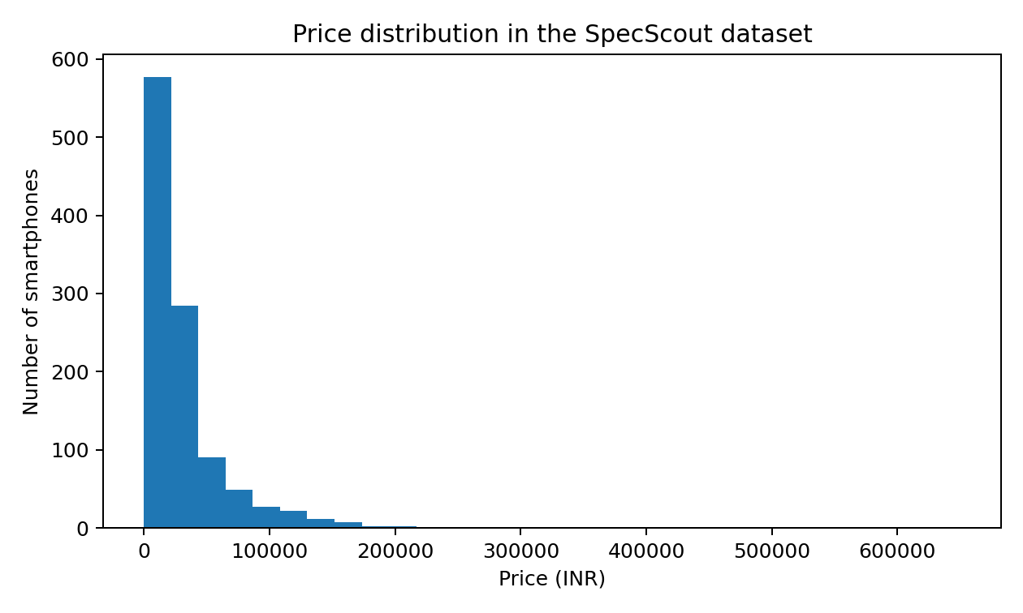
The price distribution shows why budget filtering is important. The dataset contains phones across a very wide price range, so users can receive more relevant recommendations when the budget filter is applied before weighted ranking.

10. Final Application Output to the User
After the analytics pipeline is complete, SpecScout can display a ranked shortlist rather than the entire dataset. For each recommendation, the interface can provide:
- Rank and Smart Score
- Current price and whether it is within budget
- Matched features, such as 5G, RAM, battery and camera
- Reason for recommendation based on the user's priorities
- Alternative phones with different strengths
- Saved-phone price history and price alerts when historical data is available

Conclusion
The Data Analytics phase is the intelligence layer of the SpecScout application. The uploaded dataset provides the core smartphone attributes required to filter and rank devices. The process begins by cleaning specification data and converting text into analytical features. User-selected filters then eliminate unsuitable phones, while a weighted feature-matching algorithm ranks the remaining candidates according to priorities such as gaming, camera quality, battery life and value. For complete price intelligence, the application should additionally collect date-based historical prices, enabling moving averages, trend analysis, anomaly detection and automated purchase alerts. Together, these analytics methods transform a large smartphone dataset into personalized, explainable and actionable recommendations.

