Online Exam System

Online Exam System Project Design Document
Author: <Glenn.Zheng>
Last Updated: <2016/07/24>

Executive Summary if applicable
This document mainly on the online examination system database design, class design, including the class diagram, sequence diagram, database design.
Document History
Date | Author | Summary of Change | Note
2016/07/22 | Glenn.Zheng | Add class diagram,db design,sequence diagram
<Table of Contents>
Overview 4
High Level Architecture 4
Detail Design 4
Class Diagram 4
Sequence Diagram 4
Entities and Relationship 7
Detail Database Schema 7
Interface Definitions 9
APIs/Interfaces 9
User Interfaces 9
Error and Exception Handling 9
Other Design Considerations 9

Overview
Database design, the overall design of the system

High Level Architecture

Detail Design

Class Diagram
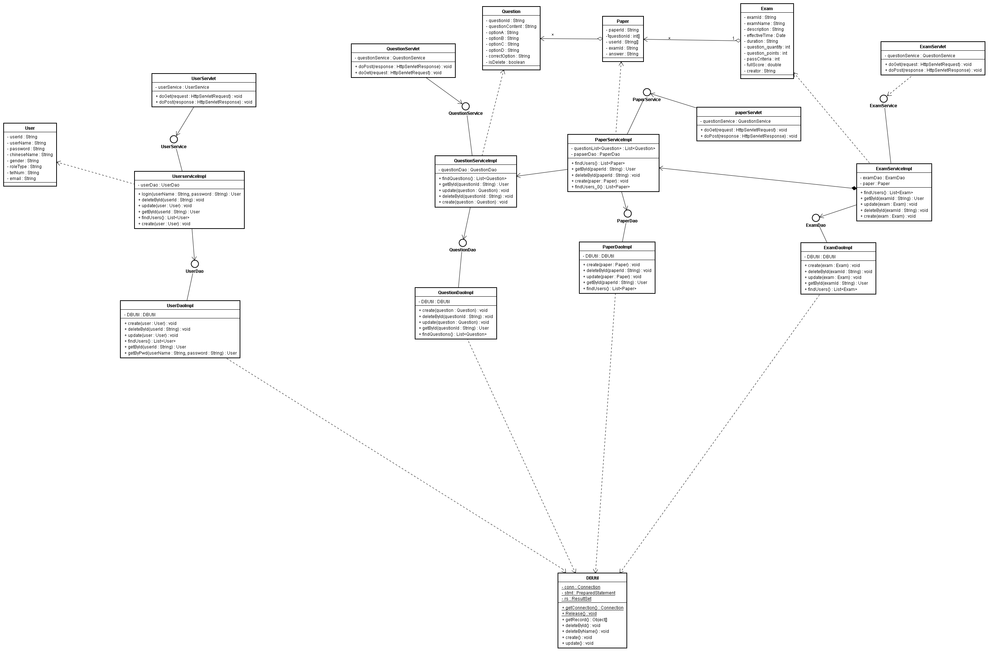

Sequence Diagram

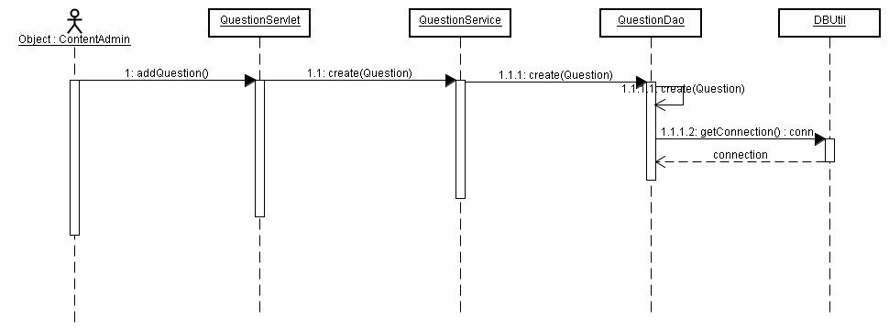
This diagram is used to describe an user add a question. If this operation failed, there will be throw an exception.
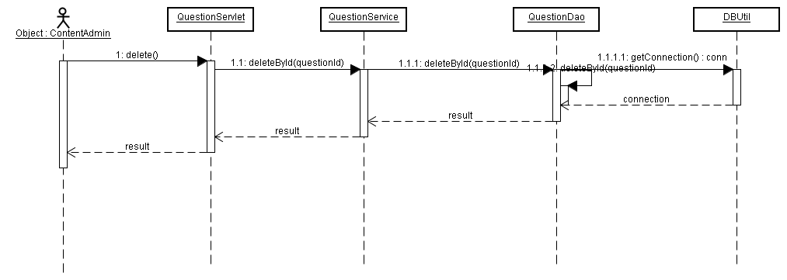

This diagram is used to describe an user delete a question. Delete operation will return a result to prompt this operation success or not. But in fact, all user can not delete any question really, because all question must be used to query. If question be deleted, it can not be find in the db, so user can not query. It will throw an exception if this operation failed.
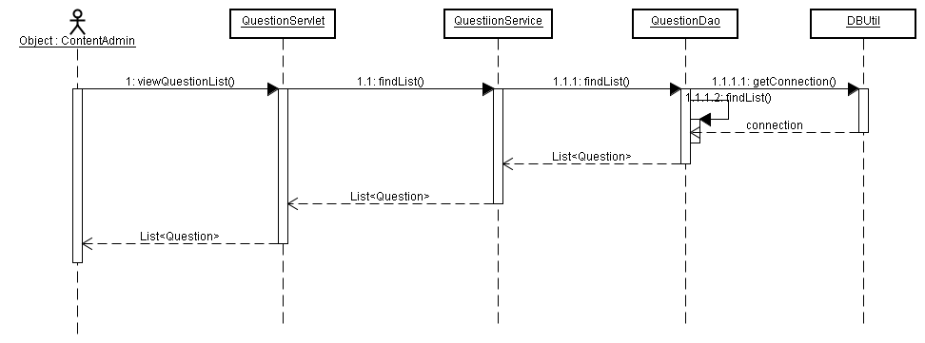
This diagram is used to describe an user view questions list. This operation will return an list, this list contain one or more than one question. It will throw an exception if this operation failed.

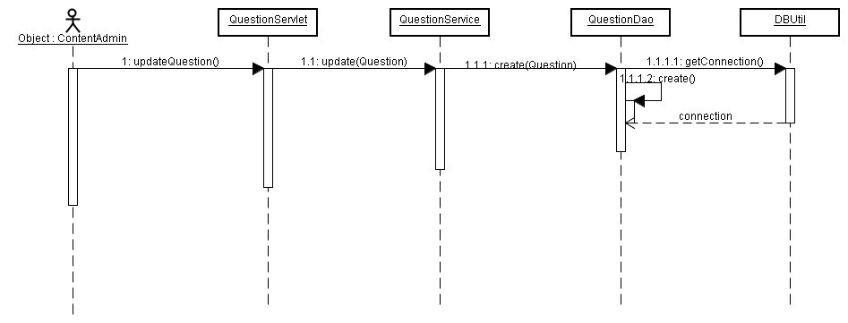
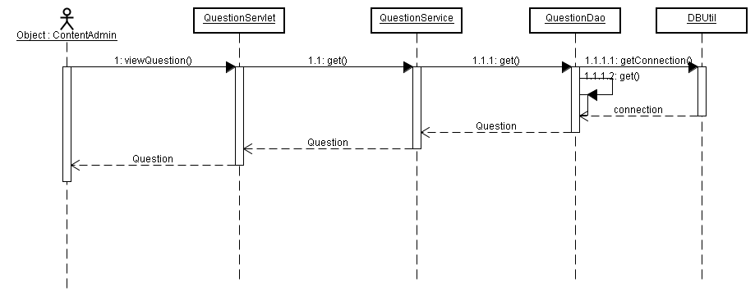
This diagram is used to describe an user update question. In fact, all user can't update question, just create question. If the question is be updated, other user can not see the past exam paper. It will throw an exception if this operation failed.

This diagram is used to describe an user query an specific question. So this operation will return an question. It will throw an exception if this operation failed.

Entities and Relationship
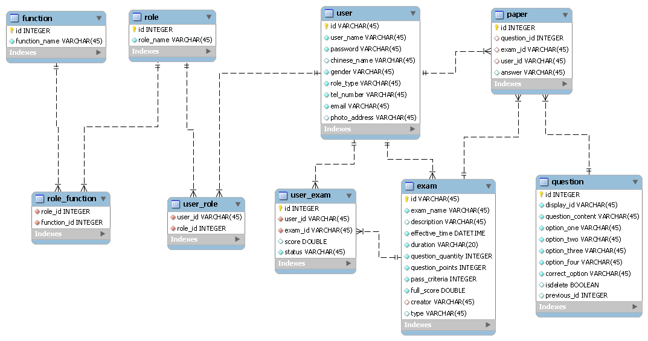

Detail Database Schema
user
Field Name | Data Type | Size | Null? | Comment
id | varchar | 45 | No | Primary key
user_name | Varchar | 45 | No | User's name
password | Varchar | 45 | No | User's password
chinese_name | Varchar | 45 | Yes | User's Chinese Name
gender | Varchar | 45 | No | User's gender
role_type | Varchar | 45 | No | User's role type
tel_number | Varchar | 45 | No | User's telphone num
email | Varchar | 45 | No | User's email
photo_address | Varchar | 45 | No | User's photo save address

role
Field Name | Data Type | Size | Null? | Comment
id | Integert | 15 | No | Primary key
role_name | Varchar | 45 | No | Role's name

function
Field Name | Data Type | Size | Null? | Comment
id | integer | 15 | No | Primary key
function_name | Varchar | 45 | No | Function's name

role_function
Field Name | Data Type | Size | Null? | Comment
role_id | integer | 15 | No | Foreign key
function_id | integer | 15 | No | Foreign key

user_role
Field Name | Data Type | Size | Null? | Comment
role_id | varchar | 45 | No | Foreign key
user_id | Varchar | 45 | No | Foreign key

paper
Field Name | Data Type | Size | Null? | Comment
id | integer | 15 | No | Primary key
question_id | integer | 15 | No | Question's id
exam_id | varchar | 45 | No | Exam's id
user_id | varchar | 45 | No | User's id
answer | varchar | 45 | No | The user's answer

question
Field Name | Data Type | Size | Null? | Comment
id | integer | 15 | No | Primary key
display_id | Varchar | 45 | No | Question's display id
question_content | Varchar | 45 | No | Question's content
option_one | Varchar | 45 | No | Question's option one
option_two | Varchar | 45 | No | Question's option two
option_three | Varchar | 45 | No | Question's option three
option_four | Varchar | 45 | No | Question's option four
correct_option | Varchar | 45 | No | Question's correct option
isdelete | boolean |  |  | Question delete or not
previous_id | integer | 11 | Yes | Question's previous id

exam
Field Name | Data Type | Size | Null? | Comment
id | Varchar | 45 | No | Primary key
exam_name | Varchar | 45 | No | Exam's name
description | Varchar | 45 | No | Exam's description
effective_time | Varchar | 45 | No | Exam's effective time
duration | Varchar | 45 | No | Exam's duration
question_quantity | integer | 15 | No | Question's quantity
question_points | integer | 15 | No | Question's point
pass_criteria | integer | 15 | No | Exam's pass criteria
full_score | integer | 15 | No | Exam's full score
creator | Varchar | 45 | No | Exam's creator
type | Varchar | 45 |  | Exam's type

user_exam
Field Name | Data Type | Size | Null? | Comment
id | integer | 15 | No | Primary key
user_id | Varchar | 100 | No | User's id
exam_id | Varchar | 100 | No | Exam' s id
score | Double | 100 | No | User's exam score
status | Varchar | 500 | Yes | Exam finished or not

Interface Definitions
QuestionDao: This interface is used to operate the database on the question table CRUD.

APIs/Interfaces
Name of the APIs or interfaces being developed and delivered to end users.
Name and description of the methods in each interface.

Each API/Interface should have unique ID for cross reference purposes (FSI0001, FSI0002, etc.)

User Interfaces
Please refer to formal User Interface Specification Template.

Error and Exception Handling
What is the behavior of features under error conditions?
What feedback mechanisms of error condition does the feature have?

In case end users are software developers who are embedding this component, also use this section to identify errors and exceptions that his component generates for the downstream error handling routines.

Other Design Considerations
You can add other design considerations into here. For example, consider to contribute public component into company standard component repository, consider to open source part of code, consider to use exist standard component, etc.

