
Online Exam System

<Online Exam System Project Functional Specification Document>
Author: <Glenn.Zheng>
Last Updated: <2016/07/22>

Document History
Date | Author | Summary of Change | Note
2016/07/20 | Glenn | Add usecase in detail step
2016/07/22 | Glenn | Add brief for all usecase

Overview 4
Use Case Diagrams 4
Use Case Scenarios 5
UC001 <Login/Logout> 5
UC002 <Create User> 7
UC003 <Edit Personal Profile> 9
UC004 <Edit User> 10
UC005 <Delete User> 10
UC006 <View Users List> 12
UC007 <Create Question> 13
UC008 <Edit Question> 15
UC009 <Delete Question> 15
UC010 <View Questions List> 16
UC011 <Create Exam> 17
UC012 <View Exams List> 18
UC013 <Search Exams> 19
UC014 <Check Exams> 20
UC015 <Preview Result> 20
UC016 <Join Exam> 21
21
UC017 <Change Password> 21
UC018 <Review Exam> 22
UC019 <Search Exam> 22
UC020 <View Exam Detail> 23
UC021 <Search Student List> 23
Non-functional Requirements 24
System Installation Requirements 24
Runtime Requirements 24
I18N and L10N Requirements 24
Documentation Requirements 24
Other Non-functional Requirement 24

Overview
Online Exam web system provides user management, question management and exam management functions. The user with SysAdmin role can manage all users including create/edit/delete user. The user with ContentAdmin role can manage questions and create exam. Each user can access this web system to edit his personal profile.

Use Case Diagrams

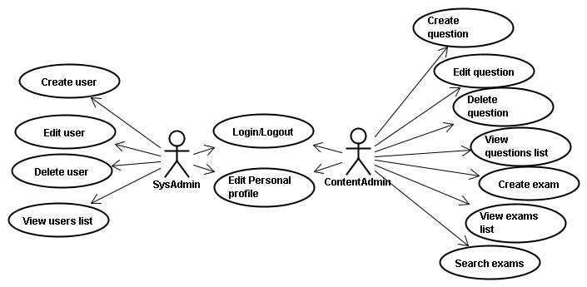
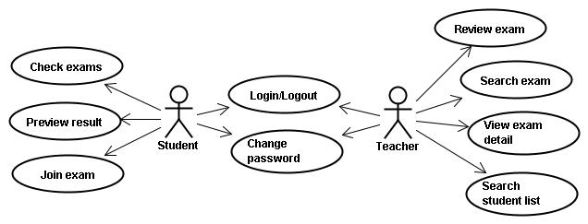

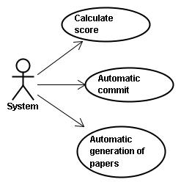
Use case id | Use Case Name
UC001 | Login/Logout
UC002 | Create User
UC003 | Edit Personal Profile
UC004 | Edit User
UC005 | Delete User
UC006 | View Users List
UC007 | Create Question
UC008 | Edit Question
UC009 | Delete Question
UC010 | View Questions List
UC011 | Create Exam
UC012 | View Exams List
UC013 | Search Exams
UC014 | Check Exams
UC015 | Preview Result
UC016 | Join Exam
UC017 | Change Password
UC018 | Review Exam
UC019 | Search Exam
UC020 | View Exam Detail
UC021 | Search Student List
UC022 | Calculate Score
UC023 | Automatic Commit
UC024 | Automatic Generation Of Papers

Use Case Scenarios

UC001 <Login/Logout>
Brief: User login with username and password, if username or password is empty, system will pop-up prompt. If username or password is wrong, system will pop up prompt too.

Actor: SysAdmin, ContentAdmin, Teacher, Student

Pre-condition: User not logged in

Mock Up UI:

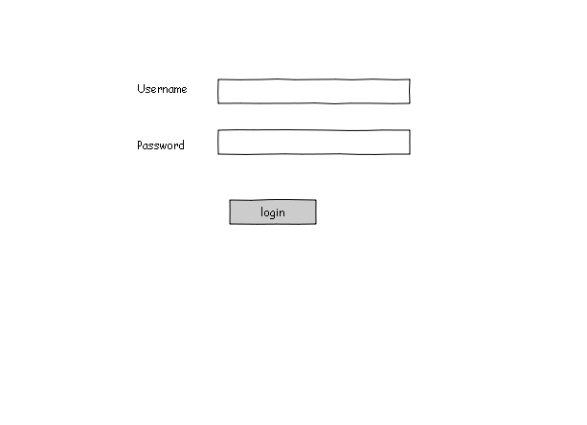
Diagram 1
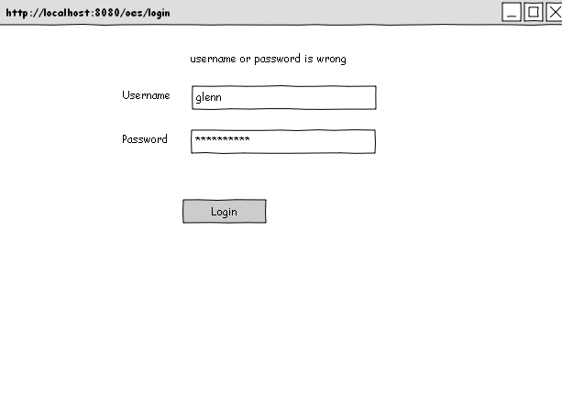
Diagram 2

General Workflow:

User Operation | System Response
1: User open system | 2: Open the login interactions.(it is Diagram 1)
3: User input username and password and click “login” button on the page(Diagram 1) | 4: System will validate username and password  4.1: Successful validation, get into system  4.2: Validation failure,display Diagram 2
Comment:
validate data
username not equal null & password not equal null

UC002 <Create User>
Brief: SysAdmin can create user, some fields is must to be input. If user's input is wrong, system will pop up prompt. All information will save in database when user finished input and click submit.

Actor: SysAdmin

Pre-condition: There is a user logged in system successfully

Mock Up UI:

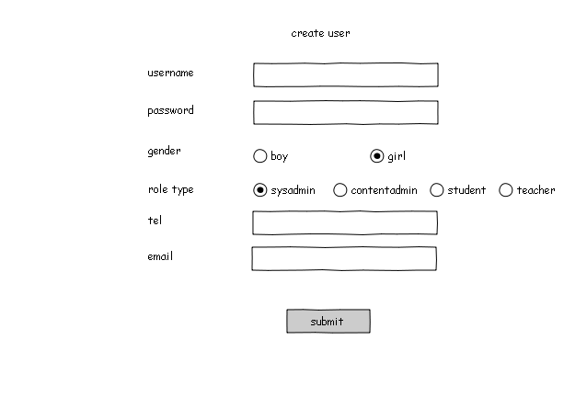

Diagram 1

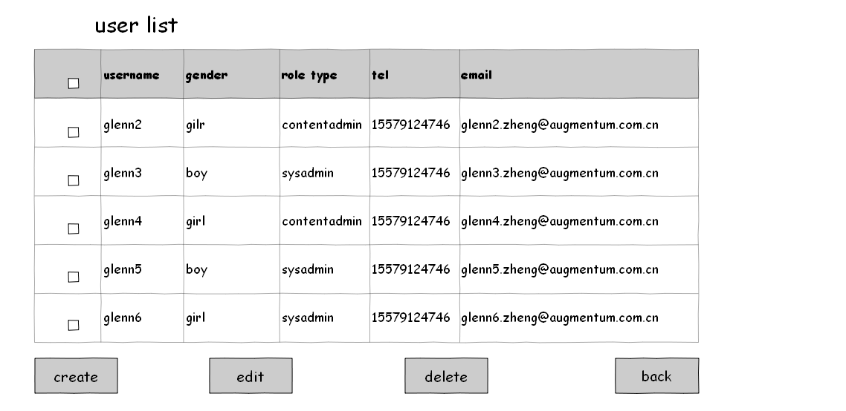

Diagram 2

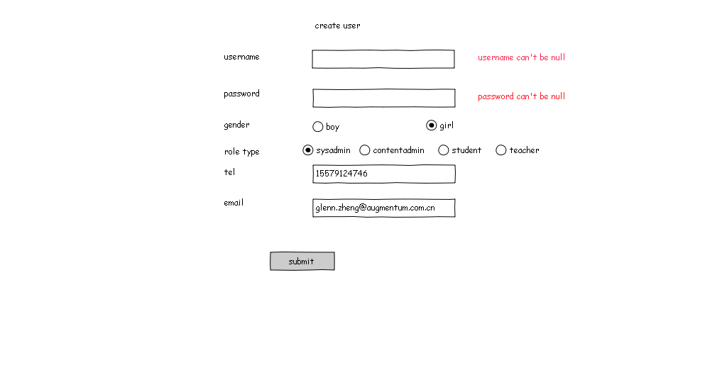
Diagram 2_1

General Workflow:

User Operation | System Response
1: User click “Create user” link on the list page(Diagram 2) | 2:Open the “create user” IT request page.(it is Diagram 1)
3:User fill the form(Diagram 1).
3.1: click submit | 4:System will validate data, if ok, System will save this create user Request and return to this page and tip save success information, if not ok, it will pop up a window take the error information.  4.1: If username or password is null,display Diagram 2_1
Comment:
validate data
Username and password can not be empty, gender and role type must be selected, the length of phone number is 11, and can not be empty, the e-mail Not with *? ^%$special symbols, such as numbers, letters, for example glenn.zheng@augmentum.com.cn

UC003 <Edit Personal Profile>
Brief: All user can edit personal profile, but can't edit others. All information will save in database when user click the submit button.

Actor: SysAdmin, ContentAdmin

Pre-condition: Users need to update profile

Mock Up UI:

General Workflow:

User Operation | System Response
Comment:
validate data

UC004 <Edit User>
Brief: The SysAdmin edit the user's information. Some fields are can't be null. If user has an wrong input, system will pop up prompt.

Actor: SysAdmin

Pre-condition: User's information needs to be update.

Mock Up UI:

General Workflow:

User Operation | System Response
Comment:
validate data

UC005 <Delete User>
Brief: SysAdmin delete user, once the operation is carried out, it will not be cancelled. When the user is deleted, the information all will delete from database.

Actor: SysAdmin

Pre-condition: Need to delete a user from the system

Mock Up UI:

Diagram 1

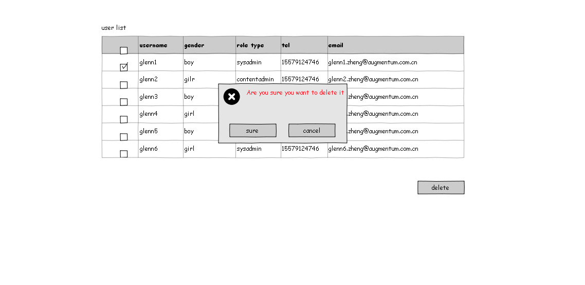
Diagram 2
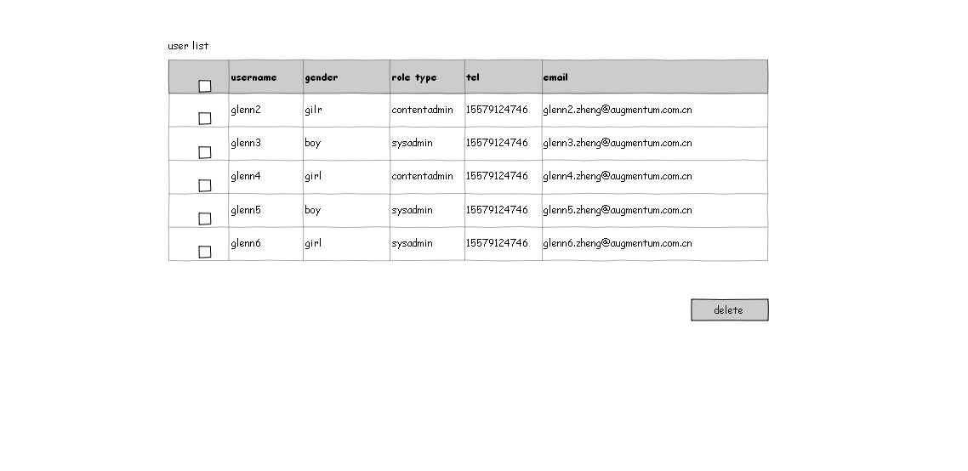
Diagram 3

General Workflow:

User Operation | System Response
1: Open user list | 2:Open the “user list” IT request page.(it is Diagram 1)
3:Select the user needs to be deleted by selecting the check box and click delete button(Diagram 1) | 4: Pop-up confirmation prompt box.( it is Diagram 2)
5.1: click sure | 6: System will delete user's related information from database, and display user list again.(it is Diagram 3)
5.2: Click cancle | 7: Show the original user list again.(it is Diagram 1)
Comment:
validate data

UC006 <View Users List>
Brief: SysAdmin can view users list. In users list, sysadmin also can delete or edit user's information.

Actor: SysAdmin

Pre-condition:

Mock Up UI:

Diagram 1

UC007 <Create Question>
Brief: ContentAdmin create question, the question will be saved in database. ContentAdmin can delete or update the question when finished create question.

Actor: ContentAdmin

Pre-condition:

Mock Up UI:
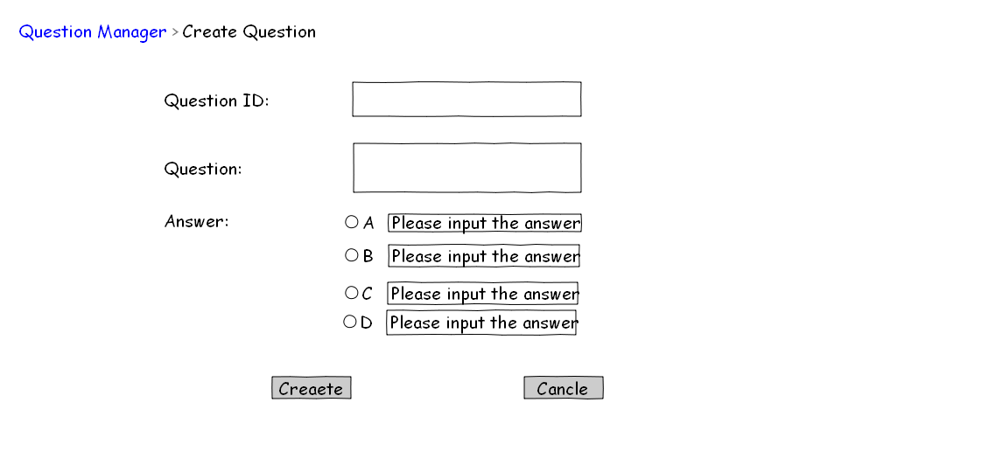
Diagram 1

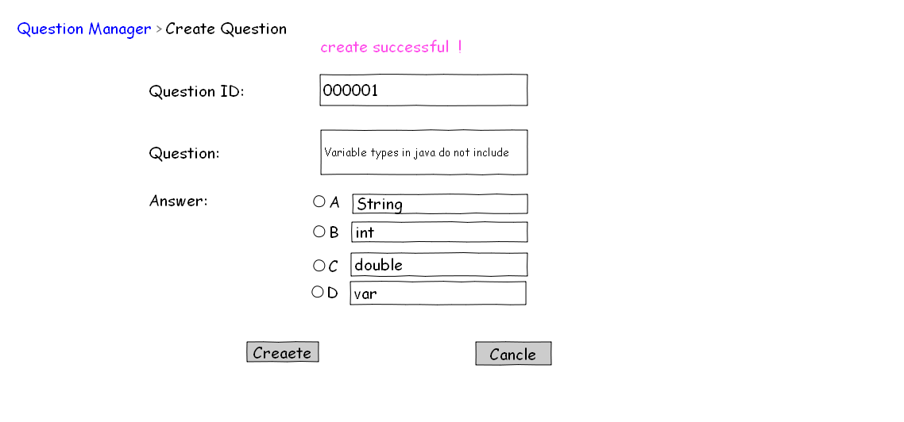
Diagram 2

General Workflow:

User Operation | System Response
1:User fill the form(Diagram 1).
2.1: Click Create | 3: System will Save the data to the database and display Diagram 2.
4: Click Cancle | 5: Display Diagram 1
Comment:
validate data
Question ID cannot be duplicate

UC008 <Edit Question>
Brief: If the question need to be update, contentAdmin can edit question. The latest information will update to database.

Actor: ContentAdmin

Pre-condition:

Mock Up UI:

General Workflow:

User Operation | System Response
Comment:
validate data

UC009 <Delete Question>
Brief: If the question is outdated or no longer needed, it can be deleted from the database. One this operation is finished, user can't cancle.

Actor: ContentAdmin

Pre-condition:

Mock Up UI:

General Workflow:

User Operation | System Response
Comment:
validate data

UC010 <View Questions List>
Brief: ContentAdmin can view question list for delete or edit. ContentAdmin can chose delete one or more, but contentadmin only edit one user in once time.

Actor: ContentAdmin

Pre-condition:

Mock Up UI:

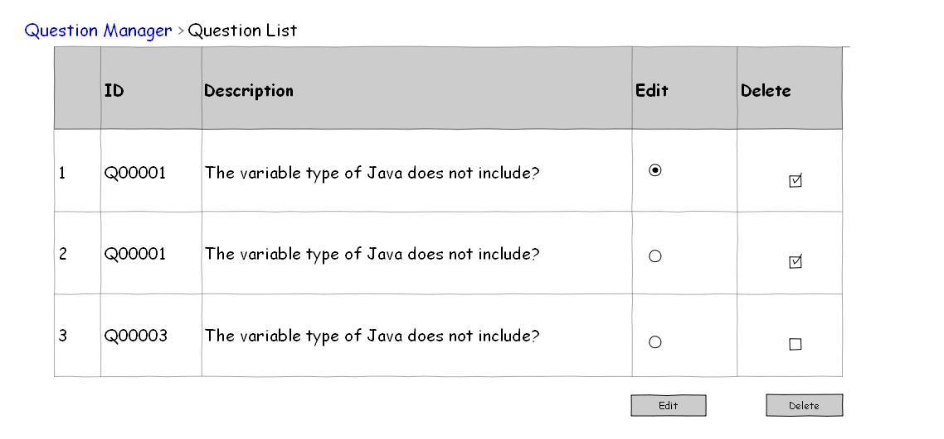

Diagram 1
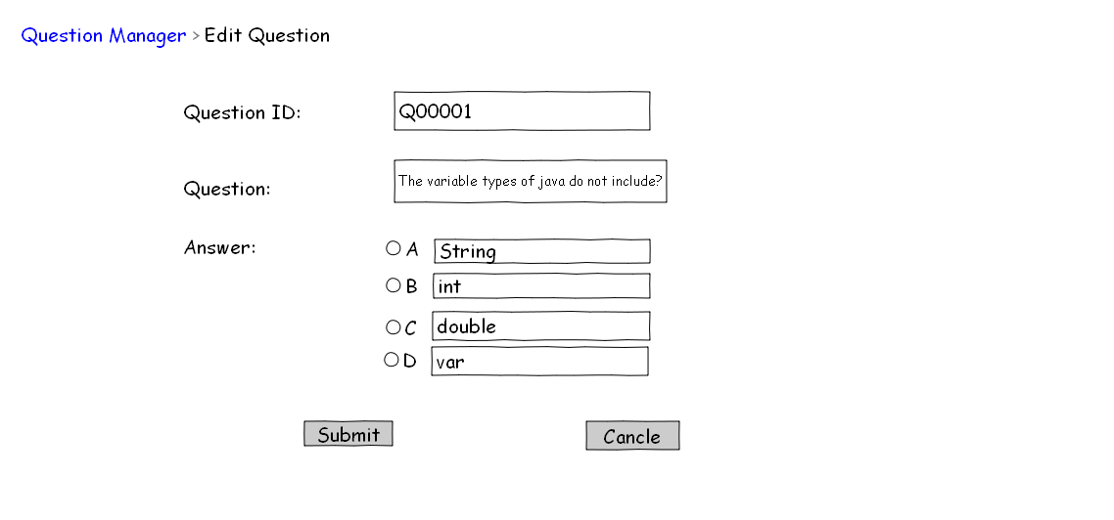
Diagram 2
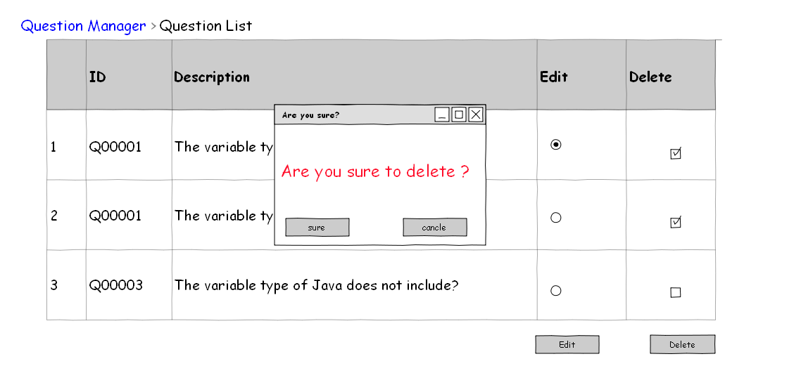
Diagram 3

General Workflow:

User Operation | System Response
1: User click “Question list” link. | 2:Open the question list page(it is Diagram 1)
3: Through the radio button to select a user to edit or through the check box to select multiple users to delete.
3.1: click edit | 4: Open the question edit page(it is Diagram 2)
3.2:click delete | 5:System will Open the confirmation prompt box.(it is Diagram 3)
Comment:
validate data:

UC011 <Create Exam>
Brief: ContentAdmin can create exam The information of the exam will be saved in database. All information can be query from database and display for user.

Actor: ContentAdmin

Pre-condition:

Mock Up UI:

General Workflow:

User Operation | System Response
3.3:Cancel | Return to the list it request page
Comment:
validate data

UC012 <View Exams List>
Brief: ContentAdmin can view exams list. In exams list page, contentadmin also can delete one or more exam, edit one exam once time.

Actor: ContentAdmin

Pre-condition:

Mock Up UI:

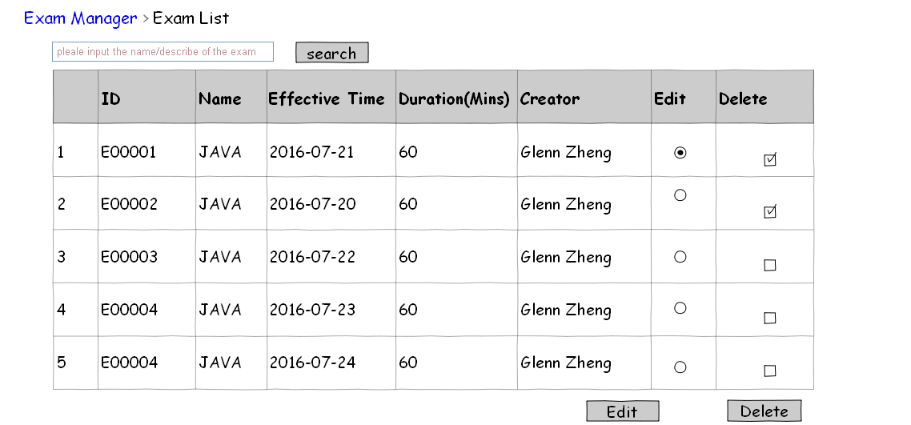
Diagram 1

General Workflow:

User Operation | System Response
1: User click exam list | 2: Open the exam list page
Comment:
validate data

UC013 <Search Exams>
Brief: Be able to fuzzy search exams by exam name field or exam description field. If there are no result, system will pop up a prompt, if there are more than 10 result, the result will be display by many page.

Actor: ContentAdmin

Pre-condition:
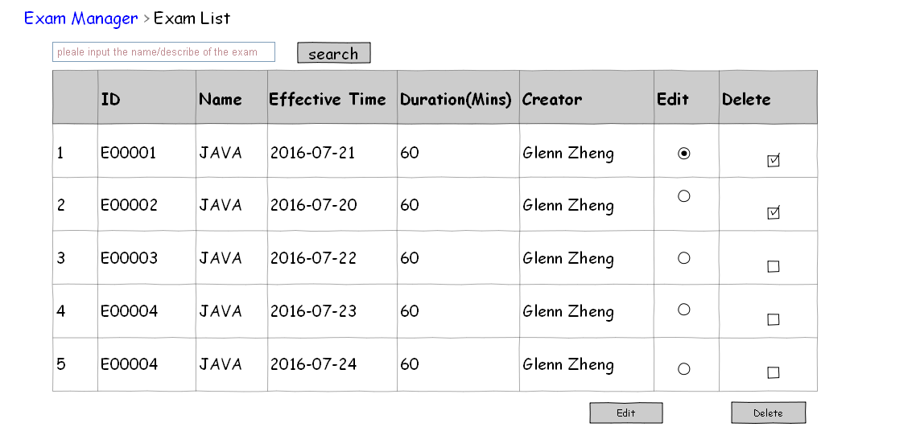

Mock Up UI:

Diagram 1
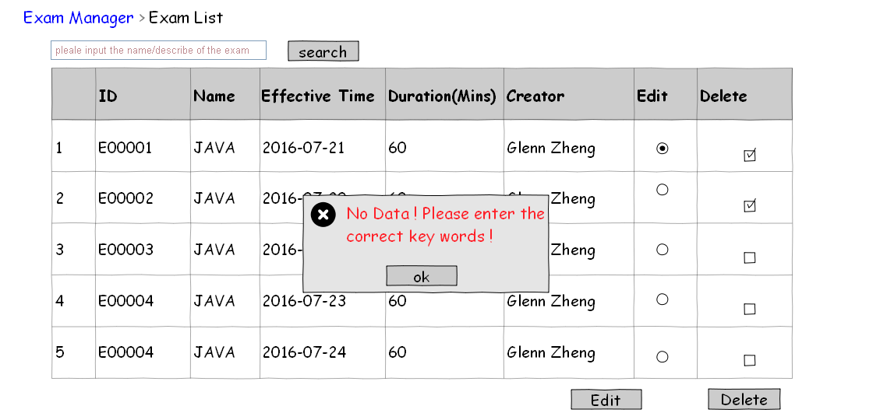
Diagram 2

General Workflow:

User Operation | System Response
1: User click the link of exam list. | 2: Open the exam list page(Pargram 1).
3: User input the name/describtion of the exam, click search button. | 4.1: If there is no data in the database, warning and display the Diagram 2.  4.2: Or display results.
Comment:
validate data

UC014 <Check Exams>
Brief: Teacher check exams when student had finished the exam.

Actor: Teacher

Pre-condition: Student finished the exam

Mock Up UI:
Diagram 1

General Workflow:

User Operation | System Response
Comment:
validate data

UC015 <Preview Result>
Brief: Teacher preview the result of exam when student finished the exam. The result page will display many information about exam.

Actor: Teacher

Pre-condition: Student finished the exam

Mock Up UI:

General Workflow:

User Operation | System Response
Comment:
validate data

UC016 <Join Exam>
Brief: Student join the exam if the exam didn't finish

Actor: Student

Pre-condition: The exam didn't finish

Mock Up UI:

General Workflow:

User Operation | System Response
Comment:
validate data

UC017 <Change Password>
Brief: Student or Teacher all have the privilege of change password. User need to use new password to login system when finished change password. The new password also be saved in database.

Actor: student, teacher

Pre-condition:

Mock Up UI:
Diagram 1

General Workflow:

User Operation | System Response
Comment:
validate data

UC018 <Review Exam>
Brief: A teacher can review all finished exam (include exam name, total score, total question quantity, exam duration, examinee count, pass rate, pass criteria and average score.

Actor: Teacher

Pre-condition:

Mock Up UI:

General Workflow:

User Operation | System Response
Comment:
validate data

UC019 <Search Exam>
Brief: A teacher can search the exam by exam name, and exam date range. If there are no result, system will pop up prompt.

Actor:

Pre-condition:

Mock Up UI:

General Workflow:

User Operation | System Response
Comment:
validate data

UC020 <View Exam Detail>
Brief: Teacher view exam detail when the exam was finished. This page will display many information about exam and the system will calculate the score automatically.

Actor: Teacher

Pre-condition:

Mock Up UI:

General Workflow:

User Operation | System Response
Comment:
validate data

UC021 <Search Student List>
Brief: Teacher search student list and can choose edit, delete it. If there are more than 10 result, system will pagination, if there are no result, system will pop up a prompt.

Actor: Teacher

Pre-condition:

Mock Up UI:

General Workflow:

User Operation | System Response
Comment:
validate data

UC022 <Calculate Score>
Brief: System can calculate score when the paper is commited.

Actor: System

Pre-condition:

Mock Up UI:

General Workflow:

User Operation | System Response
Comment:
validate data

UC023 <Automatic Commit>
Brief: System can automatic commit when the time is over to write the papers.

Actor: System

Pre-condition:

Mock Up UI:

General Workflow:

User Operation | System Response
Comment:
validate data

UC024 <Automatic Generation of Paper>
Brief: System can automatic generation when the ContentAdmin chose to create
exam.

Actor: System

Pre-condition:

Mock Up UI:

General Workflow:

User Operation | System Response
Comment:
validate data

Non-functional Requirements
Student can preview the test result details page, A teacher can review the statistics information of all the exam results, such as how many students attended exams within one month? What’s the average score of one exam? How many students are qualified in one exam. Search user by username or Chinese
name or telephone number. Mail function. A congratulation mail will be sent when he passes one exam. Report function. The score and user of each exam will be logged and use a report to show this exam history.

System Installation Requirements
Windows xp & windows 7 & windows 8 & windows 10

Runtime Requirements
What are startup/initialization/shutdown/cleanup processes?
What are the memory requirements?
What are the disk space requirements?

Each runtime requirement should have unique ID for cross reference purposes (NFR0001, NFR0002, etc.)

I18N and L10N Requirements
Are I18N (Internationalization) and L10N (Localization) required for the system? Which languages that the system needs to support?

Documentation Requirements
What does this component require from the Technical Publication team?
Does this require a user manual, samples, reference manual, quick start guide, online help, context sensitive help, etc.?

Other Non-functional Requirement
You can add section here to describe what you think is necessary here. Such as security requirements, performance requirements, legal requirements, industry protocol/standard, etc.

