Chapter 5 - Constraints Framework and Proof-of-Concept Implementation

At a glance
Question | What rules must hold in code for energy-linked finance to be credible?
Framework | Five constraints: data → issuance → pricing → settlement → governance
Evidence | Sepolia SPK v1: ~5,499 SPK, 21 payments, peg off, circulation-first
Staging | Public lab now; closed pilot and mainnet product deliberately blocked
Takeaway | Technically buildable ≠ production-ready; prototype supports feasibility only
Next chapter | Ch 6 — answer, limits, and what would falsify the thesis

5.1 Purpose of the Chapter
Chapters 2 through 4 established the thesis in three steps. Chapter 2 reviewed the literatures and identified the five-condition gap. Chapter 3 showed that energy cost can matter in an existing digital market, but that the relationship is conditional. Chapter 4 showed that renewable-energy-linked risk can be priced under explicit assumptions.
This chapter asks what rules are needed for an energy-linked digital instrument to be credible in implementation.
The key point is that a working contract is not enough. A smart contract can execute rules, but the rules must be economically meaningful. If the data is unreliable, issuance is discretionary, pricing ignores risk, or settlement is unprotected, then the instrument is not credible simply because it uses code.
The chapter therefore presents a constraints framework and a Sepolia proof-of-concept (SPK v1). The implementation is feasibility evidence: it shows that the core rules can be expressed in software and tested. It is not presented as a production-ready financial system.

5.2 The Constraints Framework
The framework has five core constraints.
First, energy data must be reliable enough for the claim being made. Modelled solar potential is useful for forecasting and benchmarking, but actual site-level settlement requires stronger evidence such as meter data, inverter logs, grid records, or audited operator files.
Second, issuance must be rule-bound. If a token or financial claim can be created without verified energy evidence, then energy is not constraining the system.
Third, risk must be priced explicitly. Energy output and energy value are uncertain. A credible system must account for volatility, shortfall risk, oracle error, and basis risk (Chapter 4, Tables 4.3–4.4 and 4.6).
Fourth, settlement must be protected. If users can redeem or settle claims, the system must define what is owed, who owes it, what happens during shortfall, and what collateral or reserve rules apply.
Fifth, governance must be limited. If administrators can change rules instantly or override constraints, then the system reintroduces discretionary control.
These constraints are not independent decorations. They work together. Reliable data without settlement protection creates weak claims. Pricing without verifiable data prices the wrong object. Rule-bound issuance without governance limits can be changed after users rely on the rules.
Table 5.1 summarises the five-constraint framework used in this thesis.
Constraint | Purpose | Failure If Missing
Reliable energy data | Defines what energy evidence the system accepts | The system may price or mint against false or weak claims
Rule-bound issuance | Limits token or contract creation to accepted evidence | The issuer regains discretionary creation power
Explicit pricing and risk controls | Accounts for volatility, basis risk, oracle error, and shortfall risk | Claims become underpriced or under-collateralised
Protected settlement and redemption accounting | Defines what is owed and what happens during fulfillment, shortfall, or dispute | Users hold claims without credible resolution rules
Limited governance | Restricts discretionary parameter changes and role abuse | The system can override its own constraints

5.3 Constraint 1: Reliable Energy Data
Energy-linked design fails when it confuses resource potential, modelled output, actual generation, surplus export, and tariff value. The proof-of-concept therefore separates modelling data (NASA POWER, PVWatts—for baselines and anomaly checks) from claim data (meter or inverter readings for minting).
The attested mint path follows five steps. First, meter-style readings are submitted. Second, readings are verified and accepted or rejected. Third, accepted readings form a deterministic source hash. Fourth, an attestation signs surplus and metadata. Fifth, the contract mints only after attestation checks pass.
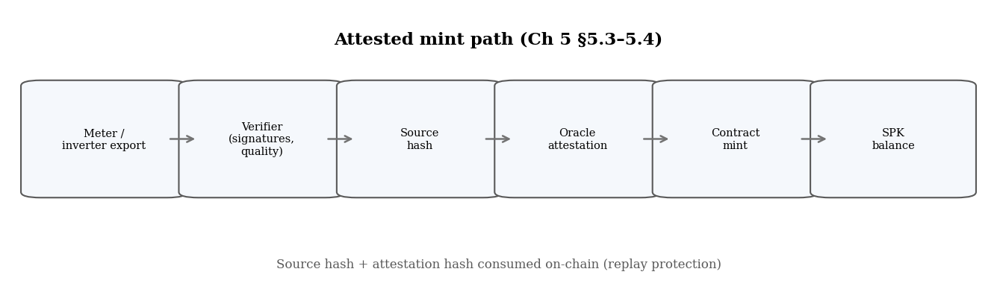
Figure 5.1. Data-to-mint pipeline — source and attestation hashes consumed on-chain.
The sample data do not prove revenue-grade meter finality. They do prove that accepted and rejected paths can be separated, bound to minting, and protected against replay.

5.4 Constraint 2: Rule-Bound Issuance
Issuance must not depend on an administrator's word alone. In the proof-of-concept, rule-bound issuance means that token creation is tied to a verified surplus claim rather than to discretionary minting authority.
The surplus-attestation path binds the recipient, surplus kWh, measurement and validity windows, source hash, chain ID, and contract address into one auditable bundle. Source and attestation hashes are consumed after use, so the same energy claim cannot mint twice. That design turns issuance from a governance decision into a verifiable event.
The public Sepolia record illustrates how this works in practice. In an earlier dollar-translated proof, a signed bundle recorded 2606.7 kWh of accepted surplus and minted 130.1697 SPK at a $0.05/kWh basis. The transaction is inspectable on-chain. That result demonstrates implementability. It does not demonstrate production readiness, live operator meters, or legal enforceability.

5.5 Constraint 3: Explicit Pricing and Risk Controls
Energy data do not imply financial value. Chapter 4 priced renewable risk under explicit assumptions. Tables 4.3–4.4 (oracle tolerance and location σ) and Table 4.6 (margin stress) are the templates a production system would need, even though SPK v1 does not embed that full pricing engine on-chain.
In the prototype, pricing appears through three channels. At mint, the system applies an energy-price basis (for example $0.05/kWh in an earlier proof, or energy-native 1 kWh → 1 SPK in SPK v1). At redemption, quotes convert burned tokens into owed kWh. In stress artifacts, reserve and shortfall requirements are exposed before any real-value deployment. Together, these channels prevent issuance and settlement from becoming blind accounting.

5.6 Constraint 4: Settlement and Redemption Accounting
Issuance without settlement clarity leaves users unsure what they hold. The currency-system contract supports invoice settlement (SPK transferred against a hashed invoice with replay protection) and redemption accounting (tokens burned into owed-kWh claims resolved as fulfilled, shortfall, or disputed).
This is rule enforcement and record-keeping, not guaranteed physical delivery. Real deployment still needs counterparties, legal terms, operator obligations, and reserve policy. The research point is that minting, circulation, redemption, and resolution can be connected in one auditable path.

5.7 Constraint 5: Governance Limits and Launch Gates
Unlimited administrative power would reintroduce discretionary issuance into a system that claims to be energy-constrained. The implementation therefore uses role separation, pausing, and governance-delay patterns in the broader design. These controls are directionally correct, but they are not sufficient on their own for production deployment.
Launch gates provide a second layer of discipline by separating three stages: public lab, closed testnet pilot, and paid or mainnet product. Only the public lab stage is launchable under the current evidence base. The pilot and mainnet stages remain blocked until governed deployment, real operator data, hardware provenance, economics, audit, legal scope, redemption policy, and production evidence are in place.
Stating those blockers explicitly is a methodological strength of the thesis. The project does not present testnet demonstration code as finished money. Table 5.2 summarises the staging logic, and Figure 5.6 visualises it.
Stage | Current Status | Interpretation
Public lab | Launchable as proof/demo/research evidence | Suitable for advisor, reviewer, and public-lab inspection
Closed testnet pilot | Blocked | Needs governed deployment, real operator data, stronger hardware provenance, and anchor economics/support terms
Paid/mainnet product | Blocked | Needs audit, legal/commercial scope, redemption policy, production deployment, reserves, real counterparties, and demand
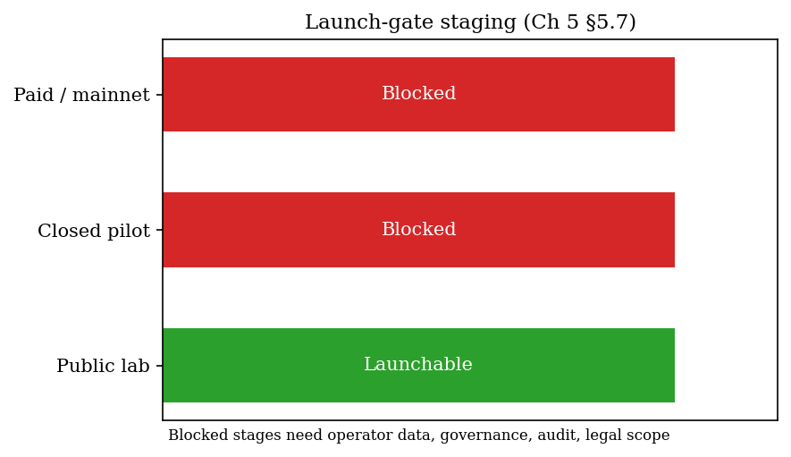
Figure 5.6. Launch-gate staging (§5.7).

5.8 What the Proof-of-Concept Demonstrates — and What It Does Not
The proof-of-concept demonstrates several things. First, an energy-data-to-token path can be implemented with attestation and replay protection. Second, token circulation and redemption accounting can be recorded on-chain. Third, public testnet evidence can be produced and indexed. Fourth, readiness can be separated by stage through launch gates.
It also has clear limits. It does not prove production readiness, legal classification, revenue-grade operator meters, market demand, liquidity, external audit, legally enforceable redemption, or fully funded reserve policy.
These limits matter because they prevent overclaiming. The thesis uses the implementation to support a narrower claim: the constraints framework is technically buildable as a proof of concept. It does not claim the prototype is ready to handle public financial value.

5.9 SPK v1 on Sepolia
After an earlier dollar-translated attested mint in May 2026 (contract 0x8ceDa…), the project deployed SPK v1 on Sepolia in June 2026. SPK v1 is an energy-native, circulation-first implementation of the same constraints framework developed earlier in the chapter.
The following table compares SPK v1 with the earlier attested proof. The earlier proof translated energy into dollars at mint through a $0.05/kWh basis and emphasised mint proof plus lab settlement. SPK v1 defaults to energy-native issuance (1 kWh → 1 SPK), emphasises network circulation through settleNetworkPayment, and keeps the dollar peg off by default. The primary contracts are 0x8e189… for SPK and 0x52016… for the CurrencySystem.
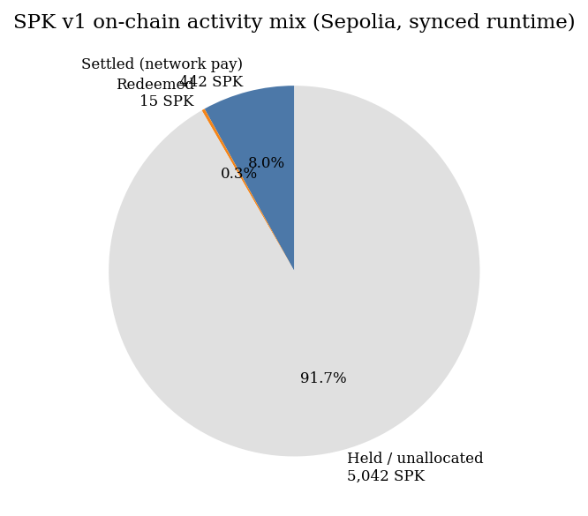
Figure 5.7. On-chain activity mix (synced runtime).
Parameter | SPK v1 (Jun 2026) | Earlier attested proof
Issuance | Energy-native (1 kWh → 1 SPK default) | Dollar-translated via $0.05/kWh basis
Primary use | Network circulation (settleNetworkPayment) | Mint proof + lab settlement
Peg | Off by default | Dollar basis implicit
Contracts | 0x8e189… (SPK), 0x52016… (CurrencySystem) | 0x8ceDa…
SPK v1 is product-oriented evidence rather than a new theoretical claim. The same five constraints appear in a circulation-first posture: hash-consumed issuance, typed network payments with invoice-hash replay protection, gated redemption, and testnet-only operator keys.
Subsections 5.9.1–5.9.2 report canonical contracts, live runtime metrics, and the indexed payment ledger (Table 5.4). These blocks are refreshed from Sepolia testnet state on each thesis build.
Figure 5.7 visualises the activity mix. Payment #15 is a wallet-initiated pilot transfer of 5 SPK. Payment #3 is operator testnet choreography of 180 SPK in NETWORK form, not external commerce.
SPK v1 therefore demonstrates that the framework can support energy-native circulation on a public testnet. It does not demonstrate mainnet readiness, legal money status, or real-site meter finality, as discussed in §5.8.
Metrics and ledger entries below are synced from public Sepolia testnet state (generated 2026-06-30T15:44:16.534445+00:00).

5.9.1 Canonical contracts and live metrics
Contract | Address
mock_usdc | 0xaD2A7169CfFBA9Bef8C45515fc85178DbBfEc2C9
solar_punk_coin | 0x8e189002228Fd4C6fA7611bA49FBe1d9C3412128
currency_system | 0x520162252F9B94824417678525FFd69145014970
- Total supply: 5499.015 SPK
- Settled: 442.0 SPK
- Network payments: 21
- Circulation share: 96.71%

5.9.2 Indexed payment ledger (Table 5.4)
# | Kind | SPK | Payee | Payer | Tx
1 | SERVICE | 12.0 | Gateway | Operator | 0x6c65e0ae…
2 | LABOR | 40.0 | Maintenance | Operator | 0x8ad9f3ce…
3 | NETWORK | 180.0 | Operator | Operator | 0x6dbbf639…
4 | GOODS | 55.0 | Merchant | Operator | 0x0d7e506b…
5 | SERVICE | 8.0 | Gateway | Operator | 0xeacc17a4…
6 | GOODS | 12.0 | Merchant | Operator | 0xb4972856…
7 | SERVICE | 6.0 | Gateway | Operator | 0x7bf52655…
8 | LABOR | 10.0 | Maintenance | Operator | 0x1f7cd596…
9 | GOODS | 14.0 | Merchant | Operator | 0x3b912b39…
10 | NETWORK | 8.0 | Network peer | Operator | 0x100b4dec…
11 | SERVICE | 6.0 | Gateway | Operator | 0x7d68647a…
12 | LABOR | 10.0 | Maintenance | Operator | 0xc1eb24c0…
13 | GOODS | 14.0 | Merchant | Operator | 0xd01d4ab8…
14 | NETWORK | 8.0 | Network peer | Operator | 0x2b8e8efb…
15 | GOODS | 5.0 | Merchant | Pilot payer | 0xbd7bb0e5…
16 | SERVICE | 6.0 | Gateway | Operator | 0x7bd6389e…
17 | LABOR | 10.0 | Maintenance | Operator | 0x2fd62cdc…
18 | SERVICE | 6.0 | Gateway | Operator | 0xfc63cd22…
19 | LABOR | 10.0 | Maintenance | Operator | 0xb620ea8c…
20 | GOODS | 14.0 | Merchant | Operator | 0x6b1f3801…
21 | NETWORK | 8.0 | Network peer | Operator | 0x5a72cc73…
Table 5.4. Indexed network payments on Sepolia (SPK v1). Payment #15 is the wallet-initiated pilot transfer (Pilot payer → Merchant).

5.10 Chapter Conclusion
Energy-linked digital finance requires all five constraints together: reliable data, rule-bound issuance, explicit pricing, protected settlement, and limited governance.
The Sepolia prototype shows that the core path can be expressed in code—attested minting, replay-protected payments, redemption accounting, and staged launch gates—while keeping production, legal, and peg claims off the table.
Chapter 6 summarises the bounded thesis answer and what would strengthen or falsify it.
Key takeaway: All five constraints must work together. SPK v1 shows the rules can run on testnet; it does not prove production readiness, a dollar peg, or legal money.

References
Barro, R. J., & Gordon, D. B. (1983). Rules, discretion and reputation in a model of monetary policy. Journal of Monetary Economics, 12(1), 101-121.
Cambridge Centre for Alternative Finance. (n.d.-b). CBECI Mining Map: Methodology. Cambridge Judge Business School. https://ccaf.io/cbnsi/cbeci/mining_map/methodology
Eichengreen, B. (1992). Golden Fetters: The Gold Standard and the Great Depression, 1919-1939. Oxford University Press.
Ethereum.org. (n.d.). The Merge. https://ethereum.org/en/upgrades/merge/
Federal Reserve History. (2013). Nixon Ends Convertibility of U.S. Dollars to Gold and Announces Wage/Price Controls. https://www.federalreservehistory.org/essays/gold_convertibility_ends
Friedman, M. (1960). A Program for Monetary Stability. Fordham University Press.
Hayes, A. S. (2019). Bitcoin price and its marginal cost of production: Support for a fundamental value. Applied Economics Letters, 26(7), 554-560.
International Energy Agency. (2023). Scaling Up Private Finance for Clean Energy in Emerging and Developing Economies. https://www.iea.org/reports/scaling-up-private-finance-for-clean-energy-in-emerging-and-developing-economies
Lazard. (2025). Levelized Cost of Energy+. https://www.lazard.com/research-insights/levelized-cost-of-energyplus/
Liu, Y., & Tsyvinski, A. (2021). Risks and returns of cryptocurrency. The Review of Financial Studies, 34(6), 2689-2727.
Nakamoto, S. (2008). Bitcoin: A Peer-to-Peer Electronic Cash System. https://bitcoin.org/bitcoin.pdf
Bank for International Settlements. (2023). Annual Economic Report 2023: Blueprint for the future monetary system. https://www.bis.org/publ/arpdf/ar2023e3.htm
Bessembinder, H., & Lemmon, M. L. (2002). Equilibrium pricing and optimal hedging in electricity forward markets. Journal of Finance, 57(3), 1347-1382.
Black, F., & Scholes, M. (1973). The pricing of options and corporate liabilities. Journal of Political Economy, 81(3), 637-654.
Bordo, M. D. (1993). The gold standard, Bretton Woods and other monetary regimes: A historical appraisal. Federal Reserve Bank of St. Louis Review, 75(2), 123-191.
Cambridge Centre for Alternative Finance. (n.d.-a). Cambridge Bitcoin Electricity Consumption Index: Methodology. Cambridge Judge Business School. https://ccaf.io/cbnsi/cbeci/methodology
Chainlink. (2025). The blockchain oracle problem. https://chain.link/education-hub/oracle-problem
Cong, L. W., & He, Z. (2019). Blockchain disruption and smart contracts. The Review of Financial Studies, 32(5), 1754-1797.
Cox, J. C., Ross, S. A., & Rubinstein, M. (1979). Option pricing: A simplified approach. Journal of Financial Economics, 7(3), 229-263.
Deng, S. J., & Oren, S. S. (2006). Electricity derivatives and risk management. Energy, 31(6-7), 940-953.
Federal Reserve Bank of St. Louis. (2010). Central bank credibility and inflation expectations. https://www.stlouisfed.org/publications/regional-economist/january-2010/central-bank-credibility-and-inflation-expectations
Kydland, F. E., & Prescott, E. C. (1977). Rules rather than discretion: The inconsistency of optimal plans. Journal of Political Economy, 85(3), 473-491.
NASA POWER. (n.d.). Prediction of Worldwide Energy Resources. NASA Langley Research Center. https://power.larc.nasa.gov/
National Renewable Energy Laboratory. (n.d.). PVWatts API. https://developer.nrel.gov/docs/solar/pvwatts/
U.S. Department of State, Office of the Historian. (n.d.). Nixon and the End of the Bretton Woods System, 1971-1973. https://history.state.gov/milestones/1969-1976/nixon-shock
Cambridge Centre for Alternative Finance. (n.d.-a). Cambridge Bitcoin Electricity Consumption Index. Cambridge Judge Business School. https://ccaf.io/cbnsi/cbeci
Bank for International Settlements. (2023). Blueprint for the future monetary system: Improving the old, enabling the new. In Annual Economic Report 2023. https://www.bis.org/publ/arpdf/ar2023e3.htm
Chainlink. (n.d.). Proof of Reserve. https://chain.link/proof-of-reserve
National Institute of Standards and Technology. (n.d.). Smart Grid. https://www.nist.gov/engineering-laboratory/smart-grid
OpenZeppelin. (n.d.). ERC20. https://docs.openzeppelin.com/contracts/5.x/api/token/ERC20
SolarPunk project artifacts. (2026). SPK_ATTESTED_MINT_PROOF.md, CURRENCY_SYSTEM_LAB.md, CURRENCY_FRAMEWORK_READINESS.md, and PRODUCT_LAUNCH_GATE.md.

