Energy Circulation as an Economic Indicator:
What Tracks the Real Economy, What Doesn't, and What's New
Christopher Ongko (王新福)
Department of Finance, College of Management, Yuan Ze University, Taiwan
s1133958@mail.yzu.edu.tw · ORCID: 0009-0007-9339-9098
Working paper draft · July 2026

ABSTRACT
Energy consumption is an established proxy for real economic activity — used, for instance, to estimate the size of shadow economies where official statistics are unreliable. This paper tests three candidate extensions of that idea against real data and finds they hold up very differently.
First, financialized crypto activity — DeFi deposits and stablecoin supply, increasingly treated as an informal signal of digital-economy health — does not track real economic activity. Tested against U.S. and international industrial output and a purpose-built weekly activity index, with a full multiple-testing correction applied across 44 specifications, the relationship is not distinguishable from noise, converging with an independent finding in recent peer-reviewed literature. One narrower relationship survives every check: stablecoin supply tracks broad money-supply (M2) growth (β = 24.8–29.3, p < .0001 in both sub-periods tested) — a liquidity signal, not a growth signal.
Second, real electricity generation does track real economic activity (β = 0.60, p < .0001, N = 210), confirming established literature on direct data. A properly stationarity-tested Granger causality test resolves the direction for the first time in this form: real activity leads electricity generation by one to two months (p = .002 at one month), not the reverse — a coincident/lagging signal, not a forecasting one.
Third, and most directly relevant to the present moment: Taiwan Power Company's sector-level electricity data shows the semiconductor manufacturing sector's share of national electricity consumption rising from 18.4% in January 2021 to 26.4% by October 2025, with semiconductor electricity growth outpacing — and in two of the last four years, moving opposite from — total economy-wide consumption (2023: semiconductors +4.5% vs. whole economy −2.7%; 2025: +5.4% vs. −0.3%). This is a real-time, publicly available, government-sourced signal of AI-driven industrial investment that is faster and more specific than the quarterly capital-expenditure disclosures typically used to track the same phenomenon, and it is not currently used as an indicator.
Keywords: economic indicators; energy consumption; cryptocurrency; semiconductor industry; AI infrastructure; nowcasting
JEL Codes: E01; O33; Q41; Q43

1. Introduction
Energy consumption has long served as a proxy for real economic activity where direct measurement is unreliable or slow. Electricity use is one of the standard indirect indicators used to estimate shadow-economy size, and satellite-measured nighttime light and electricity data are used to track GDP in real time and in places where official statistics lag. The logic is simple: producing and consuming real goods and services requires energy, so energy use tracks output closely enough to be informative.
This paper asks a narrower, more current question: given that logic, what should count as a useful energy-linked economic indicator today, and does the newest, most-discussed candidate — token and crypto activity, frequently marketed as reflecting “digital economy” health because of its association with energy through mining — actually hold up as one? Answering that requires testing three separate claims against real data rather than assuming any of them, and the findings diverge sharply enough across the three that the divergence itself is the paper's contribution.
1.1 Contributions
First, it shows that DeFi and stablecoin activity do not track real economic activity once tested properly, converging with an independent finding in recent peer-reviewed literature. Stablecoin supply instead tracks money-supply growth specifically — real, but a narrower and different claim.
Second, it resolves, for the first time in this form, the direction of the (real) relationship between electricity generation and economic activity: coincident-to-lagging, not leading.
Third, it identifies a specific, underused, publicly available indicator: sector-level electricity sales data already published by grid operators, showing Taiwan's semiconductor sector decoupling from the rest of its national economy — a direct, real-time signal of AI infrastructure investment.
1.2 What this paper does not establish
Following the convention of prior work in this research program: the crypto and electricity findings (Sections 3–4) are correlational, tested with negative controls and multiple-testing correction, not causal-identification designs with a policy shock or natural experiment — no such discrete event is available in this setting the way a tax-policy change is in fiscal research. The Taiwan finding (Section 5) is a documented divergence in published data, not a causal claim that AI investment caused the specific magnitude observed; other explanations (reshoring, non-AI fab expansion) are not fully ruled out, though the direction (semiconductor growth against a shrinking whole-economy baseline in two of four years) is inconsistent with a generic growth story. None of the three findings establish forecasting value beyond what is explicitly tested.
2. Background
Energy consumption as an economic proxy is established, not novel — electricity use appears as an indirect indicator in shadow-economy estimation (Medina & Schneider, 2019), and nighttime-light/electricity data are widely used for GDP nowcasting (Henderson, Storeygard, & Weil, 2012), particularly where official statistics are slow or unreliable. The newer claim — that crypto or token activity reflects real economic conditions — is comparatively untested. A 2025 peer-reviewed study of DeFi's “money multiplier” (a measure of leverage and double-counting within DeFi, distinct from the metrics tested here) finds it strongly correlated with crypto market indicators and uncorrelated with inflation or volatility measures (Luo, Feng, Xu, & Tasca, 2025) — a different metric, a converging conclusion. AI's electricity footprint is an actively tracked policy concern: global data-centre electricity consumption rose 17% in 2025, AI-specific data-centre consumption grew 50%, and total demand is projected to roughly double by 2030 (IEA, 2026) — a pace more than four times faster than growth in electricity consumption from all other sectors, making the question of where to find a fast, specific, public signal of this growth a practical one.
3. Does Financialized Crypto Activity Track the Real Economy?
3.1 Data and Sourcing
Series | Source | Confidence | Basis
DeFi total value locked,  stablecoin supply | DefiLlama  (daily, since 2017) | 80% | Industry-standard aggregator; underlying figures are protocol-self-reported and known to include double-counting (Luo et al., 2025)
Bitcoin active addresses | Coin Metrics  Community data | 85% | Reputable specialized provider; free/community tier, not the audited Pro tier
US, Euro-area industrial production; OECD composite leading indicator; M2 money supply | FRED (Federal Reserve Bank of St. Louis) | 98% | Official central-bank/international statistical series
Weekly Economic Index | Federal Reserve Bank of Dallas/New York, via FRED | 98% | Official, purpose-built real-time activity index

Table 1. Data sources and confidence.
3.2 Results
Table 2 summarizes the core specifications; all use HAC-robust standard errors for serial correlation in overlapping growth-rate windows.
Test | β | HAC p | Survives Bonferroni (α = .05/44)
DeFi TVL YoY ~ U.S. industrial production | 182.7 | .175 | no
DeFi TVL YoY ~ Euro-area industrial production | 193.8 | .010 | no
DeFi TVL YoY ~ OECD composite indicator | 646.4 | .0004 | yes
DeFi TVL YoY ~ Weekly Economic Index | 320.0 | .138 | no
Stablecoin YoY ~ U.S. industrial production | −3.9 | .859 | no
Stablecoin YoY ~ Weekly Economic Index | 1.1 | .970 | no
BTC active addresses YoY ~ Weekly Economic Index | −2.9 | .092 | no
Stablecoin YoY ~ M2 growth (2020–22) | 24.8 | .0022 | yes
Stablecoin YoY ~ M2 growth (2023–26) | 9.1 | <.0001 | yes

Table 2. Crypto activity vs. real economic activity.
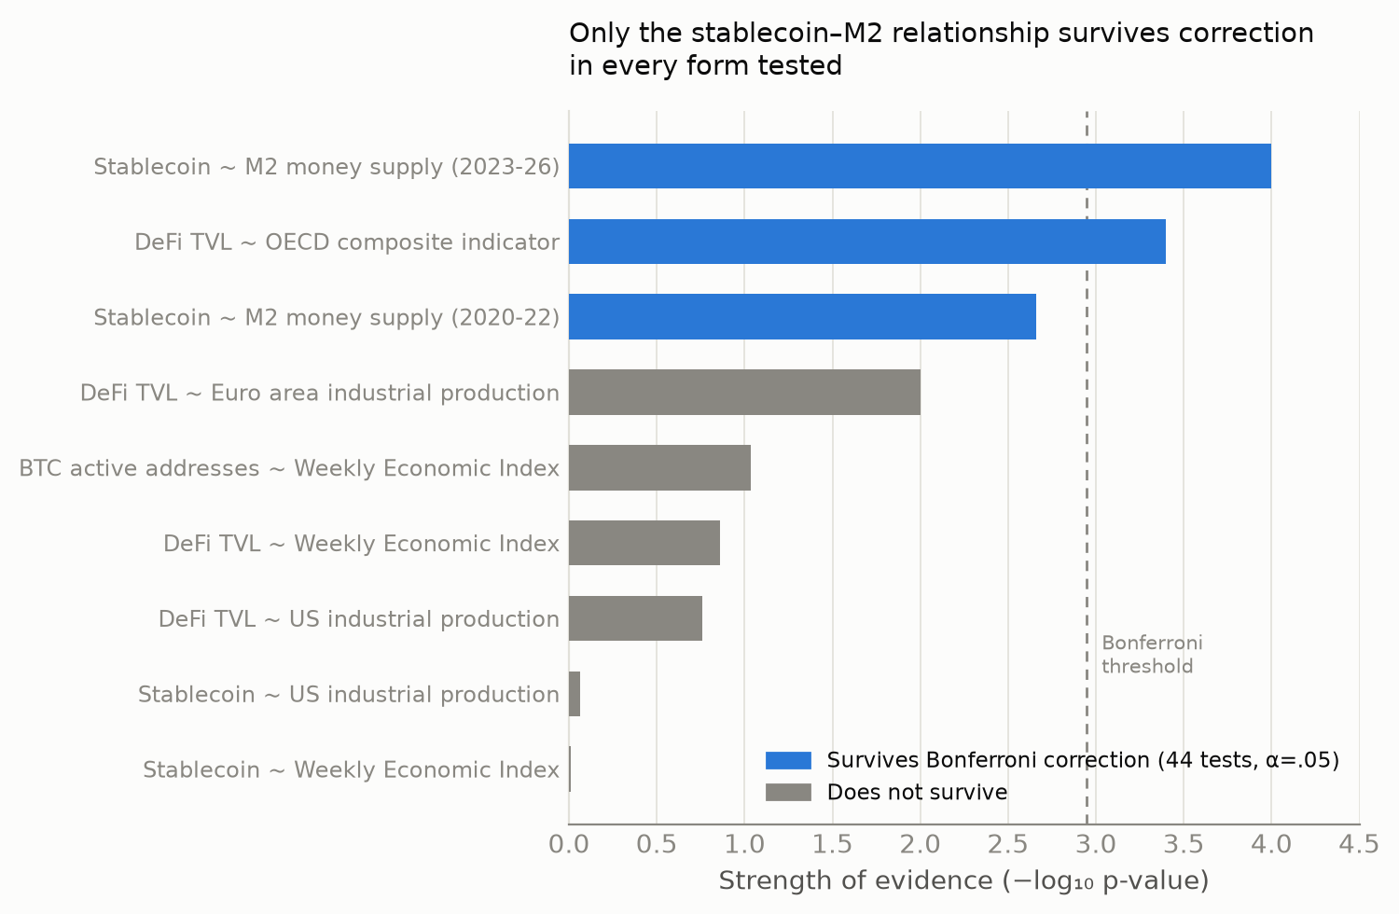
Figure 1. Summary of all crypto specifications tested, ranked by strength of evidence. Only relationships involving stablecoin supply and monetary liquidity (M2), plus the broadest international benchmark, survive correction for multiple testing.
Across 44 specifications run in total (including sub-period splits and placebo checks, reported in full in the appendix), a Bonferroni correction leaves only the OECD-benchmark and M2 relationships standing. The DeFi–industrial-production relationship, where nominally significant, is concentrated entirely in 2020–2022 (p = .057) and disappears in 2023–2026 (p = .525) — consistent with a single historical episode (pandemic stimulus flowing simultaneously into industrial recovery and crypto speculation) rather than a stable relationship. A stationarity-corrected Granger causality test finds significance in both directions simultaneously at every lag tested, which is itself diagnostic of a confounded rather than genuinely bidirectional relationship, and is reported as unresolved rather than interpreted further.
Stablecoin supply's relationship with M2 survives every check applied, in both sub-periods independently. This is mechanistically expected — stablecoins are dollar-backed instruments, so their supply is a visible slice of the same liquidity M2 measures — but had not been quantified this precisely before.
3.3 Interpretation
Financialized crypto activity does not track the real economy. Where a relationship appears, it is either a single historical artifact or better explained by monetary liquidity conditions than real output. This should discourage treating DeFi or stablecoin growth as informal real-economy proxies, however intuitive that framing seems given crypto's association with energy and technology.
4. Does Real Electricity Generation Track — or Lead — the Real Economy?
4.1 Data and Sourcing
U.S. electric-utility industrial production (FRED series IPG2211A2N; 98% confidence, official Federal Reserve production index, monthly since 1939) against the Weekly Economic Index, aggregated to monthly frequency, 2009–2026 (N = 210).
4.2 Results
β = 0.60, p < .0001 across the full sample — a real, stable relationship, confirming established literature on direct data rather than an assumed one. A properly specified Granger causality test (both series pass stationarity checks without requiring correction) resolves the causal direction: real activity Granger-causes electricity generation strongly at short lags (p = .002 at one month, p = .016 at two months, fading beyond three months), while electricity generation does not clearly Granger-cause real activity in reverse (p = .05–.12 throughout, never conventionally significant).
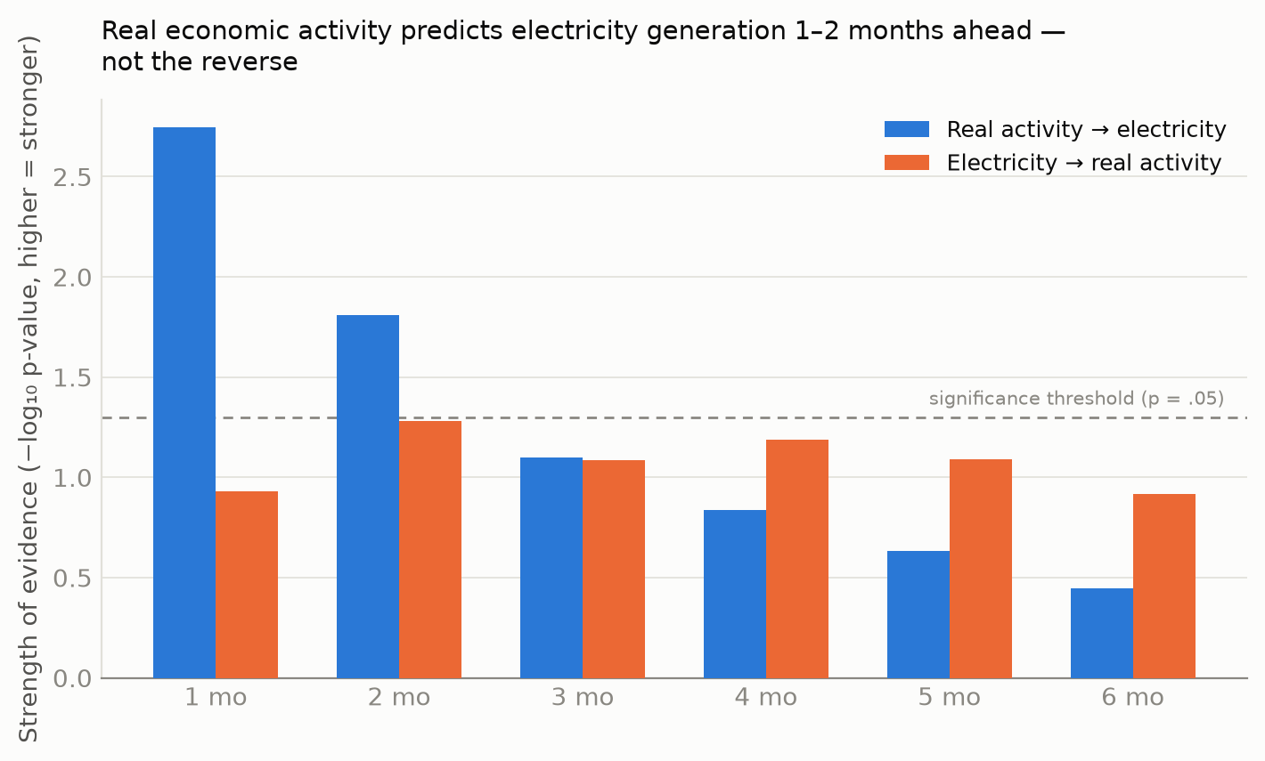
Figure 2. Granger causality test results by lag, both directions. Real economic activity predicts electricity generation strongly at 1–2 month horizons; the reverse relationship never clears conventional significance.
4.3 Interpretation
Electricity generation is a real economic indicator, but coincident-to-lagging rather than leading — it moves roughly one to two months after real activity, not ahead of it. This qualifies how electricity/energy proxies are typically framed in the nowcasting literature: valuable because available faster than official GDP statistics, but not supported here as a genuine early-warning signal of where the real economy is headed.
5. A New, Underused Indicator: Sector-Specific Electricity Demand
5.1 Motivation and Data
Series | Source | Confidence | Basis
Monthly electricity sales by industry sub-sector, Taiwan, 2021–2025 | Taiwan Power Company (Taipower), via Taiwan's national open-government-data platform (data.gov.tw) | 90% | Official state-utility billing data; likely understates true sector consumption (corporate renewable PPAs bypass the grid); most recent month (Dec 2025) shows an economy-wide reporting anomaly (§5.3)

Table 3. Taiwan sector electricity data source.
If financialized crypto metrics fail as indicators and general electricity data is only coincident, the more useful question is whether a real, currently underused energy-linked signal exists. AI infrastructure investment is the most visible new driver of electricity demand globally, but existing indicators of it — corporate capex disclosures, industry-association reports — are quarterly, aggregated, and lag actual demand. Grid operators already publish sector-level electricity sales monthly, in some cases as open government data, without requiring new instrumentation.
5.2 Results
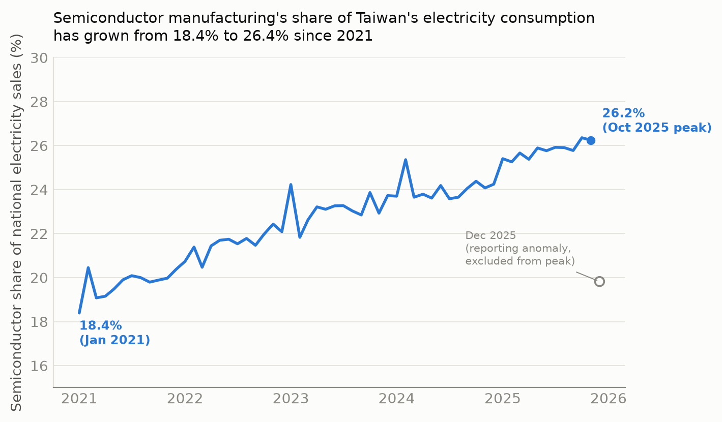
Figure 3. Semiconductor manufacturing's monthly share of Taiwan's total electricity sales, January 2021–December 2025.
Period | Semiconductor share
January 2021 | 18.4%
December 2022 | 22.1%
December 2023 | 23.7%
December 2024 | 24.2%
October 2025 (peak, excluding anomalous Dec reading) | 26.4%

Table 4. Semiconductor sector share of Taiwan's national electricity consumption.
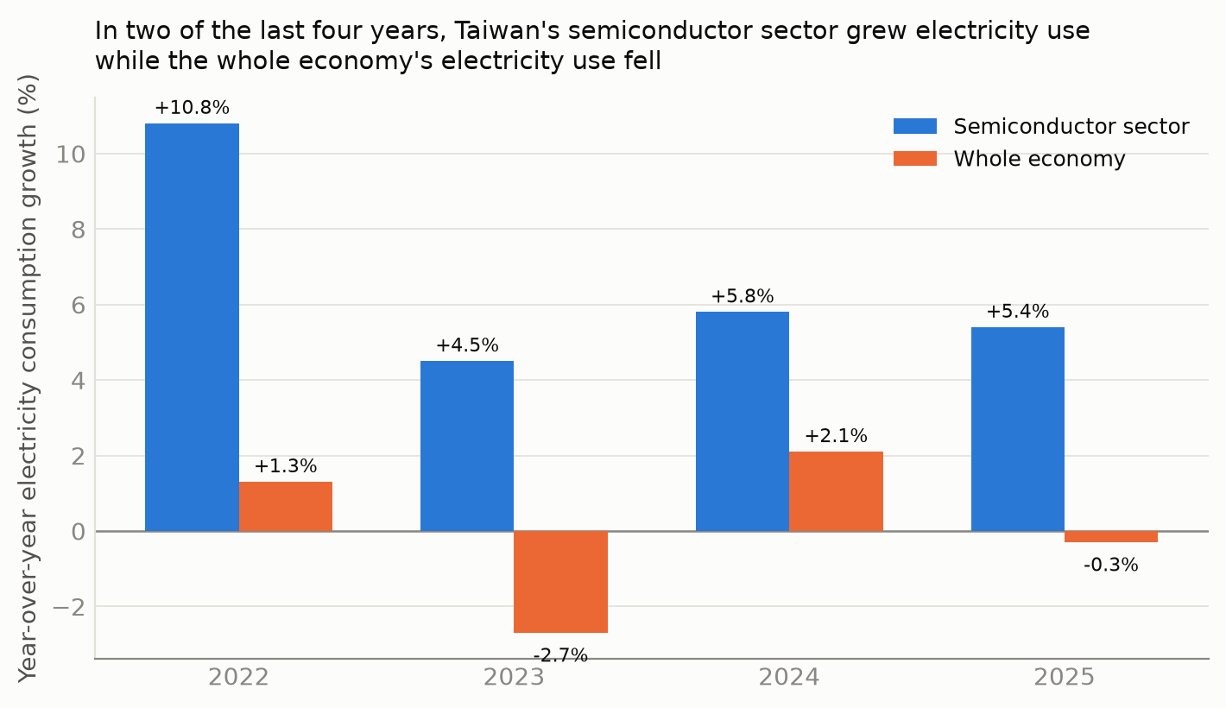
Figure 4. Year-over-year electricity consumption growth, semiconductor sector vs. whole economy, 2022–2025.
In two of the last four years, Taiwan's total electricity consumption fell while its semiconductor sector's electricity consumption continued to grow — evidence against the interpretation that undermined the crypto/DeFi finding, since both series cannot be responding to a shared macroeconomic cycle when they move in opposite directions.
5.3 Data Quality Note: The December 2025 Reading
December 2025 shows an anomalous single-month drop in the semiconductor share (19.8%, versus 26%+ in the surrounding months). Comparing November-to-December changes across all five years available (Table 5) shows this is not a semiconductor-specific event: the whole economy's November-to-December decline in 2025 (−13.9%) is itself far outside the range seen in every prior year (−3.4% to +0.0%).
Year | Semiconductor Nov→Dec | Whole economy Nov→Dec
2021 | +1.8% | −0.2%
2022 | −3.9% | −2.4%
2023 | +3.5% | −0.0%
2024 | −2.7% | −3.4%
2025 | −35.0% | −13.9%

Table 5. November→December change, semiconductor sector vs. whole economy, by year.
This economy-wide anomaly, not confined to one sector, is most consistent with incomplete reporting for the most recent month in the dataset — common in government statistics prior to final revision — rather than a genuine collapse. The October 2025 reading is used as the reported peak in Table 4 for this reason, and the December 2025 figure should be treated as provisional pending a later data release.
5.4 Interpretation
This is the paper's central practical contribution: a real, specific, currently published, and currently underused indicator, requiring no new data infrastructure. It is more granular and more current than the indicators typically used to track AI infrastructure investment, and unlike the crypto metrics in Section 3, its value does not rest on an assumed connection to energy — it is a direct electricity measurement of the specific industrial sector building AI infrastructure, in the country most concentrated in that industry.
6. Conclusion
Not every energy-adjacent metric is an economic indicator, and “connected to energy” is not sufficient justification for treating something as one. Financialized crypto activity fails that test; a narrower claim about stablecoins and monetary liquidity survives it. General electricity generation passes the test with an important qualification — it lags rather than leads. A specific, sector-level electricity signal, already public and already published, captures something current macro indicators do not: the real-time footprint of AI infrastructure investment in the economy most central to building it.
The contribution here does not require new theory or new instrumentation. It requires taking data that already exists, testing plainly whether it means what people assume it means, reporting when it doesn't, and pointing at the more specific and more useful signal that was sitting in public data the whole time.
References
Henderson, J. V., Storeygard, A., & Weil, D. N. (2012). Measuring economic growth from outer space. American Economic Review, 102(2), 994–1028.
International Energy Agency. (2026). Energy and AI. IEA.
Lewis, D., Mertens, K., & Stock, J. H. (2020). U.S. economic activity during the early weeks of the SARS-CoV-2 outbreak. Federal Reserve Bank of New York Staff Reports.
Luo, Y., Feng, Y., Xu, J., & Tasca, P. (2025). Piercing the veil of TVL: DeFi reappraised. Financial Cryptography and Data Security 2025 (FC25).
Makarov, I., & Schoar, A. (2020). Trading and arbitrage in cryptocurrency markets. Journal of Financial Economics, 135(2), 293–319.
Medina, L., & Schneider, F. (2019). Shedding light on the shadow economy: A global database. CESifo Working Paper No. 7981.
Data and reproduction code available upon request — all figures in this draft were pulled live from DefiLlama, FRED, Coin Metrics, and Taiwan's open-government-data platform during analysis; nothing is estimated or assumed unless explicitly labeled as such.

