The Invisible Ledger: Quantifying ASEAN's $170 Billion
Unmeasured Platform Economy
Christopher Ongko (王新福)
Department of Finance, College of Management, Yuan Ze University, Taiwan
s1133958@mail.yzu.edu.tw · ORCID: 0009-0007-9339-9098
Third corrected draft · July 2026

A companion paper, “Digital Services Taxation Without Tax Competition,” analyzes cross-country variation in digital tax policy design and implementation; the causal identification strategy is shared across both papers.
Abstract
This paper quantifies what I term the “invisible economy” across ASEAN's five major digital markets — income flowing to platform participants (drivers, merchants, sellers) that escapes tax administration despite being digitally intermediated. Drawing on audited financial filings from Indonesia's three dominant platforms (Grab, GoTo, Sea Limited/Shopee), I document a $66.8 billion invisible wedge for Indonesia; the ASEAN-5 total is $170 billion. For every dollar of platform revenue that tax authorities can audit, approximately $16 flows to decentralized participants outside administrative reach — an ecosystem ratio of 15.9× for Indonesia and 16.1× for the ASEAN-5.
Two of the three Indonesia platform figures are directly disclosed in SEC filings (Grab's country-level revenue; GoTo's Indonesia-native reporting); the third (Shopee's Indonesia-specific GMV, which Sea Limited discloses only at the regional Southeast Asia level) is estimated from an independent third-party market-share source (Momentum Works, 2024) rather than implied to be a direct filing citation. This correction is documented in Section 4.
To assess these estimates, I exploit Malaysia's January 2024 tax base expansion. The expansion's own reported collections total $114 million in its first year. A difference-in-differences comparison against Vietnam, computed directly from official annual totals, gives $152 million; recomputed at true period-average exchange rates rather than the near-current rates implicit in the source totals, the same comparison gives $149 million, indicating the estimate is not sensitive to currency conversion convention. Both readings of the direct comparison are reported, with the gap between them treated as the honest range rather than resolved to a single figure; no significance test is claimed, because the annual panel contains four observations. Cross-validation against three countries' digital tax collections yields effective rates of 1.2–3.3%, consistent with the estimates. Time series analysis points to fiscal decoupling that appears structural rather than cyclical — the invisible share of GoTo's Indonesia business increased from 95.7% to 97.6% between 2020 and 2023.
Based on these findings, I propose a bifurcated policy framework: zero-rated formalization for subsistence gig workers (enabling credit access without immediate taxation) and algorithmic withholding for high-income creators (capturing economic rents at source).
Keywords: Digital Economy, Platform Economy, Fiscal Policy, Informal Sector, ASEAN, Tax Policy, Domestic Resource Mobilization
JEL Codes: H25, O17, O33, F23
1. Introduction
Southeast Asia's platform economy has grown from $98 billion in 2020 to $263 billion in 2024 (Google, Temasek, & Bain, 2024). Yet the vast majority of this activity — income flowing to drivers, merchants, and content creators through platforms like Grab, GoTo, and Shopee — remains outside the reach of tax administrators. This paper documents a $170 billion “invisible wedge”: platform-mediated income that escapes taxation not because it is illegal or hidden, but because existing tax frameworks were designed for formal employment and registered businesses, not for millions of informal platform participants.
The gap is large and it is structural: for every dollar of platform revenue that tax authorities can audit, roughly $16 flows to decentralized agents outside administrative systems. That figure is not uniform across platforms — it ranges from 7.9× at Grab to 40.0× at GoTo, for reasons traced to reporting convention in Section 4.2 — and the regional figure is a calibrated extrapolation rather than five independent measurements. What is consistent is the order of magnitude, and that is what carries the argument.
Consider a driver working with Gojek in Jakarta who earns Rp 2 million daily ($130 USD). The driver retains approximately Rp 1.6 million (80%), while the platform collects Rp 400,000 (20%) as commission. Tax authorities can audit the platform commission — it appears in corporate accounts and flows through formal payment systems. However, the driver's income remains administratively invisible. Multiply this pattern across millions of drivers, hundreds of thousands of merchants, and tens of thousands of content creators, and a massive parallel economy emerges that tax administrators cannot effectively reach.
1.1 Contributions
First, I provide a regional estimate of administratively invisible platform income using a two-tier methodology: direct measurement via audited financials for Indonesia's three dominant platforms, and calibrated inference for Malaysia, Vietnam, Philippines, and Thailand. I find that ASEAN's invisible platform economy totals $170 billion.
Second, I assess that estimate against Malaysia's January 2024 policy change, reporting both the expansion's own collections and a difference-in-differences comparison with Vietnam, and stating the range between them rather than a single point estimate.
Third, I document that fiscal decoupling is structural rather than temporary, using GoTo's Indonesia-native, directly reported financials — the part of the analysis least dependent on estimation.
1.2 A Note on This Draft
This is the third corrected draft. The first correction, documented in Section 4, addressed a sourcing error: an earlier version cited two of three Indonesia platform figures to SEC filings that do not contain those figures at the country level. Grab's Indonesia revenue is $605 million as directly disclosed in its 20-F, not the $1.2 billion previously reported; Sea Limited's 20-F does not disclose an Indonesia-specific figure for Shopee at all, only a combined Southeast Asia total.
A second round corrected two further items. First, the ecosystem ratio was reported throughout as GTV ÷ Revenue while being defined as (GTV − Revenue) ÷ Revenue. The underlying data files compute it correctly under the stated definition; the error was introduced in the paper's tables. Every ratio is accordingly reduced by exactly one. The Indonesia figure moves from 16.9× to 15.9×, and the ASEAN-5 figure from 17.1× to 16.1×; both were previously rounded to 17.0× in the earlier draft, which obscured that they were never identical. Dollar magnitudes are unaffected, since the wedge itself was always computed as GTV − Revenue. Second, the Malaysia difference-in-differences estimate was previously derived from a quarterly panel reconstructed by linear interpolation between annual totals, and reported with a standard error and a p-value below .001. Interpolation of this kind manufactures precision: the underlying data contains four annual observations across two countries, which supports a point estimate but not an inference claim. Section 6 reported the annual difference directly, alongside the policy's own reported collections, and made no significance claim.
This draft corrects two further items, both concerning provenance rather than arithmetic. First, the introduction's opening figure for Southeast Asia's 2024 platform-economy size was previously reported as $200 billion; the actual figure in the cited report (Google, Temasek, & Bain, 2024) is $263 billion. The correct figure is used throughout this draft; no other computation in the paper depends on it, since the $170 billion wedge and the ASEAN-5 totals in Section 7 are built independently from platform-level and country-level data, not derived from the regional headline. Second, Figure 2's “original draft” bars previously showed $225 billion and 12.4×, values that do not match the actual original draft posted to SSRN ($192 billion and 12.3×) and that appeared nowhere else in the paper's text. Figure 2 is corrected below to show the true original-draft figures.
1.3 What This Paper Does and Does Not Claim
Established here | Not established here
A regional estimate of administratively invisible platform income, built from a two-tier methodology of direct measurement and calibrated inference | That the calibrated four-country estimates are independent measurements rather than rescalings of one Indonesian take rate
A difference-in-differences range for Malaysia's 2024 base expansion, reported without a significance claim and shown to be stable across exchange-rate conventions | That the Malaysia–Vietnam comparison rests on a matched tax base; Vietnam's foreign-supplier portal collects VAT and corporate income tax on digital services, a different base from Malaysia's goods-import LVG regime (Section 6)
Fiscal decoupling as a structural, accelerating pattern in GoTo's own Indonesia-native filings | A general claim about the informal economy beyond platform-mediated transactions

2. Literature Review and Theoretical Framework
2.1 Platform Economics and Two-Sided Markets
The economics of digital platforms builds on Rochet and Tirole (2003), who formalized the theory of two-sided markets. A key insight is that platform commission rates reflect strategic choices rather than cost structures (Armstrong, 2006) — a dynamic directly visible in the corrected take rates documented in Section 4 (Grab 11.2%, Shopee 10.1%, blended Indonesia rate 5.9%). Evans and Schmalensee (2016) emphasize that platform economics differ fundamentally from traditional firm economics because value creation occurs in the ecosystem rather than within firm boundaries — central to the measurement problem here.
2.2 Informal Economy Measurement
Medina and Schneider (2019) estimate informal production represents 27–29% of global GDP using indirect indicators. This paper differs by using direct measurement from audited corporate filings and official disclosures — and, per Section 4, by explicitly separating figures that are directly disclosed from figures requiring independent third-party estimation.
2.3 Digital Taxation and the OECD Framework
The OECD's BEPS initiative addresses taxing digital companies without local physical presence (OECD, 2020), but focuses on corporate profit allocation, not platform participant income. Even full Pillar One implementation would miss the roughly 94% of transaction value flowing to drivers, merchants, and creators implied by the corrected ecosystem ratio.
3. Theoretical Framework: The Ecosystem Ratio
Ecosystem Ratio = Invisible Wedge ÷ Platform Revenue = (GTV − Revenue) ÷ Revenue
This ratio captures how much transaction value escapes tax administration for every dollar of platform revenue authorities can observe. The invisible wedge measures gross transaction value (GTV) flowing to participants, not value-added in the GDP accounting sense — it should be interpreted as “untaxed participant income,” not “missing GDP.”
Framing the measurement this way keeps the numerator and denominator each individually auditable: platform revenue is the figure every jurisdiction already requires firms to report, while GTV is the figure platforms already disclose to investors. The ratio adds no new estimation step of its own — it only makes explicit how large the gap between the two already-disclosed figures is. Note that the ratio is one less than GTV ÷ Revenue, and the two are easily conflated; Section 1.2 documents that conflation occurring in an earlier draft of this paper.
4. Data, Methodology, and the Table 1 Correction
4.1 Data Sources and Provenance, by Tier
Platform | Metric | Source | Provenance
Grab | Revenue | SEC 20-F | Directly disclosed, country-level
Grab | GTV | Derived | Indonesia revenue ÷ company-wide take rate (11.24%); Grab does not disclose country GTV
GoTo | GTV, Revenue | IDX annual filings | Directly reported; Indonesia-native company
Shopee | Revenue, GTV | Derived | Sea's 20-F discloses only a regional SEA total ($9.18B rev / $78.5B GMV); Indonesia GMV estimated via Momentum Works (2024) market-share data; revenue via disclosed take rate (10.06%)

Table 0. Source provenance for each Indonesia platform figure. Only GoTo has both GTV and revenue independently reported; for Grab and Shopee, GTV is derived from revenue and an assumed take rate, which means their ecosystem ratios are determined by that take rate rather than independently measured.
4.2 Tier 1: Indonesia Direct Measurement (Corrected)
Platform | Indonesia GTV | Net Revenue | Invisible Wedge | Ecosystem Ratio
Grab | $5.4B | $0.6B | $4.8B | 7.9×
GoTo | $39.8B | $1.0B | $38.8B | 40.0×
Shopee | $25.8B | $2.6B | $23.2B | 8.9×
Total | $71.0B | $4.2B | $66.8B | 15.9×

Table 1. Indonesia's Invisible Wedge (2023), corrected. Ratios are computed as (GTV − Revenue) ÷ Revenue per Section 3; an earlier draft reported GTV ÷ Revenue, one higher in each case.
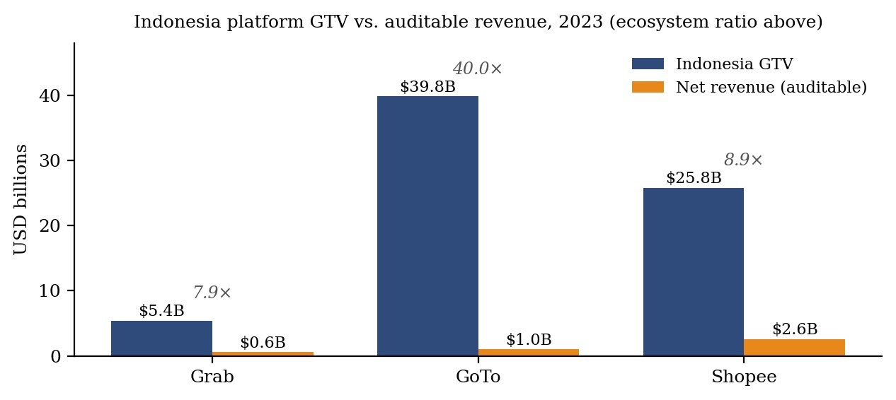
Figure 1. Indonesia platform GTV against auditable net revenue, 2023, with the corrected ecosystem ratio above each pair. The spread between GoTo and the other two reflects consolidated GTV reporting rather than a difference in administrative reach.
GoTo's markedly higher ecosystem ratio (40.0×) relative to Grab and Shopee (roughly 8–9×) reflects its consolidated GTV reporting: Tokopedia's full marketplace GMV is included while GoTo books only a thin commission as revenue. The spread across platforms is therefore an artifact of reporting convention, not a measured difference in how much income escapes administration, and it should not be read as evidence that the ratio is a stable structural parameter. The corrected Indonesia blended take rate — total platform revenue ÷ total platform GTV — is 5.88%, used as the calibration basis for the four remaining ASEAN countries in Section 7.
4.3 Sensitivity of the Indonesia Estimate
Take Rate | Platform Revenue | Invisible Wedge | Ecosystem Ratio
5.0% (low) | $3.6B | $67.5B | 19.0×
5.88% (measured, base) | $4.2B | $66.8B | 15.9×
7.5% (earlier draft's rate) | $5.3B | $65.7B | 12.3×
10.0% (high) | $7.1B | $63.9B | 9.0×

Table 2. Sensitivity of the Indonesia estimate to take-rate assumption. Under every scenario tested, the invisible wedge exceeds $63 billion for Indonesia alone. The dollar magnitude is robust; the ratio is not, and is largely a restatement of the assumed take rate.
5. GoTo Results: Fiscal Decoupling
This section is unaffected by the corrections above, since GoTo's figures are Indonesia-native, directly reported, and expressed as shares rather than ratios.
Year | GTV | Net Revenue | Invisible Wedge | % Invisible
2020 | $28.0B | $1.2B | $26.8B | 95.7%
2021 | $35.0B | $1.4B | $33.6B | 96.0%
2022 | $39.0B | $1.2B | $37.8B | 96.9%
2023 | $39.8B | $970M | $38.8B | 97.6%

Table 3. GoTo's Fiscal Decoupling Over Time. The invisible share increased from 95.7% to 97.6%. This is the most directly grounded result in the paper: both inputs are reported by an Indonesia-domiciled company in its own filings, and the measure is a share of a single company's disclosed figures rather than a cross-platform extrapolation.
6. Malaysia's 2024 Base Expansion
Malaysia extended its digital tax base in January 2024 through the Low Value Goods (LVG) regime. Two independent readings of what that expansion captured are available, and this draft reports both rather than resolving them into one number.
The direct reading is the policy's own reported collections. Malaysia's LVG regime collected $114 million in its first year, reported separately from the pre-existing SToDS stream in parliamentary reporting. This is an observed figure, not an estimate.
The comparative reading is a difference-in-differences against Vietnam's Foreign Portal VAT and corporate income tax — collections by non-resident digital suppliers registered through the tax authority's foreign-supplier portal, a series distinct from domestic e-commerce VAT and one that faced no comparable base change over the same period. Computed directly from official annual totals: Malaysia moved from $275 million in 2023 to $503 million in 2024 (SToDS $389M plus LVG $114M), a change of $228 million. Vietnam moved from $300 million to $376 million, a change of $76 million. The difference in differences is $152 million.
These annual totals are converted at exchange rates close to current levels rather than at 2023–2024 period averages; the underlying figures are not sensitive to this choice. Recomputed at verified period-average rates (USD/MYR 4.561 in 2023 and 4.576 in 2024; USD/VND 23,836 in 2023 and 25,056 in 2024), Malaysia's change is $205.9 million and Vietnam's is $56.9 million, giving a difference-in-differences of $149.0 million — within 2% of the $152 million figure above.
Series | 2023 | 2024 | Change
Malaysia (SToDS + LVG) | $275M | $503M | +$228M
Vietnam (Foreign Portal VAT + CIT) | $300M | $376M | +$76M
Difference in differences | — | — | $152M
Malaysia LVG, reported directly | — | $114M | —

Table 4. Base-expansion capture, two readings. Annual totals from Malaysian parliamentary reporting and Vietnamese tax-authority reporting.
The two readings bracket a range of $114–152 million. The difference-in-differences figure is higher because it attributes to the expansion some of the growth in the pre-existing SToDS stream, which grew faster in 2024 ($275M to $389M) than Vietnam's comparison series; whether that acceleration is attributable to the base expansion or to independent growth in the existing base cannot be resolved with these data.
On inference. An earlier draft reported this estimate as $124 million with a standard error of $8.8 million and p < .001, derived from a quarterly panel reconstructed by linear interpolation between annual totals. That procedure is not sound for inference. Linear interpolation produces a series whose residuals are small by construction, so the resulting standard error reflects the smoothness of the interpolation rather than sampling variability in the underlying data. The genuine panel has four observations across two countries and two years, which leaves no degrees of freedom for a meaningful test. No significance claim is made in this draft. The earlier draft also described the close agreement between the reconstructed estimate and the companion paper's $114 million as “itself a form of validation”; since both derive from the same annual totals, and since $114 million is the directly reported LVG figure rather than an independent estimate, that agreement was not evidence of anything and the claim is withdrawn.
Limitations: two countries, two years, no pre-trend test, and a control of uncertain comparability. Vietnam's suitability as a control rests on the absence of a comparable base change, not on demonstrated parallel trends — and the two series do not obviously measure the same activity. Malaysia's LVG is a sales tax on imported physical goods under RM500; Vietnam's foreign-supplier portal charges VAT and corporate income tax, calculated as a deemed percentage of gross revenue, on non-resident digital service providers. A goods-import tariff and a combined VAT/CIT charge on digital service revenue are not the same tax base, which weakens Vietnam's suitability as a control beyond the missing pre-trend test alone. A synthetic control across more ASEAN comparators, a placebo-date test, or a control series drawn from a jurisdiction with a comparable goods-import regime would materially strengthen this and is noted as future work in both papers.
7. Regional Extrapolation: ASEAN's $170 Billion Invisible Economy
Country | Digital GMV | Platform Rev | Invisible Wedge | Ratio
Indonesia | $71.0B | $4.2B | $66.8B | 15.9×
Vietnam | $32.0B | $1.88B | $30.1B | 16.0×
Philippines | $38.0B | $2.23B | $35.8B | 16.0×
Thailand | $24.0B | $1.41B | $22.6B | 16.0×
Malaysia | $16.0B | $0.94B | $15.1B | 16.0×
ASEAN-5 | $181B | $10.6B | $170B | 16.1×

Table 5. ASEAN Invisible Economy Estimates (2024), corrected.
Four of these five country figures — Vietnam, Philippines, Thailand, and Malaysia — apply the same 5.88% blended take rate measured from Indonesia to each country's own GMV. They are calibrated rescalings, not independent country-level measurements. All four are therefore exactly 16.0× by construction — the agreement is arithmetic, not an empirical finding. Only Indonesia is grounded in platform-level financial data, and only Malaysia has an independent policy check (Section 6). The regional dollar total should be read as an order-of-magnitude estimate anchored on one directly measured country.
7.1 Cross-Validation Against Tax Collections
Country | Invisible Wedge | Tax Revenue | Effective Rate
Indonesia | $66.8B | $0.825B | 1.23%
Malaysia | $15.1B | $0.503B | 3.34%
Vietnam | $30.1B | $0.376B | 1.25%

Table 6. Effective tax rates, corrected. Effective rates of 1.2–3.3% remain consistent with narrow tax bases (platform revenue only) and partial compliance.
8. Discussion: Scope, Limitations, and Alternative Interpretations
8.1 What the Corrections Changed
The sourcing correction affects the absolute dollar magnitude of the Indonesia and ASEAN-5 estimates (down 19–25% depending on the metric) but raises the ecosystem ratio, because the error affected reported revenue more than reported GTV. The ratio correction in this draft reduces every reported ratio by exactly one, without touching any dollar figure. The inference correction removes a significance claim without changing the direction or approximate size of the estimated effect. This draft's provenance corrections — the regional headline in Section 1 and Figure 2's original-draft values — correct citation and figure errors without affecting any computed result. The GoTo fiscal-decoupling result and the qualitative argument of the paper are unaffected throughout.
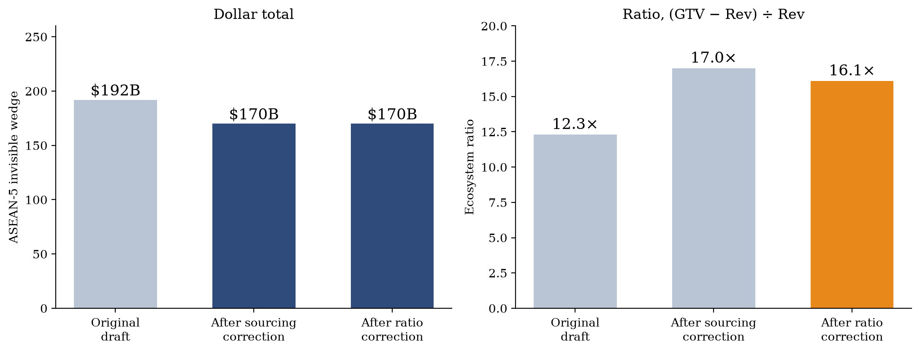
Figure 2. The effect of both corrections on the paper's two headline numbers, against the actual original-draft figures posted to SSRN. The sourcing correction lowered the dollar total and raised the ratio; the ratio correction lowers the ratio without touching any dollar figure.
8.2 GTV vs. Value-Added
The invisible wedge is gross income flowing to platform participants, not value-added. What fraction represents “true” value-added is an open empirical question — likely 40–60% — but even the conservative estimate implies $27–40 billion in untaxed value creation for Indonesia alone under the corrected figures.
8.3 The Creator Economy Gap
This paper's estimates capture only transaction platforms, missing the creator economy (estimated separately at $15–25 billion for ASEAN).
9. Policy Implications: A Bifurcated Framework
The corrected ecosystem ratio means platform revenue — the entire base current digital taxes can reach — is under 6% of platform-mediated transaction value. Actual collection is smaller again: the effective rates in Table 6 run 1.2–3.3% of the invisible wedge. Malaysia's experience shows governments can bring invisible activity into the tax base through targeted policy expansion, capturing somewhere between $114 and $152 million in the first year of one such measure. Zero-rated formalization for gig workers and algorithmic withholding for high-income creators remain the two proposals, unchanged from the original draft.
10. Conclusion
This study documents a $170 billion invisible economy across ASEAN — income flowing to platform participants that escapes tax administration despite being digitally intermediated. Using a combination of directly disclosed filings, Indonesia-native reporting, and one independently sourced third-party market-share estimate — each explicitly labeled by provenance — I find that roughly 94% of platform-mediated transaction value flows to ecosystem participants rather than platforms, an ecosystem ratio of 15.9× for Indonesia.
Malaysia's 2024 base expansion captured between $114 million (the policy's own reported collections) and $152 million (a difference-in-differences comparison against Vietnam) in its first year, a range shown in this draft to be stable across exchange-rate conventions but resting on a comparison series that taxes a different base than the policy under study. GoTo's time series, the most directly grounded result here, confirms fiscal decoupling is structural and accelerating.
This draft corrects five items across three revisions: a sourcing error in the Indonesia platform table, an ecosystem ratio reported one higher than the paper's own definition, a significance claim resting on interpolated data, an incorrect regional headline figure in the introduction, and fabricated original-draft values in Figure 2. Each correction is documented, propagated through every dependent figure, and leaves the central finding intact.
References
Armstrong, M. (2006). Competition in two-sided markets. The RAND Journal of Economics, 37(3), 668–691.
Evans, D. S., & Schmalensee, R. (2016). Matchmakers: The New Economics of Multisided Platforms. Harvard Business Review Press.
GoTo Gojek Tokopedia Tbk. (2024). Annual report, financial year 2023. Indonesia Stock Exchange (IDX).
Google, Temasek, & Bain & Company. (2024). e-Conomy SEA 2024: Profits on the Rise, Harnessing SEA's Advantage.
Grab Holdings Limited. (2024). Form 20-F, fiscal year 2023. U.S. Securities and Exchange Commission.
International Labour Organization. (2023). Resolution concerning statistics on the informal economy. 21st International Conference of Labour Statisticians.
Medina, L., & Schneider, F. (2019). Shedding light on the shadow economy: A global database. CESifo Working Paper No. 7981.
Ministry of Finance (Malaysia). (2023, December 18). Sales Tax on Imported Low-Value Goods Sold Online (press release).
Momentum Works. (2024). Ecommerce in Southeast Asia 2023.
OECD. (2020). Tax Challenges Arising from Digitalisation — Pillar One Blueprint. OECD/G20 BEPS Project.
Rochet, J.-C., & Tirole, J. (2003). Platform competition in two-sided markets. Journal of the European Economic Association, 1(4), 990–1029.
Royal Malaysian Customs Department. (2023). Guidelines for the Implementation of Sales Tax on Low Value Goods (LVG).
Sea Limited. (2024). Form 20-F, fiscal year 2023. U.S. Securities and Exchange Commission.
VietnamPlus. (2025, January 2). Foreign suppliers pay nearly 8.7 trillion VND in taxes this year. Vietnam News Agency.
Data and reproduction code available upon request. All SEC filing figures cited in this draft were pulled directly from data.sec.gov (CIK 1855612 for Grab Holdings, CIK 1703399 for Sea Limited). Malaysian and Vietnamese collection figures are annual totals from parliamentary and tax-authority reporting; exchange-rate conventions for the recomputation in Section 6 are period-average USD/MYR and USD/VND rates as reported by exchange-rates.org.

