OceanEmbed
Software Architecture & Design Document
High-Level Design, Low-Level Design, Data Flows and Framework Reference
Regime-conditioned, physics-constrained deep learning for
subsurface ocean reconstruction in the North Indian Ocean / Bay of Bengal
Smart India Hackathon · Ministry of Earth Sciences · Space Technology
Repository: github.com/Specter842/oceanembed
Document version 1.0 — September 2026

Contents

1 Introduction

1.1 Purpose and scope
This document describes the software architecture of OceanEmbed: its high-level structure (HLD), the internal design of every module (LLD), the data and control flows between them, and how each third-party framework is used. It is written to be read alongside the source tree at github.com/Specter842/oceanembed and the build specification in that repository's CLAUDE.md.
OceanEmbed reconstructs vertical profiles of ocean temperature and salinity, from the surface to about 2000 m, from satellite observations of the sea surface. It is an offline batch system: it downloads historical satellite and float data, builds a matched training set, trains a model plus a comparison baseline, evaluates them on physically-separated holdouts, and serves the results through a dashboard.

1.2 What the system claims
The contribution is a combination of three independently-proven techniques applied to a basin the international ocean-ML literature has largely passed over, not a new algorithm:
- Transfer learning from a pretrained geospatial backbone (ResNet-50 / ResNet-18 / Prithvi-EO).
- Regime conditioning derived from data that is independent of the prediction inputs (a stratification climatology and a river-discharge seasonal cycle), so the conditioning cannot leak the answer.
- A physics-consistency loss term based on the seawater equation of state.
Explicitly not claimed: a novel architecture, real-time ingestion, a from-scratch foundation embedding, or a guaranteed accuracy win in every regime.

1.3 Definitions and acronyms
Term | Meaning
Argo | Global array of autonomous profiling floats measuring T/S to ~2000 m
SST / SSH / SLA / SSS | Sea-surface temperature / height / level anomaly / salinity
MLD / ILD / BLT | Mixed-layer depth / isothermal-layer depth / barrier-layer thickness (ILD - MLD)
Barrier layer | A salinity-stratified layer between the density mixed layer and the thermocline; the Bay of Bengal's defining feature
Regime | One of {well_mixed, barrier_layer_stratified, upwelling} assigned per space-time point
FiLM | Feature-wise Linear Modulation: y = x·(1+gamma(c)) + beta(c)
EOS-80 / TEOS-10 | Equation of state of seawater (UNESCO 1983 / 2010)
ERDDAP / OPeNDAP | Server protocols for subsetting scientific gridded and tabular data over HTTP
WOA23 | World Ocean Atlas 2023 monthly temperature/salinity climatology
NIO box | Analysis domain: 5 S - 25 N, 45 E - 100 E
Holdout | A test partition separated physically (by region or season), never randomly

2 High-Level Design

2.1 System context
OceanEmbed sits between a set of public scientific data services and a set of local artefacts that downstream consumers (the evaluation scripts and the dashboard) read. It holds no server of its own and requires no authentication: every source below is reachable anonymously over HTTPS.
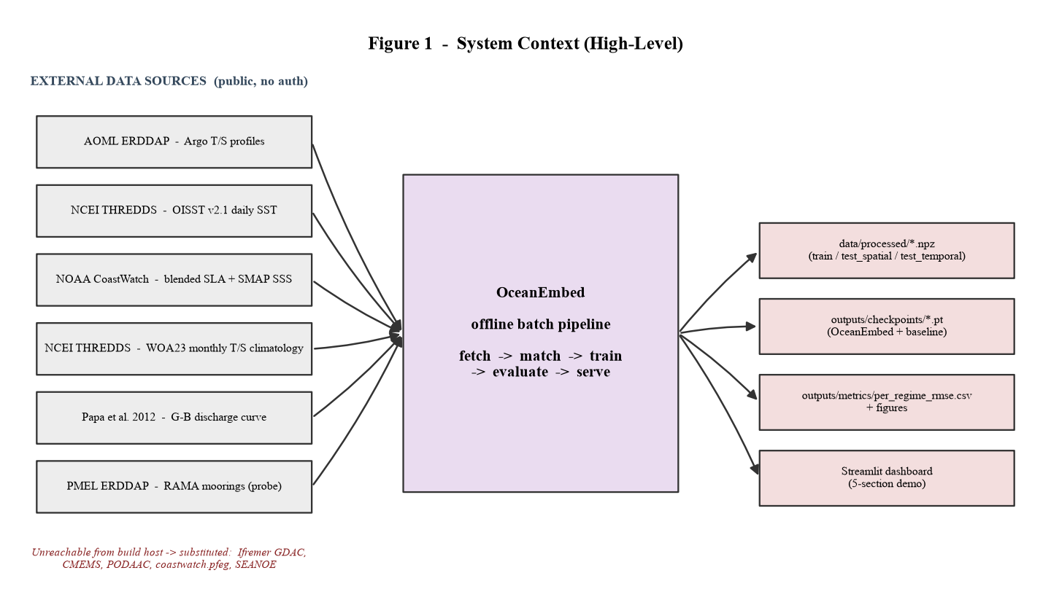
Figure 1 — System context. Left: external data services. Centre: the offline batch pipeline. Right: the local artefacts it produces.
A network constraint shaped the source list. From the build host, an entire class of hosts is unreachable (*.ifremer.fr, seanoe.org, coastwatch.pfeg.noaa.gov, CMEMS, PODAAC). Every such source was replaced by a reachable NOAA-hosted equivalent, documented per row in data/raw/phase0_report.md and in Section 3.2 below.

2.2 Architectural style and principles
- Pipeline of pure stages. Each stage reads files, writes files, and can be re-run in isolation. There is no long-running process and no shared mutable state between stages.
- Artefacts are the interface. Stages communicate only through on-disk files (Parquet, NetCDF, NPZ, JSON, CSV, PNG). The dashboard and the evaluation code never import the training code.
- Enforced non-circularity. The regime-labelling package is import-isolated from the satellite-fetching package; a unit test fails the build if that boundary is crossed.
- Physical, not random, evaluation. Train/test partitions are made by withholding a whole region and a whole season, at file-writing time.
- Device-agnostic. Training auto-detects CUDA and enables mixed precision; the same code path runs on CPU.
- Honest reporting. Results are regenerated by scripts, never hand-edited, and a negative barrier-layer result is reported as-is (Section 8).

2.3 Module decomposition
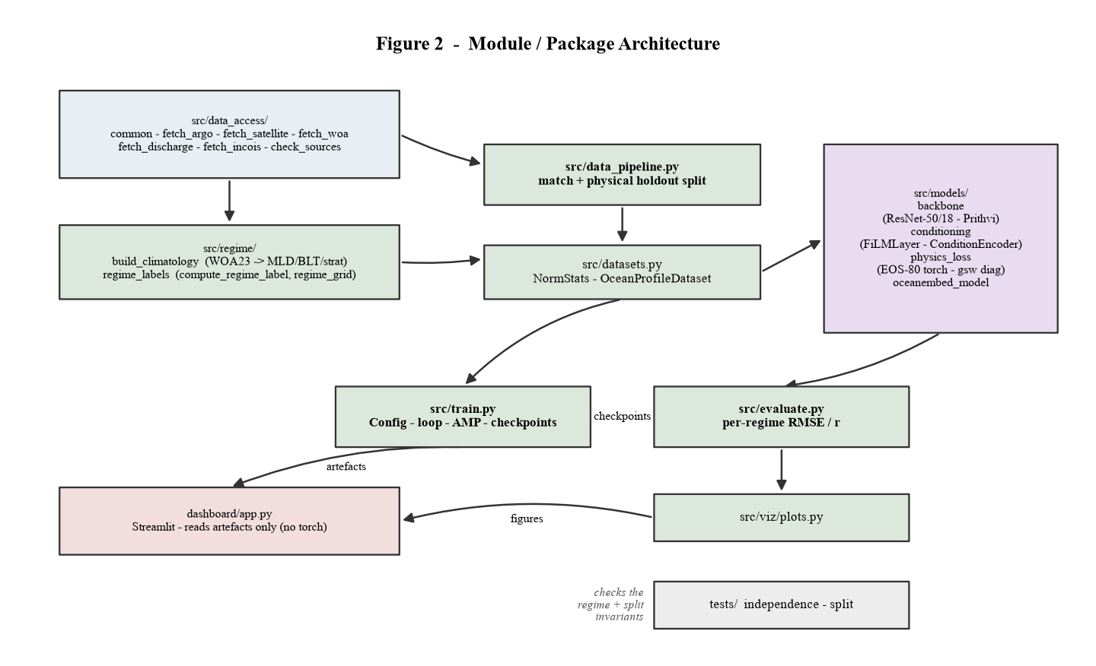
Figure 2 — Module dependency graph. Arrows point from producer to consumer. The dashboard depends only on artefacts, not on any Python module here.
Package / module | Responsibility
src/data_access/ | Fetch and cache every external dataset; expose the list of reachable endpoints (common.py)
src/regime/ | Build the stratification climatology from WOA23; assign a regime class + stratification index per point
src/data_pipeline.py | Interpolate profiles to standard depths, match to the weekly satellite stack, split into physical holdouts, write NPZ tensors
src/datasets.py | Torch Dataset over the NPZ files; load and apply normalisation statistics
src/models/ | Backbone, FiLM conditioning, EOS-80 physics loss, and the assembled OceanEmbedModel
src/train.py | Config dataclass, training/validation loop, AMP, checkpointing, CSV logging
src/evaluate.py | Batched inference; per-regime, per-depth RMSE and correlation; TEOS-10 diagnostics
src/viz/plots.py | The three Phase-3 figures
dashboard/app.py | Streamlit demo (five sections); reads artefacts only
tests/ | Static import-independence check; split-disjointness assertion

2.4 Technology stack
Concern | Choice | Notes
Language | Python 3.14 | Spec asked for 3.11; all dependencies install on 3.14 except argopy (not used)
Arrays / gridded data | numpy, xarray, netCDF4, h5netcdf, h5py | xarray for labelled arrays + OPeNDAP subsetting
Tabular / columnar | pandas, pyarrow | Parquet for the matched profile table
HTTP / data protocols | requests, erddapy, pydap | ERDDAP tabledap + griddap; THREDDS file server; OPeNDAP
Seawater physics | gsw (TEOS-10) | Climatology density + evaluation diagnostics; loss uses a torch EOS-80 port
Deep learning | PyTorch + torchvision | CPU build on the build host; CUDA build on the training machine
Geospatial backbone | terratorch (optional) | Loads Prithvi-EO-2.0; falls back to ResNet-50 if absent
Plots | matplotlib (Agg) | Phase-3 figures and the diagrams in this document
Dashboard | streamlit, plotly | Interactive demo
Testing | pytest | Two invariants (Section 6.4)

2.5 Data stores and artefacts
Nothing outside the working tree is written. The three data tiers mirror the CLAUDE.md layout:
- data/raw/ — downloaded source files, cached by month/week so re-runs are cheap. Git-ignored; ~1.7 GB.
- data/interim/ — the consolidated profile table, the weekly satellite stack, and the two climatologies.
- data/processed/ — the three training-ready NPZ tensors plus norm_stats.json.
- outputs/ — checkpoints (git-ignored, ~47 MB each), metrics CSVs and prediction NPZs, and the figures (committed as evidence).

2.6 Runtime / deployment view
There are two machines. The build host (no CUDA GPU) runs the data pipeline and holds the code; it was used to smoke-test training. The training machine (a CUDA laptop) runs the full training and evaluation. Both use the same code; train.py branches on torch.cuda.is_available(). The dashboard runs anywhere the artefacts are present and imports no torch.

3 Data Architecture

3.1 Data sources (as used)
Role | Product | Endpoint used | Access
Ground truth | Argo T/S/pressure, QC flags 1-2, delayed-mode adjusted where present | AOML ERDDAP argo_float_indian_* tabledap | anonymous
Input — SST | OISST v2.1 daily 0.25 deg | NCEI THREDDS file server (one midweek file per week) | anonymous
Input — SSH | Blended sea-level anomaly, variable sla | NOAA CoastWatch ERDDAP noaacwBLENDEDsshDaily (weekly mean) | anonymous
Input — SSS | SMAP L3 salinity, variable sss | NOAA CoastWatch ERDDAP noaacwSMAPsssDaily (weekly mean) | anonymous
Regime climatology | WOA23 monthly T/S, 1 deg | NCEI THREDDS OPeNDAP (NIO subset, 25 depth levels) | anonymous
Regime input | Ganga-Brahmaputra discharge seasonal cycle | Hard-coded monthly climatology (Papa et al. 2012 shape) | static
Probe / future validation | RAMA moored buoys T/S | PMEL ERDDAP rama_hourly_temp / _psal | anonymous

3.2 The reachability problem and the substitutions
Phase 0 attempted a real fetch from every source in the specification and logged the outcome. Several canonical endpoints time out or fail TLS from the build host. The pipeline pins only the reachable equivalents in src/data_access/common.py:
Specified source | Status | Substitute in use
Ifremer Argo GDAC / ERDDAP | unreachable (connection timeout) | AOML ERDDAP Indian-Ocean Argo datasets
OISST via coastwatch.pfeg ERDDAP | unreachable (TLS) | OISST v2.1 daily files from NCEI THREDDS
CMEMS SSH/ADT | account required | CoastWatch blended SLA (no account)
PODAAC SMAP SSS | Earthdata login required | CoastWatch SMAP SSS mirror (no login)
de Boyer Montegut MLD/BLT climatology | host unreachable (Ifremer / SEANOE) | WOA23-derived MLD / ILD / BLT / stratification index
CWC / India-WRIS river discharge | not public (transboundary basin, classified) | static literature climatology, labelled as such everywhere
INCOIS moored-buoy data | portal needs a registered ESSO request; LAS down | none in this build; RAMA probed but ends 2020
Ocean-colour channel | no reachable historical source | omitted; SSS acts as the river-plume proxy
Consequence for the abstract: the "India-specific observational data / data sovereignty" differentiator is a roadmap item, not a delivered result. The concrete wording changes are in docs/abstract_revisions.md.

3.3 Grid and matching specification
- Spatial grid: 0.25 deg x 0.25 deg, matching OISST native resolution.
- Depth grid (18 standard levels, m): 0, 10, 20, 30, 50, 75, 100, 125, 150, 200, 250, 300, 400, 500, 700, 1000, 1500, 2000.
- Temporal grid: 7-day (weekly) composites; SST is a mid-week snapshot, SSH and SSS are weekly means.
- Co-location tolerance: a profile matches a week if its time is within 4 days of a week centre, and the nearest grid cell is within 0.5 deg.
- Analysis window: 2021-01 to 2023-12.

3.4 Internal data model
Artefact | Format | Shape / schema
argo_profiles.parquet | Parquet | long table: profile_id, time, lat, lon, platform, pres, temp, psal (~5.6 M rows)
satellite_weekly.nc | NetCDF | Dataset(sst, ssh, sss) dims (week_start=157, lat=120, lon=220)
woa23_nio_monthly.nc | NetCDF | t_an, s_an dims (month=12, depth=25, lat=30, lon=55)
regime_climatology.nc | NetCDF | mld_m, ild_m, blt_m, strat dims (month=12, lat, lon)
train / test_spatial / test_temporal .npz | NPZ | see Appendix B
norm_stats.json | JSON | per-channel mean/std; per-level target mean/std

4 Low-Level Design

4.1 src/data_access

common.py
Shared infrastructure. Defines the analysis box NIO_BOX, the Bay-of-Bengal holdout rule BOB_HOLDOUT (lat >= 5 and lon >= 85), the 18 standard depths, and two functions:
http_get(url, connect=10, read=60, tries=3, backoff=2.0, expect_netcdf=False)
GET with retry + exponential backoff; raises FetchError with the real
server message. Validates the NetCDF magic bytes when expect_netcdf.
open_netcdf_bytes(body, tmp_name, decode_times=True)
Write bytes to data/raw/_tmp and open with xarray, trying the
netcdf4 -> h5netcdf -> scipy engines in turn.

fetch_argo.py
Pulls one month at a time from the AOML ERDDAP era-dataset that covers that year. Requests the raw and adjusted PRES/TEMP/PSAL plus their QC flags. Keeps a level only if its QC flag is 1 or 2, preferring the delayed-mode adjusted value where its own QC is good. Applies a hard physical clamp (T in [-2, 36] C, S in [3, 41.5]), builds a profile_id from platform + timestamp + rounded position, and writes argo_profiles.parquet. Monthly NetCDF responses are cached (filename tag v2 marks the QC-aware schema).

fetch_satellite.py
Assembles the weekly stack. For SST it downloads the OISST daily file nearest the middle of each week and subsets locally. For SSH and SSS it issues one ERDDAP griddap request per week for the NIO box and averages over time; the SMAP query includes the singleton altitude axis. SSH and SSS are regridded onto the SST grid by nearest-neighbour interpolation. A per-week try/except means one bad week is logged and skipped, not fatal. Output: satellite_weekly.nc + a JSON manifest.

fetch_woa.py
Opens each WOA23 monthly file over OPeNDAP, selects the NIO box and the top 25 depth levels server-side (a few MB, not the full 1.4 GB), strips the non-standard time encoding, and concatenates into woa23_nio_monthly.nc.

fetch_discharge.py
No live source exists. Exposes a hard-coded monthly climatology of combined Ganga-Brahmaputra freshwater discharge (dry-season minimum ~9-11 k m3/s, July-August peak ~75-82 k m3/s), with discharge_for_month(m) and discharge_anomaly(m). Module-level constant IS_CLIMATOLOGY = True and a SOURCE_NOTE string are carried into every downstream label. This module contains no satellite imports and stays importable by src/regime/.

fetch_incois.py
Probes three INCOIS endpoints and records that none yields machine-readable buoy data. Then fetches whatever RAMA T/S exists for the NIO sites (15n65e, 8n90e) from PMEL ERDDAP and writes a status.json whose summary states plainly that INCOIS integration is not delivered and that RAMA coverage ends in 2020.

check_sources.py
The Phase-0 reachability harness: one real fetch attempt per source with the actual error captured. Superseded operationally by the dedicated fetch modules and phase0_report.md; retained for reference.

4.2 src/regime — the non-circularity mechanism
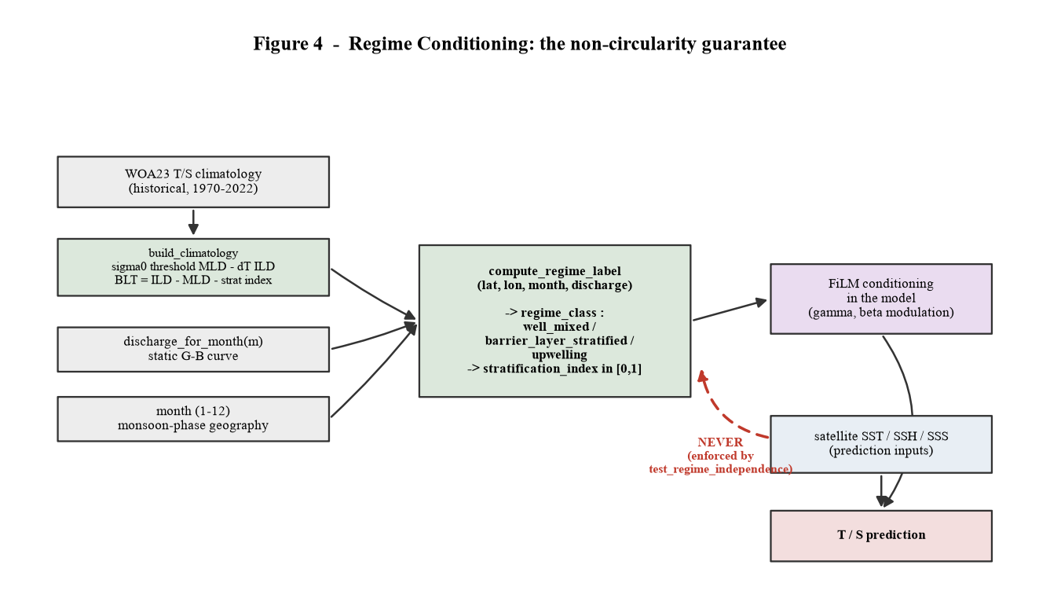
Figure 4 — Regime conditioning. Everything feeding compute_regime_label is a climatology, the calendar month, or a fixed discharge curve. The dashed edge — satellite fields into the regime label — is the circularity flaw and is forbidden by test.

build_climatology.py
From woa23_nio_monthly.nc, per (month, lat, lon) cell it computes, with gsw: potential density sigma-0; the mixed-layer depth as the depth where sigma-0 exceeds its 10 m value by 0.03 kg/m3; the isothermal-layer depth as the depth where temperature drops 0.5 C below its 10 m value; the barrier-layer thickness as ILD - MLD, clipped to [0, 60] m; and a 0-1 stratification index from the sigma-0 contrast between 10 m and 60 m. Writes regime_climatology.nc.

regime_labels.py
compute_regime_label(lat, lon, month, river_discharge=None) -> dict
reads regime_climatology.nc (nearest cell) + the discharge value + month
-> {regime_class, stratification_index, blt_m, mld_m, discharge_anom}
classification:
month in (6,7,8,9) and in an upwelling box and mld <= 40 -> 'upwelling'
blt >= 12 m and strat_index >= 0.35 -> 'barrier_layer_stratified'
otherwise -> 'well_mixed'
strat_index is nudged up by 0.15 * discharge_anom in the NE Bay of Bengal.
regime_grid(month, step=1.0) -> xarray.DataArray of class indices (for maps)
regime_onehot(regime_class) -> float32[3]
The module imports only numpy, xarray, gsw, and fetch_discharge. It never imports fetch_satellite, fetch_argo, or any SST/SSH/SSS symbol — enforced by tests/test_regime_independence.py (Section 6.4).

4.3 src/data_pipeline.py
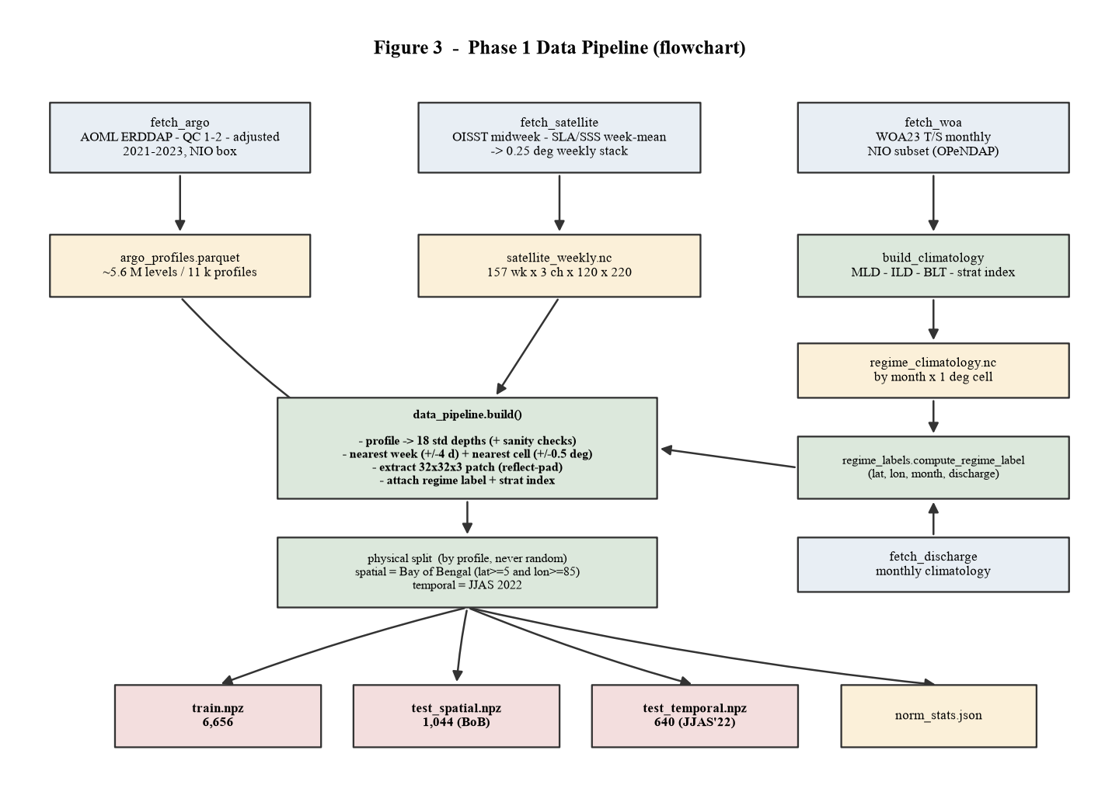
Figure 3 — Phase 1 data pipeline. Three fetchers feed two consolidated stores and a climatology; build() matches them per profile and the split writes four files.
build(patch=32) is the single entry point. Per profile:
- _profile_to_levels — sort by pressure, drop non-finite and out-of-range points, collapse duplicate pressures, run three sanity checks (deep-water T/S band; sub-thermocline salinity floor; no downward warming step > 3 C), then linear-interpolate onto the 18 standard depths with a per-level validity mask. A profile is kept only if it covers the top 12 levels (to 300 m).
- Temporal match — nearest week centre within 4 days.
- Spatial match — nearest 0.25 deg cell within 0.5 deg.
- Patch extraction — a 32x32x3 window (SST, SSH, SSS) centred on the profile, taken from a once-reflect-padded copy of each channel so edge profiles are in-bounds; out-of-range pixels become NaN then 0, with a validity mask. Reject if < 30% of the patch is valid or the centre pixel is missing.
- Regime label — compute_regime_label(lat, lon, month, discharge_for_month(month)); attach class + stratification index.
Splitting is done on the assembled table, by profile, never randomly: any profile inside the Bay-of-Bengal box goes to test_spatial; of the rest, any profile in June-September 2022 goes to test_temporal; everything else is train. _assert_disjoint verifies the three profile-id sets do not intersect before the files are written. _write_norm_stats computes per-channel and per-depth statistics from the training split only.

4.4 src/datasets.py
NormStats loads norm_stats.json and provides denorm_T / denorm_S. OceanProfileDataset(split, stats, augment) loads one NPZ into memory, applies (x - mean) / std to the patch channels (zeroing invalid pixels), normalises the per-level targets, keeps the raw physical targets and the pressure vector for the physics loss and metrics, and — when augment is set — applies random horizontal/vertical flips of the patch. __getitem__ returns a dict of tensors.

4.5 src/models
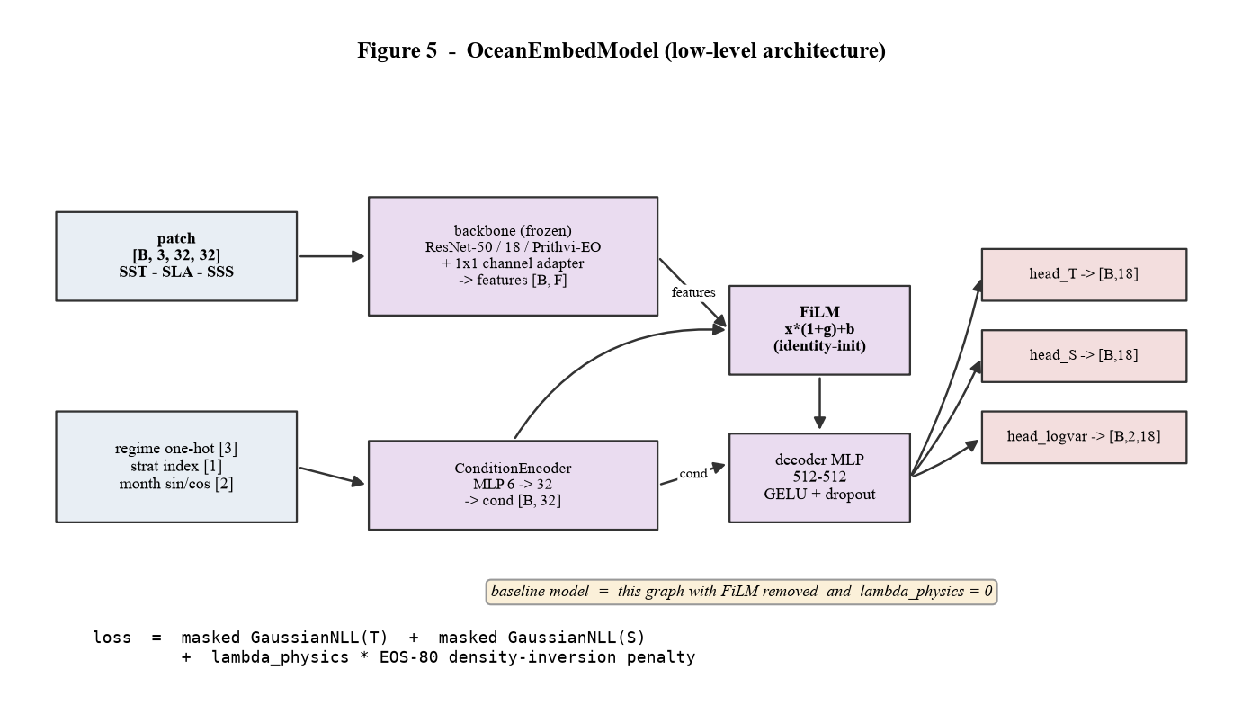
Figure 5 — OceanEmbedModel. The backbone is frozen; only the channel adapter, ConditionEncoder, FiLM, decoder and heads train. The baseline is the same graph with FiLM removed.

backbone.py
build_backbone(name, in_channels, pretrained, freeze) returns a module exposing .forward(x) -> features and .feat_dim. ResNetBackbone wraps torchvision ResNet-50 (2048-d) or ResNet-18 (512-d) with a learnable 1x1 channel adapter initialised near identity; when frozen, its BatchNorm layers stay in eval mode and its forward runs under no_grad. PrithviBackbone loads Prithvi-EO-2.0 through the terratorch backbone registry, adapts the 3 ocean channels to Prithvi's 6-band stem and upsamples the patch to 224 px; if terratorch or the weights are missing it raises ImportError and the factory falls back to ResNet-50 with a warning.

conditioning.py
FiLMLayer is exactly the specification: gamma and beta are single Linear layers, initialised to zero so an untrained FiLM is the identity and cannot damage the pretrained features. ConditionEncoder is a 6 -> 32 -> 32 MLP over [regime one-hot (3), stratification index (1), month sin/cos (2)].

physics_loss.py
density_eos80(SP, t, p_dbar) implements the UNESCO 1983 equation of state in pure torch — the published polynomial, expressed so autograd flows (gsw.rho is numpy and cannot be a loss). It agrees with full TEOS-10 (gsw) to 0.001-0.014 kg/m3 across the T/S/depth range. physics_consistency_loss(pred_T, pred_S, pressure, mask, stability_weight) penalises negative density differences between adjacent valid levels (the inversion penalty), with an optional buoyancy-roughness term. physics_diagnostics_gsw is the non-differentiable TEOS-10 check used only in evaluation.

oceanembed_model.py
OceanEmbedModel(n_levels, in_channels, backbone, freeze_backbone, use_film, condition_dim, decoder_hidden, dropout). Forward: backbone(patch) -> features; if use_film, features = FiLM(features, ConditionEncoder(...)); decoder MLP (two 512-wide GELU layers with dropout); three linear heads produce T[18], S[18] and a clamped log-variance [2, 18]. predict_mc runs N stochastic forward passes with dropout active for MC-dropout uncertainty. build_model(cfg, n_levels) is the factory; the baseline is build_model of baseline_of(cfg), which sets use_film=False and lambda_physics=0.

4.6 src/train.py
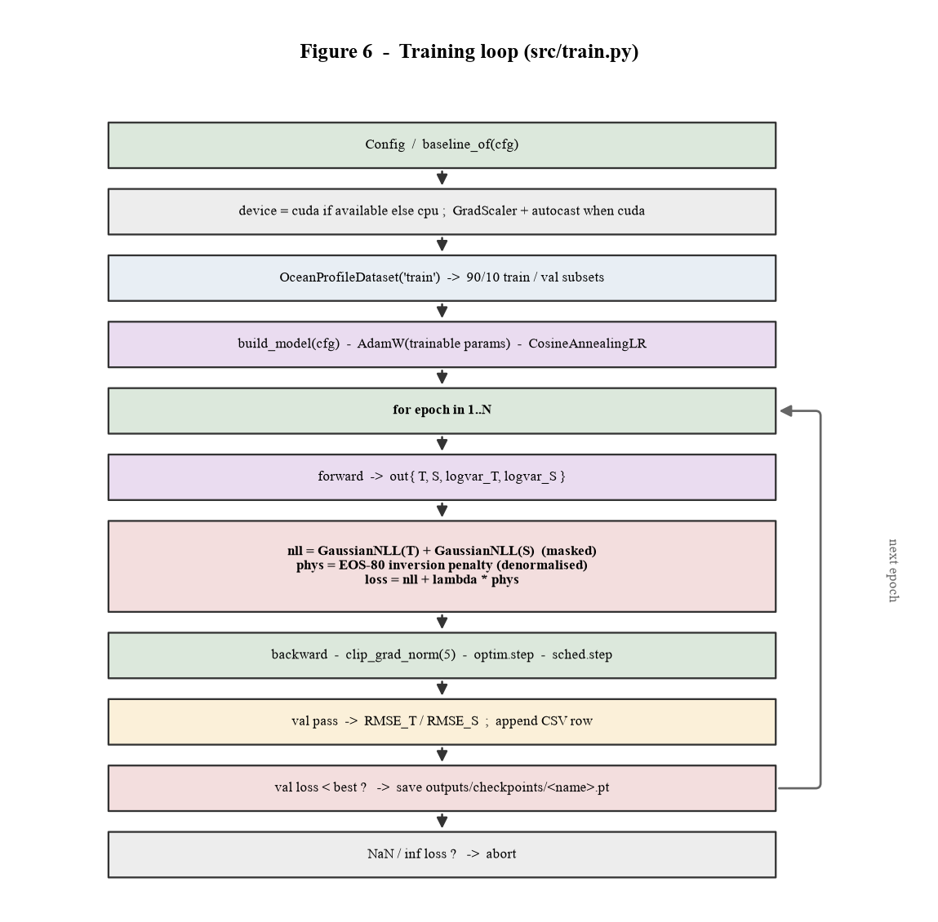
Figure 6 — Training loop. One pass per epoch over the 90% training subset, then a validation pass; the best validation loss is checkpointed.
Config is a dataclass carrying every hyperparameter; Config.add_args / from_args wire it to argparse and baseline_of derives the baseline. train_one builds the datasets (a 90/10 split of train.npz for monitoring only — the physical holdouts are never touched here), the model, an AdamW optimiser over the trainable parameters, and a cosine schedule. run_epoch computes, per batch: masked Gaussian negative log-likelihood for T and for S in normalised space; the EOS-80 inversion penalty in physical space (predictions de-normalised first); loss = nll + lambda_physics · phys. On CUDA it runs under autocast with a GradScaler. Gradients are clipped to norm 5. Each epoch writes one train and one val row to outputs/metrics/train_log_<name>.csv; a new best validation loss saves outputs/checkpoints/<name>.pt (state dict + config + metrics). A non-finite loss aborts.
The lambda_physics sweep {0.05, 0.1, 0.3} produced identical RMSE to three decimals — the term is inactive because both models already yield density-stable profiles (see Section 8).

4.7 src/evaluate.py
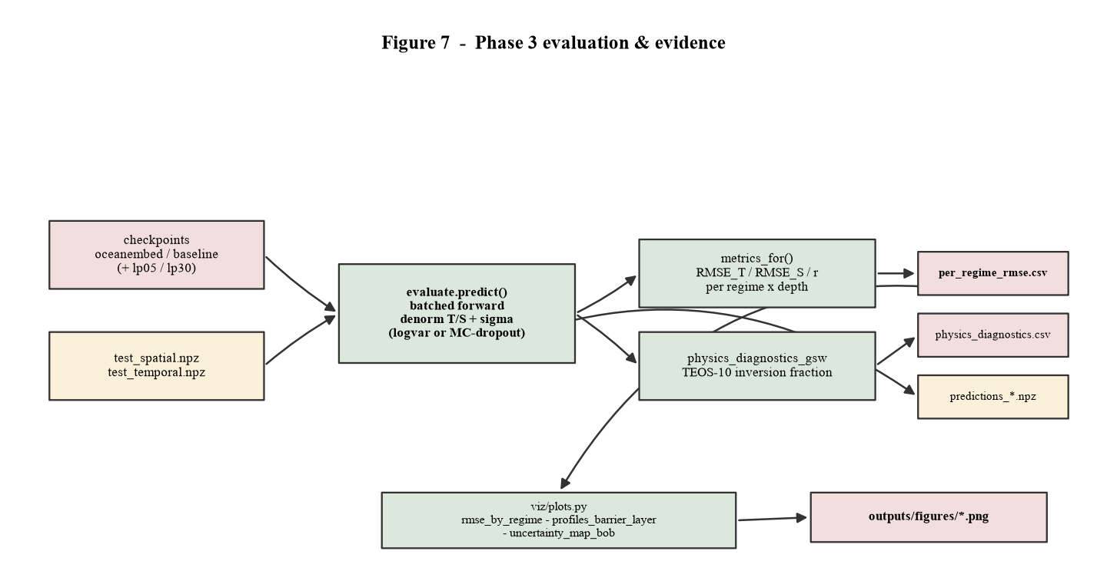
Figure 7 — Evaluation. Each checkpoint is run against both holdouts; metrics are aggregated per regime and per depth into one CSV.
load_model rebuilds the model from the checkpoint's stored config. predict runs batched inference, de-normalises T/S and the uncertainty (from the log-variance head, or from predict_mc when --mc-dropout N is given), and returns per-profile arrays. metrics_for aggregates RMSE_T, RMSE_S and Pearson r for every (model, test_set, regime_class, depth_level) cell, plus a pooled row (depth_level = -1) and an all-regime row. Output: outputs/metrics/per_regime_rmse.csv (the single most important artefact), physics_diagnostics.csv, and predictions_<model>_<set>.npz for the plots and the dashboard.

4.8 src/viz/plots.py
Reads per_regime_rmse.csv and the prediction NPZs and writes three PNGs: rmse_by_regime (grouped bars, OceanEmbed vs baseline, faceted by holdout); profiles_barrier_layer (three Bay-of-Bengal profiles, prediction vs Argo with a plus/minus 2 sigma band); uncertainty_map_bob (predictive sigma at 100 m across the holdout points).

4.9 dashboard/app.py
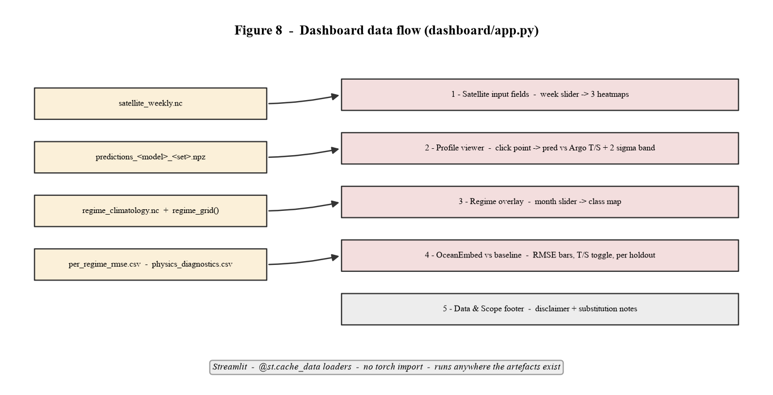
Figure 8 — Dashboard data flow. Each artefact feeds one section. The app imports no torch and runs anywhere the files exist.
A single Streamlit script with @st.cache_data loaders. Sidebar: model and holdout selectors. Section 1 renders the three input fields for a chosen week as Plotly heatmaps. Section 2 shows the holdout points on a map; clicking one (st.plotly_chart(..., on_select="rerun")) draws its predicted vs observed T and S with the uncertainty band and the per-profile RMSE. Section 3 calls regime_grid(month) and renders the class map. Section 4 draws the comparison bars from the CSV with a temperature/salinity toggle and an expandable table. Section 5 is the fixed Data & Scope disclaimer plus the substitution notes.

4.10 tests/
test_regime_independence.py parses the AST of src/regime/regime_labels.py and fails if any import names fetch_satellite, fetch_argo, or a bare SST/SSS/SSH/ADT/ocean_color symbol. test_split_integrity.py loads the three NPZ files (skipping if the pipeline has not been run) and asserts the profile-id sets are pairwise disjoint, that every spatial-holdout row is inside the Bay-of-Bengal box, that no training row is, and that the temporal holdout is a single June-September season.

5 Frameworks — how each one is used

5.1 PyTorch
- Model composition: every component is an nn.Module; OceanEmbedModel wires backbone, ConditionEncoder, FiLMLayer, decoder and heads in forward().
- Autograd through physics: the EOS-80 density function is written with torch ops so the inversion penalty contributes real gradients to T and S; gsw stays on the non-differentiable evaluation side.
- Transfer learning: torchvision weights (ResNet50_Weights.IMAGENET1K_V2) or terratorch's Prithvi weights are loaded and frozen; requires_grad is switched off on the backbone, on for the adapter.
- Mixed precision: torch.autocast + torch.amp.GradScaler are enabled only when device.type == 'cuda'.
- Data loading: torch.utils.data.Dataset / DataLoader / Subset; num_workers defaults to 0 for Windows safety.
- Heteroscedastic uncertainty: a log-variance head trained with Gaussian NLL; MC-dropout is the alternative, via repeated stochastic forward passes.

5.2 xarray, netCDF4, h5netcdf
- Labelled arrays: satellite and climatology data are xarray Datasets indexed by named dims (week_start, month, depth, lat, lon); .sel(..., method='nearest') and .isel do the slicing.
- Server-side subsetting: WOA23 is opened straight over OPeNDAP and sliced to the NIO box before any bytes are transferred in bulk.
- Engine fallback: files are opened trying netcdf4, then h5netcdf, then scipy, because different NOAA products use different NetCDF encodings; decode_times=False handles WOA's 'months since' unit.
- Regridding: DataArray.interp(latitude=..., longitude=..., method='nearest') puts SSH and SSS on the SST grid.

5.3 ERDDAP / OPeNDAP protocols
ERDDAP exposes two query styles used here. tabledap (Argo, RAMA): a .nc or .csv request with a comma-separated variable list and & -joined constraints on time, latitude and longitude. griddap (SSH, SSS): a variable name followed by bracketed [(start):(stop)] ranges on each axis, URL-encoded. The code builds these URL strings directly rather than through a client library, so the exact request is visible and cacheable; erddapy and pydap are available as fallbacks.

5.4 gsw (TEOS-10) and the EOS-80 port
- Climatology: gsw.SA_from_SP, gsw.CT_from_t, gsw.sigma0, gsw.p_from_z turn WOA practical salinity + in-situ temperature into potential density for the MLD/BLT calculation.
- Evaluation: gsw.sigma0 again, to report the fraction of adjacent level pairs that are density-inverted per full TEOS-10.
- Training loss: density_eos80 in physics_loss.py — the UNESCO 1983 pure-water density and secant-bulk-modulus polynomials, in torch. Validated against gsw (Section 4.5).

5.5 pandas + pyarrow
The matched profile table is held as a DataFrame and persisted to Parquet (columnar, ~10x smaller than CSV, preserves dtypes). groupby('profile_id') drives the per-profile loop; the frame is dropped from memory before patch extraction to keep the peak footprint low.

5.6 Streamlit
- @st.cache_data memoises every file load and the regime-grid computation across reruns.
- Widgets (select_slider, radio, selectbox) drive a full top-to-bottom rerun of the script; state lives in the widget values, not in globals.
- st.plotly_chart(fig, on_select='rerun') returns the click selection, which is how Section 2 picks a profile.
- The app deliberately imports no torch so the demo has no heavy dependency and starts fast.

5.7 matplotlib
The Agg (non-interactive) backend renders the three Phase-3 figures and the nine diagrams in this document to PNG. Diagrams are composed from FancyBboxPatch boxes and FancyArrowPatch connectors on a fixed 0-100 coordinate canvas.

6 Cross-cutting Concerns

6.1 Configuration
All model and training parameters live in the Config dataclass (src/config.py) with sane defaults; the CLI exposes every field. baseline_of(cfg) is the only place the baseline differs from OceanEmbed. A --smoke preset (ResNet-18, 2 epochs) gives a one-minute end-to-end check.

6.2 Error handling and retries
Network access goes through http_get, which retries with exponential backoff and raises FetchError carrying the server's own message. Fetchers translate an empty ERDDAP result into an empty frame rather than an error. The satellite driver isolates each week in try/except so one failure costs one week, not the run. A corrupt cached NetCDF is detected on open and re-downloaded once.

6.3 Reproducibility
- Every artefact is produced by a script and can be regenerated; none is hand-edited.
- torch and numpy seeds are set from cfg.seed; the train/val monitoring split uses a seeded generator.
- Raw downloads are cached by month/week, so a rebuild is deterministic and cheap.
- Checkpoints store their own Config, so evaluate.py reconstructs the exact model.

6.4 Testing and verification gates
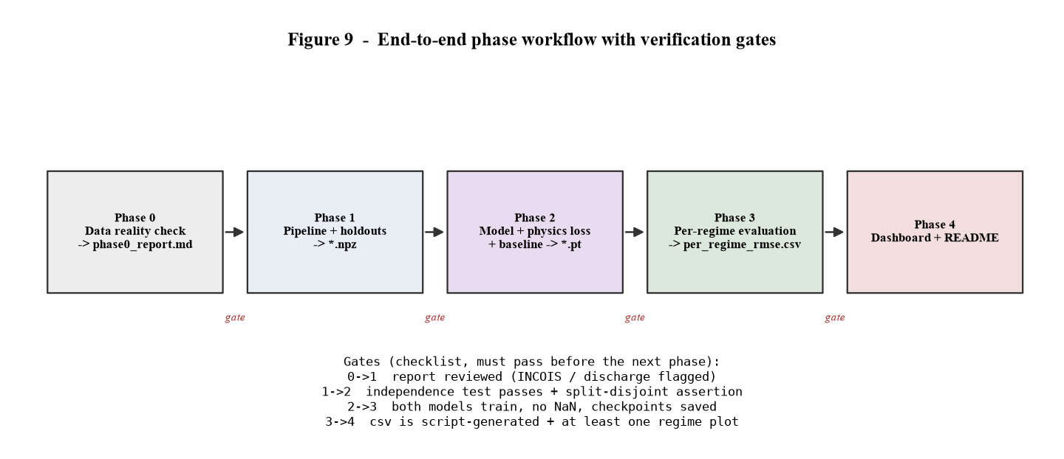
Figure 9 — The five phases and the checklist gate between each. A phase does not start until the previous gate passes.
Beyond the two pytest invariants, each phase in CLAUDE.md has an explicit checklist that must pass before the next begins: Phase 0's data report is reviewed; Phase 1's independence test and disjointness assertion pass; Phase 2's two models train without NaN and are checkpointed; Phase 3's CSV is script-generated and at least one regime figure exists.

6.5 Environment constraints
Constraint | Effect | Handling
Python 3.14 only (spec: 3.11) | argopy will not install | Raw ERDDAP against AOML instead; everything else installs
No CUDA GPU on the build host | Full training infeasible locally | Device-agnostic code; real runs on a CUDA laptop (RUN.md)
A class of hosts unreachable | Canonical endpoints fail | Reachable NOAA equivalents pinned in common.py
Repo inside OneDrive | ~1.7 GB sync pressure | data/ and checkpoints git-ignored; advised to exclude from sync

7 Workflows

7.1 End-to-end phase workflow
The build proceeds through five phases (Figure 9). Each is a set of scripts that read the previous phase's artefacts and write the next. The phases map one-to-one to the commits on the main branch.

7.2 Full reproduction sequence
python -m venv .venv && pip install -r requirements.txt
# Phase 1 — data (already built; re-run to rebuild)
python -m src.data_access.fetch_argo --start 2021-01 --end 2023-12
python -m src.data_access.fetch_satellite --start 2021-01 --end 2023-12
python -m src.data_access.fetch_woa
python -m src.regime.build_climatology
python -m src.data_access.fetch_incois
python -m src.data_pipeline --patch 32
pytest -q
# Phase 2 — training (CUDA machine)
python -m src.train --models both --backbone resnet50 --epochs 40 --batch-size 128
# Phase 3 — evaluation + figures
python -m src.evaluate
python -m src.viz.plots
# Phase 4 — demo
streamlit run dashboard/app.py

7.3 GPU / training-machine workflow
Because data/ is git-ignored, a fresh clone has code only. The training machine either re-runs the Phase-1 fetch scripts (it may reach Ifremer where the build host cannot) or copies data/processed/ and data/interim/ across. It then installs the CUDA build of torch, runs training and evaluation, and the results tables and figures are regenerated in place. Optionally pip install terratorch enables --backbone prithvi.

7.4 Data-flow summary
Reading the figures together: Figure 1 is the black-box view; Figure 2 is the module graph; Figure 3 is Phase 1 in detail; Figure 4 is the guarantee that makes the regime signal legitimate; Figures 5-7 are the model, its training and its evaluation; Figure 8 is how the demo consumes the outputs; Figure 9 is the sequence and its gates.

8 Results Snapshot and Honesty Position
Preliminary models: ResNet-18 backbone, 20 epochs, CPU. The definitive ResNet-50 / Prithvi runs happen on the training machine; the numbers below will be regenerated from those.
Holdout | Regime | Baseline RMSE_T | OceanEmbed RMSE_T
spatial (Bay of Bengal) | barrier_layer_stratified | 0.962 | 0.985
spatial | well_mixed | 0.935 | 0.949
spatial | upwelling | 1.079 | 1.052
temporal (JJAS 2022) | barrier_layer_stratified | 1.063 | 1.049
temporal | well_mixed | 1.209 | 1.187
temporal | upwelling | 1.376 | 1.397
Read honestly (CLAUDE.md 6.2): on the primary test — the Bay of Bengal, barrier-layer regime — OceanEmbed does not beat the baseline (0.985 vs 0.962 C, about 2% worse). On the temporal holdout it is about 1% better in that regime. Every difference is within run-to-run noise at this model size. No retraining was done to change this. Salinity RMSE and profile-shape correlation (r about 0.99) are indistinguishable between the two models. The TEOS-10 density-inversion fraction is about 0.00 for both, which is why the physics term is inactive.
Most likely fixable cause: on the spatial holdout the FiLM signal is nearly uniform, because the held-out Bay-of-Bengal cells take their regime label from the 1 deg WOA23 climatology. A finer barrier-layer climatology for the conditioning input is the first thing to try — without tuning to the metric.

9 Limitations and Future Work
- India-specific observational data is not integrated. INCOIS buoy data is not machine-accessible and CWC discharge is not public; the discharge input is a literature climatology. This is a roadmap item, stated as such in the README and the abstract revisions.
- Substituted products. SST/SSH/SSS are NOAA-hosted, not the CMEMS/PODAAC products named in the abstract (scientifically equivalent). The barrier-layer climatology is WOA23-derived, not the published de Boyer Montegut product. No ocean-colour channel.
- Preliminary training only on the build host — ResNet-18, 20 epochs, CPU. Prithvi-EO is wired but the tested path is ResNet.
- Not implemented: real-time ingestion; active-learning float-deployment recommendations; cyclone rapid-intensification flagging. All roadmap.
- The WOA23-derived mixed-layer depth is too shallow in the winter Arabian Sea; the regime class is robust to this through the stratification gate, but the continuous blt_m field should be used with that caveat.

Appendix A Repository Directory Tree
oceanembed/
CLAUDE.md build specification (phased)
README.md RUN.md overview / run instructions
requirements.txt
docs/abstract_revisions.md
data/
raw/ downloaded source files (git-ignored) + phase0_report.md
interim/ argo_profiles.parquet, satellite_weekly.nc, *climatology*.nc
processed/ train.npz, test_spatial.npz, test_temporal.npz, norm_stats.json
src/
data_access/ common.py fetch_argo.py fetch_satellite.py fetch_woa.py
fetch_discharge.py fetch_incois.py check_sources.py
regime/ build_climatology.py regime_labels.py
models/ backbone.py conditioning.py physics_loss.py oceanembed_model.py
data_pipeline.py datasets.py config.py train.py evaluate.py
viz/plots.py
dashboard/app.py
tests/ test_regime_independence.py test_split_integrity.py
outputs/ checkpoints/ (git-ignored) metrics/ figures/

Appendix B NPZ Artefact Schema
Each of train.npz, test_spatial.npz, test_temporal.npz contains, with N rows:
Key | dtype / shape | Meaning
patch | float32 [N, 3, 32, 32] | channel-normalised SST, SSH, SSS window; invalid pixels 0
patch_mask | float32 [N, 32, 32] | 1 where all three channels are valid
regime_onehot | float32 [N, 3] | well_mixed / barrier_layer_stratified / upwelling
strat_index | float32 [N, 1] | stratification index in [0, 1]
month_sincos | float32 [N, 2] | sin, cos of the calendar month
target_T, target_S | float32 [N, 18] | Argo T and S on the 18 standard depths
target_mask | float32 [N, 18] | 1 where the profile covers that level
lat, lon | float32 [N] | profile position
month, year | int16 [N] | profile date parts
week_start | int64 [N] | matched week (ns since epoch)
regime_class, profile_id | object [N] | string labels
depth_levels | float32 [18] | the standard depths (shared)
regime_classes | object [3] | class name order (shared)

Appendix C Key API Reference
# data access
common.http_get(url, connect, read, tries, backoff, expect_netcdf) -> bytes
common.open_netcdf_bytes(body, tmp_name, decode_times) -> xr.Dataset
fetch_argo.fetch_range(start, end, box=NIO_BOX) -> DataFrame # writes parquet
fetch_satellite.fetch_range(start, end) -> xr.Dataset # writes .nc
fetch_woa.build() -> xr.Dataset
fetch_discharge.discharge_for_month(month:int) -> float
# regime
build_climatology.build() -> xr.Dataset
regime_labels.compute_regime_label(lat, lon, month, river_discharge=None) -> dict
regime_labels.regime_grid(month, step=1.0) -> xr.DataArray
regime_labels.regime_onehot(regime_class:str) -> np.ndarray[3]
# pipeline / data
data_pipeline.build(patch=32) -> DataFrame # writes 3 npz + json
datasets.NormStats(path=None) .denorm_T(x) .denorm_S(x)
datasets.OceanProfileDataset(split, stats=None, augment=False)
# models
backbone.build_backbone(name, in_channels=3, pretrained=True, freeze=True)
conditioning.FiLMLayer(feature_dim, condition_dim)
conditioning.ConditionEncoder(condition_dim=32, hidden=32)
physics_loss.density_eos80(SP, t, p_dbar) -> Tensor
physics_loss.physics_consistency_loss(pred_T, pred_S, pressure_dbar, mask, stability_weight=0.0)
physics_loss.physics_diagnostics_gsw(T, S, pressure_dbar, lon, lat, mask=None) -> dict
oceanembed_model.OceanEmbedModel(n_levels, in_channels=3, backbone='resnet50',
freeze_backbone=True, use_film=True, condition_dim=32, decoder_hidden=512, dropout=0.2)
oceanembed_model.build_model(cfg, n_levels)
# train / evaluate
config.Config(...) config.baseline_of(cfg)
train.train_one(cfg) -> Path
evaluate.load_model(name) evaluate.predict(model, ds, mc_dropout=0)
evaluate.metrics_for(res, model_name, test_set, regime_classes) -> list[dict]

