

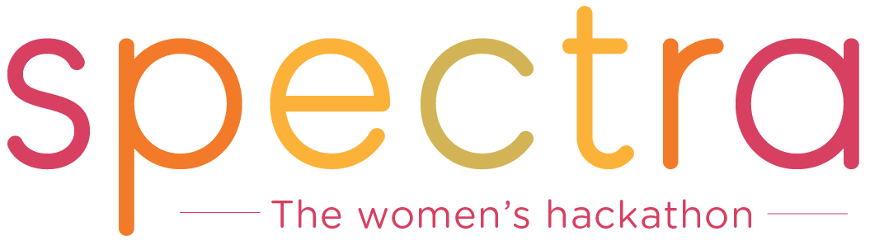

Spectra believes our community should be open to everyone, regardless of race, sexual orientation, background, etc. As such, we are committed to providing a friendly, safe, and welcoming environment for all participants, sponsors, mentors, and attendees in general from discrimination for any reason including (but not limited to) on the basis of sexual orientation, race, ability, age, ethnicity, and religion.

This code of conduct outlines our expectations for participant behavior as well as the consequences of said unacceptable behavior. Exhibitors must follow all Spectra rules, regulations, and policies.

Expected Behavior
- Be considerate, respectful, empathetic, and collaborative
- Refrain from any behavior and speech that is demeaning, discriminatory, or harassing
- Be mindful of your surroundings and of your fellow participants, who may have a different comfort level with respect to language and personal space
- Alert Spectra organizers if you notice a dangerous situation or someone in distress

Unacceptable Behavior
Unacceptable behavior includes: intimidating, harassing, abusive, discriminatory, derogatory, or demeaning conduct by any attendees. The Spectra location may be shared with members of the public; please be respectful to all patrons of these locations.

Harassment includes, but is not limited to: offensive verbal comments including as related to gender, gender identity, sexual orientation, race, ethnicity, religion, age or disability, inappropriate use of nudity and/or sexual images in public spaces (including presentation slides), deliberate intimidation, stalking or following, harassing photography or recording, sustained disruption of talks or other events, inappropriate physical contact, and unwelcome sexual attention.

Consequences of Unacceptable Behavior
Unacceptable behavior will NOT be tolerated at Spectra by anyone, such as other attendees, media, speakers, volunteers and mentors, organizers, venue staff, sponsors, etc.

Anyone asked to stop unacceptable behavior is expected to comply immediately. If a participant engages in unacceptable behavior, the Spectra staff may take any action they deem appropriate, at their sole discretion, up to and including expulsion from the event.

What to Do if You Witness or Are Subject to Unacceptable Behavior
If you are subject to unacceptable behavior, notice that someone else is being subject to unacceptable behavior, or have any other concerns, please notify a Spectra staff member as soon as possible. All reports will remain strictly confidential.

The Spectra staff will be available to help participants contact venue security or local law enforcement, to provide escorts, or to otherwise assist those experiencing unacceptable behavior to feel safe throughout the duration of the hackathon.

Scope
We expect all hackathon participants (sponsors, hackers, volunteers, speakers, attendees, and other guests) to abide by this code of conduct at all hackathon venues and Spectra-related events. Participants asked to stop a hostile or harassing behavior are expected to comply immediately. Hackathon participants seek to learn, network, and have fun. Please do so responsibly and with respect to the right of others to do likewise.

Please contact Spectra staff if you believe you have been harassed or that a harassment problem exists. Spectra staff will determine and carry out appropriate course of action and may consult with and engage other Spectra staff, leaders, and legal counsel, as appropriate. Event security and/or local law enforcement may be involved, as appropriate, based on the specific circumstances. As requested, a follow-up report will be made to individuals who report being harassed.

License and Attribution
This Code of Conduct I distributed under a Creative Commons Attribution-ShareAlike license and is based on works at Open Source Bridge and http://www.gdconf.com/codeofconduct.html.

