Homework 1 – Taylor Singleton

1. How did Bell solve the capacity problem? Please explain.

Bell solved the capacity problem by using multi-plexing. This system is like sending telegraph signals as musical notes. Multiple telegraph signals can be sent on the same wire if they are represented differently.

2. How do magicians bend the path of light? Please explain by drawing a diagram.

Using a column of water and a light source at a very particular angle, light could be “trapped” in water. Since light travels slower in water than it does in air, when the light meets the boundary of the light and air, it is reflected. When the light source is placed at the correct angle, the light is reflected back into the water until the water hits the ground.

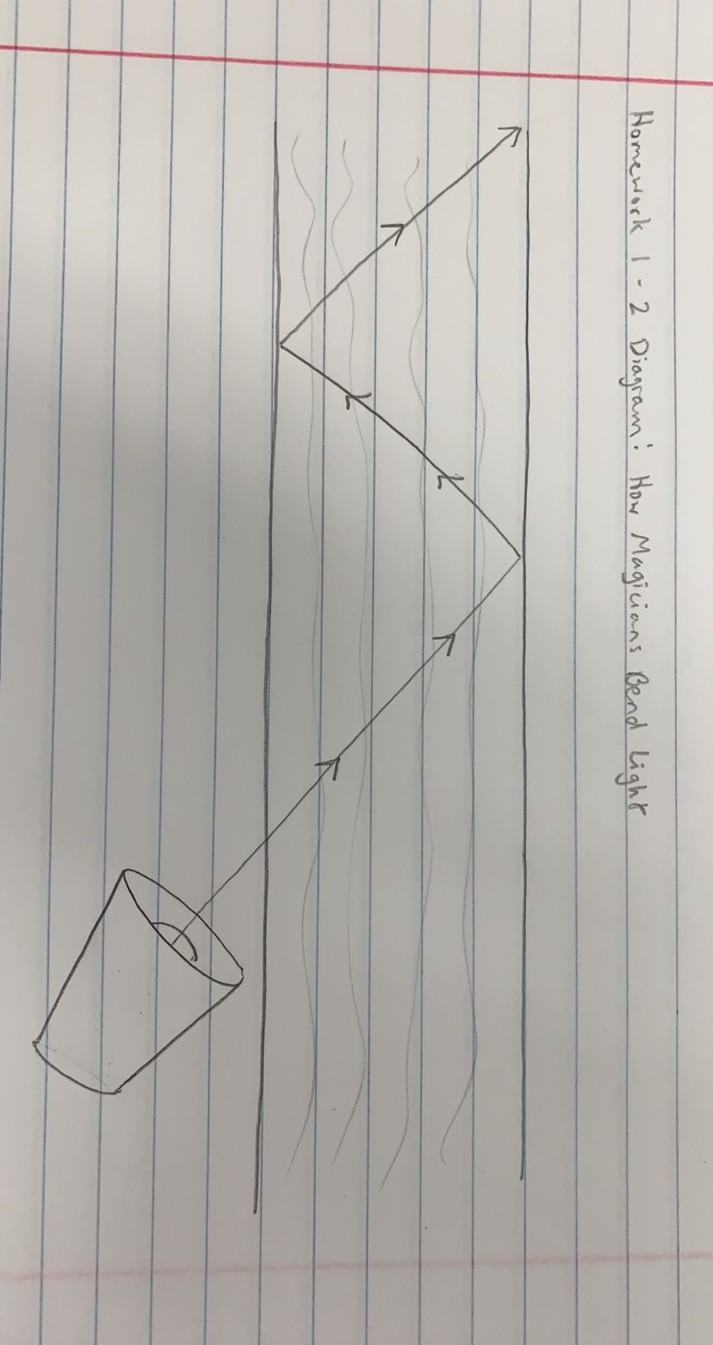

3. How do we use radio to communicate? Please explain how signal are converted to radio signal.

A radio wave used is “winked” on and off. Signals are encoded into on and off radio signals and can be used to convey a lot of information quickly. The faster the wave can be “winked”, the more information can be sent via the wave.

4. Why low frequency radio is bad for delivering voice wirelessly? Please explain.

Low frequency waves are destroyed if they are winked on and off too quickly. With a higher frequency, more information per second can be put into the wave.

5. How do engineers solve the blocking problem in microwave radio communication?

Engineers solved the blocking problem by developing coaxial cables, which are hollow pipes through which engineers could send many different frequencies of waves. However, the pipes converted much of the waves’ energy to heat. In response to this, engineers developed amplifiers to allow the waves to travel longer distances.

6. What are the problems of satellite communication?

The problems with satellite communication are higher cost, audio delay, and difficulty in launching the actual satellites.

7. Why laser is able to carry a lot of data? Please explain.

Lasers are able to carry a lot of data because the laser fluctuates somewhere around 1x10^15 times per second rather than only a million or a billion times per second. Additionally, laser can be winked on and off extremely quickly.

8. The capacity of Fiber Optics eventually made telecommunication industrial market to crash, why?

Fiber Optics are cheap and easy to make. After making and laying so much fiber for years, the world no longer needed anymore fiber. With rising supply and decreasing demand, the telecommunications industry crashed.

9. What are the two key technologies in communication make long distance medical surgery possible?

Two technologies in communication that make long distance medical surgery possible are fiber optics and robotics.