Homework 2 – Taylor Singleton

1. (20%) Please convert the following binary to decimal. Show your work. 1100011

Answer: 99. The work is in the same picture as #2.

2. (20%) Please convert the following hexadecimal to binary. Show your work. 68

Answer: 01101000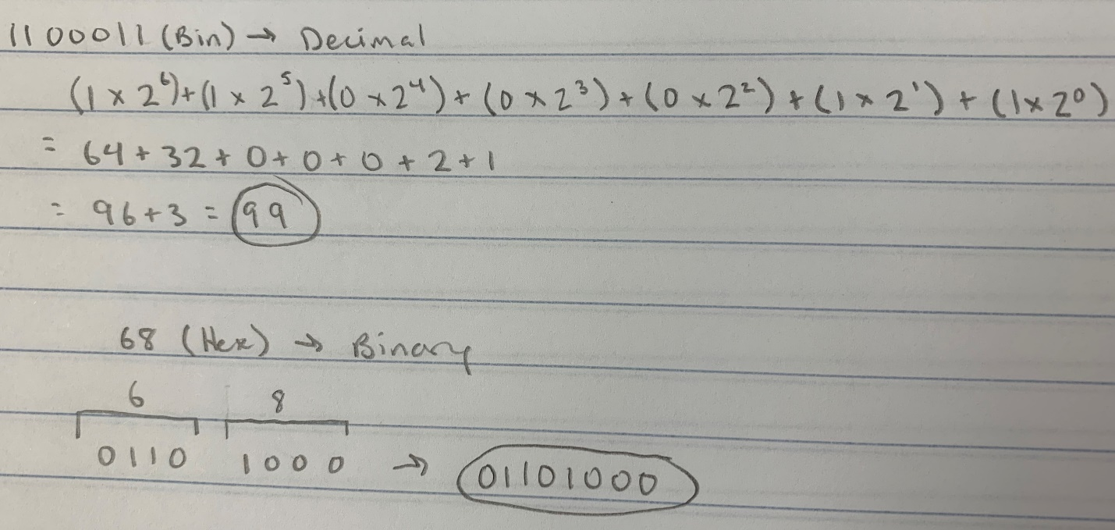

3. (20%) Please research on “Pony Express”, write a few short paragraphs to discuss the

a. Purpose.

b. Methodology.

c. Difficulties.

d. Interesting findings of “Pony Express”.

The purpose of the Pony Express was to reduce the amount of time mail could travel between the Eastern and Western United States. With the gold rush of 1849, California became a bustling new frontier. Once the area was made a state, means were needed to link it to the rest of the Union. The Pony Express was introduced in order to accomplish this goal. In the end, the Pony Express reduced the number of days it took mail to travel from coast to coast to about ten days.

The Pony Express relied on young, hardy riders and fast horses. Operating around the clock, the mail system consisted of stations about ten miles apart from each other. At each station, the rider would quickly switch out horses. Riders would ride for 75 to 100 miles at a time, and in emergencies, riders were known to ride for twenty hours straight. The riders were tasked with keeping the mail safe at all costs, even dying before they lost the mail. For their efforts, the riders were compensated considerably.

Riders faced many dangers. On the less extreme end, discomfort of riding for so long, difficult to negotiate terrain, and insects plagued the riders. More perilously, harsh weather, scarce water on the trails, and Native American attacks on rider and station alike threatened the lives of all involved with the Pony Express.

The Pony Express ended up sparking a small war with the Paiute people of Nevada. This conflict was called the Pyramid Lake War. Pony Express riders actually was required to take an oath to refrain from cursing, drinking, or fighting with other employees. Many riders took this pledge very lightly however. Additionally, the saddlebags used by the riders were specifically designed for the job of transporting mail in this system. Additionally, normal people rarely used the Pony Express. The average person could not afford the shipping costs the Pony Express demanded. Finally, the Pony Express only operated for about eighteen months before it was dealt a fatal blow by the telegraph system. With the dawn of communication over wires, once wire was laid, dangerous, multi-day rides through the wilderness were no longer necessary as communication was essentially instant. However, the Pony Express still lives on today as one of the most influential pieces of lore the American Wild West has to offer.

Works Cited

https://en.wikipedia.org/wiki/Pony_Express

https://www.britannica.com/topic/Pony-Express

https://www.history.com/news/10-things-you-may-not-know-about-the-pony-express

4. (20%) Please research on 1980s Mainframe computers and modern day computers. Write a few short paragraphs to compare these two types of computers regarding the following:

a Cost

b Size

c Performance

d Energy consumption.

In 1980, a mainframe computer cost a whopping $400,000 on the low end. This price eventually fell to $20,000 by the end of the decade, but these prices are astronomical in comparison to modern day computers. The average cost of a modern computer is about $650. This is the average price of any computer one could buy.

Mainframe computers in the 1980s were the size of a building. Just one of these massive machines filled a large data center. They were so large and produced so much heat that they had to be cooled with chilled water. Now, computers have screen that are, on average, about fifteen inches across and weigh about eleven pounds.

In 1985, IBM produced the 308X which used 1,000,000-bit memory chips. The Model 200 and Model 400 had 64 and 128 megabytes of central storage. The 308X could perform tasks fourteen times faster than its predecessor. Now, the average computer has somewhere between four to eight gigabytes of RAM and 500 gigabytes to a terabyte of central storage. This number is 7,800 times more central storage than the Model 400 IBM 308X had.

In 1985, Seymour Cray constructed the Cray-2, which improved upon its predecessor. Power consumption was down from 250 kilowatts to 195 kilowatts. In comparison to modern computers, these mainframes’ energy needs were enormous. The average modern desktop consumes somewhere around 40 to 250 Watts without monitors. Monitors add about 20 Watts to the total.

Works Cited

http://enterprisesystemsmedia.com/article/mainframe-processor-pricing-history#&ts=undefined

https://www.statista.com/statistics/722992/worldwide-personal-computers-average-selling-price/

https://www.encyclopedia.com/science-and-technology/computers-and-electrical-engineering/computers-and-computing/mainframes

https://www.techwalla.com/articles/the-average-laptop-dimensions

https://www.thocp.net/hardware/mainframe.htm

https://www.quora.com/What-are-the-specs-for-the-average-computers

http://www.cpushack.com/2018/05/27/mainframes-and-supercomputers-from-the-beginning-till-today/

https://www.kompulsa.com/much-power-computers-consume/

5. (20%) Please research on Morse code. List (Draw) all Morse code.